13
Recipes
There are a couple of places in the chapter that are indented and I know they should be flush left. I am unable to fix them.
This chapter covers:
- Implementing jQuery autocomplete text box
- Configuring automatic client-side validation
- Using NHibernate for data access
- Integrating the Spark view engine

By now you have seen all of the components of the ASP.NET MVC Framework. Surely you have asked yourself, How do I do ____ in ASP.NET MVC? Certainly with a new paradigm it’s natural to feel a bit lost when trying to implement functionality in your first application. This chapter is geared toward giving you concrete examples, or recipes, for achieving common functions such as automatic validation or data access. Take these examples verbatim and use them in your applications, or simply learn from them and apply the techniques in your own way. We start with client-side functionality, move through extending validation, and through a comprehensive data access recipe. We finish by replacing the built-in view engine that comes with ASP.NET MVC and try out the Spark view engine.
13.1 jQuery autocomplete text box
It’s not uncommon for text boxes to automatically suggest items based on what we type. The results are further filtered as we type to give us the option to select an available item with the mouse or keyboard. One of the first examples of this in the wild was Google Suggest as shown in figure 13.1.
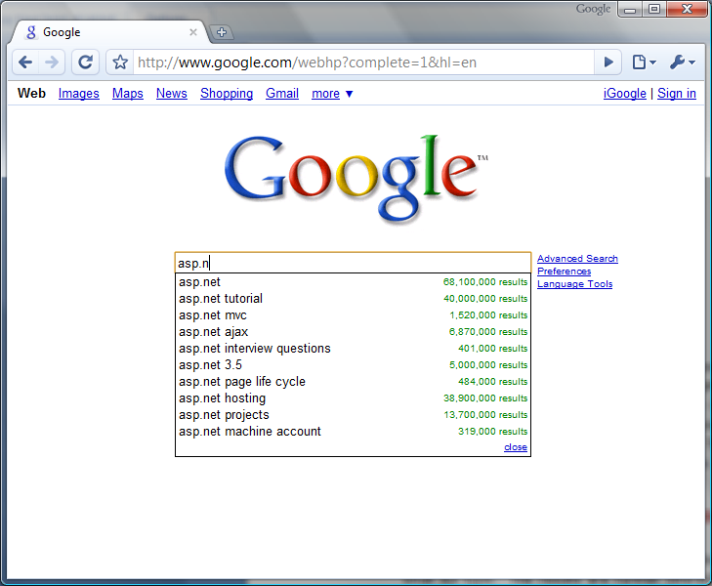
Figure 13.1 Google Suggest filters options as you type.
A rudimentary implementation of this automatic suggestion feature would be to monitor key presses and fire off AJAX requests for each one. Of course this means that a fast typist would trigger many requests, most of which would be immediately discarded for the next request coming in 5 milliseconds. An effective implementation will take into account a typing delay and also provide keyboard/mouse support for selecting the items.
Luckily jQuery has an extensive list of plugins available. One such plugin is Dylan Verheul’s autocomplete.
Dylan Verheul’s autocomplete
You can download the autocomplete plugin at http://www.dyve.net/jquery/ with a few others including googlemaps and listify.
The basic idea is that you have a simple text box on your page. The jQuery plugin adds the behavior necessary to handle key press events and fire the appropriate AJAX requests to a URL that will handle the request. The URL points to a controller action, and by convention the response is formatted so that the plugin could handle the response.
Assume for our purposes that we want to filter U.S. cities in the text box. The first step is to add a controller, action, and view for displaying the UI for this example. Ensure that jQuery (in this case jquery-1.2.6.js) and jquery.autcomplete.js are referenced at the top of the view (or master page).

<script type="text/javascript" src="../../scripts/jquery-1.2.6.js"></script>
<script type="text/javascript" src="../../scripts/jquery.autocomplete.js"> </script>

Next, add the text box. In this example we’ll call it city.

<%= Html.TextBox("city") %>
Package this up with a simple controller (listing 13.1), and the result will be similar to that show in figure 13.2.
Listing 13.1 Controller and action for displaying our test page
public class HomeController : Controller
{
public ActionResult Index()
{
return View();
}
}
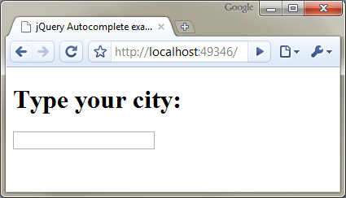
Figure 13.2 Our simple view with a text box
Now we add a little JavaScript to add the autocomplete behavior.

<script type="text/javascript">
$(document).ready(function() {
$("input#city").autocomplete('<%= Url.Action("Find", "City") %>');
});
</script>

Place the script in the <head> of the page. You can see that the URL for the autocomplete behavior is specified as Url.Action("Find", "City"). This will point to a Find() action on the CityController. We'll need to write this controller and action as shown in listing 13.2.
Local Data Mode
The autocomplete plugin can also filter local data structures. This is useful when you have a limited set of data, and you want to minimize requests sent to the server. The autocomplete plugin in local mode is also much faster, because there is no AJAX request being made behind the scenes. The only downside is that you must render the entire array onto the view.
Listing 13.2 Action to find cities from an autocomplete AJAX request
public class CityController : Controller
{
private readonly ICityRepository _repository;

public CityController()
{
string csvPath = |#A
System.Web.HttpContext.Current |#A
.Server.MapPath("~/App_Data/cities.csv"); |#A

_repository = new CityRepository(csvPath); #B
}

public CityController(ICityRepository repository) #C
{
_repository = repository;
}

public ActionResult Find(string q) #D
{
string[] cities = _repository.FindCities(q);
return Content(string.Join("\n", cities)); #E
}
}

#A Load CSV file containing citites
#B Load CSV into repository
#C Testable constructor
#D Autocomplete sends parameter ‘q’
#E Return raw text
The details of the CityRepository can be found in the code samples provided with the book. For now, we’ll focus on the new Find(string q) action. Because this is a standard action, you can navigate to it in your browser and test it out. Figure 13.3 shows a quick test.

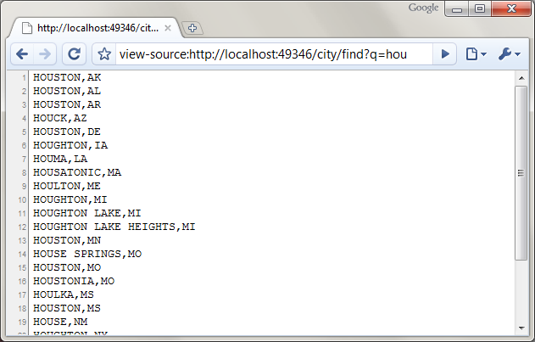
Figure 13.3 A simple HTTP GET for the action with a filter of "hou" yields the expected results.
Now that we are sure that the action is returning the correct results, we can test the text box. The JavaScript we added earlier hooks up to the key press events on the text box and should issue queries to the server. Figure 13.4 shows this in action.

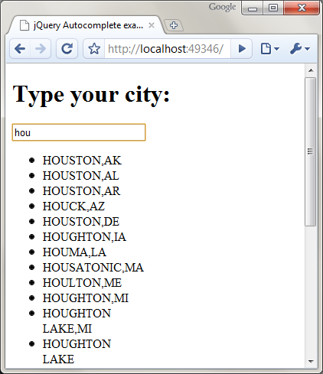
Figure 13.4 The results are displayed in a <ul> tag. We can apply CSS to make it look nicer.
The drop-down selections are unformatted by default, which makes them a little ugly. CSS magic will make it look nicer. Listing 13.3 shows sample CSS for this transformation.
Listing 13.3 CSS used to style the autocomplete results
<style type="text/css">
div.ac_results ul
{
margin:0;
padding:0;
list-style-type:none;
border: solid 1px #ccc;
}

div.ac_results ul li
{
font-family: Arial, Verdana, Sans-Serif;
font-size: 12px;
margin: 1px;
padding: 3px;
cursor: pointer;
}

div.ac_results ul li.ac_over
{
background-color: #acf;
}
</style>

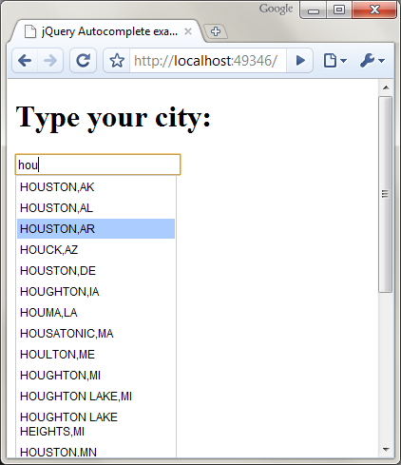
Figure 13.5 The styled drop down results look much nicer. The selected item is highlighted and can be chosen with the keyboard or mouse.
The options of autocomplete plugin enable you to configure it to your needs. For the case that we've shown here, it's as simple as this:

$(your_textbox).autocomplete('your/url/here');
No column headers on table 13.1, according to author

Table 13.1 Common options for the plugin
inputClass | This class will be added to the input box.
resultsClass | The class to apply to the results’ container. Default value is "ac_results"
loadingClass | The class to apply to the input box while results are being fetched from the server. Default is “ac_loading.”
lineSeparator | The character used to separate the results. The default is \n
minChars | The minimum # number of characters before sending a request to the server. Default is 1.
delay | The delay after typing when the request will be sent. Default is 400 ms.
To set these options, include them in a dictionary as the second argument to the autocomplete method like this:

$("input#city").autocomplete('<%= Url.Action("Find", "City") %>', {
minChars : 3,
delay : 300
});

This type of functionality is immensely useful for selecting from large lists. It keeps your initial page size down by not loading all of these items at once and is user-friendly.
13.2 Automatic client-side validation
The ASP.NET MVC Framework includes support for model validation; however the support doesn’t include client-side validation. The ModelBinders that you learned about in chapter 3 can be combined with validation attributes, such as those provided in the System.ComponentModel.DataAnnotations namespace. The Castle Project also has a good set of validation attributes that you can use on your classes. These provide simple ways of declaring properties as required, or requiring certain input.
We'd like to extend this to automatically render the appropriate JavaScript validation so that you can define your rules once, and have them used in client-side and server-side model validation.
Our preference is to use the Castle Validation attributes. These can be downloaded at http://castleproject.org. The attributes are easy to use. You simply add the appropriate attribute to the property that needs the rule, as shown here.

public class Person
{
[ValidateNonEmpty]
public string Name {get;set;}
}

To validate the instance of the class, you run it through the ValidationRunner class. All of these classes come from the Castle.Components.Validator namespace.
Do I place these attributes on my domain model?
Ask two developers this question and you'll probably get two different answers. There are good arguments from both sides. From one perspective, declarative validation is elegant, requires little code, and works well for simple, data oriented models. The other perspective sees value in not allowing domain entities to enter an invalid state. The perspective favors methods that convey behaviors for state changes rather than properties with getters and setters.
The decision of whether or not to add validation attributes to your domain model is contextual. If you're using a view model—that is, specific classes dedicated for representing the data displayed or entered on your UI—they're great.
View model objects are inherently data-oriented, and they provide a realistic representation of the data gathered from the UI. Because you always validate user input before letting it creep into your system, this is a perfect place for declarative validation attributes.
If you’re using your domain entities on your view directly, then you might favor the validation attributes within your domain model. If complexity requires you to create view models to interact with the UI and map to your domain entities, then you'll probably want to avoid placing these attributes in your domain model and rely instead on validating the view models.
Let's use an example from Code Camp Server. When users register for a conference, they need to fill in their name and contact information. These values will eventually map to domain entities, but initially they are populated in a view model object called NewAttendeeForm. This class contains all of the properties that are needed to gather user input from the view.

public class NewAttendeeForm
{
public string FirstName { get; set; }
public string LastName { get; set; }
public string Email { get; set; }
public string Url { get; set; }
public string Notes { get; set; }
}
After adding the validation attributes, our class now looks like this.
public class NewAttendeeForm
{
[ValidateNonEmpty]
public string FirstName { get; set; }

[ValidateNonEmpty]
public string LastName { get; set; }

[ValidateNonEmpty, ValidateEmail]
public string Email { get; set; }

[ValidateRegExp("http://(\w+?\.)+\w{3}")]
public string Url { get; set; }

public string Notes { get; set; }
}

The properties FirstName, LastName, and Email are all required. There is a built-in validator for email address validation for our Email property. We want to verify that the Url property is correctly formatted. Please excuse the naïve regular expression for the URL. The proper URL regular expression is enormous and not necessary for this example. Now that we have the validation attributes specified, we can implement instance validation inside of a custom model binder. Listing 13.4 shows a custom model binder for constructing and validating a class decorated with Castle Validators.
Cueballs in code and text
Listing 13.4 Custom Castle Validation ModelBinder
public class CastleValidationBinder : DefaultModelBinder
{
public override object BindModel(ControllerContext controllerContext,
ModelBindingContext bindingContext)
{
object model = |#A
base.BindModel(controllerContext, bindingContext); |#A

if (model == null) return model;

var validator = |#1
new ValidatorRunner(new CachedValidationRegistry()); |#1

if (!validator.IsValid(model)) #2
{
var summary = validator.GetErrorSummary(model);
foreach (string invalidProperty in
summary.InvalidProperties) #3
{
foreach (string error in
summary.GetErrorsForProperty(invalidProperty))
{
var modelState = bindingContext.ModelState;
modelState
.AddModelError(invalidProperty, error); #4
}
}
}

return model;
}
}

#A Copy values onto object

You can see from listing 13.4 that a ValidationRunner class is created (1), which then inspects the model (2). If the model object is found to be invalid, it loops over the properties found to be in error (3). Each property might have more than one broken rule (such as our Email property), so we need to loop over these. After we have a specific error and property name, we add it to ModelState so that the view can take advantage of it (4).
We can enable this model binder for our view model by adding the following line to Application_Start in Global.asax.cs:

ModelBinders.Binders.Add(typeof(NewAttendeeForm),
new CastleValidationBinder());

We might instead choose to make this the new default model binder, using:

ModelBinders.Binders.DefaultBinder = new CastleValidationBinder();

At this point we have a complete functioning model binder that will validate the model as it’s created. Now consider the following action:

[AcceptVerbs(HttpVerbs.Post)]
public ActionResult Index(NewAttendeeForm newAttendeeForm)
{
if(!ModelState.IsValid)
{
return View();
}

TempData["message"] = "You were successfully registered";
return RedirectToAction("index");
}

The newAttendeeForm will be created (and validated) with our custom model binder. If errors are found, they will be present in ModelState. This completes the server-side validation; however we still need to add client-side validation to avoid having to POST to the server just to get simple validation errors.
In the view, we'll need a simple helper that will output the appropriate JavaScript to automatically validate the form fields. The rules will come from the same attributes we defined earlier. We'll leverage a jQuery plug-in called jQuery.validation.js. You can get this file from http://bassistance.de/jquery-plugins/jquery-plugin-validation/.
Using jquery.validation
The jQuery Validation plug-in requires jQuery 1.2.6 or greater. This plug-in validates a form as simple as:
$("#myForm").validate();
The rules for the form can be passed in as arguments to the validate method like this:
$("#myForm").validate({
rules:{
username:{
required:true,
minlength:3
}
}
});
Some rules can be applied directly to a form element, like this.
<input type="text" id="username" class="required" minlength="3" />
Custom rules can also be added. We'll see an example of this later on.
The submit button of the form will now trigger client-side validation for the form. If any fields are found to be invalid, the form POST will be cancelled, and the user will have an opportunity to correct the error.

Now that we know the basics of the validation plug-in, we can write a helper class to automatically output the required JavaScript based on the validation attributes we placed on our model.
The basic idea is that we’ll pass in the model into a helper method. The helper will look for the attributes decorated on the class and return any JavaScript needed to validate each one.
We'll start by writing a function to get the validation attributes from a property:

private static AbstractValidationAttribute[] GetValidationAttributesFor(
PropertyInfo property)
{
return (AbstractValidationAttribute[])property.GetCustomAttributes(
typeof(AbstractValidationAttribute), true);
}

Next, we'll write a function that will take the attribute and property and return the JavaScript required to validate it.

private static string GetAttributeValidation(PropertyInfo property,
AbstractValidationAttribute attrib)
{
if (attrib is ValidateNonEmptyAttribute)
return AddCssClass(property.Name, "required");
if (attrib is ValidateEmailAttribute)
return AddCssClass(property.Name, "email");
if (attrib is ValidateRegExpAttribute)
{
var validator = (RegularExpressionValidator) attrib.Build();
return string.Format(
"$('#{0}').rules('add', {{regex:'{1}'}});",
property.Name, validator.Expression);
}

return string.Empty;
}

Here we're handling three of the validation attributes (the ones that are easy to handle in JavaScript). Creating the first two (ValidateNonEmptyAttribute and ValidateEmailAttribute) is as simple as adding a CSS class. The regular expression validation is not built-in, so we have to add a custom function for this. The custom validation script is defined like this:

$.validator.addMethod(
'regex', #A
function(value, element, regexp) { #B
var check = false;
var re = new RegExp(regexp);
return this.optional(element) || re.test(value);
},
'Please check your input.'); #C

#A Validator name
#B Validation function
#C Error message

We'll have to add this function along with our other validation script. The AddCssClass() method we saw earlier simply uses jQuery to add a CSS class to the specified element:

private static string AddCssClass(string name, string className)
{
return string.Format("$('#{0}').addClass('{1}');",
name,
className);
}

Armed with these pieces of code, we can finally write our helper. The entire helper is shown in listing 13.5.
Listing 13.5 Helper for the client-side validation for Castle Validation attributes
public static class ValidationHelpers
{
public static string ClientValidationFor<T>(this HtmlHelper<T> html,
T model) where T : class
{
var js = new StringBuilder();
js.AppendLine("<script type='text/javascript'>");
js.AppendLine(CustomRegexRule);
js.AppendLine("$(function() {");
js.AppendFormat("$('form').validate();");

var properties = typeof (T).GetProperties();

foreach(var property in properties)
foreach(var attrib in GetValidationAttributesFor(property))
js.AppendLine(GetAttributeValidation(property, attrib));

js.AppendLine("});");
js.AppendLine("</script>");
return js.ToString();
}

private const string CustomRegexRule =
@"$.validator.addMethod('regex', function(value, element, regexp) {
var check = false;
var re = new RegExp(regexp);
return this.optional(element) || re.test(value);
}, 'Please check your input.');";

private static AbstractValidationAttribute[]
GetValidationAttributesFor(PropertyInfo property)
{
return (AbstractValidationAttribute[])property.GetCustomAttributes(
typeof(AbstractValidationAttribute), true);
}

private static string GetAttributeValidation(PropertyInfo property,
AbstractValidationAttribute attrib)
{
if (attrib is ValidateNonEmptyAttribute)
return AddCssClass(property.Name, "required");
if (attrib is ValidateEmailAttribute)
return AddCssClass(property.Name, "email");

if (attrib is ValidateRegExpAttribute)
{
var validator = (RegularExpressionValidator) attrib.Build();
return string.Format("$('#{0}').rules('add',
{{regex:'{1}'}});", property.Name, validator.Expression);
}

return string.Empty;
}

private static string AddCssClass(string name, string className)
{
return string.Format("$('#{0}').addClass('{1}');",
name, className);
}
}
Usage of our helper is incredibly simple. On the view in question, we'll simply add:

<%= Html.ClientValidationFor(Model) %>

We pass in the Model property, which means our view is defined as ViewPage<NewAttendeeForm>.
Of course we'll also have to add the <%@ Import Namespace="…" %> to the top of the view for our helper to be recognized. Listing 13.6 shows our sample view.
Listing 13.6 Using automatic client-side validation helper in the view
<%@ Page Title="" Language="C#" MasterPageFile="~/Views/Shared/Site.Master"
Inherits="System.Web.Mvc.ViewPage<NewAttendeeForm>" %>
<%@ Import Namespace="AutomaticValidation.Models"%>
<%@ Import Namespace="AutomaticValidation.Helpers"%>

<asp:Content ID="Content1" ContentPlaceHolderID="MainContent" runat="server">

<h2>Register for the conference!</h2>

<%= Html.ClientValidationFor(Model) %> #A

<%= Html.ValidationSummary("Registration was unsuccessful. Please correct the errors and try again.") %> #B
<% using (Html.BeginForm()) {%>
<fieldset>
<label for="FirstName">FirstName:</label>
<%= Html.TextBox("FirstName") %>
<%= Html.ValidationMessage("FirstName", "*") %>

<label for="LastName">LastName:</label>
<%= Html.TextBox("LastName") %>
<%= Html.ValidationMessage("LastName", "*") %>

<label for="Email">Email:</label>
<%= Html.TextBox("Email") %>
<%= Html.ValidationMessage("Email", "*") %>

<label for="Blog">Blog:</label>
<%= Html.TextBox("Blog") %>
<%= Html.ValidationMessage("Blog", "*") %>

<label for="Comments">Comments:</label>
<%= Html.TextBox("Comments") %>
<%= Html.ValidationMessage("Comments", "*") %>

<input type="submit" value="Register" />
</fieldset>
<% } %>
</asp:Content>
#A Add validation scripts
#B Display ModelState errors

The client-side validation script will now be rendered with the view. We still need to retain the server-side validation summary, in case the user doesn’t have JavaScript enabled. Never rely on client-side validation. It’s a friendly addition to forms, however it’s no replacement for solid validation on the server.
If we run our view and start to enter invalid data, we'll see it right away. Figure 13.6 shows it running.

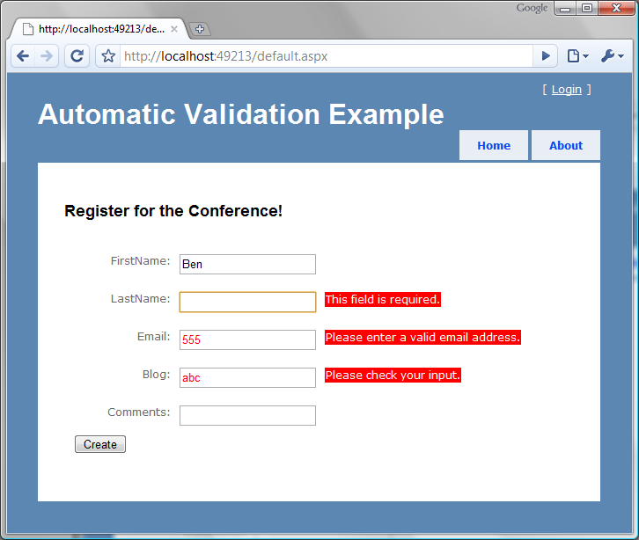
Figure 13.6 Seeing our client-side validation in action, we notice that the error messages automatically show up without a trip to the server.
The validation helper that we created demonstrates a fairly easy way of getting JavaScript validation free. This allows us to define the rules in one place (the attributes) and use them both in server-side and client-side validation. The implementation that we created still has room for improvement. For example, custom error messages are not yet implemented. In addition, we handle only three of the dozens of validation attributes that are present in the Castle Validation library.
xVal Validation Framework
Steve Sanderson (http://blog.codeville.net) started a project to fill this need. It’s called the xVal Validation Framework. This project allows you to define your rules in a variety of ways (Castle Validators, DataAnnotations attributes, custom). It also allows you to utilize one of a few client-side validation libraries, such as jQuery Validation and LiveValidation. The xVal framework is much richer in functionality. Consider using it in your projects for more flexibility. Download it at http://xval.codeplex.com.
13.3 Data access with NHibernate
Even though the ASP.NET MVC Framework is focused on the presentation layer, many developers work on small applications that do not need several layers of business logic and separation between the presentation layer and the data store. For these small applications, simpler separation patterns may be appropriate; however, many small applications grow much larger than originally anticipated. When this happens, SoC is critical to the long-term maintainability of the software. NHibernate is a popular object-relational mapper. It makes data access with relational databases trivial. As with anything new, there is a learning curve associated with understanding the method of configuring the mapping between objects and tables. This recipe demonstrates how to configure and leverage NHibernate when developing an application whose UI takes advantage of the ASP.NET MVC Framework.
13.3.1 Functional overview of reference implementation
Our reference implementation is on top of the default project template. The functionality that is added is the capability to track visits to the site. Each page tracks visitors. The site tracks the following pieces of data:
- URL
- Login name
- Browser
- Date and time
- IP Address
We see in figure 13.7 that by running the application the most recent visits are displayed at the bottom of the page. Each page displays the recent visits.
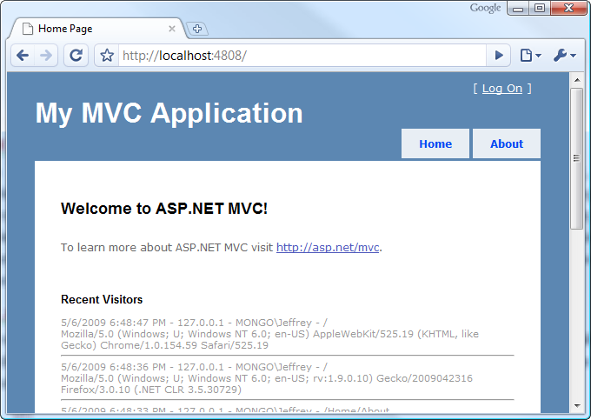
Figure 13.7 Recent visitors are displayed at the bottom of every page.
We have intentionally kept the scope of this recipe small so we can focus on the usage of NHibernate as the data access library that allows us to persist and retrieve Visitor objects. Before we go into each layer of the application, let’s review the architecture of this application at a high level.
13.3.2 Application architecture overview
At a broad level, this application uses DDD inside an Onion Architecture. At a high level, the application is composed of a domain model at its core. Figure 13.8 shows a reference layout of Onion Architecture.
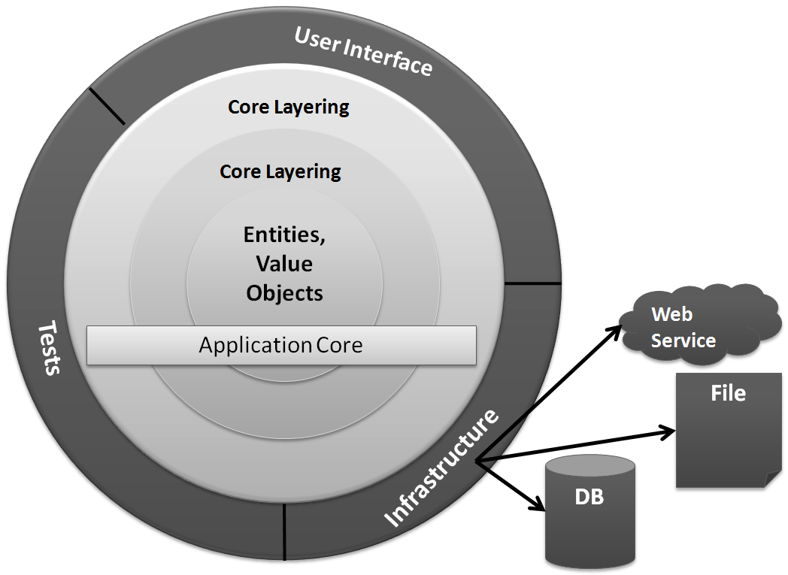
Figure 13.8 The Onion Architecture uses the concept of an application core that doesn’t depend on external libraries, such as NHibernate.
The solution structure implements the decoupling strategy that Onion Architecture requires. In figure 13.9, you can see the solution structure with the Core project’s references expanded. This application has a simple core, and the libraries referenced to implement the core are straightforward. Notice that there is no reference to NHibernate.dll from the Core project. It’s important that the Core remain portable and not coupled to external libraries that will change over time. As with everything in software, this is a trade-off. You may feel comfortable coupling to some libraries, but evaluate the consequences carefully.
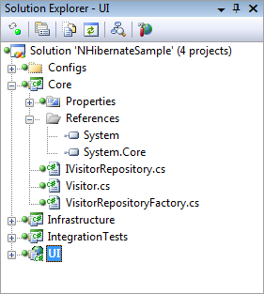
Figure 13.9 The Core project has minimal references and no external dependencies.
If we expand more of the projects, we see that no project references the Infrastructure project except for IntegrationTests, which is not deployed to production anyway. Figure 13.10 shows the solution fully expanded. Only the Infrastructure project references NHibernate.dll; no project references Infrastructure. When we examine the UI project, we’ll see how the application is organized at runtime to function properly. Note that this recipe is not focused on automated testing, so many of the necessary automated tests are omitted for the sake of brevity.
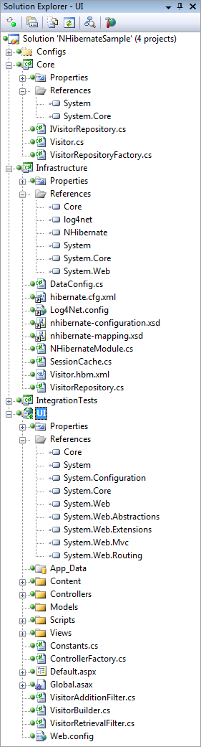
Figure 13.10 No project references Infrastructure. This arrangement is important for decoupling.
Now that we understand how the application is structured at a high level, we’ll explore each layer bit by bit. We’ll begin with the domain model.
13.3.3 Domain model–the application core
The domain model is the most important part of the application. Without the domain model, all of the pertinent concepts would be represented only in the UI. Our particular domain model contains a single aggregate made up of a single entity, the Visitor. The code for the Visitor class is shown in listing 13.7.
Listing 13.7 Visitor class is domain model for this recipe
using System;

namespace Core
{
public class Visitor
{
public virtual Guid Id { get; set; }
public virtual string PathAndQuerystring { get; set; }
public virtual string LoginName { get; set; }
public virtual string Browser { get; set; }
public virtual DateTime VisitDate { get; set; }
public virtual string IpAddress { get; set; }
}
}

We have no business logic here, and at first glance it looks just like a data structure. All other concerns have been left out in an effort to include only abstractions and logic that are necessary for leveraging NHibernate in a loosely coupled way.
The Visitor class contains properties for all of the pieces of information that we want to record. The Id property exists as an identifier for the particular visit. We could certainly use Int32 as the ID, but in a data persistence environment, that forces a dependency on the data store for the generation of a unique Int32 value. Sometimes this is appropriate, but in DDD, the developer errs on the side of giving responsibility to the domain model, not the data store. In line with that, the Id is a Guid, and the application will generate a Guid before attempting to save to the database.
The mechanism for persisting or retrieving a Visitor is called a repository. The repository will save our entity as well as retrieve it. It can also represent filtering operations. In our domain model, we have an IVisitorRepository. This interface is seen in listing 13.8
Listing 13.8 The repository defines the persistence operations
namespace Core
{
public interface IVisitorRepository
{
void Save(Visitor visitor);
Visitor[] GetRecentVisitors(int numberOfVisitors);
}
}

With our repository, we are able to save a visitor as well as get the most recent visitors. We can ask for a specific number of recent visitors. In figure 13.10, you see that the Core project doesn’t contain any class that implements IVisitorRepository. This is important because the class that actually does the work represented by the interface will be responsible for the persistence, which is not a domain model concern. Persistence is infrastructure. I could imagine that this functionality would work equally well if I persisted the data to a file instead of the database. The mechanism of persistence is not a concern for the domain model; therefore, the class responsible for it is not in the Core project.
The concern that is in the Core project, however, is a factory that is capable of locating or creating an instance of IVisitorRepository. The VisitorRepositoryFactory is responsible for returning an instance of our repository. Listing 13.9 shows that the knowledge of how to create the factory doesn’t reside with this class. This factory class merely represents the capability to return the class.
Listing 13.9 Factory offers capability to get repository
using System;

namespace Core
{
public class VisitorRepositoryFactory
{
public static Func<IVisitorRepository> RepositoryBuilder = |#A
CreateDefaultRepositoryBuilder; |#A

private static IVisitorRepository CreateDefaultRepositoryBuilder()
{
throw new Exception("No repository builder specified."); #B
}

public IVisitorRepository BuildRepository()
{
IVisitorRepository repository = RepositoryBuilder(); #C
return repository;
}
}
}

#A Initialize at application startup
#B Throw if factory not initialized
#C Use delegate to build repository

To even the inexperienced eye, this class doesn’t seem useful alone. When BuildFactory() is called, an exception will be thrown. Out of the box, the domain model doesn’t know the implementation of IVisitorRepository that will be used, so there is no way to embed this knowledge into compiled code. The public static RepositoryBuilder property will have to be set to something useful before the factory will work properly. We’ll see how this is accomplished after all the pieces have been introduced.
This explicit factory is not necessary if you’re using an IoC container that has been left out for the sake of simplicity. This domain model is simple. This is all there is. The next step is to understand how we configure NHibernate to automatically persist our entity to the database.
13.3.4 NHibernate configuration–infrastructure of the application
There is little code to write in order to leverage NHibernate for seamless persistence. NHibernate is a library, not a framework; the difference is important. Frameworks provide templates of code in which you then fill in the gaps to create something useful. Libraries are usable without providing templates. NHibernate doesn’t require your entities to derive from a specific base class or the implementation of a specific interface. NHibernate can persist any type of object as long as the configuration is correct. This section will walk through the configuration of NHibernate so that we can save and retrieve the Visitor object.
Before we dive into the configuration, let’s example the implementation of the IVisitorRepository interface specified in the domain model. The purpose for starting with this class is to demonstrate how little code is actually written when calling NHibernate to perform a persistence operation. Listing 13.10 shows the VisitorRepository class located in the Infrastructure project.
Listing 13.10 Repository implementation coupled to NHibernate APIs
using System.Collections.Generic;
using System.Linq;
using Core;
using NHibernate;

namespace Infrastructure
{
public class VisitorRepository : IVisitorRepository
{
public void Save(Visitor visitor)
{
ISession session = GetSession();
session.SaveOrUpdate(visitor);
}

public Visitor[] GetRecentVisitors(int numberOfVisitors)
{
IList<Visitor> visitors = GetSession()
.CreateQuery( #A
"select v from Visitor v order by v.VisitDate desc"
).SetMaxResults(numberOfVisitors)
.List<Visitor>();

return visitors.ToArray(); #B
}

private ISession GetSession()
{
var cache = new SessionCache(); |#C
ISession session = cache.GetSession(); |#C
return session;
}
}
}

#A Use HQL to select Visitors
#B Return array of Visitors
#C Retrieve session from cache
This class is a total of 34 lines long, and many lines are largely white space. The code that leverages the NHibernate APIs is limited. Now that we see what it looks like to call NHibernate, we’ll walk through the configuration process of NHibernate and explore each step. We’ll start with the main configuration.
like any .Net application NHibernate needs configuration
The beginning of the configuration process is the hibernate.cfg.xml file. This file is the same name as that used by the Hibernate library in Java. Because NHibernate started as a port from Hibernate, this is just one of the many similarities. Knowledge of one largely translates directly to the other.
The contents of the hibernate.cfg.xml file can also be put into the web.config file or app.config file. For simple applications, embedding this information into the .NET configuration file may be adequate; we should emphasize that this example stresses separation so that when applied to a medium-sized application, the code and configuration don’t run together. We have seen web.config files grow large, and it’s trivial to store the NHibernate configuration in a dedicated file. Listing 13.11 shows the contents of the hibernate.cfg.xml file.
Listing 13.11 Hibernate.cfg.xml file contains database connection information
<hibernate-configuration xmlns="urn:nhibernate-configuration-2.2">
<session-factory>
<property name="connection.driver_class">
NHibernate.Driver.SqlClientDriver
</property>
<property name="connection.connection_string">
server=.\SQLExpress;database=NHibernateSample;
Integrated Security=true;
</property>
<property name="show_sql">false</property>
<property name="dialect">
NHibernate.Dialect.MsSql2005Dialect
</property>
<property name="adonet.batch_size">100</property>
<mapping assembly="Infrastructure" />
</session-factory>
</hibernate-configuration>
This is a simple configuration, and there are many other options documented with the NHibernate documentation (http://nhforge.org/doc/nh/en/index.html). The most obvious piece of information is the connection string. Also, the driver class and dialect specify the details of the database engine used. This sample uses SQL Server 2005, but these values would change if you wanted to use any version of Oracle, SQLite, or the many other database engines supported out of the box.
The show_sql property will output each SQL query to the Console as the statement is being sent to the database. This is useful for debugging. The adonet.batch_size controls how many updates, deletes, or inserts will be sent to the database in a single batch. It’s more efficient to send multiple statements in a single network call than to make a separate network call for each statement. NHibernate will do this automatically. The last, but most important configuration item is the assembly where NHibernate can find the mapping files. We are telling NHibernate to look in the Infrastructure project to find the mappings.
The NHibernate mapping files–simple but powerful
NHibernate requires at least one mapping file. You can put the mappings for many entities in a single mapping file, but it’s a better practice to segment out each “class” node. The class node represents an entity. Figure 13.11 shows the Infrastructure project.
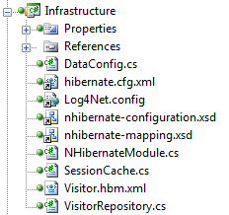
Figure 13.11 The Infrastructure project contains the Visitor.hbm.xml mapping file.
We are about to explore the Visitor.hbm.xml file, which contains the mapping information for the Visitor class. First, notice the four files that are linked into the project:
- Hibernate.cfg.xml
- Log4Net.config
- Nhibernate-configuration.xsd
- Nhibernate-mapping.xsd
These files do not belong to the project directly; they are linked from elsewhere. We do this because multiple projects need the same copy of these files. The first example that needs linked files is the IntegrationTests. It will contain tests for all data access. To test the data access, the tests need to leverage the same configuration as the application.
We have already covered the hibernate.cfg.xml file. The Log4Net.config file contains Log4Net configuration information that is broadly applicable to any type of application. If you’re not familiar with Log4Net, you can find more information at http://logging.apache.org/log4net/index.html. The two files provide the schema for the NHibernate configuration and the NHibernate mapping files. When added to the project, they enable Visual Studio to provide XML IntelliSense when you are editing these files. It makes the editing process smooth. We edit mapping files most heavily. Without this XML IntelliSense, it would be cumbersome to maintain these XML files.
Let’s now turn to the mapping file for the Visitor class. We’ll open the Visitor.hbm.xml file and examine its structure as shown in listing 13.12.
Listing 13.12 Visitor.hbm.xml file contains mapping for the Visitor class
<?xml version="1.0" encoding="utf-8" ?>
<hibernate-mapping xmlns="urn:nhibernate-mapping-2.2"
namespace="Core" assembly="Core">

<class name="Visitor" table="Visitors" dynamic-update="true">
<id name="Id" column="Id" type="Guid">
<generator class="guid.comb"/>
</id>
<property name="PathAndQuerystring" length="4000" not-null="true"/>
<property name="LoginName" length="255" not-null="true"/>
<property name="Browser" length="4000" not-null="true"/>
<property name="VisitDate" not-null="true"/>
<property name="IpAddress" not-null="true"/>
</class>
</hibernate-mapping>

The first node is pretty standard and declares the NHibernate XML namespace. Then, the default namespace and assembly are declared. Without these, the class name would have to be fully qualified, and when mapping files get more complex than this, you want to avoid having to fully qualify type names.
The class node contains the information about how to persist the Visitor class. We want the table name to be different from the class name, so we declare it. If we did not declare the table name, NHibernate would use the class name.
The id node is special, and it has to be the first property mapped on an entity. This will become the primary key on the table, and there are many ways to handle it. The generator node has many options, including SQL Server “identity” and Oracle “sequence” functionality. We want the object to have a value in the Id property before being persisted, so we are configuring NHibernate to generate a Guid for us before issuing the INSERT statement to the database. The “guid.comb” generator is special, and it generates GUIDs in sequential order so that the clustered index on the primary key column has little to do when absorbing a new record inserted into the table. This sequencing sacrifices a bit of uniqueness in the GUID algorithm, but in this context, the only thing that is important is that the GUID be unique for this particular table. You can read more about the COMB GUID from the inventor, Jimmy Nilsson: http://www.informit.com/articles/article.aspx?p=25862.
The rest of the properties are largely self-explanatory. They have names, constraints, and the strings can have a length specified. If you’re all right with the column name being the same as the property name on the class, then a column attribute is unnecessary. When you have all the properties mapped, you’re ready to move on. If you have a more complex class structure, you will want to review all your mapping options in the documentation at: http://nhforge.org/doc/nh/en/index.html.
Initializing the configuration
There are two main abstractions in NHibernate: ISessionFactory and ISession. A session factory creates a session. A session is meant to be used for a single transaction. You should use and then quickly dispose of NHibernate sessions. The session factory is intended to be kept for the life of the application so that it can be used to create all sessions. The interface is the abstraction, but the implementation provided by NHibernate requires some understanding. The code in listing 13.13 shows how to create the session factory that will be used for the life of the application.
Listing 13.13 A Configuration object creates a session factory
var configuration = new Configuration();
configuration = configuration.Configure(); #A
SessionFactory = configuration.BuildSessionFactory(); #B

#A Configure NHibernate using XML configuration
#B Build and cache session factory

The session factory is expensive to create. By expensive, we mean that it accesses the file system and parses XML from embedded resources inside DLLs. The configuration object is going to read the hibernate.cfg.xml file (out-of-process call), and then it will build the session factory using this configuration. When building the session factory, it will retrieve all the mapping files from within the DLL files (out-of-process call). Each mapping file will be parsed using the XML DOM, and then it uses reflection on all the types to ensure that every property declared in the mapping files actually exists on the types referenced. If lazy loading is enabled (the default), it will also check that all public properties and methods are marked virtual. If you prefer not to mark them virtual, disable lazy loading. With most applications, it takes several seconds to create the session factory; this operation is not something you want to do often. If you create the session factory for every web request, your web application will slow down dramatically. We push the session factory instance in a static variable so we can hold on to it for the life of the application.
The NHibernate session, on the other hand, is cheap. We’ll create and destroy many of these objects. In a stateful application, we’ll use a session for a single transaction or user operation. For a web application, we’ll use one session per web request. We’ll cover the web application usage is just a bit. The code for the creation of a session is shown in listing 13.14.
Listing 13.14 The session is inexpensive to create
ISession session = SessionFactory.OpenSession(); #A

#A Session factory provides the session

Before we can move on to the code that uses all this, we have to have a database. We have declared our connection string, and with the mapping, NHibernate knows the table structure. We can proceed to create our database schema manually, or we can get NHibernate to help us out. After creating an empty database named “NHibernateSample” inside SQL Server Express, as declared by the connection string, we can execute the code shown in listing 13.15 to have NHibernate create our schema.
Listing 13.15 NHibernate generates database from mappings
using NHibernate.Cfg;
using NHibernate.Tool.hbm2ddl;
using NUnit.Framework;

namespace IntegrationTests
{
[TestFixture]
public class DatabaseTester
{
[Test, Explicit]
public void CreateDatabaseSchmea()
{
var export = new SchemaExport(new Configuration().Configure());
export.Execute(true, true, false, true);
}
}
}
We are using an NUnit test fixture as an easy launching point for this code. It makes it trivial to run the code snippet. After running this test, we’ll see the output in the Output windows similar to listing 13.16.
Listing 13.16 Output from schema export shows table DDL
------ Test started: Assembly: IntegrationTests.dll ------

if exists (select * from dbo.sysobjects where id = object_id(N'Visitors') and OBJECTPROPERTY(id, N'IsUserTable') = 1) drop table Visitors
create table Visitors (
Id UNIQUEIDENTIFIER not null,
PathAndQuerystring NVARCHAR(4000) not null,
LoginName NVARCHAR(255) not null,
Browser NVARCHAR(4000) not null,
VisitDate DATETIME not null,
IpAddress NVARCHAR(255) not null,
primary key (Id)
)

1 passed, 0 failed, 0 skipped, took 6.86 seconds.

The NUnit test lives in the IntegrationTests project. This project also links in the hibernate.cfg.xml file to leverage the same configuration. Figure 13.12 shows the IntegrationTests project structure. We have kept it minimal for the sake of simplicity.
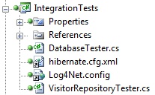
Figure 13.12 The IntegrationTests project contains tests for all the mappings and repositories.
Notice the VisitorRepositoryTester class. You can probably guess what this class does. That's right! It contains the automated testing necessary to ensure that the repository implementation functions as expected. We cannot write unit tests for data access. Data access, by its very nature, is an integration test concern. Not only are we integrating a third-party library, NHibernate, but we are also expecting another process to be running on our network, server, or workstation. SQL Server must be up and running. It also must contain the correct schema. If anything is wrong along the way, the tests will fail. Because of this arrangement, these integration tests are larger than we would expect for simple unit tests. Even so, keep them as small as possible, and only test the data access. Listing 13.17 shows the code for the VisitorRepositoryTester.
Listing 13.17 Integration test verifies mappings and database are correct
using System;
using Core;
using Infrastructure;
using NHibernate;
using NHibernate.Cfg;
using NUnit.Framework;
using NUnit.Framework.SyntaxHelpers;

namespace IntegrationTests
{
[TestFixture]
public class VisitorRepositoryTester
{
[Test]
public void When_saving_should_write_to_database()
{

var config = new DataConfig(); #A
config.PerformStartup();
config.StartSession();

var visitor = new Visitor #B
{
Browser = "1",
IpAddress = "2",
LoginName = "3",
PathAndQuerystring = "4",
VisitDate = new DateTime(2000, 1, 1)
};

var repository = new VisitorRepository();
repository.Save(visitor); #C

config.EndSession(); |#D
config.StartSession(); |#D

ISession session = new SessionCache().GetSession(); #E
var loadedVisitor = session.Load<Visitor>(visitor.Id);

Assert.That(loadedVisitor, Is.Not.Null); |#F
Assert.That(loadedVisitor.Browser, Is.EqualTo("1")); |#F
Assert.That(loadedVisitor.IpAddress, Is.EqualTo("2")); |#F
Assert.That(loadedVisitor.LoginName, Is.EqualTo("3")); |#F
Assert.That(loadedVisitor.PathAndQuerystring, |#F
Is.EqualTo("4")); |#F
Assert.That(loadedVisitor.VisitDate, |#F
Is.EqualTo(new DateTime(2000, 1, 1))); |#F
}

public void SetUpNewSession()
{
new DatabaseTester().CreateDatabaseSchmea();
var configuration = new Configuration();
configuration = configuration.Configure();
ISessionFactory factory = configuration.BuildSessionFactory();
new SessionCache().CacheSession(factory.OpenSession());
}
}
}

#A Configure NHibernate
#B Create new Visitor
#C Save Visitor
#D Create new session
#E Reload Visitor
#F Assert correct data

These tests are essential to ensuring that every query generated by NHibernate is tested and retested with every build. Because configuration changes will change the queries that are generated, tests are important for the stability of the application. When we run this test, we see that it passes as shown in figure 13.13.
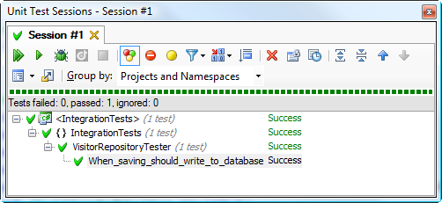
Figure 13.13 When the repository test passes, we know the mapping is correct.
You now know the basics of persisting with NHibernate. All NHibernate coupling should remain in the Infrastructure project. Remember that none of the other projects have a reference to Infrastructure, so the rest of the code is not coupled to this particular data access library. This decoupling is important because data access methods change very frequently. You do not want to couple your application to infrastructural concerns when they are likely to change frequently.
Now that we have covered both the Core and Infrastructure, we’ll see how this ties together in the UI.
13.3.5 UI leverages domain model
Now that the domain model and the NHibernate infrastructure are set up and functioning, we can turn our attention once again to the ASP.NET MVC project. We have left the project close to the default template in an effort to keep it simple as well as call out the additions necessary to enable the saving of every visitor to the site. Figure 13.14 shows the structure of the UI project.
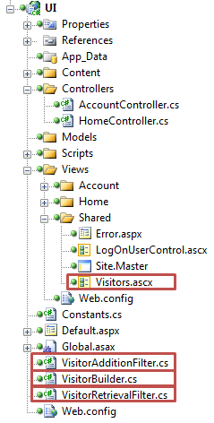
Figure 13.14 The additions to the project are boxed. We have added several files to support the capture and display of visitors.
From figure 13.7 you can recall that each page on the site shows the most recent visitors to the site at the bottom. To share this view on each page, we have wired up a partial view to the master page, Site.Master. We have covered this capability in previous chapters, so we won’t cover it in depth here.
At the highest level, we have added an action filter attribute to each controller. If the site contains many controllers, we would consider introducing a Layer Supertype for all controllers and applying the filter to just that controller. In this example, the project contains only the HomeController and AccountController. The HomeController is show in listing 13.18. Notice the action filters applied at the class level.
Cueballs in code and text
Listing 13.18 Action filters applied to controller to keep concerns separated
using System.Web.Mvc;

namespace UI.Controllers
{
[HandleError]
[VisitorAdditionFilter(Order = 0)] #1
[VisitorRetrievalFilter(Order = 1)] #2
public class HomeController : Controller
{
public ActionResult Index()
{
ViewData["Message"] = "Welcome to ASP.NET MVC!";

return View();
}

public ActionResult About()
{
return View();
}
}
}
We have introduced two filters, the VisitorAdditionFilter (1), and the VisitorRetrievalFilter (2). We have applied the Order optional parameter to ensure that they are executed in the intended order. It may be confusing, but the order the attributes are applied to the class is not the execution order. We want to persist a new visitor before we get the list of recent visitors and pass the objects to a view. Listing 13.19 shows both of the action filters.
Cueballs in code and text. Note there are two 1s and two 2s widely separated.
Listing 13.19 Action filters interact with domain model.
using System.Web.Mvc;
using Core;

namespace UI
{
public class VisitorAdditionFilter : ActionFilterAttribute
{
private readonly IVisitorRepository _repository;

public VisitorAdditionFilter(IVisitorRepository repository)
{
_repository = repository;
}

public VisitorAdditionFilter() :
this(new VisitorRepositoryFactory().BuildRepository()) #1
{
}

public override void OnResultExecuting( #2
ResultExecutingContext filterContext)
{
var builder = new VisitorBuilder();
Visitor visitor = builder.BuildVisitor(); |#3
_repository.Save(visitor); |#3
}
}
}

using System.Web.Mvc;
using Core;

namespace UI
{
public class VisitorRetrievalFilter : ActionFilterAttribute
{
private readonly IVisitorRepository _repository;

public VisitorRetrievalFilter(IVisitorRepository repository)
{
_repository = repository;
}

public VisitorRetrievalFilter() : this(
new VisitorRepositoryFactory().BuildRepository()) #1
{
}

public override void OnResultExecuting( #2
ResultExecutingContext filterContext)
{
Visitor[] visitors = _repository.GetRecentVisitors(10); |#4
filterContext.Controller |#4
.ViewData[Constants.ViewData.VISITORS] = visitors; |#4
}
}
}
Each of the filters is simple. Most of the code is just for managing the dependency of the IVisitorRepository and building the repository from the factory (1). The three lines of work that are interesting are in the OnResultExecuting method (2). We build the visitor and save it (3). Then we get the recent visitors and push them into view data (4). The VisitorBuilder class is not shown, but it’s a simple one that constructs a Visitor and populates it with information from the HttpRequest. The next interesting file is the Visitors.ascx partial view located in /Views/Shared/Visitors.ascx. Listing 13.20 shows this partial view.
Listing 13.20 Partial view is strongly typed and displays recent visitors
<%@ Control Language="C#" Inherits="System.Web.Mvc.ViewUserControl<Visitor[]>" %>
<%@ Import Namespace="Core"%>
<div style="text-align:left">
<h3>Recent Visitors</h3>
<%foreach (var visitor in ViewData.Model){%>
<%=visitor.VisitDate%> -
<%=visitor.IpAddress%> -
<%=visitor.LoginName%> -
<%=visitor.PathAndQuerystring%><br />
<%=visitor.Browser%><hr />
<%}%>
</div>

This partial is added to the page via the master page. The array of visitors is expected to be in ViewData.Model so that the array can be rendered the default way. At the bottom of the master page, the following code passes just the visitor array to the partial: <%Html.RenderPartial(Constants.Partials.VISITORS, ViewData[Constants.ViewData.VISITORS]); %>.
We use the constants so that the views do not contain duplicate string literals. Since logging and displaying visitor information are cross-cutting concerns for the application, we have taken steps to keep the logic factored out so that it can be shared across all controllers in the application. Let's review what we have done:
- Kept the persistence logic behind an interface that doesn’t belong to the UI project
- Leveraged action filters so that no single controller is responsible for knowing how to interact with IVisitorRepository
- Created a partial view to own the layout of the recent visitors
- Delegated to the partial view from the master page so that individual views don’t have to care about it
All the pieces are now in place to be pulled together.
13.3.6 Pulling it together
If you have been keeping a close eye on the code up to this point, you have noticed that we do not have a default way to create the NHibernate repository instance of IVisitorRepository that lives in the Infrastructure project. Our UI project doesn’t reference the Infrastructure project at all. This section walks through the process of wiring up these decoupled pieces.
The first piece is in the web.config file. Inside the httpModules node, we have registered an extra module:
<add name="StartupModule" type="Infrastructure.NHibernateModule, Infrastructure, Version=1.0.0.0, Culture=neutral"/>
This module kicks off the process of creating the session factory. It also hooks the BeginRequest and EndRequest events and creates and destroys NHibernate sessions for each web request. Listing 13.21 shows the code for NHibernateModule.cs, which lives in the Infrastructure project.
Listing 13.21 NHibernateModule kick-starts NHibernate.
using System;
using System.Web;

namespace Infrastructure
{
public class NHibernateModule : IHttpModule
{
private static bool _startupComplete = false;
private static readonly object _locker = new object();

public void Init(HttpApplication context)
{
context.BeginRequest += context_BeginRequest;
context.EndRequest += context_EndRequest;
}

private void context_BeginRequest(object sender, EventArgs e)
{
EnsureStartup();
new DataConfig().StartSession(); #A
}

private void context_EndRequest(object sender, EventArgs e)
{
new DataConfig().EndSession(); #B
}

private void EnsureStartup()
{
if (!_startupComplete)
{
lock (_locker)
{
if (!_startupComplete)
{
new DataConfig().PerformStartup();
_startupComplete = true;
}
}
}
}

public void Dispose()
{
}
}
}
#A Open session when request starts
#B End session when request ends
The DataConfig class (not shown) will create a session and store it in the cache. Listing 13.22 shows the SessionCache.cs file as well as an important method from DataConfig.cs.
Listing 13.22 Session cache keeps session in HttpContext items
using System.Collections;
using System.Web;
using NHibernate;

namespace Infrastructure
{
public class SessionCache
{
private const string SESSION_KEY = "NHIBERNATE_SESSION";
private static readonly IDictionary _cacheStore = new Hashtable();

public ISession GetSession()
{
var session = (ISession) GetCacheStore()[SESSION_KEY];
return session;
}

public void CacheSession(ISession session)
{
GetCacheStore()[SESSION_KEY] = session;
}

private static IDictionary GetCacheStore()
{
if (HttpContext.Current != null)
return HttpContext.Current.Items;

return _cacheStore;
}
}
}

private void InitializeRepositories() #A
{
Func<IVisitorRepository> builder =
() => new VisitorRepository();
VisitorRepositoryFactory.RepositoryBuilder = builder;
}

#A Part of DataConfig.cs

Now that we have a session factory, and we have a session, our application can call NHibernate and communicate with the database. Aside from the NHibernate initialization, we have the initialization of the VisitorRepositoryFactory. In CodeCampServer, we use StructureMap as our IOC container. IoC tools provide these factories automatically, but because this sample doesn’t leverage the IoC container, we had to provide this startup logic explicitly. There are several ways to do that. Another popular way is to declare an interface for the factory and keep an implementation around. Use your judgment when choosing a technique. The important thing is that no project should reference the Infrastructure project. We have kept NHibernate completely off to the side so that the rest of the application doesn’t care how the data access is happening.
There is one final missing piece required before we can run this application from Visual Studio using CTRL+F5. The web.config file refers to a class in the Infrastructure project, but because there is no reference, the Infrastructure assembly will not be in the bin folder of the website. We could copy it explicitly every time we compile, but that will get tiresome. The solution is to have Visual Studio copy it every time it’s compiled by adding the following lines to the Infrastructure.csproj file as a post-build event such as the command in listing 13.23.
Listing 13.23 Post-build event copies assemblies and config files
xcopy /y ".\*.dll" "..\..\..\UI\bin\"
xcopy /y ".\log4net.config" "..\..\..\UI\"
xcopy /y ".\hibernate.cfg.xml" "..\..\..\UI\bin\"

By setting up the three commands shown in listing 13.23, we have configured the Infrastructure project to copy two important configuration files as well as the necessary binaries to the UI project’s bin folder. Not only will the Infrastructure assembly be copied, the NHibernate assemblies will be copied as well. This ensures that when the UI project is run from Visual Studio, you will be greeted with a running application that is saving and showing visitors as in figure 13.15.
Figure 13.15 The application works as expected after being wired together.
Because of this post-build step, the application has all the required assemblies and configuration files. This reduces the pain of copying these files manually every time they change. This is just one type of automation required when you truly commit to decoupling your applications.
13.3.7 Wrapping up data access with NHibernate
In this recipe, you have seen how to structure your solution, configure NHibernate, use the repository pattern from ASP.NET MVC, and wire up loosely coupled code at runtime. This recipe presents a vastly simplified example, but the patterns contained within are appropriate in medium to large applications as well.
Configuring and using NHibernate is easy. It’s also easy to couple to it and get in trouble. Whether it’s NHibernate or any other data access library, do not couple your application to it. Keep your core clean and your UI separated. All data access should be behind interfaces and tested separately. For more advanced usages of NHibernate with ASP.NET MVC, you can open the CodeCampServer solution, which is included with this book’s code download.
13.4 Designing views with the Spark view engine
By default, an ASP.NET MVC application uses the WebFormViewEngine to locate and render views. But we are not forced to use Web Forms to design and render our views. One of the extension points of ASP.NET MVC is the ability to swap out the default IViewEngine for a different implementation. With a different view engine, we get a different experience in defining and developing views. Popular alternative view engines supported in ASP.NET MVC through various open source efforts include:
- Brail
- NHaml
- NVelocity
- Spark
But why would we want to investigate other view engines? One issue with the WebFormViewEngine is that you do not have many options for server-side coding except with complex languages such as C# and VB.NET. Although these languages are quite powerful, seeing code interspersed with markup is ugly. Creating a simple loop of HTML requires a foreach loop and curly braces mixed with our HTML tags. For more complex view logic, it becomes nearly impossible to understand what is going on. The WebFormViewEngine suffices in many situations, but it’s obvious that it was not built with MVC-style applications in mind, where we are almost guaranteed to need code in our views. Although this code is strictly view-centric, it’s still unavoidable.
These alternative view engines are designed to be view engines, rather than holdovers from the Web Forms days. Each is optimized for designing an MVC view, and many are ported versions of other, established view engines for other, established MVC frameworks. For example, NHaml is a port of the popular (and extremely terse) Haml view engine. Another view engine, designed for both ASP.NET MVC and MonoRail, is Spark (http://sparkviewengine.com/). Spark provides a unique blend of C# code in line with HTML, disguised as XML elements and attributes. There are disadvantages to some view engines, such as the lack of IntelliSense and a slightly less integrated feel in Visual Studio. Spark provides integration with Visual Studio, including IntelliSense and a view compiler. The view compiler ensures that at least we do not have to wait for runtime exceptions to expose typos and bugs in our views. In this section, we examine the major features of Spark to see the advantages it has over the default view engine. But first, we’ll walk through the installation and configuration process.
13.4.1 Installing and configuring Spark
The latest release can be found at Spark’s CodePlex site, at http://sparkviewengine.codeplex.com/. The release includes:
- The Spark assemblies we need in our MVC project
- Documentation
- Samples
- Installer for Visual Studio IntelliSense
To get Spark running in our MVC project, we need only the binaries. However, the IntelliSense is quite helpful, so we’ll run the installer before launching Visual Studio. Next, we add references to both the Spark and Spark.Web.Mvc assemblies, shown in figure 13.16.
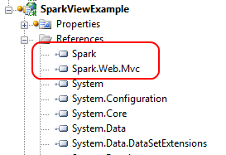
Figure 13.16 Adding the Spark assembly references to our project
With our Spark assembly references added to our project, we can configure ASP.NET MVC to use Spark as our view engine. Spark has additional configuration, which we can either place in our Web.config file or in code. For this example, we’ll configure Spark in code, but the Spark documentation has full examples of both options. Our Spark configuration is shown in listing 13.24.
Listing 13.24 Spark configuration code
var settings = new SparkSettings()
.SetDebug(true)
.AddAssembly("SparkViewExample")
.AddNamespace("System")
.AddNamespace("System.Collections.Generic")
.AddNamespace("System.Linq")
.AddNamespace("System.Web.Mvc")
.AddNamespace("System.Web.Mvc.Html");

ViewEngines.Engines.Add(new SparkViewFactory(settings));

We place the code into the Application_Start method in our Global.asax.cs file, as the Spark configuration and MVC view engine configuration only need to happen once per application domain. In the first section, we create a SparkSettings object, configuring the compilation mode, and adding our project assembly and various assemblies for compilation. This section should look similar to configuring the WebFormViewEngine in our Web.config file. Next, we add a new SparkViewFactory instance to the System.Web.Mvc.ViewEngines.Engines collection. The ViewEngines class allows additional view engines to be configured for our application. To the SparkViewFactory instance we pass our SparkSettings object created earlier. That is all it takes to configure Spark! Now that Spark is configured, we can move on to creating views for our example.
13.4.2 Simple Spark view example
On the controller and model pieces of our MVC application, we won't see any changes with our new view engine. We want to show a list of Product model objects, shown in listing 13.25.
Listing 13.25 Simple Product model
public class Product
{
public string Name { get; set; }
public string Description { get; set; }
public decimal Price { get; set; }
}
Again, the Spark view engine places no specific constraints on our model, nor our controller action, shown in listing 13.26.
Listing 13.26 A ProductController for displaying Product objects
public class ProductController : Controller
{
public ViewResult Index()
{
var products = new[] #A
{
new Product {
Name = "Toothbrush",
Description = "Cleans your teeth",
Price = 2.49m
},
new Product {
Name = "Hairbrush",
Description = "Styles your hair",
Price = 10.29m
},
new Product {
Name = "Shoes",
Description = "Protects your feet",
Price = 55.99m
},
};
return View(products); #B
}
}

#A Create dummy products
#B Send products to the view

We show only a dummy list of products for our Spark views to display. To create our Spark views, the folder structure is similar to our structure for other view engines. In the root Views folder, we create a Product folder to correspond to our ProductController. Additionally, we create a Layouts and Shared folder, as shown in figure 13.17.
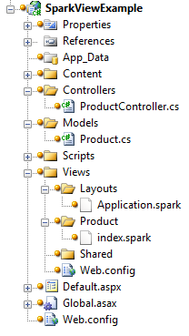
Figure 13.17 Complete folder structure for our Spark views
In Spark, view files use the.spark file extension. This is mainly so that the file extension doesn’t conflict with other view engines in the IDE or at runtime.
Spark supports the concept of layouts, which are similar in nature to the Web Forms Master Pages. By convention, the default layout name is Application.spark, found in either the Layouts or Shared folder. To start, we’ll create just a text file in Visual Studio named Application.spark (instead of a Web Form or other template). This is shown in figure 13.18.
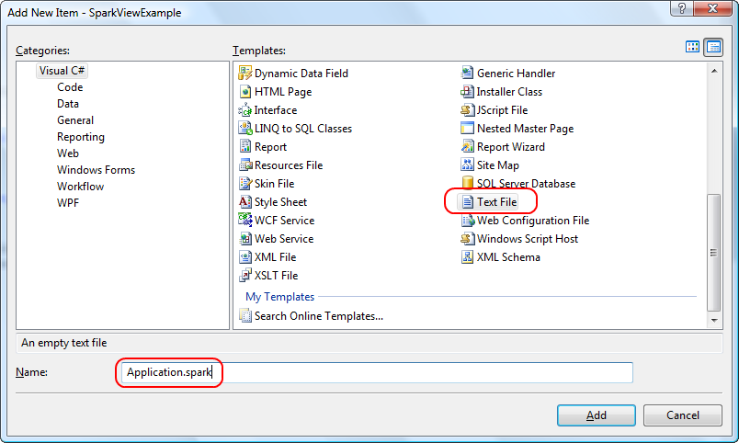
Figure 13.18 Adding an Application.spark layout for our views
We choose the Text File template as we don't want any of the built-in functionality with something like a Web Form template; we need only a blank file. Inside our base layout, we need to place a couple of links as well as provide a placeholder for the actual child content. Our entire layout is shown in listing 13.27.
Listing 13.27 Entire Application.spark layout template
<!DOCTYPE html PUBLIC "-//W3C//DTD XHTML 1.0 Strict//EN" "http://www.w3.org/TR/xhtml1/DTD/xhtml1-strict.dtd">
<html xmlns="http://www.w3.org/1999/xhtml">
<head>
<title>Spark View Example</title>
<link href="~/Content/Site.css" rel="stylesheet" type="text/css" />
</head>
<body>
<div class="page">
<div id="header">
<div id="title">
<h1>My MVC Application</h1>
</div>
<div id="logindisplay">
Welcome!
</div>
<div id="menucontainer">
<ul id="menu">
<li>${Html.ActionLink("Home", "Index", "Home")}</li>
<li>${Html.ActionLink("About", "About", "Home")}</li>
</ul>
</div>
</div>
<div id="main">

<use content="view"/>

<div id="footer">
</div>
</div>
</div>
</body>
</html>
The first interesting item is the “link” element linking to our CSS file. It uses the familiar tilde (“~”) notation to note the base directory of our website, instead of relative path notation (“..\..\”). We can rebase our website and redefine what the tilde means in our Spark configuration if need be. This method is helpful in web farm or Content-Delivery Network (CDN) scenarios. The next interesting item is our familiar Html.ActionLink calls, but this time, we enclose the code in the ${} syntax. This syntax is synonymous with the <%= %> syntax of Web Forms. However, if we place an exclamation point after the dollar sign, using $!{} instead, any NullReferenceExceptions will have empty content, instead of an error screen. This is one advantage of Spark over Web Forms, where a null results in an error for the end user, even though missing values are normal. The last interesting piece of our layout is the <use content="view"/> element. The named content section, “view,” defaults to the view name from our action. In our example, this would be an Index.spark file in a Product folder. We can create other named content sections, for a header, footer, sidebar, and anything else we might need in our base layout. Like master pages, we can nest our layouts as much as our application demands.
With the layout in place, we can create our action-specific view, shown in listing 13.28.
Listing 13.28 Spark view for the Index action
<viewdata model="SparkViewExample.Models.Product[]" />
<var styles="new [] {'even', 'odd'}" isCurrent="false" />
<h2>Products</h2>
<table>
<tr>
<th>Name</th>
<th>Price</th>
<th>Description</th>
</tr>
<var i="0">
<tr each="var product in ViewData.Model" class="${styles[i%2]}">
<td>${product.Name}</td>
<td>${product.Price}</td>
<td>${product.Description}</td>
<set i="i+1" />
</tr>
</var>
</table>
In the Index view, we want to loop through all of the Products in the model, displaying a row for each Product. With Web Forms, we would need to put in <% %> code blocks for our for loop. With Spark, we have cleaner options. First, we use the <viewdata /> element to tell Spark that we are using a strongly typed view, and our model type is an array of Products. Spark also supports the key-based ViewData dictionary. Next, we create local styles and isCurrent variables with the <var /> element. Each attribute name becomes a new local variable, and the attribute value is the value assigned. These two variables will help us create alternating row styles.
Next, we put normal HTML in our view, including a header, table, and header row. With Spark, special Spark XML elements are interspersed with HTML elements, making our view look cleaner without C#’s distracting angle brackets. After the header row, we create a counter variable to help in the alternating row styles. We need to iterate through all the Products in our model, creating a row for each item. In Web Forms, this is accomplished through a foreach loop. In Spark, we need only to add an each attribute to the HTML element we want to repeat, giving the snippet of C# code to iterate in each attribute’s value. The class element in our row element is set to an alternating style, using a counter to switch between odd and even styles.
Inside our row, we use the ${} syntax to display each individual product. Because we installed the Spark Visual Studio integration, we get IntelliSense in our views, as demonstrated in figure 13.19.
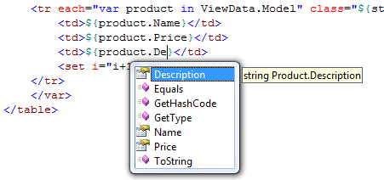
Figure 13.19 IntelliSense in our Spark views is possible because of the Visual Studio add-in.
To complete the alternating row styles, we increment the count using the <set /> element. This element lets us assign values to variables we created earlier in our view. In addition to the each attribute and <set /> element, Spark provides complex expressions for conditional operators (if…else), macros, and more. With our Spark view complete, our view renders as expected in the browser, as shown in figure 13.20.
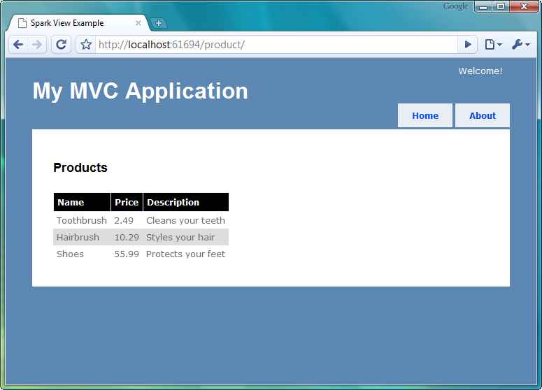
Figure 13.20 Our running Spark application
Because of the ASP.NET MVC architecture, we can swap out view engines without needing to change our controllers or actions. As we saw in this section with the Spark view engine, many view engines provide a cleaner way to create views in our MVC application. The Spark view engine gives us a terser, more readable markup, blending code and HTML seamlessly. Because Spark supports compiling views and IntelliSense, we do not need to give up all the nice integration that Web Forms offers. The decision to choose a different view engine is still quite important, as it has long-term technical and non-technical ramifications. Alternative view engines should be another option to investigate for MVC applications, as they offer compelling alternatives to the default WebFormViewEngine.

13.5 Summary
In this chapter, you have seen how the ASP.NET MVC framework can dovetail with other libraries and tools. Because this framework is based on interfaces and abstractions, it’s simple to mesh other libraries and techniques in your web applications.
Here, we have reviewed client-side extension techniques with jQuery, one way to perform client-side validation, method to leverage NHibernate with an ASP.NET MVC application, and an alternate view engine that integrates with the framework as well as Visual Studio. These recipes can be applied individually or together. These recipes have several moving parts, so we encourage you to explore the code that comes with this book. Feel free to use and extend the code as you apply it to your own ASP.NET MVC applications.

