two-component models result

Kate Zhang

23/02/2021

## Computation time for two-component models

# With data1:

N = 350 mixing_p = c(0.20, 0.80) mu = c(10, -2) prec = c(1/4, 1/25) sigma = sqrt(1/prec) 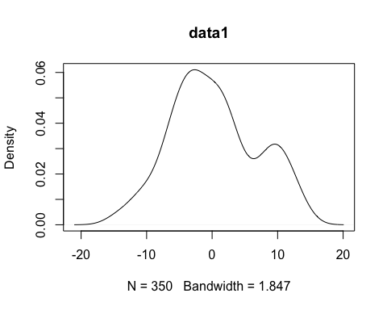

# three dimensional array for storing data  
# 3 - 3 models  
# 4 - 1:fit.time, 2:sample.tim, 3:ess, 4:(fit+sam)/ess  
# 5 - 5 trials  
result <- array(rep(0, 12*NT), dim=c(3,4,NT),   
 dimnames = list(c("m1","m2","m3"),  
 c("fit","sam","ess","res"),  
 sprintf("t%d",1:NT)))  
resultr <- array(rep(0, 12*NT), dim=c(3,4,NT),   
 dimnames = list(c("m1r","m2r","m3r"),  
 c("fit","sam","ess","res"),  
 sprintf("t%d",1:NT)))  
  
resultstan <- array(rep(0, 3*NT), dim=c(3,NT),   
 dimnames = list(c("time","ess","stan"),  
 sprintf("t%d",1:NT)))  
  
r1 <- sampling(here("Data", "data1.txt"), result, resultr, resultstan)

## Warning: There were 2 divergent transitions after warmup. Increasing adapt_delta above 0.8 may help. See  
## http://mc-stan.org/misc/warnings.html#divergent-transitions-after-warmup

## Warning: Examine the pairs() plot to diagnose sampling problems

## Warning: Bulk Effective Samples Size (ESS) is too low, indicating posterior means and medians may be unreliable.  
## Running the chains for more iterations may help. See  
## http://mc-stan.org/misc/warnings.html#bulk-ess

## Warning: Tail Effective Samples Size (ESS) is too low, indicating posterior variances and tail quantiles may be unreliable.  
## Running the chains for more iterations may help. See  
## http://mc-stan.org/misc/warnings.html#tail-ess

## Compiling model graph  
## Resolving undeclared variables  
## Allocating nodes  
## Graph information:  
## Observed stochastic nodes: 350  
## Unobserved stochastic nodes: 355  
## Total graph size: 1416  
##   
## Initializing model  
##   
## Compiling model graph  
## Resolving undeclared variables  
## Allocating nodes  
## Graph information:  
## Observed stochastic nodes: 350  
## Unobserved stochastic nodes: 355  
## Total graph size: 1416  
##   
## Initializing model  
##   
## Compiling model graph  
## Resolving undeclared variables  
## Allocating nodes  
## Graph information:  
## Observed stochastic nodes: 350  
## Unobserved stochastic nodes: 355  
## Total graph size: 1416  
##   
## Initializing model  
##   
## Compiling model graph  
## Resolving undeclared variables  
## Allocating nodes  
## Graph information:  
## Observed stochastic nodes: 350  
## Unobserved stochastic nodes: 5  
## Total graph size: 5275  
##   
## Initializing model  
##   
## Compiling model graph  
## Resolving undeclared variables  
## Allocating nodes  
## Graph information:  
## Observed stochastic nodes: 350  
## Unobserved stochastic nodes: 5  
## Total graph size: 5275  
##   
## Initializing model  
##   
## Compiling model graph  
## Resolving undeclared variables  
## Allocating nodes  
## Graph information:  
## Observed stochastic nodes: 350  
## Unobserved stochastic nodes: 5  
## Total graph size: 5275  
##   
## Initializing model  
##   
## Compiling data graph  
## Resolving undeclared variables  
## Allocating nodes  
## Initializing  
## Reading data back into data table  
## Compiling model graph  
## Resolving undeclared variables  
## Allocating nodes  
## Graph information:  
## Observed stochastic nodes: 350  
## Unobserved stochastic nodes: 705  
## Total graph size: 7374  
##   
## Initializing model  
##   
## Compiling data graph  
## Resolving undeclared variables  
## Allocating nodes  
## Initializing  
## Reading data back into data table  
## Compiling model graph  
## Resolving undeclared variables  
## Allocating nodes  
## Graph information:  
## Observed stochastic nodes: 350  
## Unobserved stochastic nodes: 705  
## Total graph size: 7374  
##   
## Initializing model  
##   
## Compiling data graph  
## Resolving undeclared variables  
## Allocating nodes  
## Initializing  
## Reading data back into data table  
## Compiling model graph  
## Resolving undeclared variables  
## Allocating nodes  
## Graph information:  
## Observed stochastic nodes: 350  
## Unobserved stochastic nodes: 705  
## Total graph size: 7374  
##   
## Initializing model  
##   
## Compiling model graph  
## Resolving undeclared variables  
## Allocating nodes  
## Graph information:  
## Observed stochastic nodes: 350  
## Unobserved stochastic nodes: 355  
## Total graph size: 1416  
##   
## Initializing model

## Warning in jags.model(file = here("Models", model), data = data_jags, n.chains =  
## chains): Adaptation incomplete

## NOTE: Stopping adaptation  
##   
##   
## Compiling model graph  
## Resolving undeclared variables  
## Allocating nodes  
## Graph information:  
## Observed stochastic nodes: 350  
## Unobserved stochastic nodes: 355  
## Total graph size: 1416  
##   
## Initializing model  
##   
## Compiling model graph  
## Resolving undeclared variables  
## Allocating nodes  
## Graph information:  
## Observed stochastic nodes: 350  
## Unobserved stochastic nodes: 355  
## Total graph size: 1416  
##   
## Initializing model  
##   
## Compiling model graph  
## Resolving undeclared variables  
## Allocating nodes  
## Graph information:  
## Observed stochastic nodes: 350  
## Unobserved stochastic nodes: 5  
## Total graph size: 5275  
##   
## Initializing model  
##   
## Compiling model graph  
## Resolving undeclared variables  
## Allocating nodes  
## Graph information:  
## Observed stochastic nodes: 350  
## Unobserved stochastic nodes: 5  
## Total graph size: 5275  
##   
## Initializing model  
##   
## Compiling model graph  
## Resolving undeclared variables  
## Allocating nodes  
## Graph information:  
## Observed stochastic nodes: 350  
## Unobserved stochastic nodes: 5  
## Total graph size: 5275  
##   
## Initializing model  
##   
## Compiling data graph  
## Resolving undeclared variables  
## Allocating nodes  
## Initializing  
## Reading data back into data table  
## Compiling model graph  
## Resolving undeclared variables  
## Allocating nodes  
## Graph information:  
## Observed stochastic nodes: 350  
## Unobserved stochastic nodes: 705  
## Total graph size: 7374  
##   
## Initializing model  
##   
## Compiling data graph  
## Resolving undeclared variables  
## Allocating nodes  
## Initializing  
## Reading data back into data table  
## Compiling model graph  
## Resolving undeclared variables  
## Allocating nodes  
## Graph information:  
## Observed stochastic nodes: 350  
## Unobserved stochastic nodes: 705  
## Total graph size: 7374  
##   
## Initializing model  
##   
## Compiling data graph  
## Resolving undeclared variables  
## Allocating nodes  
## Initializing  
## Reading data back into data table  
## Compiling model graph  
## Resolving undeclared variables  
## Allocating nodes  
## Graph information:  
## Observed stochastic nodes: 350  
## Unobserved stochastic nodes: 705  
## Total graph size: 7374  
##   
## Initializing model

data1 <- c(rowMeans(r1$result[,4,]), rowMeans(r1$resultr[,4,]),rowMeans(r1$resultstan)[3])  
boxplot(t(rbind(r1$result[,4,],r1$resultr[,4,],r1$resultstan[3:3,,drop=FALSE])),main="data1")

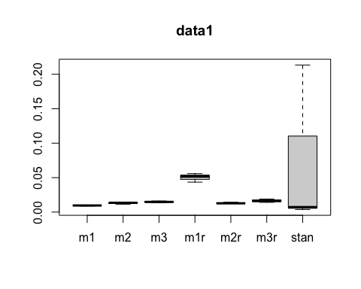

data1

## m1 m2 m3 m1r m2r m3r   
## 0.009491452 0.012982067 0.014908840 0.050287583 0.013249134 0.016421697   
## stan   
## 0.074786621

r1$resultstan

## t1 t2 t3  
## time 14.2120000 1.313100e+01 1.334900e+01  
## ess 66.6000935 3.521542e+03 1.844293e+03  
## stan 0.2133931 3.728764e-03 7.238005e-03

# With data2:

N = 800 mixing_p = c(0.60, 0.40) mu = c(0, -1) prec = c(9, 4) sigma = sqrt(1/prec)

x <- as.numeric(unlist(read.table(here("Data", "data2.txt"))))  
plot(density(x), main="data2")

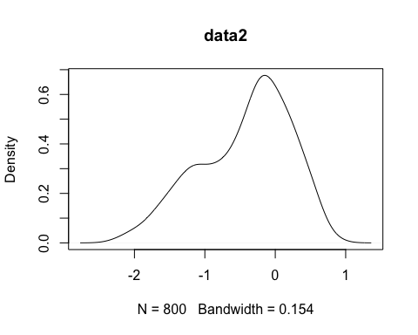

## Compiling model graph  
## Resolving undeclared variables  
## Allocating nodes  
## Graph information:  
## Observed stochastic nodes: 800  
## Unobserved stochastic nodes: 805  
## Total graph size: 3216  
##   
## Initializing model  
##   
## Compiling model graph  
## Resolving undeclared variables  
## Allocating nodes  
## Graph information:  
## Observed stochastic nodes: 800  
## Unobserved stochastic nodes: 805  
## Total graph size: 3216  
##   
## Initializing model  
##   
## Compiling model graph  
## Resolving undeclared variables  
## Allocating nodes  
## Graph information:  
## Observed stochastic nodes: 800  
## Unobserved stochastic nodes: 805  
## Total graph size: 3216  
##   
## Initializing model  
##   
## Compiling model graph  
## Resolving undeclared variables  
## Allocating nodes  
## Graph information:  
## Observed stochastic nodes: 800  
## Unobserved stochastic nodes: 5  
## Total graph size: 12025  
##   
## Initializing model  
##   
## Compiling model graph  
## Resolving undeclared variables  
## Allocating nodes  
## Graph information:  
## Observed stochastic nodes: 800  
## Unobserved stochastic nodes: 5  
## Total graph size: 12025  
##   
## Initializing model  
##   
## Compiling model graph  
## Resolving undeclared variables  
## Allocating nodes  
## Graph information:  
## Observed stochastic nodes: 800  
## Unobserved stochastic nodes: 5  
## Total graph size: 12025  
##   
## Initializing model  
##   
## Compiling data graph  
## Resolving undeclared variables  
## Allocating nodes  
## Initializing  
## Reading data back into data table  
## Compiling model graph  
## Resolving undeclared variables  
## Allocating nodes  
## Graph information:  
## Observed stochastic nodes: 800  
## Unobserved stochastic nodes: 1605  
## Total graph size: 16824  
##   
## Initializing model  
##   
## Compiling data graph  
## Resolving undeclared variables  
## Allocating nodes  
## Initializing  
## Reading data back into data table  
## Compiling model graph  
## Resolving undeclared variables  
## Allocating nodes  
## Graph information:  
## Observed stochastic nodes: 800  
## Unobserved stochastic nodes: 1605  
## Total graph size: 16824  
##   
## Initializing model  
##   
## Compiling data graph  
## Resolving undeclared variables  
## Allocating nodes  
## Initializing  
## Reading data back into data table  
## Compiling model graph  
## Resolving undeclared variables  
## Allocating nodes  
## Graph information:  
## Observed stochastic nodes: 800  
## Unobserved stochastic nodes: 1605  
## Total graph size: 16824  
##   
## Initializing model  
##   
## Compiling model graph  
## Resolving undeclared variables  
## Allocating nodes  
## Graph information:  
## Observed stochastic nodes: 800  
## Unobserved stochastic nodes: 805  
## Total graph size: 3216  
##   
## Initializing model  
##   
## Compiling model graph  
## Resolving undeclared variables  
## Allocating nodes  
## Graph information:  
## Observed stochastic nodes: 800  
## Unobserved stochastic nodes: 805  
## Total graph size: 3216  
##   
## Initializing model  
##   
## Compiling model graph  
## Resolving undeclared variables  
## Allocating nodes  
## Graph information:  
## Observed stochastic nodes: 800  
## Unobserved stochastic nodes: 805  
## Total graph size: 3216  
##   
## Initializing model  
##   
## Compiling model graph  
## Resolving undeclared variables  
## Allocating nodes  
## Graph information:  
## Observed stochastic nodes: 800  
## Unobserved stochastic nodes: 5  
## Total graph size: 12025  
##   
## Initializing model  
##   
## Compiling model graph  
## Resolving undeclared variables  
## Allocating nodes  
## Graph information:  
## Observed stochastic nodes: 800  
## Unobserved stochastic nodes: 5  
## Total graph size: 12025  
##   
## Initializing model  
##   
## Compiling model graph  
## Resolving undeclared variables  
## Allocating nodes  
## Graph information:  
## Observed stochastic nodes: 800  
## Unobserved stochastic nodes: 5  
## Total graph size: 12025  
##   
## Initializing model  
##   
## Compiling data graph  
## Resolving undeclared variables  
## Allocating nodes  
## Initializing  
## Reading data back into data table  
## Compiling model graph  
## Resolving undeclared variables  
## Allocating nodes  
## Graph information:  
## Observed stochastic nodes: 800  
## Unobserved stochastic nodes: 1605  
## Total graph size: 16824  
##   
## Initializing model  
##   
## Compiling data graph  
## Resolving undeclared variables  
## Allocating nodes  
## Initializing  
## Reading data back into data table  
## Compiling model graph  
## Resolving undeclared variables  
## Allocating nodes  
## Graph information:  
## Observed stochastic nodes: 800  
## Unobserved stochastic nodes: 1605  
## Total graph size: 16824  
##   
## Initializing model  
##   
## Compiling data graph  
## Resolving undeclared variables  
## Allocating nodes  
## Initializing  
## Reading data back into data table  
## Compiling model graph  
## Resolving undeclared variables  
## Allocating nodes  
## Graph information:  
## Observed stochastic nodes: 800  
## Unobserved stochastic nodes: 1605  
## Total graph size: 16824  
##   
## Initializing model

data2 <- c(rowMeans(r2$result[,4,]), rowMeans(r2$resultr[,4,]),rowMeans(r2$resultstan)[3])  
boxplot(t(rbind(r2$result[,4,],r2$resultr[,4,],r2$resultstan[3:3,,drop=FALSE])),main="data2")

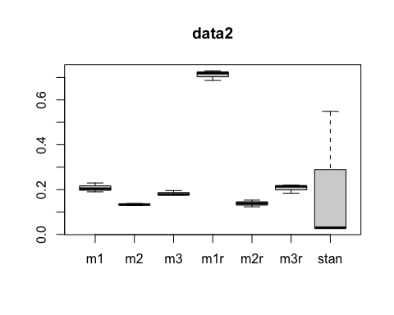

r2$resultstan

## t1 t2 t3  
## time 4.23120e+01 4.166700e+01 895.7910000  
## ess 1.42701e+03 1.544535e+03 1632.1699427  
## stan 2.96508e-02 2.697704e-02 0.5488344

# With data3:

N = 350 mixing_p = c(0.30, 0.7) mu = c(8, -10) prec = c(1/9, 1/4) sigma = sqrt(1/prec)

x <- as.numeric(unlist(read.table(here("Data", "data3.txt"))))  
plot(density(x), main="data3")

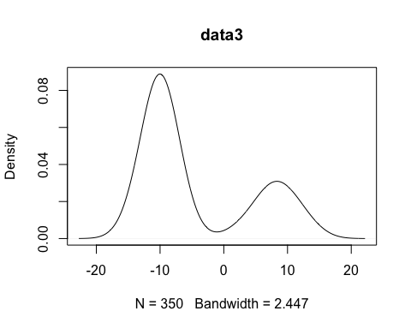

r3 <- sampling(here("Data", "data3.txt"), result, resultr, resultstan)

## Compiling model graph  
## Resolving undeclared variables  
## Allocating nodes  
## Graph information:  
## Observed stochastic nodes: 350  
## Unobserved stochastic nodes: 355  
## Total graph size: 1416  
##   
## Initializing model  
##   
## Compiling model graph  
## Resolving undeclared variables  
## Allocating nodes  
## Graph information:  
## Observed stochastic nodes: 350  
## Unobserved stochastic nodes: 355  
## Total graph size: 1416  
##   
## Initializing model  
##   
## Compiling model graph  
## Resolving undeclared variables  
## Allocating nodes  
## Graph information:  
## Observed stochastic nodes: 350  
## Unobserved stochastic nodes: 355  
## Total graph size: 1416  
##   
## Initializing model  
##   
## Compiling model graph  
## Resolving undeclared variables  
## Allocating nodes  
## Graph information:  
## Observed stochastic nodes: 350  
## Unobserved stochastic nodes: 5  
## Total graph size: 5275  
##   
## Initializing model  
##   
## Compiling model graph  
## Resolving undeclared variables  
## Allocating nodes  
## Graph information:  
## Observed stochastic nodes: 350  
## Unobserved stochastic nodes: 5  
## Total graph size: 5275  
##   
## Initializing model  
##   
## Compiling model graph  
## Resolving undeclared variables  
## Allocating nodes  
## Graph information:  
## Observed stochastic nodes: 350  
## Unobserved stochastic nodes: 5  
## Total graph size: 5275  
##   
## Initializing model  
##   
## Compiling data graph  
## Resolving undeclared variables  
## Allocating nodes  
## Initializing  
## Reading data back into data table  
## Compiling model graph  
## Resolving undeclared variables  
## Allocating nodes  
## Graph information:  
## Observed stochastic nodes: 350  
## Unobserved stochastic nodes: 705  
## Total graph size: 7374  
##   
## Initializing model  
##   
## Compiling data graph  
## Resolving undeclared variables  
## Allocating nodes  
## Initializing  
## Reading data back into data table  
## Compiling model graph  
## Resolving undeclared variables  
## Allocating nodes  
## Graph information:  
## Observed stochastic nodes: 350  
## Unobserved stochastic nodes: 705  
## Total graph size: 7374  
##   
## Initializing model  
##   
## Compiling data graph  
## Resolving undeclared variables  
## Allocating nodes  
## Initializing  
## Reading data back into data table  
## Compiling model graph  
## Resolving undeclared variables  
## Allocating nodes  
## Graph information:  
## Observed stochastic nodes: 350  
## Unobserved stochastic nodes: 705  
## Total graph size: 7374  
##   
## Initializing model  
##   
## Compiling model graph  
## Resolving undeclared variables  
## Allocating nodes  
## Graph information:  
## Observed stochastic nodes: 350  
## Unobserved stochastic nodes: 355  
## Total graph size: 1416  
##   
## Initializing model  
##   
## Compiling model graph  
## Resolving undeclared variables  
## Allocating nodes  
## Graph information:  
## Observed stochastic nodes: 350  
## Unobserved stochastic nodes: 355  
## Total graph size: 1416  
##   
## Initializing model  
##   
## Compiling model graph  
## Resolving undeclared variables  
## Allocating nodes  
## Graph information:  
## Observed stochastic nodes: 350  
## Unobserved stochastic nodes: 355  
## Total graph size: 1416  
##   
## Initializing model  
##   
## Compiling model graph  
## Resolving undeclared variables  
## Allocating nodes  
## Graph information:  
## Observed stochastic nodes: 350  
## Unobserved stochastic nodes: 5  
## Total graph size: 5275  
##   
## Initializing model  
##   
## Compiling model graph  
## Resolving undeclared variables  
## Allocating nodes  
## Graph information:  
## Observed stochastic nodes: 350  
## Unobserved stochastic nodes: 5  
## Total graph size: 5275  
##   
## Initializing model  
##   
## Compiling model graph  
## Resolving undeclared variables  
## Allocating nodes  
## Graph information:  
## Observed stochastic nodes: 350  
## Unobserved stochastic nodes: 5  
## Total graph size: 5275  
##   
## Initializing model  
##   
## Compiling data graph  
## Resolving undeclared variables  
## Allocating nodes  
## Initializing  
## Reading data back into data table  
## Compiling model graph  
## Resolving undeclared variables  
## Allocating nodes  
## Graph information:  
## Observed stochastic nodes: 350  
## Unobserved stochastic nodes: 705  
## Total graph size: 7374  
##   
## Initializing model  
##   
## Compiling data graph  
## Resolving undeclared variables  
## Allocating nodes  
## Initializing  
## Reading data back into data table  
## Compiling model graph  
## Resolving undeclared variables  
## Allocating nodes  
## Graph information:  
## Observed stochastic nodes: 350  
## Unobserved stochastic nodes: 705  
## Total graph size: 7374  
##   
## Initializing model  
##   
## Compiling data graph  
## Resolving undeclared variables  
## Allocating nodes  
## Initializing  
## Reading data back into data table  
## Compiling model graph  
## Resolving undeclared variables  
## Allocating nodes  
## Graph information:  
## Observed stochastic nodes: 350  
## Unobserved stochastic nodes: 705  
## Total graph size: 7374  
##   
## Initializing model

data3 <- c(rowMeans(r3$result[,4,]), rowMeans(r3$resultr[,4,]),rowMeans(r3$resultstan)[3])  
boxplot(t(rbind(r3$result[,4,],r3$resultr[,4,],r3$resultstan[3:3,,drop=FALSE])),main="data3")

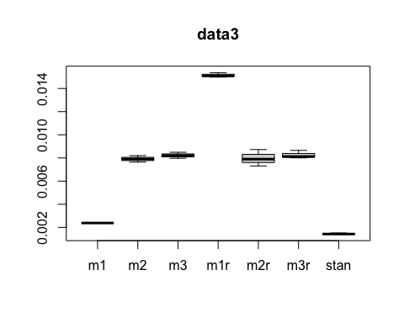

r3$resultstan

## t1 t2 t3  
## time 1.080900e+01 1.088600e+01 1.038200e+01  
## ess 7.121927e+03 7.694470e+03 7.276841e+03  
## stan 1.517707e-03 1.414782e-03 1.426718e-03

# With data4:

N = 950 mixing_p = c(0.50, 0.50) mu = c(10, -10) prec = c(1/81, 1/64) sigma = sqrt(1/prec)

x <- as.numeric(unlist(read.table(here("Data", "data4.txt"))))  
plot(density(x), main="data4")

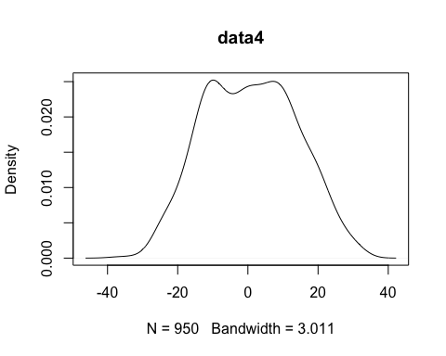

# data <- read.table(here("Data", "data4.txt"))  
# y <- data[,1]  
# iterations <- 4000  
# burnin <- floor(iterations/2)  
# chains <- 3  
#   
# N <- nrow(data)  
# data_jags <- list(N=N, y=y)  
# parameters = c("mu", "sigma", "mixing_p","z")  
#   
# s_data <-   
# model_fit <- stan(file = here("Models","two-componentModel.stan"),   
# data = data_jags, iter=iterations, chain=chains,  
# warmup=burnin)  
# summary(model_fit)

r4 <- sampling(here("Data", "data4.txt"), result, resultr, resultstan)

## Warning: There were 97 divergent transitions after warmup. Increasing adapt_delta above 0.8 may help. See  
## http://mc-stan.org/misc/warnings.html#divergent-transitions-after-warmup

## Warning: Examine the pairs() plot to diagnose sampling problems

## Warning: The largest R-hat is 5.38, indicating chains have not mixed.  
## Running the chains for more iterations may help. See  
## http://mc-stan.org/misc/warnings.html#r-hat

## Warning: Bulk Effective Samples Size (ESS) is too low, indicating posterior means and medians may be unreliable.  
## Running the chains for more iterations may help. See  
## http://mc-stan.org/misc/warnings.html#bulk-ess

## Warning: Tail Effective Samples Size (ESS) is too low, indicating posterior variances and tail quantiles may be unreliable.  
## Running the chains for more iterations may help. See  
## http://mc-stan.org/misc/warnings.html#tail-ess

## Warning: There were 120 divergent transitions after warmup. Increasing adapt_delta above 0.8 may help. See  
## http://mc-stan.org/misc/warnings.html#divergent-transitions-after-warmup

## Warning: Examine the pairs() plot to diagnose sampling problems

## Warning: The largest R-hat is 5.26, indicating chains have not mixed.  
## Running the chains for more iterations may help. See  
## http://mc-stan.org/misc/warnings.html#r-hat

## Warning: Bulk Effective Samples Size (ESS) is too low, indicating posterior means and medians may be unreliable.  
## Running the chains for more iterations may help. See  
## http://mc-stan.org/misc/warnings.html#bulk-ess

## Warning: Tail Effective Samples Size (ESS) is too low, indicating posterior variances and tail quantiles may be unreliable.  
## Running the chains for more iterations may help. See  
## http://mc-stan.org/misc/warnings.html#tail-ess

## Warning: There were 200 divergent transitions after warmup. Increasing adapt_delta above 0.8 may help. See  
## http://mc-stan.org/misc/warnings.html#divergent-transitions-after-warmup

## Warning: Examine the pairs() plot to diagnose sampling problems

## Warning: The largest R-hat is 5.15, indicating chains have not mixed.  
## Running the chains for more iterations may help. See  
## http://mc-stan.org/misc/warnings.html#r-hat

## Warning: Bulk Effective Samples Size (ESS) is too low, indicating posterior means and medians may be unreliable.  
## Running the chains for more iterations may help. See  
## http://mc-stan.org/misc/warnings.html#bulk-ess

## Warning: Tail Effective Samples Size (ESS) is too low, indicating posterior variances and tail quantiles may be unreliable.  
## Running the chains for more iterations may help. See  
## http://mc-stan.org/misc/warnings.html#tail-ess

## Compiling model graph  
## Resolving undeclared variables  
## Allocating nodes  
## Graph information:  
## Observed stochastic nodes: 950  
## Unobserved stochastic nodes: 955  
## Total graph size: 3816  
##   
## Initializing model  
##   
## Compiling model graph  
## Resolving undeclared variables  
## Allocating nodes  
## Graph information:  
## Observed stochastic nodes: 950  
## Unobserved stochastic nodes: 955  
## Total graph size: 3816  
##   
## Initializing model  
##   
## Compiling model graph  
## Resolving undeclared variables  
## Allocating nodes  
## Graph information:  
## Observed stochastic nodes: 950  
## Unobserved stochastic nodes: 955  
## Total graph size: 3816  
##   
## Initializing model  
##   
## Compiling model graph  
## Resolving undeclared variables  
## Allocating nodes  
## Graph information:  
## Observed stochastic nodes: 950  
## Unobserved stochastic nodes: 5  
## Total graph size: 14275  
##   
## Initializing model  
##   
## Compiling model graph  
## Resolving undeclared variables  
## Allocating nodes  
## Graph information:  
## Observed stochastic nodes: 950  
## Unobserved stochastic nodes: 5  
## Total graph size: 14275  
##   
## Initializing model  
##   
## Compiling model graph  
## Resolving undeclared variables  
## Allocating nodes  
## Graph information:  
## Observed stochastic nodes: 950  
## Unobserved stochastic nodes: 5  
## Total graph size: 14275  
##   
## Initializing model  
##   
## Compiling data graph  
## Resolving undeclared variables  
## Allocating nodes  
## Initializing  
## Reading data back into data table  
## Compiling model graph  
## Resolving undeclared variables  
## Allocating nodes  
## Graph information:  
## Observed stochastic nodes: 950  
## Unobserved stochastic nodes: 1905  
## Total graph size: 19974  
##   
## Initializing model  
##   
## Compiling data graph  
## Resolving undeclared variables  
## Allocating nodes  
## Initializing  
## Reading data back into data table  
## Compiling model graph  
## Resolving undeclared variables  
## Allocating nodes  
## Graph information:  
## Observed stochastic nodes: 950  
## Unobserved stochastic nodes: 1905  
## Total graph size: 19974  
##   
## Initializing model  
##   
## Compiling data graph  
## Resolving undeclared variables  
## Allocating nodes  
## Initializing  
## Reading data back into data table  
## Compiling model graph  
## Resolving undeclared variables  
## Allocating nodes  
## Graph information:  
## Observed stochastic nodes: 950  
## Unobserved stochastic nodes: 1905  
## Total graph size: 19974  
##   
## Initializing model  
##   
## Compiling model graph  
## Resolving undeclared variables  
## Allocating nodes  
## Graph information:  
## Observed stochastic nodes: 950  
## Unobserved stochastic nodes: 955  
## Total graph size: 3816  
##   
## Initializing model  
##   
## Compiling model graph  
## Resolving undeclared variables  
## Allocating nodes  
## Graph information:  
## Observed stochastic nodes: 950  
## Unobserved stochastic nodes: 955  
## Total graph size: 3816  
##   
## Initializing model  
##   
## Compiling model graph  
## Resolving undeclared variables  
## Allocating nodes  
## Graph information:  
## Observed stochastic nodes: 950  
## Unobserved stochastic nodes: 955  
## Total graph size: 3816  
##   
## Initializing model  
##   
## Compiling model graph  
## Resolving undeclared variables  
## Allocating nodes  
## Graph information:  
## Observed stochastic nodes: 950  
## Unobserved stochastic nodes: 5  
## Total graph size: 14275  
##   
## Initializing model  
##   
## Compiling model graph  
## Resolving undeclared variables  
## Allocating nodes  
## Graph information:  
## Observed stochastic nodes: 950  
## Unobserved stochastic nodes: 5  
## Total graph size: 14275  
##   
## Initializing model  
##   
## Compiling model graph  
## Resolving undeclared variables  
## Allocating nodes  
## Graph information:  
## Observed stochastic nodes: 950  
## Unobserved stochastic nodes: 5  
## Total graph size: 14275  
##   
## Initializing model  
##   
## Compiling data graph  
## Resolving undeclared variables  
## Allocating nodes  
## Initializing  
## Reading data back into data table  
## Compiling model graph  
## Resolving undeclared variables  
## Allocating nodes  
## Graph information:  
## Observed stochastic nodes: 950  
## Unobserved stochastic nodes: 1905  
## Total graph size: 19974  
##   
## Initializing model  
##   
## Compiling data graph  
## Resolving undeclared variables  
## Allocating nodes  
## Initializing  
## Reading data back into data table  
## Compiling model graph  
## Resolving undeclared variables  
## Allocating nodes  
## Graph information:  
## Observed stochastic nodes: 950  
## Unobserved stochastic nodes: 1905  
## Total graph size: 19974  
##   
## Initializing model  
##   
## Compiling data graph  
## Resolving undeclared variables  
## Allocating nodes  
## Initializing  
## Reading data back into data table  
## Compiling model graph  
## Resolving undeclared variables  
## Allocating nodes  
## Graph information:  
## Observed stochastic nodes: 950  
## Unobserved stochastic nodes: 1905  
## Total graph size: 19974  
##   
## Initializing model

data4 <- c(rowMeans(r4$result[,4,]), rowMeans(r4$resultr[,4,]),rowMeans(r4$resultstan)[3])  
boxplot(t(rbind(r4$result[,4,],r4$resultr[,4,],r4$resultstan[3:3,,drop=FALSE])),main="data4")

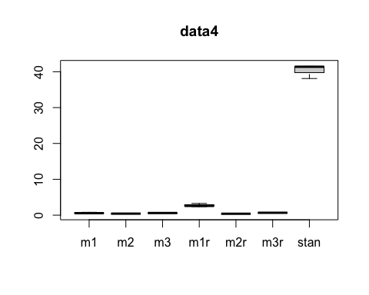

r4$resultstan

## t1 t2 t3  
## time 62.100000 62.256000 57.175000  
## ess 1.500417 1.500412 1.500411  
## stan 41.388496 41.492593 38.106222

# With data5:

N = 350 mixing_p = c(0.40, 0.60) mu = c(7, -12) prec = c(1, 4) sigma = sqrt(1/prec)

x <- as.numeric(unlist(read.table(here("Data", "data5.txt"))))  
plot(density(x), main="data5")

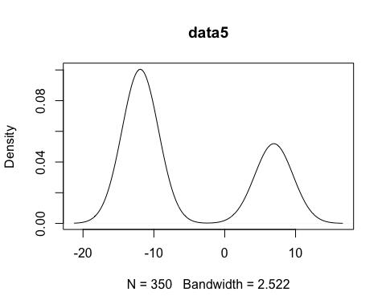

r5 <- sampling(here("Data", "data5.txt"), result, resultr, resultstan)

## Compiling model graph  
## Resolving undeclared variables  
## Allocating nodes  
## Graph information:  
## Observed stochastic nodes: 350  
## Unobserved stochastic nodes: 355  
## Total graph size: 1416  
##   
## Initializing model  
##   
## Compiling model graph  
## Resolving undeclared variables  
## Allocating nodes  
## Graph information:  
## Observed stochastic nodes: 350  
## Unobserved stochastic nodes: 355  
## Total graph size: 1416  
##   
## Initializing model  
##   
## Compiling model graph  
## Resolving undeclared variables  
## Allocating nodes  
## Graph information:  
## Observed stochastic nodes: 350  
## Unobserved stochastic nodes: 355  
## Total graph size: 1416  
##   
## Initializing model  
##   
## Compiling model graph  
## Resolving undeclared variables  
## Allocating nodes  
## Graph information:  
## Observed stochastic nodes: 350  
## Unobserved stochastic nodes: 5  
## Total graph size: 5275  
##   
## Initializing model  
##   
## Compiling model graph  
## Resolving undeclared variables  
## Allocating nodes  
## Graph information:  
## Observed stochastic nodes: 350  
## Unobserved stochastic nodes: 5  
## Total graph size: 5275  
##   
## Initializing model  
##   
## Compiling model graph  
## Resolving undeclared variables  
## Allocating nodes  
## Graph information:  
## Observed stochastic nodes: 350  
## Unobserved stochastic nodes: 5  
## Total graph size: 5275  
##   
## Initializing model  
##   
## Compiling data graph  
## Resolving undeclared variables  
## Allocating nodes  
## Initializing  
## Reading data back into data table  
## Compiling model graph  
## Resolving undeclared variables  
## Allocating nodes  
## Graph information:  
## Observed stochastic nodes: 350  
## Unobserved stochastic nodes: 705  
## Total graph size: 7374  
##   
## Initializing model  
##   
## Compiling data graph  
## Resolving undeclared variables  
## Allocating nodes  
## Initializing  
## Reading data back into data table  
## Compiling model graph  
## Resolving undeclared variables  
## Allocating nodes  
## Graph information:  
## Observed stochastic nodes: 350  
## Unobserved stochastic nodes: 705  
## Total graph size: 7374  
##   
## Initializing model  
##   
## Compiling data graph  
## Resolving undeclared variables  
## Allocating nodes  
## Initializing  
## Reading data back into data table  
## Compiling model graph  
## Resolving undeclared variables  
## Allocating nodes  
## Graph information:  
## Observed stochastic nodes: 350  
## Unobserved stochastic nodes: 705  
## Total graph size: 7374  
##   
## Initializing model  
##   
## Compiling model graph  
## Resolving undeclared variables  
## Allocating nodes  
## Graph information:  
## Observed stochastic nodes: 350  
## Unobserved stochastic nodes: 355  
## Total graph size: 1416  
##   
## Initializing model  
##   
## Compiling model graph  
## Resolving undeclared variables  
## Allocating nodes  
## Graph information:  
## Observed stochastic nodes: 350  
## Unobserved stochastic nodes: 355  
## Total graph size: 1416  
##   
## Initializing model  
##   
## Compiling model graph  
## Resolving undeclared variables  
## Allocating nodes  
## Graph information:  
## Observed stochastic nodes: 350  
## Unobserved stochastic nodes: 355  
## Total graph size: 1416  
##   
## Initializing model  
##   
## Compiling model graph  
## Resolving undeclared variables  
## Allocating nodes  
## Graph information:  
## Observed stochastic nodes: 350  
## Unobserved stochastic nodes: 5  
## Total graph size: 5275  
##   
## Initializing model  
##   
## Compiling model graph  
## Resolving undeclared variables  
## Allocating nodes  
## Graph information:  
## Observed stochastic nodes: 350  
## Unobserved stochastic nodes: 5  
## Total graph size: 5275  
##   
## Initializing model  
##   
## Compiling model graph  
## Resolving undeclared variables  
## Allocating nodes  
## Graph information:  
## Observed stochastic nodes: 350  
## Unobserved stochastic nodes: 5  
## Total graph size: 5275  
##   
## Initializing model  
##   
## Compiling data graph  
## Resolving undeclared variables  
## Allocating nodes  
## Initializing  
## Reading data back into data table  
## Compiling model graph  
## Resolving undeclared variables  
## Allocating nodes  
## Graph information:  
## Observed stochastic nodes: 350  
## Unobserved stochastic nodes: 705  
## Total graph size: 7374  
##   
## Initializing model  
##   
## Compiling data graph  
## Resolving undeclared variables  
## Allocating nodes  
## Initializing  
## Reading data back into data table  
## Compiling model graph  
## Resolving undeclared variables  
## Allocating nodes  
## Graph information:  
## Observed stochastic nodes: 350  
## Unobserved stochastic nodes: 705  
## Total graph size: 7374  
##   
## Initializing model  
##   
## Compiling data graph  
## Resolving undeclared variables  
## Allocating nodes  
## Initializing  
## Reading data back into data table  
## Compiling model graph  
## Resolving undeclared variables  
## Allocating nodes  
## Graph information:  
## Observed stochastic nodes: 350  
## Unobserved stochastic nodes: 705  
## Total graph size: 7374  
##   
## Initializing model

data5 <- c(rowMeans(r5$result[,4,]), rowMeans(r5$resultr[,4,]),rowMeans(r5$resultstan)[3])  
boxplot(t(rbind(r5$result[,4,],r5$resultr[,4,],r5$resultstan[3:3,,drop=FALSE])),main="data5")

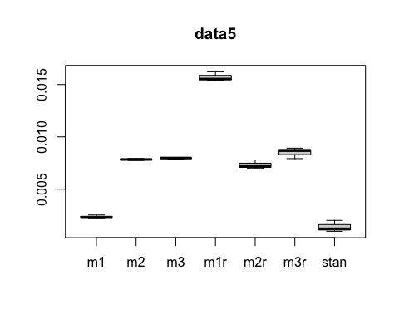

r5$resultstan

## t1 t2 t3  
## time 7.101000e+00 9.787000e+00 1.635600e+01  
## ess 7.241655e+03 7.989933e+03 8.081286e+03  
## stan 9.805769e-04 1.224916e-03 2.023935e-03

## Warning: Removed 1 rows containing missing values (geom_point).

## Warning: Removed 1 row(s) containing missing values (geom_path).

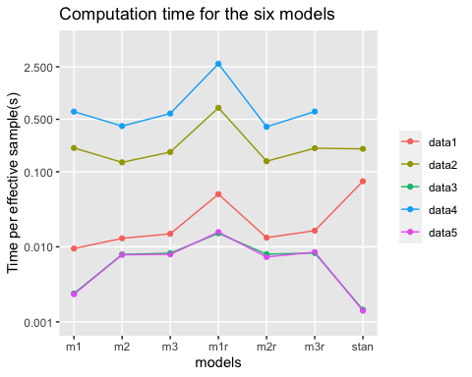

## Warning: Removed 1 rows containing missing values (geom_point).

## Warning: Removed 1 row(s) containing missing values (geom_path).

