**Decision Analytics for Business and Policy: Airline Ticket Strategy**

Jeff Scanlon

Ticket types are indexed by *t =* 1,…,4. Possible scenarios for ticket demand are indexed by *s =* 1,…,1000 for each ticket type. Possible scenarios for fares are indexed by f = 1,…,3 for each ticket type.

**Parameters**

$$D_{ts} = demand for ticket type t in scenario s$$

$$P_{s}= probability of scenario s occuring$$

$F_{ft}=fare$ under scenario f for ticket type t

$${FP}_{f}= probability of fare scenario f$$

St = number of economy-equivalent seats occupied by one seat of ticket t (constants are used in my formulation rather than the variable St)

**First-Stage Decision Variable**

$$X_{t} = number of tickets allocated to ticket type t for the flight before demand is known or realized$$

**Second-Stage Decision Variable**

$$Y_{t} = expected value for number of tickets sold for ticket type t after demand has been realized$$

Equation (1) defines that the objective function is to maximize expected revenue. Revenue is calculated as the fare ($400, $500, $800, or $1000) multiplied by the number of seats sold at that fare multiplied by the probability of each demand scenario, summed across all 1000 demand scenarios. Equation (2) defines the constraint that the total number of seats sold for each ticket type must not exceed the total number of seats assigned or allocated to each ticket type before demand is realized. Equation (3) stipulates that the number of seats sold for each ticket type must not exceed the number of seats demanded for each ticket type for each of the 1000 demand scenarios. Equation (4) requires that the total number of seats used does not exceed the 190 seats available, and accounts for the additional space required for Economy+, Business, and First Class seats by multiplying the number allocated (Xt) by a constant (1.2, 1.5, and 2, respectively). Equation (5) represents the constraint that there may be no negative sales for any ticket type. A non-negativity constraint for Xt is subsumed within this constraint because Xt must already be greater than or equal to Yts, which itself must be greater than or equal to 0.

**Model 1** *– Known Fares, Unknown Demand*

$$max Revenue= \sum_{s=1}^{1000}{{(400•Y}_{0,s}• P_{s}) + {(500•Y}_{1,s}• P_{s}) + {(800•Y}_{2,s}• P_{s}) + {(1000•Y}_{3,s}• P_{s})} (1) \\ s.t. X_{t}≥ Y_{ts} ∀t =1,…,4, ∀s =1,…,1000$$ $\left(2\right)$ $$Y_{ts} ≤ D_{ts} ∀t =1,…,4, ∀s =1,…,1000$$ $(3)$

${ X}_{0} + {(1.2 • X}_{1}) + {(1.5 • X}_{2}) + {(2 • X}_{3}) ≤190$ $(4)$ $Y_{ts}≥0 ∀k =1,…,4$ $(5)$

A second model is also created to reflect the idea that fares for flights are influenced by market and are therefore subject to change and cannot be wholly set by an airline. Equation (6) gives the objective function for this new model. Each ticket type now requires four terms to calculate revenue: the fare for that ticket type under that fare scenario, the probability of that fare scenario, the number of seats sold for that ticket type under each demand scenario, and the probability of that demand scenario. Thus, each combination of fare scenario and demand scenario is achieved, meaning 3 x 1000, or 3000 scenarios, are generated. Statement (7) indicates that nothing else changes from Model 1 to Model 2. In particular, all of the constraints in Model 1 also apply to Model 2.

**Model 2** *– Unknown Fares, Unknown Demand $max Revenue= \sum_{f=1}^{3}{\sum_{s=1}^{1000}{{(F_{f,0}•{FP}_{f }•Y}_{0,s}• P_{s}) + {(F_{f,1}•{FP}_{f }•Y}_{1,s}• P_{s}) +}}$*  **(6)**

$${(F_{f,2}•{FP}_{f }•Y}_{2,s}• P_{s}) + {(F_{f,3}•{FP}_{f }•Y}_{3,s}• P_{s})$$

$* This model is also subject$ $to all four of the constraintsl isted in Model 1.$**(7)**

**Computational Results**

**Model 1**

This model yields the following results when implemented with Gurobi in python:

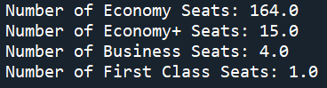

**The total expected revenue from this allocation is: $75,636.13.**

To understand why the Simplex algorithm may have selected this outcome, some basic summary statistics and visualizations of the data can be generated to better understand the distribution of scenario values.

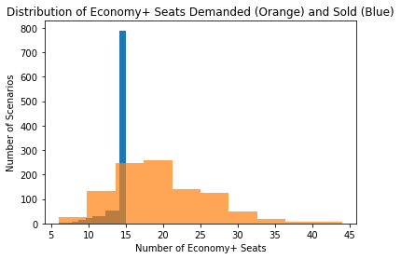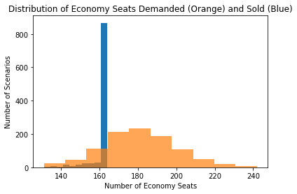

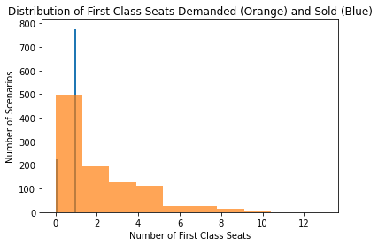

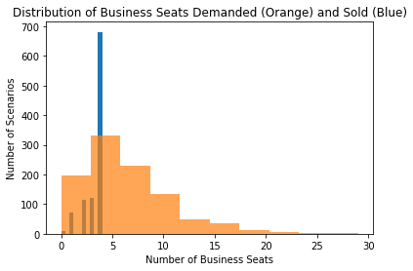

The histograms above indicate that the the number of seats allocated to business and first class tickets (4 and 1 respectively), closely align the the peaks of demand (in orange). This might suggest that business and first class seats have a greater marginal value than economy and economy+ tickets, since economy and economy+ did not allocate seats to where demand was highest. Economy and economy+ were assigned 164 and 15 seats, respectively, while their peak demands were around 180 and 20. Thus, it generates more revenue to scale back on those tickets somewhat in order to make room for some business and first class seats. However, once demand for these more expensive tickets declines (past 5 seats and 1 seat respectively), it becomes less beneficial to continue reducing economy seats to make room for these more expensive seats.

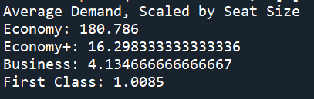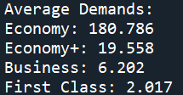

The summary statistics above also help to explain the allocation. The average demands for buisness and first class tickets are met (when scaling the demands by seat size), while the demand for economy+ just barely overshoots the number allocated. The demand for economy vastly overshoots the number of seats allocated because the remaining seats that could be used to meet this demand are better served supplying more expensive seats.





About two-thirds of the 1000 scenarios result in the flight being underbooked. In almost all of the scenarios (993 out of 1000), the number of tickets sold is less than the demand and in only seven cases does the number sold directly equal the demand.

**Model 2**

This model yields the following results when implemented with Gurobi in python:

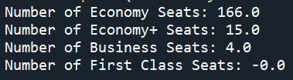

In this model, one less seat is available for First Class, which opens up two additional seats for Economy. Economy+ and Business are unchanged. This may be due to the fact that the expected value of First Class seats has declined, while the expected value of Economy seats have remained the same and are thus less risky (less deviation in expected value as well).