Analysis of Gentrification and Transportation Changes in Urban Cores from 2000-2015

by Jeff Scanlon

Background

This analysis utilizes data from the U.S. Census Bureau’s American Community Survey (ACS) to understand changes in 100 urban cores across the United States from 2000 to 2015. The data contains demographic and socioeconomic data for residents of these urban cores, as well as data pertaining to activities related to work and commuting.

The data contains only three categorical variables: the name of the urban core (typically a city name), the state the UC is located in, and the year of the observation. Since there are only two years and exactly 100 observations in each year, frequency tables are unnecessary for these two variables. Thus, a frequency table is provided for State only.

Unsurprisingly, California, the country’s most populous states, has over one-fourth of the total urban cores. Somewhat surprisingly, the states of Florida and Ohio each constitute more than one-tenth of the total observations. These states span many geographic locations across the U.S. and also have very different unique industries and economies. Thus, economic conditions pertaining to gentrification and transportation could behave somewhat differently within each context. This provides further justification that a paired t-test will be the best method for hypothesis testing later on.

N st | Frequency | Percent | Cumulative  Frequency | Cumulative  Percent
AL | 2 | 1.00 | 2 | 1.00
AR | 2 | 1.00 | 4 | 2.00
AZ | 4 | 2.00 | 8 | 4.00
CA | 28 | 14.00 | 36 | 18.00
CO | 4 | 2.00 | 40 | 20.00
CT | 4 | 2.00 | 44 | 22.00
DC | 2 | 1.00 | 46 | 23.00
FL | 16 | 8.00 | 62 | 31.00
GA | 4 | 2.00 | 66 | 33.00
IA | 4 | 2.00 | 70 | 35.00
ID | 2 | 1.00 | 72 | 36.00
IL | 2 | 1.00 | 74 | 37.00
IN | 4 | 2.00 | 78 | 39.00
KS | 2 | 1.00 | 80 | 40.00
KY | 2 | 1.00 | 82 | 41.00
LA | 6 | 3.00 | 88 | 44.00
MA | 4 | 2.00 | 92 | 46.00
MD | 2 | 1.00 | 94 | 47.00
MI | 4 | 2.00 | 98 | 49.00
MN | 4 | 2.00 | 102 | 51.00
MO | 4 | 2.00 | 106 | 53.00
MS | 2 | 1.00 | 108 | 54.00
NC | 10 | 5.00 | 118 | 59.00
NE | 4 | 2.00 | 122 | 61.00
NJ | 2 | 1.00 | 124 | 62.00
NV | 2 | 1.00 | 126 | 63.00
NY | 8 | 4.00 | 134 | 67.00
OH | 14 | 7.00 | 148 | 74.00
OK | 4 | 2.00 | 152 | 76.00
OR | 2 | 1.00 | 154 | 77.00
PA | 6 | 3.00 | 160 | 80.00
RI | 2 | 1.00 | 162 | 81.00
TN | 8 | 4.00 | 170 | 85.00
TX | 14 | 7.00 | 184 | 92.00
UT | 4 | 2.00 | 188 | 94.00
VA | 4 | 2.00 | 192 | 96.00
WA | 4 | 2.00 | 196 | 98.00
WI | 4 | 2.00 | 200 | 100.00

The next table provides basic summary statistics for all of the numeric, continuous variables in the dataset. Right away there are some important insights. First, by comparing the mean for each variable from 2000 to 2015, it is apparent that many of the variables appear to have experienced either significant increase or decrease during this time, and these changes could signal gentrification. For example, the median household income and the percent of residents with a bachelors degree or higher appear to have increased substantially. Additionally, the standard deviation of these variables is also increasing, which may be indicative of the population becoming less homogeneous as wealthier individuals and families move into these urban cores. However, only hypothesis testing (in the form of a paired t-test) can determine if these changes are statistically significant.

year | N Obs | Variable | N | Mean | Std Dev | Std Error | Median | Minimum | Maximum
2000 | 100 | median_hhincome  pct_1person_hh  pct_amerind  pct_asian  pct_bachdegree_orhigher  pct_black  pct_commute_bike  pct_commute_car  pct_commute_home  pct_commute_pubtrans  pct_commute_walk  pct_diploma_orhigher  pct_hisp  pct_owner  pct_renter  pct_white  pop_18to39  sqmi  total_workers  totpop  travel_time_to_work  unemployment_rate | 100  100  100  100  100  100  100  100  100  100  100  100  100  100  100  100  100  100  100  100  100  100 | 44550.29  0.3129736  0.0080538  0.0338392  0.2271454  0.2831294  0.0080864  0.8191771  0.0263620  0.0892560  0.0477561  0.7284743  0.1923545  0.4985291  0.5014709  0.5528388  18447.38  25.5431000  20804.54  49501.31  10.3902956  0.0927679 | 17849.13  0.0908022  0.0093931  0.0417583  0.1475972  0.2693998  0.0123036  0.1260368  0.0134219  0.0956825  0.0406914  0.1379782  0.2374145  0.1518698  0.1518698  0.2346330  12480.48  66.7032774  12936.49  29968.79  4.3219399  0.0451341 | 1784.91  0.0090802  0.000939311  0.0041758  0.0147597  0.0269400  0.0012304  0.0126037  0.0013422  0.0095682  0.0040691  0.0137978  0.0237415  0.0151870  0.0151870  0.0234633  1248.05  6.6703277  1293.65  2996.88  0.4321940  0.0045134 | 40975.08  0.3223218  0.0044650  0.0227800  0.1790159  0.1783325  0.0048252  0.8653538  0.0248080  0.0615171  0.0333658  0.7311703  0.0878226  0.5058634  0.4941366  0.5491764  15176.50  12.3400000  17959.00  44027.00  10.4786954  0.0880294 | 19965.19  0.0743780  0.000932836  0.000589692  0.0398788  0.0051322  0  0.4125592  0.0018660  0.000521912  0.0032673  0.2903154  0.0062439  0.1807485  0.0955689  0.0236416  2427.00  6.8900000  3360.00  7504.00  1.2707235  0.0231003 | 144025.67  0.5849399  0.0549891  0.2331259  0.6951559  0.9595254  0.1049827  0.9643647  0.0881547  0.5033747  0.2334739  0.9589540  0.9316071  0.9044311  0.8192515  0.9098331  67030.00  618.3700000  81005.00  176478.00  21.3075842  0.2417518
2015 | 100 | median_hhincome  pct_1person_hh  pct_amerind  pct_asian  pct_bachdegree_orhigher  pct_black  pct_commute_bike  pct_commute_car  pct_commute_home  pct_commute_pubtrans  pct_commute_walk  pct_diploma_orhigher  pct_hisp  pct_owner  pct_renter  pct_white  pop_18to39  sqmi  total_workers  totpop  travel_time_to_work  unemployment_rate | 100  100  100  100  100  100  100  100  100  100  100  100  100  100  100  100  100  100  100  100  100  100 | 48996.78  0.3503282  0.0074058  0.0466677  0.3045648  0.2686570  0.0136213  0.7938318  0.0430848  0.0807061  0.0552617  0.8279411  0.2229023  0.4525219  0.5474781  0.5781157  11746.14  25.5431000  28209.94  60916.11  25.4271059  0.0926150 | 22887.39  0.0934095  0.0103902  0.0482348  0.1676199  0.2384135  0.0189133  0.1469055  0.0218490  0.0987460  0.0579255  0.0988358  0.2390817  0.1399241  0.1399241  0.2155923  7629.49  66.7032774  17731.86  33615.49  5.6460249  0.0417738 | 2288.74  0.0093409  0.0010390  0.0048235  0.0167620  0.0238414  0.0018913  0.0146906  0.0021849  0.0098746  0.0057926  0.0098836  0.0239082  0.0139924  0.0139924  0.0215592  762.9487586  6.6703277  1773.19  3361.55  0.5646025  0.0041774 | 42544.48  0.3664914  0.0038642  0.0321194  0.2586287  0.1971911  0.0069293  0.8517295  0.0362857  0.0462312  0.0347413  0.8380376  0.1305935  0.4411084  0.5588916  0.6326586  9410.60  12.3400000  22979.00  53108.50  24.2563524  0.0829099 | 19801.05  0.0753905  0  0.000663405  0.0624580  0.0038932  0  0.2889627  0.0080296  0.000423278  0.0022825  0.4461285  0.0038328  0.1367750  0.1389916  0.0154120  1449.50  6.8900000  4237.00  12059.00  17.1168747  0.0262216 | 167837.99  0.5528927  0.0694401  0.2470619  0.7241453  0.9583915  0.1090808  0.9564884  0.1052023  0.5864088  0.3088757  0.9773878  0.9370362  0.8610084  0.8632250  0.8919549  37659.69  618.3700000  98146.00  206676.00  48.4936077  0.2244178

To further understand the data and relationships between variables, several plots were produced and are shown on the pages that follow. The two histograms are provided as an example of the use of log transformations to “normalize” right-skewed data. The first histogram uses the raw median household income variable, which has a right-skewed distribution. By creating a new variable that returns the log of this value, the distribution becomes more normal, which can enhance visualization and impact correlation interpretations (in both positive and negative ways).

Moments
N | 200 | Sum Weights | 200
Mean | 46773.5338 | Sum Observations | 9354706.75
Std Deviation | 20592.7928 | Variance | 424063114
Skewness | 2.39450748 | Kurtosis | 8.74794274
Uncorrected SS | 5.21941E11 | Corrected SS | 8.43886E10
Coeff Variation | 44.0265918 | Std Error Mean | 1456.13034

Basic Statistical Measures
Location |  | Variability
Mean | 46773.53 | Std Deviation | 20593
Median | 41913.25 | Variance | 424063114
Mode | . | Range | 148037
 |  | Interquartile Range | 17692

Tests for Location: Mu0=0
Test | Statistic |  | p Value
Student's t | t | 32.1218 | Pr > |t| | <.0001
Sign | M | 100 | Pr >= |M| | <.0001
Signed Rank | S | 10050 | Pr >= |S| | <.0001

Quantiles (Definition 5)
Level | Quantile
100% Max | 167838.0
99% | 136758.1
95% | 90122.5
90% | 69611.9
75% Q3 | 52291.8
50% Median | 41913.3
25% Q1 | 34600.1
10% | 27599.8
5% | 25508.5
1% | 20656.0
0% Min | 19801.0

Extreme Observations
Lowest |  | Highest
Value | Obs | Value | Obs
19801.0 | 200 | 97172.7 | 106
19965.2 | 9 | 97559.7 | 116
21346.9 | 168 | 129490.6 | 181
21464.0 | 109 | 144025.7 | 82
23319.0 | 13 | 167838.0 | 182

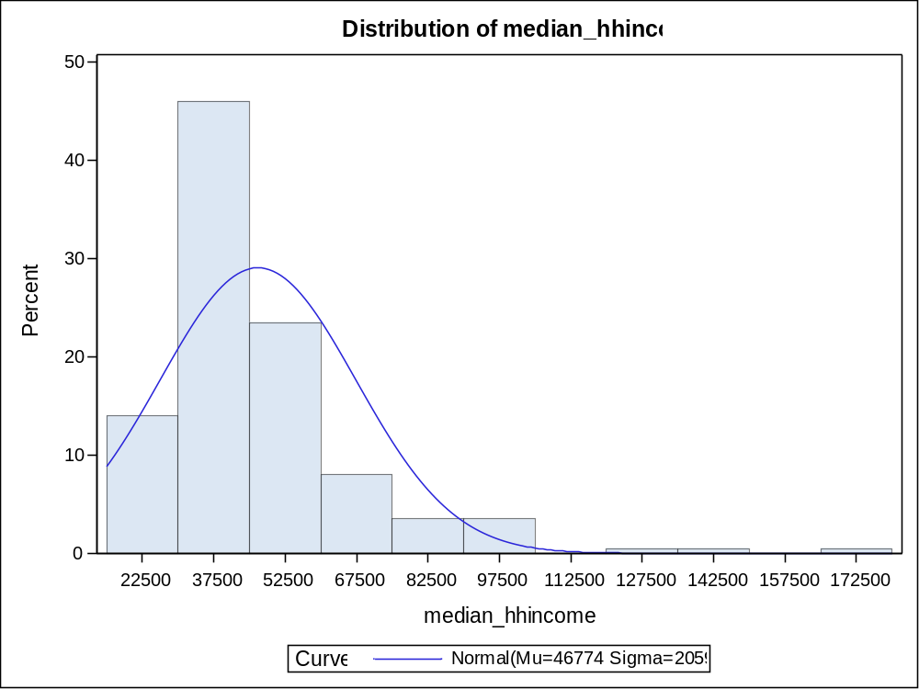

Parameters for Normal Distribution
Parameter | Symbol | Estimate
Mean | Mu | 46773.53
Std Dev | Sigma | 20592.79

Goodness-of-Fit Tests for Normal Distribution
Test | Statistic |  | p Value
Kolmogorov-Smirnov | D | 0.16284762 | Pr > D | <0.010
Cramer-von Mises | W-Sq | 1.68064982 | Pr > W-Sq | <0.005
Anderson-Darling | A-Sq | 9.44981298 | Pr > A-Sq | <0.005

Quantiles for Normal Distribution
Percent | Quantile
Percent | Observed | Estimated
1.0 | 20656.0 | -1132.47
5.0 | 25508.5 | 12901.40
10.0 | 27599.8 | 20382.81
25.0 | 34600.1 | 32883.91
50.0 | 41913.3 | 46773.53
75.0 | 52291.8 | 60663.16
90.0 | 69611.9 | 73164.26
95.0 | 90122.5 | 80645.66
99.0 | 136758.1 | 94679.53

Moments
N | 200 | Sum Weights | 200
Mean | 10.6801496 | Sum Observations | 2136.02991
Std Deviation | 0.36579163 | Variance | 0.13380352
Skewness | 0.69846079 | Kurtosis | 1.0506918
Uncorrected SS | 22839.7458 | Corrected SS | 26.6268995
Coeff Variation | 3.42496728 | Std Error Mean | 0.02586537

Basic Statistical Measures
Location |  | Variability
Mean | 10.68015 | Std Deviation | 0.36579
Median | 10.64336 | Variance | 0.13380
Mode | . | Range | 2.13726
 |  | Interquartile Range | 0.41298

Tests for Location: Mu0=0
Test | Statistic |  | p Value
Student's t | t | 412.913 | Pr > |t| | <.0001
Sign | M | 100 | Pr >= |M| | <.0001
Signed Rank | S | 10050 | Pr >= |S| | <.0001

Quantiles (Definition 5)
Level | Quantile
100% Max | 12.03075
99% | 11.82456
95% | 11.40892
90% | 11.15053
75% Q3 | 10.86459
50% Median | 10.64336
25% Q1 | 10.45161
10% | 10.22556
5% | 10.14677
1% | 9.93520
0% Min | 9.89349

Extreme Observations
Lowest |  | Highest
Value | Obs | Value | Obs
9.89349 | 200 | 11.4842 | 106
9.90175 | 9 | 11.4882 | 116
9.96866 | 168 | 11.7714 | 181
9.97413 | 109 | 11.8777 | 82
10.05702 | 13 | 12.0308 | 182

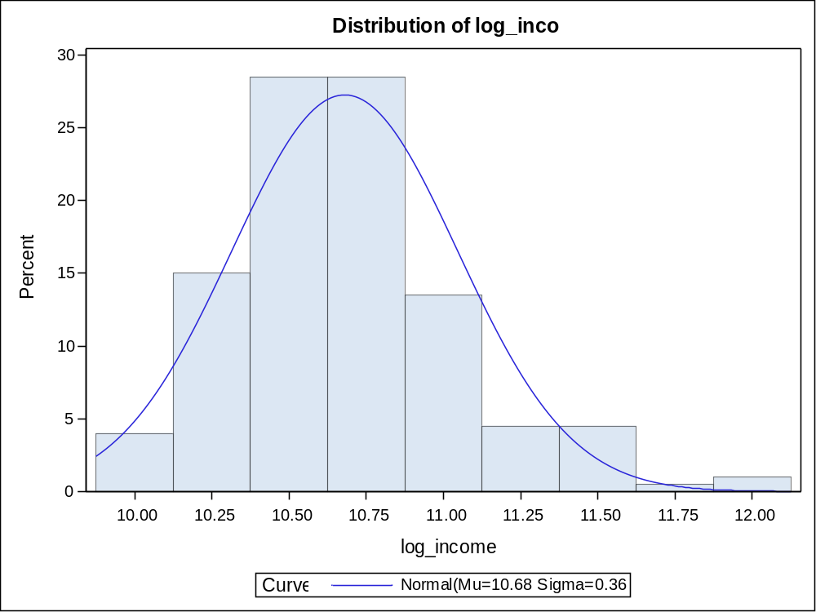

Parameters for Normal Distribution
Parameter | Symbol | Estimate
Mean | Mu | 10.68015
Std Dev | Sigma | 0.365792

Goodness-of-Fit Tests for Normal Distribution
Test | Statistic |  | p Value
Kolmogorov-Smirnov | D | 0.07754845 | Pr > D | <0.010
Cramer-von Mises | W-Sq | 0.27808600 | Pr > W-Sq | <0.005
Anderson-Darling | A-Sq | 1.61501991 | Pr > A-Sq | <0.005

Quantiles for Normal Distribution
Percent | Quantile
Percent | Observed | Estimated
1.0 | 9.93520 | 9.82919
5.0 | 10.14677 | 10.07848
10.0 | 10.22556 | 10.21137
25.0 | 10.45161 | 10.43343
50.0 | 10.64336 | 10.68015
75.0 | 10.86459 | 10.92687
90.0 | 11.15053 | 11.14893
95.0 | 11.40892 | 11.28182
99.0 | 11.82456 | 11.53111

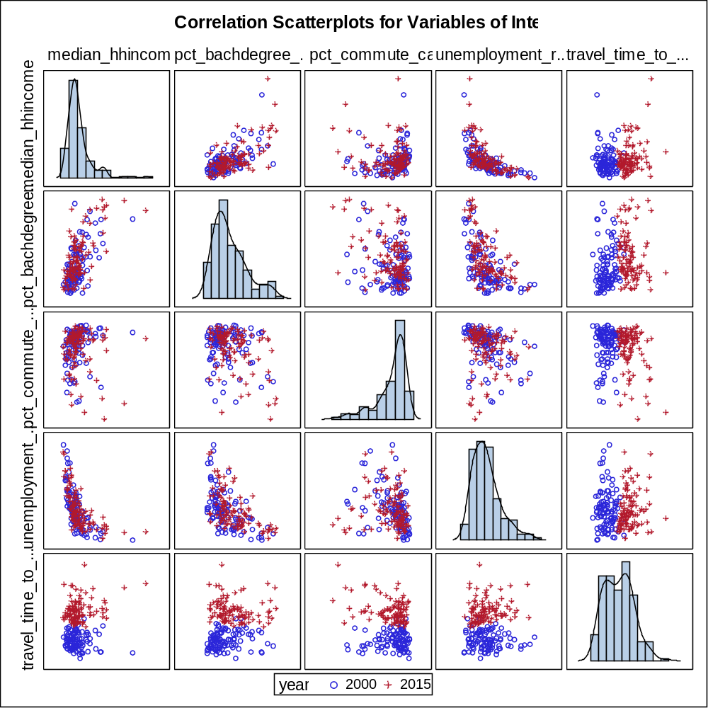

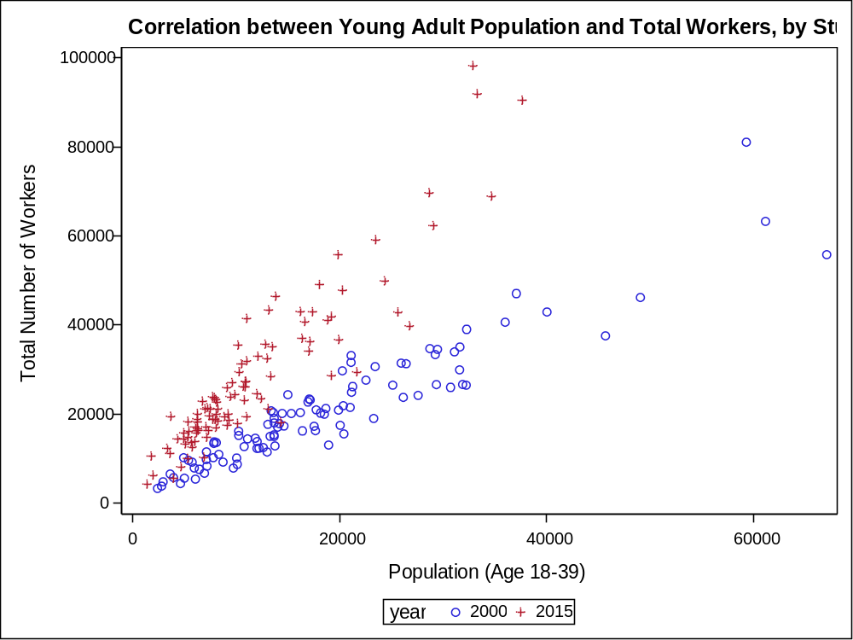

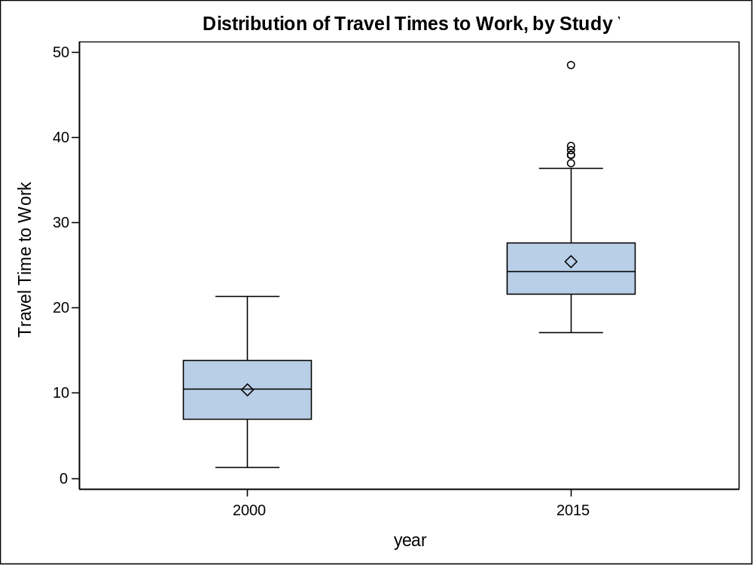

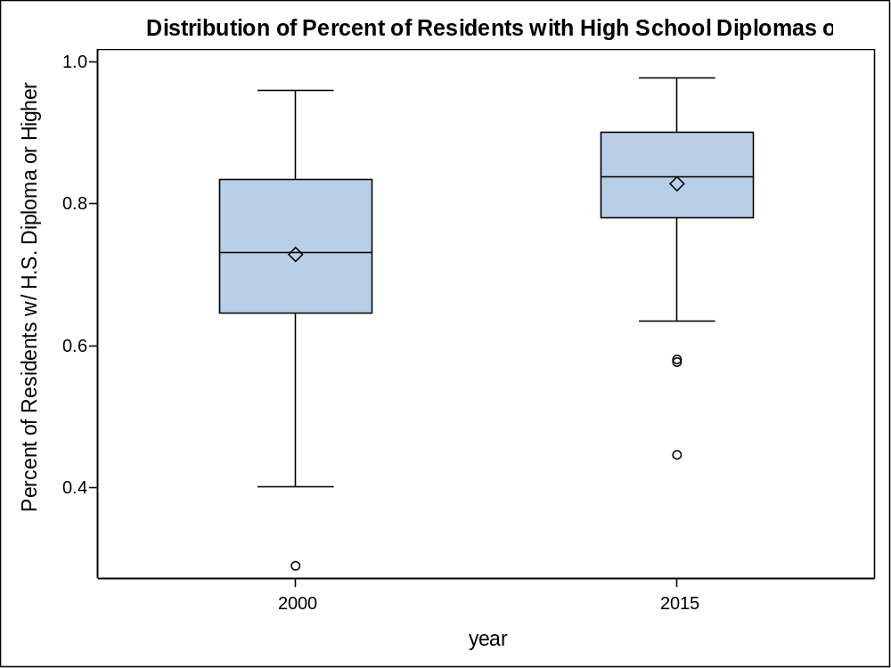

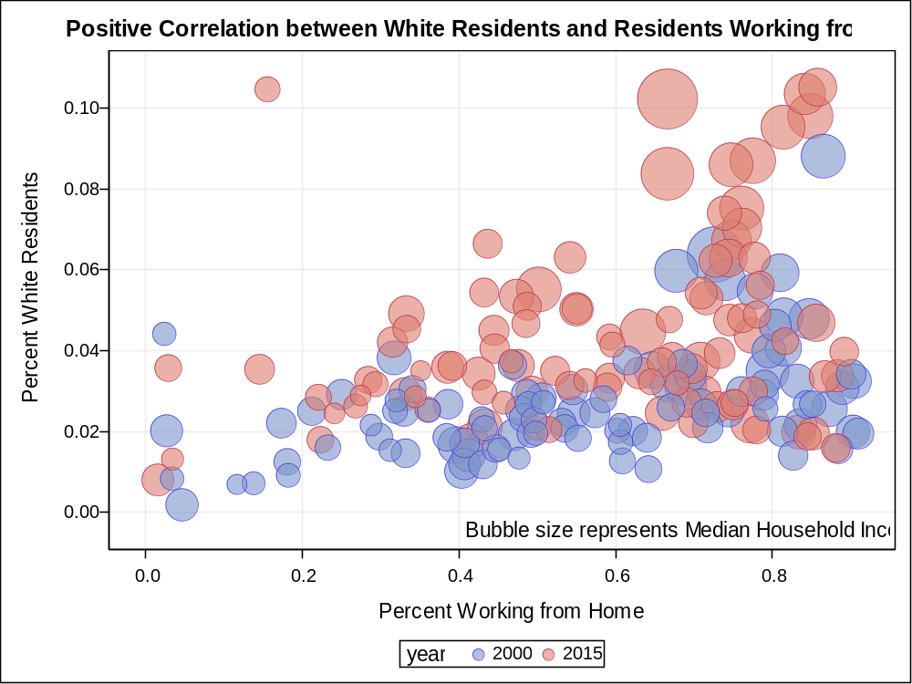

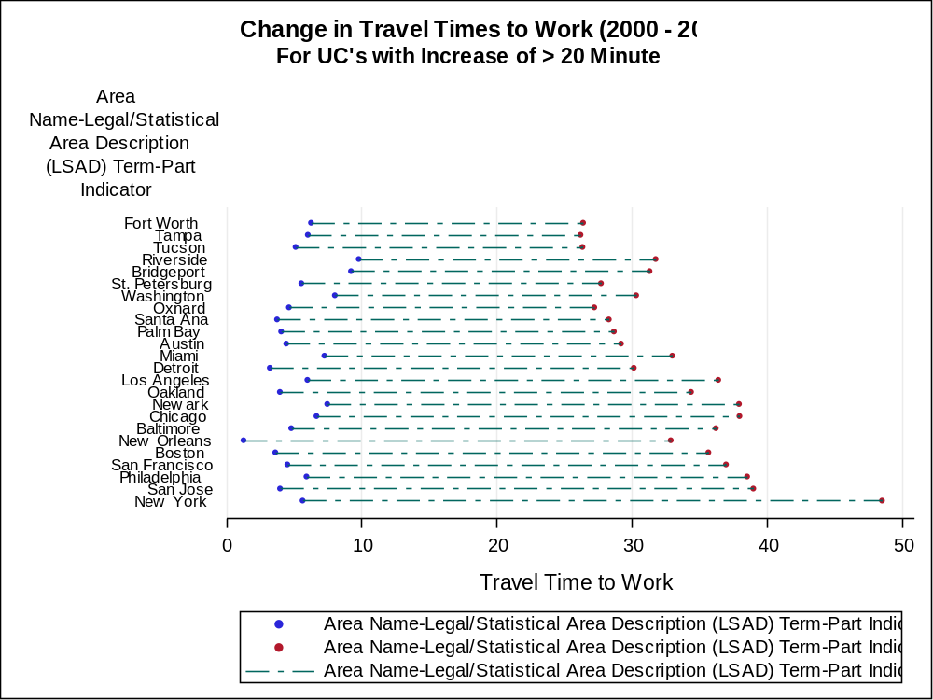

The correlation procedure yields some interesting findings. First, there appear to be several variables that are highly correlated and have small p-values. These correlations will likely be useful when constructing regression models for prediction. For example, travel time is highly and positively correlated with year, meaning that the year 2015 is associated with larger travel times compared to 2000. Likewise, income is associated with the percent of residents working from home, which seems to make sense given that working from home is a privilege that many lower income workers in the service industry do not often have. Percent of black residents in these urban cores is associated with a smaller percentage of college degrees, lower income, and a lower percentage of residents working from home.

7 Variables: | pct_black year_ind median_hhincome travel_time_to_work pct_bachdegree_orhigher pct_commute_pubtrans pct_commute_home

Simple Statistics
Variable | N | Mean | Std Dev | Sum | Minimum | Maximum
pct_black | 200 | 0.27589 | 0.25384 | 55.17864 | 0.00389 | 0.95953
year_ind | 200 | 0.50000 | 0.50125 | 100.00000 | 0 | 1.00000
median_hhincome | 200 | 46774 | 20593 | 9354707 | 19801 | 167838
travel_time_to_work | 200 | 17.90870 | 9.05328 | 3582 | 1.27072 | 48.49361
pct_bachdegree_orhigher | 200 | 0.26586 | 0.16224 | 53.17102 | 0.03988 | 0.72415
pct_commute_pubtrans | 200 | 0.08498 | 0.09708 | 16.99621 | 0.0004233 | 0.58641
pct_commute_home | 200 | 0.03472 | 0.01993 | 6.94468 | 0.00187 | 0.10520

Pearson Correlation Coefficients, N = 200
Prob > |r| under H0: Rho=0
 | pct_black | year_ind | median_hhincome | travel_time_to_work
pct_black | 1.00000 | -0.02858  0.6879 | -0.41998  <.0001 | -0.06453  0.3640
year_ind | -0.02858  0.6879 | 1.00000 | 0.10823  0.1271 | 0.83255  <.0001
median_hhincome | -0.41998  <.0001 | 0.10823  0.1271 | 1.00000 | 0.16733  0.0179
travel_time_to_work | -0.06453  0.3640 | 0.83255  <.0001 | 0.16733  0.0179 | 1.00000
pct_bachdegree_orhigher | -0.25312  0.0003 | 0.23920  0.0006 | 0.64908  <.0001 | 0.19575  0.0055
pct_commute_pubtrans | 0.25461  0.0003 | -0.04415  0.5348 | -0.05811  0.4137 | 0.09779  0.1683
pct_commute_home | -0.27532  <.0001 | 0.42050  <.0001 | 0.62095  <.0001 | 0.39444  <.0001

Pearson Correlation Coefficients, N = 200
Prob > |r| under H0: Rho=0
 | pct_bachdegree_orhigher | pct_commute_pubtrans | pct_commute_home
pct_black | -0.25312  0.0003 | 0.25461  0.0003 | -0.27532  <.0001
year_ind | 0.23920  0.0006 | -0.04415  0.5348 | 0.42050  <.0001
median_hhincome | 0.64908  <.0001 | -0.05811  0.4137 | 0.62095  <.0001
travel_time_to_work | 0.19575  0.0055 | 0.09779  0.1683 | 0.39444  <.0001
pct_bachdegree_orhigher | 1.00000 | 0.03339  0.6388 | 0.70874  <.0001
pct_commute_pubtrans | 0.03339  0.6388 | 1.00000 | -0.05769  0.4171
pct_commute_home | 0.70874  <.0001 | -0.05769  0.4171 | 1.00000

Numerous paired t-tests could have been run with this dataset, but only a few were ultimately selected for inclusion in this report. Paired t-tests are necessary in this analysis to control for all of the various factors influencing the economy that vary from city to city. Thus, changes should only be compared within each city, not across multiple cities.

The first t-test is for the percentage of black residents in these urban cores from 2000-2015. The story of gentrification often involves black families and communities being forced out of neighborhoods they have historically occupied. The t-test yields a t-statistic of 1.95 and a p-value of 0.0539. This is just shy of the 1.96 and 0.05 threshold to reject the null hypothesis with 95% confidence. However, this does not suggest that other indicators of gentrification will also fail to reject the null.

N | Mean | Std Dev | Std Err | Minimum | Maximum
100 | 0.0145 | 0.0742 | 0.00742 | -0.2340 | 0.2819

Mean | 95% CL Mean |  | Std Dev | 95% CL Std Dev
0.0145 | -0.00025 | 0.0292 | 0.0742 | 0.0651 | 0.0862

DF | t Value | Pr > |t|
99 | 1.95 | 0.0539

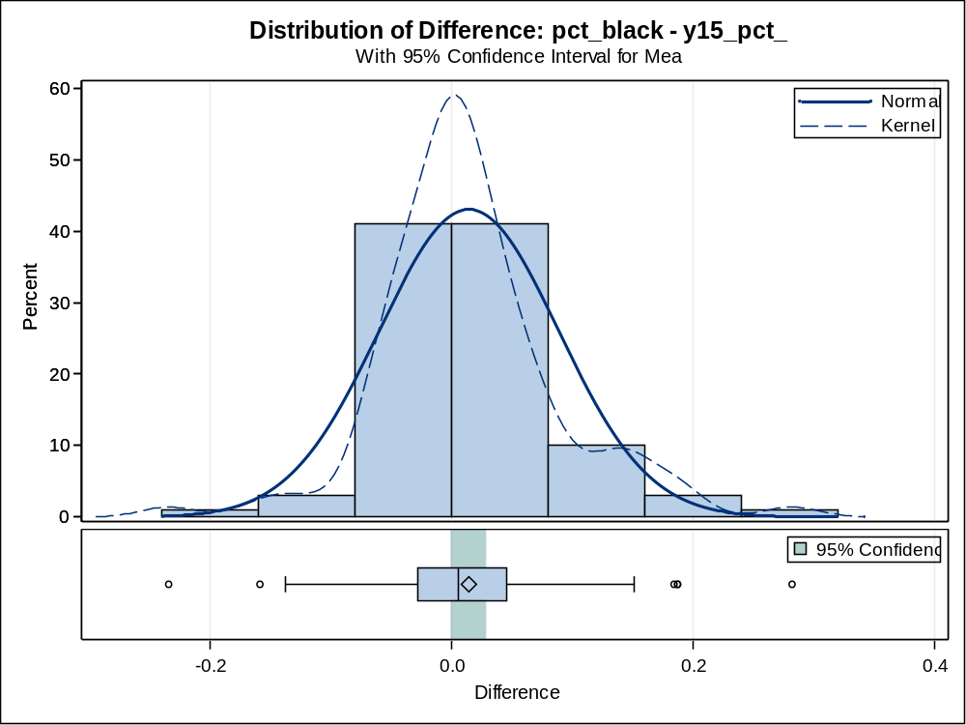

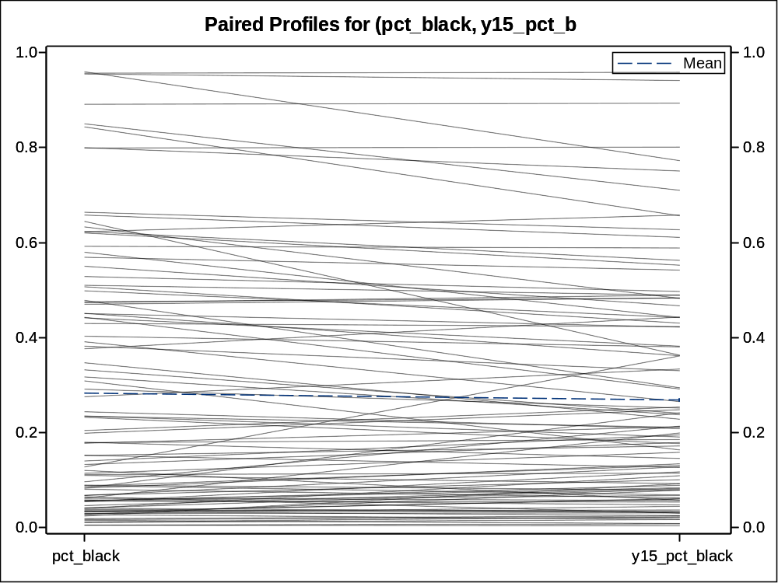

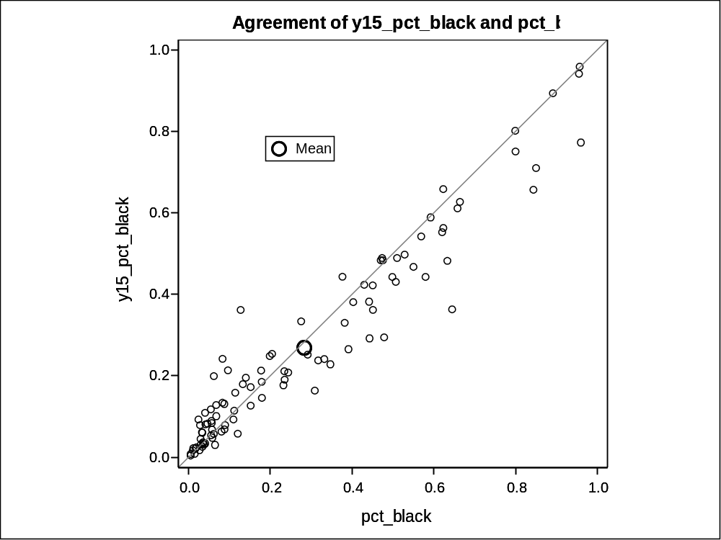

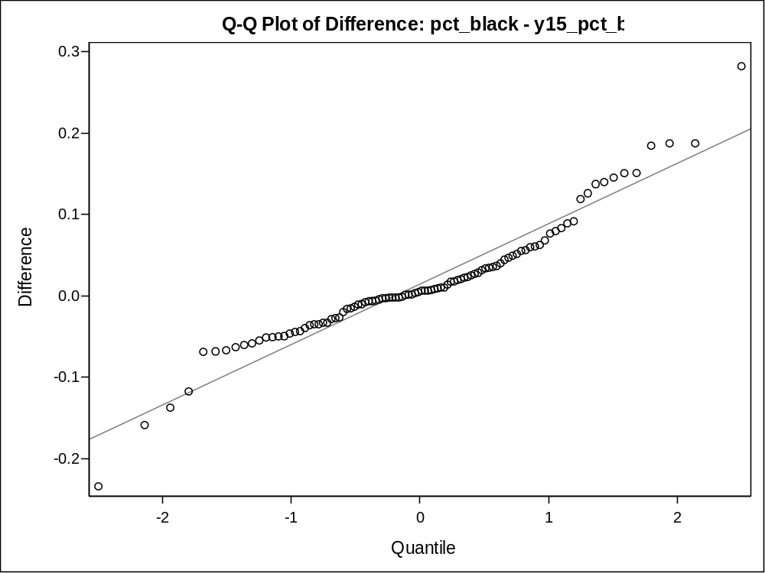

Difference: median_hhincome - y15_median_hhincome
The t-test for median income yields a p-value of less than 0.0001, well below the threshold that allows for the rejection of the null hypothesis. Thus, there is sufficient evidence to conclude that the median income in 2015 is significantly greater than that in 2000. Alone, this would likely not be a bad indicator for a city, if this increase in income applied to the residents who have been living in these cores all along. However, deeper analysis would be able to grant a fuller picture on who exactly is represented in the higher incomes and who is receiving this benefit.

N | Mean | Std Dev | Std Err | Minimum | Maximum
100 | -4446.5 | 9636.0 | 963.6 | -49564.6 | 14315.9

Mean | 95% CL Mean |  | Std Dev | 95% CL Std Dev
-4446.5 | -6358.5 | -2534.5 | 9636.0 | 8460.5 | 11193.9

DF | t Value | Pr > |t|
99 | -4.61 | <.0001

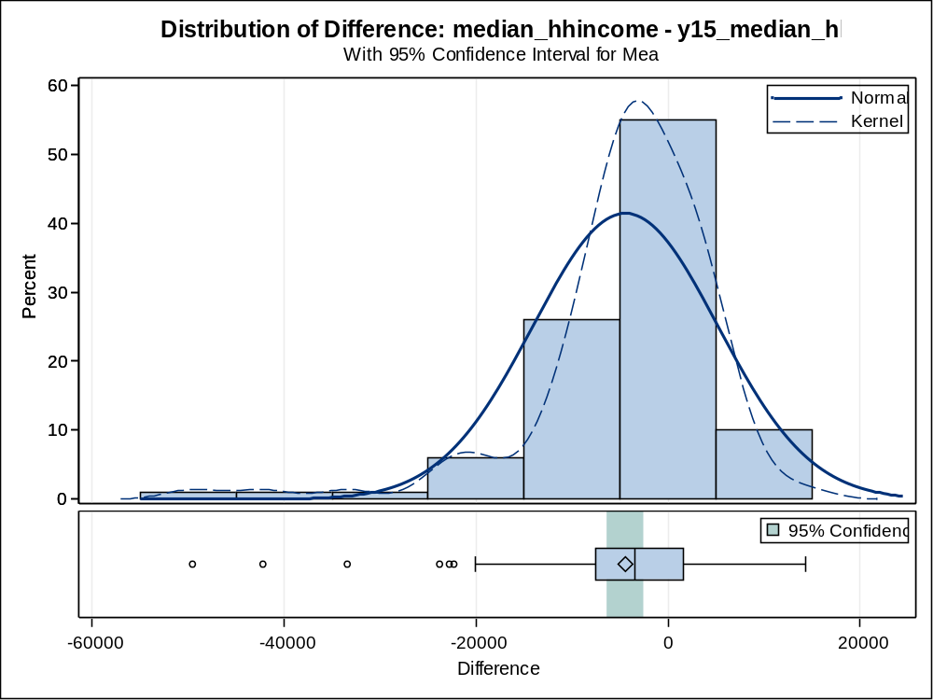

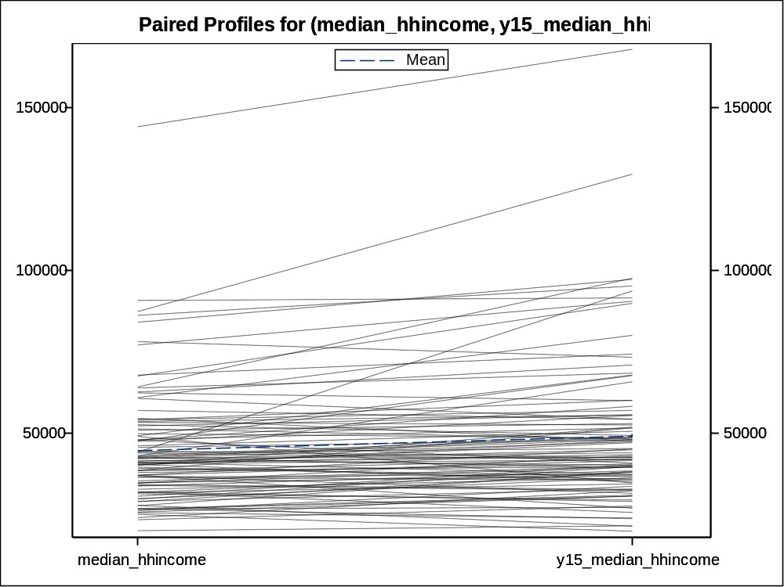

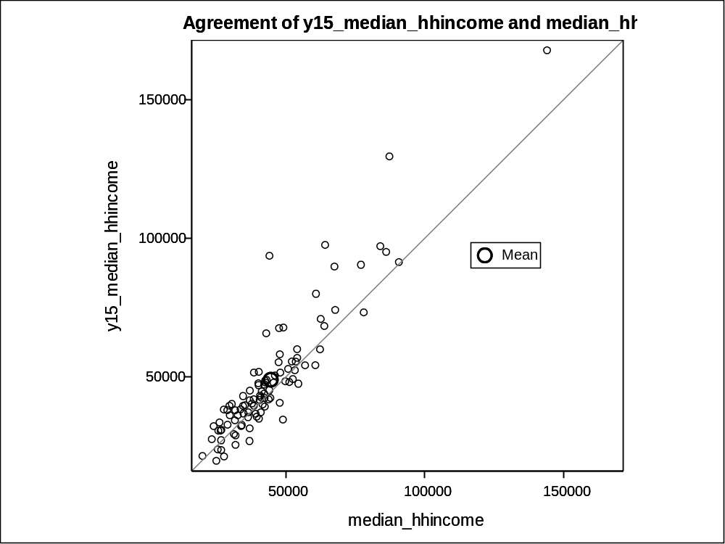

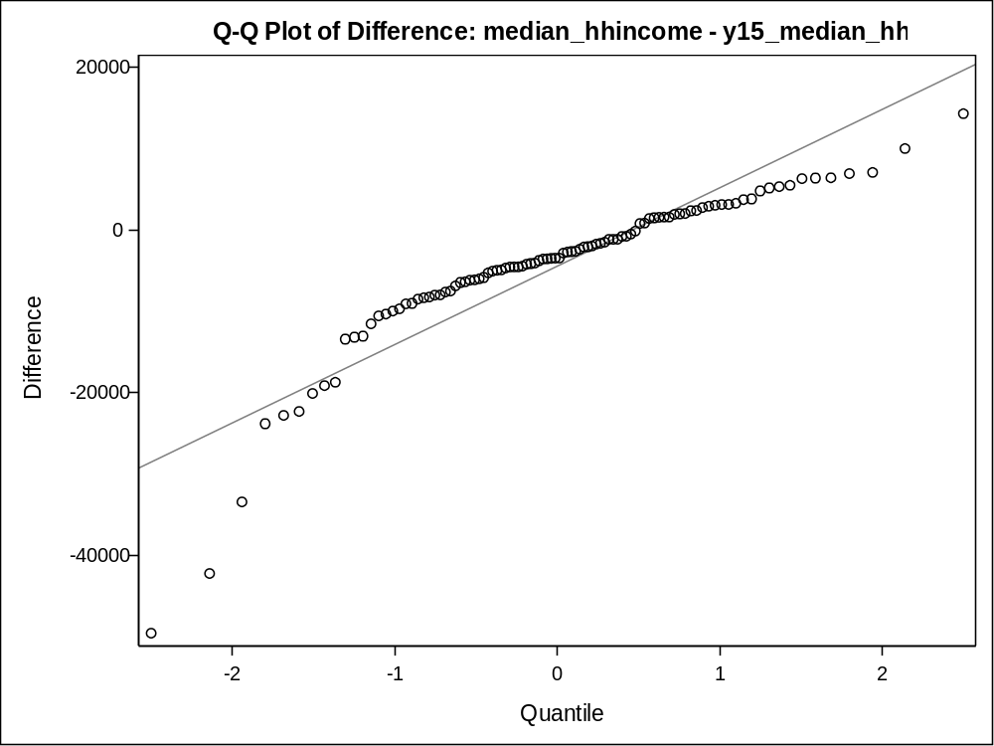

Difference: travel_time_to_work - y15_travel_time_to_work

N | Mean | Std Dev | Std Err | Minimum | Maximum
100 | -15.0368 | 8.9219 | 0.8922 | -42.8528 | 2.8158

Mean | 95% CL Mean |  | Std Dev | 95% CL Std Dev
-15.0368 | -16.8071 | -13.2665 | 8.9219 | 7.8335 | 10.3644

DF | t Value | Pr > |t|
99 | -16.85 | <.0001

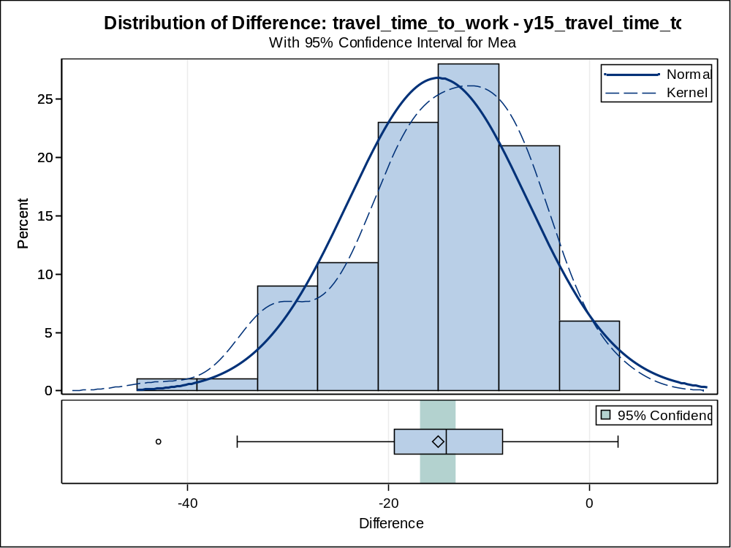

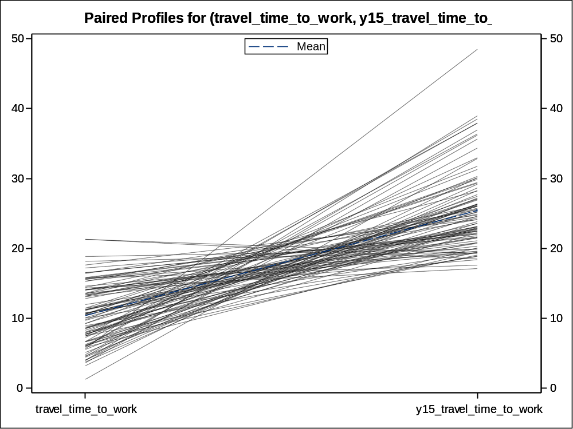

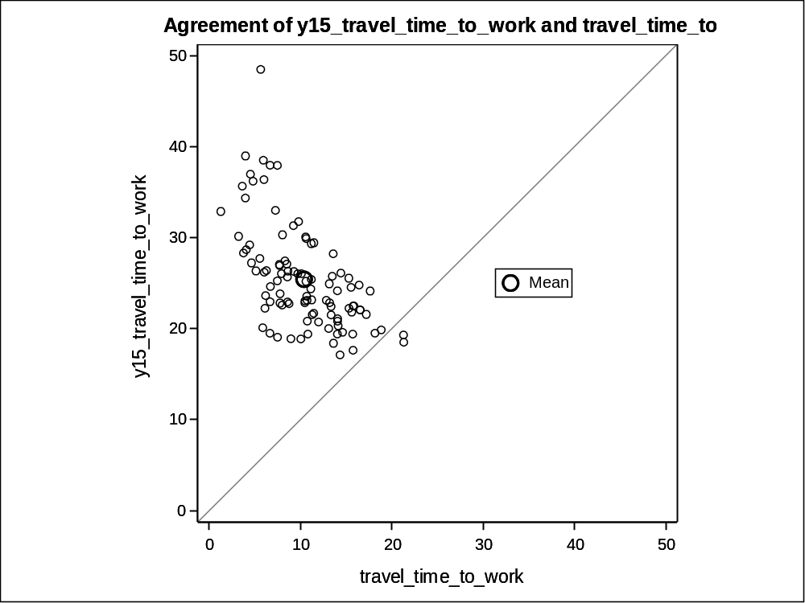

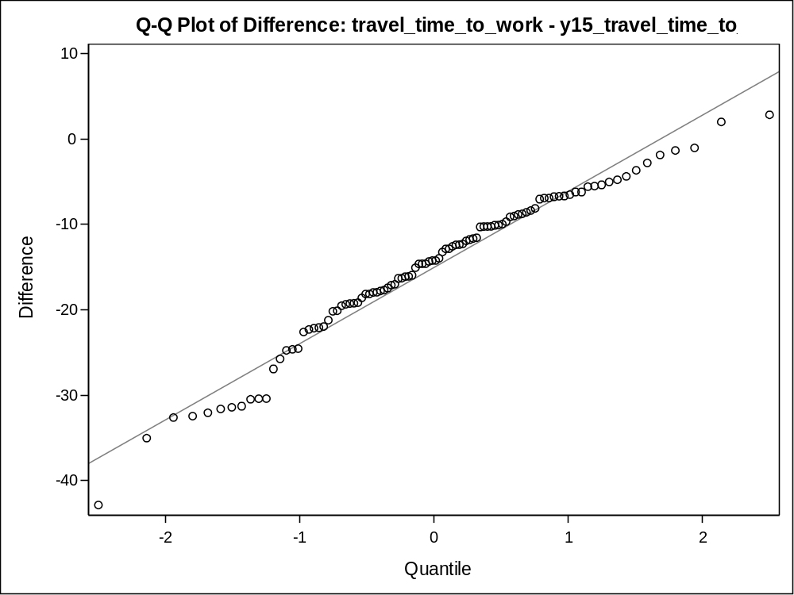

Difference: pct_diploma_orhigher - y15_pct_diploma_orhigher

N | Mean | Std Dev | Std Err | Minimum | Maximum
100 | -0.0995 | 0.0613 | 0.00613 | -0.2822 | 0.0418

Mean | 95% CL Mean |  | Std Dev | 95% CL Std Dev
-0.0995 | -0.1116 | -0.0873 | 0.0613 | 0.0538 | 0.0712

DF | t Value | Pr > |t|
99 | -16.23 | <.0001

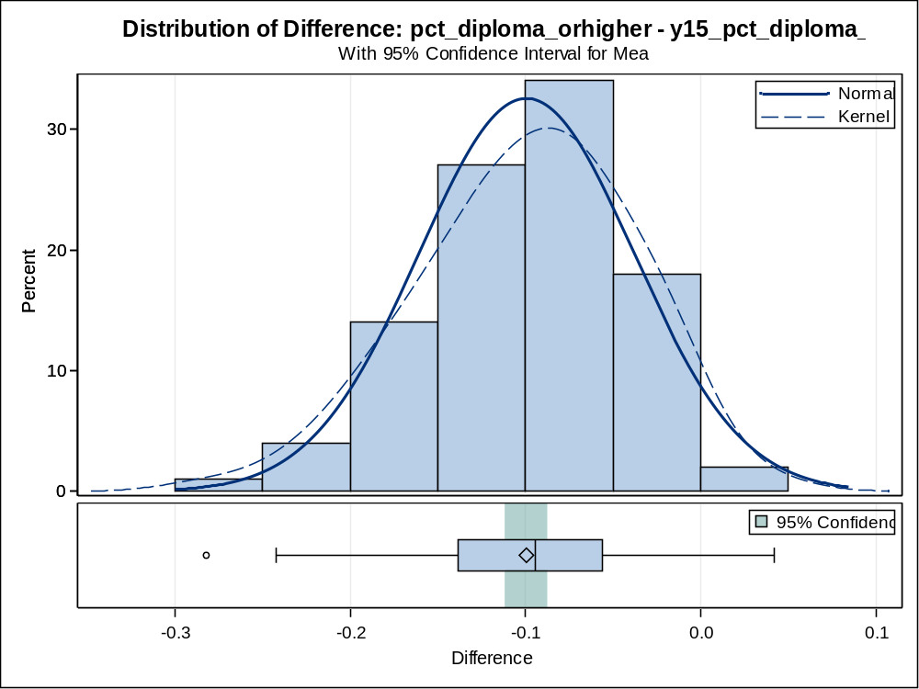

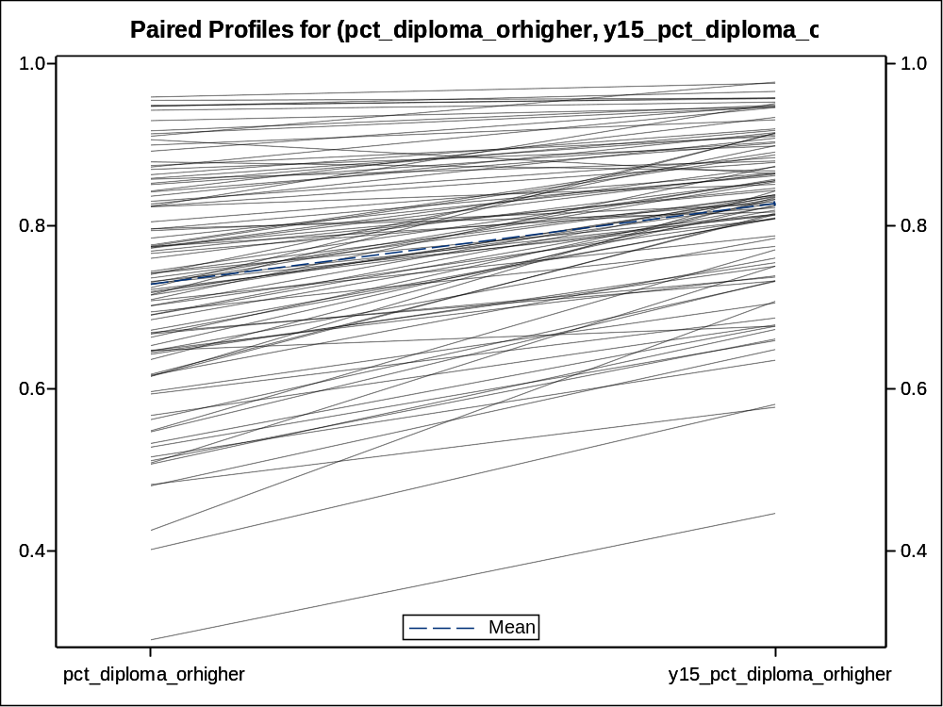

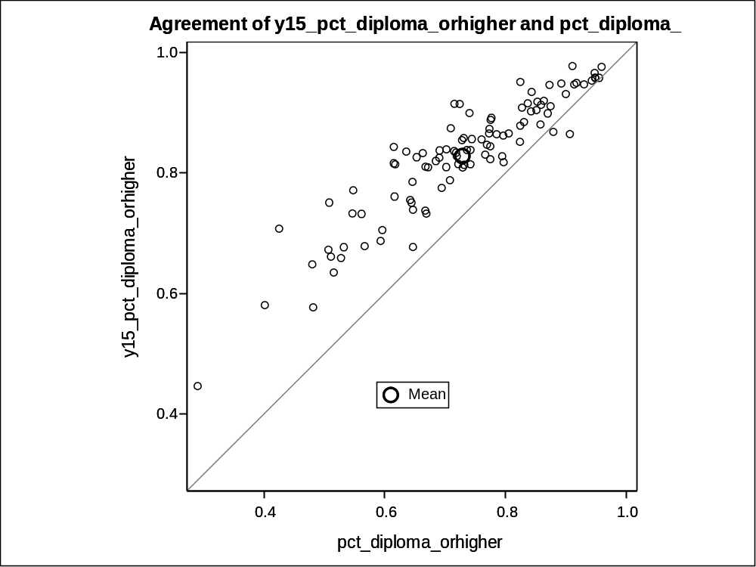

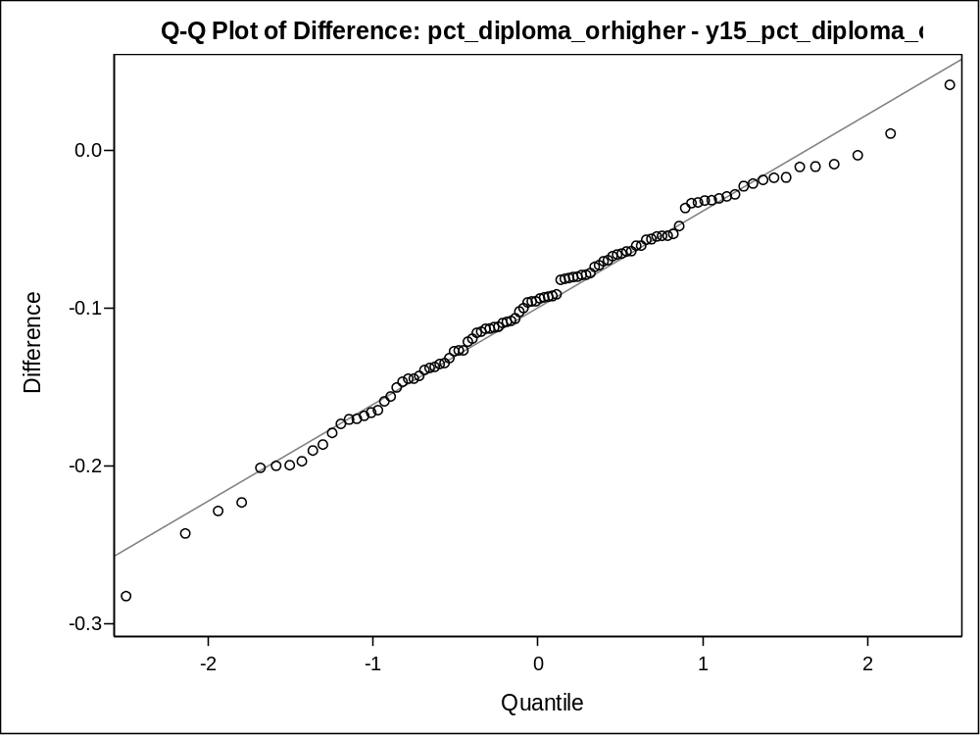

Difference: pct_commute_home - y15_pct_commute_home

N | Mean | Std Dev | Std Err | Minimum | Maximum
100 | -0.0167 | 0.0151 | 0.00151 | -0.0630 | 0.0129

Mean | 95% CL Mean |  | Std Dev | 95% CL Std Dev
-0.0167 | -0.0197 | -0.0137 | 0.0151 | 0.0133 | 0.0176

DF | t Value | Pr > |t|
99 | -11.06 | <.0001

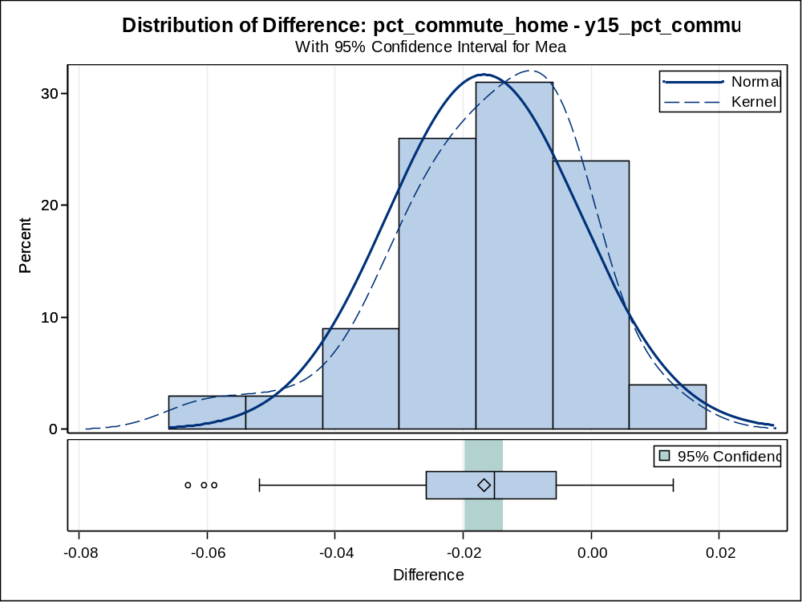

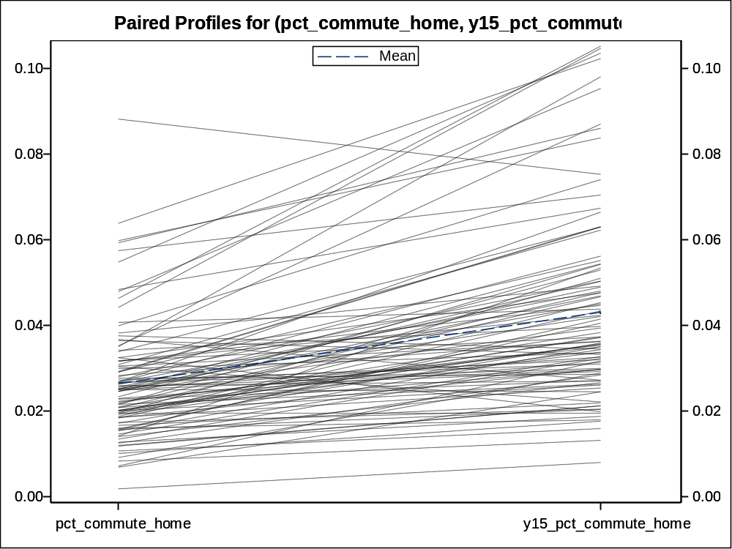

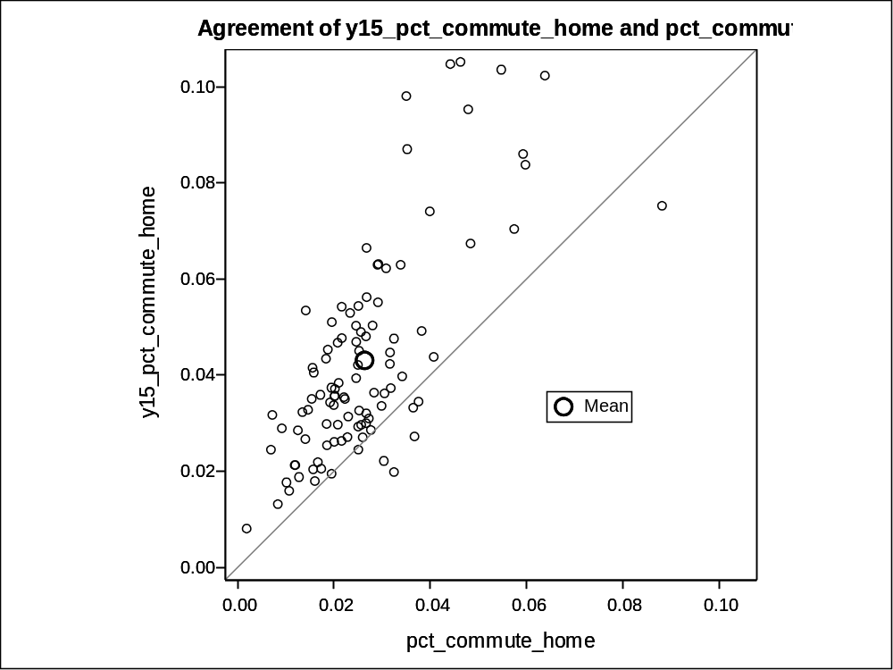

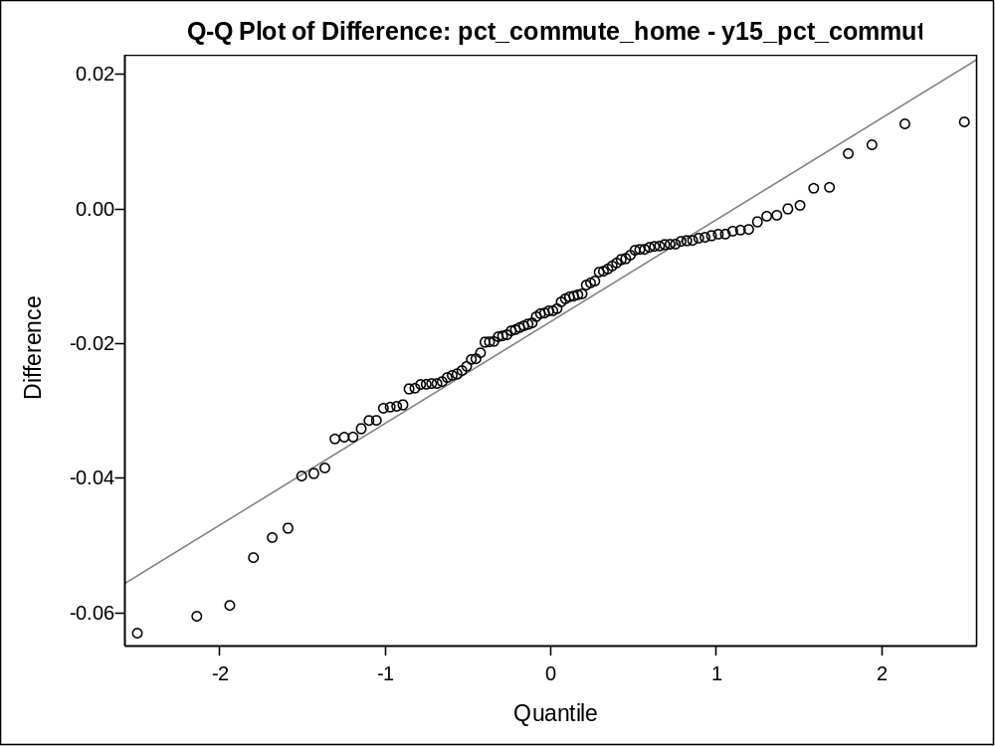

A few regressions were also conducted to determine the individual contributions of different independent variables to dependent variables of interest. The first dependent variable considered is the log of the percent of residents commuting by car. The regression output yields an R-squared of 0.61, indicating that 61% of the variation in this dependent variable is explained or captured by the variation within the independent variables of this model. Of the seven independent variables included in the model, five are significant (with a p-value of 0.05 or less). These include: year, population age 18 to 39, percent of white residents, percent with college degrees, and log of unemployment rate. The coefficient for percent of white residents is positive, meaning white residents are associated with a higher percentage of commuters by car. The coefficient for population age 18 to 39 is negative, which indicates a negative correlation. This might seem to make sense, given that younger individuals are usually less financially established and may own cars at a lower rate than older generations. Thus, younger generations may defer to other types of transportation at a greater rate, such as public transit, walking, or biking.

Number of Observations Read | 200
Number of Observations Used | 200

Analysis of Variance
Source | DF | Sum of  Squares | Mean  Square | F Value | Pr > F
Model | 7 | 5.25486 | 0.75069 | 43.13 | <.0001
Error | 192 | 3.34192 | 0.01741
Corrected Total | 199 | 8.59678

Root MSE | 0.13193 | R-Square | 0.6113
Dependent Mean | -0.23369 | Adj R-Sq | 0.5971
Coeff Var | -56.45495

Parameter Estimates
Variable | DF | Parameter  Estimate | Standard  Error | t Value | Pr > |t|
Intercept | 1 | 7.47810 | 2.95780 | 2.53 | 0.0123
year | 1 | -0.00409 | 0.00152 | -2.68 | 0.0079
pct_owner | 1 | 0.14302 | 0.12019 | 1.19 | 0.2355
pop_18to39 | 1 | -0.00001061 | 0.00000120 | -8.81 | <.0001
pct_white | 1 | 0.11907 | 0.05804 | 2.05 | 0.0416
pct_bachdegree_orhigher | 1 | -0.61126 | 0.10887 | -5.61 | <.0001
log_income | 1 | 0.04314 | 0.05607 | 0.77 | 0.4426
log_unemployment | 1 | -0.09070 | 0.04185 | -2.17 | 0.0315

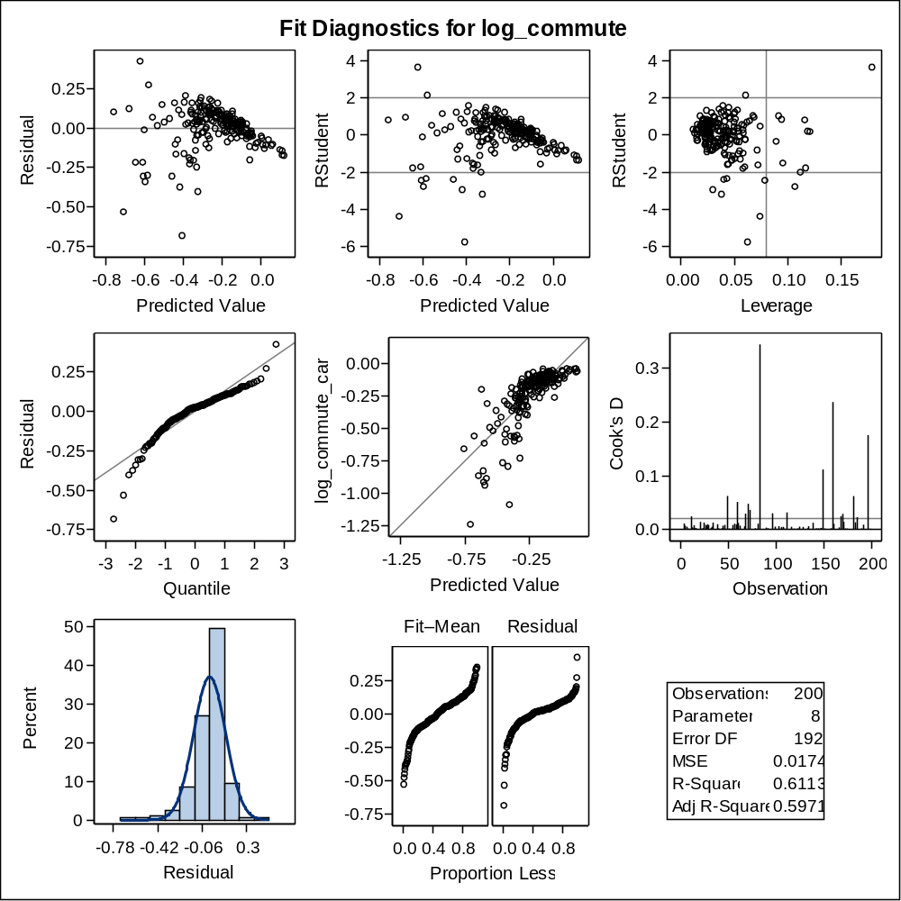

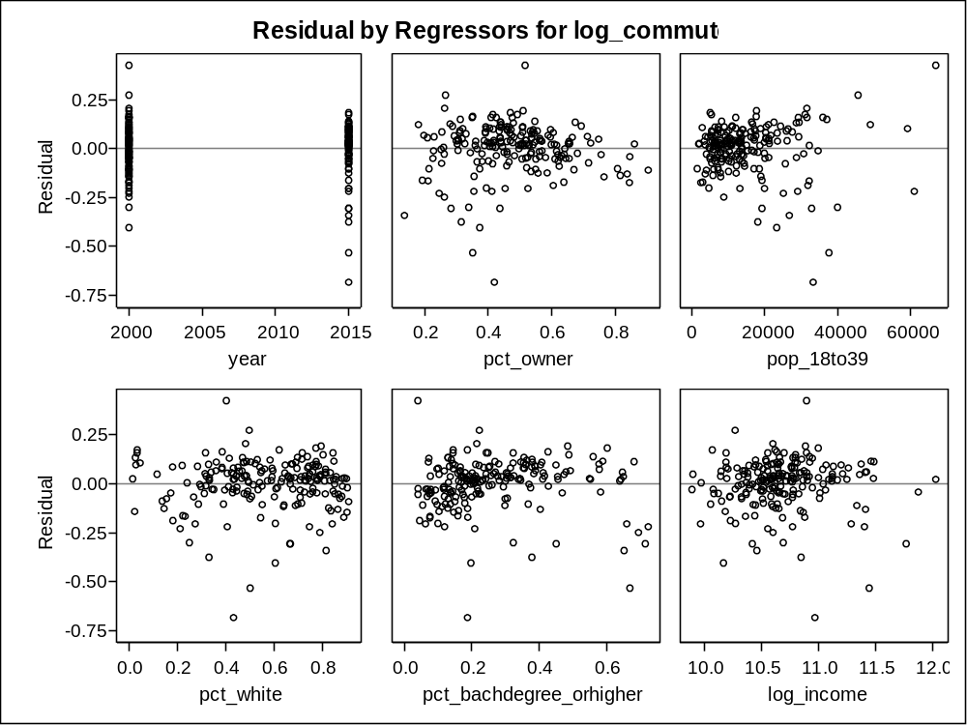

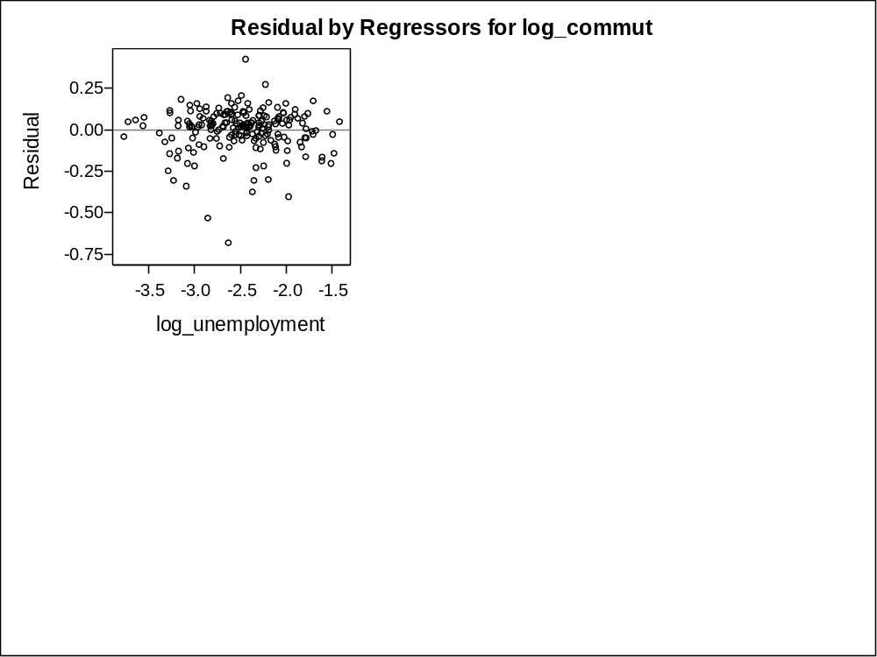

The second regression aims to understand which variables might explain variation in commute times. Of the seven variables provided, only three are significant this time: year, log of income, and log of unemployment rate. All three of these variables are positively associated with commute time. For year, a positive association makes sense and was witnessed earlier in plotting when so many cities saw increases in commute time of more than 20 minutes on average. It is also possible to create explanatory reasons for which the relationships for the other variables might hold true as well.

Number of Observations Read | 200
Number of Observations Used | 200

Analysis of Variance
Source | DF | Sum of  Squares | Mean  Square | F Value | Pr > F
Model | 7 | 11647 | 1663.91781 | 68.51 | <.0001
Error | 192 | 4662.97779 | 24.28634
Corrected Total | 199 | 16310

Root MSE | 4.92812 | R-Square | 0.7141
Dependent Mean | 17.90870 | Adj R-Sq | 0.7037
Coeff Var | 27.51801

Parameter Estimates
Variable | DF | Parameter  Estimate | Standard  Error | t Value | Pr > |t|
Intercept | 1 | -1984.55120 | 110.48484 | -17.96 | <.0001
year | 1 | 0.96905 | 0.05691 | 17.03 | <.0001
pct_owner | 1 | -4.24598 | 4.48973 | -0.95 | 0.3455
pop_18to39 | 1 | -0.00000203 | 0.00004495 | -0.05 | 0.9640
pct_white | 1 | 3.42401 | 2.16806 | 1.58 | 0.1159
pct_bachdegree_orhigher | 1 | -4.54819 | 4.06652 | -1.12 | 0.2648
log_income | 1 | 6.33129 | 2.09424 | 3.02 | 0.0028
log_unemployment | 1 | 3.70526 | 1.56338 | 2.37 | 0.0188

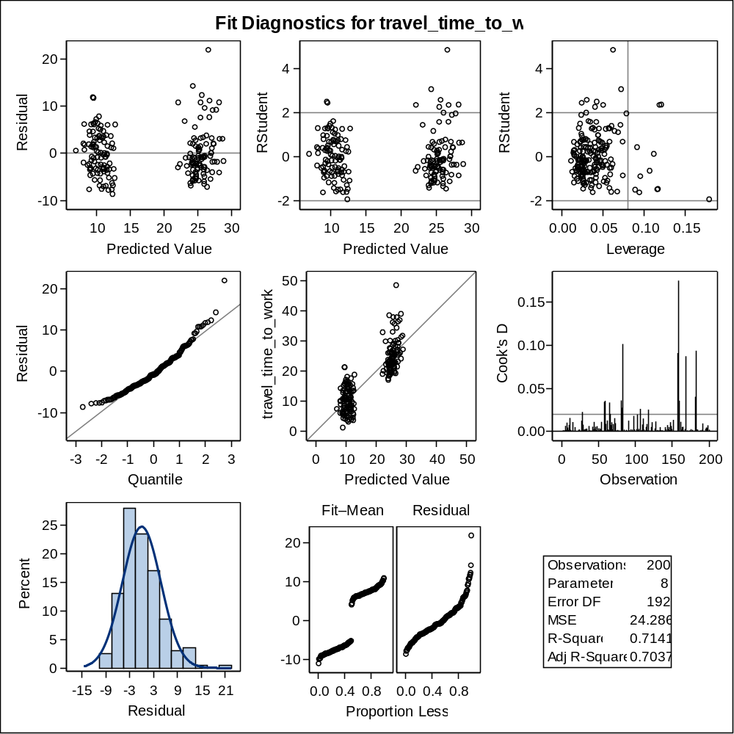

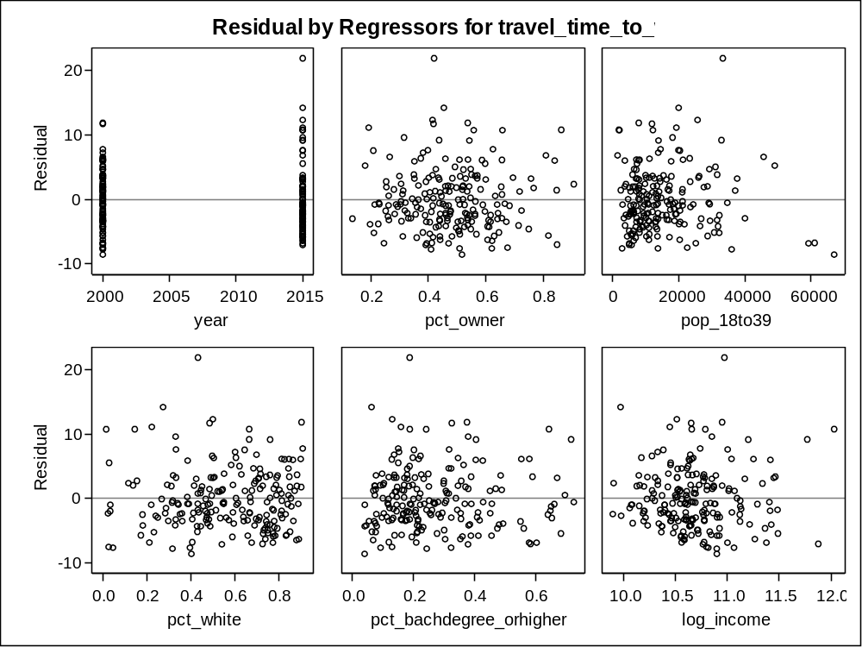

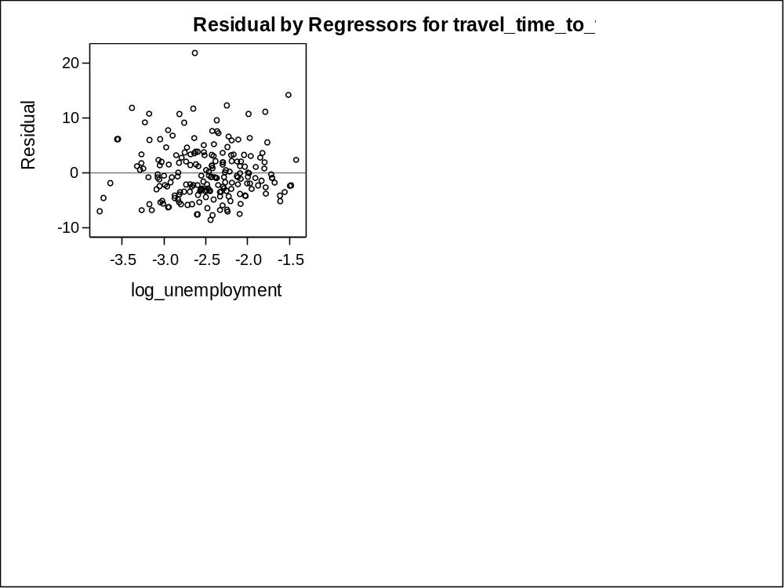

Summary
In this analysis, I used SAS procedures to first organize datasets by merging and joining two data sets in two different ways, and to create and modify variables in preparation for further analysis. I then used SAS procedures like PROC MEANS, PROC FREQ, and PROC UNIVARIATE to generate summary statistics that provide a birds eye view of the dataset and to identify important features or preliminary trends that can be explored in greater detail. I then plotted relationships and correlations between variables and boxplots distributions of variables to better visualize this data and to compare, for example, between 2000 and 2015. This process allowed for me to identify key relationships that I would later include in regression models. Lastly, I used SAS to conduct paired t-tests to hypothesis test which variables experienced statistically significant changes from 2000 to 2015 and to build predictive regression models that identify the individual contributions of independent variables on these changes. Although not all of my analyses were chosen to be included in this final report, the findings overall do suggest that there have been significant changes to transportation in these 100 urban cores from 2000 to 2015 and that there are several indicators that gentrification is indeed occurring.

