Performance Benchmark Report: Dell Precision 7960 vs. NVIDIA DGX Spark
1. Executive Summary
This report evaluates the performance differences between the Dell Precision 7960 (Lab Machine) and the NVIDIA DGX Spark when running Large Language Model (LLM) workloads.
The primary objective was to compare serial execution on a high-bandwidth workstation against parallel execution on a unified-memory AI supercomputer. While the DGX Spark successfully demonstrated its capacity to load four models simultaneously (~90GB load), this parallel stress test revealed significant bandwidth bottlenecks.
Specifically, the Lab Machine (Dell) benefited from dedicated access to 576 GB/s of memory bandwidth per model. In contrast, the DGX Spark shares its 273 GB/s system bandwidth across all active processes. With four models running concurrently, the effective bandwidth available to each model dropped to approximately 68 GB/s, resulting in a substantial reduction in throughput compared to the Lab Machine.
as a multi-model development environment.
2. Hardware Specifications
The two systems represent fundamentally different architectures: a high-performance workstation with discrete VRAM versus a compact AI supercomputer with unified memory.
Feature | Dell Precision 7960 Tower (Lab Machine) | NVIDIA DGX Spark
Processor | Intel Xeon w7-3565X | NVIDIA Grace CPU (ARM64)
GPU | NVIDIA RTX 5000 Ada Generation | NVIDIA Blackwell B100 Tensor Core GPU
Total Memory | 32 GB GDDR6 (Discrete VRAM) | 128 GB LPDDR5X (Unified Memory)
Total System Bandwidth | 576 GB/s | 273 GB/s
Execution Mode | Serial (1 Model at a time) | Parallel (4 Models at a time)
Effective Bandwidth (Per Model) | 576 GB/s | ~68.25 GB/s (273 GB/s ÷ 4)
Critical Insight: Because the DGX Spark was running a simulation with 4 concurrent models, its total memory bandwidth was effectively split four ways. This gave the Dell Lab Machine an approximate 8.4x advantage in available memory speed per model, directly correlating to the higher throughput observed on the Dell.
3. Methodology & Dataset
3.1 Execution Strategy
- Lab Machine (Dell): Models were executed sequentially. This ensured that 100% of the GPU's compute and 576 GB/s bandwidth were dedicated to a single model during its run.
- DGX Spark (NVIDIA): Models were executed concurrently to stress-test the unified memory architecture. The system successfully loaded all models, consuming ~90GB of the 128GB available.
3.2 Models Tested
The following four models were deployed for the parallel simulation on the DGX Spark:
- gemma-7b
- microsoft-phi-4-instruct
- Mistral-7B-Instruct-v0.3
- Qwen2.5-7B-Instruct (Note: Excluded from results)
Note on Qwen2.5-7B-Instruct: While this model was part of the simultaneous run, it did not complete the 512-chunk size iteration in time for this report. Consequently, its performance data has been excluded from the results

3.3 Workload Details
Volume: 900 chunks processed per chunk size iteration.
Input Data Example (128 Chunk Size)
JSON
{
"chunk": "which most conventional texts incorporate video is cumbersome...",
"qa_pairs": [
{
"question": "Why is it cumbersome to incorporate video...?",
"answer": "The videos are contained in a separate library..."
},
{
"question": "What is the issue with the video library in the context...?",
"answer": "The issue is that the videos are stored in a separate..."
}
]
}

4. Performance Analysis
4.1 Throughput & Bandwidth Impact
The throughput gap illustrates the impact of bandwidth starvation. The Dell machine, capable of feeding data to the GPU at 576 GB/s, processed chunks significantly faster than the DGX Spark, which was limited to ~68 GB/s per model.
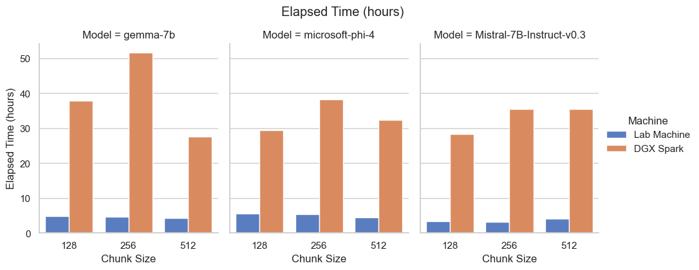
Figure 1: Comparison of total elapsed time for each machine.
Machine | Model | Total Compute Time (Hours)
Lab Machine | Mistral-7B-Instruct-v0.3 | 53.2
Lab Machine | gemma-7b | 68.7
Lab Machine | microsoft-phi-4-instruct | 77.5
DGX Spark | Mistral-7B-Instruct-v0.3 | 375.7
DGX Spark | microsoft-phi-4-instruct | 428.5
DGX Spark | gemma-7b | 505.9

4.2 Success Rate & Stability
Metric: Percentage of successful generations vs. failures.
The Lab Machine maintained a high and success rate was slightly higher than the DGX Spark. likely due to timeouts or memory bandwidth bottlenecks during parallel execution.
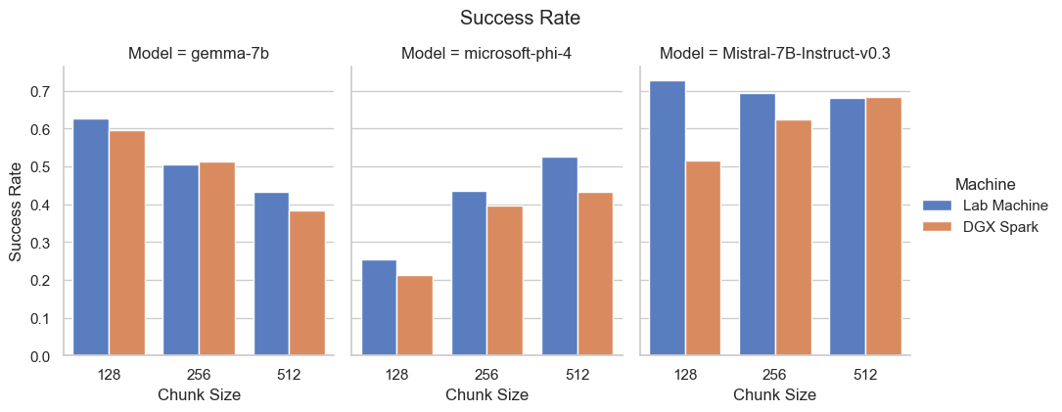
Figure 2: Success rate percentage by model and machine. Note the stability of the Lab Machine vs. the variance in the DGX Spark.
Machine | Model | Avg Success Rate
Lab Machine | Mistral-7B-Instruct-v0.3 | 70.10%
Lab Machine | gemma-7b | 52.10%
Lab Machine | microsoft-phi-4-instruct | 40.50%
DGX Spark | Mistral-7B-Instruct-v0.3 | 63.20%
DGX Spark | gemma-7b | 50.46%
DGX Spark | microsoft-phi-4-instruct | 33.59%

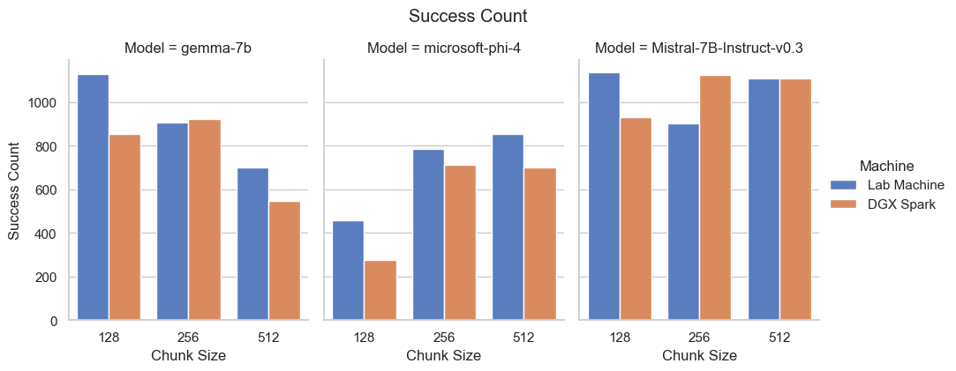
Figure 3: Total count of successfully processed chunks.
4.3 Error Analysis
Metric: Failures and QA Mismatches.
Under heavy parallel load, the DGX Spark recorded a higher number of failures compared to the serial execution on the Dell. Additionally, we tracked "QA Misses" (where the generated output structure did not match the expected format).
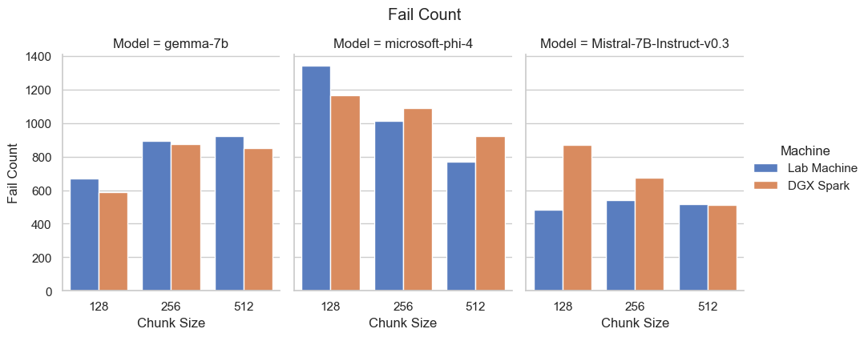
Figure 4: Total number of failed chunk generations.
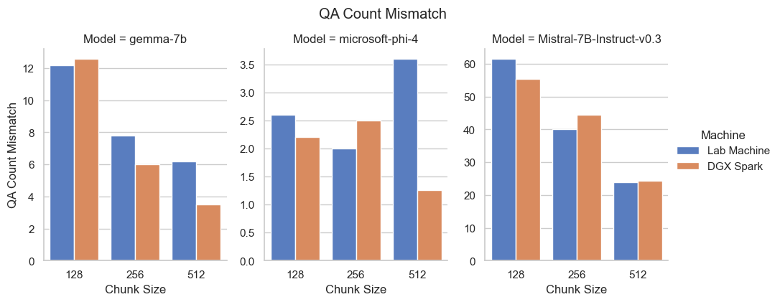
Figure 5: QA Mismatch count. High values here indicate the model lost coherence or formatting during generation.

5. Conclusion
- Bandwidth is the Bottleneck: The primary factor limiting the DGX Spark in this specific test was the division of memory bandwidth. Running four models simultaneously split the 273 GB/s pipe into roughly 68 GB/s per model, whereas the Dell Precision 7960 provided a dedicated 576 GB/s to each model.
- Use Case Recommendation:
  - Choose the Dell Precision 7960 for production inference pipelines where speed and throughput are critical. Serial execution maximizes the hardware's high-bandwidth potential.
  - Choose the NVIDIA DGX Spark for development and prototyping. Its ability to hold 90GB of concurrent models in memory without crashing is a unique capability that simplifies multi-model testing, provided that lower throughput per model is acceptable.

