**BACKGROUND**

Modern systems neuroscience seeks to understand how complex behavior arises from the dynamic information exchange and control process across the network of brain regions, and how these change with learning and development. Children’s arithmetic, more specifically children's small number addition (hereafter just “arithmetic” or “addition”) provides a unique opportunity to investigate these questions, as the phenomena in this domain are complex and foundational, yet still tractable. Addition involves a range of cognitive, often physical actions1, 2, yet it has well-defined structure with formally correct answers, so that the space of possible correct (or plausibly incorrect) algorithms can be clearly mapped out3. Moreover, how children carry out addition, what mistakes they make, and how they transition from pre-addition (only knowing counting sequences) through adult-type “pure retrieval”4-8, occurs in a relatively consistent cognitive- and neuro-developmental time-window4, 9.

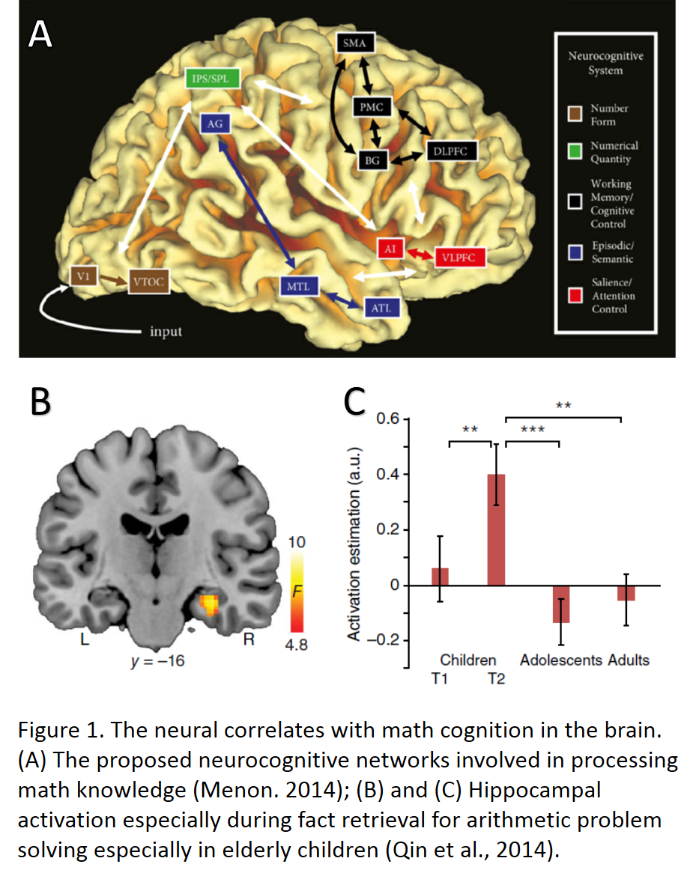As a result of its great educational importance[10-14](#_ENREF_10" \o "Clements, 2014 #1243), children's arithmetic has been well-studied by psychologists, cognitive neuroscientists, and computational modelers. Several core brain regions contribute to math competence and processing[15-19](#_ENREF_15" \o "Menon, 2014 #1311), including the ventral visual stream (e.g., posterior fusiform gyrus; pFG) for decoding number forms, parietal circuits (majorly around inferior parietal sulcus; IPS) for anchoring the visuospatial numerical representations, prefrontal-parietal cortices for manipulating quantity representations in working memory, and medial temporal lobe (MTL) and especially hippocampus for associative memory processing in children[20-22](#_ENREF_20" \o "Cho, 2012 #1312) (Figure 1). Difficulties in math processing in some children (e.g., developmental dyscalculia; DD) are associated with abnormalities such as hypo-activation in these brain regions[23](#_ENREF_23" \o "Ashkenazi, 2012 #1315), or increased functional connectivity among these regions[24](#_ENREF_24" \o "Rosenberg-Lee, 2015 #1316). Studies further suggest that that MTL, left prefrontal, and bilateral posterior parietal cortices correlate with the use of different strategies[25](#_ENREF_25" \o "Cho, 2011 #1317), and hippocampus seems crucial for the transition from overt to implicit strategies[22](#_ENREF_22" \o "Qin, 2014 #1314). Even given all this detailed knowledge regarding children's arithmetic, we still do not understand how the large-scale dynamic network of widely-distributed brain regions supports the organized execution of arithmetic reasoning, nor, especially, how their interactions and change through learning and development.

Computational studies of arithmetic development, which have been undertaken for decades4, 5, 26-28, have generally been rendered either in purely symbolic, purely connectionist, or hybrid symbolic/connectionist paradigms. These paradigms suffer from several critical drawbacks: (a) implementation of procedural memory and executive control systems were not theory-driven (not relevant theory was available at that time); (b) memory and knowledge was not represented in distributed manner (as is not believed to be the case); and (c) model structure was not informed by current understanding of the brain. For example, theorists have elicidated the role of prefrontal cortex in system control of cognitive tasks[32](#_ENREF_32" \o "Miller, 2001 #1323), and neural networks have be shown to naturally combined with system-control models for adaptive learning and optimal control[33-36](#_ENREF_33" \o "Suykens, 2012 #1327), but these advances have not made their way into computational models of arithmetic.

Modelers have recently demonstrated that systems-oriented computational neural networks can account well for neural dynamics in human and animal studies, as well as provide good mechanistic explanations for dynamic changes and developmental evolution of brain network functions 29-31.Therefore, the primary goal of the presently proposed research is to apply this methodology to develop a novel systems-control/connectionist model of the interactive dynamics and developmental evolution of arithmetic skill and number sense. By modeling the neurocognitive networks in human brain, this new model will be able to provide explanations that encompass the existing rich body of cognitive theory, data, and computational experimentation in arithmetic within a framework of modern systems neuroscience.

**GOALS AND HYPOTHESES**

**Goal 1**: **Develop a neuro-computational model accounting for both behavioral and neurobiological outcomes in arithmetic development.** I will establish a connectionist model to demonstrate the face validity and feasibility of this neuro-computational approach that bridges both behavioral and neuroimaging data in arithmetic model. ***Hypothesis 1***: The development of arithmetic problem solving in children results in behavioral neurobiological changes over development, which can be partly explained by the differences in efficiency of neural pathways in a connectionist model.

**Goal 2: Extend the connectionist model into a hybrid model to explain arithmetic development through learning.** The development of the prefrontal control systems is facilitated by the learning process of arithmetic problem solving. To explore this feature, I will combine the connectionist model above with a system-control model, thus creating a more comprehensive model that is a hybrid of strategy representation and execution aligned with our current knowledge of the cognitive functions of brain regions, how these regions are interconnected, and how the execution of complex procedures are initiated and controlled, in the context of development of arithmetic problem solving. ***Hypothesis 2A***: The revised hybrid model, wherein the activation status of different neural pathways for strategy use is monitored by prefrontal control units and changes their controlling parameters, can more accurately explain the developmental evolution of strategy application and change in arithmetic and number knowledge. ***Hypothesis 2B***: The model will exhibit and thereby serve as an account for well establish phenomena, such as that learning overt and inefficient strategies can scaffold the development of more efficient, retrieval-like strategies. I will specifically demonstrate that manipulating the training environment in the model will lead to different behavioral outcomes in arithmetic development that are similar to those observed in the data.

**Goal 3: Explore sources of individual differences in neural basis to explain typical and atypical development**. I will employ the new model above to try to explain aspects of typical and atypical (DD population) arithmetic development as individual differences in the models neural architecture and parameterization. ***Hypothesis 3***: The behavioral and neurobiological abnormality of DD can be explained by different settings of global learning parameters analogous to biological dysfunctions in human brain. To the extent that this is not possible, we will document phenomena that must be explained by by systems-level architectural changes in the model.

**EXPERIMENTAL METHODS**

**Part 1**. The development of arithmetic skills from overt strategies to retrieval strategies is accompanied by processing efficiency observed in behavioral data, and a general tendency of prefrontal-to-parietal (anterior-to-posterior) in brain activations.

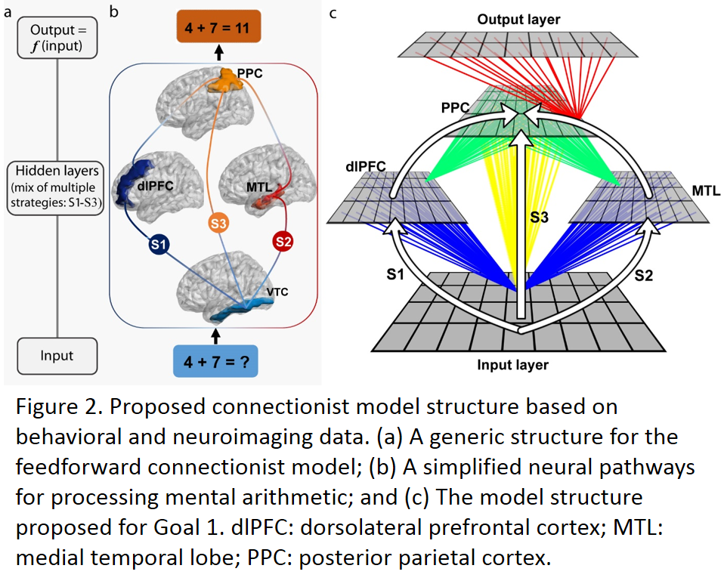***Modeling***. I will use feed-forward connectionist models (example depicted in Figure 2) to establish three distinct neurocognitive pathways hypothesized for distinct strategy uses (2b), including effortful counting strategies (S1; dlPFC), hippocampal-dependent associative memory retrieval (S2; MTL), and hippocampal-independent fact memory retrieval (S3, PPC). By manipulating the additional potentiation from controlling units, the processing efficiency of each neuro-pathway for strategy use is manipulated to test the performance and neural activities of child-like (i.e., recruiting more inefficient pathways) and adult-like models (i.e., recruiting more efficient pathways) after practice solving simple addition problems. ***Behavior and neuroimaging***. I will re-analyze *behavioral* data (e.g., accuracy, response latency, inter-problem variability, etc.) and *neuroimaging* data (e.g., functional activation, representational stability, etc.) from Qin et al. (2014) to evaluate the model in terms of developmental changes in behavioral efficiency and the brain involvement from prefrontal to parietal cortices.

**Part 2.** I will extend the NN model to include recent understanding of the involvement of other brain systems, especially sensory, motor, memory, and control processes, and including external aspects of behavior, especially regarding phonological (hearing the problem) and visual (finger counting) involvement.

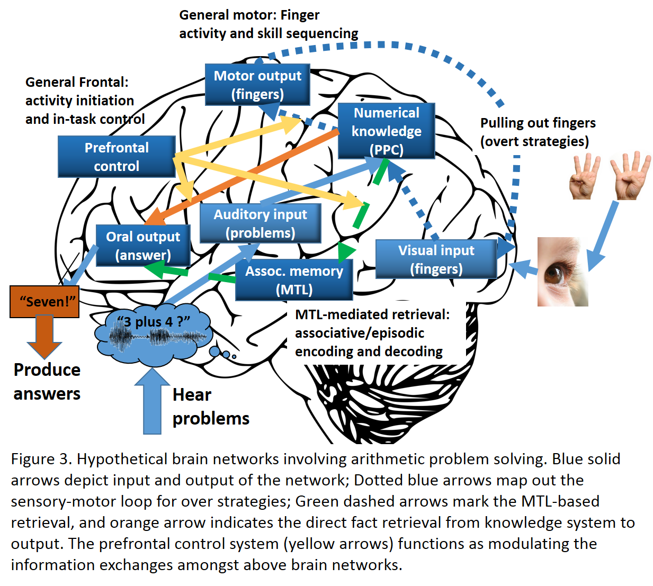***Modeling***. I will extend the previous models by adding information and control system analogous to the proposed function of prefrontal cortex32, in maintaining and controlling task-relevant information exchange in distributed brain networks, as well as other systems (Figure 3), focusing on the interaction between different neuro-pathways/systems underlying the execution of different strategies, and how the control and other brain systems support the development of each other. ***Behavior and neuroimaging***. I will conduct a large-scale *behavioral* data re-analysis from previous studies to demonstrate the developmental changes in strategy use for addition problems in children from age 5-10 years old. I will use this analysis to examine how well the model can accounts for (a) the response distribution across correct and incorrect answers for different addition problems; and (b) the U-shaped retrieval usage that retrieval strategy is heavily used early in the learning process but rapidly gives away to extended period of over strategy use, and eventually comes back again as an adult-like behavior (Hypothesis 2A). I will also conduct a *behavioral* study, using video capture to record overt strategy use, to examine, in much detail greater than any currently available, how overt strategy learning and practice evolve, eventually into retrieval (Hypothesis 2B). I will conduct additional *neuroimaging* analyses: (a) dynamic causal modeling (DCM) analysis20, 37, 38 on data from Qin et al. (2014) and (b) functional connectivity analysis on resting-state data and DTI analysis from the same dataset to investigate the role of prefrontal cortex in information control and the evolution of this brain network across development (Hypothesis 2A).

**Part 3. *Modeling***. I will study the effect of different global learning parameters on performance and internal representations for arithmetic and number knowledge, and explore their implications for behavioral and neurobiological dysfunctions in DD. The specific manipulations will include (but not restricted to): (a) learning rate(LR) and weight decay (WD)39-41: as synaptic plasticity for learning; (b) number of processing units (NPU)40, 42: as neural pathway capacity (e.g., number of cortical minicolumns) for learning; and (c) internal noise (IN) 41, 42: as signal-to-noise in neural processing (i.e., high baseline excitation). ***Behavior and neuroimaging***. I will conduct meta-analysis of behavioral data on DD on arithmetic problem solving to examine to what extent the model accounts for DD phenomena. I will also conduct analyses of functional and structural neuroimaging data from DD populations to investigate how well the different settings of global learning parameters in the model can account for functional and structural abnormalities in DD.

**Reference**

1. Siegler, R.S. *Emerging minds: The process of change in children's thinking* (Oxford University Press, 1996).

2. Geary, D.C. *Children's mathematical development: Research and practical applications* (American Psychological Association, 1994).

3. VanLehn, K. *Mind bugs: The origins of procedural misconceptions* (MIT press, 1990).

4. Siegler, R.S. & Shrager, J. Strategy choices in addition and subtraction: How do children know what to do. *Origins of cognitive skills*, 229-293 (1984).

5. Shrager, J. & Siegler, R.S. SCADS: A model of children's strategy choices and strategy discoveries. *Psychological Science* **9**, 405-410 (1998).

6. Groen, G.J. & Parkman, J.M. A chronometric analysis of simple addition. *Psychological Review* **79**, 329 (1972).

7. Geary, D.C., Hoard, M.K., Byrd‐Craven, J., Nugent, L. & Numtee, C. Cognitive mechanisms underlying achievement deficits in children with mathematical learning disability. *Child Development* **78**, 1343-1359 (2007).

8. Ashcraft, M.H. The development of mental arithmetic: A chronometric approach. *Developmental Review* **2**, 213-236 (1982).

9. Svenson, O. & Sjöberg, K. Evolution of cognitive processes for solving simple additions during the first three school years. *Scandinavian journal of psychology* **24**, 117-124 (1983).

10. Clements, D.H. & Sarama, J. *Learning and teaching early math: The learning trajectories approach* (Routledge, 2014).

11. Clements, D.H. & Sarama, J. Early Childhood Mathematics Intervention. *Science* **333**, 968-970 (2011).

12. Siegler, R.S.*, et al.* Early predictors of high school mathematics achievement. *Psychological Science* **23**, 691-697 (2012).

13. Price, G.R., Mazzocco, M.M. & Ansari, D. Why mental arithmetic counts: brain activation during single digit arithmetic predicts high school math scores. *The Journal of Neuroscience* **33**, 156-163 (2013).

14. Geary, D.C., Bow-Thomas, C.C. & Yao, Y. Counting knowledge and skill in cognitive addition: A comparison of normal and mathematically disabled children. *Journal of Experimental Child Psychology* **54**, 372-391 (1992).

15. Menon, V. Arithmetic in child and adult brain. in *Handbook of mathmatical cognition* (ed. K.R. Cohen & A. Dowker) (Oxford University Press, published onlin, 2014).

16. Hubbard, E.M., Piazza, M., Pinel, P. & Dehaene, S. Interactions between number and space in parietal cortex. *Nature Reviews Neuroscience* **6**, 435-448 (2005).

17. Rivera, S.M., Reiss, A., Eckert, M.A. & Menon, V. Developmental changes in mental arithmetic: evidence for increased functional specialization in the left inferior parietal cortex. *Cereb. Cortex* **15**, 1779-1790 (2005).

18. Ansari, D. Effects of development and enculturation on number representation in the brain. *Nature Reviews Neuroscience* **9**, 278-291 (2008).

19. Dehaene, S., Piazza, M., Pinel, P. & Cohen, L. Three parietal circuits for number processing. *Cognitive Neuropsychology* **20**, 487-506 (2003).

20. Cho, S.*, et al.* Hippocampal–prefrontal engagement and dynamic causal interactions in the maturation of children's fact retrieval. *Journal of Cognitive Neuroscience* **24**, 1849-1866 (2012).

21. Supekar, K.*, et al.* Neural predictors of individual differences in response to math tutoring in primary-grade school children. *Proceedings of the National Academy of Sciences* **110**, 8230-8235 (2013).

22. Qin, S.*, et al.* Hippocampal-neocortical functional reorganization underlies children's cognitive development. *Nature Neuroscience* **17**, 1263-1269 (2014).

23. Ashkenazi, S., Rosenberg-Lee, M., Tenison, C. & Menon, V. Weak task-related modulation and stimulus representations during arithmetic problem solving in children with developmental dyscalculia. *Developmental cognitive neuroscience* **2**, S152-S166 (2012).

24. Rosenberg-Lee, M.*, et al.* Brain hyper-connectivity and operation-specific deficits during arithmetic problem solving in children with developmental dyscalculia. *Dev. Sci.* **18**, 351-372 (2015).

25. Cho, S., Ryali, S., Geary, D.C. & Menon, V. How does a child solve 7+ 8? Decoding brain activity patterns associated with counting and retrieval strategies. *Dev. Sci.* **14**, 989-1001 (2011).

26. Siegler, R.S. & Shipley, C. Variation, selection, and cognitive change. *Developing cognitive competence: New approaches to process modeling*, 31-76 (1995).

27. McCloskey, M. & Lindemann, A.M. MATHNET: Preliminary results from a distributed model of arithmetic fact retrieval. *Advances in psychology* **91**, 365-409 (1992).

28. Anderson, J.R., Lebiere, C., Lovett, M. & Reder, L. ACT-R: A higher-level account of processing capacity. *Behav. Brain Sci.* **21**, 831-832 (1998).

29. Chen, L. & Rogers, T.T. A Model of Emergent Category-specific Activation in the Posterior Fusiform Gyrus of Sighted and Congenitally Blind Populations. *Journal of Cognitive Neuroscience*  (2015).

30. Plaut, D.C. & Behrmann, M. Complementary neural representations for faces and words: A computational exploration. *Cognitive Neuropsychology* **28**, 251-275 (2011).

31. Stoianov, I. & Zorzi, M. Emergence of a'visual number sense'in hierarchical generative models. *Nature Neuroscience* **15**, 194-196 (2012).

32. Miller, E.K. & Cohen, J.D. An integrative theory of prefrontal cortex function. *Annual Review of Neuroscience* **24**, 167-202 (2001).

33. Suykens, J.A., Vandewalle, J.P. & de Moor, B.L. *Artificial neural networks for modelling and control of non-linear systems* (Springer Science & Business Media, 2012).

34. Pan, Y. & Wang, J. Model predictive control of unknown nonlinear dynamical systems based on recurrent neural networks. *Industrial Electronics, IEEE Transactions on* **59**, 3089-3101 (2012).

35. Liu, D., Wang, D., Zhao, D., Wei, Q. & Jin, N. Neural-network-based optimal control for a class of unknown discrete-time nonlinear systems using globalized dual heuristic programming. *Automation Science and Engineering, IEEE Transactions on* **9**, 628-634 (2012).

36. Ferrari, S. & Stengel, R.F. Classical/neural synthesis of nonlinear control systems. *Journal of Guidance, Control, and Dynamics* **25**, 442-448 (2002).

37. Friston, K.J. Functional and effective connectivity: a review. *Brain connectivity* **1**, 13-36 (2011).

38. Uddin, L.Q., Supekar, K.S., Ryali, S. & Menon, V. Dynamic reconfiguration of structural and functional connectivity across core neurocognitive brain networks with development. *The Journal of Neuroscience* **31**, 18578-18589 (2011).

39. Plaut, D.C. Structure and function in the lexical system: Insights from distributed models of word reading and lexical decision. *Language & Cognitive Processes* **12**, 765-806 (1997).

40. Dilkina, K., McClelland, J.L. & Plaut, D.C. A single-system account of semantic and lexical deficits in five semantic dementia patients. *Cognitive Neuropsychology* **25**, 136-164 (2008).

41. Lambon Ralph, M.A., Lowe, C. & Rogers, T.T. Neural basis of category-specific semantic deficits for living things: Evidence from semantic dementia, HSVE and a neural network model. *Brain* **130**, 1127-1137 (2007).

42. Dovgopoly, A. & Mercado III, E. A connectionist model of category learning by individuals with high-functioning autism spectrum disorder. *Cognitive, Affective, & Behavioral Neuroscience* **13**, 371-389 (2013).