**Jeffrey A. Sirocki jasirocki CS 3431 November 10, 2014 Homework 1**

**Problem 1: Hospital Database**

* **Has Access (Emp)**
* **Has (Patient)**
* **Has (Doctor)**
* **Has (EType)**

**Relationships**

* **Is A (Emp)**
* **Manages (Emp)**
* **Provides (Service)**
* **Is type (Equipment)**
* **Schedules (Patient)**
* **Stays In (Room)**

**Entities**

* **Employees**
* **Doctors**
* **Patients**
* **Rooms**
* **Equipment**
* **Equipment Type**

Actions

* Room Status
* Equipment Status
* Patient Stays/Scheduling
* Room Access
* Doctor Interactions

**Other (Relationships)**

time_in time_out doctor_comments

**General Manager (ISA)**

**Service (Weak)**

service_type

**Division Mananager (ISA)**

**Regular** (ISA)

**Employee**

emp_id first_name last_name title salary office_num

**Equipment Type**

type model description instructions quantity

**Doctor**

Doc_id fname lname specialty gender

**Equipment**

serial_number purchase_year last_inspection

**Patient**

ssn fname lname address phone

**Room**

room_num occupied_flag equipment

**Visit (Weak)**

admitted_date leave_date amount_paid %_by_insurance

**ER Diagram**

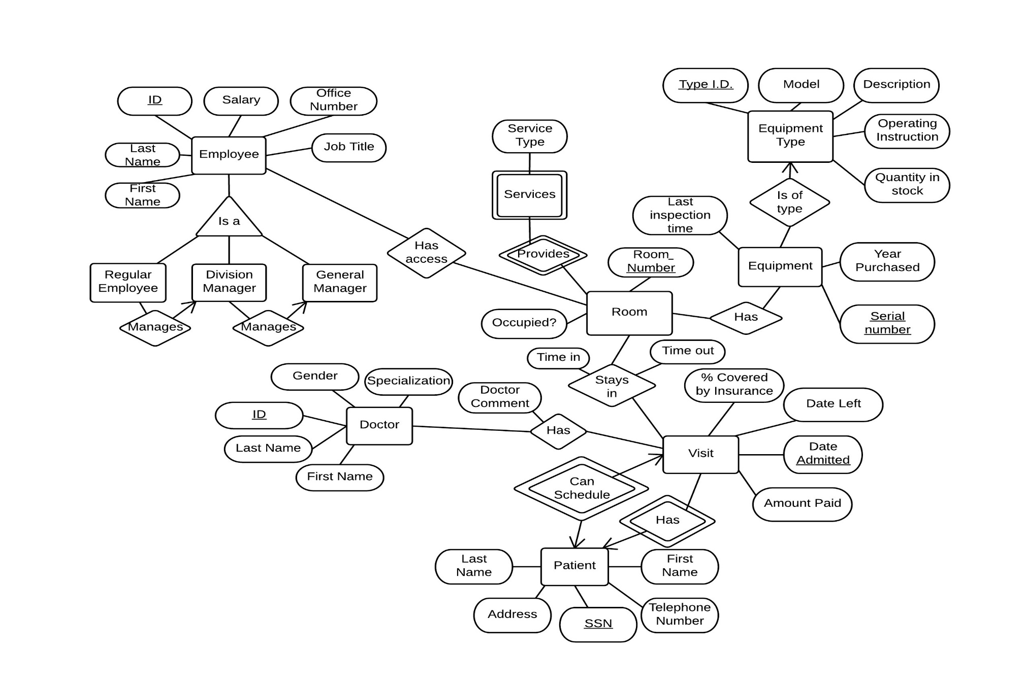

**Relational Model:**

ASSUME

* Major and Minor are accessed by ID
* Name is mandatory
* Courses need a semester

Doctor(doc_id, first_name, last_name, specialty, gender)

Patient(SSN, first_name, last_name)

Visit(SSN, date_admitted, date_left, amount_paid, %_insurace_paid)

HasDoctor(date_admitted, doc_id, doctor_comments)

StaysIn(room_num, date_admitted, time_in, time_out)

Room(room_num, occupied_flag)

roomContains(room_num, serial_number)

Service(room_num, service_type)

Equipment(serial_number, year_purchased, last_inspection)

Equipment-Type(type_id, model, description, instructions, quantity

Employee(emp_id, first_name, last_name, salary, office_num, title)

HasAcces(emp_id, room_num)

CREATE TABLE Room

(room_num: Varchar2(10) Primary Key,

occupied_flag: CHAR(1));

CREATE TABLE Doctors

(ID: CHAR(20) Primary Key,

first_name: CHAR(20) NOT NULL,

last_name: CHAR(20) NOT NULL,

specialty: CHAR(20),

gender: CHAR(1),

Contraint genderVal check(gender in (‘M’, ‘F’)) );

CREATE TABLE Patients

(ssn: CHAR(20) Primary Key,

first_name: CHAR(20) NOT NULL,

last_name: CHAR(20) NOT NULL,

address: Varchar2(255),

phone:CHAR(15),

gender: CHAR(1),

Contraint genderVal check(gender in (‘M’, ‘F’)) );

CREATE TABLE Equipment

(serial_number: CHAR(20),

Purchase_year: CHAR(4),

Last_inspection: DATE);

CREATE TABLE Equipment_Type

(ID: CHAR(20),

model: CHAR(20),

instructions: CHAR(255)

quantity: INTEGER);

CREATE TABLE Division_Manager

(ID: CHAR(20));

CREATE TABLE Employee

(ID: CHAR(20) Primary Key,

first_name: CHAR(20) NOT NULL,

last_name: CHAR(20) NOT NULL,

job_title: CHAR(20),

salary: INTEGER,

office_num: INTEGER);

Contraint genderVal check(gender in (‘M’, ‘F’)) );

CREATE TABLE Division_Manager

(ID: CHAR(20));

CREATE TABLE General_Manager

(ID: CHAR(20));

CREATE TABLE Enrolled

(sid: CHAR(20),

cid: Varchar2(20),

semester: CHAR(2),

grade: CHAR(2),

Constraint pk Primary Key (sid, cid, semester),

Constraint fk_sid Foreign Key (X) References Students (sid),

Constraint fk_sid Foreign Key (X) References Courses (cid));