- 添加 dfu mode依赖。Add dfu mode dependency.

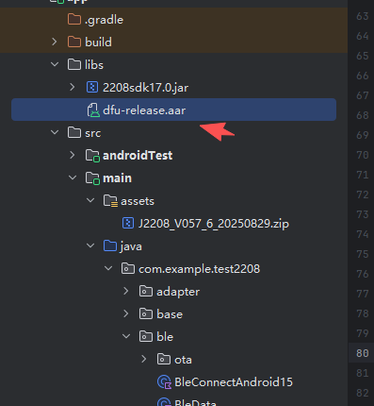

- 注册服务。Registration Services
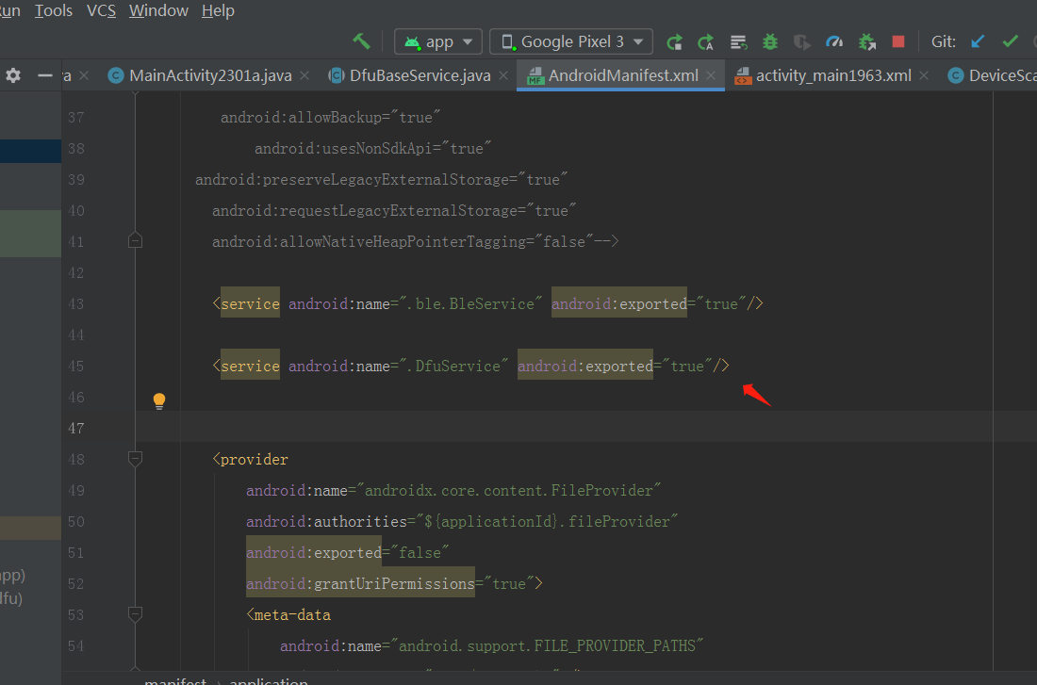

- 权限。App permissions

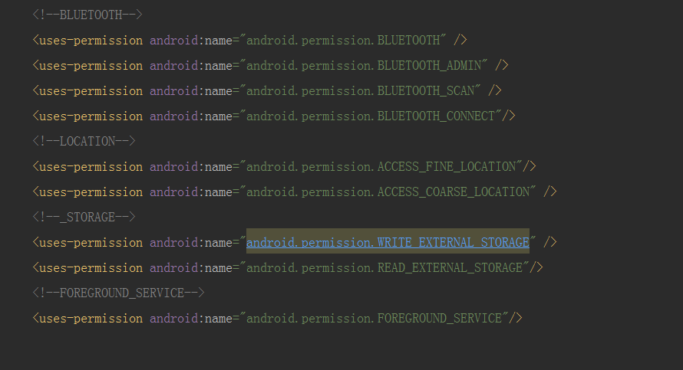

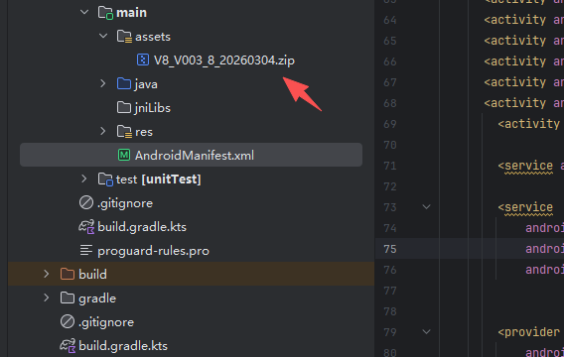

- 升级流程：Upgrade process

- Zip包我们测试app直接从assets文件夹中复制并且解压zip文件。文件中firmware.zip为ota升级包。
- We test the Zip package by copying the app directly from the assets folder and extracting the zip file. Firmware.zip in the file is the ota upgrade package.

- 连接设备。Connected Device
- 设备名字为dfu的设备直接ota升级，不需要发送0x47指令给设备。
- 如果设备名字不包含dfu，需要发送0x47指令给设备，让设备进入ota升级模式。
1. The device with the device name dfuxx can be upgraded directly to ota without sending the 0x47 command to the device.
2. If the device name does not contain dfu, you need to send the 0x47 command to the device to enter ota upgrade mode.

5.升级代码为OtaActivity（Upgrade code to OtaActivity）

