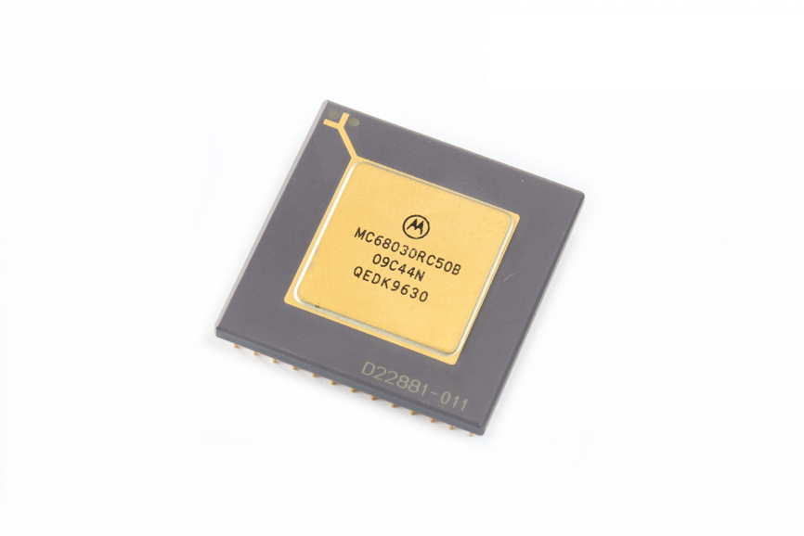

Jeff Sponaugle

[Company name] | [Company address]

Roscoe

A 68030 based Single Board Computer Technical Hardware Manual

Table of Contents

Section 1: 2

# Section 1: System Description

Roscoe is a 68030 base Single Board Computer with the following key characteristics:

* Support for PGA 13x13 Based 68030 processors with speeds from 16Mhz to 40Mhz.
* 68881/68882 PLCC Math Coprocessor (optional)
* 4 MB of FAST Static RAM (0WS Synchronous Bus Cycle, 10ns)
* 8x 72 Pin SIMM DRAM slots supporting 8MB, 16MB, 32MB, 64MB and 128MB SIMMS
* Total maximum onboard DRAM supported: 1GB
* Dual TLC2552 UART Serial Ports
* DS12887 Real Time Clock
* 82C54 Programmable Timer Counter with Interrupt support
* 2x Dual IDE Interfaces
* W5300 10/100MB Ethernet Interface (with TCP offloading)
* ATX Form Factor with ATX power supply interface, soft power on/off, self power off
* USB 2.0

