NORTHSHORE STRATEGIC ADVISORY

Parent Coach Playbook
24-Month Strategic Business Plan
Path to 100,000 Monthly Visitors and a Diversified Revenue Stack
PREPARED FOR PREPARED BY
Jeff Thomas Northshore Strategic Advisory
Owner, eepskalla LLC Independent Strategic Review
DBA Parent Coach Playbook (pending) Pacific Northwest

Issued May 9, 2026
Confidential. For internal planning use.
Contents

1. Executive Summary

Parent Coach Playbook (parentcoachplaybook.com) is a youth-sports parent media property with a differentiated editorial voice and a working set of unique tools. The site enters this 24-month plan with 875+ live pages, 533 drills, 289 articles, 29 gear guides, and a custom-built camps directory operating on Cloudflare D1. Owner Jeff Thomas is a sitting D-III head football coach with two decades of recruiting and player-development context. The brand is operated under eepskalla LLC. A DBA filing for Parent Coach Playbook is in process. No separate entity will be formed until 24-month proof of concept clears.
This plan covers May 2026 through May 2028. It defines the path from current traffic (estimated 3K-5K monthly visitors) to a target of 100,000 monthly visitors, with five revenue lines, a clear staffing model, and explicit milestone gates.

The headline targets
- Monthly visitors at month 24: 95,000 to 115,000 (base case 110,000)
- Email subscribers at month 24: 18,000 to 25,000
- Run-rate revenue at month 24: $5,500 to $7,500 per month, averaged across the four operating lines
- Two-year cumulative net (base case): approximately $48,000 after VA, freelance writer, tooling, and entity costs
- Path B (private-label gear) prototype ordered by month 24, soft launch in Year 3

The strategic wedge
The market for youth-sports parent content is bifurcated. Institutional, donor-funded properties (Aspen Project Play, MomsTEAM, Positive Coaching Alliance) write authoritative but emotionally flat content. Premium-course operators (ChangingTheGame Project, SoccerParenting.com) sell $79-$200 courses to a small slice of high-intent parents. Sport-specific gear blogs compete on commerce but lack voice. No competitor occupies the peer-to-peer-voice plus commerce-driven quadrant at scale. That is the wedge Parent Coach Playbook is built to take.

The non-negotiables
- Voice integrity. Every VA-assisted gear guide and every freelance-written essay passes the Anti AI Writing checklist before publishing. Voice is the moat. If it slips, the trust slips, the affiliate revenue collapses, and the Year 3 product launch becomes impossible.
- Compatibility with the broader 2026 stack. Owner-operator hours are capped at 15-20 per week through October 2026. Anything that competes with that cap gets cut, not crammed in.

What changed from the May 8 strategy conversations
- Coaching app is dropped from the priority stack. Time and attention reallocated to this plan.
- Editorial voice is consolidated to a single Editorial byline. Persona contributors retired.
- Revenue lines expanded from four to five. Newsletter sponsorship added.
- Path B (private-label gear) treated as a Year 3 setup play, not a Year 1 or Year 2 launch.

2. Market and Competitive Landscape

2.1 Market sizing
The US youth sports market totaled approximately $40 billion in spend per Empower research and projects to $62 billion globally per Business Research Insights, with a CAGR near 10 percent. The audience is enormous and growing: 60 million US kids participate annually, and 55.4 percent of youth ages 6 to 17 play organized sports.
The most relevant macro signal for this plan is parent spending per family, which Aspen Project Play measured at $1,016 per child per primary sport in 2024, up 46 percent over five years. Soccer leads at $1,188, followed by basketball at $1,002, baseball at $714, and tackle football at $581. The price-elasticity ceiling for honest gear advice is therefore high; parents are spending money and want to spend it well.
Bottom line: the audience is large, the spend is rising, and the channels that connect honest editorial voice to commercial intent are under-served. The 24-month plan is built for that gap.

2.2 Competitive map
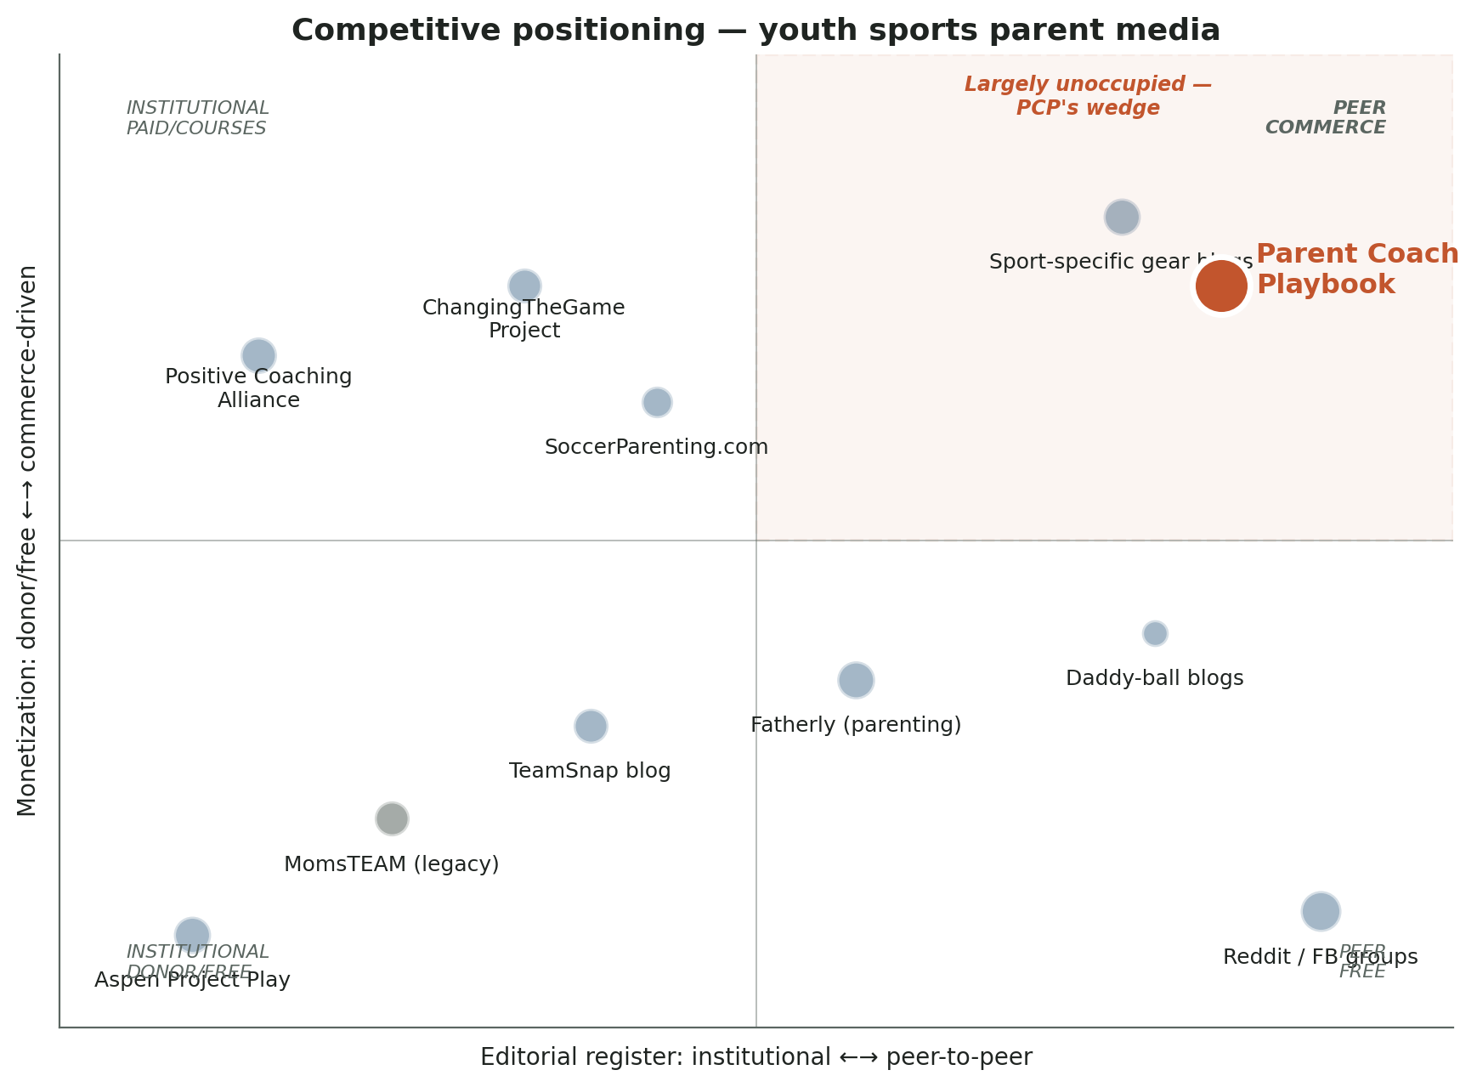
Figure 1. Competitive positioning matrix. Editorial register on the horizontal axis, monetization model on the vertical. The peer-voice and commerce-driven quadrant is the position Parent Coach Playbook is built to occupy.

2.3 Competitor profiles

Aspen Institute Project Play
- Type: Non-profit, donor-funded initiative under the Aspen Institute Sports & Society program
- Audience: Stakeholders, administrators, coaches, parents. Macro authority play, not gear-buyer intent
- Monetization: None directly. Drives policy and partnerships
- Strength: Surveys (2024 cost data), state-of-play reports, governing-body relationships, partnership roster
- Weakness vs. PCP: Institutional voice. Reads as thought leadership. Does not help a parent on a Saturday morning decide what bat to buy
- Implication: PCP can target Project Play as a backlink source (cost calculator pitch) without competing for the same audience

MomsTEAM (legacy)
- Type: 25-year legacy site. Founder retiring in 2025-2026
- Audience: Youth sports safety, mom-of-athlete demo. 10,000+ articles, 1,000+ videos
- Monetization: Non-profit donor model
- Strength: Massive content footprint, brand recognition with safety-first segment
- Weakness vs. PCP: Site is being archived. Curated subset is moving to Smart-Teams.org. Active content production has stopped
- Implication: Largest opportunity in the market. PCP should aggressively rank for safety queries (helmet sizing, concussion protocols, mouthguard selection) where MomsTEAM was previously the default

Positive Coaching Alliance
- Type: Non-profit, 18 chapters, 20,000+ workshops delivered to 19.2M+ youth
- Audience: Coaches primarily, parents secondary
- Monetization: Workshops (paid), online courses ($79+), institutional partnerships
- Strength: PCADevZone.org has 1,500+ resources. Brand authority
- Weakness vs. PCP: Coach-first, not parent-first. Institutional voice. Paywall
- Implication: PCP should pitch parent-coach pillar pieces for PCA cross-promotion. Different audience overlap, complementary positioning

ChangingTheGame Project (John O'Sullivan)
- Type: Personal brand. Three #1 bestselling books. International speaking. Online courses
- Audience: Parents and coaches. Premium tier
- Monetization: Books, $200+ courses, speaking fees
- Strength: Founder authority. Press placements (CNN, ESPN, Outside, NBC Sports). Conference circuit
- Weakness vs. PCP: Long-form, manifesto-style content. Not gear-buyer adjacent. Limited weekly cadence
- Implication: Different revenue model entirely. PCP is not a competitor for course sales. Cross-pollination opportunity through podcast appearances post-November

SoccerParenting.com (Skye Eddy)
- Type: Soccer-specific membership site. Videos, monthly meetups, book clubs
- Audience: Soccer parents specifically
- Monetization: Paid membership
- Implication: Sport-vertical play. PCP wins on breadth across all sports, plus tools (cost calculator, camps) that single-sport sites cannot match

TeamSnap blog
- Type: Editorial blog as content marketing for the TeamSnap SaaS product
- Audience: Team managers, parents, coaches
- Monetization: Lead generation for the SaaS, not direct revenue
- Implication: Strong distribution. TeamSnap parents are PCP's exact audience. Worth pitching guest posts and cross-promotion in Year 2

Sport-specific gear review blogs
- Type: Affiliate-driven gear sites (Chalk and Clay, baseballmode.com, JustBallGloves, GoRout, Legends Only League, sportsgearlab.com)
- Audience: Buyer-intent search traffic
- Monetization: Amazon affiliate, direct retailer affiliates
- Strength: SEO-optimized for gear queries. Comprehensive product matrices
- Weakness vs. PCP: Thin editorial voice. AI-generated copy in many cases. No tools, no email list, no community
- Implication: These are the direct competitors for the affiliate traffic. PCP wins on voice and trust, not catalog completeness. Editorial discipline is the SEO defense as Google's helpful-content updates continue to demote thin affiliate content

Wirecutter, The Strategist (parent companies)
- Type: General-purpose review properties owned by NYT and New York Magazine
- Coverage gap: Almost no youth-sports gear coverage. Wirecutter has reviewed mouthguards and helmets at the consumer level, but no systematic youth-sports coverage exists
- Implication: The Wirecutter-shaped hole in youth sports is the Path B opportunity. Curation plus brand.

2.4 Where the moat actually is
The defensible position for PCP is the intersection of three things competitors cannot copy quickly:
- Editorial voice from a sitting D-III head coach with two decades of college recruiting and player-development context. The credentialing is real and rare.
- Tools that do not exist anywhere else. The cost calculator with sport-and-tier defaults. The camps directory with quality framework. Age pathways and season calendars. Each tool is a backlink magnet and a commerce funnel.
- Single-Editorial voice consistency across 875+ pages, with the AI-residue discipline to sound human at scale. As Google continues to demote AI-generated affiliate content, this becomes a structural ranking advantage.
Competitive read: the field is wide open in the peer-voice plus commerce-driven quadrant. The MomsTEAM exit creates a content-authority vacuum. The premium-course players are not gear-buyer adjacent. The thin gear blogs cannot defend their voice. PCP wins this position by holding voice integrity through year-two scale.

3. Where We Are Today

Inventory taken from the live site and src/content directory on May 9, 2026.
Surface | Live count | Strategic health
Articles | 289 | Strong
Drills (coaching tips) | 533 | Strongest collection in the niche
What to Buy guides | 29 | Active, voice good, ~30% affiliate fill
Scripts | 23 | Flagship format, room to triple
Decisions | 13 | Flagship format, room to triple
Recruiting | 15 | Pillar exists, secondary to youth focus
Body / health | 17 | Reference layer
Age pathways | 10 | One per sport
Rules | 20 | Reference layer
Season calendars | 10 | Reference layer
Resources / lead magnets | 18 | Drive Home Playbook is the headline
Adaptive | 4 | Either build out or fold into body
Camps directory | Phase 1 live | Custom D1, submission, admin queue, quality framework
Tools | 9 | Cost calculator is the unique asset
Affiliate links | 39 destinations | Amazon only; tag parentcoachpl-20
Email | 1 form, Drive Home PDF magnet | Drip not yet wired
External backlinks | ~zero | Single biggest authority bottleneck
Active social channels | None | Distribution layer not yet built

Technical health is strong: HSTS, CSP-adjacent headers, Cloudflare DDoS protection, secure admin paths, and clean Astro build. Schema markup deployment is the first major SEO upgrade pending. Mobile experience is solid. Editorial standards are documented.
The opportunity is distribution and SERP visibility, not the product. The 24-month plan is built to scale what already works.

4. Strategy and Positioning

4.1 The bet
Build a youth-sports parent media property at the intersection of trust and gear-buyer intent. Editorial voice that does not exist anywhere else. Tools that do not exist anywhere else. Affiliate revenue funds the operation. Display ads and camps revenue layer in. Newsletter sponsorship adds the fifth line. White-label gear (Path B) is the Year 3 graduation play.

4.2 24-month outcome
- 100,000 monthly unique visitors by May 2028 (linear growth from 50K at month 12 with realistic step-function plateaus)
- 20,000+ active email subscribers
- $5,500 to $7,500 per month average revenue across five operating lines by month 24
- Three months of validated reader data on which Path B private-label SKU to launch in Year 3
- Defensible authority through external backlinks, voice, and unique tools

4.3 The traffic mix that matters
50,000 visitors of essay readers and 50,000 visitors of gear buyers are not the same business. Same total volume, 5 to 10 times revenue gap. The mix to drive toward by month 24:
Intent type | Target share at month 24 | What it lands on
Gear-buyer intent | 45% | What to Buy guide, sport landing page, gift guide
Decision / script intent | 25% | Decisions, scripts, situational pieces
Essay / voice intent | 20% | Drive There, Game, Drive Home essays
Tool intent | 10% | Cost calculator, age pathways, camps directory

The gear-buyer 45 percent funds the operation. The essay 20 percent makes the audience product-launch-ready in Year 3 and gets shared into Facebook groups. Both must grow.

4.4 What this plan does not do
- Does not build a coaching app (removed from priority stack)
- Does not pivot to recruiting (recruiting pillar stays as a sub-section)
- Does not chase TikTok or X / Twitter
- Does not run paid acquisition (Facebook boost, Google Ads) in either year
- Does not expand the editorial voice to multiple personas (already consolidated)
- Does not form a separate LLC for Parent Coach Playbook before 24-month proof of concept
- Does not integrate Chain Reaction promotion into the site (separate project)

5. Five Revenue Lines

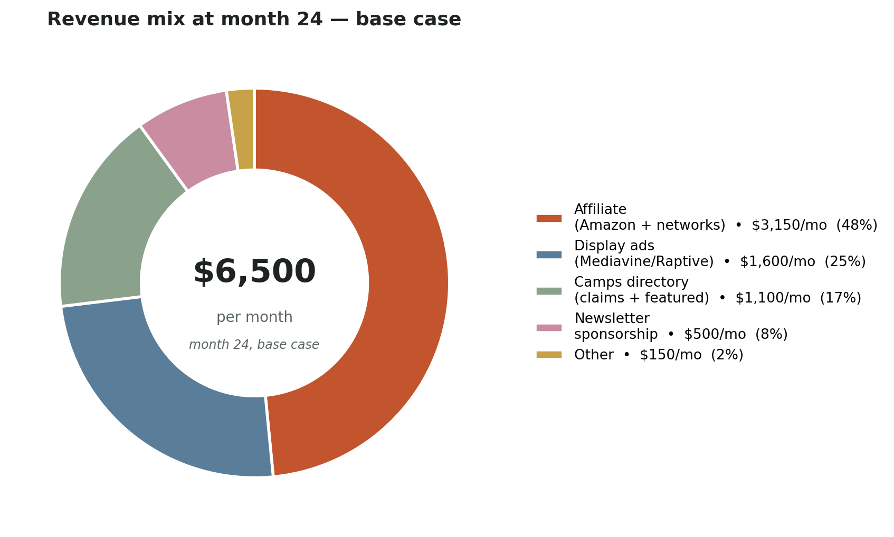
Figure 2. Revenue mix at month 24, base case. Five active lines totaling approximately $6,500 per month run rate.

5.1 Line 1: Affiliate (Amazon plus multi-network)
Amazon Associates active under tag parentcoachpl-20 with 39 destinations live. Tier 1 networks (Dick's, ShareASale, Bookshop) listed in the existing AFFILIATE_NETWORKS_TO_APPLY documentation but not yet applied for. Tier 2 (CJ, Impact, BSN, Soccer.com, Sport-Monkey family, Eastbay) follows.
Quarter | Action | Run-rate target
Q3 '26 (months 1-3) | Apply ShareASale, Dick's, Bookshop. Backfill across 289 articles. Reach ~150 destinations. | $300-500/mo
Q4 '26 (months 4-6) | Apply CJ, Impact, BSN, Soccer.com, Sport-Monkey. Build Season Essentials guide. Back-to-school push. | $600-1,000/mo
Q1 '27 (months 7-9) | Optimize top 50 highest-traffic guides. Pre-build Q4 gift guides. | $1,000-1,800/mo
Q2 '27 (months 10-12) | Holiday push. Nov-Dec is the highest revenue window in this niche. | $2,000-3,500/mo
H2 '27 (months 13-18) | Freelance writer producing 8-12 long-tail age-specific guides per month. | $2,500-4,000/mo avg
H1 '28 (months 19-24) | Direct brand affiliates (Wilson, Easton, Rawlings, REI). Higher commission on big-ticket. | $3,000-4,500/mo avg

Honest caveats: Amazon sports & outdoors pays 3 percent. A $200 glove returns $6. Seasonality is brutal: August registration, November-December gifts, February-March spring spend are the peaks. June-July and January are dead months. Plan for 2-3x swings.

5.2 Line 2: Display advertising
Mediavine eligibility threshold is 50,000 sessions per month, which corresponds to approximately 35-40K unique visitors with this audience's session-to-visitor ratio. Raptive (formerly AdThrive) requires 100,000 page views per month.
Milestone | Action | Expected impact
Month 9-10 | Apply to Mediavine when sessions cross 50K. Quality and niche pass. | Application submitted
Month 12 | Approved Mediavine ads live. RPM in this niche typically $20-35. | $1,500-2,800/mo
Month 18 | Apply to Raptive at 100K page views or hold Mediavine. | $2,500-4,000/mo
Month 24 | Mature ad placements, sticky desktop ads, sidebar plus in-content. | $3,000-5,000/mo

Honest caveats: ad approvals slow page load. Quarterly Lighthouse audits to keep mobile performance above 80. Some readers will cancel their email subscription when ads launch. Expect 1-2 percent unsubscribe spike. Acceptable trade for $20-40K per year.

5.3 Line 3: Camps directory monetization
Camps directory Phase 1 is live. Custom Cloudflare D1 build. Quality framework operational. Zero monetization wired in yet.

Mechanism A: Claim listings (free tier with paid upgrade)
- Free listing: anyone submits, PCP moderates, basic listing goes live
- Claimed listing ($49 first year, $99 renewal): operator claims, edits dates and prices, gets Verified by Operator badge
- Premium claimed listing ($199-299/year): 3 photos, longer description, registration deep-link with conversion tracking, priority placement in their region

Mechanism B: Featured placement
- Per-region or per-sport featured slot. Sponsored badge, prominent placement on relevant filter view. $99-299 per slot per month depending on region size.
- Cap: maximum 1 featured slot per (region × sport) at any time. Editorial wall: featured placement is bought, not earned, and is labeled.
Quarter | Build / sales action | Revenue target
Q3 '26 | Phase 2 build: map view, geocoding cache, filtering UI. Reach 100-200 PNW camps. | $0
Q4 '26 | Phase 3: zip-code radius, photos, basic reviews. Soft launch claim flow. | $0-500
Q1 '27 | Charge $49 first-year claim. 50 paid claims = $2,450 ARR. | $200-400/mo
Q2 '27 | Featured placement program. 10 slots/month at $149 average. | $500-1,500/mo
H2 '27 | National expansion. 1,000+ camps. 30-50 featured slots/month. | $1,500-3,000/mo
H1 '28 | Camps becomes the second-most-valuable asset. | $2,500-4,500/mo

Camps tech (Phase 2 and Phase 3) stays with Jeff. No outsourced contractor. Pace adjusts to available hours. If hours are constrained, the monetization timeline slips by one to two quarters rather than scope being cut.

5.4 Line 4: Newsletter sponsorship
Native sponsor slots in the weekly Friday newsletter. Charged when the list crosses 5,000 active subscribers. Pricing benchmarks for niche parenting newsletters: $300-800 per send for 5K-10K lists, $800-1,500 per 10K-20K lists, $1,500-3,000 per 20K+ lists.

Sponsor categories
- Camps and clinics: regional camps wanting list reach into Pacific Northwest, then national
- Direct-to-consumer gear brands: emerging brands (mouthguards, water bottles, recovery gear) wanting parent-coach distribution
- Books and parenting resources: youth-sports-adjacent authors, sport-psych books
- Local services: youth sports photography, sport-specific lessons, recovery clinics

Build sequence
Quarter | Action | Run-rate target
Q3 '26 | Hold. Build the list to 1,500+ before considering sponsors. | $0
Q4 '26 | Add native ad placement template to newsletter design. List target: 3,000. | $0
Q1 '27 | First sponsor at 5K list. $300 per send, monthly cadence. | $300/mo
Q2 '27 | Two sponsor slots, monthly. $500 per slot. | $1,000/mo
H2 '27 | Cap at 2 sponsors per send. Move to weekly with sponsor rotation. | $800-1,400/mo avg
H1 '28 | 20K+ list. $800-1,200 per send, 1-2 sponsors per send. | $1,200-2,000/mo avg

Editorial wall: sponsor slots are clearly labeled. Sponsored content is never integrated into the editorial body. The Friday note is editorial; the sponsor slot is bought. This is the discipline that Wirecutter, Morning Brew, and The Skimm hold and that makes the channel sustainable.

5.5 Line 5: White-label gear (Path B, Year 3)
Triggered after the site clears 100,000 monthly visitors and the email list clears 20,000. Year 3 work, not Year 1 or Year 2. The 24-month plan does not produce revenue from this line. It produces the audience and the brand mark (Parent Coach Approved, see Section 13) that make Year 3 launch viable.

5.6 Quarterly revenue trajectory
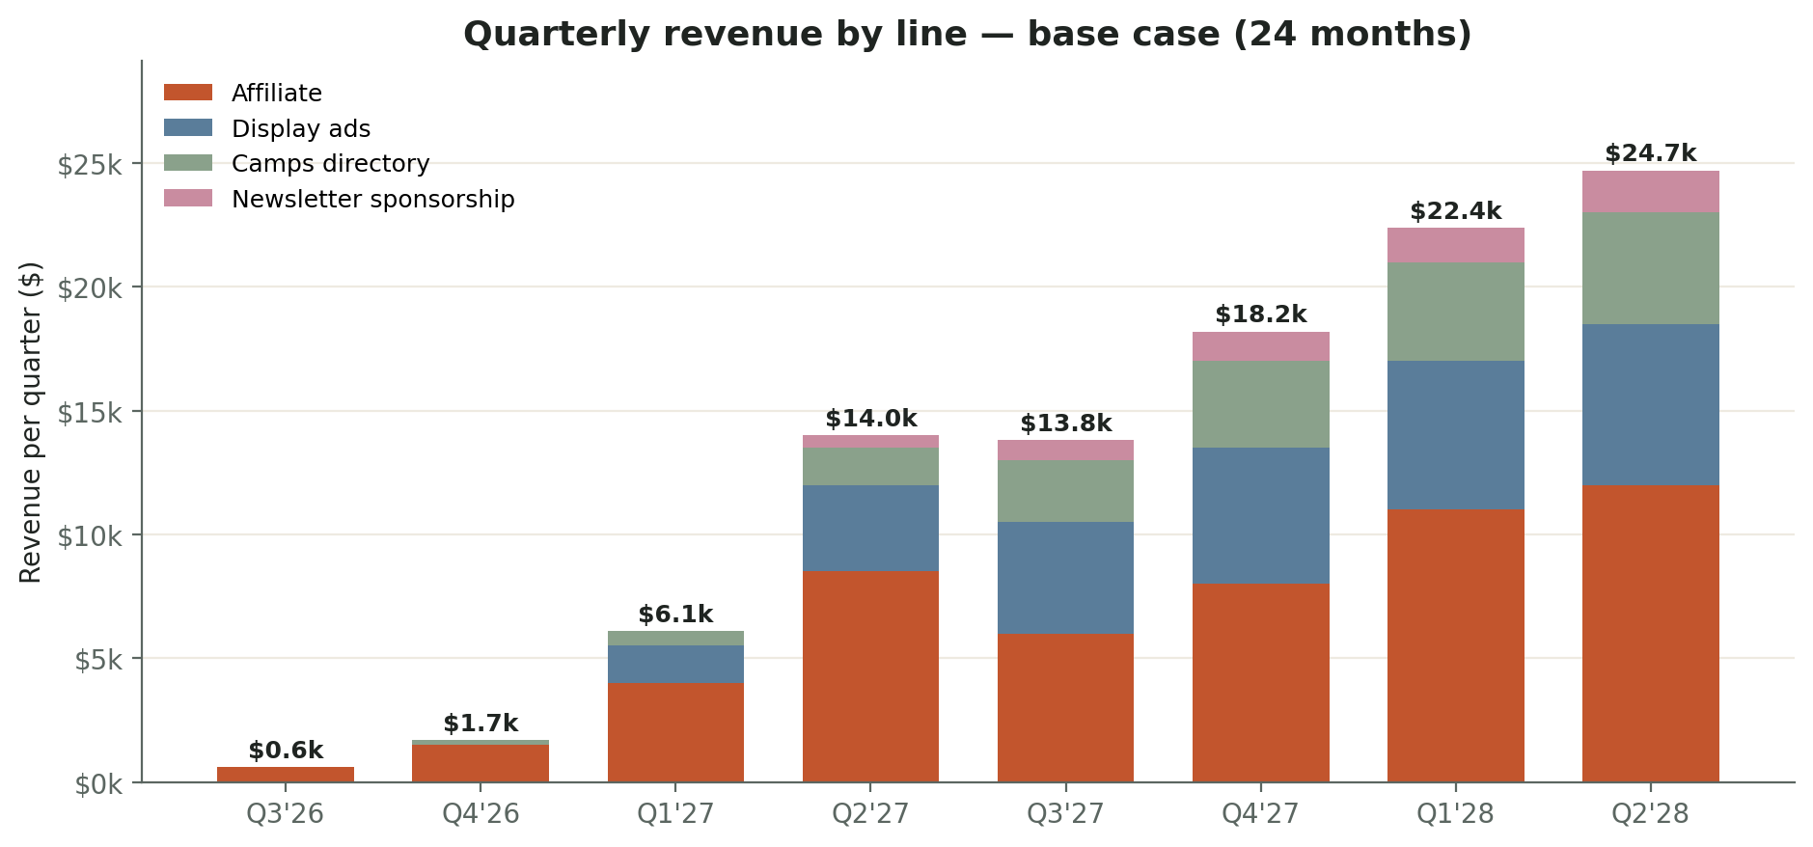
Figure 3. Quarterly revenue by line, base case, 24 months. Stacked bars show how the four operating lines layer in over time. Year 2 holiday quarter (Q1 '28) is the peak.

6. Unit Economics

The core question: what does an email subscriber cost to acquire, what is each subscriber worth, and what conversion rates does the funnel need to hit at month 24.

6.1 Funnel benchmarks at month 24
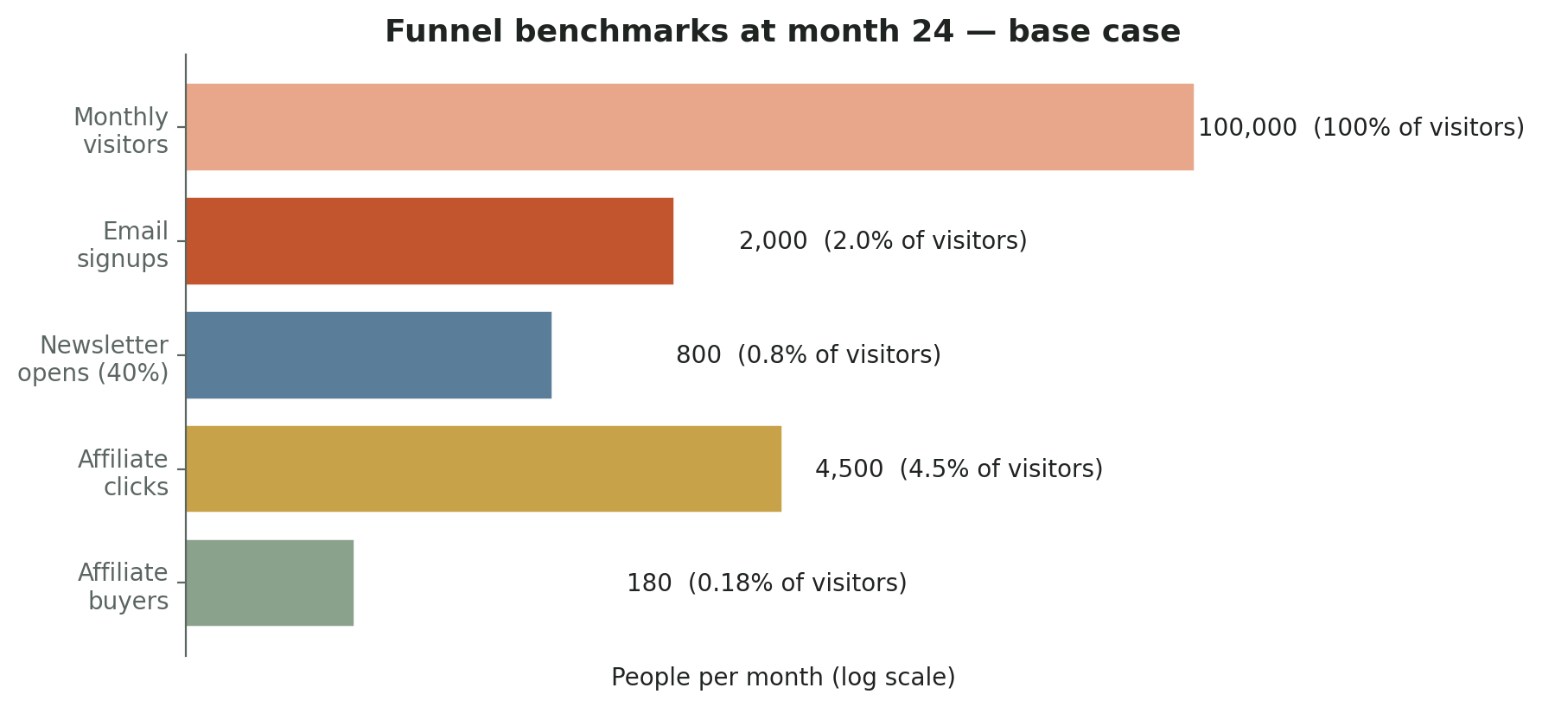
Figure 4. Funnel benchmarks at month 24, base case. Conversion rates calibrated to typical performance for niche editorial sites in adjacent verticals (parenting, recipes, finance).

6.2 Conversion rate targets
Stage | Industry baseline | PCP target month 24 | Why we believe it
Visitor → email signup | 1.0-2.5% | 2.0% | Multiple lead magnets, tool-results email, prominent placement
Email open rate (weekly) | 25-35% | 40% | Niche audience, strong voice, opt-in only
Email click-through (open → site) | 2.5-5% | 3.5% | One CTA per send, voice-driven
Visitor → /go/ click (gear page) | 3-7% | 4.5% | Gear-buyer intent traffic, clean comparison tables
/go/ click → Amazon purchase | 5-10% | 8.0% | Honest recs build trust
Cost calculator → email signup | 5-12% | 8.0% | Tool-result lead magnet

6.3 Per-visitor revenue (RPMV)
Revenue per thousand visitors is the operational benchmark. At month 24, base case, with the target mix and conversion rates:
Channel | Visitors / mo | Revenue / mo | RPMV (revenue per 1,000 visitors)
Affiliate (gear-buyer share) | 45,000 | $3,150 | $70.00
Display ads (all visitors) | 100,000 | $1,600 | $16.00
Camps (tool intent + general) | 30,000 | $1,100 | $36.67
Newsletter sponsorship (subs only) | 20,000 subs | $500 | n/a
All-site blended | 100,000 | $6,500 | $65.00

Reference points for blended RPMV in adjacent verticals: parenting blogs $20-45, recipe sites $40-80, personal finance $60-150. PCP at $65 blended is realistic and competitive. The lever to pull for upside is gear-buyer share. Every percentage point shifted from essay to gear-buyer intent adds approximately $250-350 per month.

6.4 Email subscriber LTV
LTV calculation, base case at month 24:
- Average subscriber tenure: 18 months (industry: niche editorial newsletters last 12-30 months)
- Average revenue per subscriber per month: $6,500 / 20,000 = $0.325 (blended; subscribers convert better than non-subscribers, so true subscriber RPM is approximately $0.50)
- Subscriber LTV: 18 months × $0.50 = $9.00 per subscriber
- Implication: spending up to $1.50 to acquire a subscriber via paid social is plausible by month 18-24. Not in current plan but worth pricing.

6.5 What unit economics tell us
Three operational implications:
- Email is the highest-leverage asset. A subscriber is worth approximately $9. Total list value at 20,000 subs is approximately $180,000 over the average subscriber lifetime. Protect this asset.
- Mix shift toward gear-buyer intent moves the needle harder than total volume growth. A 5-point mix shift adds more revenue than a 10K visitor increase at constant mix.
- Display ads are the floor. They subsidize traffic that does not convert through any other line. Run them, but do not optimize the site for them.

7. Cashflow Scenarios

Revenue collection lags by 60 to 90 days for the two largest lines. Amazon Associates pays 60 days after month close. Mediavine pays NET 65. Camps and newsletter sponsorship are upfront but smaller. This timing gap creates a meaningful float requirement that the original revenue projections did not address.
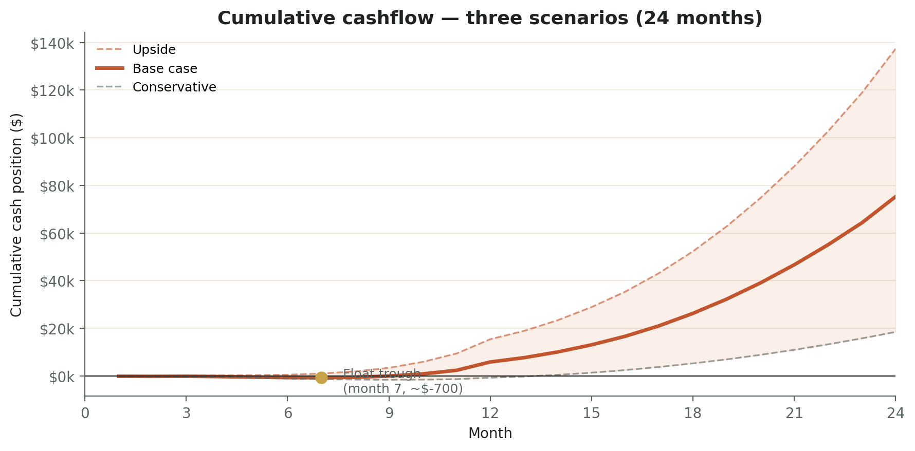
Figure 5. Cumulative cashflow position, three scenarios, 24 months. Conservative, base, and upside cases shown. Float trough in base case occurs around month 6.

7.1 Scenario assumptions

Conservative
- Affiliate revenue at 60% of base case forecast
- Mediavine eligibility delayed to month 14
- Camps directory monetization at 50% of base case
- Newsletter sponsorship not launched until month 18
- VA hire delayed to month 8
- No freelance writer hired
- Float trough: month 7 at approximately -$2,000

Base case
- Revenue per Section 5 forecasts
- VA hired month 4-6 at $500/month
- Freelance writer hired month 12-13 at $2,000/month
- Tooling: Kit paid plan ($30-40/mo), domain, occasional analytics tool
- DBA filing and accountant: $1,500 in year 1
- Float trough: month 6 at approximately -$700

Upside
- Mediavine eligibility hits month 9
- One earned-media placement (NYT, The Athletic) generates step-function traffic
- Cost calculator backlink campaign generates 10+ DR-30+ links
- Camps directory hits 100 paid claims by month 18
- Float never goes negative

7.2 Float requirements
Practical implications for owner planning:
Scenario | Peak negative cash position | Months under water | Float buffer needed
Conservative | -$2,000 | 10 months (month 4-13) | $3,000
Base case | -$700 | 5 months (month 4-8) | $1,500
Upside | $0 or positive | 0 months | $500 working capital

Recommended action: maintain $3,000 of working capital allocated to PCP through month 12. This covers conservative scenario without owner cash injection. Year 2 is cashflow-positive across all three scenarios once Mediavine and the freelance writer system are running.

7.3 The freelance writer hire timing
Hiring the writer requires both 50K monthly visitors and at least $1,500 per month in steady affiliate revenue. Cashflow timing means the actual cash to support that hire arrives 60-90 days after the revenue posts. The plan accounts for this through the float buffer and a soft trigger:
- Hard trigger: 50K visitors AND $1,500/mo run rate for two consecutive months
- Soft trigger: $3,000+ in unallocated cash on hand
- If both trigger by month 12, hire month 13. If only soft trigger, delay hire by one quarter and increase Jeff's hours instead.

8. Traffic and Audience Growth

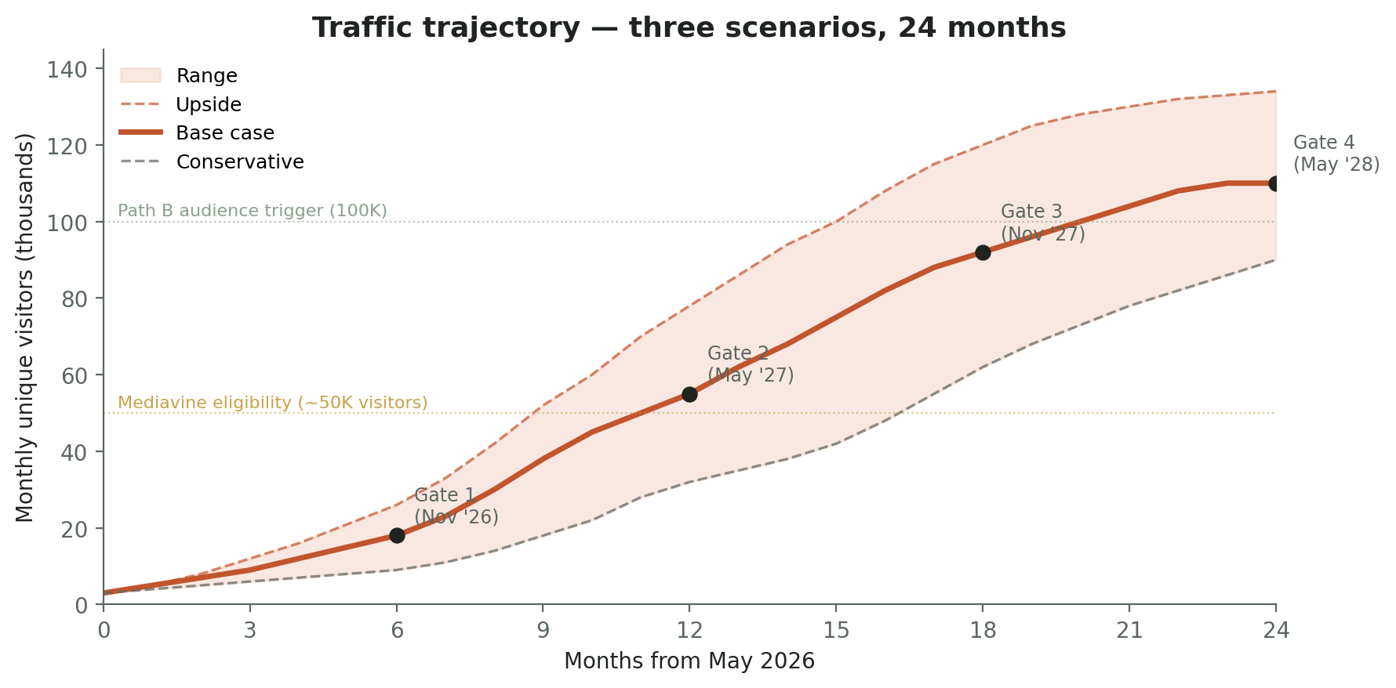
Figure 6. Traffic trajectory across three scenarios. Step-function plateaus reflect the realistic shape of compounding SEO-driven traffic, not linear growth.

8.1 The shape, not the line
SEO traffic does not grow linearly. It grows in steps. A piece sits at position 30-50 for 2-4 months doing nothing. Then a cluster jumps to page 1 and traffic does a step-function increase. Then plateau. Then another step. Plan for the plateaus or year two breaks.

8.2 The four traffic engines
Engine | Share at month 24 | Notes
Organic search (SEO) | 70% | Built through systematic gear guides, sport landing pages, essay backlog ranking
Email re-share | 10% | Friday newsletter sends 500-1,500 click-throughs per send by month 24
Social referral | 12% | Facebook (year 1), Pinterest and Instagram (year 2)
Direct + earned media | 8% | Backlinks from governing bodies, parenting pubs, local press

8.3 The four-phase distribution rollout
Phase | Window | Channel actions
Phase 1 | Months 1-3 | Facebook only. 3 posts/week, 30 min/day group engagement, 10-15 parent groups
Phase 2 | Months 4-6 | Add Instagram. Reels are the engine. Carousels for situational pieces
Phase 3 | Months 5-8 | Add Pinterest. 5-10 pins/week batched. Slow to start, compounds for years
Phase 4 | Months 7+ | Face-forward post-November. Podcasts, HS coach distribution, earned media, LinkedIn

9. Operations

9.1 Content production cadence
Content type | Year 1 cadence | Year 2 cadence (with writer)
Long pillar (gear V2, decisions, cornerstones) | 2 / week | 4-6 / week
Short essay (Drive There/Game/Drive Home) | 1 / week | 2 / week
Drills | 1 / week (maintain 533) | 1-2 / week
Lead magnet (PDF) | 1 / month | 1 / month
Sport landing page | Build 8 in months 1-3, then maintenance | New sport quarterly
Newsletter | Weekly Friday | Weekly Friday

9.2 Content mix discipline
40 / 30 / 20 / 10 split across every quarter:
- 40% gear guides and What to Buy upgrades (SEO traffic engine, VA-assisted)
- 30% Drive There / Game / Drive Home essays (voice and trust layer)
- 20% tools, frameworks, decisions, scripts (the differentiator)
- 10% product research articles (doubles as Path B SKU intelligence)

9.3 Editorial calendar tooling
The queue lives in Notion. Single database titled Editorial Queue. Schema:
Field | Type | Purpose
Title (working) | Text | Working headline; final headline added at SHIPPED
Status | Select | PIPELINE → DRAFTING → IN REVIEW → SCHEDULED → SHIPPED
Type | Select | Gear guide / Essay / Decision / Script / Tool / Lead magnet
Priority sport | Multi-select | Baseball, soccer, basketball, etc.
Age band | Multi-select | 5-7, 8-10, 11-12, 13-14, 15+
Phase | Select | Drive There / Game / Drive Home / Team Parent / Foundations
Source | Select | Reader email / GSC / Interview / Roadmap / Refresh
Owner | Person | Jeff or VA or Writer
Target date | Date | When this ships
URL | URL | Filled at SHIPPED
Word count | Number | Filled at SHIPPED
6-month traffic | Number | Filled at month 6 post-ship from GSC
Refresh due | Date | Set automatically to ship date + 18 months
Notes | Text | Free-form context

Weekly cadence
- Monday 30 min: Jeff reviews queue, moves things from PIPELINE to DRAFTING for the week
- Friday 15 min: status sweep, mark anything SHIPPED that went live, schedule next week
- Monthly 60 min: refresh-due review (see Section 9.5), reader-email pattern review

9.4 Reader research mechanism
Five voice memo interviews per month with parent-coaches in Jeff's network. Each interview produces approximately three articles, three scripts, and one decision. The mechanism specified:

Recruiting
- Source: Jeff's existing parent-coach network plus targeted asks via the newsletter ('Looking for 5 parent-coaches each month for a 30-min voice memo. Coffee on me')
- Compensation: $25 Amazon gift card per completed interview, or a copy of an upcoming lead magnet
- Cadence: 5 per month sustained. Calendly link in newsletter footer year-round.

Interview script (six questions)
- Walk me through your last hard moment as a sports parent. The most recent one. What happened, what did you do, what do you wish you'd done.
- What do you Google at 11pm about your kid's sport? The thing you're embarrassed to ask anyone.
- What gear have you bought that was a waste? What gear has surprised you by lasting?
- If you could go back to the start of last season and tell yourself one thing, what is it?
- Anything else you wish someone had told you about being a parent in this sport, at this age?

Output filing
- Voice memo recorded, transcribed via Otter or Granola
- Transcript reviewed within 48 hours by Jeff for patterns, lifted quotes, and content ideas
- Each interview produces a one-page summary in Notion (READER_INTERVIEWS database) with 3+ article topic candidates flagged
- Article topic candidates flow into the Editorial Queue with Source = 'Interview'
- Monthly review: Jeff scans the last 5 interviews for patterns. Three or more interviews mentioning the same friction = article topic priority

9.5 Article refresh plan
By month 24, the site will have 600+ live pieces. Without a refresh discipline, older articles lose ranking and revenue. The refresh model:

Triggers
- Automatic: 18 months from publish date, article hits Refresh Due in the Editorial Queue
- Manual: GSC shows ranking drop > 5 positions in a quarter for any top-50 article
- Seasonal: gear guides reviewed every August (back-to-school) and October (gift season prep)

Refresh actions (in priority order)
- Verify all product links in /go/ still resolve (Amazon products discontinue regularly)
- Update affiliate links to new model years where applicable
- Add a 30-50 word lede tuned to the current top GSC query
- Update internal links to point to newer flagship pieces published in the meantime
- Refresh image alt text for current alt-search keywords
- Update meta description and title only if a stronger query emerged

Decommission criteria
Some pieces should be killed, not refreshed. Decommission when:
- Article has under 50 visits per month at month 18 AND has no internal incoming links
- Article has been superseded by a stronger piece on the same topic
- Topic is no longer accurate (rules changed, product discontinued without replacement)
Decommission method: 301 redirect to the strongest related article. Never 404. Maintain link equity.

Refresh cadence
- Year 1: 5-8 refreshes per quarter (low volume, queue still building)
- Year 2: 15-25 refreshes per quarter, batched in monthly half-day blocks
- Year 3 forward: 30-50 per quarter as the library matures

9.6 Org and staffing

Year 1 (months 1-12): solo plus one VA
Jeff at 15-20 hours per week. One VA at 10-15 hours per week starting month 4-6 once the systems are scaffolded.
Role | Hours/week | Cost/month | Scope
Jeff (owner) | 15-20 | $0 (sweat equity) | Drafting, editing, voice, distribution, ops
VA | 10-15 | $400-700 | Gear research, comparison tables, FAQ structure, product-fact verification

Year 2 (months 13-24): solo plus VA plus freelance writer
Adds one part-time freelance writer at month 12-13. Triggered by Section 7.3 hiring criteria.
Role | Hours/week | Cost/month | Scope
Jeff (owner) | 15-20 | $0 (sweat equity) | Editing, voice, cornerstones, ops
VA | 10-15 | $500-800 | Same as Year 1, plus refresh batches
Freelance writer | 20-30 | $1,500-3,000 | 8-12 gear guides per month under Editorial direction

Contracts and per-piece comp logic for VA and writer are deferred to a Year 1 operations addendum. Not in this plan.

10. SEO Infrastructure

Technical SEO is the highest near-term lever. Every fix here compounds across every existing and future piece.

10.1 Months 1-2 (immediate)
- Article schema (JSON-LD) on every read. Highest single-shot SEO upgrade. Two hours.
- FAQPage schema on decisions and body pages. Two hours.
- HowTo schema on drills (533 pieces of surface area). Three hours.
- Person schema on /about/ with author byline linkage. Two hours.
- Fix the 404s flagged by the audit (are-youth-sports-worth-it, why-i-stopped-asking-did-you-have-fun). One hour.
- Author bio with credentials before November (pre-face-reveal: 'Two decades in the youth sports pipeline'). Three hours.

10.2 Months 3-4 (structural)
- Sport-level landing pages: /sports/baseball/, /sports/soccer/, etc. Aggregates articles, drills, what-to-buy, pathways, calendars, rules tagged that sport. Six hours per page templated, or one dynamic page for top 8 sports.
- H1 and title rewrites for top 50 highest-search-volume articles. Match query language. Keep warmer headline as H2. Two days focused work.
- Anchor text discipline added to the editorial style guide. Query-shaped anchors going forward.

10.3 Months 5-6 (compounding)
- Cost calculator promoted to homepage block. Currently buried in Tools dropdown.
- Cost calculator backlink campaign. 10-week outreach push to governing bodies, parenting publications, financial planning sites. Goal: 10-15 quality backlinks.
- Image SEO. ImageObject schema on heroes. Optimized srcset by viewport.

10.4 Months 7-12 (maturation)
- Internal linking audit. Every new piece reaches existing content; every existing piece points forward.
- GSC weekly review. Watch for queries we partially rank for and write the matching pieces.
- Featured snippet optimization. Add 30-50 word lede to top 100 articles answering the query directly.

10.5 Year 2 (months 13-24)
- Sport landing pages V2 (photos, drill clips, comparison widgets).
- Camps directory schema: LocalBusiness + Event schema on each listing.
- Tool pages get their own backlink campaigns. Pendulum quiz, body hub, mental skills hub.

11. Distribution Channels

Phased rollout. Do not launch all four at once.

11.1 Phase 1 (months 1-3): Facebook only
3 posts per week (Monday question, Wednesday excerpt, Friday voice piece). 30 min daily group engagement across 10-15 parent groups. Anonymous-friendly until November face-reveal.
Targets at 90 days: 200-500 page followers, 1-2 organic article shares from group members, one weekly DM from a parent asking a real question.

11.2 Phase 2 (months 4-6): add Instagram
Reels are the engine. 30-second clips with text overlay and quiet b-roll. Carousels for situational pieces. Visual identity (Fraunces, cream, terracotta) translates well to the platform.
4-5 posts per week: 2 reels, 2 carousels, 1 quote post. Daily stories. Save Highlights organized by Drive There / Game / Drive Home / Parent-Coach.

11.3 Phase 3 (months 5-8): add Pinterest
Slow to start, compounds for years. 5-10 pins per week in one batched session. Cost calculator screenshots, packing lists, drive-home script cards. First 90 days produce ~zero traffic. Day 90+ is when the compounding starts.

11.4 Phase 4 (post-November 2026): face-forward acceleration
Once Jeff's name and face go on the site, four channels open up that were locked:
- Podcast tour. 1-2 per month for six months. Tudor Collegiate Strategies, NCSA-adjacent shows, sport-specific recruiting podcasts, parenting podcasts.
- HS coach distribution. 'I'm Jeff Thomas, head coach at Puget Sound, I wrote this guide for your parents, feel free to forward.' 100 HS coaches forwarding to their parent lists is more valuable than 100K of cold search traffic.
- Earned media. One Athletic / NYT Parenting / local press placement in the first six months post-reveal.
- LinkedIn presence. Jeff personal account. Findable and quotable when journalists or HS coaches search.

12. Legal Structure, Compliance, and Insurance

12.1 Entity structure
Parent Coach Playbook operates as a DBA (doing business as) under eepskalla LLC. The DBA filing is in process at the time this plan issues. No separate entity will be formed for Parent Coach Playbook before 24-month proof of concept.

Why this works for the 24-month window
- Single-entity simplicity. One LLC, one bank account, one tax return. Lower accounting overhead in the build phase.
- Asset protection at the LLC level. Eepskalla LLC's existing protections cover the DBA operations.
- Brand separation through DBA. 'Parent Coach Playbook' appears on contracts, affiliate accounts, sponsor invoices, and branded materials. The underlying entity is eepskalla.
- Optionality preserved. At month 24, if Path B launches and the operation justifies it, spin out a dedicated LLC (Parent Coach Playbook LLC or similar) and transfer DBA assets at clean valuation.

DBA filing checklist (Q3 2026)
- File DBA / Assumed Business Name registration in the state where eepskalla is registered (likely WA per Jeff's coaching role).
- Update business banking: add 'doing business as Parent Coach Playbook' to account naming, or open a sub-account if the bank requires it.
- Update affiliate accounts: legal entity is eepskalla LLC, payee name is Parent Coach Playbook (where allowed). Most networks accept DBAs.
- Update W-9: legal name eepskalla LLC, business name Parent Coach Playbook, EIN unchanged.
- Update Stripe / payment processors with DBA naming for camps and sponsor invoices.

12.2 Tax obligations
Once revenue crosses $5,000 per year (estimated month 4-6), the tax picture matters.
- Self-employment tax applies on net earnings (15.3% on the first $168,600 of combined income)
- Quarterly estimated taxes due April, June, September, January once expected liability exceeds $1,000
- State sales tax research needed for camps revenue line specifically. Sales tax on digital services varies by state. Engage accountant before launching paid claim listings.
- 1099-K threshold ($5,000 in 2024, $2,500 in 2025, $600 going forward) triggers reporting from payment processors. Plan for it.

12.3 FTC and affiliate disclosure compliance
Existing site-wide footer disclosure is correct ('Some links pay us when you buy. We only recommend things we use.'). The Amazon Operating Agreement language on /disclosure/ is compliant. Quarterly review is the right discipline. Specific items to audit:
- Every gear card on the site shows the Amazon Associates required disclosure
- Affiliate links use rel='sponsored nofollow noopener' per Amazon and Google best practice
- No fixed prices displayed (Amazon Operating Agreement prohibits this outside the Product Advertising API)
- /disclosure/ page contains required Amazon language

12.4 Liability and insurance
Real exposure increases through Year 1 and accelerates with Path B in Year 3. Three layers needed by month 12:

Layer 1: General Liability + Errors and Omissions (E&O)
- Coverage: protects against claims arising from editorial content (gear recommendations, safety advice, decision frameworks)
- Carrier options: Hiscox, Next Insurance, The Hartford, Progressive Commercial
- Estimated cost: $300-600/year for $1M general liability + $1M E&O for a media business at this revenue scale
- Trigger: when revenue crosses $10,000/year (estimated month 8-10)

Layer 2: Cyber liability
- Coverage: data breach response, customer notification costs, regulatory fines if subscriber email list is compromised
- Estimated cost: $400-700/year for $1M coverage
- Trigger: when email list crosses 5,000 subscribers (estimated month 9-12)

Layer 3: Product liability (Year 3, pre-Path B)
- Coverage: required before any private-label SKU ships to customers
- Estimated cost: $1,000-3,000/year minimum, sport-protective gear category specifically can run higher
- Trigger: when Path B prototype is ordered (month 22-24)

Year 1-2 insurance budget
- Year 1 (post month 8): General liability + E&O. ~$500.
- Year 2: General liability + E&O + Cyber. ~$1,100.
- End of Year 2: add Product liability quotes in advance of Year 3 launch.

12.5 UPS institutional considerations
Jeff is a sitting D-III head football coach at the University of Puget Sound. The site operates personally, independent of UPS. Three actions to take before November face-reveal:
- Brief the AD on the site existence and the November face-forward transition. Frame as institutional asset (D-III coach with public platform contributing to athletics visibility).
- Add a small disclaimer to /about/: 'Parent Coach Playbook is a personal project independent of the University of Puget Sound.'
- Confirm there are no specific topics off-limits (recruiting tactics that could be construed as institutional advice, opposing program references).

13. Parent Coach Approved (Brand Mark Spec)

The Parent Coach Approved mark is the brand promise that earns trust through Year 2 and unlocks Path B in Year 3. It is the methodology, the visible badge, and the editorial discipline that Wirecutter, Strategist, and Consumer Reports built their categories on. PCP's version is youth-sports specific and operates at the trust level a single-coach byline cannot.

13.1 What the mark means
A product earns the Parent Coach Approved mark when it passes a documented test protocol that includes:
- First-hand use by at least one parent-coach in the network for one full season (minimum 12 weeks of regular use)
- Comparison against at least 2 alternatives in the same category and price range
- Documented break-down or wear test (cleats checked at 4 weeks and 12 weeks; gloves photographed at 1, 4, 12 weeks; helmet retention tested per the manufacturer's protocol)
- Honest verdict including 'who this is wrong for' and 'when to skip this category entirely'
- No paid placement. PCP does not accept payment for the mark.

13.2 What the mark does not mean
- It is not a safety certification. NOCSAE, HECC, USA Baseball stamps remain the regulatory authority. PCP defers to those.
- It is not 'best in class.' Many products earn the mark in the same category. The mark indicates 'this is genuinely fine; we used it; here's the trade-off.'
- It is not a manufacturer endorsement. The mark belongs to PCP, not the brand. Manufacturers cannot use it in their own marketing without licensing.

13.3 Visual treatment
Small badge inline next to the product name in gear cards. Specs:
- Size: 18px round badge in mobile, 24px in desktop
- Color: warm rust on cream (matches existing brand palette)
- Hover state: tooltip 'Parent Coach Approved: tested for 1+ season. See methodology.'
- Click target: routes to /parent-coach-approved/ methodology page

13.4 Methodology page
Single page at /parent-coach-approved/. Must exist before the first badge ships. Sections:
- What the mark means (one paragraph)
- How a product earns it (the four criteria)
- How a product loses it (recall, manufacturer change, season-three failure)
- Current marked products (live list, sortable by sport and age)
- Conflict of interest statement (PCP earns affiliate commission on Amazon and other retailer sales; the mark is awarded independently)
- Contact for a manufacturer response or correction

13.5 Build sequence
Quarter | Action
Q4 '26 | Methodology page draft. Visual badge design. Internal review.
Q1 '27 | First 5 marked products (1 per priority sport). Test protocol documented. Page goes live.
Q2 '27 | Expand to 15-20 marked products. Begin tracking which marked products outperform unmarked equivalents in /go/ click-through.
H2 '27 | 30-50 marked products. Path B research articles cite the mark.
H1 '28 | Mark is established as PCP's quality signal. Path B private-label products launch under the mark in Year 3.
The mark is the bridge from affiliate site to product company. Years 1 and 2 build the trust signal. Year 3 launches the SKU under it.

14. Milestone Gates

Decision criteria at each phase. If a gate fails, stop and re-plan. Do not just push harder.

14.1 Gate 1: Month 6 (November 2026)

Targets to clear
- 8K-12K monthly visitors
- 1,000-1,500 email subscribers
- 50+ live affiliate destinations across 3+ networks
- Schema deployment complete
- Facebook page at 200-500 followers
- VA hired and producing 6-8 articles per month
- DBA filing complete; insurance Layer 1 quoted

If we don't clear
Diagnose whether the bottleneck is content production, traffic ceiling on existing pieces, or distribution failure. Do not add channels until the gap is identified.

14.2 Gate 2: Month 12 (May 2027)

Targets to clear
- 35K-50K monthly visitors
- 4,000-6,000 email subscribers
- $1,500-3,500 per month revenue (mostly affiliate)
- Mediavine application submitted or approved
- Facebook + Instagram + Pinterest all running
- Backlink portfolio: 5-10 quality external links
- Cost calculator moved to homepage; backlink campaign generated 3-5 specific links
- Face-forward transition complete (2-4 podcast appearances completed)
- Insurance Layer 1 + Layer 2 active
- Parent Coach Approved methodology page live

If we don't clear
Freelance writer hire is contingent on this gate. Without 50K visitors and $1,500/mo revenue, do not fund the writer. Year 2 stays solo + VA, traffic target reduces to 75-85K by month 24.

14.3 Gate 3: Month 18 (November 2027)

Targets to clear
- 65K-80K monthly visitors
- 10,000-13,000 email subscribers
- $3,000-5,000 per month revenue
- Display ads contributing $800-1,500 per month
- Camps directory: 500+ camps, 30-50 paid claims, 5-10 featured slots/month
- Newsletter sponsorship: at least one paid sponsor per month
- Reader question pattern file shows top 3-5 product categories with clear demand
- 15-20 marked products under Parent Coach Approved

If we don't clear
Year 3 Path B launch slips. Stay focused on audience build and revenue maturity through Year 3.

14.4 Gate 4: Month 24 (May 2028)

Targets to clear
- 95K-115K monthly visitors
- 18,000-25,000 email subscribers
- $5,500-7,500 per month average revenue
- Path B prototype ordered (200 units of one SKU)
- Year 3 plan written, soft-launch criteria documented
- Decision on whether to spin out a separate LLC for Parent Coach Playbook (Year 3 entity question)

15. KPIs to Watch

15.1 Weekly review (15 minutes)
- New email subscribers
- Top 10 articles by visitors (GSC or Plausible)
- Top 5 outbound /go/ affiliate clicks
- Newsletter open rate from Friday's send
- Camps queue status (pending submissions count)

15.2 Monthly review (60 minutes)
- Total visitors, sessions, page views (compare to plan)
- Affiliate revenue by network and by /go/ campaign
- Email list growth and unsubscribe rate
- Top 10 GSC queries (impressions and clicks)
- Top 10 ranking-but-bouncing articles (improve lede or H1)
- Backlink portfolio additions
- Articles published vs queued
- Reader interview pipeline (5 per month sustained)

15.3 Quarterly review (4 hours)
- Mix shift (gear-buyer vs essay-reader vs tool intent)
- Revenue mix vs plan
- Path B candidate categories (which categories generated the most reader questions)
- VA performance (articles produced, voice quality, time-to-edit)
- Refresh queue progress
- Strategic audit refresh: any new bottlenecks?

15.4 What not to watch
- Total Twitter/X engagement (not on the platform)
- Daily traffic fluctuations (signal-to-noise too low)
- Competitor traffic (use the time on improving your own)
- Vanity metrics (followers, likes) instead of saves and shares

16. Risks and Mitigations

Risk | How it breaks the plan | Mitigation
Voice slip in VA or freelance content | Trust erodes, share rates drop, Google notices the AI-tells, ranking suffers, affiliate revenue collapses, Path B becomes unviable | Anti AI Writing checklist on every piece. 30-45 min Jeff edit on every VA or writer piece. Quarterly fresh-reader audit.
Google algorithm update | 60-80% of affiliate revenue runs through SEO. Helpful-content updates have demolished thin affiliate sites | Diversify by month 18: no single channel >60% of traffic. Defensible content traits (real photos, anecdotes, 'what to skip').
Time conflict with UPS football and recruiting | If this plan eats time those need, the plan loses | Hard cap at 20 hrs/week through October 2026. VA hire moved earlier if needed.
Camps directory moderation overwhelm | Quality framework is solid but spike could consume 5+ hrs/week | Trust-tier auto-approval. Quality dashboard catches aggregator domains. Defer Phase 2 build if needed.
Affiliate program account suspension | Amazon can suspend for sub-3-sales-in-180-days, FTC issues, or operating agreement violations | Quarterly /go/ audit. Multi-network strategy means we are not single-source-of-failure on Amazon.
UPS institutional friction at November face-reveal | Worst case: directive to remove Jeff's name from the site | Brief AD before November. Frame as institutional asset. Have a pseudonym pivot ready.
Path B ambition pulls focus pre-Year 3 | Distracts from audience building; the audience is the moat for Path B | Path B is Year 3 only. Year 1-2 work limited to reader question tracking and product research articles in Q3-Q4 2027.
Cashflow gap funding the writer | 60-90 day affiliate lag means writer hire requires float buffer | $3,000 working capital reserve through month 12. Soft trigger ($3K cash on hand) before hire.
VA dependency / single point of failure | If VA quits or quality drops, gear guide production halts | Documented systems (Voice Guide, Article Template, Product Research SOP). Replaceable in 30 days.
Newsletter list deliverability | Spam classification or sender reputation damage tanks list value | Kit handles deliverability hygiene. Avoid bought lists. Quarterly authentication review (SPF, DKIM, DMARC).

17. Quarter-by-Quarter Execution

Q3 2026 (May - Jul 2026): Foundation
Primary focus: Schema deployment, fix 404s, wire email drip, launch Facebook, file DBA
Supporting work: Apply Tier 1 affiliate networks. Continue gear V2 upgrades on top 3 sports.
Ship by quarter end: Article + FAQPage + HowTo + Person schema live. Drive Home Playbook drip live. Facebook page running. DBA filed.

Q4 2026 (Aug - Oct 2026): Production scale
Primary focus: Hire VA, build VA scaffolding, build sport landing pages for top 8 sports, back-to-school traffic push
Supporting work: Continue Tier 1 backlink outreach. Add Instagram. Apply CJ, Impact, BSN.
Ship by quarter end: VA producing 6-8 articles/month. 8 sport landing pages live. Lead magnets 2 and 3 live.

Q1 2027 (Nov 2026 - Jan 2027): Face-forward + holiday
Primary focus: Jeff name and bio on site. First podcast appearances booked. Holiday gift guide season.
Supporting work: Pinterest launches. HS coach distribution outreach begins. Insurance Layer 1 active.
Ship by quarter end: Author bio with credentials live by Nov 1. Holiday gift guides for top 6 sports live by Nov 15. First podcast recorded by Jan.

Q2 2027 (Feb - Apr 2027): Compounding
Primary focus: Cost calculator backlink campaign. Spring sport buying season. Apply Mediavine.
Supporting work: Continue VA-driven gear expansion. Reader interview series begins. Earned media pitches.
Ship by quarter end: Cost calculator campaign generates 3-5 backlinks. Mediavine submitted. 10K+ subscribers. Parent Coach Approved page live.

Q3 2027 (May - Jul 2027): Year 2 begins
Primary focus: Hire freelance writer. Camps monetization launches.
Supporting work: Display ads live. Sport landing pages V2. National backlink expansion.
Ship by quarter end: Writer producing 8-12 articles/month. First $200-500/mo of camps revenue. Insurance Layer 2 active.

Q4 2027 (Aug - Oct 2027): Audience-as-moat
Primary focus: Audience build at scale. Path B research articles begin. Sourcing conversations with Alibaba.
Supporting work: Back-to-school 2027. Camps at 500+. Email list crosses 13K.
Ship by quarter end: 5 Path B research articles published. 3 sourcing conversations active. Camps revenue at $1,500-2,000/mo.

Q1 2028 (Nov 2027 - Jan 2028): Holiday + product spec
Primary focus: Holiday season 2027 (revenue peak). Path B product spec finalized for one SKU.
Supporting work: Continue all four traffic engines. Newsletter at 15K+.
Ship by quarter end: Path B product spec, brand mark, packaging design complete. Holiday gift guides drive $5K+ in affiliate.

Q2 2028 (Feb - Apr 2028): Year 2 close + Year 3 prep
Primary focus: Hit 100K monthly visitors. Order Path B prototype (200 units). Year 3 plan written.
Supporting work: Gate 4 review. Decide on co-founder vs solo for Path B launch.
Ship by quarter end: Path B prototype ordered. Year 3 business plan written. Soft-launch criteria documented. 20K+ subscribers.

18. Exit and Asset Framing

Most operators of media properties in this category never name what the asset is worth, which means they never make explicit decisions about reinvestment, distribution, or sale. The 24-month plan should produce a property that has an honest market value, not just a monthly revenue number.

18.1 Asset valuation framework
Affiliate-driven content sites trade on trailing 12-month revenue multiples. Comp data from broker marketplaces (Empire Flippers, Motion Invest, FE International) for the parenting and sports niches:
Asset type | Typical multiple (months of avg revenue) | Notes
Pure affiliate site, low brand | 30-36x monthly | Single-revenue-line, no email, low defensibility
Affiliate + email + display | 36-45x monthly | Diversified, brand-recognizable, transferable
Affiliate + community + tools | 45-55x monthly | Higher defensibility, harder to replicate
Plus paid product layer | 60-90x monthly | Operating product company

18.2 PCP asset value at month 24 (base case)
Trailing 12-month revenue at month 24, base case: approximately $48,000 ($4,000/mo average over months 13-24).
Multiple range: 36-50x. PCP fits the mid-tier (affiliate + email + tools) and approaches the upper end given the camps directory and Parent Coach Approved mark.
Scenario | TTM revenue | Multiple | Asset value
Conservative | $30,000 | 30x mo avg = ~30 × $2,500 | $75,000
Base case | $48,000 | 40x mo avg = 40 × $4,000 | $160,000
Upside | $72,000 | 50x mo avg = 50 × $6,000 | $300,000

Three implications:
- This is a real asset, not a side hobby. Treat it that way. Document everything (operating procedures, vendor logins, account credentials, content systems) so it is transferable. Asset value depends on transferability.
- Year 3 Path B launch could 2-3x the asset valuation if the SKU works (operating product company multiples), or zero out the affiliate value if a product liability event occurs (insurance is the hedge). Path B cuts both ways.
- Reinvestment vs distribution decisions in Year 2 should be made against the asset value, not the cash. Spending $3,000 on a refresh batch that adds $200/mo to revenue increases asset value by $8,000-10,000. Spending $3,000 on personal use does not.

18.3 Possible outcomes at month 24
Three serious paths from the month-24 position:

Path 1: Hold and grow
Continue operating, launch Path B in Year 3, bring in a co-founder for the product side. Asset value grows toward $250-500K by month 36 if Path B works.

Path 2: Sell
List the property with a broker. At base case, $160K asset value, transaction completes in 60-120 days, net to seller after 8-15% broker commission: $135-145K. This is the cleanest exit; preserves Jeff's coaching role and time.

Path 3: License or partner
Keep editorial control, license the brand and tools to an operating partner (gear retailer, camps platform, parenting media company). Lower upside, lower risk, no ongoing operational burden.
Decision is not required at month 24. Just have the conversation honestly. The 24-month plan succeeds when all three paths are real options.

Appendix A: Financial Model Assumptions

A.1 Traffic assumptions
- Visitor-to-session ratio: 1.4 (sessions/visitor) based on niche editorial benchmarks
- Sessions-to-pageviews: 1.8 average across content types
- Step-function plateau cycle: 2-4 month plateau followed by 20-40% step up
- Year 1 average growth: 3-5K visitors per month net
- Year 2 average growth: 5-8K visitors per month net

A.2 Revenue assumptions (base case)
- Amazon affiliate effective commission: 3.5% blended across categories
- Amazon affiliate conversion: 8% of /go/ clicks
- Mediavine RPM: $25 average ($18 mobile, $35 desktop, weighted)
- Camp claim renewal rate: 65% year-over-year
- Newsletter sponsor sell-through: 60% of available slots filled by month 18

A.3 Cost assumptions
Cost item | Year 1 | Year 2
VA (gear research) | $3,500 (months 4-12) | $8,000
Freelance writer | $0 | $24,000
Kit (paid plan from month 1) | $420 | $540
Hosting (Cloudflare Pages) | $0 (free tier) | $240 (paid tier as scale grows)
Domain | $20 | $20
Insurance (GL+E&O from month 8) | $300 | $1,100
Accounting | $800 | $1,500
DBA filing + state fees | $200 | $50
Tooling (analytics, Ahrefs, etc.) | $300 | $1,200
Year total | $5,540 | $36,650

A.4 Sources for market data
- Aspen Institute Project Play, State of Play 2025
- Aspen Institute, National Youth Sports Parent Survey 2025
- EMARKETER + DICK'S Media Survey 2025
- Empower Research, 'Game on: The $40 billion play in youth sports'
- Business Research Insights, Youth Sports Market Outlook 2026-2035
- YSBR (Youth Sports Business Report) 2025-2026
- MomsTEAM Institute of Youth Sports Safety, public statements re: site retirement
- Positive Coaching Alliance, public chapter and workshop counts
- ChangingTheGame Project, public bibliography and speaking history

End of Report
Northshore Strategic Advisory • May 2026
Prepared for Jeff Thomas, Owner, eepskalla LLC, dba Parent Coach Playbook (pending)

