**Sample Test Data Screenshots:**

1. An input of hello will require the password to be re-input, and a password of password123 will also require the password to be re-input, and a password of 12345678901 will also require the password to be re-input.

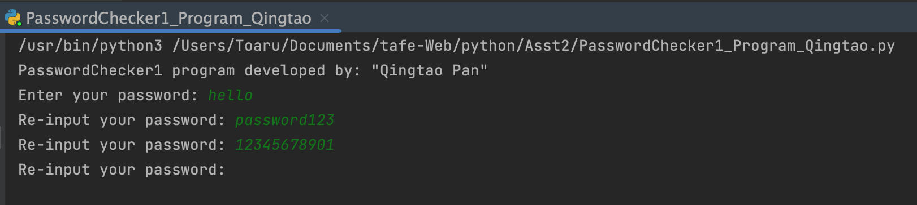

1. An input of Password will be accepted but a message will be produced stating the password has 8 characters and it is weak - contains only letters.

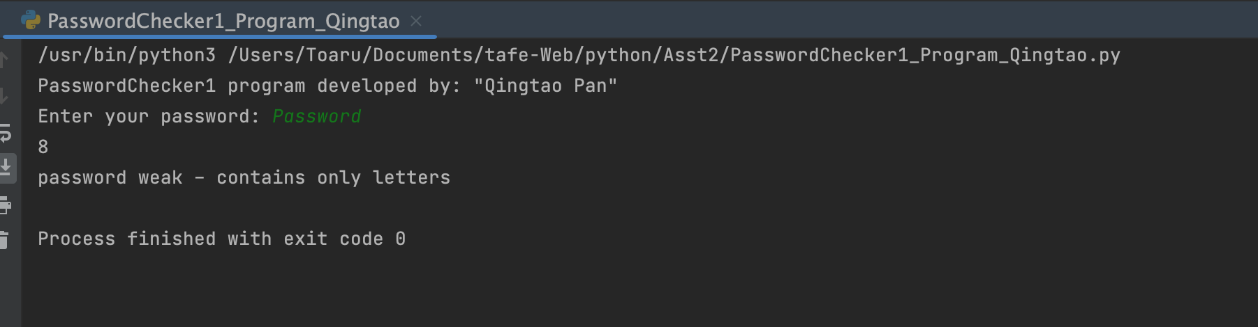

1. An input of 123456 will be accepted but a message will be produced stating the password has 6 characters and is weak - contains only numbers.

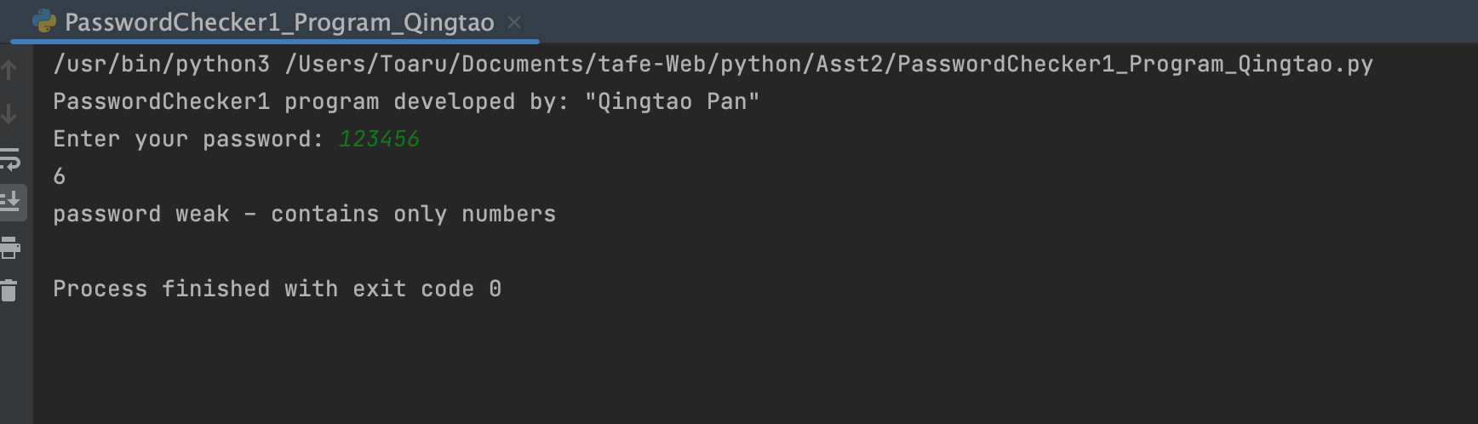

1. An input of password12 will be accepted and a message will be produced stating the password has 10 characters and is strong.

