Heathkit H-89 MSX Graphics Board Documentation
Jeff Tranter <tranter@pobox.com>
Last Updated: 26 February 2026

Introduction

This document contains notes on the Heathkit H-89 MSX Graphics board designed by Norberto Collado. I have assembled one of these boards and have written these notes to assist others who may be doing the same. My thanks go to the members of the SEBHC Discord channel for providing input to this document.

Note: The information here was written for the revision 1.1 board. There may be slight differences if you have a different board revision.

Board Features

The H-89 MSX board adds support to the Heathkit H-89 computer (and compatibles like the Zenith Z90) for MSX-compatible graphics, sound, and joysticks, allowing it to run programs (primarily video games) written for that platform.

MSX was a home computer architecture developed by Microsoft and ASCII Corporation in the 1980s as a standard for home computers. It was popular in Japan and several other countries, but not in North America, which a few exceptions such as the Canadian NABU Network machine. Most systems used the Texas Instruments TMS9918 graphics chip and General Instrument AY-3-8910 sound generator.

A loader program has been developed which runs under CP/M (HDOS is not currently supported) that can load and run MSX programs (ROM files).

Video output is to an HDMI monitor (not the H-89 display). Line level stereo audio output is provided which can drive amplified speakers or a monitor with a suitable audio input. Two wireless Bluetooth game controllers (joysticks) are supported, as well as wired joysticks. The board is installed in any of the three left side expansion slots of the H-89.

The board was designed by Norberto "Norby" Collado. The design is similar the MSX board for the Heathkit H8 computer, designed by Les Bird, and leverages some of the work done by him. That board is similar in functionality to the HA-8-3 graphics board (see reference [8]) that was originally offered by Heathkit for the H-8, but lacks some features of that board like the 9511 math coprocessor and A/D converter for analog joysticks. Heath also later made a similar board for the H-89. Some programs written for the HA-8-3 board should work with the MSX board in H8 mode. See Heath Users Group (HUG) disks 885-1098, 885-1099, and 885-114, available from the SEBHC web site.

Parts List

See reference [10] for a more detailed bill of materials.

Qty | Designation | Type | Description
15 | C2,C3,C4,C5,C6,C7,C11,C12,C13,C14,C15,C16,C17,C18,C19 | Capacitor | 0.1uF ceramic disc
2 | C1,C10 | Capacitor | 10uF, 25V, non-polarized
2 | C8,C9 | Capacitor | 47uF, 25V, tantalum or electrolytic
6 | R2,R3,R10,R11,R12,R13 | Resistor | 4.7K
3 | R1,R4,R5 | Resistor | 470
2 | R6,R7 | Resistor | 1K
2 | R8,R9 | Resistor | 1.8K
1 | L1 | Inductor | Ferrite bead, 76 Ohm
2 | D2,D3 | Diode | 1N5819
2 | D4,D5 | Diode | 1N4148
1 | D1 | Diode | BAT48
5 | U5,U6,U7,U10,U11 | IC | 74LVC245
2 | U12,U13 | IC | 74LS540
1 | U1 | IC | 74LS32
1 | U2 | IC | 74LS02
1 | U3 | IC | 74LS74
1 | U4,U7 | IC | AY-3-8910
1 | U8 | IC | 74LS245
1 | U9 | IC | ESP32-WROOM (30-pin)
1 | U14 | IC | 74LS125
1 | U15 | IC | GAL, 16V8
1 | - | IC | Tang Nano 9K F18A
1 | SW1 | Switch | DIP switch, 4-pos.
2 | JP1,JP2 | Connector | 1x3 male header
1 | JP5 | Connector | 1x2 male header
2 | J1,J2 | Connector | 2x5 male header
1 | J3 | Connector | 3.5mm stereo audio jack
2 | J4,J5 | Connector | 1x24 pin socket
1 | P507,P508,P509 | Connector | 25-pin Molex
1 | P501,P502,P503 | Connector | 10-pin Molex
1 | J13 | Connector | 1x6 male header, right angle
1 | n/a | n/a | Printed Circuit Board
1 | n/a | IC socket | 40-pin
4 | n/a | IC socket | 14-pin
9 | n/a | IC socket | 20-pin
1 | n/a | Cable | HDMI cable
2 | n/a | Joystick | Nintendo Switch type Bluetooth Controllers
2 | n/a | Joystick | Wired joysticks
7 | n/a | Wires | Dupont jumper wires, female to female

Board Assembly and Test

Install all components on the board using the schematic, board layout picture, and PCB silkscreen as guides. See references [10] and [2].

PCBs are available from Todd Goodman at reference [11].

You will also need to assemble a U509 buffer board, which is on a separate small PCB and is documented in reference [3].

In general, the recommendation is to install the lowest height parts first, i.e. resistors, small capacitors, IC sockets, etc. Ensure the correct orientation of the electrolytic or tantalum capacitors, diodes, and ICs. Note that not all ICs are oriented the same way.

The 25-pin Molex edge connectors are no longer available. You can use two 10-pin with one 5-pin in the middle. They are available from Digikey, Newark, Mouser, etc. The part numbers are 5-pin: Molex #22-15-2056, 10-pin: Molex #22-15-2106.

The two 10uF capacitors are non-polarized. The recommended part is Murata RCER71E106K3DBH03A (available from Digikey).

The ferrite bead is a Tayda 76 Ohm or similar. I used the Digikey part 1934-1556-ND.

Ensure you obtain the 30-pin version of the ESP-32 WROOM microcontroller (there is also a 38-pin version of the device which will not fit the board footprint).

Make sure that you purchase the 9K version of the Tang Nano FPGA. In this application it is used to emulate the functions of the TMS9918 video controller originally used on MSX systems. You may need to solder headers to the chip.

The board footprint for the audio jack fits Digikey part CP1-3535NG-GR-ND.

The General instrument AY-3-8910 chip is not longer manufactured, but NOS chips can be found on sources like eBay and Amazon. The Yamaha YM2149F chip should also work.

It is highly recommended to use sockets for all ICs. I used tall headers for installing the ESP32 and Tang Nano. See the pictures at reference [2]. Ensure that there is sufficient clearance for the ICs and sockets which are installed underneath them.

If using any NOS ICs, clean the pins if they look tarnished or oxidized.

The GAL, ESP32, and Tang Nano need to be programmed. See the instructions below.

Programming the GAL

The GAL is a programmable device of type 16V8. I used Atmel part number F16V8B-15PU.
You will need a suitable device programmer to program it. I programmed mine with a TL866II Plus programmer using the Linux Minipro software. Extract the files from H89-MSX-LS-GAL.zip from reference[9] and program it using the provided JED file, i.e. MSX-H89-DECODER.jed.

Programming the ESP32

You need to program the ESP32 over the USB port. It can be programmed out of the circuit. You can use the Flash Download Tool Windows application from reference [1]. You may need to install the Windows CP102 USB to UART driver if the ESP32 is not found on a COM port. Use the files and settings shown in the screen shots below.

- Select ChipType ESP32.
- Select the three .bin files, enter addresses and enable checkboxes.
- Check other settings (defaults should be okay).
- Set COM port (mine appeared on COM5).
- Click on START.
- It should program the ESP32 and complete in a minute or so.

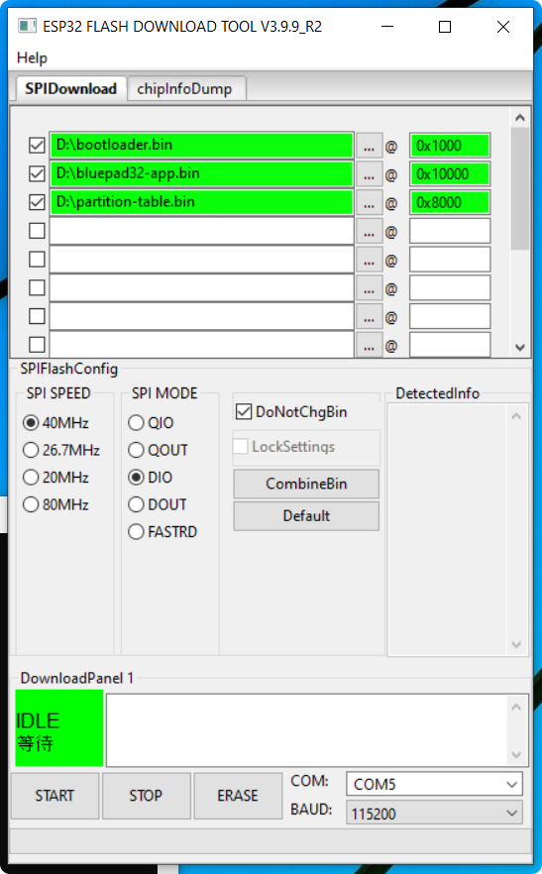

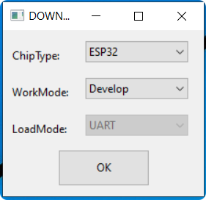

The ESP32 microcontroller is not needed if you only use wired joysticks. If you omit it from the board, then you should also remove U10, U11, U12, and U13.

Programming the Tang Nano

Program the Tang Nano over USB using the instructions at reference [6]. It can be programmed out of the circuit.

Joystick Support

Two Nintendo Switch compatible multifunction Bluetooth game controllers such as those at reference [14] are supported.

Alternatively you can connect wired “Atari type” joysticks to the joystick headers on the MSX board. These can be connected using DB9 serial male port bracket to 10 pin motherboard header panel mount cables such as found at reference [13].

CP/M Software

You will need to obtain the CP/M MSX loader program from references [5] and [10], including the BIOS file msx-us.rom and some MSX games from reference [4] and transfer them to your H-89.

Installation

The MSX board can be installed in any of the three left slide slots of the CPU board, using connectors P501/P507, P502/P508, or P503/P509. Note that there is no keying on the connectors for the board, so take care not to offset the pins or you may damage the MSX board and/or H-89 CPU board or power supply.

If your H-89 has a guide bracket on the left side with plastic guide pins for each slot, you should adjust the guide pin for the position of the VDIP board. The three guide pins holes are for boards with components facing left; you can have three different boards. The other holes for the guide pins are only for boards with components facing to the right; you only can have two. You can also have combinations of both setups. Refer to this picture:
https://github.com/jefftranter/Z80/blob/master/H89VDIP1/pictures/guidebracket.png

The U509 buffer board must be installed as described in reference [3]. You need to connect seven jumper wires from J13 on the MSX board to the corresponding pins on the buffer board. If you are using an H-89 VDIP board which is already connected to the U509 buffer board, you can connect the MSX jumpers to the signals at J5 on the VDIP board. The U509 buffer board also needs to have its two pin header for /RESET and /INT3 connected to a four pin header that is soldered to the H37/H67 disk controller or serial port boards (or any board in a right side slot). The signals are picked up from edge connector pins 15 (/RESET) and 18 (/INT3). See reference [16].
Connect the HDMI connector of the Tang Nano to an HDMI monitor.

Connect the audio out jack from J3 to amplified speakers or the audio line input of your monitor, if present.

DIP Switch and Jumper Settings Reference

Switch | Normal Setting | Description
32SPR | OFF | 32 sprites per line
SCANL | OFF | Simulated scan lines
GCLK | ON | GROM clock
CCLK | ON | CPU clock

Jumper | Description
JP2 | Jumper in upper or lower position depending on whether you are using wired joysticks or ESP32 (Bluetooth) joysticks.
PS_CTL | Normally jumpered in upper (A0) position.
MSX_8_PORT_SEL | When installed, use same i/o ports as the Heathkit graphics board for the H8. When not installed, runs in MSX mode. Normally not installed.

Connector Reference

Connector | Description
J1 | First wired joystick.
J2 | Second wired joystick.
J3 | Line level stereo audio out to headphones or amplified speakers.
J13 | Jumpered to corresponding pins on U509 buffer board or VDIP board (if present).

I/O Port Usage

The base i/o ports (in hex) used by the board are shown below:

Device | MSX Mode | H8 Mode
AY-3-8910 PSG | $A0 | $BA
Tang Nano VDP | $98 | $B8

Operation

Power up the system. You should see a display on the HDMI monitor when the Tang Nano boots up.

If using Bluetooth controllers, pair them with the ESP32. Check the instructions that came with your controllers for how to do this (on mine, I had to press the A and HOME keys for 3 seconds). Make sure that the controllers are charged. See the documentation that came with the controller(s).

Run the CP/M program MSX89.COM, specifying a ROM file, e.g.

A>MSX89 GALAG204.ROM

MSX89 ROM LOADER
USAGE: MSX89 GAMEFILE.ROM
2024 BY LES BIRD

LOADING MSX89-US.ROM BIOS
……………………………………………………………………
DONE

LOADING GAME
……………………………………………………………………

START ADDRESS: 4017

Verify that video, audio, and controllers are working. Download and run more MSX programs and have fun!

Troubleshooting

If the board does not work, here are some things to check:

- Check the board for solder bridges, unsoldered pins, incorrect parts or incorrect orientation of parts, and bent IC pins under sockets.
- Confirm that you have programmed the GAL, ESP32, and Tang Nano devices.
- Check jumper and DIP switch settings.
- Check the installation and wiring of the U509 buffer board including connections to a right side board.
- There is a known issue with the Tang Nano 9K where it will not work with some HDMI TVs. If you plug in your graphics board and you don't see anything on the screen, try plugging it into a different monitor/TV.

Board Images

Some pictures of the assembled board can be found at reference [2].

References

- https://docs.espressif.com/projects/esp-test-tools/en/latest/esp32/production_stage/tools/flash_download_tool.html#regular-download
- https://github.com/jefftranter/Z80/tree/master/H89MSX
- https://github.com/jefftranter/Z80/tree/master/H89VDIP1
- https://github.com/lesbird/MSX8/blob/main/romlist.md
- https://github.com/lesbird/MSX8/tree/main
- https://github.com/sebhc/sebhc/blob/master/wiki/F18ACLONE/Programming_Tang_Nano_9K_for_H8-8-3.txt
- https://github.com/sebhc/sebhc/wiki/F18A-TMS9918-FPGA-EMULATOR
- https://github.com/sebhc/sebhc/wiki/HA-8-3
- https://koyado.com/heathkit/New-H8-Website/download/h89-msx-ls-gal.zip
- https://koyado.com/heathkit/New-H8-Website/h89-msx_graphics_board.html
- https://retrobrewcomputers.org/doku.php?id=boardinventory
- https://github.com/sebhc/sebhc/wiki/H8%E2%80%90MSX
- https://www.amazon.com/Antrader-Serial-Bracket-Motherboard-Adapter/dp/B07FZZ34RD
- https://www.amazon.com/dp/B0DZBJYT7P?ref=ppx_pop_dt_b_product_details&th=1
- https://github.com/sebhc/sebhc/wiki/HA-8-3#games
- https://discord.com/channels/1051285909292716112/1171841560061673512/1334447535305261056

