Ambari Configuration Guide

A guide for configuring Ambari to use Red Hat Storage

Version 1.0
August 2013


Table of Contents

1 Introduction 3
2 Ambari Configuration 3
2.1 Wizard Install 3

1 Introduction

This guide assumes that all of the steps within the README, that is located within the rhs-ambari-install-<version> tarball have been completed. Specifically the install.sh script has run successfully to completion on a Red Hat Storage 2.0.5 cluster.

2 Ambari Configuration

After the ambari-server and ambari-agent(s) have successfully installed and started, use the Ambari Wizard tool to configure the cluster.

Verify their status by issuing the following commands

- On the server node: ambari-server status
- On the agent node(s): ambari-agent status

If the commands do not return a positive confirmation start the components via the command line

- On the server node: ambari-server start
- On the agent node(s): ambari-agent start

2.1 Wizard Install

Open a web broswer and point the URL to the ambari-server hostname in the following format

http://<ambari-server hostname>:8080

Once the login screen loads use admin/admin for the credentials and press the Sign In button:

Use the following screenshots to successfully configure you cluster.

2.1.1 Welcome Screen

Select a name for your cluster:

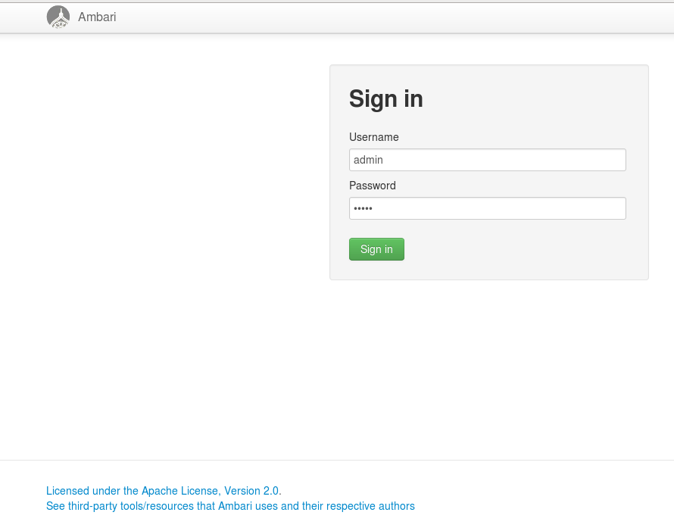
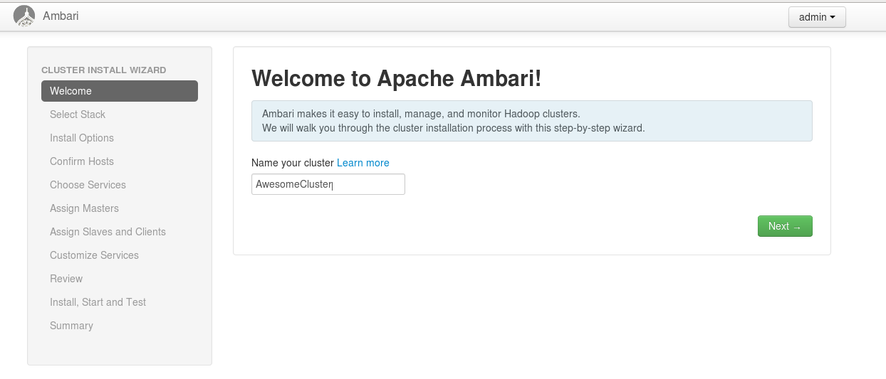
Press Next when complete

2.1.2 Select Stack

Select HDP 1.3.2 as the stack definition as seen below:
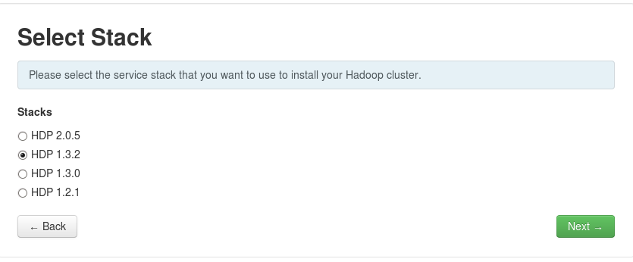
Press Next.

2.1.3 Target Hosts
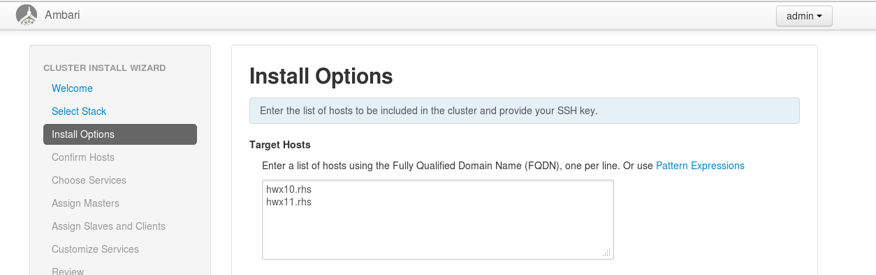
Enter your hosts as Fully Qualified Domain names into the box labeled ‘Target Hosts’. These are the same hostnames you provided in the ‘hosts’ file prior to running the install.sh script. Enter one per line.

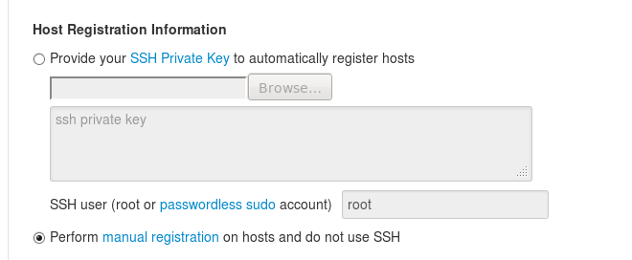
2.1.4 Host Registration Information

Select the second option in this section ‘Perform manual registration on the hosts and do not use SSH”

Upon chosing this option a warning window will appear
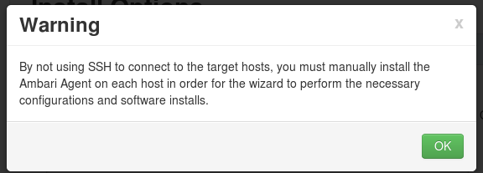
The manual install of the agents was completed by the install.sh script. No addition action needs to take place. Press OK to continue.

2.1.5 Advanced Options

Do not select anything under this section. Press ‘Register and Confirm” to continue
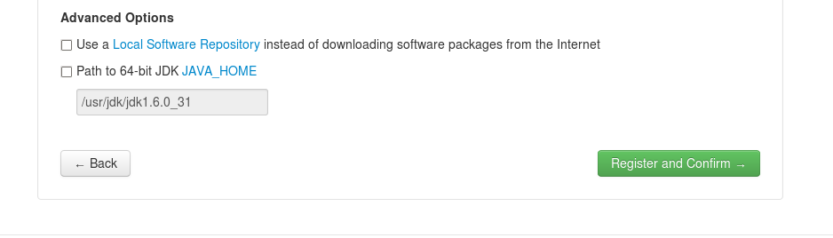
You will get another warning window. Select OK to continue, this step has already been completed by the install.sh script

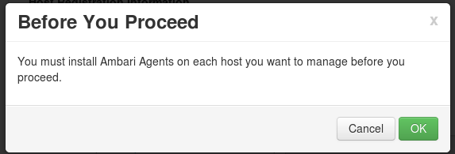

2.1.6 Confirm Hosts

Each agent will now register back to the sever node. This can sometimes take several minutes.
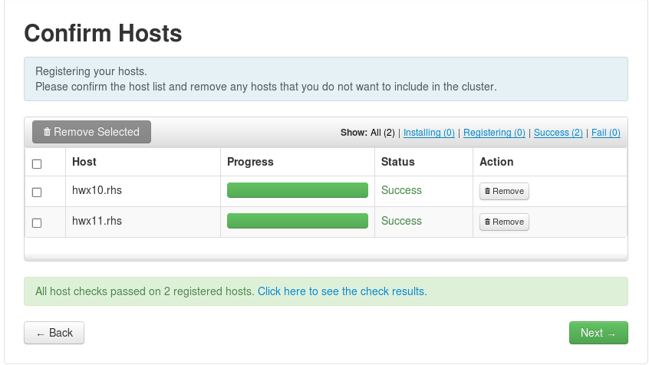

Select Next to continue once all hosts have registered successfully. You may receive a warning about existing directories and/or services. You can ignore this warning and proceed to the next step.

2.1.6 Choose Services

First press the ‘minimum’ link to remove any unnecessary services. Then select HCFS and MapReduce for the minimum services.

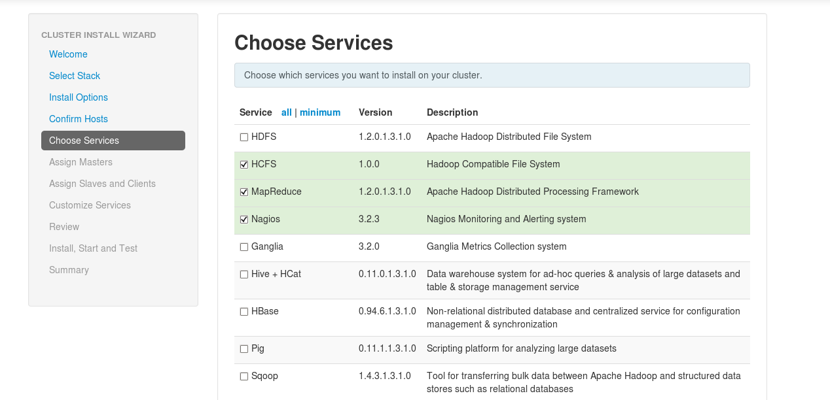
If you do not select Nagios and/or Ganglia you will get the following warning:
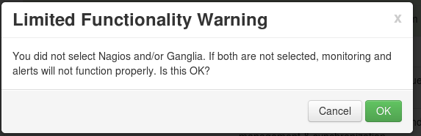

Select OK and continue.

2.1.7 Assign Masters

The next screen will allow you to select where you which hosts the services will run on.

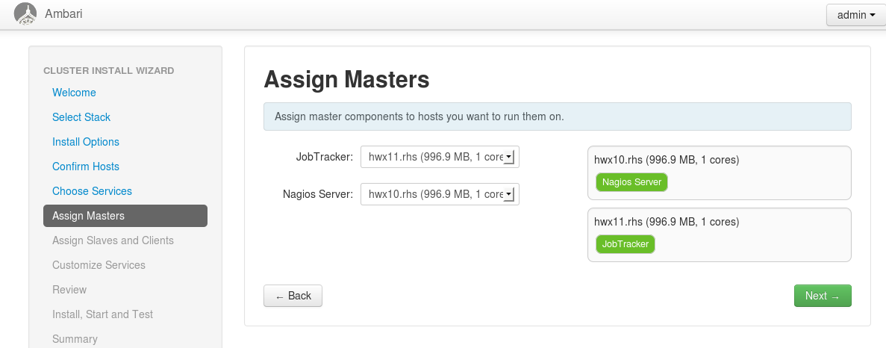
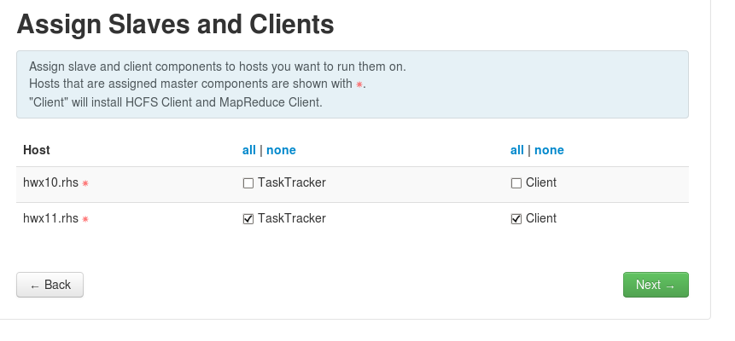
2.1.8 Assign Slaves and Clients

Put the HCFS client on all the nodes by selecting the checkbox for ‘Client’ on all nodes.

2.1.9 Customize Services

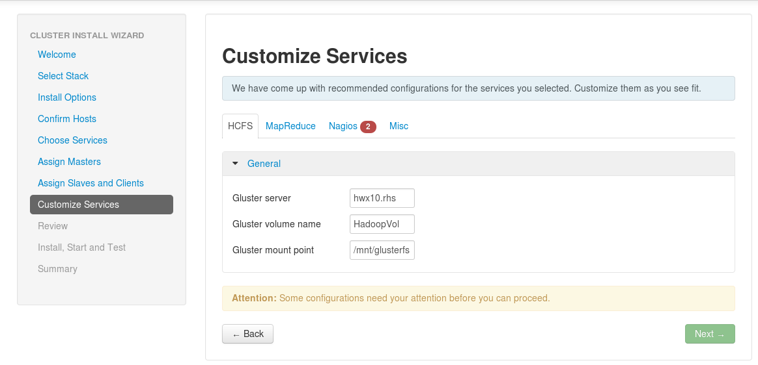
Next you can customize the services. You can accept the defaults provided except for the Nagios and Mapreduce tabs.

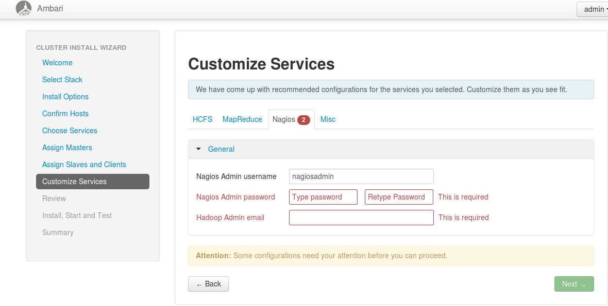
The Nagios tab requires you to provide a password and email address

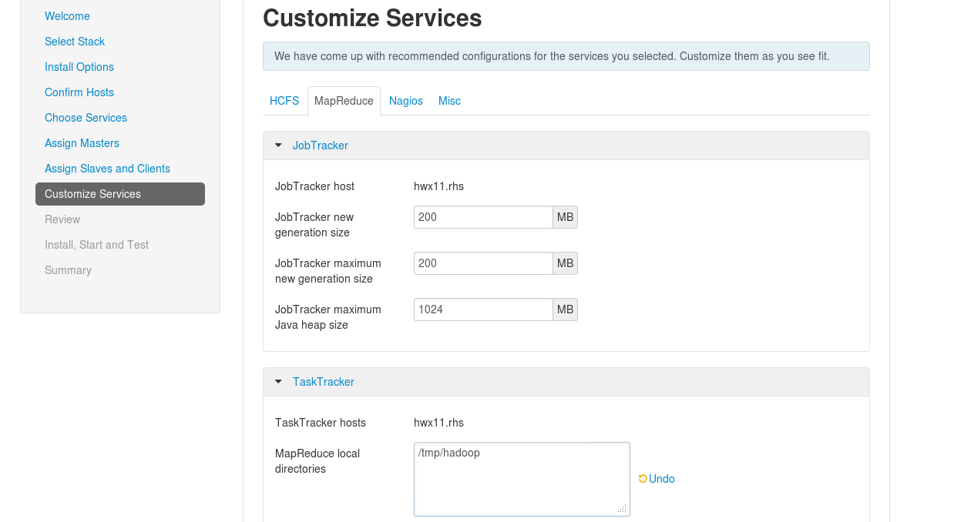
Under the MapReduce tab set the value for mapred.local.dir to /mnt/brick1/mapredlocal
Delete any of the other values that were prepopulated in that field.

Then Click Next.

2.1.10 Review Selections

Review the services and settings selected and click ‘Deploy’

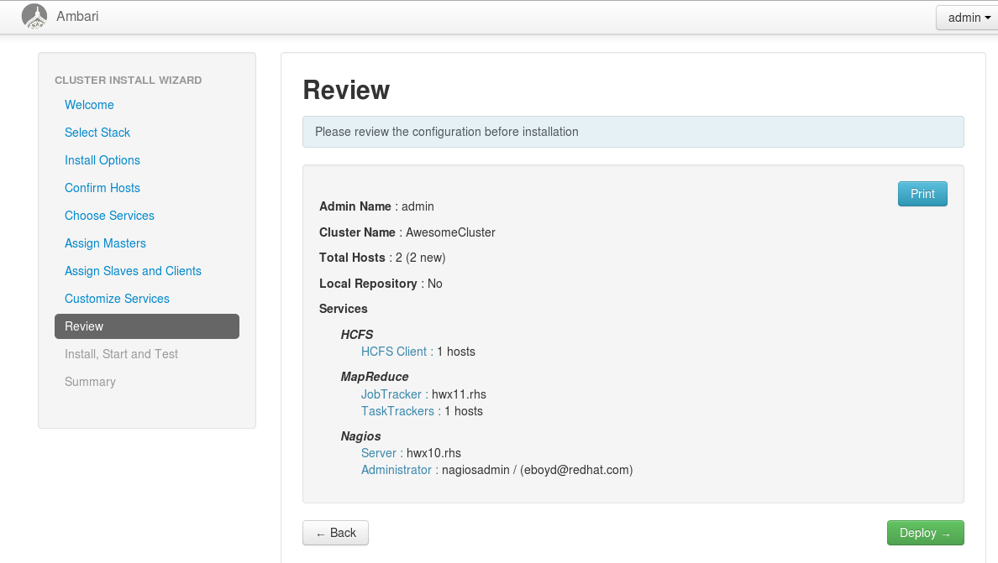
The installation can take an upwards of 20 minutes. Once completed you can start using your Red Hat Storage Hadoop Cluster!

Please refer back to the README for information on how to Test Hadoop on your new cluster.

