Untangling Scattered Business Logic
An Architecture for a Single Source of Truth Across Code, Rules Engines, and Ontologies
Architecture Proposal — Domain-Centric Metadata & Execution-Translation Pipeline
Prepared for internal architecture review

Executive Summary
Business logic in most enterprises is scattered across legacy code, database triggers, rules engine UIs, and informal ontologies — with no single place that tells you what the system actually does, or why. The result is logic drift: the same rule re-implemented three different ways, each drifting further from the others with every change.
This proposal lays out an architecture that fixes the root cause rather than the symptom. Two ideas do the work:
- A domain-centric Single Source of Truth (SSOT). Every constraint, rule, and computation is defined once, in a declarative spec, under version control.
- An explicit execution-translation pipeline. A CI/CD build step compiles that one spec into whatever each runtime needs — typed code, semantic graph artifacts, or rules-engine XML — instead of forcing every runtime to speak the same language.
The architecture is deliberately not a call to replace legacy engines with one universal tool. It treats business logic as a governed, versioned data artifact, and lets code, rules engines, and ontologies keep doing what each does best.

The Problem: Logic Has No Fixed Address
Legacy estates accumulate three failure modes simultaneously, and they compound each other:
- Duplication. The same eligibility rule lives in a stored procedure, a Drools ruleset, and a service-layer if-statement — each maintained independently.
- Silent drift. A rule changes in one place during an incident fix and is never propagated to the other two.
- No audit trail. Rules engine UIs and database triggers are edited directly in production, with no PR, no review, and no version history.
The instinctive fix — pick one tool and force everything into it — reliably fails. Procedural algorithms don't belong in a rules engine, and stateful workflows don't belong in an ontology. Section 1 gives each kind of logic its correct home before anything is centralized.

1. Classify Logic by Layer — the “Right Home” Principle
Before centralizing anything, classify what kind of logic you're looking at. Mixing these categories — running procedural code inside an ontology, or building stateful algorithms inside a rules engine — is the single largest driver of legacy bloat.
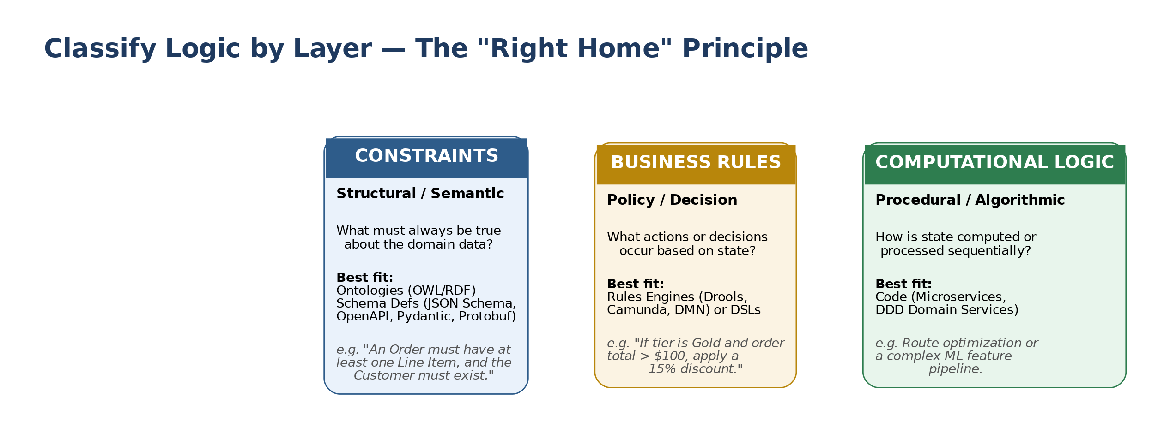
Figure 1. Three logic categories, each routed to the tool built for its paradigm.
Category | Governing question | Best-fit tooling | Example
Constraints  (structural / semantic) | What must always be true about the domain data? | Ontologies (OWL/RDF); schema definitions (JSON Schema, OpenAPI, Pydantic, Protobuf) | An Order must have at least one Line Item, and the Customer must exist.
Business Rules  (policy / decision) | What actions or decisions occur based on state? | Rules engines (Drools, Camunda, DMN) or a DSL | If customer tier is Gold and order total > $100, apply a 15% discount.
Computational Logic  (procedural / algorithmic) | How is state computed or processed sequentially? | Code — microservices, DDD domain services | Route optimization, or a multi-step ML feature pipeline.

2. Treat Logic as Code — the Governance Pipeline
Once logic is classified, it needs a Single Source of Truth: a central repository holding logic specs in human-readable form (YAML, DMN, Turtle/OWL). The hard rule that makes this work: nobody edits a rule directly in a Rules Engine UI or a production database. Everything is checked into source control first, and reaches production only by passing through CI.

Continuous Integration for Logic
Rule and schema changes go through the same discipline as application code:
- Linting & validation. Semantic reasoners (e.g., HermiT) catch contradictory ontology axioms; static analysis catches malformed or conflicting DMN tables before merge.
- Automated unit & scenario testing. Rule changes run against synthetic datasets pre-deployment, to catch side effects a human reviewer would miss.
- Semantic versioning. Rule sets and schemas are versioned explicitly. Consuming microservices declare which version of a policy or schema they depend on, so a rule change cannot silently break a downstream consumer.
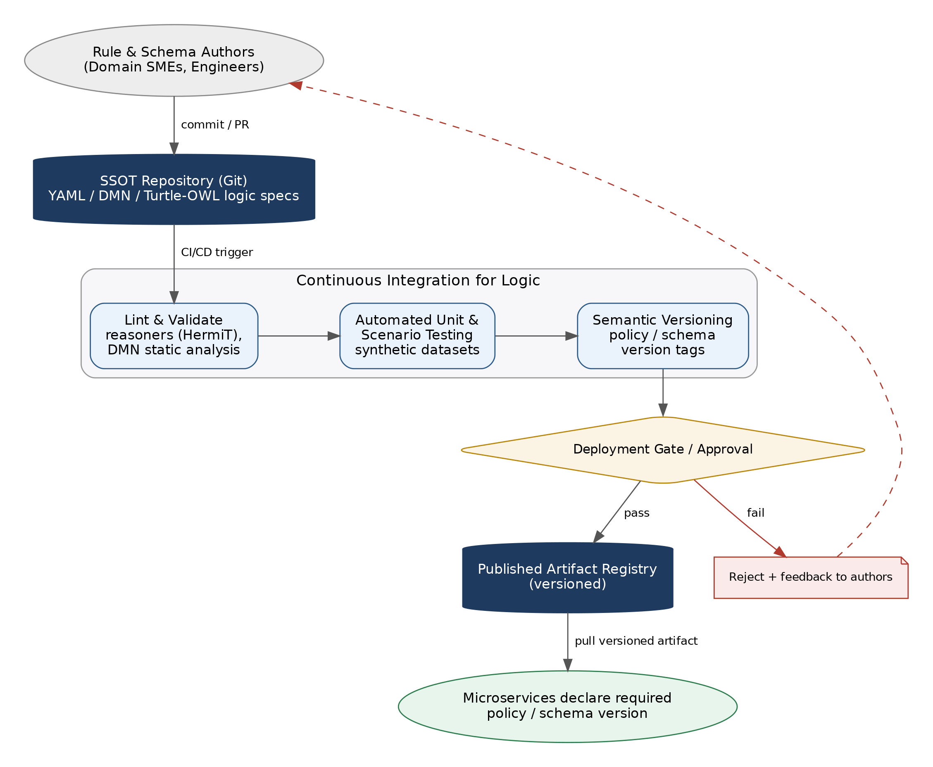
Figure 2. The GitOps loop for logic: commit → CI validation → gated release → versioned consumption, with rejected changes routed back to the author.

3. The Modern Pattern: Declarative Spec + Generated Executables
Rather than rewriting legacy applications to “speak the same language,” the architecture is declarative-first: logic is written once, and a build pipeline compiles it down to whatever each target runtime needs.
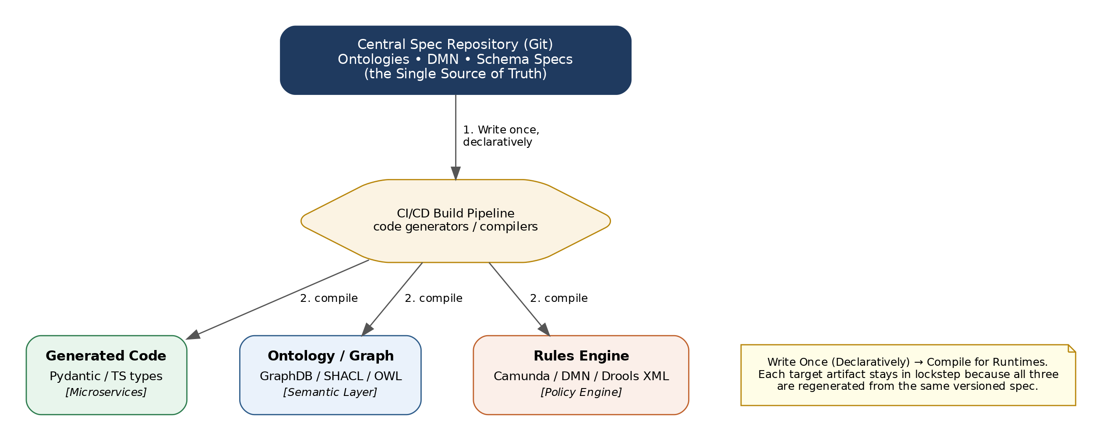
Figure 3. One declarative spec, three generated runtime artifacts, one CI/CD compiler in between.

How it works
- Write once, declaratively. Schema constraints, taxonomy, and core decisions are defined in standardized formats — OpenAPI/JSON Schema for constraints, DMN for rules.
- Compile for runtimes. Code generators in CI/CD produce the target artifacts on every merge:
  - TypeScript/Python interfaces for microservices
  - SHACL/OWL files for the semantic graph store
  - DMN/Drools XML for the rules-engine runtime
Because all three artifacts regenerate from the same versioned spec on every build, they cannot drift out of sync with each other — drift becomes a build failure, not a production incident.

Runtime View: The Decision API
At request time, callers don't talk to the rules engine, the ontology store, or a legacy stored procedure directly. They talk to a standardized Decision API that resolves the caller's declared policy version, validates the request against the current schema, and routes to whichever backend currently owns that decision — including a wrapped legacy engine that hasn't been migrated yet.
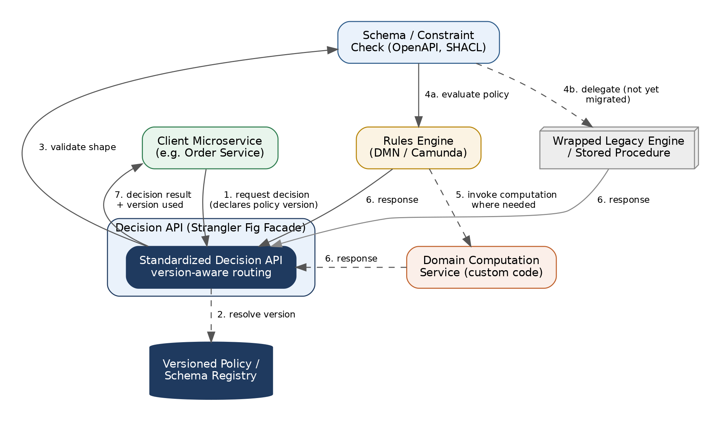
Figure 4. A client microservice never calls the rules engine, ontology store, or legacy procedure directly — it calls the Decision API, which is free to route to legacy or modern backends without the client knowing which.
This indirection is what makes the migration in Section 4 possible: the facade lets legacy and modernized decision logic sit behind one interface, so callers never need to change when the backend behind that interface changes.

4. Practical Migration Blueprint for Legacy Systems
For logic trapped in stored procedures, hardcoded Java/COBOL, and legacy rules engines, migrate in three phases rather than attempting a rewrite:

Phase 1 — Logic Discovery & Extraction
- Inventory & audit. Map existing logic with tracing tools and static analysis. Log every point where a business decision is made.
- Classify. Sort each finding into Constraint, Rule, or Computation using the framework in Section 1.

Phase 2 — Decouple via API Boundaries (Strangler Fig)
- Wrap, don't rewrite. Put legacy rules engines and stored procedures behind the standardized Decision API from Section 3 before touching their internals.
- Extract incrementally. Pull hardcoded logic out of application code into externalized configuration or DMN files piece by piece, re-pointing the facade as each piece lands.

Phase 3 — Centralize Schemas First
- Standardize data shapes. Unify data definitions across teams via a common ontology or schema registry before consolidating rules.
- Consolidate rules second. Once the underlying data definitions (constraints) are unified, reconciling the business rules that operate on that data becomes dramatically simpler — most apparent rule conflicts turn out to be data-shape conflicts in disguise.
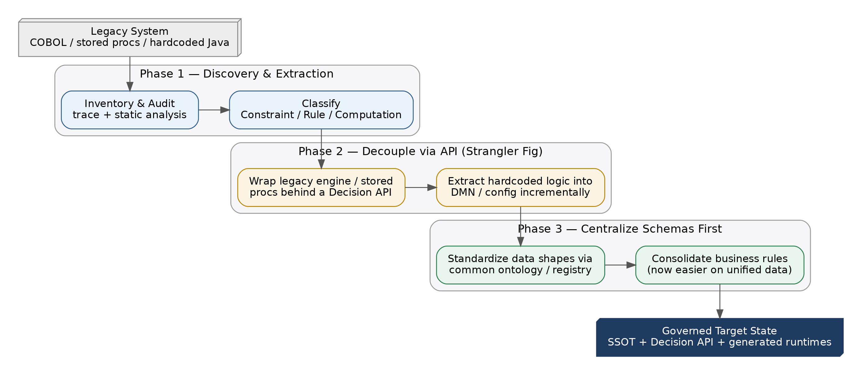
Figure 5. Three-phase strangler-fig migration: discover and classify, decouple behind a Decision API, then centralize schemas before consolidating rules.

5. Extending the Architecture: SME Ownership, Interfaces & Storage
Centralizing logic only works if the people who actually know the rules — domain SMEs — can maintain their slice without waiting on a platform team, and without being able to silently break someone else's. That requires three things: a namespace model that separates enterprise-wide logic from domain-specific logic, an interface that mirrors the classification from Section 1 instead of exposing raw spec syntax, and a storage choice that doesn't force unnecessary complexity onto teams that don't need it.

5.1 Core vs. Domain Ownership
Split the SSOT repository into a /core namespace and one /domains/<name> namespace per business domain. Domain schemas and rules extend core definitions through composition — allOf/$ref for JSON Schema, import statements for DMN and OWL — rather than copying core fields. A claims domain schema imports the core Customer definition and only adds claims-specific fields; it cannot redefine what a Customer is.
Ownership is enforced structurally rather than by convention, using a CODEOWNERS file that maps directories to teams: /core/** routes to the architecture/governance team, /domains/claims/** routes to the claims SME team, and so on. A PR touching only a domain directory needs domain-SME approval plus the automated CI checks from Section 2; a PR touching /core additionally requires architecture sign-off, because a core change can ripple into every domain that extends it.
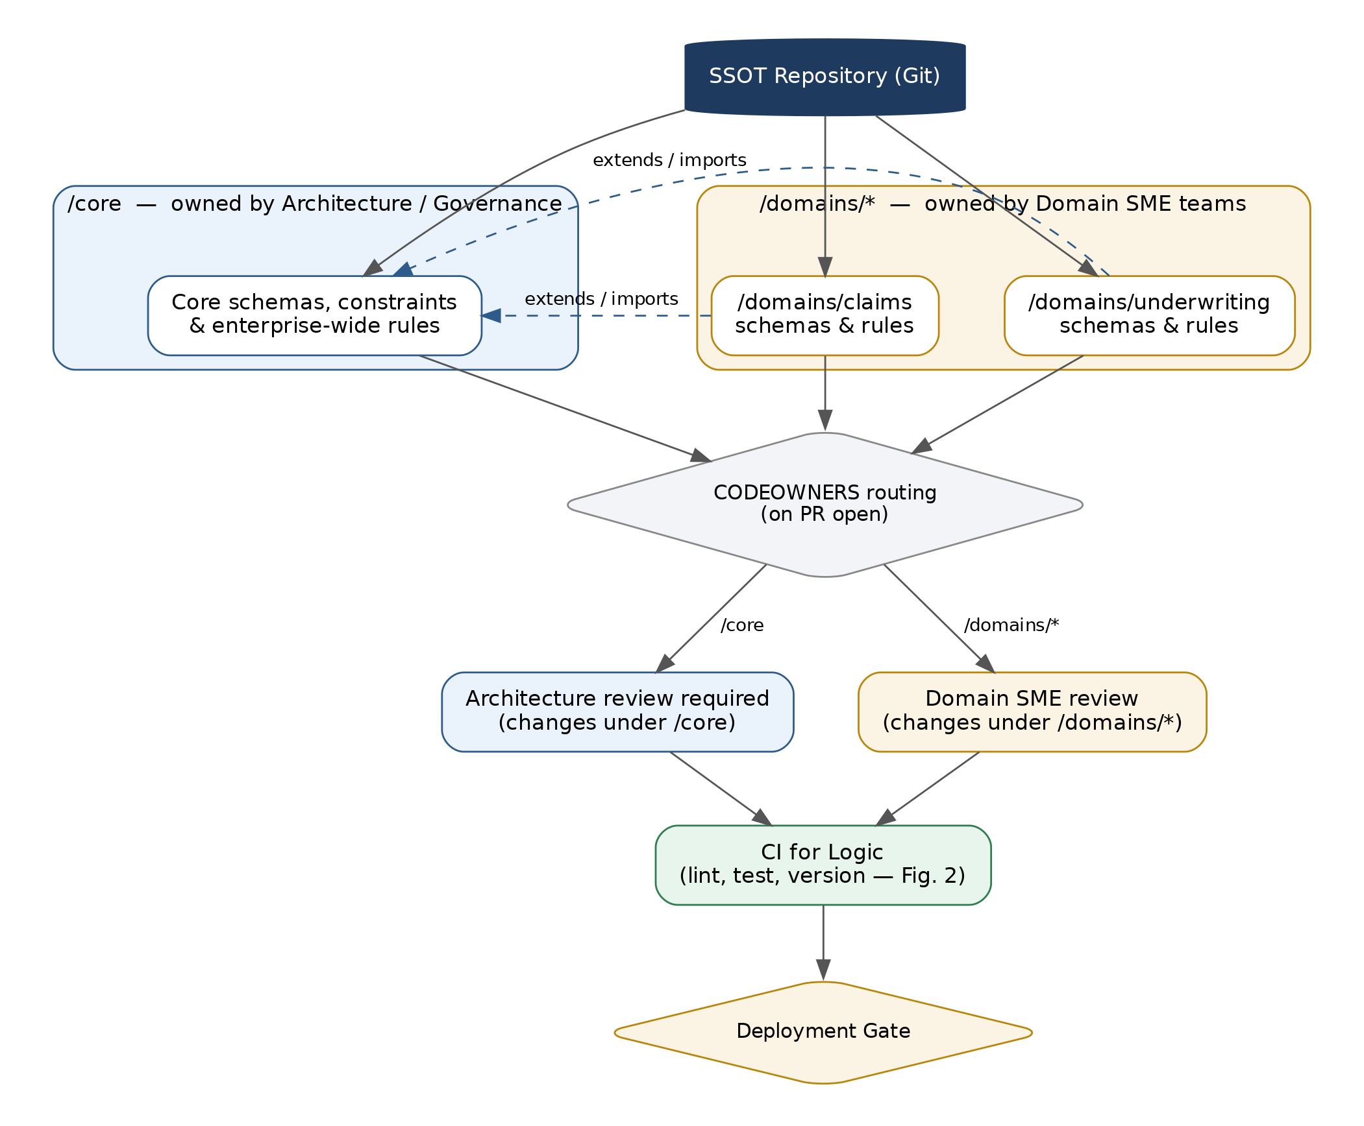
Figure 6. Core and domain specs share one SSOT repository; CODEOWNERS routes each PR to the right reviewer before it reaches the same CI pipeline from Figure 2.

5.2 SME Interface: One Surface per Logic Type
The common mistake is a single generic “rule editor” that mixes schema fields and decision logic in one screen. Instead, give SMEs a distinct surface for each category from Section 1 — and deliberately withhold the third:
- A schema/constraint surface. A data-dictionary-style form — field name, type, required, allowed values, cardinality — never raw JSON Schema, Turtle, or SHACL syntax. SMEs think in terms of which fields exist and what's valid, not RDF serialization.
- A rules surface. DMN decision tables, presented as the grid they already are — conditions as columns, outcomes as rows — editable directly by a business user through a tool like Camunda Modeler or an embedded decision-table widget.
- No logic surface. Computational/procedural logic stays in code, owned by engineers, and is not exposed for SME editing at all — this is the “right home” principle applied to the interface, not just to storage. SMEs can see a read-only trace of which services consume a given rule or constraint, but they don't touch the computation itself.
Both editable surfaces write back through the same Git-plus-CI pipeline from Section 2, so “easy to review” and “governed” are the same workflow rather than two competing ones.

5.3 Storage: When (Not) to Reach for Triples or a Graph Database
The instinct that SHACL and SWRL are painful to maintain at scale is correct, but the two are not equally at fault. SHACL is a validation language — closed-world, non-inferential — tedious to hand-author but not inherently hard to scale. SWRL is the real problem: combined with OWL it pushes reasoning into undecidable territory, tooling outside Protégé/HermiT is thin, and very few organizations run it successfully in production. If a rule needs SWRL-style inference, it's almost always a Business Rule, not a Constraint — it belongs in the DMN layer from Section 1, not in the ontology.
That reframes the original question. Storing raw triples in Postgres without a reasoner sitting on top is usually the worst of both options: it inherits RDF's schema-loose, hard-to-query shape without gaining OWL's inference power, so any “semantic” logic ends up hand-rolled in application code anyway — exactly the work a graph engine exists to avoid. The better move is to route each need to the simplest tool that actually satisfies it:
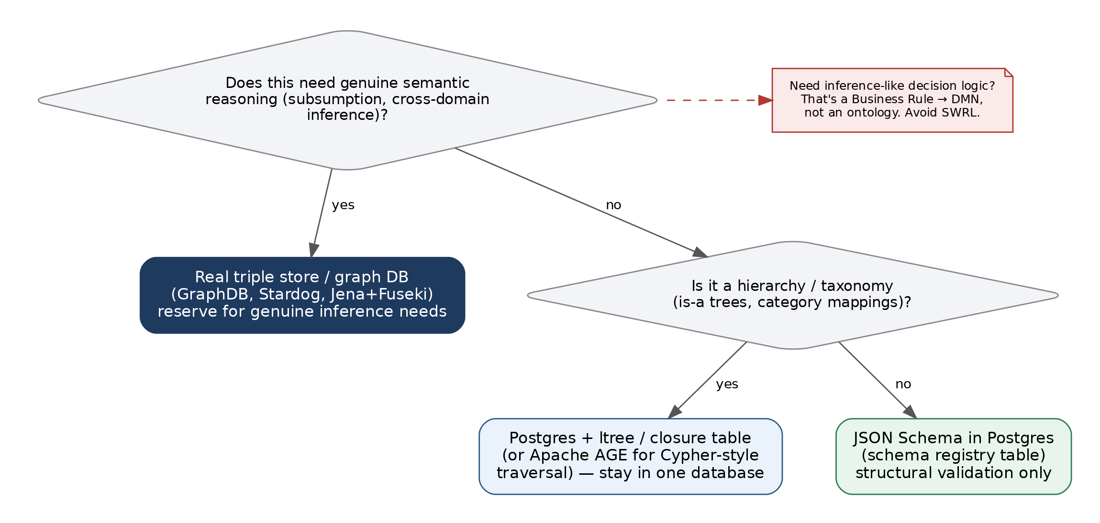
Figure 7. Most constraint and taxonomy needs are satisfied inside Postgres; a real triple store is reserved for the narrow case of genuine cross-domain semantic reasoning.
- Structural validation (the bulk of SME-maintained constraints). Model as JSON Schema, stored as versioned rows in a Postgres schema-registry table. This also removes a translation step from the pipeline in Section 3, since JSON Schema compiles directly to the Pydantic/TypeScript types microservices consume.
- Hierarchies and taxonomies (is-a trees, category mappings). These are genuinely graph-shaped, but Postgres handles trees and DAGs well via the ltree extension or a closure table — or Apache AGE if you want Cypher-style traversal — without standing up a second database system.
- Genuine cross-domain semantic reasoning. Reserve a real triple store or graph database (GraphDB, Stardog, Jena+Fuseki) for the narrow case where you actually need subsumption or cross-domain inference — not by default, only when a concrete reasoning requirement exists.

6. Version Control, Lifecycle, and Cross-Boundary Meaning
Two mechanisms complete the governance model: a lifecycle state machine that makes version numbers trustworthy rather than aspirational, and a mapping layer that lets domains extend Core's vocabulary without redefining it, duplicating it, or silently merging concepts that only look alike.

6.1 Versioning & Lifecycle Management
SemVer alone only records that something changed — it doesn't guarantee the author picked the right severity. The fix is to let the diff decide the bump instead of trusting a human to remember: a schema-diff tool in CI classifies each change automatically (adding a required field or narrowing a type is MAJOR; adding an optional field is MINOR; a description edit is PATCH), and the build fails if the declared bump doesn't match what the diff actually contains.
Every artifact also carries an explicit lifecycle state as metadata that travels with it through Git history, not a side channel:
- Draft → Candidate. Authored, then opened as a PR and run through the CI pipeline from Section 2.
- Released. Published to a versioned artifact registry and treated as immutable — consumers pin to a range (e.g. "^2.3.0") rather than a single fixed version.
- Deprecated → Retired. A sunset date is attached when a version is superseded; once that date passes the version is removed from the registry and any consumer still pinned to it fails its build rather than silently drifting onto stale logic.
Because domain specs extend Core through composition (Section 5), domain manifests declare a compatibility range against Core (e.g. requires core >= 2.1, <3.0), and CI periodically checks that range is still satisfiable — surfacing domains that have fallen behind Core's deprecation window before it becomes an incident.
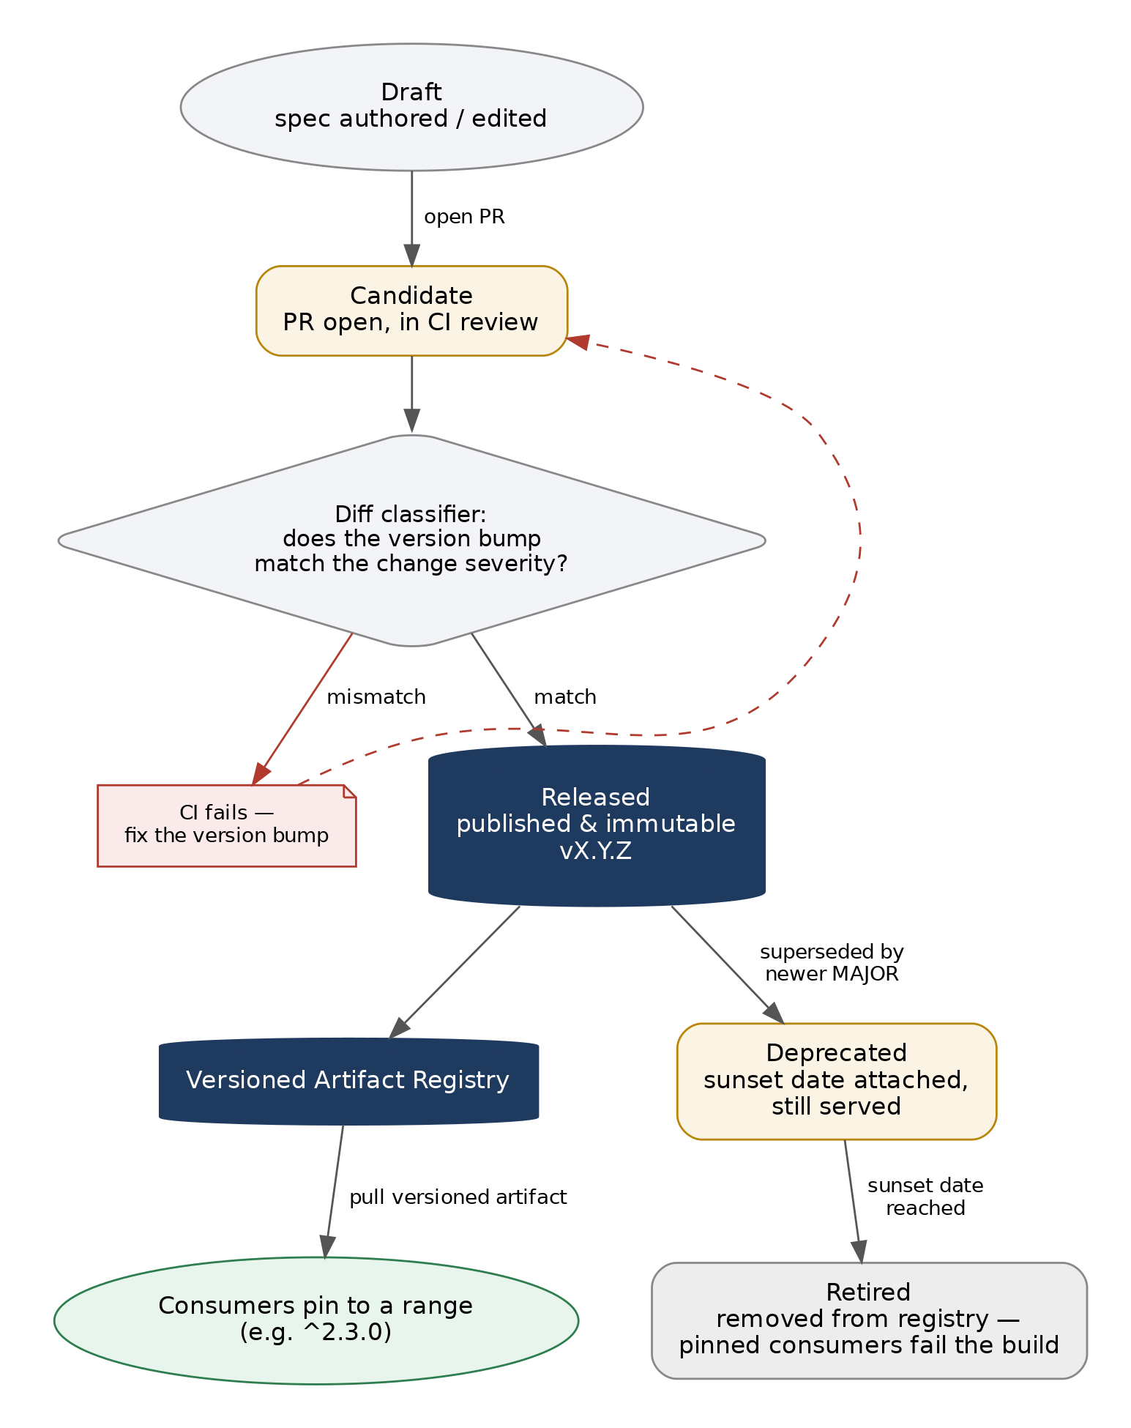
Figure 8. A diff classifier gates promotion to Released; deprecation and retirement are explicit, scheduled transitions rather than silent removals.

6.2 Attribution, Classification & Boundary Management via Mapping Ontologies
Domains redefining or ambiguously overloading a Core concept is what happens when domains are allowed to reuse Core terms directly instead of declaring an explicit relationship to them. The fix is a third namespace that neither Core nor any domain owns outright: a mapping (bridge) layer.
Core stays minimal and stable — it never imports domain terms to accommodate a domain's needs. Each domain defines its own vocabulary freely, then publishes a separate mapping file declaring how its terms relate to Core's, using SKOS rather than full OWL: skos:broader/narrower for hierarchy, skos:exactMatch only when two concepts are genuinely identical, skos:closeMatch when they're similar but not interchangeable. SKOS is deliberately weaker than owl:equivalentClass/owl:sameAs — it records a relationship for humans and tooling to query without triggering the kind of inference chain that quietly merges two concepts that only resemble each other.
This one mechanism addresses all three problems at once:
- Attribution. Every mapping file records who defined a term and what it claims to relate to in Core (owner, source domain, mapping type) — provenance is a field on the artifact, not something reconstructed after the fact.
- Boundary management. The topology is a star, not a mesh: domains map to Core, never to each other directly. Core stays simple because it never has to know about every domain, and a domain can't accidentally couple itself to a sibling domain's internal vocabulary.
- Classification consistency. A CI closure check walks the mapping graph and fails the build if any domain term has no path to a Core root — the same check doubles as duplicate-prevention, since it surfaces existing close matches before an SME creates a new term that already exists under another name.
Because an incorrect exactMatch claim can cause a quiet cross-domain inference error downstream, the mapping file is the one domain-adjacent artifact that's CODEOWNERS-routed to require sign-off from both the domain SME and Architecture — the seam where boundary violations actually happen gets the extra review, not every domain change.
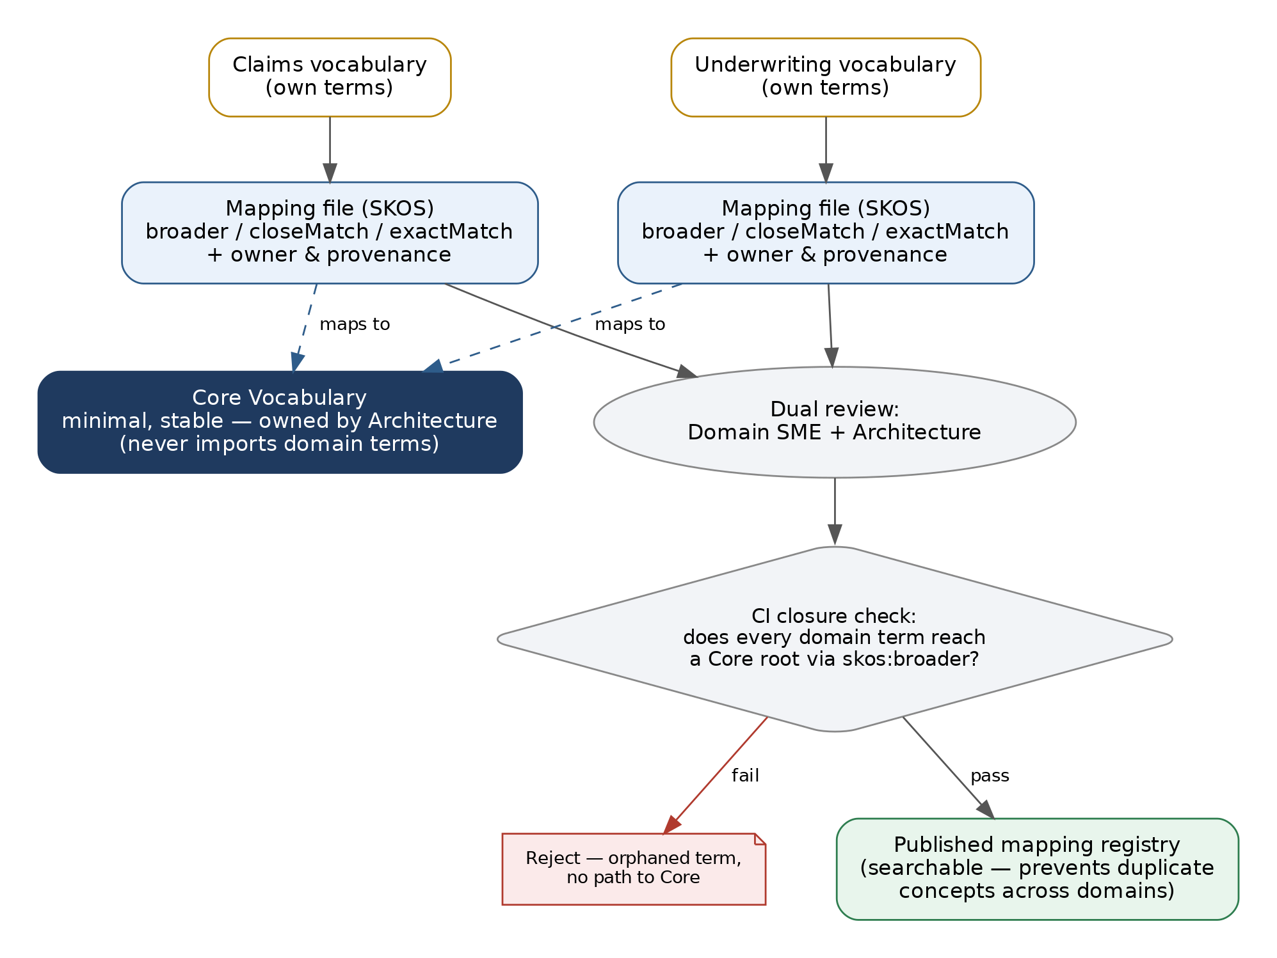
Figure 9. Domains map to Core through a reviewed, versioned SKOS bridge file rather than importing or redefining Core terms directly — a star topology, not a mesh.
This stays consistent with the storage guidance in Section 5.3: the mapping relationships are a small, well-typed edge list — a relational table with indexes, not a reason to stand up a triple store. If the mappings ever need to leave the organization as standards-based RDF/SKOS, generate that as a compiled output from the pipeline in Section 3, rather than making it the system of record.

Key Pitfalls to Avoid
Pitfall | Why it matters / what to do instead
The “Universal Engine” Trap | Don't run procedural code inside an ontology, or build complex stateful algorithms inside a rules engine. Use each tool for the paradigm it was built for — see Section 1.
Unversioned Database Triggers | Move validation logic out of SQL triggers and into upstream microservices or declarative schema checks, where it can be versioned, tested, and reviewed.
Orphaned Rule Authoring | Avoid business-user UIs that save directly to production databases without passing through Git and CI testing first — this is the single fastest way to reintroduce logic drift.
Triples Without a Reasoner | Don't store raw RDF triples in Postgres as a default choice — without a reasoner on top it loses OWL's inference benefit while keeping RDF's query complexity. Use JSON Schema or a tree structure instead unless genuine reasoning is required.
Overusing exactMatch / owl:sameAs | Claiming strict equivalence between a domain term and a Core term when they're only similar merges their identity for any downstream reasoner. Default to skos:closeMatch and reserve exactMatch for concepts that are truly interchangeable.

Recommended Next Steps
- Stand up the SSOT repository and CI pipeline first — before extracting a single rule. Governance has to exist before there's anything worth governing.
- Pilot on one bounded decision (e.g., discount eligibility) to prove the classify → spec → compile → deploy loop end-to-end, including the Decision API facade.
- Inventory before you migrate. Run Phase 1 across the legacy estate broadly before committing engineering time to Phase 2 extraction — classification changes the shape of the migration plan.
- Make version declaration mandatory for any service consuming a policy or schema from day one, so the versioning discipline never has retrofitting debt.
- Define /core vs. /domains boundaries before onboarding SMEs. Agree the CODEOWNERS map and composition rules up front — retrofitting ownership boundaries onto an already-shared namespace is far more disruptive than setting them at the start.
- Stand up the diff classifier and mapping closure check in CI before the first domain onboards. Both are cheap to add early and expensive to retrofit once versions and mappings already exist without them.

