Name: 王冠鈞

ID: F74036108

UML Class Diagram

|  |
| --- |
| Points |
| - points: Integer  - prepoints: Integer |
| + backZero()  + changePoint(a:Integer)  + get(): Integer  +prev(): Integer |

|  |
| --- |
| MainWindow |
| - grid[4][4]: Integer  - lastgrid[4][4]: Integer  - regretgrid[4][4]: Integer  - ifCombined[4][4]: bool  - ifMove: bool  - pointCnt: Points *  - pix[2049]: QPixmap  - ui: Ui::MainWindow * |
| <<constructor>>+ MainWindow(parent: QWidget *)  + keyPressEvent(event: QKeyEvent *)  + moveUp(i: Integer, j: Integer)  + moveDown(i: Integer, j: Integer)  + moveRight(i: Integer, j: Integer)  + moveLeft(i: Integer, j: Integer)  + bound(i: Integer, j: Integer): bool  + allNonZero(): bool  + possible(): Integer  + refreshBoard()  + showLabel()  + hideLabel()  - on_pushButton_pressed()  - on_pushButton_released()  - on_pushButton_2_pressed()  - on_pushButton_2_released()  - on_pushButton_3_clicked()  - on_pushButton_4_clicked() |

Normal version:

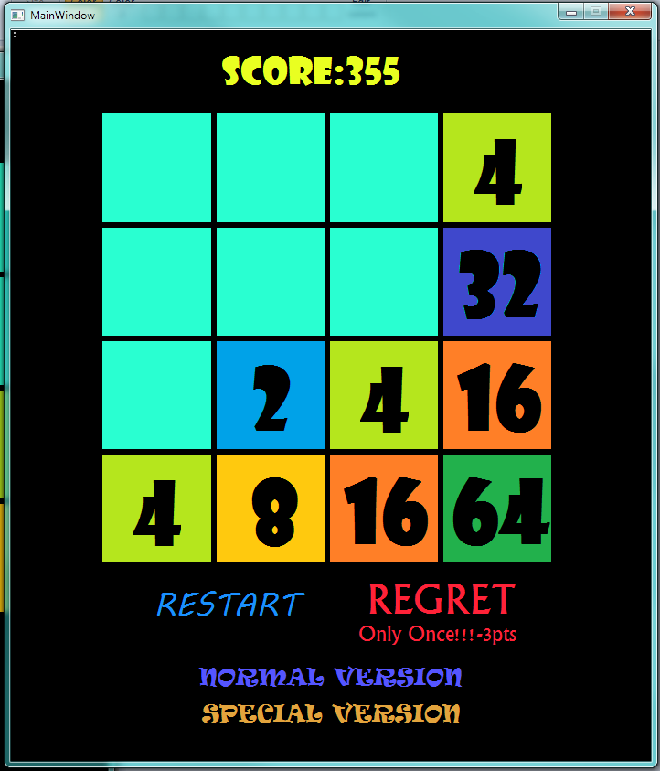

Special version:

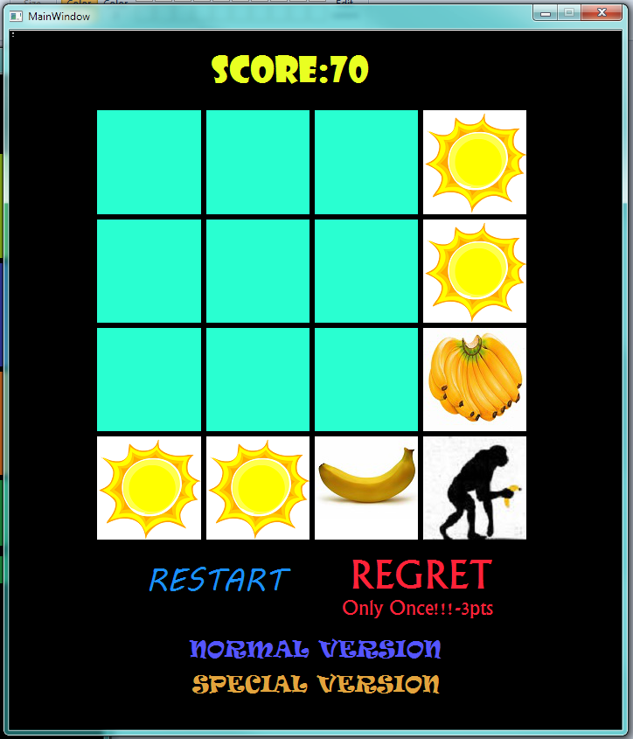

Win&lose:

