An Analysis of Characteristic Relationships of Craft Beer

Claudia Woodruff & Jeff Weltman

October 12, 2017



## Overview

W&W Analytics has been commissioned by *Stars, Stripes, and Beer Co.* to analyze the Craft Beer market in the United States and to determine any associative relationship between primary beer characteristics.

The owners would like to grow their business and would like any insight we may provide to enable them to make the best decisions to increase their market share. Specifically, they would like to have a better understanding of the relationship between ABV and IBU across each of the 50 states in the United States. They suspect that refining the ABV and IBU levels of their craft beers would be key to gaining more market share of the craft beer segment.

## Project Description

W&W Analytics has been commissioned by *Stars, Stripes, and Beer Co.* - hereafter referred to as *SS&B* - to analyze a sample of the craft beer market in order to answer the following research questions:

* How many breweries are present in each state?
* What is the median alcohol content (ABV) for each state?
* What is the median international bitterness unit (IBU) for each state?
* Which state has the maximum alcoholic (ABV) beer?
* Which state has the most bitter (IBU) beer?
* Is there any apparent relationship between the bitterness of the beer and its alcoholic content?

#### Hypothesis

In this study we will determine whether there is an associative relationship between ABV and IBU levels in beer.

#### Observational Study

As this is an observational study, we note that any conclusions drawn from the data can only be inferred as associative within the scope of this sample population.

This research is therefore not intended to support such conclusions as, for example, a higher ABV *causes* a higher IBU. Instead the findings might indicate that evidence suggests *an association* between ABV and IBU.

## Study Design and Data Processing

The study was designed to be a representative sample of craft breweries, both large and small, across all 50 states of the United States of America. The data, obtained by the client, was consolidated from disparate sources into these two data files.

These data were collected from public domain sources. The sources are known to be reputable and include *ratebeer.com*, *Brewer's Association* websites, and social media.

Beers <- "https://raw.githubusercontent.com/jeffweltman/StarsStripesAndBeer/master/Raw/Beers.csv"   
DFBeers <- repmis::source_data(Beers)

## Downloading data from: https://raw.githubusercontent.com/jeffweltman/StarsStripesAndBeer/master/Raw/Beers.csv

## SHA-1 hash of the downloaded data file is:  
## d3e3e8f8e9cf27e0df038f47ccfcfc2dfccf4217

#SHA-1 hash of the downloaded data file is:  
# d3e3e8f8e9cf27e0df038f47ccfcfc2dfccf4217  
  
Breweries <- "https://raw.githubusercontent.com/jeffweltman/StarsStripesAndBeer/master/Raw/Breweries.csv"  
DFBreweries <- repmis::source_data(Breweries)

## Downloading data from: https://raw.githubusercontent.com/jeffweltman/StarsStripesAndBeer/master/Raw/Breweries.csv

## SHA-1 hash of the downloaded data file is:  
## 4579c1fc92624c25cb2643d7e61c542972fdc7ab

#SHA-1 hash of the downloaded data file is:  
# 4579c1fc92624c25cb2643d7e61c542972fdc7ab

## Method

### Data Tidying

Our raw data required some tidying, which is common with this type of data. First, we renamed variable names in order to aid in merging the two files.

colnames(DFBeers) <- c("BeerName","Beer_ID","ABV","IBU","Brewery_ID","Style","Ounces")  
colnames(DFBreweries) <- c("Brewery_ID","BreweryName","City","State")

We discovered that there were many incomplete records in the raw data sets, likely due to the dependency on self-reported information. Therefore, some data tidying was necessary. There were numerous observations with missing ABV and/or IBU values. As the analysis was dependent upon these values, these observations were not included in this study. We chose to remove the observations after We merge the data sets. North Dakota was an exception, as an IBU value was missing from all ND observations. To avoid omitting all ND beers from the study, we set their IBU value to zero rather than deleting the observations completely.

colSums(is.na(DFBeers)) # DFBeers has 1,005 observations with IBU of NA but will be removed after merge

## BeerName Beer_ID ABV IBU Brewery_ID Style   
## 0 0 62 1005 0 0   
## Ounces   
## 0

colSums(is.na(DFBreweries)) # DFBreweries has no NA

## Brewery_ID BreweryName City State   
## 0 0 0 0

We also checked for outliers. The standard deviation for the ABV variables was low, concluding there were no outliers of concern. Although the standard deviation for the IBU measurement was quite high at over 25, we did not remove any outliers based on IBU as research indicates that IBU values do typically have a wide range. (ref: <https://www.brewersfriend.com/2017/05/07/beer-styles-ibu-chart-2017-update/>)

summary(DFBeers)

## BeerName Beer_ID ABV IBU   
## Length:2410 Min. : 1.0 Min. :0.00100 Min. : 4.00   
## Class :character 1st Qu.: 808.2 1st Qu.:0.05000 1st Qu.: 21.00   
## Mode :character Median :1453.5 Median :0.05600 Median : 35.00   
## Mean :1431.1 Mean :0.05977 Mean : 42.71   
## 3rd Qu.:2075.8 3rd Qu.:0.06700 3rd Qu.: 64.00   
## Max. :2692.0 Max. :0.12800 Max. :138.00   
## NA's :62 NA's :1005   
## Brewery_ID Style Ounces   
## Min. : 1.0 Length:2410 Min. : 8.40   
## 1st Qu.: 94.0 Class :character 1st Qu.:12.00   
## Median :206.0 Mode :character Median :12.00   
## Mean :232.7 Mean :13.59   
## 3rd Qu.:367.0 3rd Qu.:16.00   
## Max. :558.0 Max. :32.00   
##

summary(DFBreweries)

## Brewery_ID BreweryName City State   
## Min. : 1.0 Length:558 Length:558 Length:558   
## 1st Qu.:140.2 Class :character Class :character Class :character   
## Median :279.5 Mode :character Mode :character Mode :character   
## Mean :279.5   
## 3rd Qu.:418.8   
## Max. :558.0

sd(DFBeers$ABV) # 0.0126

## [1] NA

sd(DFBeers$IBU) # 25.954

## [1] NA

### Data Merging

Since all beers from South Dakota were missing IBU data, we set their IBU to 0. Otherwise, all their beers would be deleted in the null removal process.

We noted that two of the observations had a blank in the "Styles" column. We recoded these to N/A so they would not be removed from our data set, as our research questions were chiefly interested in ABV and IBU. We then merged the raw data sets and removed the observations with NA's as previously described.

BrewsAndBreweries <- merge(x=DFBeers, y=DFBreweries, by="Brewery_ID", all=TRUE)  
BrewsAndBreweries$IBU <- ifelse(BrewsAndBreweries$State=="SD",0,BrewsAndBreweries$IBU)  
BrewsAndBreweries[which(BrewsAndBreweries$Style==""),]

## Brewery_ID BeerName Beer_ID ABV IBU Style  
## 227 30 Special Release 2210 NA NA   
## 455 67 OktoberFiesta 2527 0.053 27   
## 946 161 Kilt Lifter Scottish-Style Ale 1635 0.060 21   
## 992 167 The CROWLERâ<U+0084>¢ 1796 NA NA   
## 993 167 CAN'D AID Foundation 1790 NA NA   
## Ounces BreweryName City State  
## 227 16 Cedar Creek Brewery Seven Points TX  
## 455 12 Freetail Brewing Company San Antonio TX  
## 946 12 Four Peaks Brewing Company Tempe AZ  
## 992 32 Oskar Blues Brewery Longmont CO  
## 993 12 Oskar Blues Brewery Longmont CO

# Two beers - OktoberFiesta and Kilt Lifter Scottish-Style Ale have no Style provided. Re-coded as "N/A"  
BrewsAndBreweries$Style <- ifelse(BrewsAndBreweries$Style=="","N/A",BrewsAndBreweries$Style)  
  
# Any NA's from merged (breweries with beers with no ABV or IBU rating)?   
colSums(is.na(BrewsAndBreweries)) # Yes

## Brewery_ID BeerName Beer_ID ABV IBU Style   
## 0 0 0 62 998 0   
## Ounces BreweryName City State   
## 0 0 0 0

BrewsAndBreweries <- subset(BrewsAndBreweries, !is.na(IBU)) # Remove them  
BrewsAndBreweries <- subset(BrewsAndBreweries, !is.na(ABV))

We wrote the merged data set to a csv file. We also created two tidy data sets from the clean merged data set and wrote them to csv files.

# Write the merged data set to a csv file:  
write.csv(BrewsAndBreweries, file = "BrewsAndBreweries.csv", row.names=FALSE)  
  
# Create tidy data files  
TidyBeers <- BrewsAndBreweries[,c(1:7)]  
TidyBreweries <- BrewsAndBreweries[,c(1,8:10)]  
write.csv(TidyBeers,"TidyBeers.csv",row.names=FALSE)  
write.csv(TidyBreweries,"TidyBreweries.csv",row.names=FALSE)

A check on the first and last six observations from the merged (tidy) file did not indicate any issues with the merged file. We also checked that we indeed have no NA's remaining.

head(BrewsAndBreweries, 6) # Looks okay

## Brewery_ID BeerName Beer_ID ABV IBU  
## 1 1 Get Together 2692 0.045 50  
## 2 1 Maggie's Leap 2691 0.049 26  
## 3 1 Wall's End 2690 0.048 19  
## 4 1 Pumpion 2689 0.060 38  
## 5 1 Stronghold 2688 0.060 25  
## 6 1 Parapet ESB 2687 0.056 47  
## Style Ounces BreweryName City  
## 1 American IPA 16 NorthGate Brewing Minneapolis  
## 2 Milk / Sweet Stout 16 NorthGate Brewing Minneapolis  
## 3 English Brown Ale 16 NorthGate Brewing Minneapolis  
## 4 Pumpkin Ale 16 NorthGate Brewing Minneapolis  
## 5 American Porter 16 NorthGate Brewing Minneapolis  
## 6 Extra Special / Strong Bitter (ESB) 16 NorthGate Brewing Minneapolis  
## State  
## 1 MN  
## 2 MN  
## 3 MN  
## 4 MN  
## 5 MN  
## 6 MN

tail(BrewsAndBreweries, 6) # Looks okay

## Brewery_ID BeerName Beer_ID ABV IBU  
## 2386 545 Pyramid Hefeweizen (2011) 399 0.052 18  
## 2387 545 Haywire Hefeweizen (2010) 82 0.052 18  
## 2388 546 Rumspringa Golden Bock 392 0.066 30  
## 2389 546 Lancaster German Style KÃ¶lsch 195 0.048 28  
## 2390 547 Common Sense Kentucky Common Ale 382 0.053 22  
## 2391 547 Upstate I.P.W. 381 0.065 70  
## Style Ounces BreweryName City  
## 2386 Hefeweizen 12 Pyramid Breweries Seattle  
## 2387 Hefeweizen 16 Pyramid Breweries Seattle  
## 2388 Maibock / Helles Bock 12 Lancaster Brewing Company Lancaster  
## 2389 KÃ¶lsch 12 Lancaster Brewing Company Lancaster  
## 2390 American Brown Ale 16 Upstate Brewing Company Elmira  
## 2391 American IPA 12 Upstate Brewing Company Elmira  
## State  
## 2386 WA  
## 2387 WA  
## 2388 PA  
## 2389 PA  
## 2390 NY  
## 2391 NY

colSums(is.na(BrewsAndBreweries)) # 0 NA's

## Brewery_ID BeerName Beer_ID ABV IBU Style   
## 0 0 0 0 0 0   
## Ounces BreweryName City State   
## 0 0 0 0

### Analysis

We took a look at various statistics such as median IBU, ABV by state, and IBU by state.

medianIBU <-median(BrewsAndBreweries$IBU, na.rm=TRUE)  
ABV_ByState <- aggregate(ABV ~ State, data=BrewsAndBreweries, median)  
IBU_ByState <- aggregate(IBU ~ State, data=BrewsAndBreweries, median)

A bar chart was created; First, we merged the median ABV and median IBU data with the state data to get a "wide" table. For easier side-by-side comparison, we multiply ABV by 807 to approximate the same range of values. Then we melted these facts to get a long table with ABV and IBU as two values for the *variable* column and their levels became values in the *Value* column. The following plot shows side-by-side median IBU and ABV data per state:

library(reshape2)

## Warning: package 'reshape2' was built under R version 3.4.1

BeerFacts <- merge(x=ABV_ByState,y=IBU_ByState,by="State")  
  
# For easier side-by-side comparison, we multiply ABV by 807 to approximate the same range of values  
BeerFacts$ABV <- BeerFacts$ABV * 807  
  
# Then we melt these facts to get a long table with ABV and IBU as two values for the variable column, and their levels in the Value column  
BeerFacts.long <- melt(BeerFacts)

## Using State as id variables

BeerFacts.long <- BeerFacts.long[order(BeerFacts.long$State),]  
  
# The following plot shows side-by-side median IBU and ABV data per state  
library(ggplot2)

## Warning: package 'ggplot2' was built under R version 3.4.1

theme(plot.title = element_text(hjust = 0.5))

## List of 1  
## $ plot.title:List of 11  
## ..$ family : NULL  
## ..$ face : NULL  
## ..$ colour : NULL  
## ..$ size : NULL  
## ..$ hjust : num 0.5  
## ..$ vjust : NULL  
## ..$ angle : NULL  
## ..$ lineheight : NULL  
## ..$ margin : NULL  
## ..$ debug : NULL  
## ..$ inherit.blank: logi FALSE  
## ..- attr(*, "class")= chr [1:2] "element_text" "element"  
## - attr(*, "class")= chr [1:2] "theme" "gg"  
## - attr(*, "complete")= logi FALSE  
## - attr(*, "validate")= logi TRUE

theme_update(plot.title = element_text(hjust = 0.5))  
  
ggplot(BeerFacts.long,aes(x=State,y=value,fill=factor(variable)))+  
 geom_bar(stat="identity",position="dodge", width=0.8)+  
 scale_fill_discrete(name="Measurement",  
 breaks=c(0,1),  
 labels=c("ABV","IBU"))+  
 xlab("State")+ylab("Level")+  
 ggtitle("Median ABV and Median IBU Per State")+  
 coord_flip() # sets value on y axis, States on x. Commenting out the + above and this line will reverse

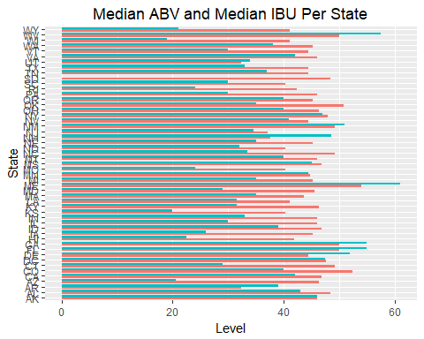

This bar plot shows median ABV data per state:

ggplot(ABV_ByState,aes(State,ABV))+  
 geom_col(fill="#45415E")+  
 coord_cartesian(ylim=c(0.03,0.075))+  
 ggtitle("Median ABV Per State")+  
 coord_flip() # sets value on y axis, States on x. Commenting out the + above and this line will reverse

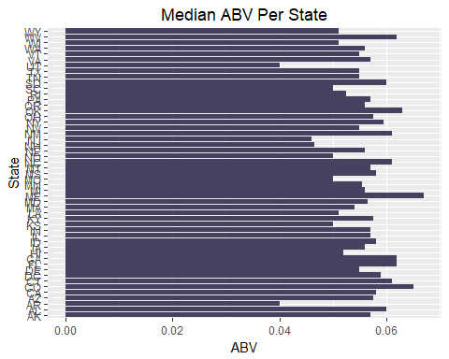

This bar plot shows median IBU data per state (South Dakota == 0):

ggplot(IBU_ByState,aes(State,IBU))+  
 geom_col(fill="#91B3BC")+  
 coord_cartesian(ylim=c(0,63))+  
 ggtitle("Median IBU Per State")+  
 coord_flip() # sets value on y axis, States on x. Commenting out the + above and this line will reverse

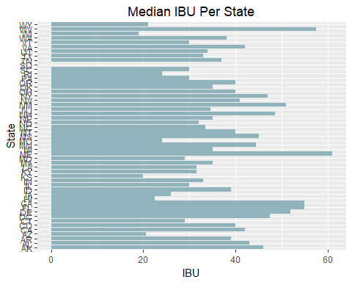

We determined which state had the highest ABV.

MaxABV <- aggregate(ABV ~ State,   
 data=BrewsAndBreweries,   
 max)  
MaxABV <- MaxABV[order(-MaxABV$ABV),]  
paste("With an ABV of ", (MaxABV[1, "ABV"]),", ", (MaxABV[1, "State"]), " has the beer with the highest alcohol content: ", BrewsAndBreweries$BeerName[which(BrewsAndBreweries$ABV==MaxABV[1, "ABV"])],".", sep="")

## [1] "With an ABV of 0.125, KY has the beer with the highest alcohol content: London Balling."

We determined which state had the highest IBU.

MaxIBU <- aggregate(IBU ~ State,   
 data=BrewsAndBreweries,   
 max)  
MaxIBU <- MaxIBU[order(-MaxIBU$IBU), ]  
paste("With an IBU of ", (MaxIBU[1, "IBU"]),", ", (MaxIBU[1, "State"]), " has the beer with the highest bitterness: ", BrewsAndBreweries$BeerName[which(BrewsAndBreweries$IBU==MaxIBU[1, "IBU"])],".", sep="")

## [1] "With an IBU of 138, OR has the beer with the highest bitterness: Bitter Bitch Imperial IPA."

We reviewed the summary and plots which indicated a positive correlation does appear likely.

print(summary(BrewsAndBreweries$ABV))

## Min. 1st Qu. Median Mean 3rd Qu. Max.   
## 0.02700 0.05000 0.05700 0.05991 0.06800 0.12500

plot(x=BrewsAndBreweries$ABV, y=BrewsAndBreweries$IBU, xlab = "Alcohol Content (ABV)", ylab = "Bitterness (IBU)", main = "Relationship Between Bitterness and Alcohol Content")

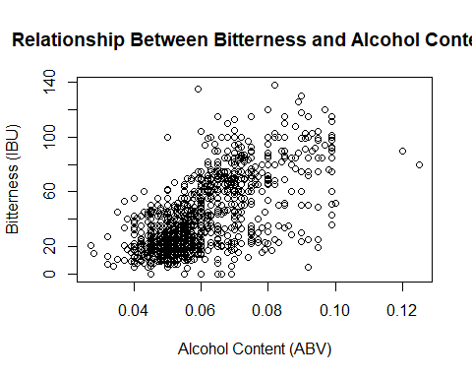

To confirm, we ran a correlation test to get Pearson's R, which indicated that 66.6% of the variation in IBU is explained by a change in ABV.

cor.test(BrewsAndBreweries$ABV, BrewsAndBreweries$IBU)

##   
## Pearson's product-moment correlation  
##   
## data: BrewsAndBreweries$ABV and BrewsAndBreweries$IBU  
## t = 33.525, df = 1410, p-value < 2.2e-16  
## alternative hypothesis: true correlation is not equal to 0  
## 95 percent confidence interval:  
## 0.6359280 0.6940543  
## sample estimates:  
## cor   
## 0.6660009

We can see this correlation more clearly with the following scatter plot.

# Add a factor column on the ABV:  
# Number | Label | Value of ABV  
# -----------------------------------  
# 1 | low | min-050  
# 2 | med low | 0.050-0.059  
# 3 | med high | 0.060-0.069  
# 4 | high | 0.07-max  
  
BrewsAndBreweries$ABVlvl[BrewsAndBreweries$ABV < 0.05 ] <- 1  
BrewsAndBreweries$ABVlvl[BrewsAndBreweries$ABV  
 >= 0.05 &  
 BrewsAndBreweries$ABV < 0.06 ] <- 2  
BrewsAndBreweries$ABVlvl[BrewsAndBreweries$ABV  
 >= 0.06 &  
 BrewsAndBreweries$ABV < 0.07 ] <- 3  
BrewsAndBreweries$ABVlvl[BrewsAndBreweries$ABV >= 0.07 ] <- 4

# Create a vector of factor level labels, and convert labels to a factor.  
#-----------------------------------------------------------------------#  
ABVlabels <- c("low", "med low", "med high", "high")  
BrewsAndBreweries$ABVlvl <- factor(BrewsAndBreweries$ABVlvl, labels = ABVlabels)

reg <- lm(IBU ~ ABV, data=BrewsAndBreweries) # Getting the intercept and slope for abline  
  
library(ggplot2)  
ggplot(data = BrewsAndBreweries, aes(x=ABV, y=IBU, color = ABVlvl))+  
 geom_point(size=2)+  
 geom_abline(intercept=-34.1, slope = 1282.0)+  
 ggtitle("Correlation Between ABV and IBU")

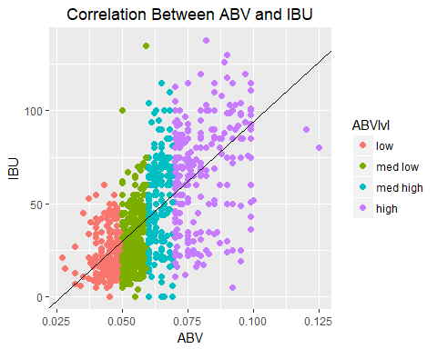

## Conclusion

The evidence suggests that there is a positive correlation between ABV and IBU value in beer, indicated both graphically and by the 0.666 Pearson's R. As 66.6% of the variation in IBU is explained by variation in ABV, we expect to see the IBU levels trend higher as ABV increases. Furthermore, by including breweries from all 50 states, we have accounted for a wide variety of confounding variables. These include brewery location - altitude, barometric pressure, temperature, etc. - as well as the ingredients of the craft brews themselves. As this is an observational study, we cannot conclude that alcohol level *causes* bitterness, but the evidence of assocation merits further study. After thorough data analysis, we therefore conclude that alcohol content is positively associated with bitterness level within this population.