1. **RESEARCH QUESTIONS**

A plant fertilizer manufacturer implemented a new formulation of fertilizer that yields the most increase in the height of Blueberry plants. To test the effectiveness of this new formulation of fertilizer, three groups of 50 identical Blueberry seedlings: a group with no fertilizer, a group with the manufacturer’s fertilizer(called GrowFast), and another group with fertilizer (called SuperPlant) from competitor’s are placed in a controlled greenhouse environment for about 16 weeks (approximately 4 months) and thereafter measured the Blueberry plants’ heights (in cm).

Is there a significant difference in plant growth between Blueberry plants with no fertilizer, plants with the manufacturer’s fertilizer, and plants with the competitor fertilizer at 5% level of significance?

1. **SOURCES OF DATA**

The source of data collected from MINITAB and reference link is shown below:

[*https://support.minitab.com/en-us/minitab/18/help-and-how-to/graphs/how-to/interval-plot/before-you-start/example/*](https://support.minitab.com/en-us/minitab/18/help-and-how-to/graphs/how-to/interval-plot/before-you-start/example/)

1. **PRELIMINARY ANALYSIS ON DESCRIPTIVE STATISTICS**

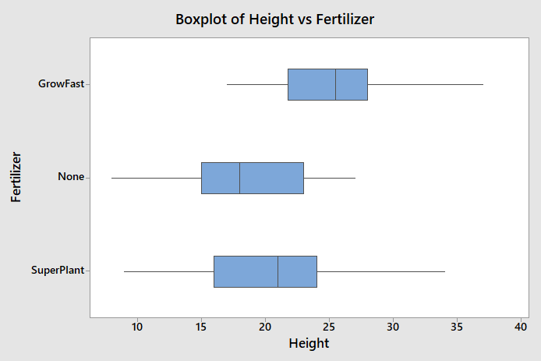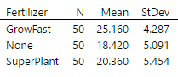

**Interpretation of Results:**

* There is no outlier found in the boxplot between the groups. Hence, there should be no influence on the data analysis.
* Based on the width of the box (IQR), GrowFast does not seems to be overlapping with other groups (no fertilizer and SuperPlant) showing the significant difference between the groups. However, no fertilizer and SuperPlant seems to be overlapping with one another showing that there might be no significant difference between these two groups.
* Appropriate hypothesis testing should be conducted to check if the difference is statistically significant.

1. **TYPE OF HYPOTHESIS TESTING**

The samples drawn here involved with 3 population groups, and therefore **one-way ANOVA** will be used to check if the difference is statistically significant.

1. **ASSUMPTIONS OF HYPOTHESIS TESTING**
2. **Each sample is independence.** The residuals on the plot fall randomly around the center line.

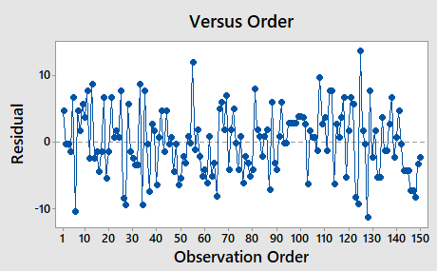

1. **Residuals or errors follows a normal distribution** as most of the points are close to the line in the normal probability plot.

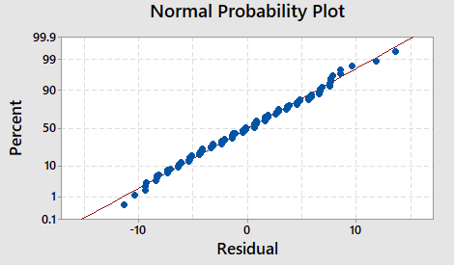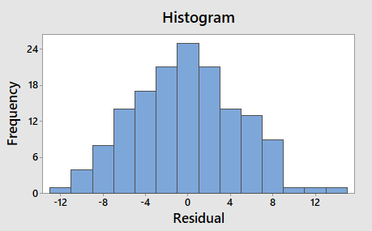

1. **Equal variances using Levene’s Test**

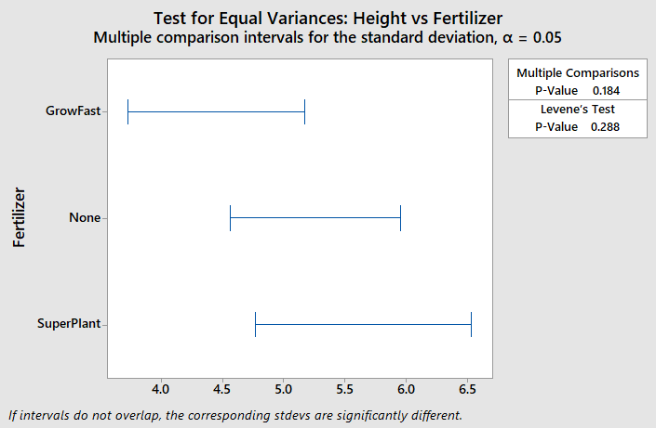

H0 : variances are equal

H1 : variances are not equal

Since P-value = 0.288 > α = 0.05, therefore **H0 is not rejected** and the 3 samples have equal variances.

Based on all above assumptions, the assumption of ANOVA is satisfied.

1. **RESPONSE, FACTOR, NUMBER OF LEVELS AND LEVELS**

|  |  |
| --- | --- |
| **Response** | Plant’s height (in cm) |
| **Factor** | Fertilizer |
| **Number of Levels** | 3 |
| **Levels** | Plants with no fertilizer; plants with manufacturer’s fertilizer (called GrowFast); plants with competitor’s fertilizer (called SuperPlant) |

1. **SETTING UP NULL AND ALTERNATIVE HYPOTHESIS**

H0 : µGrowFast = µnone = µSuperPlant

H1 : Not all means are equal

1. **DATA ANALYSIS AND INTERPRETATION OF RESULTS USING MINITAB**

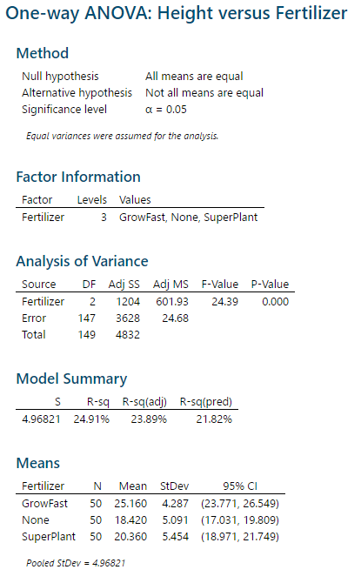

**Interpretation of Results:**

* P-value 0.000
* R2 = SSB /SST = (1204/4832) *100% = 24.91%
* 24.91% indicates that the variation in Blueberry plant’s height (in cm) can be explained by level of fertilizers.
* Since **P-value $≈$ 0.000 < α = 0.05**, therefore **H0 is rejected**.
* The mean plant’s height (in mm) for the different levels of fertilizers are different.
* Since H0 is rejected, we would then proceed to with **multiple comparison test** to know which pairs of means differ.

1. **MULTIPLE COMPARISON (TUKEY PAIRWISE COMPARISON) TEST USING MINITAB**

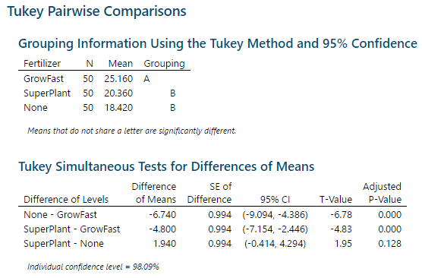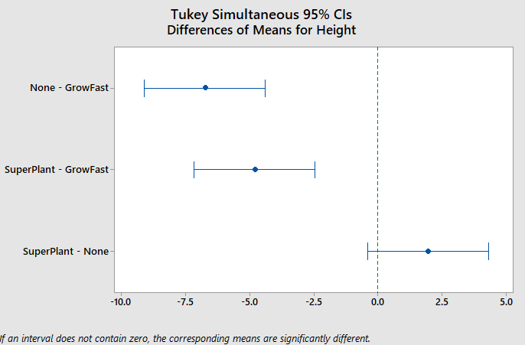

**Interpretation of Results:**

* There is a **significant difference** in mean plant’s height (in cm) for with no fertilizer and with manufacturer’s fertilizer (called GrowFast). P-value $≈$ 0.000 < α=0.05, and the 95% confidence interval for µnone - µGrowFast is (-9.094, -4.386), which does not include 0.
* There is a **significant difference** in mean plant’s height (in cm) for with competitor’s fertilizer (called SuperPlant) and with manufacturer’s fertilizer (called GrowFast). P-value $≈$ 0.000 < α=0.05, and the 95% confidence interval for µSuperPlant - µGrowFast is (-7.154, -2.446), which does not include 0.
* There is **no significant difference** in mean plant’s height (in cm) for with competitor’s fertilizer (called SuperPlant) and with no fertilizer. P-value $≈$ 0.128 > α=0.05, and the 95% confidence interval for µSuperPlant - µNone is (-0.414, 4.294), which does include 0.

1. **POSSIBLE TYPE I OR TYPE II ERROR IN HYPOTHESIS TESTING**

Since H0 is rejected, there is a possible of 5% chance of committing of Type I error. A Type I error would have occurred if we conclude that the mean plant’s height (in cm) for different levels of fertilizers are different, when it is not.

**11.0 CONCLUSION**

On average, the blueberry plant with manufacturer’s fertilizer (called GrowFast) has the higher mean plant’s height (in cm) as compared with other fertilizers.

***Reference Link:***

[*https://support.minitab.com/en-us/minitab/18/help-and-how-to/graphs/how-to/interval-plot/before-you-start/example/*](https://support.minitab.com/en-us/minitab/18/help-and-how-to/graphs/how-to/interval-plot/before-you-start/example/)