Contents
Introduction 1
User Registration 1
Setting up Multi-Factor Authentication (MFA) 6
Logging on with Multi-Factor Authentication (MFA) 8

Introduction
Thank you for your interest in the Australian Renewable Energy Agency (ARENA).
Applying for and maintaining a grant with ARENA is managed via our ARENANet platform. To gain access to ARENANet, you are required to create a user account.
To ensure your security and ours, we secure the login process with multi-factor authentication (MFA). On the second occasion you log in to the ARENANet platform, you will be requested to select your preferred method of authentication.
Once you have registered, there are further user guides available to you for:
- Applying for a grant
- Maintaining a grant.

User Registration
- Follow this link ARENANet
- Click on the Register Here link highlighted below
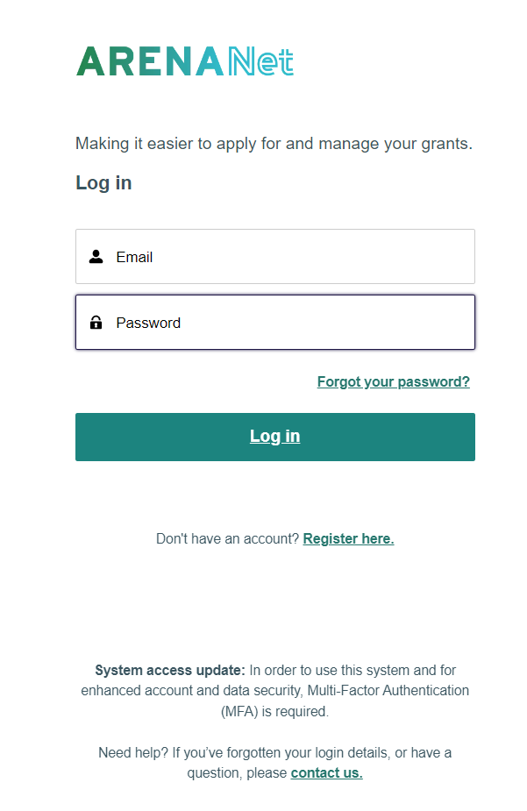
- Add in your details and click on ‘Register’.

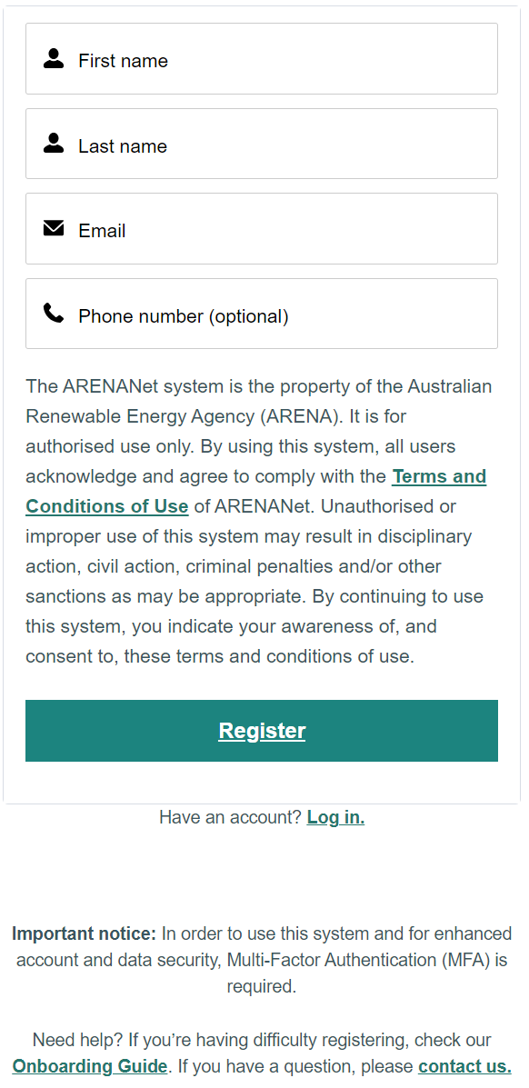

- Tick the box to acknowledge that you are not a robot
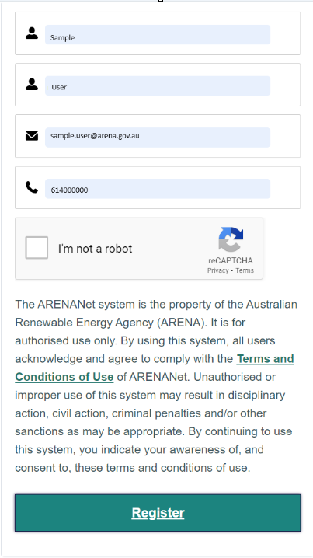

- Check your email to complete your registration and click on the link ‘Return to login’
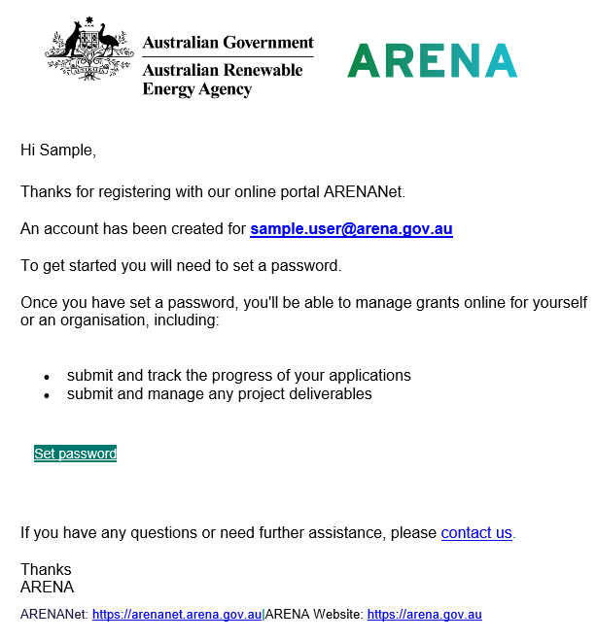

- This will prompt you to change your password. Set a new strong password and click ‘Change Password’ (The Change Password button will be enabled once you have satisfied the password criteria shown below).
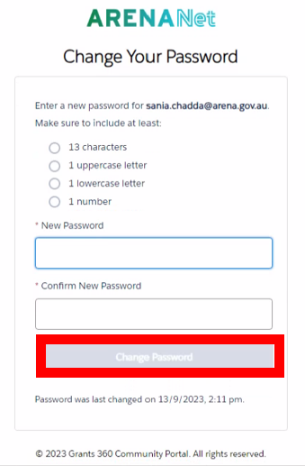

- Congratulations, you have now registered for ARENANet.

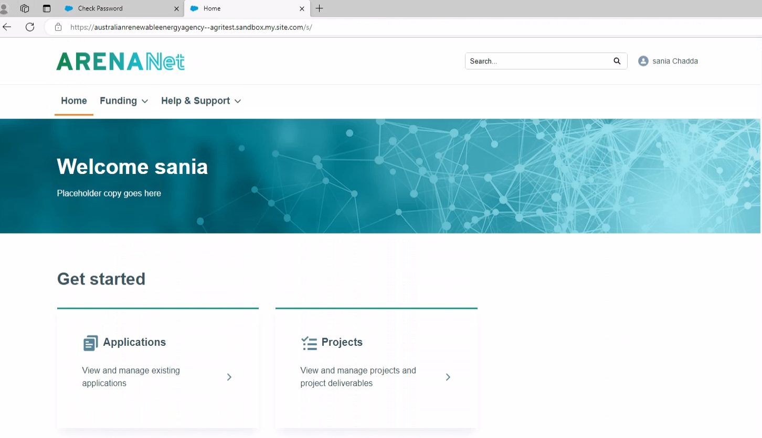

Setting up Multi-Factor Authentication (MFA)
Once you have created your ARENANet account and you log in for a second time, you will be required to select a method of multi-factor authentication.

- Follow this link ARENANet
- Enter your username and password. Click on ‘Log in’

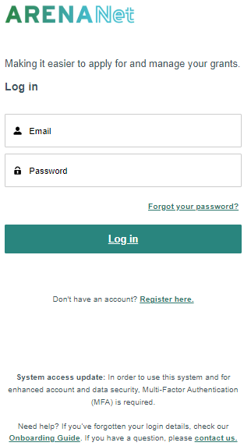

- Choose a verification method. Click on ‘Continue’
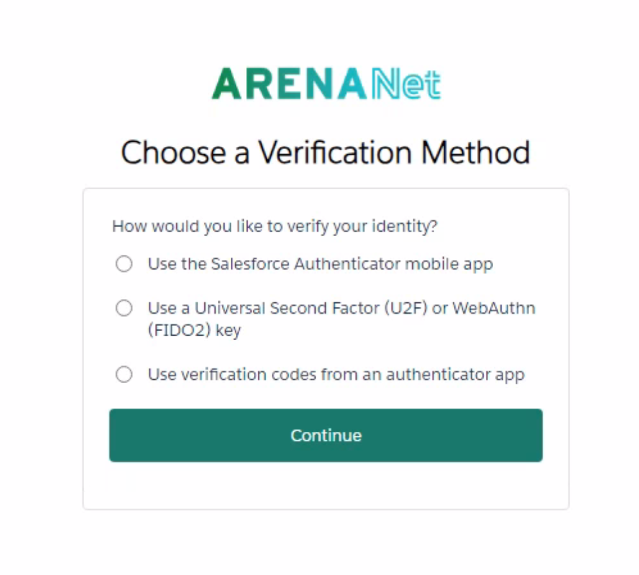
- Information on how to install and use the Salesforce Authenticator application is available here. Connect Your Salesforce Account to Salesforce Authenticator
- Universal Second Factor or FIDO2 involves the usage of either the inbuilt biometric authentication on your device or a plug-in device as shown below.
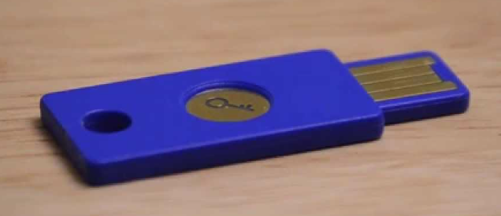
- Many users will already have an authentication application installed on their mobile device. For example, Microsoft.

- If you are using an authentication application, follow the steps for adding a new account and scan the QR code to generate a 6-digit code. Enter the code in the verification code box. Click ‘Connect’
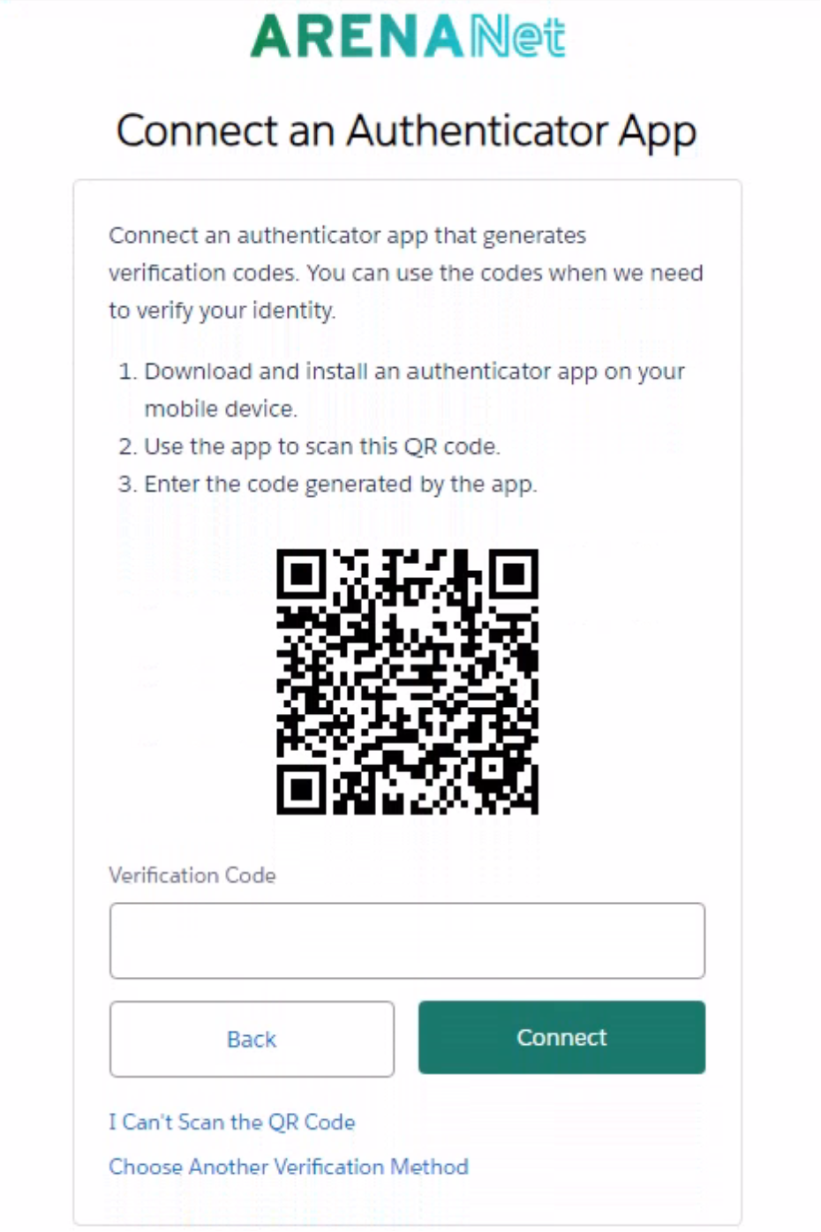

Logging on with Multi-Factor Authentication (MFA)
- Follow this link ARENANet
- Enter your username and password. Click on ‘Log in’


- Open your Authenticator application on your mobile device and enter the verification code displayed and click Verify.
