# Listening

## Listening Test Instructions

1. There are 8 parts in this test.
2. For each part you will hear the audio clip only once. Answer the questions based on what you remember from the audio clip.
3. When you mouse over an option, it will change colour. You must CLICK on the answer to choose it. When you click on the answer you want, it will be bolded and underlined. To change your answer, click on the answer you want to choose.
4. The time bar will show you how much time you have to complete each part. When you are ready for the next part of the Listening Test, click on "NEXT."
5. On the official test, once you leave a page, you cannot go back to it to change your answers. However, in this practice test, you can.
6. You have 46 minutes to complete the Listening Test.

# Listening Part 1: Identifying Similar Meanings

Listen to each short statement. You will only hear each statement once.

Choose the one sentence that is closest in meaning to each statement.

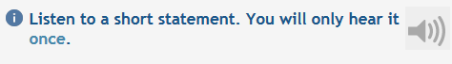

# Question 1 of 8

## Choose the sentence that is closest in meaning to the statement.

Matt’s brothers look alike.

Matt and his brother like each other.

Matt wishes he had a brother.

Matt and his brother are similar.



# Question 2 of 8

## Choose the sentence that is closest in meaning to the statement.

She will be able to finish if she works hard.

The work will not be finished by the deadline.

She never finishes her work on time.

She does not want to work tonight.



# Question 3 of 8

## Choose the sentence that is closest in meaning to the statement.

I will likely be in touch with Jacob soon.

Jacob and I haven’t talked for a long while.

I’m not sure when I’ll hear from Jacob next.

Jacob and I need to talk as soon as possible.



# Question 4 of 8

## Choose the sentence that is closest in meaning to the statement.

Justin is always late for class.

Justin doesn’t have time to study.

Justin never goes to school.

Justin never misses a day of class.



# Question 5 of 8

## Choose the sentence that is closest in meaning to the statement.

The show was not on last night.

I wasn’t able to see the show.

The show hasn’t played for a long time.

I don’t have a television set.



# Question 6 of 8

## Choose the sentence that is closest in meaning to the statement.

We recently met.

I’d like to meet him.

We met a while back.

I’ll meet him soon.

# 

# Question 7 of 8

## Choose the sentence that is closest in meaning to the statement.

I’ve decided to travel in July.

I’ve decided not to travel in July.

July is definitely the best time to travel.

I’m reconsidering traveling in July.



# Question 8 of 8

## Choose the sentence that is closest in meaning to the statement.

The doctor is not available to see you.

It’s not a good idea to see a doctor.

Medical attention is not necessary.

You may see a doctor in the future.

# Listening Part 2: Answering Short Questions

Listen to each question. You will only hear each question once.

Choose the best answer to each question.



# Question 1 of 8

## Choose the best answer.

I didn’t like him, I won’t hire him again.

Yes, he’s already gone home.

Yes, he does work long hours.

He’s been a builder for years.



# Question 2 of 8

## Choose the best answer.

Yes, you can put it right over there.

I’m not sure if they know where it is.

Actually, you need to apply in person.

I’m certainly interested in the position.



# Question 3 of 8

## Choose the best answer.

Yes, since the buses have already stopped running.

It’s just around the corner.

I don’t walk home from work, I drive.

I know I should work at home, but it’s hard.



# Question 4 of 8

## Choose the best answer.

It was certainly a useful meeting.

Yes, the meeting was canceled.

I guess rescheduling would be best.

Our meetings are very productive.

# 

# Question 5 of 8

## Choose the best answer.

I can’t sleep for some reason.

I’m usually up early on Mondays.

Because I’m tired, I need to go to bed.

I should sleep longer than 5 hours.



# Question 6 of 8

## Choose the best answer.

Cuba is my favourite holiday destination.

I expect that I’ll be back next week.

My winter getaway was excellent.

Probably not for another 6 weeks.

# 

# Question 7 of 8

## Choose the best answer.

I love it.

OK, I can get it done this morning.

I get it done on the weekends.

Thank you! That would be very helpful.



# Question 8 of 8

## Choose the best answer.

I’d love to learn how to use this app.

The software actually works really well.

My manager showed me how it works.

Certainly, it’ll take me just 2 minutes.

# Listening Part 3: Listening to Problem Solving

You will hear a conversation between a man and a woman in a health club. The woman provides customer service; the man is a customer.

Listen to the conversation. You will hear the conversation only once. It is about 1 to 1.5 minutes long.

# Question 1 of 8

## Choose the best answer to each question.

to get a membership

to receive a discount

to check his account

to take a cardio class

# Question 2 of 8

## Choose the best answer to each question.

10%

15%

20%

50%

You will hear the second section of the conversation shortly.

# Question 3 of 8

## Choose the best answer to each question.

to wait until it stops raining outside

to look for something in his locker

to return something that wasn’t his

to get back a missing personal item

# Question 4 of 8

## Choose the best answer to each question.

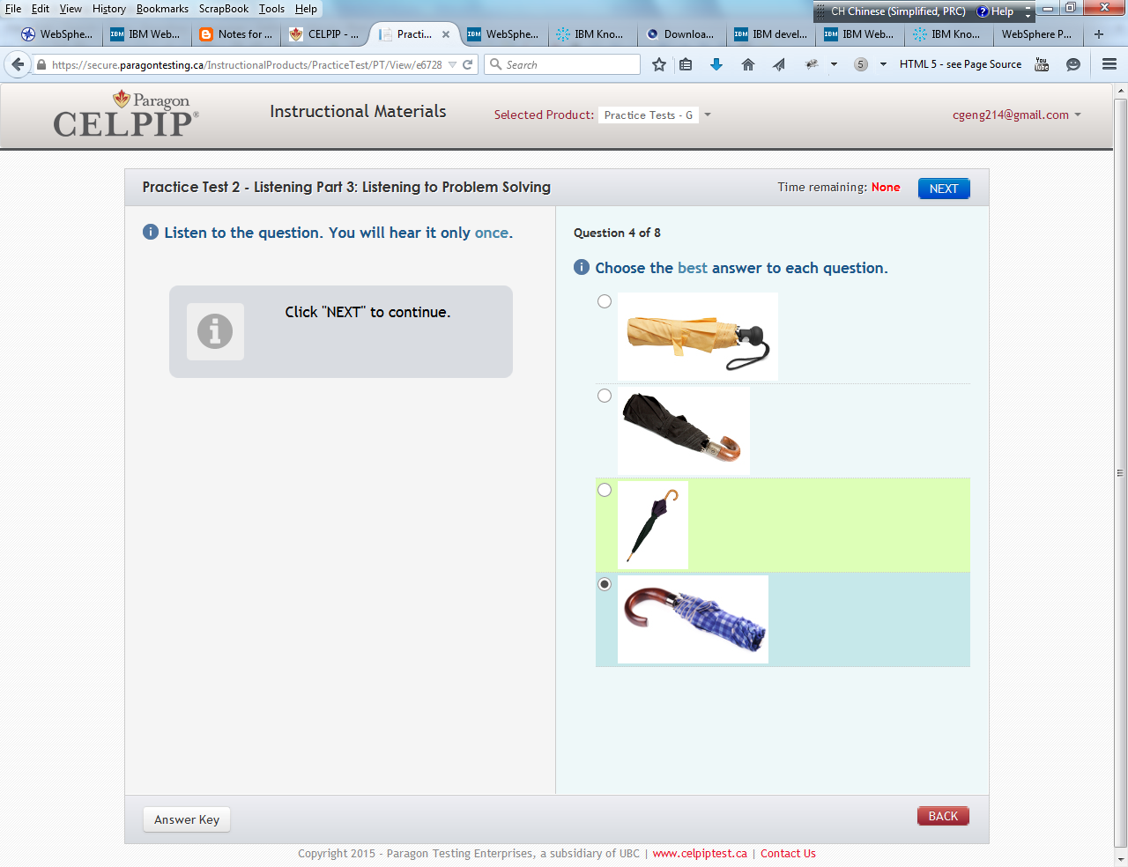

# Question 5 of 8

## Choose the best answer to each question.

The man was walking home from the gym.

The man should have received a discount.

The gym’s clients rarely carry umbrellas.

The gym’s clients don’t use the lockers.

You will hear the third section of the conversation shortly.

Listen to the conversation. You will hear the conversation only once. It is about 1 to 1.5 minutes long.

# Question 6 of 8

## Choose the best answer to each question.

He interrupted her clean-up routine.

He made her re-open the health club.

He thinks he is bothering the woman.

He is making the woman work late.

# Question 7 of 8

## Choose the best answer to each question.

It belonged to someone else.

He wanted to make a deal.

It was the wrong type of fabric.

He found a small rip at the top.

# Question 8 of 8

## Choose the best answer to each question.

The woman will apologize to the man.

The man will need help getting out.

The man will buy a better umbrella.

The woman will begin her chores.

# Listening Part 4: Conversation One

1. You will hear a conversation followed by five questions.
2. Listen to each question. You will only hear the questions once.
3. Choose the best answer to each question.

### Instructions:

### You will hear a conversation. The conversation is between two journalists. The man is telling the woman about a problem with an interview.

Listen to the conversation. You will only hear the conversation once. It is about 2 to 2.5 minutes long.



# Question 1 of 5

## Choose the best answer.

Two years.

About a month.

A day.

Four days.

# Question 2 of 5

## Choose the best answer.

She apologized.

She asked another server for help.

She got embarrassed and ran off.

She offered the man a free dessert.

# Question 3 of 5

## Choose the best answer.

Because there was a problem with his order.

Because the food wasn’t to his liking.

Because the server forgot to put in his order.

Because he may not be able to attend the opera.

# Question 4 of 5

## Choose the best answer.

By paying to replace the customer’s ruined shirt.

By offering a complimentary dessert.

By offering a free meal.

By offering complimentary opera tickets.

# Question 5 of 5

## Choose the best answer.

Fire the waitress from her job.

Require the waitress to practice.

Move the waitress to hosting.

Take money from the waitress’ pay.

# Listening Part 5: Conversation Two

1. You will hear a conversation followed by six questions.
2. Listen to each question. You will only hear the questions once.
3. Choose the best answer to each question.

You will hear a conversation. A woman is calling a garden store about her problems with garden pests.

Listen to the conversation. You will only hear the conversation once. It is about 2 to 2.5 minutes long.



# Question 1 of 6

## Choose the best answer.

To inquire about in-store painting lessons.

To claim a gift from his grandson.

To purchase painting items he ran out of.

To learn a new painting technique.

# Question 2 of 6

## Choose the best answer.

Recreating family portraits inspired by old pictures.

Capturing real-life scenes from Toronto’s downtown.

Reproducing the look of Toronto’s downtown sunset.

Painting rural landscapes from his childhood.

# Question 3 of 6

## Choose the best answer.

Because it is too difficult for first-time painters.

It is not suitable for the kind of painting he plans to do.

It can take up to several days or even weeks to dry.

He won’t be able to capture details with this painting technique.

# Question 4 of 6

## Choose the best answer.

It does not take a long time to mix.

It has a much quicker drying time.

It is can be easily removed with water.

It can be used indoors safely.

# Question 5 of 6

## Choose the best answer.

Because the man needs help with his technique.

Because the man could help beginner painters.

Because the man enjoys painting outdoors.

Because the man could get assistance.

# Question 6 of 6

## Choose the best answer.

Become part of a painting group.

Take painting classes every Saturday.

Try to learn painting by himself.

Return to his hometown for a visit.

# Practice Test 1 - Listening Part 5: News Item

Listening to a News Item

1. You will hear a news item once, then five questions will appear. It is about 1.5 minutes long.
2. Choose the best way to complete each sentence from the drop-down menu.

You will hear a news item about a very talented bird.

Listen to the following news item. You will only hear the news item once. It is about 1.5 minutes long.



# Choose the best way to complete each statement from the drop-down menu.

## 1. Michael Jansen was driving back to the campsite when

he nearly hit a person crossing the road.

he hit a deer that crossed the road.

he saw an accident on the highway.

a large bird flew into his windshield.

## 2. The area where the accident took place is

at a busy intersection.

near a city zoo.

in a protected area.

near their home.

## 3. The accident caused

the engine to break down.

the children to get hurt.

the deer to die.

the bird to die.

## 4. That night Jansen’s daughter, Emily,

had a picnic on the side of the road.

cooked the animal they had hit.

refused to eat dinner.

used her survival skills to get help.

## 5. Emily’s actions that night were prompted by

a survival course she had taken.

distress over the accident.

being stranded in the woods.

the family running out of food.

# Listening Part 7: Listening to a Discussion

**Listening to a Discussion**

* + You will watch a 2-minute video. Then 8 questions will appear.
  + Choose the best way to answer each question.

You will watch a discussion between three people who work together for the same company. They are members of the organizing committee and they’re meeting to discuss an important company event.

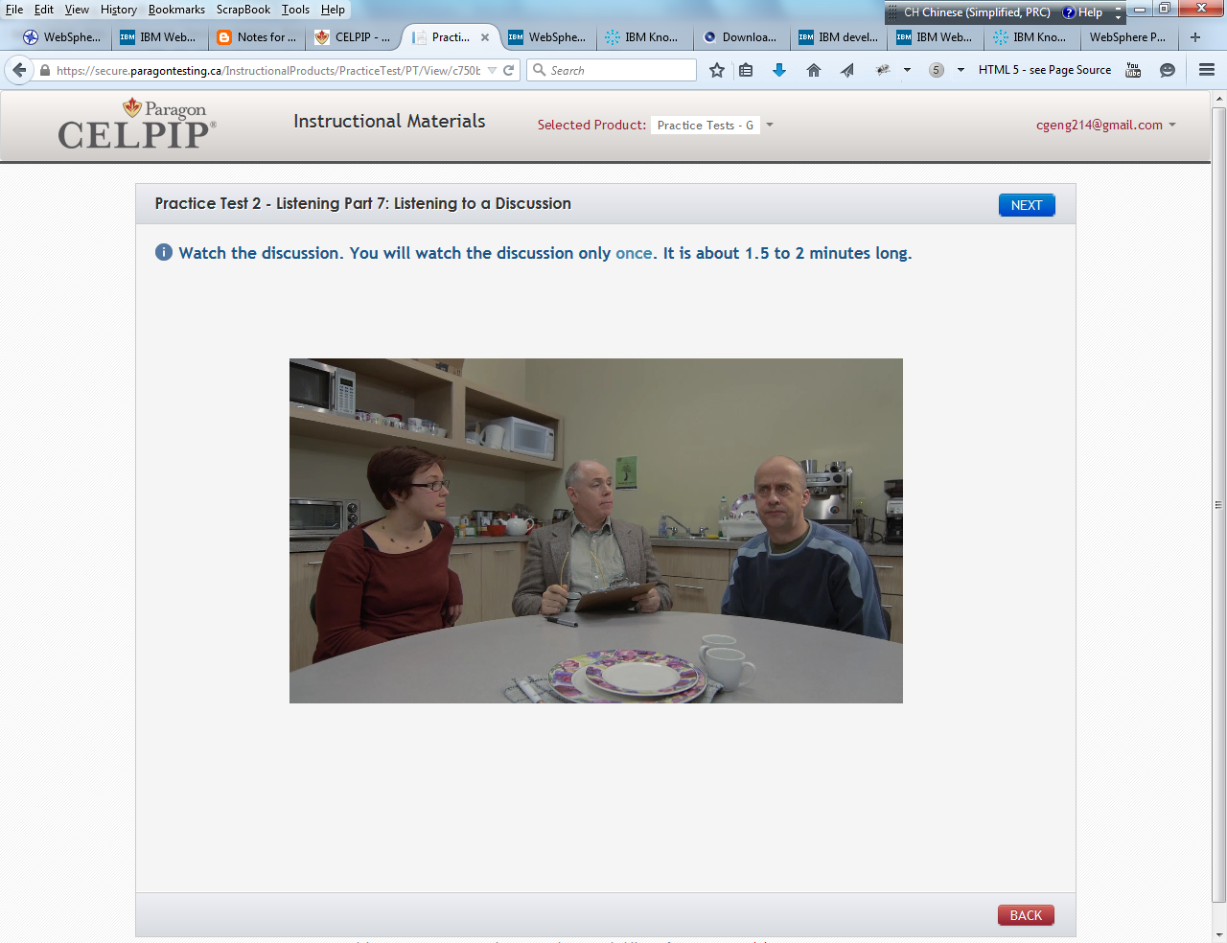

Watch the discussion. You will watch the discussion only once. It is about 1.5 to 2 minutes long.

# 1. Why is the party being organized? ▾

to acknowledge an important date

to celebrate the company’s success

to mark the boss’s 20th anniversary

to say farewell to retiring employees

# 2. What is the main limitation for the organizers? ▾

booking dates

menu options

financial means

seating capacity

# 3. What does the woman say about Griffin's Restaurant? ▾

She accepts its disadvantages.

She criticizes it as impractical.

She dismisses it for no reason.

She feels it is worth considering.

# 4. What would the speakers probably consider most important? ▾

avoiding complaints about the organizers

ensuring top staff members receive awards

avoiding indirect responsibility for accidents

ensuring that the events unfold on schedule

# 5. Why did the woman and the man wearing glasses laugh? ▾

They said something that sounded wrong.

They were making fun of the man’s opinion.

They were pretending to agree with the man.

They said the same thing at the same time.

# 6. Which option did the committee consider but reject? ▾

an out-of-town restaurant location

an alternate entertainment provider

a party that welcomed staff only

a smaller range of menu items

# 7. What information is needed about The Red Door? ▾

Is it cheaper to book on weekdays?

Is it located on the subway line?

Do they have space for a hundred?

Do they have the city’s top chef?

# 8. Which statement is most likely true? ▾

The organizers will reject The Red Door.

The event will be on a Saturday night.

The food quality will please the guests.

The staff will have to walk to the event.

# Listening Part 8: Viewpoints

Listening to Viewpoints

1. On the next page, you will hear a report once. It is about 3 minutes long.
2. Six questions will then appear.
3. Choose the best way to complete each statement from the drop-down menu.

Instructions:

You will hear a report about fish farming in Canada. The environmental impact of fish farming is discussed in detail.

Listen to the following report. You will only hear the report once. It is about 3 minutes long.



# Choose the best way to complete each statement from the drop-down menu.

## 1. Asha Miller’s campaign has received

unanimous support from students and teachers.

opposition from all of the school’s faculty.

resistance from traditionalists in the school.

growing media support following the school debate.

## 2. School uniform policy

has been newly implemented in the public school system.

affects mostly students attending private schools.

is being considered as a country-wide policy in Canada.

was eliminated by a student initiative at Giles Secondary.

## 3. Uniforms are generally adopted because they

eliminate issues of religious affiliations.

promote equal rights for all students.

help students focus on academics, not fashion.

reduce awareness of individual identity.

## 4. According to the report, opponents of uniforms state that their use

is not always culturally sensitive.

impacts academic achievement negatively.

does not interfere with obedience in class.

may generate fights amongst students.

## 5. The school administration shows

some flexibility to the enforcement of uniform rules.

unwillingness to bring the matter for discussion.

disapproval for teachers who support the petition.

intention to ban the use of uniform rules in the future.

## 6. An alternative to the prevailing uniform policy, Asha suggests that the school should

allow Muslim girls to wear pants.

allow students to personalize their uniforms with accessories.

allow students to vote on whether uniforms should be banned.

provide students with a clear dress code to be applied to regular clothes.

# End of the Listening Test

1. End of the Listening Test.
2. Click here to view the Listening Transcripts. Transcripts will not be provided on the official test.
3. Click "NEXT" to continue.

# Reading

# Reading Test Instructions

1. There are four parts in this test. Each part has short instructions and a different number of questions.
2. For each part, you will see the reading text on the left side of the screen. Instructions and questions are on the right side of the screen.
3. You may sometimes need to move the scrollbar up and down to see everything.
4. When you click on the answer, it will be bolded. To change your answer, click again on the answer that you want to choose.
5. The time bar will show you how much time you have to complete each part. When you are ready for the next part, click on "NEXT."
6. On the official test, once you leave a page, you cannot go back to it to change your answers. However, in this practice test, you can.
7. You have 48 minutes to complete the Reading Test. Watch the timer in the top right corner to make sure that you complete the Reading Test before the time is up.

# Reading Part 1: Reading Correspondence

## Read the following message.

*Dear Grandpa,*

*Thank you so much! I was surprised and delighted to receive your parcel and open your thoughtful present. A two-person camping tent is just what I needed. I've used it already; my friend Ryan and I spent a week camping in the Kootenay region of BC. We just got back. I was going to use our old family tent, but it's not only too big, it is also getting pretty worn out, so your gift was perfect.*

*We planned on camping at various locations in the Kootenay region, but we ended up staying at our first campsite for the whole trip. The campground, located on the east side of Arrow Lake, was called McDonald Creek Provincial Park. We were looking forward to the white sand beach, but when we arrived, the park ranger informed us that all the recent rainfall had caused the lake to flood a couple metres higher than normal. The beach was completely submerged. We still had a great time, though, hiking in the beautiful wilderness.*

*We drove a different route to get home so we could pass through the city of Nelson. It looks different from the last time I was there, but that’s not too surprising; I was there just a couple times as a kid. Last time we were there, Dad showed me the house where he had been born, and also your old clothing store. I drove around and I couldn’t find your old house, Grandpa; however, I did find your old store! It’s a cafe now, but they kept your old shop sign as a decoration in the cafe. I got pretty emotional when I saw it. I felt really proud of our family history.*

*Now I'm back in Calgary, but the trip to Nelson made me realize how much I miss you. So, I was thinking that maybe I should fly over to visit you. I have 2 weeks before college starts, so I could come for a week or so. I have enough money saved up from my summer job to pay for the ticket to Montreal. How does that sound? Perhaps the two of us can go camping like in the old days. We haven’t done that since you moved east. I’ll bring the new tent!*

*Love, Greg*

# Using the drop-down menu ( ), choose the best way to complete each statement according to the information given in the message.

## 1. Greg

got used to his old family tent.

got a new tent in the mail.

needs a new tent for his trip.

bought a new tent.

## 2. Greg and Ryan

toured several campsites in the Kootenay region.

enjoyed the provincial park’s white sand beaches.

were surprised by the water level at the lake.

were unable to tour and camp because of the rainfall.

## 3. Greg took an alternative way back because

he wanted to revisit his dad’s hometown.

his grandpa still owns a shop there.

he wanted to pay his father a visit.

he used to live there as a child.

## 4. Greg became emotional when

he found out his grandpa’s business had shut down.

his father told him stories about his childhood.

he saw the house where his father grew up.

he saw something that belonged to his grandfather.

## 5. Greg is hoping to

use the tent for the first time.

travel to Montreal very soon.

be accepted in college this year.

get a summer job before starting school.

## 6. Greg’s grandpa

is coming to Calgary for a few weeks.

bought Greg a ticket back to Nelson.

used to go camping with Greg.

is moving back to Calgary.

## Here is a response to the message. Complete the response by filling in the blanks. Select the best choice for each blank from the drop-down menu.

## Greg,

## It goes without saying that I’d love to 7.

visit Montreal.

visit the Kootenays.

go to Calgary.

see you here.

## Now with my old bones, I’m not so sure that 8.

flying here is wise,

I can make it to Calgary,

we should visit the old cafe,

camping is a great idea,

## but even if it’s not, I think we should do it anyway. After all, we have to put the tent to good use! You just email me your travel plans. Also, there’s no need to 9.

plan a camping trip for us;

spend your own money on a ticket;

buy a new tent for this trip;

drive all the way to Montreal;

I can take care of that, you should keep your savings for tuition.

## Well, I can’t say I’ve been to Nelson since I sold my business there many years ago. Did you take any photos of 10.

the old store sign?

the old cafe?

your father at the cafe?

the house where your dad was born?

## If you did, I’d love to see them. I’m sorry you 11.

didn’t find the old house.

didn’t find the old store.

didn’t recognize the cafe.

couldn’t buy the old sign.

## I don’t even know if it’s still standing. If it is, it would be a hundred years old.

## Anyway, email me as soon as you book the flight over here.

## Grandpa

# Practice Test 1 - Reading Part 2: Reading to Apply a Diagram

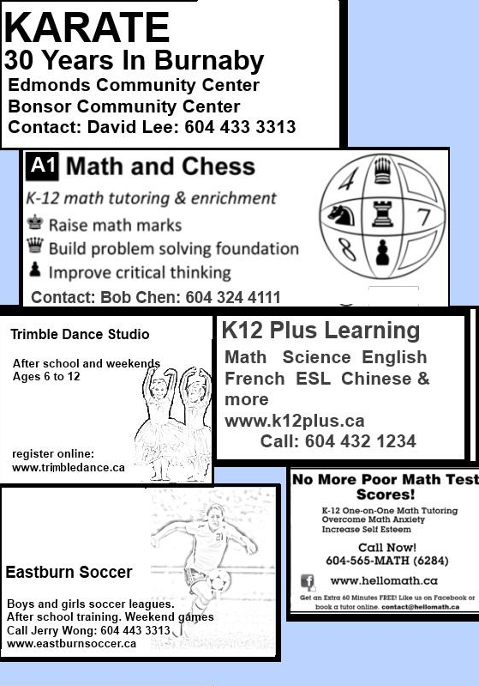

# Read the following email message about the diagram on the left. Complete the email by filling in the blanks. Select the best choice for each blank from the drop-down menu ( ).

## Subject: Kids Activities To: Mary S <t.smithers@frimpton.bc.ca> From: Sandy Rockton <srockton@sterlings.ca> Hi Mary, It was a pleasure meeting you and the kids at the park on Sunday. I hope you’re settling into our neighborhood. You said you were looking for 1.

some after school activities for your kids.

some helpful educational websites.

babysitting services for your children.

online classes for your son.

## I saw a few possibilities in the latest Burnaby Parks and Recreation brochure. I remember you saying that Alex is contemplative 2.

Trimble Studio

hellomath.ca

A1 Math and Chess

Eastburn Soccer

## seems a great choice for thinkers like Alex. He will get to think hard and learn some additional math skills. You said Melissa is quite scared of math, in which case you could check out 3.

Eastburn Soccer.

Trimble Studio.

Karate.

the hellomath.ca website.

## They may help her feel better about her schoolwork. Speaking of Melissa, she may want to join my daughter Cindy in the young teens’ soccer league. This is quite a commitment as there is 4.

a boys and girls soccer league.

training in the week and a weekend game.

a website where you can get information.

a week long summer training session.

## If that’s a problem, she could try karate. I’m not sure about the class times 5.

there’s no website.

they are not well established.

there’s no contact information.

I don’t know where they practice.

## You’ll have to call and ask. Sandy

# Complete these statements by selecting the best choice.

## 6. Mary and Sandy

have been friends for a long time.

met at their kids’ soccer practice.

now live in the same area.

were neighbours in the past.

## 7. Sandy

is looking for activities for her own children.

is suggesting activities in the neighbourhood.

works for Burnaby Parks and Recreation.

has committed to drive the girls to soccer practice.

## 8. Melissa

prefers individual to team activities.

doesn’t have the weekends off.

doesn’t enjoy math as much as Alex.

is too young to play team sports.

# Practice Test 1 - Reading Part 3: Reading for Information

## Read the following passage.

***A.*** *The first record of chewing gum dates back to Finland about 5,000 years ago. Neolithic-period chewing gum was made of bark tar and was widely utilized for its antiseptic and medicinal properties. In America, chewing gum was first introduced to settlers by the American Indians who chewed resin made from the sap of spruce trees. After World War II chewing gum was made of a latex sap substance called chicle, which has been steadily engineered and replaced by synthetic rubbers and artificial sweeteners that allow for greater flavouring, colouring, and texture. Modern chewing gum hardly resembles its predecessors in appearance and flavour. It has also gained unprecedented popularity, becoming a 20-billion-dollar industry in North America.****B.****Over the past decades, the bad reputation chewing gum earned for causing cavities and gum disease has also begun to dwindle. With the advent of sugarless chewing gum, most dentists today deem chewing gum in moderation to be harmless, or even potentially beneficial to oral hygiene. In addition, functional chewing gum, a special category of gum that imparts a practical function in addition to, or as a replacement for, the usual enjoyment provided by a confectionery gum, has become increasingly prescribed by dentists and doctors alike. Conditions such as bad breath and tobacco addictions are now commonly treated with functional gum. Surgeons also prescribe functional chewing gum for patients recovering from gastrointestinal surgeries.****C.*** *Recent research suggests the benefits of gum may not be limited to medicated gum. Chewing regular gum has been found to boost cognitive performance in many ways including improved reaction time, motor control, and alertness. These effects have been found to come at an expense, however. Although as many as eight areas of the brain are activated by the simple act of chewing gum, the cognitive gains of mastication-induced arousal can only be sustained for a short period. Moreover, chewing gum was observed to interfere with verbal-fluency and short-memory tasks.****D.*** *Oral health researchers posit the short-lived cognitive gains of chewing gum pale in comparison to their potentially hazardous health effects. They claim the innocuousness of sugarless gum is a myth, expounding that sugar substitutes such as aspartame have been increasingly linked to different types of cancer and autoimmune diseases. They also point to possible chronic irreversible conditions that may ensue from excessive gum chewing such as headaches, tightness in jaw muscles and nerves, metabolic imbalances, and irregularities in mastication that range from tooth decay to bone loss.****E.*** *Not given in any of the above paragraphs.*

# Decide which paragraph, A to D, has the information given in each statement below. Select E if the information is not given in any of the paragraphs.

## 1. Evidence suggests gum chewing can enhance some brain functions.

A

B

C

D

E

## 2. The chemical bases of chewing gum have been reformulated.

A

B

C

D

E

## 3. Chewing gum is used post-operatively as a healing aid.

A

B

C

D

E

## 4. There can be lifelong damage associated with regular intake of synthetic sugars.

A

B

C

D

E

## 5. Chewing gum can curb some unhealthy dependence behaviours.

A

B

C

D

E

## 6. Some researchers oppose the reported benefits of chewing gum.

A

B

C

D

E

## 7. Patients who chew gum regularly tend to be more neglectful of their oral hygiene.

A

B

C

D

E

## 8. Early chewing gum was entirely natural.

A

B

C

D

E

## 9. The benefits of sugar-free gum are recognized.

A

B

C

D

E

# Practice Test 1 - Reading Part 4: Reading for Viewpoints

# Read the following article from a website.

*Stephanie Lee is a science teacher at Ryerson Secondary who believes that real science should encourage critical thinking, even if it means challenging what's written in the textbook. Part of the curriculum involves learning about climate change, and Lee was dismayed to find the textbook material to be "little more than propaganda, which claims that global warming is chiefly a human-caused phenomenon."   
  
Lee argues that education is supposed to teach students how to see objectively, yet textbooks often monopolize certain viewpoints and push them as the only truth. In the case of climate change, Lee was appalled to find that no alternative theories were presented. "The absence of other perspectives seems to indicate that the topic of global warming has been made into a sort of doctrine which seeks to diminish the credibility of other points of view," Lee says. Lee taught her students additional perspectives. Not only did she teach the theory of anthropogenic global warming, that is, that global warming is caused by human consumption of fossil fuels and the release of carbon dioxide into the atmosphere, but also taught that throughout history, the earth's temperature has naturally risen and fallen.   
  
Other science teachers at Lee's school have raised concerns that Lee's approach is only confusing students. Carol Harvey argues that the greenhouse gas effect and subsequent global warming is not a controversy in the scientific community. It has been proven that humans have increased the amount of greenhouse gases in the atmosphere by roughly 30% in the last 100 years. "Our textbooks are up to date, and Lee is only prompting students to dismiss valuable textbook information," Harvey says.   
  
Lee disagrees, asserting that science should not shy away from evaluating multiple perspectives. "Carbon dioxide changes have not been proven to be the primary cause of global warming," Lee says. "In fact, research indicates the reverse might be happening: global warming might be causing changes in carbon dioxide levels. Either way, my job is to help students to analyze both theories, not simply accept the one presented in the textbook."*

# Complete each statement by selecting the best option according to the information on the website.

## 1. Stephanie Lee’s main objective in teaching science is to

make sure students have mastered the textbook content.

teach about the impact of human activities in global warming.

challenge well established educational publications.

promote reflection on different scientific perspectives.

## 2. According to Lee, the main issue with textbooks is that

they reflect research sponsored by private businesses.

they typically present information from particular vantage points.

they promote low-standard research with no scientific credibility.

they contest less-popular theories about global warming.

## 3. Lee’s opinion on climate change differs from science textbooks in that downsize their companies and reduce costs.

she agrees it is actually a chiefly human-caused phenomenon.

she argues that fossil fuel consumption is mostly to blame.

she observes that historically the earth’s temperature has fluctuated.

she demonstrates that the temperature around the world has mainly dropped.

## 4. The main criticism of Lee's teaching approach is that

it ignores controversy in the scientific community.

it could be misleading for some students.

it ignores the views presented in the textbook.

it lacks a historical perspective.

## 5. Lee responds to criticism of her teaching approach by

arguing multiple perspectives ought to be part of learning science.

reiterating that global warming is yet to be scientifically confirmed.

questioning her colleagues' scientific knowledge.

highlighting how well her students have accepted her approach.

# The following is a comment by a visitor to the website page. Complete the comment by choosing the best option to fill in each blank.

## Lee is right that schools 6.

should not hire underqualified science teachers.

should not have a fixed science curriculum.

should teach multiple perspectives on a subject.

should teach children about the politics of research.

## The trouble is how we decide which points of view we teach and who decides. On the one hand, as Lee notes, 7.

we cannot rely on textbooks to provide a balanced view.

teachers are unwilling to supplement the content of their classes.

part of the school day should be spent investigating research articles.

students have assumed a rather passive interest in scientific research.

## On the other hand, are teachers any better at presenting an unbiased perspective? 8.

The responsibility of science teachers

The question of changing the school’s curriculum

The value of reading original research in class

The issue of climate change and global warming

## upon which Lee seems to focus is very complex. The scientists themselves have yet to make up their minds and yet Lee believes that science teachers are qualified to 9.

create tests that measure scientific knowledge.

dictate how researchers should carry out their investigations.

make choices about which theories should be taught.

teach students about the impact of global warming.

## This is a complicated problem. In the end, however, I tend to side with Lee. Teachers 10.

should present diverse positions

stop using the textbook

focus on environmental problems

hire better-prepared teachers

## on a topic and allow students to draw their own conclusions. M. Ladner

# End of the Reading Test

1. End of the Reading Test.
2. Click "NEXT" to continue.

# Practice Test 2 - Writing

## Writing Test Instructions

1. There are two tasks in the Writing Test.
2. Use the computer keyboard to write your response.
3. You can see how many words you have written by looking at the bottom of the writing area to see the word count.
4. You have 30 minutes to complete each task. Watch the timer in the top right corner to make sure that you complete each task before the time is up.
5. On the official test, if you do not finish Task 1 in 30 minutes, the screen will move to Task 2. You cannot go back to Task 1. However, in this practice test, in order to move forward in the test you must click on “NEXT.”
6. You have 60 minutes to complete the Writing Test.

# Writing Task 1: Writing an Email

## Read the following information.

**Gym Membership**   
  
You recently purchased a 2-year membership to an expensive gym. After using it for 2 months you realized many of the services advertised are not being delivered. You spoke to the gym manager, but nothing changed.

## In about 150-200 words, write an email to your brother. Your email should do the following things:

* Describe what services were advertised and are not being delivered.
* Complain about the manager’s response.
* Describe how you want the company to resolve the problem to your satisfaction.

# Writing Task 2: Responding to Survey Questions

## Read the following information.

**Food Survey**

Students at your college have indicated that the food options available on campus are not satisfactory. In order to improve the food services on campus, university officials are consulting students about two possibilities.

## Choose the option that you prefer. Explain the reasons for your choice. Why do you prefer your choice? What problems are there with the other choice? Write about 150-200 words.

**Option A**: Cafeteria: This large cafeteria serves multiple food options ranging from vegetarian to ethnic dishes. Features buffet-style service and low prices.

**Option B**: Restaurants: A large variety of well-known restaurants to open their stores on campus. Features a wide variety of food in different places with competitive prices.

# End of the Writing Test

1. End of the Writing Test.
2. Click here to view the Performance Standards for Writing.
3. Click "NEXT" to continue.

# Practice Test 2 - Speaking

## Speaking Test Instructions

1. There are nine tasks in the Speaking Test: one practice task and eight scored tasks. In this practice test, no score will be provided for any of the speaking tasks. However, you can refer to the Performance Standards for Speaking at the end of the Speaking Test.
2. The instructions and questions are in writing. You will not hear them.
3. For each task, there are two timed sections: Preparation Time and Recording Time. You will be able to see these times in the top right corner of the screen. For this practice test, you should use a timer to make sure that you complete each task within the given time.
4. The practice test will not record your answers. If you wish to record your own answers, record and save your responses using your computer microphone or your own recording device (cellphone, digital recorder, etc.).
5. On the official test, if you do not finish a task in the time provided, the screen will move to the next task. You cannot go back to the previous task. However, in this practice test, in order to move forward in the test you must click on “NEXT.”
6. Try to complete the Speaking Test in a maximum of 20 minutes, since this is how much time you have to do the official Speaking Test.

# Speaking Practice Task

## Talk about one of your best friends.

## 

prepare.png Preparation: **30 seconds**

record.png Recording: **60 seconds**

# Speaking Task 1: Giving Advice

## Your best friend has been under great stress lately and his health is suffering. Advise him or her about what he or she should do to relieve stress and improve his or her health.

prepare.png Preparation: **30 seconds**

record.png Recording: **90 seconds**

# Speaking Task 2: Talking about a Personal Experience

## Talk about a possession that you value very much. Maybe you can talk about a family object that is important to you, something you purchased after a long wait, something you received as a gift, or anything else you can remember. What is it, and why is it so valuable to you?

prepare.png Preparation: **30 seconds**

record.png Recording: **60 seconds**

# Speaking Task 3: Describing a Scene

## Describe some things that are happening in the picture below as well as you can. The person with whom you are speaking cannot see the picture.

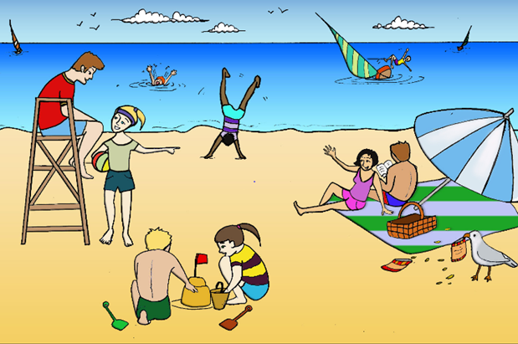

prepare.png Preparation: **30 seconds**

record.png Recording: **60 seconds**

# Speaking Task 4: Making Predictions

## T2S1.png

## In this picture, what do you think will happen next?

prepare.png Preparation: **30 seconds**

record.png Recording: **60 seconds**

# Speaking Task 5: Comparing and Persuading

## Your family (2 adults and 2 children) have decided to take a month-long trip across Canada this summer. Using the pictures and information, compare the two recreational vehicles (RV). You are choosing the vehicle that you think is best to rent for your trip.

## If you do not choose an option, the computer will choose one for you. You do not need to speak for this task.

## 

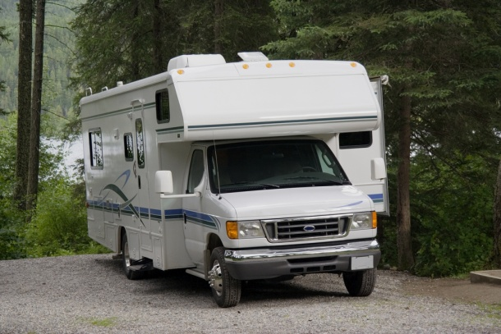  
**Family RV**   
  
- $2,000 per week  
- TV and air conditioning  
- shower, toilet, stove, fridge, and freezer  
- sleeps up to 4 people

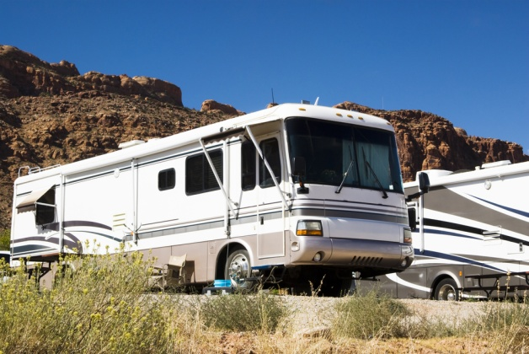

**Luxury Edition**   
  
- $3,500 per week  
- air conditioning, TV, and satellite radio  
- large bathroom and living area  
- sleeps 6 people

prepare.png Preparation: **60 seconds**

## Your partner wants to rent the RV on the left. Persuade him or her to agree to select the RV that you chose by comparing the two vehicles.

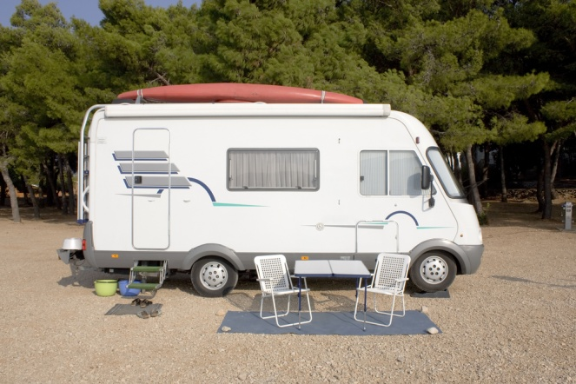

**Reliable Old-fashioned RV**   
- $1,000 per week  
- kitchenette with sink and small fridge   
- portable toilet and shower head   
- sleeps 3 people p.m.



**Luxury Edition**   
  
- $3,500 per week  
- air conditioning, TV, and satellite radio  
- large bathroom and living area  
- sleeps 6 people

prepare.png Preparation: **60 seconds**

record.png Recording: **60 seconds**

# Speaking Task 6: Dealing with a Difficult Situation

## A close relative has some financial problems and has asked to borrow some money. Your wife/husband does not want you to lend him any money because he has not paid people back in the past.

**Choose ONE:  
EITHER  
Explain to your relative why you cannot lend him the money.  
OR  
Explain to your husband/wife why you should lend your relative the money.**

prepare.png Preparation: **60 seconds**

record.png Recording: **60 seconds**

# Speaking Task 7: Expressing Opinions

## Answer the following question and give reasons for your answer. Question: **Do you think magazine and newspaper photographers (paparazzi) have the right to photograph celebrities during the celebrities' private time?**

prepare.png Preparation: **30 seconds**

record.png Recording: **90 seconds**

# Speaking Task 8: Describing an Unusual Situation

## While you were shopping, something happened to your parked car. Phone a member of your family. Provide a full and clear description of your situation.

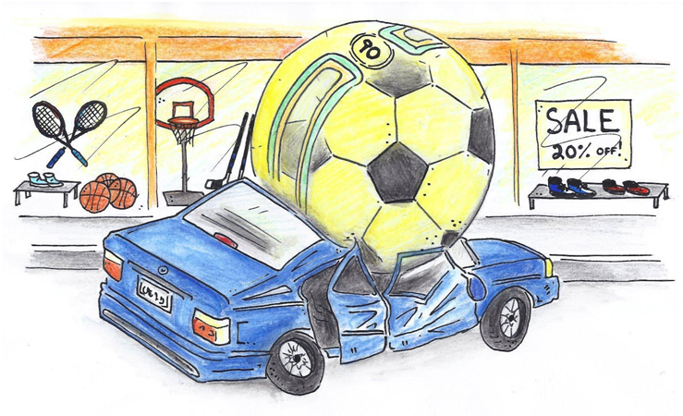

prepare.png Preparation: **30 seconds**

record.png Recording: **60 seconds**

# End of the Speaking Test

1. End of the Speaking Test.
2. Click here to view the Performance Standards for Speaking.

# Appendix A Practice Test 1 - Listening Transcripts

Part 1: Identifying Similar Meanings   
  
1. Matt is just like his brother.  
2. Even if she works all night, she won’t finish on time.   
3. I expect to hear from Jacob early next week.  
4. Justin never makes it to class on time.   
5. I missed the show on TV last night.  
6. I’ve known him for a while now.  
7. I’m wondering whether traveling in July is best.   
8. You don’t have to see a doctor about your shoulder.

Part 2: Answering Short Questions   
  
1. Is the builder already done for the day?  
2. Can I apply for the position online?  
3. Should we just walk home?  
4. Should we postpone our meeting?  
5. It’s late; why are you still up?  
6. When are you going away next?  
7. How do you find time to do housework?  
8. Would you mind showing me how this software works?

## Part 3: Conversation One

|  |  |
| --- | --- |
| MAN: | Hey, I haven't seen you before! You must be new here. My name's Jonathan. How do you like it here so far? |
| WOMAN: | I'm Anna, nice to meet you. Yes, I just started this afternoon. It's... it's okay. Have you worked at this restaurant long? |
| MAN: | Two years now, but I only work 4 days a week. I really enjoy it. But you... you don't sound like you're having much fun. |
| WOMAN: | This is my first time waitressing and I'm afraid I'm not very good. I just spilled wine on a customer a couple of minutes ago! The guy was really upset, and I didn't know what to do, so I just ran off! What do I do now? |
| MAN: | Aww, that's okay, everyone makes mistakes, even experienced servers! Don't be so hard on yourself. Don't worry! Just go back and apologize and bring him another glass of wine, and tell him dessert will be free. |
| WOMAN: | What about his shirt? It's got a huge red wine stain on the arm. I heard him tell his date that he can't go to the opera with a ruined shirt. |
| MAN: | Hmm. I'll tell you what, I'll go talk to him with you. We’ll tell him the restaurant will reimburse him for his shirt. But first, we should tell Laura, the manager, what happened. |
| WOMAN: | Oh no... I'll get fired! She's going to think I'm the worst waitress ever. |
| MAN: | Laura's very understanding. Trust me, you won't get fired! She *will* make you practice carrying wine glasses, though. Actually, if this is your first time waitressing, I'm surprised she let you carry wine glasses at all! Usually they train you for at least a week first. |
| WOMAN: | Another waitress just passed me a tray with wine glasses on it and asked me to take it to table five. She said she was too busy. |
| MAN: | Oh, I see. She must not have known it was your first day! Anyways, let's go solve this situation. You’ll feel much better. It’ll be fine, you'll see! |

**Now answer questions 1-5.**  
  
1. How long has the woman been a waitress?   
2. Why is the waitress apprehensive?  
3. Why was the customer upset?  
4. How does the man suggest they fix the problem?  
5. What does the man think the manager will do?

## Part 4: Conversation Two

|  |  |
| --- | --- |
| WOMAN: | Hi there! What brings you into Art Land today? |
| MAN: | Hi! I'm looking to take up painting as a hobby and my grandson just gave me a gift certificate to this store. The problem is, I really have no idea where to start. I'm wondering if you could give me some advice. |
| WOMAN: | Of course! That's what I'm here for. Well, let me start by asking you a few questions. Were you looking to enroll in our classes? |
| MAN: | I have a lot of free time, so I figured I would try it on my own. |
| WOMAN: | Certainly. Do you have ideas about what subjects you want to paint? |
| MAN: | I think landscapes. We were looking at some old photographs on my birthday, and I thought it would be nice to recreate the rolling hills of the beautiful farm I grew up on in Manitoba. I’ve been living in Toronto for 5 decades now, and though I love city life and the downtown skyline, the memories of sunsets on the farm are still with me. |
| WOMAN: | Wonderful! Well, the three basic types of paints are watercolour, acrylic, and oil. They are all suitable for landscapes. I would say watercolour is the hardest for a beginner to start with, even though it is the most affordable of them all. |
| MAN: | I don’t think watercolour will be the one for me then. What’s the main difference between acrylics and oils? |
| WOMAN: | The amount of time it takes for the paint to dry. Acrylic paints dry very quickly, within a matter of hours, whereas oil paints can take up to several days, even weeks to dry. A lot of our beginner students like acrylics because if they make a mistake they don't have to wait long to paint over it. However, that can also be frustrating, because it's hard to mix the colours you want when they dry so fast. |
| MAN: | I see. Well, I don't think I'll mind fast-drying paints. I'll go for acrylics, then. What other kind of supplies will I need? |
| WOMAN: | Do you think you’ll be painting indoors or outdoors? |
| MAN: | Definitely outdoors. I’d like to paint landscapes while immersed fully in nature myself. I'm a big wilderness explorer. |
| WOMAN: | Sounds lovely! And if you ever feel you need some extra help, we have painting workshops at a local farm not too far from the city, every last Saturday of the month. The workshop goes from 9 a.m. to 5 p.m., and participants enjoy a nice farm-style lunch meal. |
| MAN: | Thank you. I’ll go at my own pace, but I’ll definitely consider it. It might be a nice way to learn, socialize, make new friends, and reminisce about my mother’s cooking. |

**Now answer questions 1-6.**  
  
1. Why is the man at the art store?  
2. What is the man interested in doing?  
3. Why does the woman advise against watercolour?  
4. According to the woman, why is acrylic better than oil paint?  
5. Why does the woman suggest the workshop?  
6. What is the man planning to do?

Part 5: News Item   
  
A family driving near Banff, British Columbia, on a camping trip last weekend narrowly avoided crashing into a deer, only to hit a large pheasant instead. Banff is a nature reserve, home to thousands of wild animals including bears, deer, and countless game birds such as pheasant. Michael Jansen, who was driving at the time, said they were heading back to their campsite around dusk when they came around a bend of the highway and saw a deer trotting across the road. Jansen swerved successfully around the animal, but only a few seconds later a pheasant flew across the road in the opposite direction and hit the windshield. He pulled over to the side of the road as the deer ran into the forest unharmed. Unfortunately for the pheasant, the impact of the windshield killed it immediately. However, Jansen's daughter, Emily, who took a wilderness survival course last year, decided to make the best of the situation. She took the bird back to the campsite and roasted it with garlic and onions. "It's completely legal to eat roadkill in British Columbia," she explained. "Why waste perfectly good food? It's sad that we hit it, but at least it didn't go to waste."

Part 6: Viewpoints   
  
Asha Miller is a grade 11 student at Giles Secondary, a private school. She is pushing for her school to change their school uniform policy. Asha has recently started a petition protesting the school's mandatory attire. Her cause has attracted a large number of supporters within the student body, and also from some parents and school staff. At the same time, many among the student body, faculty, and parents are in favour of continuing the school tradition.   
  
The debate about whether or not students should wear a uniform to school or not is quite common in Canadian private schools. Although a few public schools also require students to wear a school uniform, most public schools don’t require this.   
  
One of the most common arguments for uniforms is that students will not be as distracted from their studies by fashion choices or peer pressure. Consequently, students focus on better grades and they are also easier to discipline. Uniforms are also thought to play a role in creating a sense of belonging and school culture that is important for cooperation and unity.   
  
Critics, such as child psychologist Dr. Jason Ferguson, say there is no concrete evidence that links school uniforms to improved educational results. In fact, academic performance scores in schools that adopt uniforms and those that do not often average the same. Moreover, dissenters point out that students required to wear uniforms typically manage to fight the rules, and "individualize" their uniforms by wearing unique shoes or accessories. But perhaps the most damaging argument against uniforms is that they can discriminate against certain religions or cultures.   
  
The school’s administration advocates that there is a middle ground. Uniforms can work with students' diverse cultural needs, if the school authorities consult parents about what is acceptable. Exceptions could be made, such as, for example, allowing Muslim girls to wear long loose trousers instead of skirts that might not provide adequate coverage.   
  
Asha Miller thinks such accommodations don’t quite suffice, and she advances a different alternative. She is suggesting that uniforms be abolished in favour of a dress code that specifies the kinds of clothes that can be worn, including the length of dresses, amount of exposed skin, cleanliness, and so on. She argues this solution would address the concerns of all parties. Students wouldn’t feel constrained in how they express their identity and cultural beliefs; meanwhile, appropriate school attire and discipline would be maintained. She adds that adolescence is a particularly critical phase in a person’s life in which they are trying to figure out who they are and where they fit, and clothing choice is a way to truly express one’s interests and personality.

# APPENDIX B Listening Result

|  |  |  |
| --- | --- | --- |
| **Question** | **Answer Key** |  |
| Listening Part 1: Identifying Similar Meanings - Q1 | Matt and his brother are similar. |  |
| Listening Part 1: Identifying Similar Meanings - Q2 | The work will not be finished by the deadline. |  |
| Listening Part 1: Identifying Similar Meanings - Q3 | I will likely be in touch with Jacob soon. |  |
| Listening Part 1: Identifying Similar Meanings - Q4 | Justin is always late for class. |  |
| Listening Part 1: Identifying Similar Meanings - Q5 | I wasn’t able to see the show. |  |
| Listening Part 1: Identifying Similar Meanings - Q6 | We met a while back. |  |
| Listening Part 1: Identifying Similar Meanings - Q7 | I’m reconsidering traveling in July. |  |
| Listening Part 1: Identifying Similar Meanings - Q8 | Medical attention is not necessary. |  |
| Listening Part 2: Answering Short Questions - Q1 | Yes, he’s already gone home. |  |
| Listening Part 2: Answering Short Questions - Q2 | Actually, you need to apply in person. |  |
| Listening Part 2: Answering Short Questions - Q3 | Yes, since the buses have already stopped running. |  |
| Listening Part 2: Answering Short Questions - Q4 | I guess rescheduling would be best. |  |
| Listening Part 2: Answering Short Questions - Q5 | I can’t sleep for some reason. |  |
| Listening Part 2: Answering Short Questions - Q6 | Probably not for another 6 weeks. |  |
| Listening Part 2: Answering Short Questions - Q7 | I get it done on the weekends. |  |
| Listening Part 2: Answering Short Questions - Q8 | Certainly, it’ll take me just 2 minutes. |  |
| Listening Part 3: Listening to Problem Solving - Q1 | to check his account |  |
| Listening Part 3: Listening to Problem Solving - Q2 | 10% |  |
| Listening Part 3: Listening to Problem Solving - Q3 | to get back a missing personal item |  |
| Listening Part 3: Listening to Problem Solving - Q4 | C:\Users\jguo\AppData\Local\Temp\ayUhsRky |  |
| Listening Part 3: Listening to Problem Solving - Q5 | The man was walking home from the gym. |  |
| Listening Part 3: Listening to Problem Solving - Q6 | He thinks he is bothering the woman. |  |
| Listening Part 3: Listening to Problem Solving - Q7 | It belonged to someone else. |  |
| Listening Part 3: Listening to Problem Solving - Q8 | The woman will begin her chores. |  |
| Listening Part 4: Listening to a Daily Life Conversation - Q1 | a day |  |
| Listening Part 4: Listening to a Daily Life Conversation - Q2 | She got embarrassed and ran off. |  |
| Listening Part 4: Listening to a Daily Life Conversation - Q3 | because he may not be able to attend the opera |  |
| Listening Part 4: Listening to a Daily Life Conversation - Q4 | by paying to replace the customer’s ruined shirt |  |
| Listening Part 4: Listening to a Daily Life Conversation - Q5 | require the waitress to practice |  |
| Listening Part 5: Listening for Information - Q1 | to claim a gift from his grandson |  |
| Listening Part 5: Listening for Information - Q2 | painting rural landscapes from his childhood |  |
| Listening Part 5: Listening for Information - Q3 | Because it is too difficult for first-time painters. |  |
| Listening Part 5: Listening for Information - Q4 | It has a much quicker drying time. |  |
| Listening Part 5: Listening for Information - Q5 | because the man could get assistance |  |
| Listening Part 5: Listening for Information - Q6 | try to learn painting by himself |  |
| Listening Part 6: Listening to a News Item - Q1 | a large bird flew into his windshield. |  |
| Listening Part 6: Listening to a News Item - Q2 | in a protected area. |  |
| Listening Part 6: Listening to a News Item - Q3 | the bird to die. |  |
| Listening Part 6: Listening to a News Item - Q4 | cooked the animal they had hit. |  |
| Listening Part 6: Listening to a News Item - Q5 | a survival course she had taken. |  |
| Listening Part 7: Listening to a Discussion - Q1 | to acknowledge an important date |  |
| Listening Part 7: Listening to a Discussion - Q2 | financial means |  |
| Listening Part 7: Listening to a Discussion - Q3 | She criticizes it as impractical. |  |
| Listening Part 7: Listening to a Discussion - Q4 | avoiding indirect responsibility for accidents |  |
| Listening Part 7: Listening to a Discussion - Q5 | They said the same thing at the same time. |  |
| Listening Part 7: Listening to a Discussion - Q6 | an out-of-town restaurant location |  |
| Listening Part 7: Listening to a Discussion - Q7 | Is it cheaper to book on weekdays? |  |
| Listening Part 7: Listening to a Discussion - Q8 | The food quality will please the guests. |  |
| Listening Part 8: Listening to Viewpoints - Q1 | resistance from traditionalists in the school. |  |
| Listening Part 8: Listening to Viewpoints - Q2 | affects mostly students attending private schools. |  |
| Listening Part 8: Listening to Viewpoints - Q3 | help students focus on academics, not fashion. |  |
| Listening Part 8: Listening to Viewpoints - Q4 | is not always culturally sensitive. |  |
| Listening Part 8: Listening to Viewpoints - Q5 | some flexibility to the enforcement of uniform rules. |  |
| Listening Part 8: Listening to Viewpoints - Q6 | provide students with a clear dress code to be applied to regular clothes. |  |

# APPDENIX 2 Listening Transcripts

**Part 1: Identifying Similar Meanings**   
  
1. Matt is just like his brother.  
2. Even if she works all night, she won’t finish on time.   
3. I expect to hear from Jacob early next week.  
4. Justin never makes it to class on time.   
5. I missed the show on TV last night.  
6. I’ve known him for a while now.  
7. I’m wondering whether traveling in July is best.   
8. You don’t have to see a doctor about your shoulder.

**Part 2: Answering Short Questions**   
  
1. Is the builder already done for the day?  
2. Can I apply for the position online?  
3. Should we just walk home?  
4. Should we postpone our meeting?  
5. It’s late; why are you still up?  
6. When are you going away next?  
7. How do you find time to do housework?  
8. Would you mind showing me how this software works?

**Part 3: Listening to Problem Solving**   
  
*You will hear a conversation between a man and a woman in a health club. The woman provides customer service; the man is a customer.*   
  
**Section 1:**

|  |  |
| --- | --- |
| MAN: | Excuse me, before I leave, could you take a look at my account and see how many cardio classes I have left? |
| WOMAN: | Sure. Do you have your membership card? |
| MAN: | Here it is. I joined this health club a couple of months ago, but haven’t been keeping track of how often I come. |
| WOMAN: | No worries, I can look it up. Let’s see . . . You have 5 classes left. Did you know we have a special promotion this month? If you buy a 20-class package, you get a 10% discount. |
| MAN: | Hmm. I already get a 15% student discount. Can I add it on to that? |
| WOMAN: | Oh, no, sorry, the current promotion can’t be combined with any other discounts. |
| MAN: | Oh, well. Thanks and have a great day! |

**Now answer questions 1-2.**

1. What does the man want?
2. What discount does the woman offer the man?

**Section 2:**

|  |  |
| --- | --- |
| MAN: | Hi again. Hey, I must be having bad luck. I was on my way home and once it started raining I discovered that I’d forgotten my umbrella. Do you have a lost and found bin? I think I might have left my umbrella in the locker room. |
| WOMAN: | Sure, we have a lost and found. What does your umbrella look like? |
| MAN: | It’s black, the kind where the stem collapses and it becomes really small. The handle is wooden. It’s the Bay brand. It might have the brand logo on the handle, I don’t remember. |
| WOMAN: | Let me check . . . Wow, umbrellas seem to be a commonly forgotten item! But I think I found yours! |
| MAN: | Oh that’s great! Thank you! |
| WOMAN: | You’re welcome! See you next time! |

**Now answer questions 3-5.**

1. Why does the man return to the health club?
2. What does the umbrella look like?
3. Which statement is most likely true?

**Section 3:**

|  |  |
| --- | --- |
| MAN: | Hey, it’s me again. Sorry, I see you’re closing in a few minutes! |
| WOMAN: | No worries. It always takes a while for the last class to leave, and it takes an hour to clean-up after that. What can I do for you? |
| MAN: | Sorry, but I think I took the wrong umbrella! |
| WOMAN: | What? Really? |
| MAN: | Yeah! Are you sure there weren’t two black Bay umbrellas in the lost and found? Mine has a rip in the fabric, near the top. But the one you gave me doesn’t have a rip. Here, see? I don’t feel right taking it. |
| WOMAN: | Wow, what are the chances of that happening? Okay, let me go check the lost and found again. I didn’t really look that carefully because I thought for sure that one was yours. |
| MAN: | Yeah, if you could check that would be fantastic. |
| WOMAN: | One second . . . [Pause] Wow, you’re right! I can’t believe there were two umbrellas exactly the same. Let’s open this one. Yep, it’s got a rip at the top! |
| MAN: | That’s the one! Here, I’ll trade you. |
| WOMAN: | It’s a deal. See you next time! Just press the buzzer to unlock the door on your way out. |

**Now answer questions 6-8.**

1. Why does the man apologize to the woman?
2. Why does the man return the item?
3. What will most likely happen next?

**Part 4: Listening to a Daily Life Conversation**   
  
*You will hear a conversation. The conversation is between two servers at a restaurant. The woman is having a problem at work.*

|  |  |
| --- | --- |
| MAN: | Hey, I haven't seen you before! You must be new here. My name's Jonathan. How do you like it here so far? |
| WOMAN: | I'm Anna, nice to meet you. Yes, I just started this afternoon. It’s . . . it’s okay.. Have you worked at this restaurant long? |
| MAN: | Two years now, but I only work 4 days a week. I really enjoy it. But you . . . you don’t sound like you’re having much fun. |
| WOMAN: | This is my first time waitressing and I'm afraid I'm not very good. I just spilled wine on a customer a couple of minutes ago! The guy was really upset, and I didn't know what to do, so I just ran off! What do I do now? |
| MAN: | Aww, that's okay, everyone makes mistakes, even experienced servers! Don't be so hard on yourself. Don't worry! Just go back and apologize and bring him another glass of wine, and tell him dessert will be free. |
| WOMAN: | What about his shirt? It's got a huge red wine stain on the arm. I heard him tell his date that he can't go to the opera with a ruined shirt. |
| MAN: | Hmm. I'll tell you what, I'll go talk to him with you. We’ll tell him the restaurant will reimburse him for his shirt. But first, we should tell Laura, the manager, what happened. |
| WOMAN: | Oh no . . . I’ll get fired! She's going to think I'm the worst waitress ever. |
| MAN: | Laura's very understanding. Trust me, you won't get fired! She *will* make you practice carrying wine glasses, though. Actually, if this is your first time waitressing, I'm surprised she let you carry wine glasses at all! Usually they train you for at least a week first. |
| WOMAN: | Another waitress just passed me a tray with wine glasses on it and asked me to take it to table five. She said she was too busy. |
| MAN: | Oh, I see. She must not have known it was your first day! Anyways, let's go solve this situation. You’ll feel much better. It’ll be fine, you'll see! |

**Now answer questions 1-5.**  
  
1. How long has the woman been a waitress?   
2. Why is the waitress apprehensive?  
3. Why was the customer upset?  
4. How does the man suggest they fix the problem?  
5. What does the man think the manager will do?

**Part 5: Listening for Information**   
  
*You will hear a conversation. A man is interested in painting and is at an art supply store.*

|  |  |
| --- | --- |
| WOMAN: | Hi there! What brings you into Art Land today? |
| MAN: | Hi! I'm looking to take up painting as a hobby and my grandson just gave me a gift certificate to this store. The problem is, I really have no idea where to start. I'm wondering if you could give me some advice. |
| WOMAN: | Of course! That's what I'm here for. Well, let me start by asking you a few questions. Were you looking to enroll in our classes? |
| MAN: | I have a lot of free time, so I figured I would try it on my own. |
| WOMAN: | Certainly. Do you have ideas about what subjects you want to paint? |
| MAN: | I think landscapes. We were looking at some old photographs on my birthday, and I thought it would be nice to recreate the rolling hills of the beautiful farm I grew up on in Manitoba. I’ve been living in Toronto for 5 decades now, and though I love city life and the downtown skyline, the memories of sunsets on the farm are still with me. |
| WOMAN: | Wonderful! Well, the three basic types of paints are watercolour, acrylic, and oil. They are all suitable for landscapes. I would say watercolour is the hardest for a beginner to start with, even though it is the most affordable of them all. |
| MAN: | I don’t think watercolour will be the one for me then. What’s the main difference between acrylics and oils? |
| WOMAN: | The amount of time it takes for the paint to dry. Acrylic paints dry very quickly, within a matter of hours, whereas oil paints can take up to several days, even weeks to dry. A lot of our beginner students like acrylics because if they make a mistake they don't have to wait long to paint over it. However, that can also be frustrating, because it's hard to mix the colours you want when they dry so fast. |
| MAN: | I see. Well, I don't think I'll mind fast-drying paints. I'll go for acrylics, then. What other kind of supplies will I need? |
| WOMAN: | Do you think you’ll be painting indoors or outdoors? |
| MAN: | Definitely outdoors. I’d like to paint landscapes while immersed fully in nature myself. I'm a big wilderness explorer. |
| WOMAN: | Sounds lovely! And if you ever feel you need some extra help, we have painting workshops at a local farm not too far from the city, every last Saturday of the month. The workshop goes from 9:00 a.m. to 5:00 p.m., and participants enjoy a nice farm-style lunch meal. |
| MAN: | Thank you. I’ll go at my own pace, but I’ll definitely consider it. It might be a nice way to learn, socialize, make new friends, and reminisce about my mother’s cooking. |

**Now answer questions 1-6.**  
  
1. Why is the man at the art store?  
2. What is the man interested in doing?  
3. Why does the woman advise against watercolour?  
4. According to the woman, why is acrylic better than oil paint?  
5. Why does the woman suggest the workshop?  
6. What is the man planning to do?

**Part 6: Listening to a News Item**   
  
*You will hear a news item about an unexpected event during a family trip.*   
  
A family driving near Banff, British Columbia, on a camping trip last weekend narrowly avoided crashing into a deer, only to hit a large pheasant instead. Banff is a nature reserve, home to thousands of wild animals including bears, deer, and countless game birds such as pheasant. Michael Jansen, who was driving at the time, said they were heading back to their campsite around dusk when they came around a bend of the highway and saw a deer trotting across the road. Jansen swerved successfully around the animal, but only a few seconds later a pheasant flew across the road in the opposite direction and hit the windshield. He pulled over to the side of the road as the deer ran into the forest unharmed. Unfortunately for the pheasant, the impact of the windshield killed it immediately. However, Jansen's daughter, Emily, who took a wilderness survival course last year, decided to make the best of the situation. She took the bird back to the campsite and roasted it with garlic and onions. "It's completely legal to eat roadkill in British Columbia," she explained. "Why waste perfectly good food? It's sad that we hit it, but at least it didn't go to waste."

**Part 7: Listening to a Discussion**   
  
*You will watch a discussion between three people who work together for the same company. They are members of the organizing committee and they’re meeting to discuss an important company event.*

|  |  |
| --- | --- |
| MAN 1: | Well, thanks for being on time, folks. Our agenda today is pretty short: We’re just trying to decide on the venue for our company’s 20th anniversary celebration. Any ideas? |
| WOMAN: | I’ve got a couple of places in mind. One’s smaller and one’s larger. It depends how many people we’re talking about. How many are coming? |
| MAN 1: | Well, we’re up to a hundred maximum. Everyone’s allowed to invite their spouse or partner. Here’s the program as we know it: Starting at 7:00 p.m. wine, speeches, and maybe award presentations, followed at 8:00 p.m. by a buffet dinner. Starting at 9:30, there’ll be entertainment . . . ideally, a live band, if we can afford one. |
| MAN 2: | Up to a hundred people . . . That’s quite a crowd. Obviously, we need space for everyone, but we don’t want to go over budget. |
| WOMAN: | Well, I have got a few penny-pinching tricks up my sleeve. We could find a venue on a weekday . . . Monday through Thursday is cheaper. We can also find a place that’s out of town. Maybe even out in the suburbs. And, if worse comes to worst, we could always hire a DJ instead of a live band. |
| MAN 2: | Also, we don’t need to go overboard on the menu. We could just order reasonably priced food that everyone will enjoy. |
| MAN 1: | And we can always tweak the menu a bit, assuming the caterer will let us. |
| WOMAN: | Yeah, I know a place called Griffin's that might be perfect. It’s in Wimberton. |
| MAN 2: | Where’s Wimberton? |
| WOMAN: | About 30 minutes east by car on Highway 18. Anyway, Griffin's is family owned, has great ambience, and fairly reasonable prices. They do group bookings as well. I know the manager. I might be able to talk him into giving us a discount. |
| MAN 1: | Yeah, my concern would be the location. My brother retired and moved to Wimberton, and it’s impossible to get there by public transit. You know, we don’t want to say farewell to people as they’re getting behind the wheel after a few drinks. You know, we’d want to get them all to take taxis home, and then we’d have to reimburse them for the ride. |
| MAN 2: | We don’t want to incur that expense! |
| WOMAN & MAN 1: | Ditto here. Jinx! |
| MAN 2: | Hey, how about The Red Door? It’s just two blocks north of here. It’s right on the subway line. I know their dining area seats over a hundred people. I’m pretty sure the owner can accommodate us price-wise . . . and he just hired the top chef in the city. |
| MAN 1: | Sounds well worth checking out! Brian, could you contact the manager and get an estimate? Oh, better yet, get two: one for a Thursday and one for a Saturday. So, we’ll meet again next week and we’ll take it from there. |

**Part 8: Listening to Viewpoints**   
  
*You will hear a report about the use of uniforms in schools in Canada.*   
  
Asha Miller is a grade 11 student at Giles Secondary, a private school. She is pushing for her school to change their school uniform policy. Asha has recently started a petition protesting the school's mandatory attire. Her cause has attracted a large number of supporters within the student body, and also from some parents and school staff. At the same time, many among the student body, faculty, and parents are in favour of continuing the school tradition.   
  
The debate about whether or not students should wear a uniform to school or not is quite common in Canadian private schools. Although a few public schools also require students to wear a school uniform, most public schools don’t require this.   
  
One of the most common arguments for uniforms is that students will not be as distracted from their studies by fashion choices or peer pressure. Consequently, students focus on better grades and they are also easier to discipline. Uniforms are also thought to play a role in creating a sense of belonging and school culture that is important for cooperation and unity.   
  
Critics, such as child psychologist Dr. Jason Ferguson, say there is no concrete evidence that links school uniforms to improved educational results. In fact, academic performance scores in schools that adopt uniforms and those that do not often average the same. Moreover, dissenters point out that students required to wear uniforms typically manage to fight the rules, and "individualize" their uniforms by wearing unique shoes or accessories. But perhaps the most damaging argument against uniforms is that they can discriminate against certain religions or cultures.   
  
The school’s administration advocates that there is a middle ground. Uniforms can work with students' diverse cultural needs, if the school authorities consult parents about what is acceptable. Exceptions could be made, such as, for example, allowing Muslim girls to wear long loose trousers instead of skirts that might not provide adequate coverage.   
  
Asha Miller thinks such accommodations don’t quite suffice, and she advances a different alternative. She is suggesting that uniforms be abolished in favour of a dress code that specifies the kinds of clothes that can be worn, including the length of dresses, amount of exposed skin, cleanliness, and so on. She argues this solution would address the concerns of all parties. Students wouldn’t feel constrained in how they express their identity and cultural beliefs; meanwhile, appropriate school attire and discipline would be maintained. She adds that adolescence is a particularly critical phase in a person’s life in which they are trying to figure out who they are and where they fit, and clothing choice is a way to truly express one’s interests and personality.

# APPENDIX 3 Reading Result Page

|  |  |  |
| --- | --- | --- |
| **Question** | **Answer Key** |  |
| Reading Part 1: Reading Correspondence - Q1 | got a new tent in the mail. |  |
| Reading Part 1: Reading Correspondence - Q2 | were surprised by the water level at the lake. |  |
| Reading Part 1: Reading Correspondence - Q3 | he wanted to revisit his dad’s hometown. |  |
| Reading Part 1: Reading Correspondence - Q4 | he saw something that belonged to his grandfather. |  |
| Reading Part 1: Reading Correspondence - Q5 | travel to Montreal very soon. |  |
| Reading Part 1: Reading Correspondence - Q6 | used to go camping with Greg. |  |
| Reading Part 1: Reading Correspondence - Q7 | see you here. |  |
| Reading Part 1: Reading Correspondence - Q8 | camping is a great idea, |  |
| Reading Part 1: Reading Correspondence - Q9 | spend your own money on a ticket; |  |
| Reading Part 1: Reading Correspondence - Q10 | the old store sign? |  |
| Reading Part 1: Reading Correspondence - Q11 | didn’t find the old house. |  |
| Reading Part 2: Reading to Apply a Diagram - Q1 | some after school activities for your kids. |  |
| Reading Part 2: Reading to Apply a Diagram - Q2 | A1 Math and Chess |  |
| Reading Part 2: Reading to Apply a Diagram - Q3 | the hellomath.ca website. |  |
| Reading Part 2: Reading to Apply a Diagram - Q4 | training in the week and a weekend game. |  |
| Reading Part 2: Reading to Apply a Diagram - Q5 | there’s no website. |  |
| Reading Part 2: Reading to Apply a Diagram - Q6 | now live in the same area. |  |
| Reading Part 2: Reading to Apply a Diagram - Q7 | is suggesting activities in the neighbourhood. |  |
| Reading Part 2: Reading to Apply a Diagram - Q8 | doesn’t enjoy math as much as Alex. |  |
| Reading Part 3: Reading for Information - Q1 | C |  |
| Reading Part 3: Reading for Information - Q2 | A |  |
| Reading Part 3: Reading for Information - Q3 | B |  |
| Reading Part 3: Reading for Information - Q4 | D |  |
| Reading Part 3: Reading for Information - Q5 | B |  |
| Reading Part 3: Reading for Information - Q6 | D |  |
| Reading Part 3: Reading for Information - Q7 | E |  |
| Reading Part 3: Reading for Information - Q8 | A |  |
| Reading Part 3: Reading for Information - Q9 | B |  |
| Reading Part 4: Reading for Viewpoints - Q1 | promote reflection on different scientific perspectives. |  |
| Reading Part 4: Reading for Viewpoints - Q2 | they typically present information from particular vantage points. |  |
| Reading Part 4: Reading for Viewpoints - Q3 | she observes that historically the earth’s temperature has fluctuated. |  |
| Reading Part 4: Reading for Viewpoints - Q4 | it could be misleading for some students. |  |
| Reading Part 4: Reading for Viewpoints - Q5 | arguing multiple perspectives ought to be part of learning science. |  |
| Reading Part 4: Reading for Viewpoints - Q6 | should teach multiple perspectives on a subject. |  |
| Reading Part 4: Reading for Viewpoints - Q7 | we cannot rely on textbooks to provide a balanced view. |  |
| Reading Part 4: Reading for Viewpoints - Q8 | The issue of climate change and global warming |  |
| Reading Part 4: Reading for Viewpoints - Q9 | make choices about which theories should be taught. |  |
| Reading Part 4: Reading for Viewpoints - Q10 | should present diverse positions |  |