Gumbuals Hero

GAME DESIGN DOCUMENT

Jennifer Thai

“You may not control all events that happen to you, but you can decide not to be reduced by them” – Maya Angelou

|  |  |  |
| --- | --- | --- |
| Table of Contents  [3 Game Overview](https://n-xovwktmtjsnaxyc2mwes2xu7pohqedmdm6zjw5q-2lu-script.googleusercontent.com/userCodeAppPanel)  [3 High Concept](https://n-xovwktmtjsnaxyc2mwes2xu7pohqedmdm6zjw5q-2lu-script.googleusercontent.com/userCodeAppPanel)  [3 Unique Selling Points](https://n-xovwktmtjsnaxyc2mwes2xu7pohqedmdm6zjw5q-2lu-script.googleusercontent.com/userCodeAppPanel)  [3 Platform Minimum Requirements](https://n-xovwktmtjsnaxyc2mwes2xu7pohqedmdm6zjw5q-2lu-script.googleusercontent.com/userCodeAppPanel)  [3 Competitors / Similar Titles](https://n-xovwktmtjsnaxyc2mwes2xu7pohqedmdm6zjw5q-2lu-script.googleusercontent.com/userCodeAppPanel)  [4 Synopsis](https://n-xovwktmtjsnaxyc2mwes2xu7pohqedmdm6zjw5q-2lu-script.googleusercontent.com/userCodeAppPanel)  [4 Game Objectives](https://n-xovwktmtjsnaxyc2mwes2xu7pohqedmdm6zjw5q-2lu-script.googleusercontent.com/userCodeAppPanel)  [4 Game Rules](https://n-xovwktmtjsnaxyc2mwes2xu7pohqedmdm6zjw5q-2lu-script.googleusercontent.com/userCodeAppPanel)  [5 Game Structure](https://n-xovwktmtjsnaxyc2mwes2xu7pohqedmdm6zjw5q-2lu-script.googleusercontent.com/userCodeAppPanel)  [5 Game Play](https://n-xovwktmtjsnaxyc2mwes2xu7pohqedmdm6zjw5q-2lu-script.googleusercontent.com/userCodeAppPanel)  [10.1 Game Controls](https://n-xovwktmtjsnaxyc2mwes2xu7pohqedmdm6zjw5q-2lu-script.googleusercontent.com/userCodeAppPanel)  [10.2 Game Camera](https://n-xovwktmtjsnaxyc2mwes2xu7pohqedmdm6zjw5q-2lu-script.googleusercontent.com/userCodeAppPanel)  [10.2.1 HUD](https://n-xovwktmtjsnaxyc2mwes2xu7pohqedmdm6zjw5q-2lu-script.googleusercontent.com/userCodeAppPanel)  [10.2.2 Maps](https://n-xovwktmtjsnaxyc2mwes2xu7pohqedmdm6zjw5q-2lu-script.googleusercontent.com/userCodeAppPanel)  [7 Players](https://n-xovwktmtjsnaxyc2mwes2xu7pohqedmdm6zjw5q-2lu-script.googleusercontent.com/userCodeAppPanel)  [11.1 Characters](https://n-xovwktmtjsnaxyc2mwes2xu7pohqedmdm6zjw5q-2lu-script.googleusercontent.com/userCodeAppPanel)  [11.2 Metrics](https://n-xovwktmtjsnaxyc2mwes2xu7pohqedmdm6zjw5q-2lu-script.googleusercontent.com/userCodeAppPanel)  [11.3 States](https://n-xovwktmtjsnaxyc2mwes2xu7pohqedmdm6zjw5q-2lu-script.googleusercontent.com/userCodeAppPanel)  [11.4 Weapons](https://n-xovwktmtjsnaxyc2mwes2xu7pohqedmdm6zjw5q-2lu-script.googleusercontent.com/userCodeAppPanel)  [8 Player Line-up](https://n-xovwktmtjsnaxyc2mwes2xu7pohqedmdm6zjw5q-2lu-script.googleusercontent.com/userCodeAppPanel)  [9 NPC](https://n-xovwktmtjsnaxyc2mwes2xu7pohqedmdm6zjw5q-2lu-script.googleusercontent.com/userCodeAppPanel)  [13.1 Enemies](https://n-xovwktmtjsnaxyc2mwes2xu7pohqedmdm6zjw5q-2lu-script.googleusercontent.com/userCodeAppPanel)  [13.1.1 Enemy States](https://n-xovwktmtjsnaxyc2mwes2xu7pohqedmdm6zjw5q-2lu-script.googleusercontent.com/userCodeAppPanel)  [13.1.2 Enemy Spawn Points](https://n-xovwktmtjsnaxyc2mwes2xu7pohqedmdm6zjw5q-2lu-script.googleusercontent.com/userCodeAppPanel)  [13.2 Allies / Companions](https://n-xovwktmtjsnaxyc2mwes2xu7pohqedmdm6zjw5q-2lu-script.googleusercontent.com/userCodeAppPanel)  [13.2.1 Ally States](https://n-xovwktmtjsnaxyc2mwes2xu7pohqedmdm6zjw5q-2lu-script.googleusercontent.com/userCodeAppPanel)  [13.2.2 Ally Spawn Points](https://n-xovwktmtjsnaxyc2mwes2xu7pohqedmdm6zjw5q-2lu-script.googleusercontent.com/userCodeAppPanel)  [10 Art](https://n-xovwktmtjsnaxyc2mwes2xu7pohqedmdm6zjw5q-2lu-script.googleusercontent.com/userCodeAppPanel)  [14.1 Setting](https://n-xovwktmtjsnaxyc2mwes2xu7pohqedmdm6zjw5q-2lu-script.googleusercontent.com/userCodeAppPanel)  [14.2 Level Design](https://n-xovwktmtjsnaxyc2mwes2xu7pohqedmdm6zjw5q-2lu-script.googleusercontent.com/userCodeAppPanel)  [14.3 Audio](https://n-xovwktmtjsnaxyc2mwes2xu7pohqedmdm6zjw5q-2lu-script.googleusercontent.com/userCodeAppPanel)  [11 Procedurally Generated Content](https://n-xovwktmtjsnaxyc2mwes2xu7pohqedmdm6zjw5q-2lu-script.googleusercontent.com/userCodeAppPanel)  [15.1 Environment](https://n-xovwktmtjsnaxyc2mwes2xu7pohqedmdm6zjw5q-2lu-script.googleusercontent.com/userCodeAppPanel)  [15.2 Levels](https://n-xovwktmtjsnaxyc2mwes2xu7pohqedmdm6zjw5q-2lu-script.googleusercontent.com/userCodeAppPanel)  [15.3 Artificial Intelligence NPC](https://n-xovwktmtjsnaxyc2mwes2xu7pohqedmdm6zjw5q-2lu-script.googleusercontent.com/userCodeAppPanel)  [15.4 Visual Arts](https://n-xovwktmtjsnaxyc2mwes2xu7pohqedmdm6zjw5q-2lu-script.googleusercontent.com/userCodeAppPanel)  [15.5 Audio](https://n-xovwktmtjsnaxyc2mwes2xu7pohqedmdm6zjw5q-2lu-script.googleusercontent.com/userCodeAppPanel)  [15.6 Minimum Viable Product (MPV)](https://n-xovwktmtjsnaxyc2mwes2xu7pohqedmdm6zjw5q-2lu-script.googleusercontent.com/userCodeAppPanel)  [12 Wish List](https://n-xovwktmtjsnaxyc2mwes2xu7pohqedmdm6zjw5q-2lu-script.googleusercontent.com/userCodeAppPanel)  13 Bibliography   |  | | --- | |  | | Game Development Team Members    PRODUCER  Jennifer Thai    PRODUCTION MANAGER  Jennifer Thai    PRODUCTION COORDINATOR  Jennifer Thai  GAME DESIGNERS  Jennifer Thai  SYSTEMS/IT COORDINATOR  Jennifer Thai  PROGRAMMERS  Jennifer Thai  TECHNICAL ARTISTS  Jennifer Thai  AUDIO ENGINEERS  Jennifer Thai  UX TESTERS  Jennifer Thai |

1 Game Overview

Title: Gumbuals Hero

Platform: PC Standalone

Genre: Genre of your game

Rating: (10+) ESRB

Target: Casual gamer (aging from 10 - 55)

Release date: October 2020

Publisher: Epic Publisher Company

# 2 High Concept

Gumbuals Hero is a left to right 2D game, where the players who represents the characters they pick called “Gumbuals” must undergo through a series of dangerous encounters of King Ravana’s enemies. Players are required to surpass and defeat all enemies that come along their path. The players should avoid contact with these dangerous species, Nitpian, as it will respawn the players back to their checkpoint. The level of difficulty will increase as the player gets further into the game. The goal of the players is to get to the endpoint to defeat King Ravana before it is too late.

# 3 Unique Selling Points

* Original story line which will draw players into the game
* Quick and easy to start the game
* Unique nostalgic/old game
* The level will get increasingly difficult as the game progresses
* The game is cute and adorable

# 4 Platform Minimum Requirements

* Processor: Intel Core I3 or higher
* Ram: minimum 4 GB
* Resolution: 1280 X 960

# 5 Competitors / Similar Titles

* Super Mario Bros 35
* Legends of Zelda
* Kirby

# 6 Synopsis

The country of Gilia was a peaceful place, with beautiful colors and diversity. Everything changed when a new King named Ravana, from the species Nitpian, ruled as King. Envious, he loathed the abilities the species Gumbuals inherited, that he banished all Gumbuals species from the country where the king ruled in Gilia. They country has turned dark soon after. Ever since the banishment, Gumbuals have suffered through discrimination and hate from other species. It wasn’t known to the Gumbuals that the King devised a plan to destroy all species in Gilia, and have the ravenous species, Nitpian, take over the world. He wanted Gumbuals to leave so that they would not know of such news, and, the King was powerless without his army. Once the Gumbuals received disturbing news, they were rushed with anger and quickly returned to Gilia. On their adventure back, they encountered many of Ravana’s army. Luckily, with the Gumbuals’ special abilities, they are able to conquer through the enemies.

# 7 Game Objectives

The objective of the game is for players/Gumbuals to defeat all enemies that it encounters while avoiding being attacked by the enemies during a time frame. It must undergo all obstacles to reach to King Ravana and defeat him once and for all!

# 8 Game Rules

Players must defeat the enemies that they encounter throughout the game. Any character that runs out of its heath will respawn back to its checkpoint. If the player dies when attempting to defeat the boss (King Ravana), then the player must restart the game from the beginning point.

# 9 Game Structure

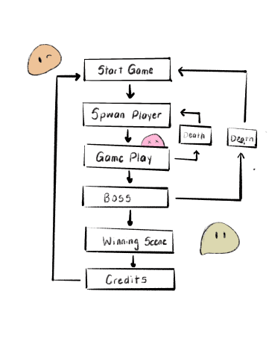

# 10 Game Play

## 10.1 Game Controls

Left arrow Key / A key on keyboard: move left

Up arrow Key /W key on keyboard: Jump up

Right arrow Key/ A key on keyboard: move right

Spacebar: Jump

## 10.2 Game Camera

The menu screen will show the menu setting. Once the game starts, the setting of the game will move as the character moves. The camera will be motioned left, right, or up as the character moves left, right or down. The camera will focus on the player from left to right or right to left on X axis.

### 10.2.1 HUD

The game will show the player’s health on the top left of their game. It will also show the time countdown below that.

### 10.2.2 Maps

This is going to be a horizontal map. Players are required to reach to the end of the X axis to reach the boss. Additionally, there will be obstacles that players must undergo such as rocks, poles, enemies, etc.

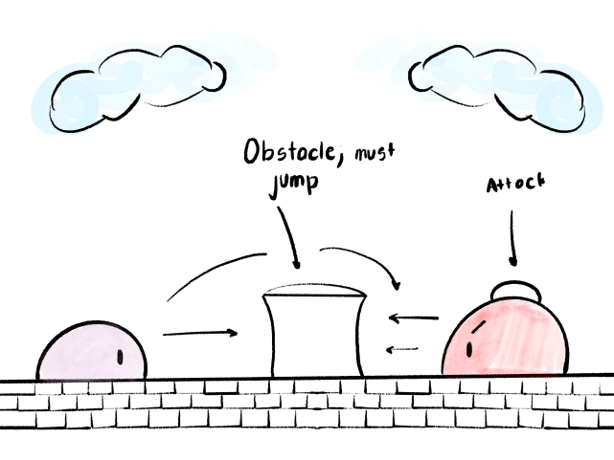

Please note that the photo above is a prototype. It is not the complete map of the game.

# 11 Players

The main characters are the heroes of the game. These species are called “Gumbuals” and they are cute little bubbles who seems very gentle on the outside, but their abilities say otherwise. They are very flexible, and they hold no skeletal structure in their body, making them easy to access through holes, creeks, etc. They although they are from the same species, they vary in colors.



## 11.1 Characters

Gumbuals: Species (Main Character)

Nitpian: Species who believes that it is best of its kind and should be the only one to dominate the world (Enemies)

Ravana: The King; part of the Nitpian species. Banished all Gumbuals species in order to successfully go through with his notorious plain to take over the world. (Enemy/Boss)

## 11.2 Metrics

Max Health: 5

Attack Damage: Once the enemy is attacked it will die instantly. The boss has another condition where multiple attacks will kill the King.

Time to Attack: Once an attack is executed and not on screen, players can attack again (around < 2 seconds)

Horizontal speed: 4

Jump Force: Not yet determined

## 11.3 States

Idle: Players/ characters who are idled and not active, will stay in place. It will make very small up and down motion to show they are still active in the game.

Move: when players trigger the movement of the characters, it will perform sliding motions as the Gumbuals are maneuvering left or right.

Jump/ Fall: The Gumbuals will show a jumping amination and a falling animation when jumping up or down.

## 11.4 Weapons

Gumbuals have naturally inherited powerful abilities. They attack with lightning bolts, and an unknown mist that will kill of an enemy if within its proximity.

# 12 Player Line-up

Gumbuals are shown below:





Character looking at player

Character looking up

Character looking down

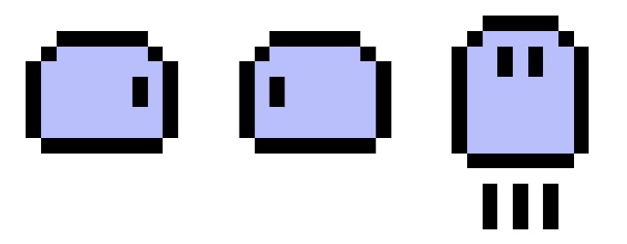

Character looking right Character looking left character jumping up

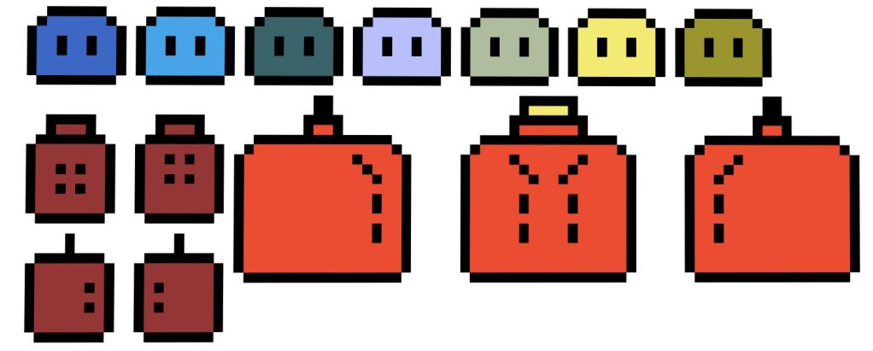

The bottom characters are our enemies and will be shown later.

# 13 NPC

Nitpian: Species who believes that it is best of its kind and should be the only one to dominate the world (Enemies)

Ravana: The King; part of the Nitpian species. Banished all Gumbuals species in order to successfully go through with his notorious plain to take over the world. (Enemy/Boss)

## 13.1 Enemies

Nitpian Species Character



Enemy Looking at player Enemy looking up Enemy looking down

King Ravana from species Nitpian



King Looking Right King looking at player King Looking left

### 13.1.1 Enemy States

Move: enemies will move in an X-axis direction, going against the players. It will constantly be moving.

Jump: Enemies do not have the ability to jump

Idle: Enemies will not be in Idle state. It will constantly try to attack the Gumbuals.

### 13.1.2 Enemy Spawn Points

Enemies will spawn from the right side of the game (the opposite side from where the Gumbuals are entering). It will spawn at a random time at that point.

## 13.2 Allies / Companions

### 13.2.1 Ally States

There will be no allies in this game.

### 13.2.2 Ally Spawn Points

N/A

# 14 Art

## 14.1 Setting

The setting of this game will take place in a country called Gilia. It is a beautiful, bright, and colorful place. When King Ravana took over, the country lost its colors.



## 14.2 Level Design

The level design will consist of a X-axis medieval mixed with modern obstacles. There will be several spawning points in the game. For players who are defeated by the King’s army, will respawn back to its checkpoint. For players who are defeated by King Ravana himself, will not respawn, but will direct players to the beginning of the game (automatic kill).

## 14.3 Audio

With a wide variety of beautiful sounds, the audio has not yet been chosen. A few audios that I have in mind is that it will be a retro yet nostalgic sounds that will draw in the players emotionally.

# 15 Procedurally Generated Content

## 15.1 Environment

All environments and objects in this game are pre-designed. It does NOT generate an environment as the game progresses.

# 16 Wish List

* Longer environment scene
* Adding obstacles (other than enemies) such as bushes, poison, trash, etc.
* Adding reward system such that once character defeats an X number of enemies, it will enhance in its skills.

# 18 Bibliography

Original art:

* Button
* Cover of game
* Characters
* Enemies