Turok: Bloodlands

Universal Gamedev Challenge

# Game Design Document

Version 0.1.032818

## Design

Jeff Sparks

## Art

Joshua Brugh

## Engineer

Chris Coniglio?

# Game Overview

Title Turok: Bloodlands

Platform Windows 10 PC

Genre Dark Fantasy Action Adventure

Rating Mature (17+) ESRB

Target Core Gamer (Age 20-40)

**Turok: Bloodlands** is a third-person adventure game where the Player controls Eli Talutah, a young Native American warrior and hunter who inherits the ancient powers of “The Turok”, granting him unnatural strength, focus, and strange otherworldly powers. This new Turok must now survive in the corrupted Bloodlands, a seething wasteland of savage creatures, deadly traps, and mysterious forces that challenge his every move. These forces are controlled, in part, by viewers on Mixer.

Combat choices include using mythical daggers and axes for close-range melee attacks or opting for a ranged approach using the bow and arrow. When successful, players collect Blood (XP) from vanquished enemies that can be used to strengthen Turok at a campfire rest area called The Heart. However, falling in battle is particularly punishing, as the player loses all accumulated Blood and any defeated enemies are respawned. Because of this, players must be cautious, use every advantage, and rely on their skill more than anything else.

# Unique Selling Points

Challenging, Gritty Combat Surreal Dark Fantasy Setting

Dynamic Mixer Interactions Dramatic New Take on Turok

# Platform Minimum Requirements

CPU: 2.6 GHz Dual-Core

CPU SPEED: Info

RAM: 1 GB (XP), 2 GB (Vista/7)

OS: Windows XP, Windows Vista, Windows 7, or newer

VIDEO CARD: ATI Radeon 4850 or higher, NVIDIA GeForce 8800 GT or higher

SOUND CARD: Yes

FREE DISK SPACE: 4 GB

# Synopsis

You are Turok! Survive your journey into the darkest corners of the Bloodlands as malevolent forces conspire to torment you with bizarre monsters, warriors, and traps at every turn! Can you defeat the shadowy rulers of these realms and uncover the truth about your powers?

# Game Objectives

The main objective of the game is to progress through increasingly difficult dungeon layouts, gathering Blood (XP), Bones (Weapon Upgrades), and other Treasures by exploring and defeating enemies, ultimately discovering the Final Boss.

Against All Odds; Survive Conserve Healing Potions Earn Blood to Level Up

Uncover Route to Boss Activate Checkpoint(s) Collect Items & Treasures

Defeat the Boss Upgrade Equipment Encourage Mixer Interactions

# Game Rules

## Areas & Campfires

The game consists of two distinct areas; A “hub” area called **The Heart** and a “dungeon” area called **The Lost Bog**.

The Heart is a safe gathering place that allows players to level up Turok using Blood collected in the Dungeons, manage and upgrade items, and prepare to return to battle. Once ready, interacting with the fire at the center of this area transports Turok to the dungeon area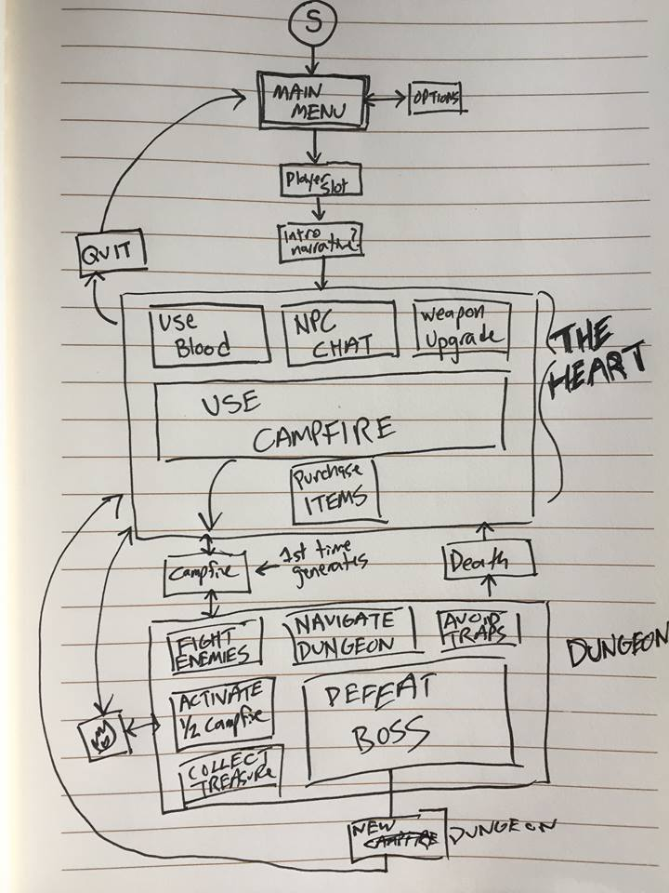, where he rises from a smoldering campfire. These fires allow players to travel between the Hub and the Dungeon at will. Additionally, progressing through the dungeon may reveals additional “checkpoint” campfires that function the same way.

Using a campfire to returning to The Heart has several implications; most importantly, it refills Turok’s Health, replenishes finite supplies (like healing potions), and allows any accumulated Blood to be used to Level Up. On the negative side, it also respawns any enemies the Player may have defeated in the dungeon up to that point. Choosing when to return to The Heart is one of the most strategic choices Players will make.

## Dungeons

Starting from these campfires, Players are on a mission to clear a path through the dungeon. Doing so requires progressing past enemies using evasion or combat, avoiding taking damage from traps, and interacting with devices that ultimately open a route to defeat the final boss.

Additionally, there is treasure (like upgrade items and better equipment) to discover and NPCs to encounter. The key is to avoid overextending… healing items are finite and enemies are ruthless!

## Death, Blood & Blood Pools

If Turok is defeated in battle, he is returned to the last campfire he interacted with, but the he Blood collected up to that point becomes a “Blood Pool”, remaining at the location of his death. Players can attempt to seek out this Pool and retrieve their lost Blood; however, if the player dies during this attempt, the Blood is lost for good. Since enemies are also repopulated when Turok dies, this is a significant decision the Player must make.

## Leveling Up & Upgrading Equipment

In order to succeed when dungeons become more difficult, players will be able to level up Turok, upgrade his weapons, and gather useful items like equipment and consumables. Upgrading Turok with Blood allows Players to increase his base stats, like max health and stamina. Using collected Bones to upgrade weapons increases their damage, collecting better pieces of equipment protects against specific types of damage from enemies, and consumables can be used in dungeons to damage enemies, heal Turok when his health is depleted, and an array of other effects.

## Mixer Interactions

Viewers on Mixer are given quite a bit of influence over the structure and contents of the dungeons as the player progresses, often being called upon to populate or alter specific aspects of the dungeon. These range from moderately impactful to more dramatic, as Viewers are called upon to influence difficulty, darkness, treasures, NPC encounters, as well as spawning or strengthening specific monsters. In the absence of Viewer input, these elements are selected randomly.

## Enemy Spawning

## Healing Potions

## Boss Encounter

# Game Controls

Taken from Dark Souls 1 PC for now – some controls will not apply

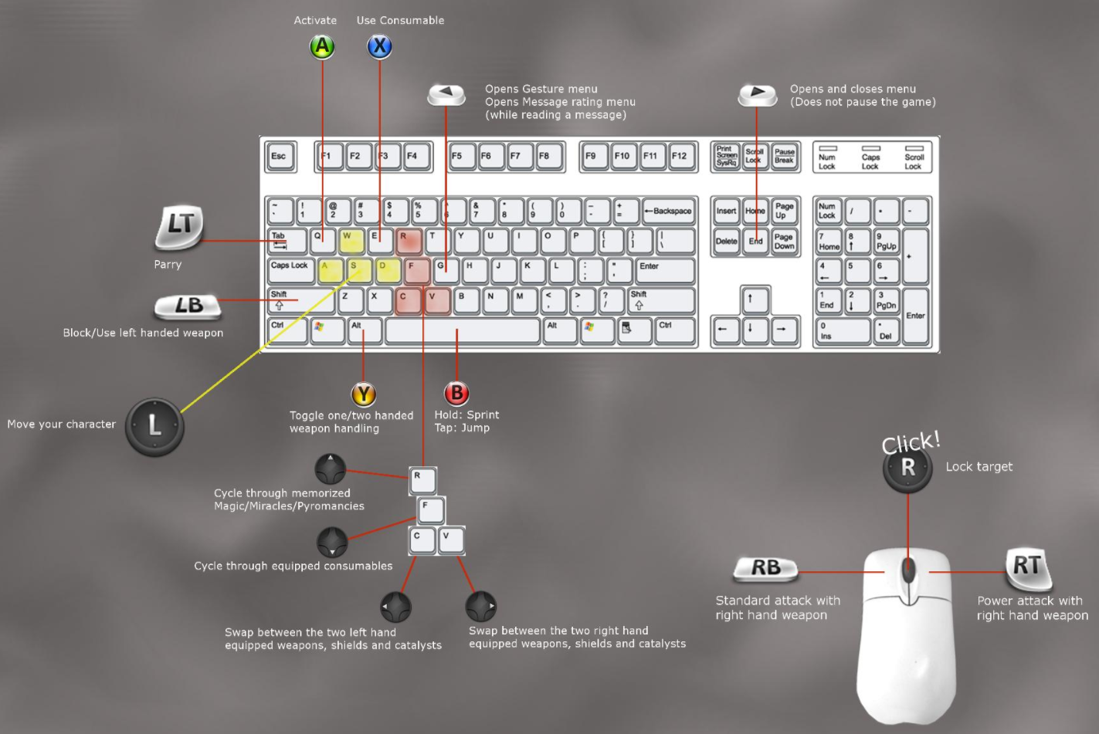

# Game Camera

As this is a third person game in the vein of *Dark Souls* or *Tomb Raider*, the camera follows closely behind Turok by default but can ultimately overridden by the Player’s use of Target Lock or simply by rotating the camera with the Right Analog Stick / Mouse.

# Image result for dark souls screenshotHUD

Health Bar: The amount of health the player has.

Stamina Bar: The amount of stamina the player has.

Item Selection: Currently selected item, allows cycling through all items

Weapon Selection: Currently selected weapon, allows for swapping between them.

# Player Character

## The Turok

The power of the Turok resides in a young Native American hunter and warrior named Elijah Talutah. He fights with melee weapons, a bow and arrow, and other assorted items as he survives in the Bloodlands.

## Base Stats

Each time Turok levels up, a point can be added to one of the stats below. These stats adhere to the concept of “diminishing returns”, where each investment in any one category results in a smaller benefit than the previous investment.

Health = Max Health

Stamina = Max Stamina

Strength = Base Attack

Resistance = Base Defense

Speed = Base Speed

## Player States

*most included in acquired *Invector-3rdPersonController* Asset

Idle: Standing, Crouching

Basic Movement: Walk, Run, Jump, Dodge Roll, Take Damage, Death

Terrain Movement: Climb onto ledges & obstacles, Fall from ledges, Crawl

Melee Attack(s): Several successive close-range attacks; Light, Mid, Heavy combinations

Ranged Attack: Draw bow; Change, aim and release arrows

Use Item: Heal, Throw Item

Context Sensitive: Interact with Levers, Pull Chains, Blood Pools, Campfires, Treasure Chests

# Weapons

## Melee

|  |  |  |  |  |  |  |
| --- | --- | --- | --- | --- | --- | --- |
| **Type** | **Hand** | **Range** | **Damage** | **Speed** | **Effects** | **Name** |
| Knife | Right | Short | 10 | 100 | None | "Talon" |
| Tomahawk | Right | Short | 15 | 90 | None | "Malice" |
| Hammer | Right | Short | 20 | 75 | None | "Striker" |
| Club | Right | Mid | 35 | 55 | None | "Dreadnight" |
| Spear | 2Hand | Long | 45 | 45 | None | "Ender" |

## Shields

|  |  |  |  |  |  |  |
| --- | --- | --- | --- | --- | --- | --- |
| **Type** | **Hand** | **Defense** | **Slash** | **Blunt** | **Stance** | **Name** |
| Small Shield | Left | 10 | 1 | 1 | 10 | "Wind" |
| Large Shield | Left | 60 | 5 | 5 | 30 | "Barricade" |

## Ranged Weapons

* Bows / Arrows

## Consumables

* Health Potions / Stamina Potions / Bombs

## Equipment

* Headdresses / Necklaces / Rings

# Enemies

## The Rival Tribe

Once the biggest rivals of Turok’s tribe, these violent warriors are a sign of how much worse everything in the Bloodlands has become. A sinister tribe with dark intentions even in regular times, they ornament themselves with bones and antlers, seeking the appearance of otherworldly spirits and ghouls. The corruption has made these disguises all the more convincing.

Possible Variations:

* Skull Mask – Melee Axe
* Mohawk - Daggers
* Antlers – Spear
* Feathers – Axe & Shield
* Big Man (Bird Skull) – Hammer
* Big Man (No Jaw) – Big Axe & Big Shield

## The Hill people

Giant, mindless ogres that lived in the caves and canyons of the Bloodlands, the corruption has reached them too. Communicating with grunts and growls was always their way, only now their incoherence is punctuated with rage and violence.

Possible Variations:

* Regular Flavor – No Weapon
* Fast & Lanky – Daggers and stones
* Big Papa – Axe
* Big Mama – Tree Branch
* Massive One-Eyed – Stone Slab

## The Wooden Ones

Spirits of dying trees brought to life, twisted and gnarled by the corruption, thirsty for vengeance and the blood of men. When they move, black sap sloshes out of their branches.

Possible Variations:

* Zombie – Shambling
* Crawly – Faster, avoids attacks
* Elder – Massive arms
* Slender – Avoids Turok, creates Saplings
* Saplings – Creepy tree babies w daggers

## The Forgotten

The reanimated remains of fallen warriors from other eras, often undead or skeletal in appearance. These rotting men and women of ancient battlefields from across the globe carry foreign weapons and armors.

## Skinwalkers

Monsters of the forest that seem unaffected by the corruption, perhaps due to their affinity for necromancy and other dark powers. They take the shape of enormous beasts and men, endlessly stalking and devouring their prey.

## Beholder (Mixer Only)

Seemingly an enormous eye surrounded by a teeming mass of sinewy tendons, vines, and clumps of smaller eyeballs, this creature avoids direct contact with Turok, instead summoning other enemies (elected by viewers on Mixer) which rise from the pools of muck.

## Flesh Raptors

These ancient lizards, brought here by mysterious circumstances, hunted freely and thrived in the jungles and swamps of the Bloodlands—before the corruption took hold. Now, still traveling instinctually in hunting packs, these monsters hunger endlessly for meat and blood, even as their bodies hopelessly dissolve and mutate.

## Skull Birds

Savage, flightless birds used as mounts by several tribes, the corrupted variety are dissolving and falling apart, lashing out at anything that moves.

# Bosses

## The Tyrant

Already a monstrous beast in the best of times, this corrupted T-Rex guards the final area of The Lost Bog. Outside of attacking Turok with his enormous size and strength, Tyrant vomits pools of poisonous bile, knocks rocks loose from the ceiling, and summons undead Velociraptors from the ground.

# NPCs

## Wendigo

The keeper of the Blood who seems to have knowledge about the origins of Turok’s power, Players can interact with this creature to Level Up.

## Owl Woman

A strange priestess with a massive headdress of feathers, Players can interact with her to purchase items with Blood.

## Warchief Fireseed

The spirit of a previous Turok now rests beside the main fire at The Heart. He cannot feel the warmth of the space, and his mind is all but lost, but he fully recalls the instruments of battle. Players can interact with him to spend Bones on Weapon Upgrades.

# Environments

## The Heart

The hub is a small, warm area with mysterious Totems and NPCs that serve Turok by allowing him to level up, upgrade equipment, etc. The massive fire in the center of the space serves as an entrance to dungeons.

## The Lost Bog

Once a humid jungle swampland full of life, the corruption blotted out the sky and covered the land in a black tar substance that hangs and drips from everything. The trees are sickly and burnt, melting like old candles being bent away from the sky. All the creatures have a burnt, sickly, violent, undead appearance.

# Level Design

# Minimum Viable Product

* Turok w Initial Axe & Shield (No Ranged Weapons or Additional Melee Options)
* Three Basic Enemies (No Aesthetic/Weapon Variants)
* One Dungeon Area (Required Hub functionality is Menus, no NPCs)
* One End Boss Encounter
* One Significant Mixer Audience Gameplay Effect

# Wishlist

## More Enemies & Bosses

The core of the game thrives on varied enemies to engage with. Push additional dungeon replay diversity by building diverse, impactful boss encounters

## Status Effects

Poison, Fire, Immobilize, and other such effects applied to weapons

# Visual References

## Image result for zombie t rexImage result for velociraptor zombie monster conceptImage result for beholderRelated imagehttps://cdna.artstation.com/p/assets/images/images/007/433/654/large/david-rivera-sentient-tree.jpg?1506097709Image result for evil native american game character concept arthttps://cdna.artstation.com/p/assets/images/images/004/185/742/large/alexa-renee-ogreonacliff-mini.jpg?1481142529Enemies

## Environments

### The Heart

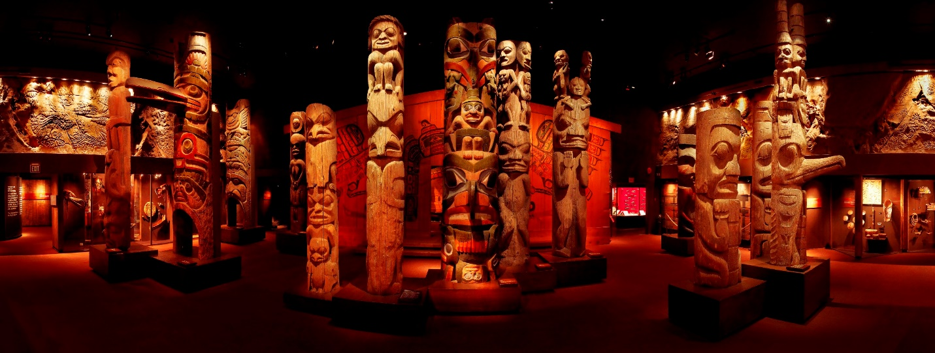

### The Lost Bog

