The
Holonomic Quantum Manifesto
Unifying Relativity and Quantum Mechanics
Concise Edition — Revised (Path A)

or:
Holonomic Quantum Mechanics:
The Comprehensive Guide
Author: J. F. Ricks, Holonomic Quantum Research Group
www.HQRG.org
Website companion to the book for interactive visualizations: https://jefrix.github.io/HQR

$$S_{\text{HQR}}=\int{d^{11}x}\sqrt{-G}\left(\frac{R_{11}}{16πG_{11}}+L_{\text{QI}}\right)$$Holonomic Action Principle
This action suggests that spacetime emerges as a manifestation of underlying informational gradients. By treating curvature as a byproduct of quantum informational interactions, it unifies gravity and quantum mechanics, laying the groundwork for HQR’s approach to quantum gravity.
Academic
Publishing
Consortium

Table of Contents
Preface
Part I: Foundations of Holonomic Quantum Reality
Chapter 1: Quantum Mechanics and General Relativity – The Incompatibility
Chapter 2: Higher Dimensions, M-Theory, and Holography
Chapter 3: Determinism, Bohmian Mechanics, and Hidden Order
Part II: Mathematical Foundations
Chapter 4: Tensor Calculus in Higher Dimensions
Chapter 5: Spacetime Emergence and the Holonomic Action
Chapter 6: Quantum Information, Category Theory, and Holography
Chapter 7: Unified Equations and Holographic Entropy
Part III: Predictions and Tests
Chapter 8: Bell’s Theorem and Higher-Dimensional Non-Locality
Chapter 9: Quantum Gravity Signatures and Experimental Protocols
Chapter 10: Resolving Cosmological and Particle Anomalies
Part IV: Advanced Topics and Outlook
Chapter 11: Quantum Computation and Holography
Chapter 12: Quantum Consciousness and Biological Systems
Chapter 13: Philosophical and Societal Implications
Appendices
Appendix A: Comprehensive Mathematical Formulations
Appendix B: Reference Chart of HQR Equations
Appendix C: Experimental Protocols for Testing HQR

The Holonomic Quantum Manifesto Unifying Relativity and Quantum Mechanics Concise Version
Author: J. F. Ricks, Holonomic Quantum Research Group www.HQRG.org
Interactive visualizations: https://jefrix.github.io/HQR

Preface
0.1 Objectives This book presents Holonomic Quantum Reality (HQR) — a unified framework in which spacetime, matter, and quantum phenomena emerge from deterministic quantum information dynamics in 11 dimensions, governed by subtle “hidden order.”
HQR treats both quantum mechanics and general relativity as 4D projections of deeper informational structures. It introduces two central innovations:
- The Holonomic Action Principle: $S=∫d^{11}x\sqrt{-g^{\left(11\right)}}\left(\frac{R^{\left(11\right)}}{16πG_{11}} + L_{info}\right)$
- The Quantum Informational Stress-Energy Tensor $T_{μν}^{info}$, which augments the classical stress-energy tensor with entanglement and informational gradients.
These objects enable a natural unification while generating concrete, testable predictions that distinguish HQR from existing approaches. The framework builds rigorously on Bohmian mechanics, M-theory, Kaluza-Klein theory, and the holographic principle (AdS/CFT).
0.2 Structure and How to Use This Book
- Part I: Conceptual foundations (accessible introduction).
- Part II: Mathematical core — the heart of HQR.
- Part III: Specific predictions and experimental tests.
- Part IV: Advanced applications and broader implications.
- Appendices: Equations, protocols, and resources.
Readers may begin with Part I for intuition or dive directly into Part II/Appendices for technical depth. Educators can use chapters modularly; researchers will find Appendix B (HQR Equations) and Appendix C (Test Protocols) especially useful.

Part I: Foundations of Holonomic Quantum Reality

Chapter 1: Quantum Mechanics and General Relativity – The Incompatibility
Quantum mechanics and general relativity succeed spectacularly in their domains but clash at Planck scales and singularities.
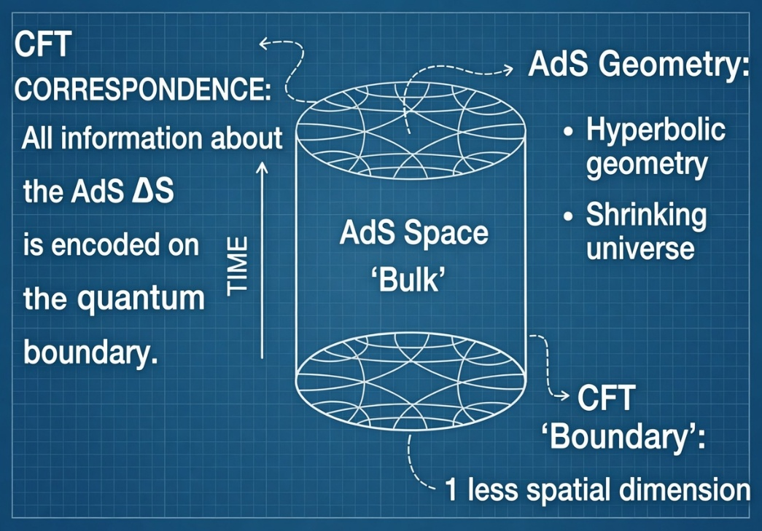Knitting space–time out of quantum entanglement
1.1 Core Principles of Quantum Mechanics Quantum theory is built on superposition, entanglement, and the Born rule. The wave function $∣ψ⟩$evolves unitarily via the Schrödinger equation $iℏ\frac{∂}{∂t}∣ψ⟩=\hat{H}∣ψ⟩$yet yields probabilistic outcomes upon measurement. Entanglement produces correlations that violate Bell inequalities, e.g., the singlet state $∣Ψ^{-}⟩=\frac{1}{\sqrt{2}}\left(∣↑↓⟩-∣↓↑⟩\right).$
1.2 Principles of General Relativity Gravity is spacetime curvature. Einstein’s field equations read $R_{μν}-\frac{1}{2}Rg_{μν}+Λg_{μν}=\frac{8πG}{c^{4}}T_{μν}.$This theory is confirmed by gravitational waves, black-hole shadows, and precision tests, yet fails at singularities and cannot be consistently quantized.
1.3 The Unification Challenge and HQR Resolution Standard quantization of gravity produces non-renormalizable infinities. The black-hole information paradox and cosmological constant problem remain unresolved.
HQR Solution: HQR proposes that both theories can be modeled as 4D projections of an 11-dimensional informational structure, so that apparent 4D non-locality and randomness arise from deterministic higher-dimensional dynamics. As made precise in Section 2.5, this is a modeling programme built on a postulated informational scalar; the stronger claim that entanglement literally is the source of geometry is motivation, not a derived result. The quantum informational stress tensor $T_{μν}^{\text{info}}$sources spacetime curvature alongside ordinary matter, while the holonomic action (above) governs the full 11D evolution.

Chapter 2: Higher Dimensions, M-Theory, and Holography
2.1 String/M-Theory Essentials String theory requires 10 or 11 spacetime dimensions. Extra dimensions compactify on Calabi-Yau manifolds. M-theory unifies the five consistent string theories in 11D and naturally includes branes and dualities.
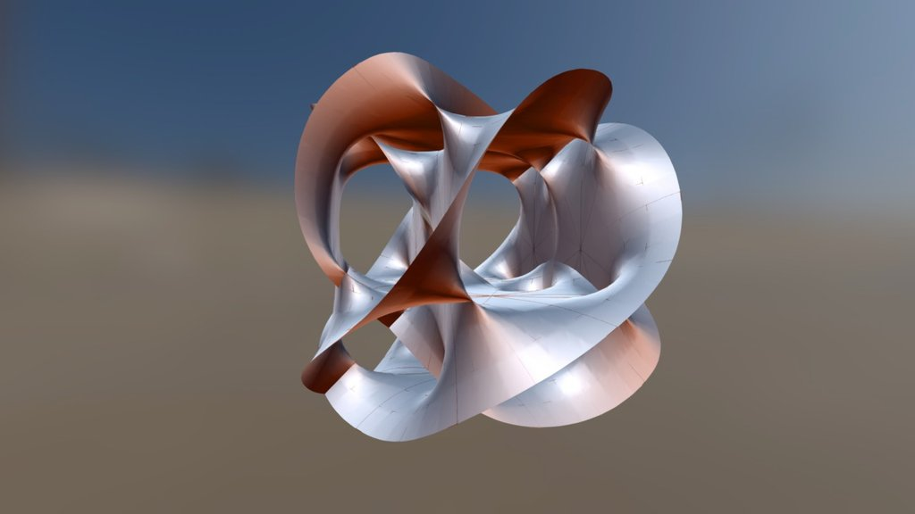 Calabi-Yau Space Modeling in Blender? - Modeling - Blender Artists Community
2.2 Compactification and Calabi-Yau Geometry The geometry of compactified dimensions determines 4D physics. Different Calabi-Yau topologies yield different particle spectra and couplings. In HQR these manifolds actively encode quantum information; their topological invariants (Hodge numbers, Euler characteristic) store hidden-order correlations.
2.3 The Holographic Principle The AdS/CFT correspondence states that gravity in the bulk of anti-de Sitter space is dual to a conformal field theory on its boundary. Holographic entropy is given by the Ryu-Takayanagi formula: $S=\frac{\text{Area}(γ)}{4G_{N}}$where $γ$is the minimal surface homologous to the boundary region.
HQR elevates this duality to ontology: our 4D spacetime is a holographic projection of 11D quantum information. Entanglement on the boundary generates bulk geometry.
2.4 Brane Intersections and the Geometric Origin of Entanglement
In Type IIB superstring theory, D1-branes (D-strings) connect to higher-dimensional D-branes through open strings whose endpoints are fixed by Dirichlet boundary conditions. An open string can have one end anchored on a D-string and the other on a D3-, D5-, or D7-brane. The vibrational modes of these open strings give rise to gauge fields on the brane.
When lifted to M-theory via strong-coupling duality, fundamental strings become M2-branes wrapped around the compact 11th dimension, while D-branes lift to M5-branes. The connection is no longer a sharp endpoint but a smooth intersecting membrane junction: an M2-brane meets or dissolves into an M5-brane, forming a tube-like boundary or localized charge on the M5 surface.
From the perspective of a 4D observer confined to the brane, this geometry produces the appearance of entanglement. The observer sees two point-like excitations whose states correlate instantly (e.g., opposite spins) with no visible connection. In reality, the two “particles” are simply the projections of the same twisting D-string. What appears as non-local entanglement in 4D is ordinary local geometry in 11D. This provides HQR with a concrete mechanism for entanglement as higher-dimensional locality.

2.5 The Status of the Informational Field $ρ^{ent}$
The field $ρ$appearing in the action $S_{local}$is the structural core of HQR, and it is essential to state precisely what it is and what it is not. This subsection makes that status explicit so that the derivations which follow rest on a defined object rather than an interpretive one.
**$ρ^{ent}$ is a fundamental scalar field, not a derived entanglement entropy.** Throughout this work, $ρ^{ent}(X)$denotes an independent real scalar field on $M^{11}$, with its own kinetic term, potential $U(ρ)$, and non-minimal coupling $αρR^{\left(11\right)}$. It is a dynamical degree of freedom of the theory in exactly the sense that a dilaton or a Brans–Dicke scalar is. It is *not* defined as the von Neumann entanglement entropy $S(A)=-Tr⁡(ρ_{A}log⁡ρ_{A})$of any state and bipartition, and no step in the formal development computes it from a quantum state.
This distinction is not a technicality. Entanglement entropy is a global, state-dependent, and bipartition-dependent functional; it is not a local field that can be inserted into a Lagrangian and varied. Treating $ρ^{ent}$as a local variational field is therefore a *modeling postulate*, adopted because it yields a well-posed and calculable 11-dimensional theory. The name "entanglement density" records the physical intuition that motivated the construction — that informational structure should gravitate — but within the formal model that name is interpretation, not derivation.
What this buys, and what it costs. With $ρ^{ent}$taken as an independent scalar, every subsequent step is well-defined. The variation $δS/δg^{AB}$is unambiguous because $ρ^{ent}$does not itself depend on the metric being solved for; there is no circularity. Dimensional reduction on a specified internal manifold yields finite, definite 4D field equations (this has been verified explicitly for the minimal product compactification on $T^{7}$with a zero-mode profile, where the reduction produces a clean 4D scalar-tensor structure with no divergence or ambiguity). In this reading, HQR is a specific 11-dimensional scalar–tensor theory with flux and topological terms: an unconventional and testable model, but a conservative and self-consistent one.
The cost is equally explicit. Under this postulate, statements of the form "entanglement *is* the source of curvature" are not established by the formalism. What the formalism establishes is that a scalar field, which we interpret as informational, contributes to curvature in the manner of any non-minimally coupled scalar. The stronger ontological claim — that $ρ^{ent}$is literally the entanglement content of an underlying quantum state, and that this content sources geometry — is a separate hypothesis that the present construction motivates but does not prove.
Open direction (not assumed here). A genuinely entropic version of HQR, in which the 4D field equations emerge from an entanglement-entropy functional rather than from a postulated scalar (in the spirit of thermodynamic derivations of gravity), would upgrade the interpretive claim to a derived one. Such a derivation faces substantial and currently unresolved obstacles: the non-local character of entanglement entropy, the requirement of a first law that closes variationally, and the role of the hidden-order terms in supplying the missing constraints. We regard this as an open research direction and do not rely on it. All results in this work are stated within the postulated-scalar reading above.
Readers should therefore carry the following convention through the remainder of the text. Where the formal development uses $ρ^{ent}$, it refers to the postulated scalar field. Where the surrounding discussion speaks of entanglement, holography, or information as the *origin* of geometry, that language is the physical motivation and interpretive program of HQR, clearly distinct from what the equations by themselves demonstrate.

2.6 The Candidate HQR Effective Action
With the status of the informational field fixed by Section 2.5, we can state the candidate variational structure of HQR without ambiguity. Throughout this section, ρ denotes the postulated scalar field of Section 2.5; the word “informational” is its interpretation, not a derivation. The model is a specific 11-dimensional scalar–tensor theory with a four-form flux and a topological sector, and it should be read as a compact proposal whose purpose is to give HQR a variational backbone from which projection, stress-energy, entropy correction, and experimental signatures can be derived.
S_{HQR} = S_{local} + S_{hidden/top}.
The local dynamical sector is
S_{local} = ∫ d¹¹x √(−g) [ ( 1/2κ₁₁² + αρ ) R⁽¹¹⁾ − (β/2) g^{AB} ∇_{A}ρ ∇_{B}ρ − U(ρ) + ℒ_{matter} − (1/2·4!) F_{ABCD}F^{ABCD} ], with F₄ = dC₃ and ρ ≡ ρ^{ent} the postulated scalar of Section 2.5.
The hidden-order / topological sector is written separately as S_{hidden/top} = ∫ [ η C₃ ∧ F₄ ∧ F₄ + λ C₃ ∧ X₈(R) + ζ dΘ(ρ) ∧ Y₁₀ ]. The local terms curve spacetime; the topological terms select which informational states are allowed. Hidden order is therefore a set of protected constraints, not merely another energy field.
Interpretation of the terms. The Einstein–Hilbert piece (1/2κ₁₁²) R⁽¹¹⁾ is ordinary 11-dimensional gravity. The non-minimal coupling αρR⁽¹¹⁾ is the central HQR term: the postulated scalar ρ, which we interpret as an informational density, couples to curvature in the manner of a Brans–Dicke or dilaton field. This is the mathematical structure that motivates the HQR interpretation that organized information is associated with geometry; as established in Section 2.5, it is the postulated-scalar reading, not a derivation from entanglement entropy, and the slogan “information → geometry” should be read in that motivational sense throughout. The kinetic term gives ρ dynamics so that informational gradients propagate rather than sit as a fixed background. The potential U(ρ) encodes stable hidden-order configurations, whose minima define preferred informational vacua that may project into different effective 4D behaviour. The four-form term ties the construction to M-theory: since M2-branes couple to C₃, it supplies the natural language for the M2/M5 brane-junction picture of higher-dimensional locality discussed in Section 2.4.
Field equation and informational stress tensor. Varying the local action with respect to the 11D metric, and moving the non-minimal piece to the left so it reads as a field-dependent gravitational coupling, gives
( 1/κ₁₁² + 2αρ ) G_{AB}⁽¹¹⁾ = T_{AB}^{matter} + T^{ρ}_{AB} + T^{F4}_{AB} + 2α( ∇_{A}∇_{B}ρ − g_{AB}□ρ ) + T^{hidden}_{AB} ,
where the scalar contribution is T^{ρ}_{AB} = β( ∇_{A}ρ∇_{B}ρ − ½ g_{AB}(∇ρ)² ) − g_{AB}U(ρ), and T^{F4}_{AB} is the standard four-form stress tensor. The field ρ therefore does two things at once: it contributes stress-energy through its gradients and potential, and through αρR⁽¹¹⁾ it modifies how strongly geometry responds. Both effects follow from the postulated-scalar reading of Section 2.5 and require no claim that ρ is the entanglement entropy of a quantum state.
Projection to four dimensions. Compactifying over the internal seven-dimensional structure K⁷ with a specified ansatz (Section 2.5; the minimal flat-torus case has been checked explicitly and yields a finite, well-defined reduction) gives a 4D effective equation of the form G_{μν} + Λ_{eff} g_{μν} = 8πG_{eff} ( T^{matter}_{μν} + T^{info}_{μν} + T^{hidden}_{μν} ) + Δ^{proj}_{μν} . The effective cosmological term decomposes as Λ_{eff} = Λ₀ + Λ_{ρ} + Λ_{hidden}, with Λ_{ρ} ∼ ⟨U(ρ)⟩ averaged over K⁷.
Caveat on Δ^{proj}. The projection-residue tensor Δ^{proj}_{μν} is, at present, an unconstrained object: its form depends entirely on the choice of compactification, warp factor, and flux, and the framework does not yet contain a principle that fixes it. It must therefore be regarded as a placeholder for residual reduction effects, not as a predictive term. Fixing the form of Δ^{proj}_{μν} on an explicit compactification, so that it cannot absorb arbitrary discrepancies, is an open problem on the same footing as the dynamics of ρ itself.
With these conventions, the action maps cleanly onto the master chain: the holonomic action governs the 11D structure; the projection map reduces it to 4D; the informational stress tensor describes how the postulated scalar and its gradients contribute to curvature; the hidden/topological sector preserves correlations not visible in the 4D projection; and the residue appears as the observable signatures catalogued in Part III. Stated without overclaiming: HQR proposes that the observed universe is the 4D projection of an 11D variational structure in which a postulated informational scalar contributes to curvature, hidden topology preserves correlations, and observable anomalies arise as projection residues. The full derivation, sign conventions, and the explicit reduction integral are collected in Appendix A.

Chapter 3: Determinism, Bohmian Mechanics, and Hidden Order
3.1 Bohmian Mechanics Bohm’s pilot-wave theory restores determinism. The wave function $ψ=Re^{iS/ℏ}$guides particles via $v=\frac{ℏ}{m}∇S,$with the quantum potential $Q=-\frac{ℏ^{2}}{2m}\frac{∇^{2}R}{R}.$This reproduces all quantum statistics under quantum equilibrium while maintaining objective trajectories.
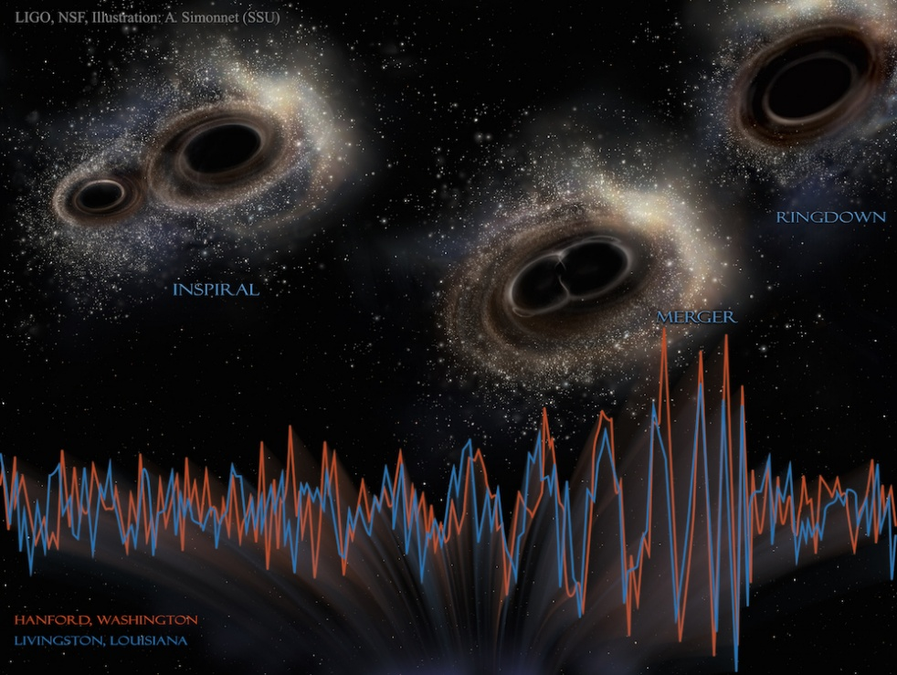 Stunning New Image Shows Gravitational Waves As Two Black Holes Merge | Live Science

3.2 Hidden Order in HQR HQR interprets the pilot wave and quantum potential as 4D shadows of deterministic 11D informational dynamics. Non-locality in 4D becomes ordinary locality in the compactified dimensions. Uncertainty arises from information loss under dimensional projection.
3.3 Key Testbed: Hidden Order in URu₂Si₂ The heavy-fermion compound URu₂Si₂ undergoes a mysterious second-order transition at $T_{HO}≈17.5$K featuring large entropy loss and Fermi-surface reconstruction, yet the order parameter remains undetected. HQR predicts this “hidden order” arises from informational stress $T_{μν}^{\text{info}}$projected from higher dimensions, producing detectable entanglement-modulated signatures in transport, neutron scattering, or strain measurements. This real material provides an immediate near-term test of HQR’s core mechanism.

Part II: Mathematical Foundations

Chapter 4: Tensor Calculus in Higher Dimensions
Higher-dimensional physics requires robust geometric tools. HQR operates in an 11-dimensional manifold $M^{11}$with metric $g_{AB}$(capital indices run 0 to 10).
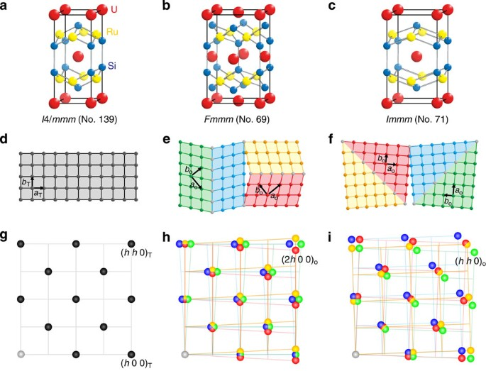 Direct observation of lattice symmetry breaking at the hidden-order transition in URu2Si2 | Nature Communications

4.1 Key Tensors The Christoffel symbols, Riemann tensor, and Ricci tensor are defined in the usual way but extended to 11D. The Einstein-Hilbert term generalizes to:
$$R^{\left(11\right)}=g^{AB}R_{AB}^{\left(11\right)}$$
4.2 Quantum Informational Extensions HQR introduces the Quantum Informational Metric Tensor:
$$g_{μν}^{\text{info}}=g_{μν}+κ ρ_{μν}^{\text{ent}}$$
where $ρ_{μν}^{\text{ent}}$encodes entanglement density and $κ$is a coupling constant.
The central object is the Quantum Informational Stress-Energy Tensor:
$$T_{μν}^{\text{info}}=-\frac{2}{\sqrt{-g}}\frac{δS_{\text{info}}}{δg^{μν}}$$
This tensor sources curvature from quantum informational gradients and hidden-order correlations.
4.3 Generalized Kaluza-Klein Reduction Dimensional reduction from 11D to 4D yields modified 4D Einstein equations:
$$R_{μν}-\frac{1}{2}Rg_{μν}+Λg_{μν}=\frac{8πG}{c^{4}}\left(T_{μν}^{\text{matter}} + T_{μν}^{\text{info}}\right)$$
The extra terms from compactified dimensions appear as effective sources for dark energy and modified gravity.

Chapter 5: Spacetime Emergence and the Holonomic Action
5.1 Spacetime as Emergent In HQR, classical spacetime is not fundamental. It arises from quantum informational degrees of freedom via a variational principle.
5.2 The Holonomic Action Principle
$$S=∫d^{11}x \sqrt{-g^{\left(11\right)}}\left(\frac{R^{\left(11\right)}}{16πG_{11}}+L_{\text{info}}[ψ,ρ^{\text{ent}}]\right)$$
where $L_{\text{info}}$includes entanglement entropy density and higher-categorical structures. Varying with respect to the 11D metric yields the unified field equations.
5.3 Quantum Informational Einstein Equations
$$R_{AB}^{\left(11\right)}-\frac{1}{2}R^{\left(11\right)}g_{AB}^{\left(11\right)}=8πG_{11}\left(T_{AB}^{\text{matter}} + T_{AB}^{\text{info}}\right)$$
Projecting to 4D gives the effective theory with informational corrections.
5.4 Information Flow and Curvature The curvature is driven by informational gradients:
$$R_{μν}∝∇_{μ}∇_{ν}log⁡ρ^{\text{info}}+\text{entanglement terms}$$
Dark energy emerges naturally as residual entanglement entropy after dimensional reduction:
$$Λ_{\text{eff}}≈\frac{8πG}{c^{4}}⟨ρ^{\text{ent}}⟩_{\text{vac}}$$
5.5 Gravitational Corrections to Bell Violations In curved spacetime, the CHSH inequality receives informational corrections:
$$∣S∣≤2\sqrt{2}+δ_{\text{grav}}$$
where $δ_{\text{grav}}$depends on the quantum informational stress tensor and is potentially measurable near strong gravitational fields or in precision lab experiments.

Chapter 6: Quantum Information, Category Theory, and Holography
6.1 Quantum Information Geometry HQR employs category-theoretic tools. The quantum informational tensor arises from derived functors on sheaves of entanglement data. L∞-algebras describe higher-order entanglement structures.
6.2 Tensor Networks and Holography Multiscale entanglement renormalization ansatz (MERA) tensor networks provide a discrete realization of holographic duality. The Ryu-Takayanagi formula for entanglement entropy is:
$$S(A)=\frac{\text{Area}(γ_{A})}{4G_{N}}$$
where $γ_{A}$is the minimal surface in the bulk homologous to boundary region A. HQR interprets this as literal information encoding.
6.3 Noncommutative Geometry Coordinates satisfy
$$[x^{μ},x^{ν}]=iθ^{μν}$$
leading to the noncommutative extension of Einstein’s equations:
$$R_{μν}-\frac{1}{2}Rg_{μν}=8πG\left(T_{μν} + T_{μν}^{θ}\right)$$

Chapter 7: Unified Equations and Holographic Entropy
7.1 Core Unified Equations The complete set is summarized in Appendix B. Key examples:
- Holographic Entropy with Hidden Order:
$$S_{\text{HQR}}=\frac{A}{4G_{N}}+S_{\text{hidden}}$$
where $S_{\text{hidden}}$accounts for higher-dimensional correlations.
- Entanglement Evolution:
$$\frac{d}{dt}ρ^{\text{ent}}=-i[H,ρ^{\text{ent}}]+D_{\text{info}}(ρ)$$
- Informational Curvature Identity:
$$R_{μν}^{\text{info}}=κ ∂_{μ}∂_{ν}log⁡ρ^{\text{info}}+\text{topological terms}$$
7.2 Black Hole Thermodynamics HQR resolves the information paradox: information is preserved in the higher-dimensional bulk and recovered through hidden-order correlations during Hawking evaporation. Gravitational wave echoes are predicted as holographic signatures.
7.3 Cosmological Implications The framework naturally produces a time-dependent cosmological constant and explains dark energy as vacuum entanglement energy. It also addresses the Hubble tension via informational corrections to early-universe expansion.

Part III: Predictions and Tests

Chapter 8: Bell’s Theorem and Higher-Dimensional Non-Locality
8.1 Rethinking Non-Locality In standard quantum mechanics, Bell inequalities are maximally violated by entangled states. HQR interprets this non-locality as higher-dimensional locality: particles separated in 4D spacetime may be adjacent in the compactified 11D geometry.
8.2 Gravity-Modified Bell Tests The quantum informational stress tensor $T_{μν}^{\text{info}}$couples entanglement to curvature, producing measurable corrections. The CHSH correlator becomes:
$$∣S∣≤2\sqrt{2}+δ_{\text{grav}}\left( ∫ T_{μν}^{\text{info}} dV\right)$$
where $δ_{\text{grav}}$scales with local spacetime curvature and informational density.
Prediction: Precision Bell tests near massive bodies, in strong gradients, or using entangled systems in superconducting cavities will show small but systematic deviations from Tsirelson’s bound. Table-top experiments with ultra-cold atoms or nitrogen-vacancy centers in diamond near tunable masses are feasible.
8.3 URu₂Si₂ as a Condensed-Matter Testbed The hidden-order phase at $T_{HO}≈17.5$K is predicted to exhibit entanglement-modulated transport and symmetry breaking driven by $T_{μν}^{\text{info}}$. Signatures include anomalous thermal conductivity, modified neutron scattering cross-sections, and strain-dependent Bell-like correlations in mesoscopic devices fabricated from URu₂Si₂.

Chapter 9: Quantum Gravity Signatures and Experimental Protocols
9.1 Gravitational Wave Echoes HQR predicts that black-hole mergers produce holographic echoes due to information retention in the higher-dimensional bulk. The ringdown waveform includes delayed echoes:
$$h(t)=h_{GR}(t)+ϵ h_{echo}\left(t − Δt\right)$$
with $Δt∼2Mlog⁡(M/l_{Pl})$(where $l_{Pl}$is the Planck length) and amplitude $ϵ$set by hidden-order entropy $S_{hidden}$.
Prediction: Search LIGO/Virgo/KAGRA data and future detectors (Einstein Telescope, LISA) for repeated echoes in the post-merger signal. Current marginal hints exist; next-generation sensitivity should confirm or rule out the effect.
9.2 Casimir Experiments and Vacuum Fluctuations The quantum informational metric modifies the Casimir force at sub-micron scales:
$$F_{Casimir}^{HQR}=F_{std}\left(1 + α ρ^{ent}\right)$$
where $ρ^{ent}$is the local entanglement density.
Prediction: High-precision Casimir measurements between plates in varying quantum states (e.g., superconducting vs. normal) or near entangled photon sources should detect anomalous forces attributable to informational stress.
9.3 Laboratory Quantum Gravity Tests
- Entangled photon or atom interferometers in gravitational gradients.
- Precision spectroscopy of atoms in curved spacetime.
- tabletop analogs of black-hole horizons using sonic or optical analogs.
HQR predicts measurable violations of standard quantum field theory in curved spacetime proportional to $T_{μν}^{info}$.

Chapter 10: Resolving Cosmological and Particle Anomalies
10.1 Dark Energy and the Cosmological Constant HQR derives the effective cosmological constant from residual vacuum entanglement:
$$Λ_{eff}≈\frac{8πG}{c^{4}}⟨ρ^{ent}⟩_{vac}$$
This naturally yields the observed small positive value and predicts mild time dependence.
Prediction: Improved CMB (CMB-S4) and large-scale structure surveys should detect subtle deviations from $Λ$CDM, particularly in the late-time expansion rate.
10.2 Dark Matter Higher-dimensional matter on parallel branes or hidden-order excitations projects purely gravitational effects into our 4D slice.
Prediction: Direct-detection experiments may continue to see null results while astrophysical probes (galactic rotation curves, bullet cluster, gravitational lensing) remain explained. Weakly interacting hidden-order modes could appear in high-energy cosmic-ray or collider data.
10.3 Hubble Tension and Other Anomalies Informational corrections to early-universe expansion naturally reconcile local and CMB measurements of $H_{0}$. The hierarchy problem is alleviated by the landscape of Calabi-Yau compactifications weighted by informational entropy. Baryon asymmetry and ultra-high-energy cosmic rays receive explanations via higher-dimensional leakage channels.
10.4 Overall Test Strategy Appendix C details protocols ranked by near-term feasibility:
- URu₂Si₂ hidden-order studies (condensed matter, 1–5 years).
- Gravity-modified Bell tests (quantum optics labs, 3–7 years).
- Gravitational wave echo searches (ongoing + next-gen detectors).
- Precision Casimir and vacuum experiments.
Positive detection of any signature would strongly support HQR; null results in multiple channels would constrain the coupling parameters $κ$and $ρ^{ent}$.

Part IV: Advanced Topics and Outlook
Epistemic status of Part IV. The chapters in this Part are exploratory extrapolations, not consequences of the formal model. As established in Section 2.5, the rigorous core of HQR is a postulated 11-dimensional scalar–tensor theory; the informational interpretation of that scalar is motivation, not a derived result. The applications discussed here — quantum computation, quantum biology and coherence, consciousness, free will, and societal implications — assume the strongest interpretive reading of HQR and are presented as directions of inquiry and possible implications, not as predictions that follow from the equations. Nothing in the formal development of Parts I–III depends on the material in this Part, and a reader who rejects the speculative extrapolations can do so without affecting the testable content of the framework.

Chapter 11: Quantum Computation and Holography
Quantum computers are not merely powerful calculators — in the HQR framework they are laboratories for exploring higher-dimensional information dynamics.
11.1 Holographic Quantum Gates Standard quantum gates (Hadamard, CNOT, etc.) are 4D projections of higher-dimensional informational transformations. A holographic encoding distributes logical qubits non-locally across the system, naturally enhancing robustness:
$$U_{\text{holo}}=\sum_{i}{c_{i}} ∣ϕ_{i}⟩_{\text{boundary}}⟨ψ∣_{\text{bulk}}$$
This approach aligns with topological quantum computing using non-Abelian anyons and tensor-network representations (MERA).
11.2 Simulation of Higher-Dimensional Physics Quantum computers excel at simulating systems that are intractable classically. HQR predicts they can efficiently model:
- 11D compactification on Calabi-Yau manifolds,
- Entanglement-driven spacetime emergence,
- Gravitational dynamics from boundary entanglement (ER=EPR).
A sufficiently advanced quantum processor could test HQR’s unified equations directly by evolving informational stress tensors in simulation.
11.3 AI Pattern Recognition in Quantum Systems Machine learning on quantum hardware (quantum machine learning) is ideally suited to detect hidden-order patterns. Early indications — such as repeating structures in quantum processor data — suggest underlying informational order. Future QML systems may autonomously discover new compactification geometries or entanglement architectures predicted by HQR.
Prediction: By 2030–2035, fault-tolerant quantum computers running holographic algorithms will simulate small-scale quantum gravity effects, providing indirect verification of HQR.

Chapter 12: Quantum Consciousness and Biological Systems
12.1 Quantum Coherence in Biology Living systems may exploit quantum effects for efficiency. Photosynthetic light-harvesting complexes demonstrate long-lived quantum coherence at room temperature. HQR suggests that biological structures (microtubules, ion channels, biophoton networks) can maintain protected entanglement channels, allowing informational processing beyond classical limits.
12.2 Consciousness as Emergent Holographic Phenomenon Consciousness is proposed as a higher-order integration of quantum informational patterns. In HQR, the unified experience of awareness arises from holographic binding of distributed quantum information across neural and sub-neural structures. This view is compatible with (but does not require) Orchestrated Objective Reduction (Orch-OR) ideas, while grounding them in the broader 11D informational ontology.
12.3 Experimental Outlook and Caution Promising directions include:
- Precision biophoton correlation measurements,
- Entanglement detection in neural ensembles,
- Quantum effects in cytoskeletal dynamics under anesthesia or psychedelics.
Important Note: These ideas remain highly speculative. While HQR provides a natural theoretical home for quantum biology and consciousness studies, rigorous experimental confirmation is still in early stages. Claims should be pursued with extreme caution and high evidentiary standards.

Chapter 13: Philosophical and Societal Implications
13.1 Metaphysics of Informational Reality
HQR shifts the fundamental ontology from matter to information. Spacetime, particles, and minds are emergent patterns in a cosmic informational field.
Consider a modern retelling of Plato’s Cave. Instead of prisoners watching flickering shadows cast by a fire on a cave wall, imagine we are seated in a vast, advanced 3D holographic theater. The screen before us displays a breathtaking, fully immersive movie of the cosmos — galaxies, clusters, and the large-scale structure of the universe in stunning three dimensions. Astronomers and physicists in the audience use sophisticated instruments to make careful measurements. Their observations consistently show that the universe is expanding: every galaxy is moving away from every other.
One viewer, however, notices something profound. The expansion is not caused by the galaxies themselves rushing apart within the projected scene. Rather, the projector and the holographic screen are slowly moving farther apart. The entire projected image is expanding because the distance between the projector and the screen is increasing.
In the Holonomic Quantum Reality framework, this is precisely what we observe. Our 4D spacetime is the holographic projection. The galaxies we see receding are part of the image. The true cause of cosmic expansion — what we call dark energy — lies in the dynamics of the higher-dimensional “projector” and “screen”: the informational boundary and bulk geometry evolving in the full 11-dimensional structure. What appears as intrinsic expansion in 4D is an emergent effect of the holographic apparatus itself changing.
This analogy reveals the deep truth of HQR: we are not inside a material universe that is expanding; we are observers of a holographic projection whose apparent expansion reflects the deeper informational dynamics of the reality from which it arises. (Cross-reference: Chapter 2.3 The Holographic Principle and Chapter 10 on Cosmological Anomalies)
Figure 13.1: The Holographic Theater – Plato’s Cave Reimagined (Visual: 3D holographic theater showing expanding cosmos on screen while projector and screen physically move apart.)
13.2 Free Will in a Deterministic Framework Higher-dimensional determinism projects apparent indeterminacy and openness in 4D. Free will emerges as genuine participatory choice among quantum possibilities — not violation of physical law, but navigation within the informational landscape. Consciousness actively influences which potential branches become experienced reality.
13.3 Ethical and Societal Horizons An informational worldview expands moral consideration to any system exhibiting sufficient informational integration and coherence (biological, artificial, or otherwise). Quantum entanglement implies deep interconnectedness: actions ripple through the cosmic informational fabric.
Technologically, HQR points toward:
- Holographic quantum computers with intrinsic error correction,
- Consciousness-compatible AI,
- Informational medicine that restores coherent quantum patterns.
Societally, it encourages a shift from competition to cooperation, from material accumulation to informational and experiential flourishing, and from anthropocentrism to cosmic participation.
13.4 Outlook HQR is a living framework. Near-term tests (URu₂Si₂, gravity-modified Bell experiments, gravitational wave echoes) will determine its viability. Positive results would mark one of the most profound paradigm shifts in scientific history — uniting quantum mechanics, gravity, information, and consciousness under a single informational ontology.
Even if specific details require refinement, the core insight — that reality is fundamentally informational, holographic, and participatory — offers a coherent, hopeful, and testable vision for 21st-century physics.
The universe is not a cold machine but a self-exploring informational process. We are not accidental observers but active participants in its unfolding. As we build better quantum technologies and deeper understanding, we may finally glimpse the hidden order that has always governed reality.

Appendix A: Comprehensive Mathematical Formulations This appendix collects the foundational mathematical tools used throughout HQR.
- A.1 Tensor Calculus & Differential Geometry: Metric tensor, Christoffel symbols, Riemann/Ricci tensors in 11D, geodesic equations.
- A.2 Holonomic Functions & Sequences: Linear differential/recurrence relations with polynomial coefficients.
- A.3 Quantum Knizhnik–Zamolodchikov Equations and applications.
- A.4 Topological Quantum Field Theory (TQFT) and Atiyah’s axioms.
- A.5 Unified Equations in HQR: Full list cross-referenced to Appendix B.

Appendix B: Reference Chart of HQR Equations (Polished & Consolidated)
# | Equation Name | Expression | Physical Meaning | Key Testable Prediction
B.1 | Holonomic Action Principle | $$S=∫d^{11}x\sqrt{-g}\left(\frac{R^{\left(11\right)}}{16πG_{11}} + L_{info}\right)$$ | 11D variational principle unifying gravity & information | Deviations in entangled + gravitational systems
B.2 | Quantum Informational Stress Tensor | $$T_{μν}^{info}=-\frac{2}{\sqrt{-g}}\frac{δS_{info}}{δg^{μν}}$$ | Sources curvature from entanglement gradients | Anomalies in URu₂Si₂, superconductors
B.3 | Quantum Informational Metric | $$g_{μν}^{info}=g_{μν}+κρ_{μν}^{ent}$$ | Entanglement modifies geometry | Temporal asymmetries in decoherence
B.4 | Modified Einstein Equations (4D) | $$R_{μν}-\frac{1}{2}Rg_{μν}+Λg_{μν}=8πG(T_{μν}^{matter}+T_{μν}^{info})$$ | Unified field equation | Gravitational anomalies near quantum systems
B.5 | Holographic Entropy with Hidden Order | $$S_{HQR}=\frac{A}{4G_{N}}+S_{hidden}$$ | Includes higher-D correlations | GW echoes, modified Page curve
B.6 | Informational Curvature Identity | $$R_{μν}^{info}=κ∂_{μ}∂_{ν}log⁡ρ^{info}+…$$ | Information gradients curve spacetime | Bell violations in strong gravity
B.7 | Gravity-Modified CHSH | |S| ≤ 2√2 + δ_{grav}(T^{info}) | Curvature/informational stress corrects the Tsirelson bound | Systematic deviations from the Tsirelson bound in precision Bell tests near masses or in engineered informational-stress environments
B.8 | Effective Cosmological Constant | $$Λ_{eff}≈\frac{8πG}{c^{4}}⟨ρ^{ent}⟩_{vac}$$ | Dark energy from vacuum entanglement | Time-varying Λ in CMB/LSS
B.9 | Entanglement Evolution | $$\frac{d}{dt}ρ^{ent}=-i[H,ρ]+D_{info}(ρ)$$ | Information flow in curved spacetime | Gravitational wave signatures
(Full 19-equation version with derivations available in the extended technical edition.)
Appendix C: Experimental Protocols for Testing HQR (Polished Summary)
Experiment | HQR Signature | Feasibility | Priority | Status
URu₂Si₂ Hidden Order | Informational stress on transport/scattering | High | Immediate | Ongoing crystals available
Gravity-Modified Bell Tests | $δ_{grav}$in CHSH | Medium-High | High | Tabletop possible now
Gravitational Wave Echoes | Post-merger holographic repeats | Medium | High | LIGO/Virgo data mining
Modified Casimir Force | Entanglement-dependent deviation | High | Medium | Lab-ready
CMB & Large-Scale Structure | Time-varying Λ, Hubble tension | Medium | Medium | Future surveys (CMB-S4)

Table of Terms in Holonomic Quantum Reality
Symbol | Term | Definition & Context in HQR
$$SHQRS_{\text{HQR}}S_{\text{HQR}}$$ | HQR Entropy | The extended holographic entropy incorporating hidden-order quantum correlations. Used in black hole entropy models and spacetime emergence.
$$AprojA_{\text{proj}}A_{\text{proj}}$$ | Projected Area | The lower-dimensional area term in holographic entropy calculations. Directly linked to spacetime surfaces encoding quantum information.
$$ShiddenS_{\text{hidden}}S_{\text{hidden}}$$ | Hidden Order Entropy | Represents quantum correlations that exist beyond 4D spacetime. Crucial in black hole thermodynamics and entanglement entropy evolution.
$$RμνR_{μν}R_{μν}$$ | Ricci Curvature Tensor | Describes spacetime curvature in general relativity. In HQR, this is modified by quantum informational stress tensors.
$$GμνhigherG_{μν}^{\text{higher}}G_{μν}^{\text{higher}}$$ | Higher-Dimensional Einstein Tensor | A generalization of the Einstein tensor incorporating higher-dimensional contributions from entanglement and quantum stress-energy.
$$QμνQ_{μν}Q_{μν}$$ | Quantum Informational Metric Tensor | A new tensor in HQR that defines the influence of entanglement on spacetime curvature. Plays a role in Bell violations and gravitational wave effects.
$$TμνQIT_{μν}^{\text{QI}}T_{μν}^{\text{QI}}$$ | Quantum Informational Stress-Energy Tensor | The quantum counterpart to the classical stress-energy tensor, governing how quantum information alters gravitational dynamics.
$$ψ4Dψ_{4D}ψ_{4D}$$ | 4D Quantum Wavefunction | The standard quantum mechanical wavefunction in 4D spacetime, derived as a projection from $Ψ11DΨ_{11D}Ψ_{11D}$.
$$Ψ11DΨ_{11D}Ψ_{11D}$$ | 11D Quantum Wavefunction | The fundamental quantum state in HQR, defined over 11 dimensions and projected into 4D.
$$EHQR\left(a,b\right)E_{\text{HQR}}\left(a,b\right)E_{\text{HQR}}\left(a,b\right)$$ | HQR Entanglement Correlation Function | Defines how quantum entanglement correlations emerge from hidden dimensions. Expands the CHSH inequality to account for higher-dimensional influences.
$$G11G_{11}G_{11}$$ | 11D Gravitational Constant | The fundamental gravitational constant in 11 dimensions. Related to the emergence of 4D gravity via dimensional reduction.
$$ΛHQR\left(4D\right)Λ_{\text{HQR}}\left(4D\right)Λ_{\text{HQR}}\left(4D\right)$$ | HQR Dark Energy Density | A modified cosmological term derived from quantum informational curvature, providing an alternative explanation for dark energy.
$$α-1α^{-1}α^{-1}$$ | Fine-Structure Constant in HQR | Reformulated as a ratio between quantum informational density and curvature, suggesting a deeper link between fundamental constants and higher-dimensional structure.
$$SbulkS_{\text{bulk}}S_{\text{bulk}}$$ | Bulk Entropy in Holography | The entropy contribution from the bulk side of AdS/CFT duality, affecting the holographic stress-energy tensor.
$$\left(h\left(t\right)\right)$$ | Gravitational Wave Perturbation | The time-dependent strain function in gravitational wave models. In HQR, it modifies entanglement correlations in curved spacetime.
$$∇g∇_{g}∇_{g}$$ | Gravitational Entanglement Gradient | The rate of change of entanglement correlations due to spacetime curvature. Used in gravitationally modified Bell tests.
$$τττ$$ | Entanglement Decay Timescale | A parameter governing how quantum correlations dissipate over time. Appears in black hole entropy models and information loss equations.
$$ρQIρ_{\text{QI}}ρ_{\text{QI}}$$ | Quantum Informational Density | A measure of quantum entanglement energy per unit volume, contributing to spacetime structure and dark energy emergence.
$$RDR_{D}R_{D}$$ | Higher-Dimensional Ricci Scalar | A curvature scalar term in the modified HQR action, capturing higher-dimensional gravitational effects.
$$δQδ_{Q}δ_{Q}$$ | Quantum Dimensional Correction | The entanglement-driven correction term in Bell inequality tests within HQR. Represents extra-dimensional influences on non-locality.

References for further research
To provide a comprehensive foundation for further research in Holonomic Quantum Reality (HQR), the following seminal works and resources are recommended:
Foundational Texts:
Bohm, David. Wholeness and the Implicate Order. Routledge, 1980. This book introduces the concepts of implicate and explicate orders, foundational to understanding the interconnectedness proposed in HQR.
Pribram, Karl H. Brain and Perception: Holonomy and Structure in Figural Processing. Lawrence Erlbaum Associates, 1991. Pribram's work on the holonomic brain theory offers insights into the holographic nature of cognitive processes, aligning with HQR principles.
Bohm, David, and Hiley, Basil J. The Undivided Universe: An Ontological Interpretation of Quantum Theory. Routledge, 1993. This text delves into the ontological implications of quantum mechanics, supporting the theoretical framework of HQR.
Supplementary Resources:
Mitchell, Edgar D., and Staretz, Robert. "The Quantum Hologram and the Nature of Consciousness." Journal of Cosmology, 2011. This paper explores the quantum hologram model, offering perspectives on consciousness that complement HQR studies.
Laszlo, Ervin. The Connectivity Hypothesis: Foundations of an Integral Science of Quantum, Cosmos, Life, and Consciousness. State University of New York Press, 2003. Laszlo's hypothesis presents a holistic view of the universe, resonating with the principles of HQR.
Penrose, Roger. Shadows of the Mind: A Search for the Missing Science of Consciousness. Oxford University Press, 1994. Penrose's exploration of consciousness and quantum mechanics provides valuable insights relevant to HQR.
Foundational Papers on M-Theory:
Witten, Edward. "String Theory Dynamics in Various Dimensions." Nuclear Physics B, vol. 443, no. 1-2, 1995, pp. 85–126. Witten's work on M-theory unifies various string theories into an eleven-dimensional framework, offering a mathematical foundation that supports the higher-dimensional aspects of HQR.​
Banks, Tom, Fischler, Willy, Shenker, Stephen H., and Susskind, Leonard. "M Theory as a Matrix Model: A Conjecture." Physical Review D, vol. 55, no. 8, 1997, pp. 5112–5128. This conjecture presents M-theory in terms of a matrix model, providing a non-perturbative formulation that aligns with the mathematical structures utilized in HQR.
Advanced Theoretical Frameworks:
Bousso, Raphael. "The Holographic Principle." Reviews of Modern Physics, vol. 74, no. 3, 2002, pp. 825–874. Bousso's comprehensive review of the holographic principle elucidates the concept that all information contained within a volume can be described by data on its boundary, aligning with HQR's perspective on information distribution in the universe.​
Ryu, Shinsei, and Takayanagi, Tadashi. "Holographic Derivation of Entanglement Entropy from AdS/CFT." Physical Review Letters, vol. 96, no. 18, 2006, Article 181602. The authors propose a formula connecting entanglement entropy in conformal field theories to minimal surfaces in anti-de Sitter spaces, providing a geometric understanding of quantum entanglement that supports the informational aspects of HQR.​
Sachdev, Subir, and Ye, Jinwu. "Gapless Spin-Fluid Ground State in a Random Quantum Heisenberg Magnet." Physical Review Letters, vol. 70, no. 21, 1993, pp. 3339–3342. This study introduces a model describing a gapless spin-liquid state, offering insights into quantum many-body systems that are pertinent to the emergent properties emphasized in HQR.​

Quantum Holography and Information Storage:
Manoharan, Hari C., et al. "Quantum Holographic Encoding in a Two-Dimensional Electron Gas." Nature Nanotechnology, vol. 3, 2009, pp. 36–40. This research demonstrates the encoding of quantum holographic information in electron systems, providing experimental support for holographic information storage concepts integral to HQR.​
Neuroscience and Consciousness Studies:
Pribram, Karl H. "Conscious Awareness: Processing in the Synaptodendritic Web." New Ideas in Psychology, vol. 17, no. 3, 1999, pp. 205–214. Pribram discusses the role of synaptodendritic processes in consciousness, aligning with HQR's view of distributed information processing in the brain.​
Gabor, Dennis. "Holographic Model of Temporal Recall." Nature, vol. 217, 1968, pp. 584–585. Gabor's introduction of holographic principles to model memory recall offers foundational insights into the holographic nature of cognitive processes, resonating with HQR's approach to brain function.​
Susskind, Leonard. The Black Hole War: My Battle with Stephen Hawking to Make the World Safe for Quantum Mechanics. Little, Brown and Company, 2008. This narrative delves into the debate over black hole information paradoxes, shedding light on information conservation principles that are central to HQR.​

