USPS Priority Mail Label 228 - Calibration Revision 1
Print on US Letter at 100% / Actual Size. Do not use Fit, Shrink, or Scale.
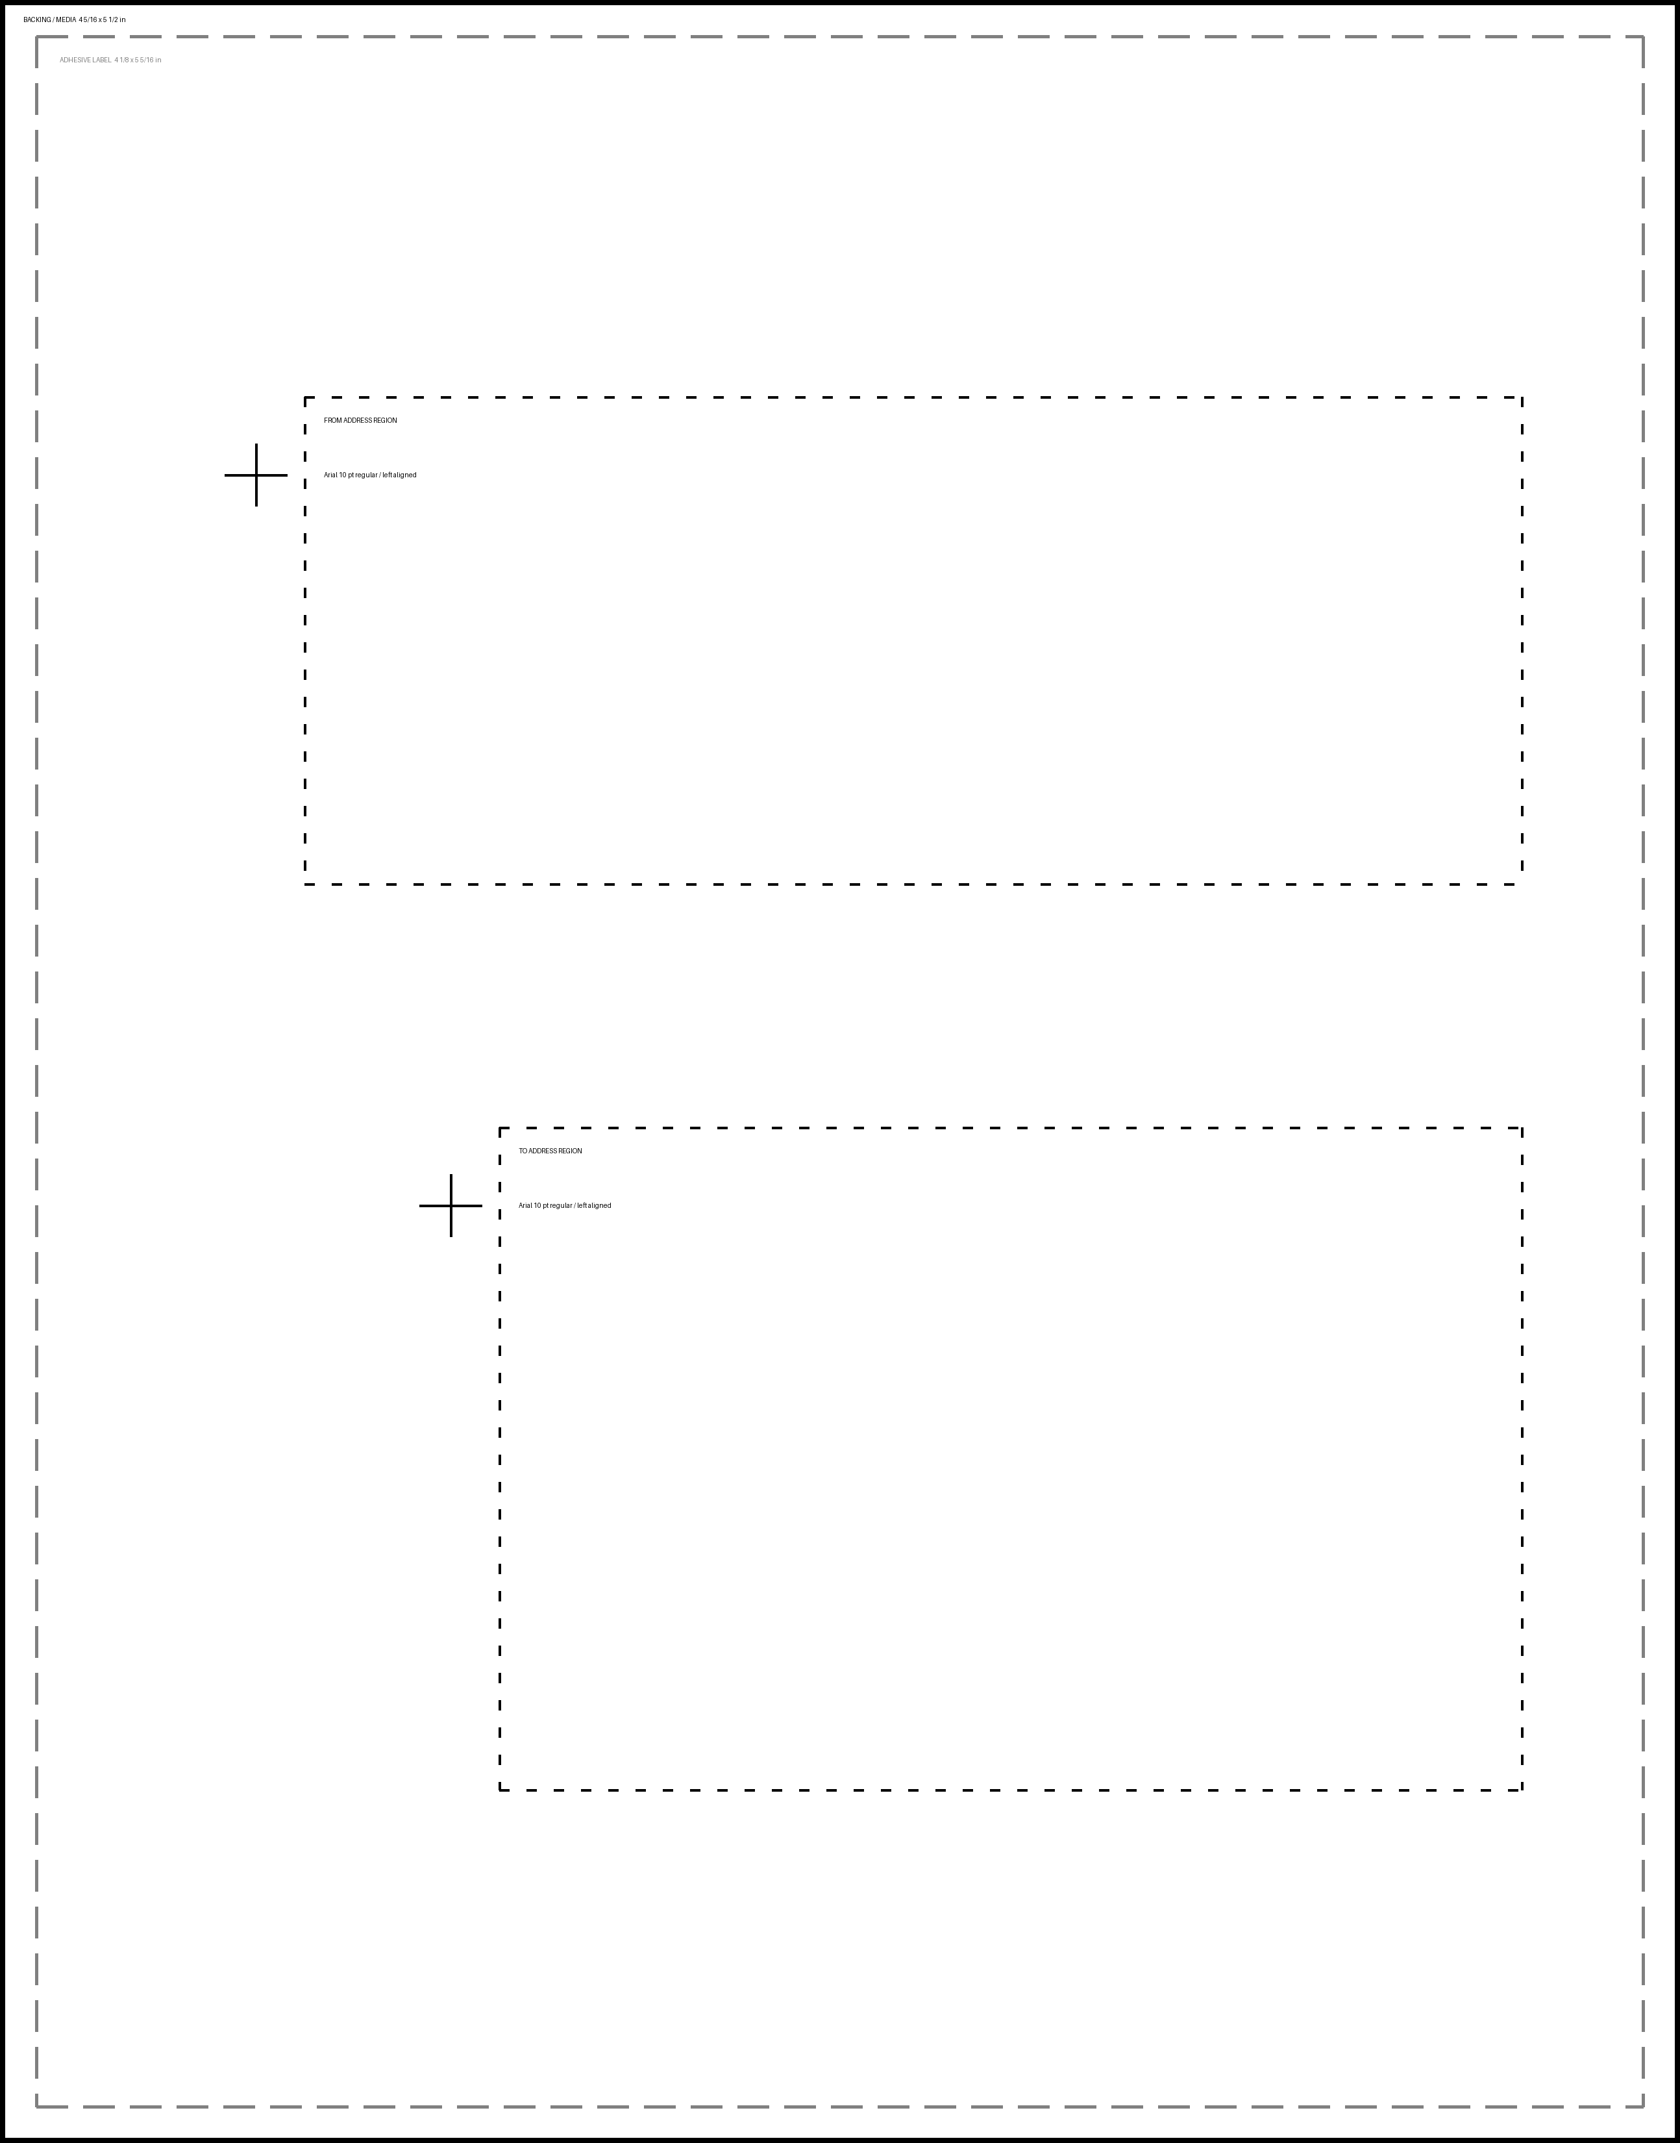
Solid = backing/media boundary | Dashed = adhesive-label boundary
Dotted = proposed address regions | Crosshairs = measured FROM/TO reference anchors

