USPS Priority Mail Label 228 - Calibration Revision 2
Print on US Letter at 100% / Actual Size. Do not use Fit, Shrink, or Scale.
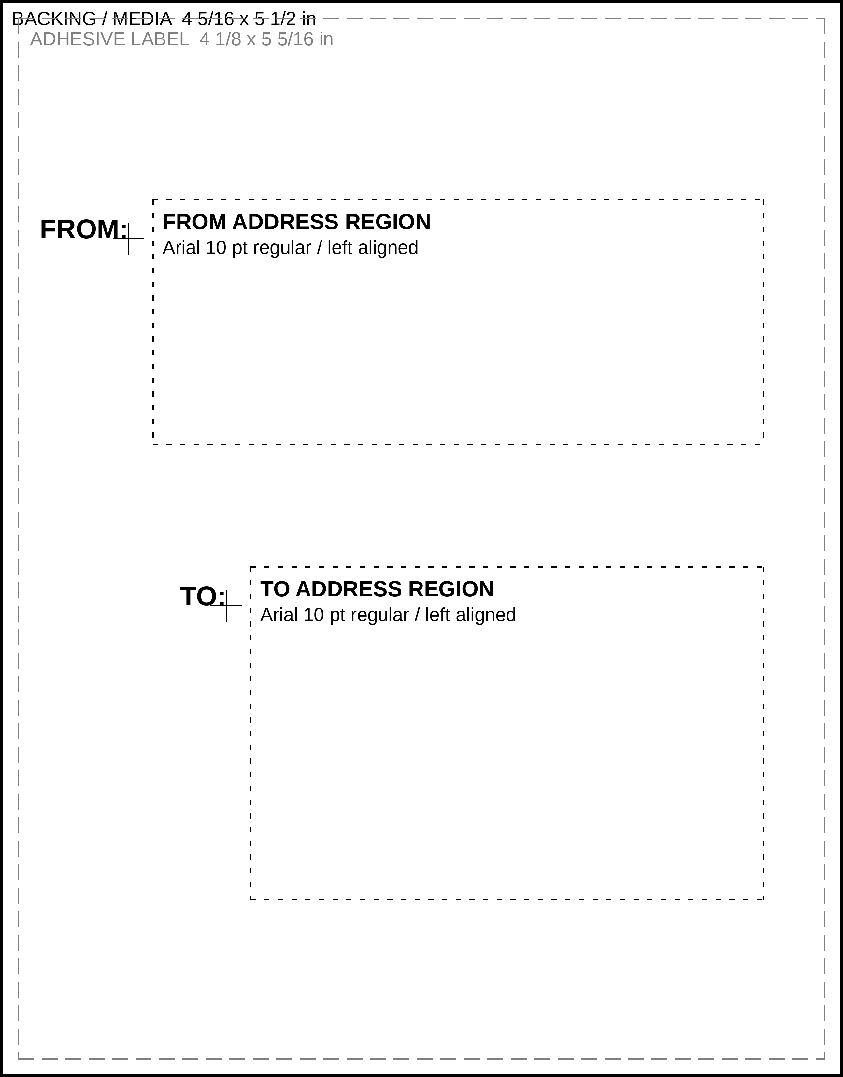
Revision 2 adds black FROM: and TO: replicas for registration reference.
Typography is an Arial Bold-compatible approximation; measured right/bottom anchors control placement.

