

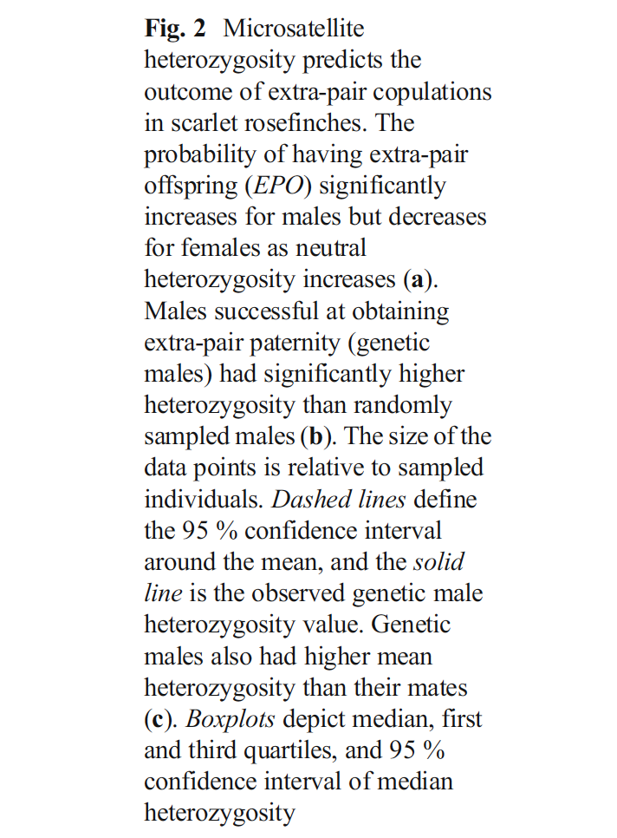

This paper looked at the effects between MCH diversity and heterozygosity on the patterns of extra-pair copulations in adult passerines (scarlet rose finch). I like this figure due to its simplicity which allows for efficient interpretation (I am sure this is nice for a reviewer). There are no unnecessary grids lines (the tick marks do the trick). The text is clear has appropriately sized font. Color schemes are very important and can be distracting and here the authors just used a grey scale which is considerate of those who may experience colorblindness. The only thing I will add is that the colors could be slightly darker especially since the graph is comparing only male and female adults.

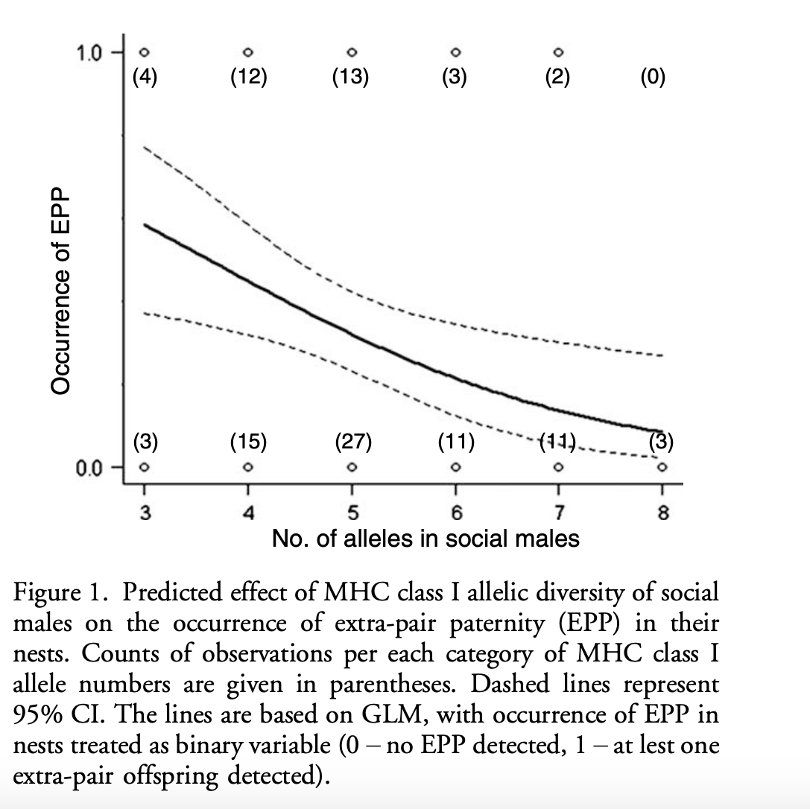

This plot is easy to comprehend; however, it is expressing both count and model data. In my opinion, this plot seems to be cramming a little too much information. The lines are not very smooth. I noticed that the count numbers in parentheses and graph labels may have been inserted manually. The other main issue is that the count data overlap the GLM lines and confidence intervals. Overall, this graph could have been two separate graphs. In addition, it is not aesthetically pleasing. I will also add that I am being extra critical for someone with subpar coding and graphing skills.