Jessica Gutierrez

Data Visualization

Assignment 10

23March21

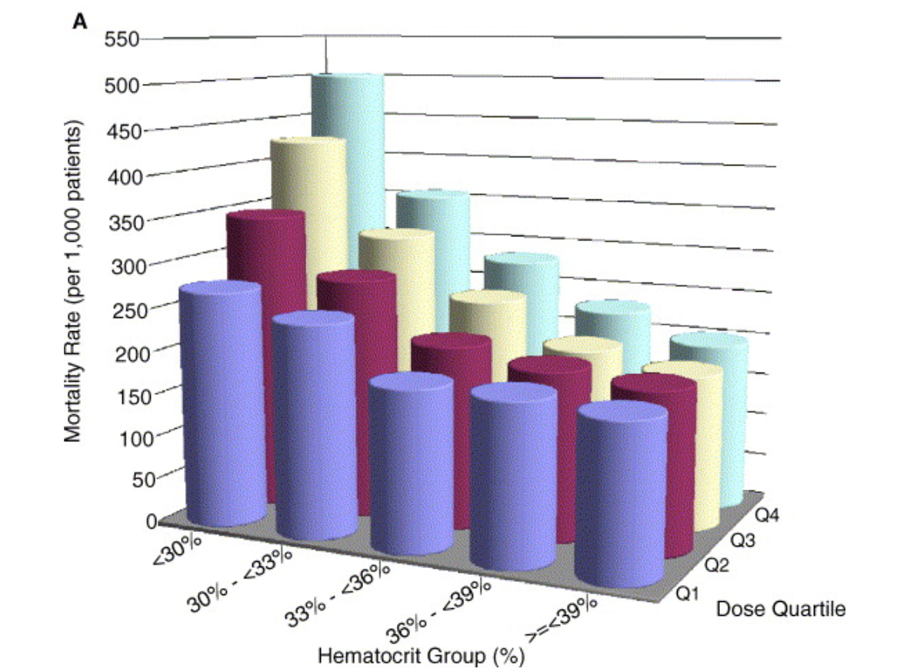

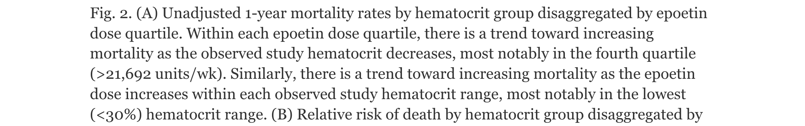

Kara, Cindy and I found this figure by Googling the worst 3-D figures. A link led us to the paper “Hematocrit was not validated as a surrogate end point for survival among epoetin-treated hemodialysis patients” by Cotter et al. (2004). This study was looking into treating patients who suffer from anemia due to chronic kidney failure and undergo dialysis. However, epoetin may directly or indirectly lead to patient death if provided the incorrect dose based on hematocrit levels in patients. The figure above, was not terrible but Dr. Wilke may not have approved of the use of a 3D figure for this. Therefore, we used an alternative code provided by his book. Cindy and Kara helped transform the data and parse out any errors in the code. Please see my figure below.



**Here is my code from Figure 6.8 in the book:**

# Take the darkest seven colors from 8-class ColorBrewer palette "PuBu"

colors_seven = RColorBrewer::brewer.pal(8, "Purples")[2:8]

data$Hematocrit=factor(data$Hematocrit,levels=c("<30%","30%to<33%","33%to<36%","36%to<39%","≥39%","All"))

data$Hematocrit

ggplot(data, aes(x = Quartile, y = Mortality, fill = Hematocrit)) +

geom_col(position = "dodge", alpha = 0.9) +

scale_y_continuous(

expand = c(0, 0),

name = "Mortality rates (per 1000 patients)"

) +

scale_fill_manual(values = colors_seven, name = "Hematocrit group %") +

coord_cartesian(clip = "off") +

xlab(label = NULL) +

theme_classic() +

theme(

axis.line.x = element_blank(),

axis.ticks.x = element_blank(),

legend.title.align = 0.5

) -> p_income_age_dodged

p_income_age_dodged