Jessica Gutierrez

Data Visualization

Figure that did not include the all data

09March2021

I worked with a data set that Cindy found. The data was taken from the paper “Frugivore biodiversity and complementarity in interaction networks enhance landscape-scale dispersal function”, of García, Donoso, and Rodríguez-Pérez 2018. While reading the paper, we noticed that bird species was not including when evaluating seed density. This may have been important to show as the paper discussed how species networks may influence dispersal rates. Thus Kara, Cindy, and I decided explore different plots in the dataset. The data I chose to explore were plant species, seed density, and bird counts. I do not have a lot of experience in R Studio and regardless of whether or not this plot is useful, I think I was able to get some good practice.

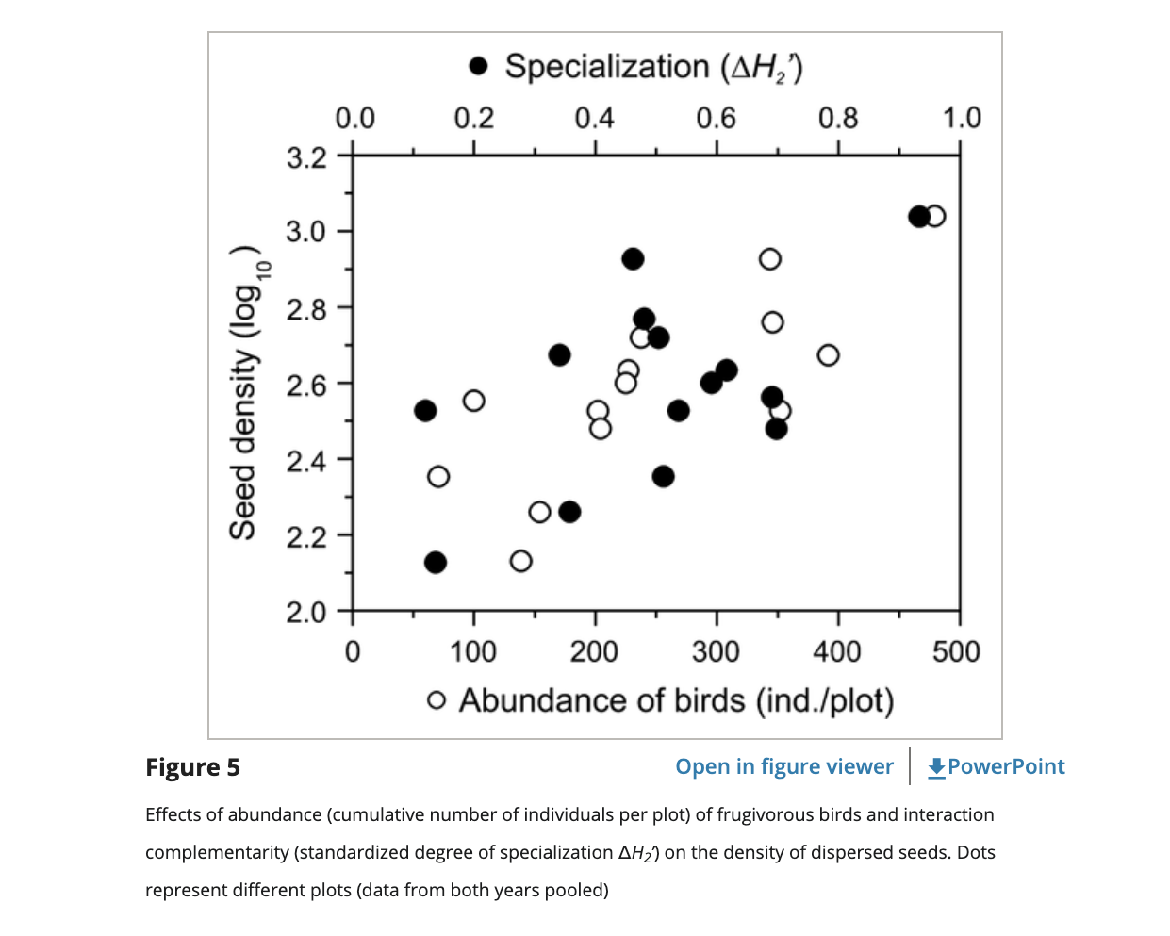

This is my graph:

