Jessica Gutierrez

Data Visualization

Assignment 9: Uncommon figure I like

March 16, 2021

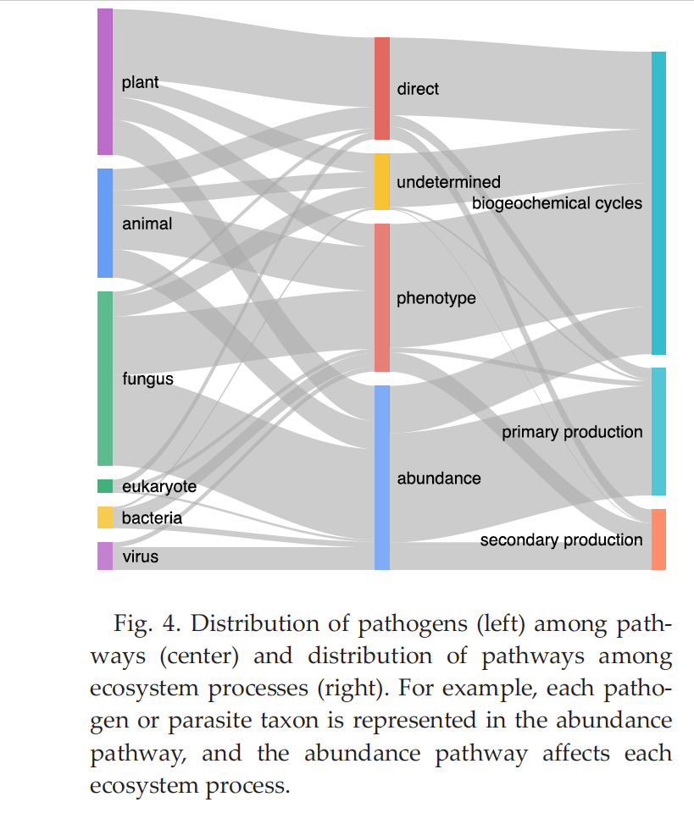

For this assignment, I chose to read “Parasite and pathogen effects on ecosystem processes:

A quantitative review” byFischhoff *et al* (2020). This paper is a meta-analysis that describes how pathways in which parasites and pathogens may affect ecosystem processes and in turn effect secondary and primary production and biogeochemical cycles. I chose this figure because I usually do not encounter network flow diagrams in general but I can see how necessary they are when describing complex networks such as large-scale ecosystems, microbial ecosystems, and trophic interactions. I like the width of the bands in the figure that represent the effect sizes as well. Although, I think the color scheme could have been better, this figure does a great job wrapping up the main take-aways found in the paper.