DEVOPS TRAINING

DAY 1 TASK

Step 1:

**(**Installing Ubuntu**)**

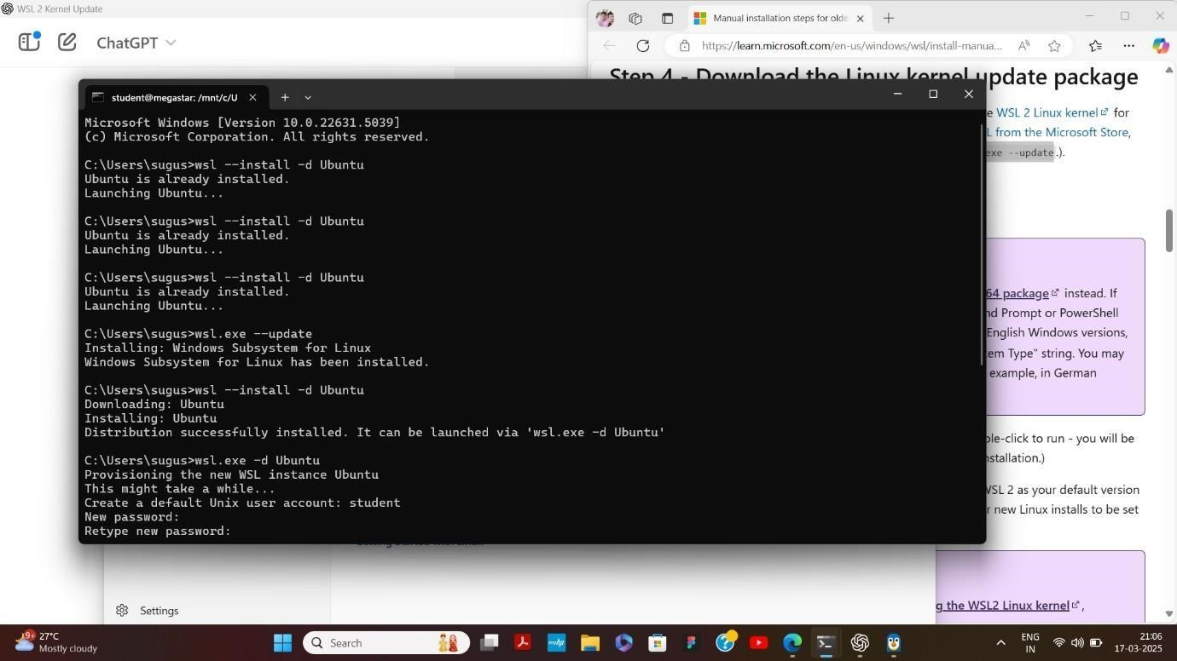

Step 2:

**(**Set New Password**)**

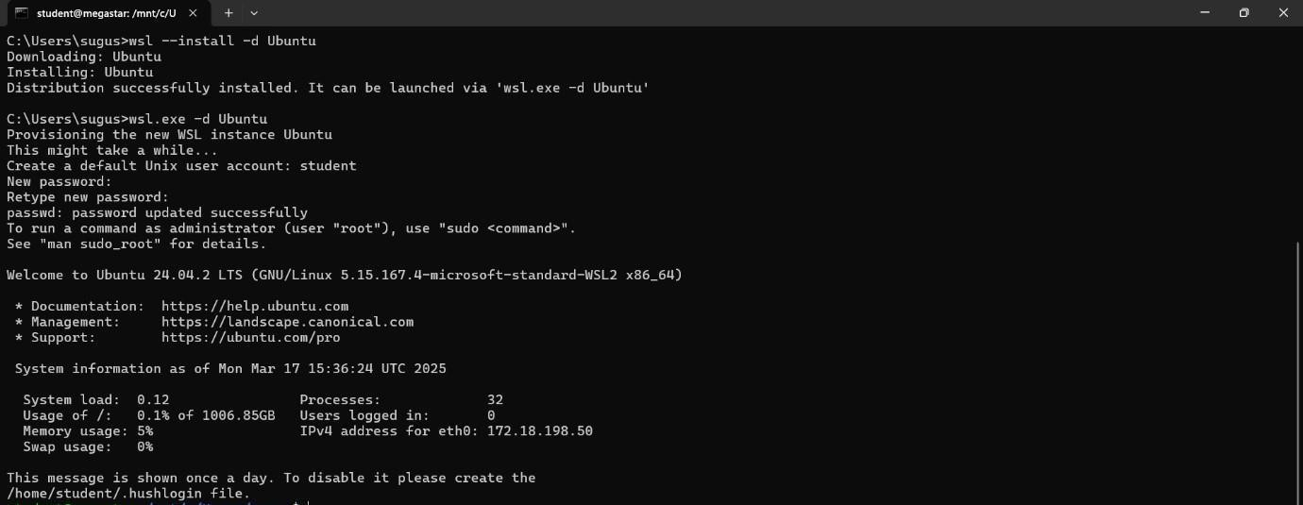

**(**New WSL Window Will Open**)**

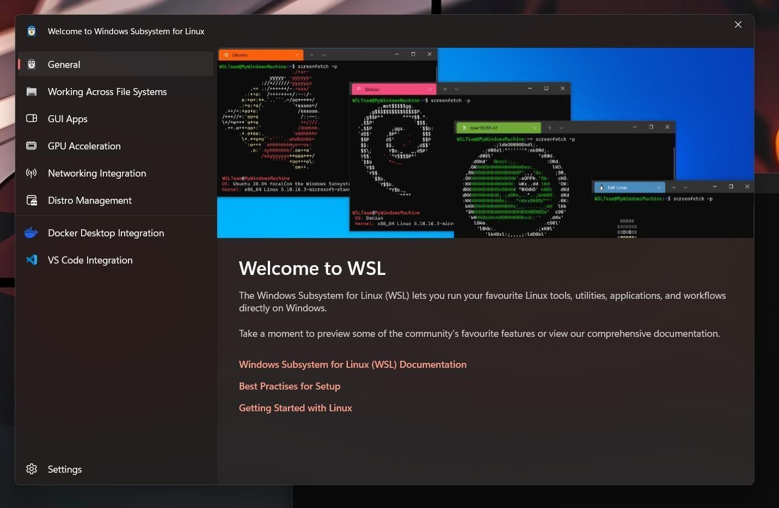

**(**Check JDK Version**)** If not available install it .

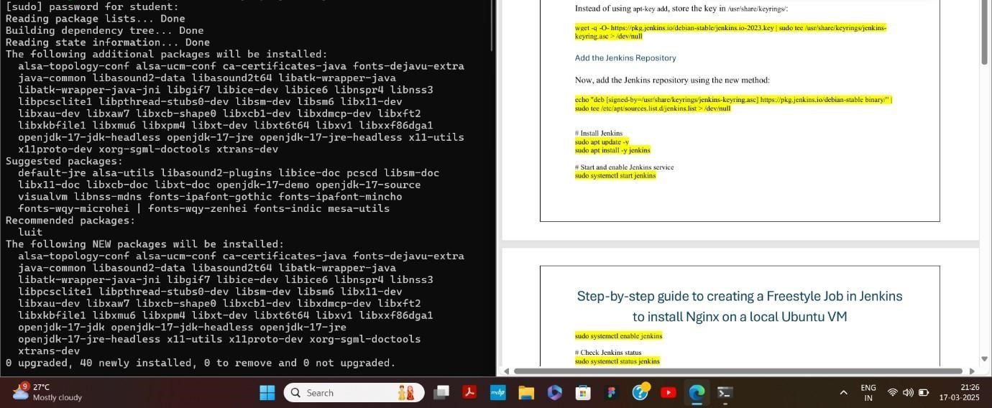

(Installing Packages)

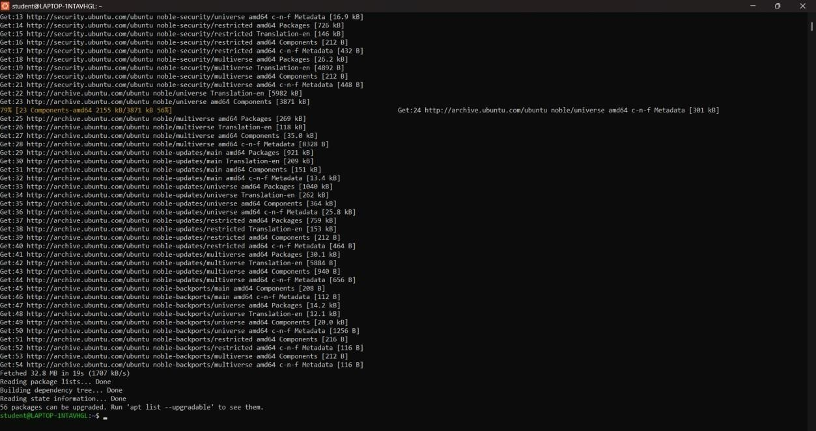

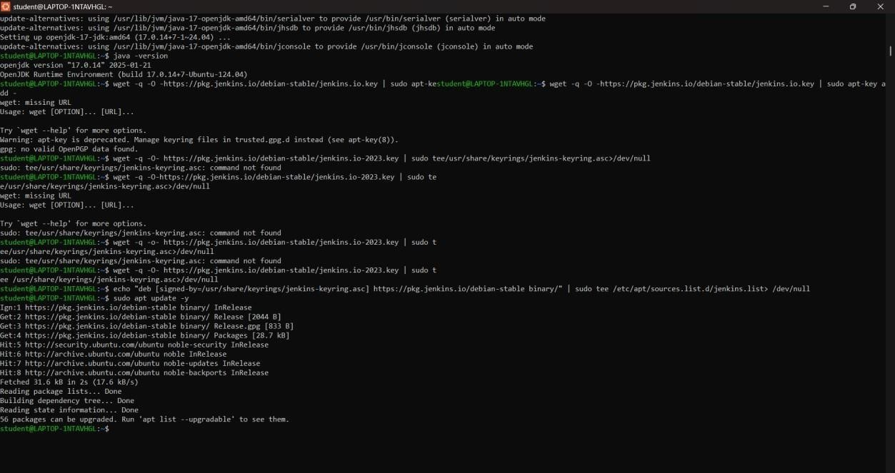

(Installing Jenkins)

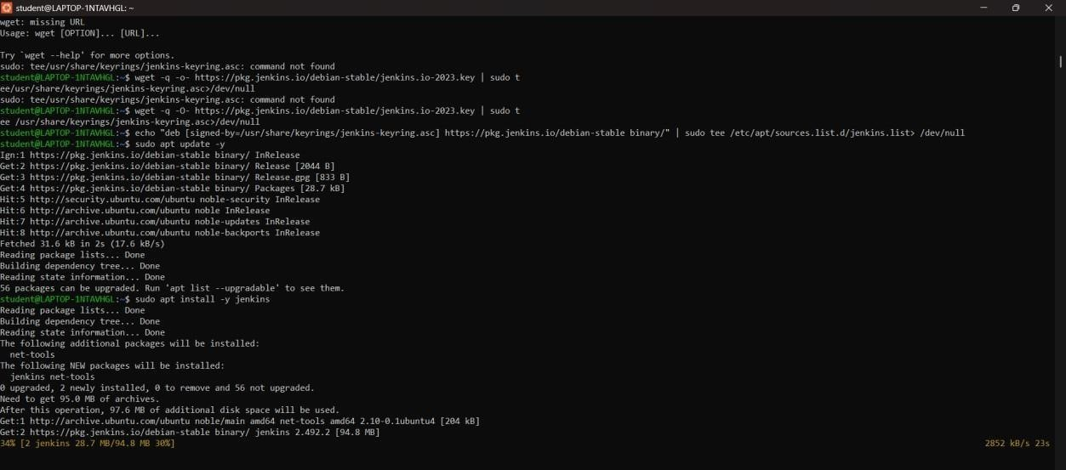

Step 7:

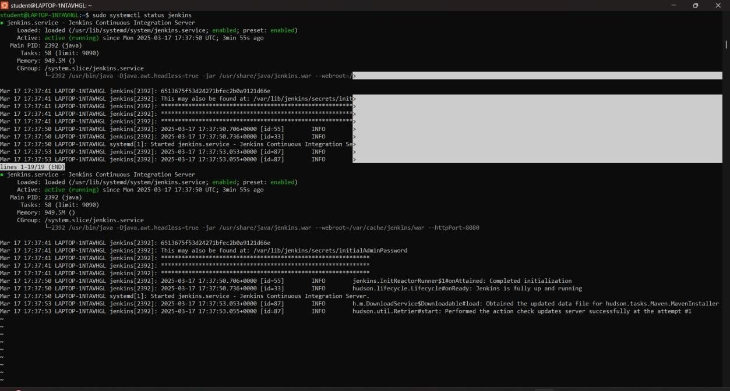

Step 8:

**(**Enter the Administrator Password**)**

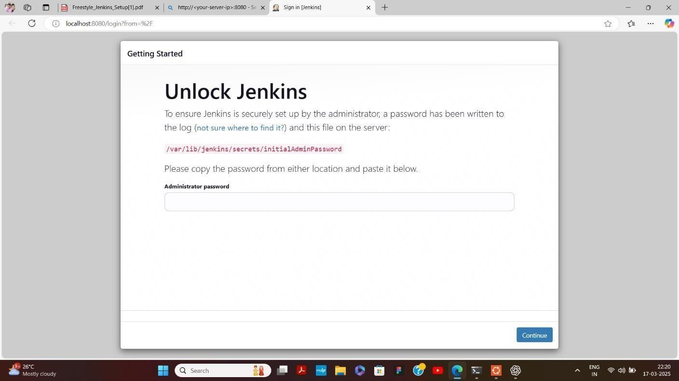

Step 9:

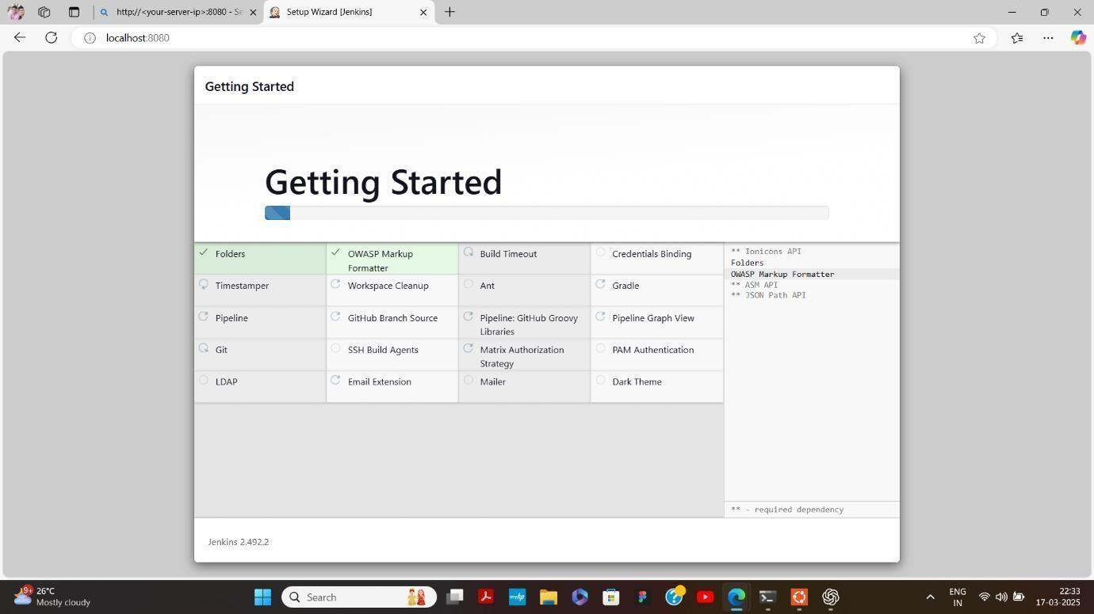

Step 10:

**(**Enter the URL**)**

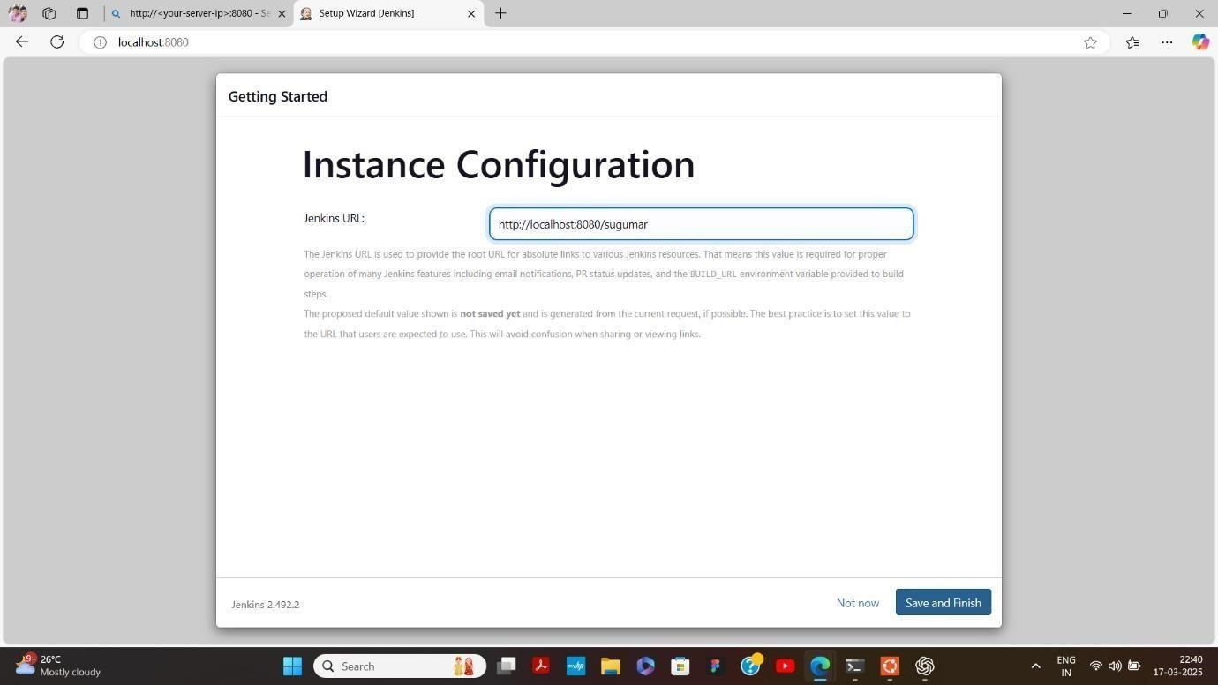

Step 12:

**(**Create an Project ex:ms**)**

**(**In Configure build and Select Execute shell**)**

**(**Build the Project**)**

**SELECT BUILD NOW**

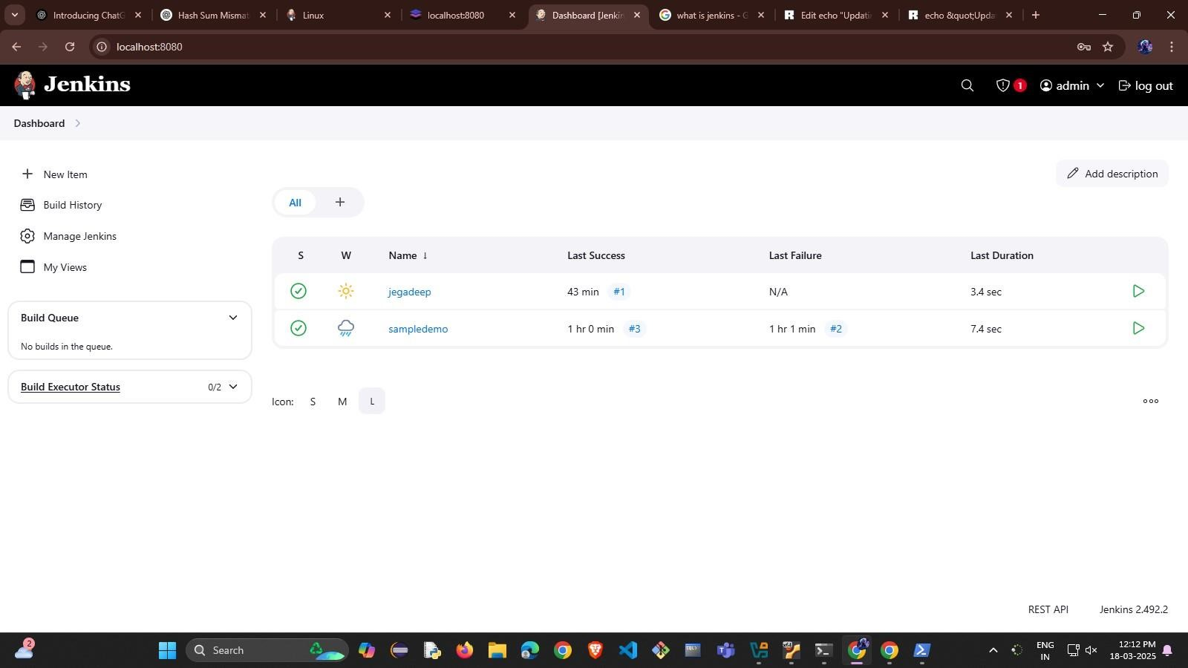

Step 13:

**(**We can check the output in console output**)**

