21. PYTHON PROGRAM FOR TIC TAC TOE GAME
Aim
To write a Python program to implement the Tic Tac Toe game for two players using a 3 × 3 board.
Algorithm
- Start the program.
- Create a 3 × 3 game board.
- Set player X as the first player.
- Display the board.
- Ask the current player to enter a position from 1 to 9.
- Check whether the position is empty.
- Place the player's symbol in the selected position.
- Check whether the player has won.
- If all positions are filled without a winner, declare a draw.
- Otherwise, switch players and repeat.
- Stop the program.
Python Code

# Tic Tac Toe Game

board = [' '] * 9

def display():
print()
for i in range(0, 9, 3):
print(board[i], '|', board[i+1], '|', board[i+2])
if i < 6:
print('--+---+--')
print()

def check_winner(player):
wins = [
(0, 1, 2), (3, 4, 5), (6, 7, 8),
(0, 3, 6), (1, 4, 7), (2, 5, 8),
(0, 4, 8), (2, 4, 6)
]

for a, b, c in wins:
if board[a] == board[b] == board[c] == player:
return True
return False

player = 'X'

while True:
display()
print("Player", player)

try:
position = int(input("Enter position (1-9): ")) - 1
except ValueError:
print("Enter a valid number.")
continue

if position < 0 or position > 8 or board[position] != ' ':
print("Invalid position! Try again.")
continue

board[position] = player

if check_winner(player):
display()
print("Player", player, "wins!")
break

if ' ' not in board:
display()
print("Game Draw!")
break

player = 'O' if player == 'X' else 'X'
Output:
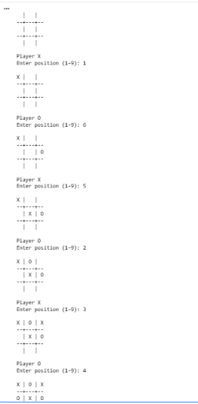
22. PYTHON PROGRAM TO IMPLEMENT MINIMAX ALGORITHM FOR GAMING
Aim
To write a Python program to implement the Minimax algorithm for selecting the best move in a game.
Algorithm
- Start the program.
- Define the game tree with possible scores.
- Set the maximum player and minimum player.
- The maximum player selects the highest score.
- The minimum player selects the lowest score.
- Repeat until the final score is reached.
- Display the best score.
- Stop the program.
Python Code

# Minimax Algorithm

def minimax(depth, node, is_max, scores):
if depth == 2:
return scores[node]

if is_max:
return max(
minimax(depth + 1, node * 2, False, scores),
minimax(depth + 1, node * 2 + 1, False, scores)
)
else:
return min(
minimax(depth + 1, node * 2, True, scores),
minimax(depth + 1, node * 2 + 1, True, scores)
)

scores = [3, 5, 2, 9]

best_score = minimax(0, 0, True, scores)

print("Leaf Scores:", scores)
print("Best Score using Minimax:", best_score)
Output:
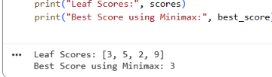
23. PYTHON PROGRAM TO IMPLEMENT ALPHA-BETA PRUNING ALGORITHM FOR GAMING
Aim
To write a Python program to implement Alpha-Beta Pruning to reduce the number of nodes evaluated in a game tree.
Algorithm
- Start the program.
- Define the game tree with leaf scores.
- Initialize alpha to negative infinity and beta to positive infinity.
- Find the maximum value at the maximizing node.
- Find the minimum value at the minimizing node.
- If alpha is greater than or equal to beta, prune the remaining branches.
- Display the best score.
- Stop the program.
Python Code

# Alpha-Beta Pruning

def alphabeta(depth, node, alpha, beta, is_max, scores):
if depth == 2:
return scores[node]

if is_max:
best = float('-inf')

for child in [node * 2, node * 2 + 1]:
value = alphabeta(
depth + 1, child, alpha, beta, False, scores
)
best = max(best, value)
alpha = max(alpha, best)

if beta <= alpha:
break

return best

else:
best = float('inf')

for child in [node * 2, node * 2 + 1]:
value = alphabeta(
depth + 1, child, alpha, beta, True, scores
)
best = min(best, value)
beta = min(beta, best)

if beta <= alpha:
break

return best

scores = [3, 5, 2, 9]

best_score = alphabeta(
0, 0, float('-inf'), float('inf'), True, scores
)

print("Leaf Scores:", scores)
print("Best Score using Alpha-Beta Pruning:", best_score)
output:
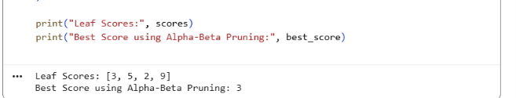
24. PYTHON PROGRAM TO IMPLEMENT DECISION TREE
Aim
To write a Python program to implement a Decision Tree classification algorithm using the Scikit-learn library.
Algorithm
- Start the program.
- Import the required libraries.
- Create a sample dataset.
- Separate the input features and target values.
- Create a Decision Tree classifier.
- Train the model using the dataset.
- Predict the output.
- Display the prediction and accuracy.
- Stop the program.
Python Code

# Decision Tree Classification

from sklearn.tree import DecisionTreeClassifier
from sklearn.metrics import accuracy_score

# Sample dataset: [Study Hours, Attendance]
X = [
[1, 50],
[2, 60],
[3, 70],
[4, 80],
[5, 90],
[6, 95]
]

# 0 = Fail, 1 = Pass
y = [0, 0, 0, 1, 1, 1]

# Create and train the model
model = DecisionTreeClassifier(random_state=0)
model.fit(X, y)

# Predict using the training data
predictions = model.predict(X)

print("Actual Output:", y)
print("Predicted Output:", predictions)
print("Accuracy:", accuracy_score(y, predictions) * 100, "%")

# Predict for a new student
result = model.predict([[4, 85]])
print("New Student Prediction:",
"Pass" if result[0] == 1 else "Fail")

Output:
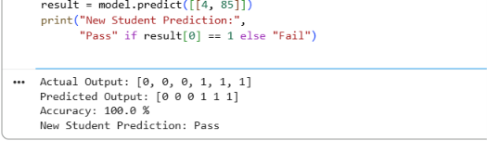
25. PYTHON PROGRAM TO IMPLEMENT FEED FORWARD NEURAL NETWORK
Aim
To write a Python program to implement a Feed Forward Neural Network for classification using the Scikit-learn library.
Algorithm
- Start the program.
- Import the required libraries.
- Create a sample dataset.
- Initialize a Feed Forward Neural Network.
- Train the network using the dataset.
- Pass the input through the hidden layer and output layer.
- Predict the output.
- Display the predicted values and accuracy.
- Stop the program.
Python Code

# Feed Forward Neural Network

from sklearn.neural_network import MLPClassifier
from sklearn.metrics import accuracy_score

# Sample dataset: [Input 1, Input 2]
X = [
[0, 0],
[0, 1],
[1, 0],
[1, 1]
]

# XOR output
y = [0, 1, 1, 0]

# Create a neural network with one hidden layer
model = MLPClassifier(
hidden_layer_sizes=(4,),
activation='tanh',
solver='lbfgs',
max_iter=5000,
random_state=1
)

# Train the network
model.fit(X, y)

# Predict the output
predictions = model.predict(X)

print("Actual Output:", y)
print("Predicted Output:", predictions)
print("Accuracy:", accuracy_score(y, predictions) * 100, "%")

# Test a new input
result = model.predict([[0, 1]])
print("Output for [0, 1]:", result[0])

output:
