***1.Customers who brought multiple products.***

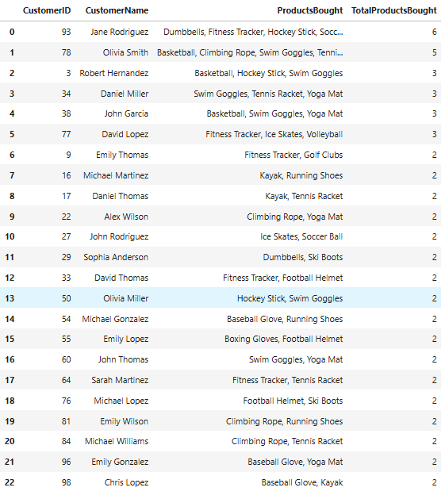

**Insights**

1. **Most Purchased Products**: Swim Goggles, Yoga Mat, Tennis Racket, Climbing Rope, Fitness Tracker.
2. **Low Purchase Volume**: Majority buy only 2-3 products per transaction.
3. **Popular Customer Segments**: Fitness enthusiasts, outdoor adventurers, and team sports players.
4. **Limited Cross-Selling**: No strong pattern of complementary purchases.

**Recommendations**

1. **Product Bundling**: Offer discounts on related items (e.g., "Tennis Racket + Tennis Balls").
2. **Loyalty Programs**: Give rewards for purchasing more than 3 products.
3. **Targeted Marketing**: Personalized ads based on past purchases.
4. **Better Recommendations**: "Customers Also Bought" suggestions.
5. **Seasonal Offers**: Fitness gear for New Year, outdoor items before summer.
6. **Customer Feedback**: Expand product variety based on reviews.

-------------------------------------------------------------------------------------------------------

***2.Customers who viewed the product but not purchased***

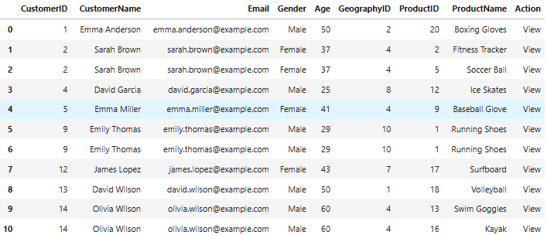

**Insights:**

* High-interest products: **Boxing Gloves, Football Helmets, Golf Clubs, Fitness Trackers** but low conversions.
* **Repeat views** indicate strong intent (e.g., Emily Thomas, Olivia Brown).
* **Older customers (40-60+)** dominate views but hesitate to buy.
* Possible **price sensitivity** for expensive products.
* **Data issues:** Gender mismatches need correction.

✅ **Recommendations:**

* Send **personalized discounts & reminders** to repeat viewers.
* Use **retargeting ads** for hesitant customers.
* Add **reviews & comparisons** to boost confidence.
* Offer **EMI/payment plans** for high-priced items.
* Fix **data inconsistencies** for better targeting.
* **Analyze checkout drop-offs** to improve conversions.

🚀 **These strategies can boost sales and engagement!**

----------------------------------------------------------------------------------------------------------------

***3.why customers dropped off ? //// Drop off points***



**Insight:**

* **14 customers abandoned checkout**, indicating possible friction in the final purchase step.
* Common reasons could be **high shipping costs, payment failures, mandatory account creation, or lack of trust in security**.

✅ **Recommendations:**

* **Optimize checkout process** (guest checkout, fewer steps).
* **Show total costs upfront** to avoid last-minute surprises.
* **Offer multiple payment options & seamless transactions**.
* **Provide trust signals** (secure payment badges, refund policy).
* **Send abandoned cart reminders with limited-time discounts**.

🚀 **Implementing these can reduce drop-offs and improve conversions!**

----------------------------------------------------------------------------------------------------------------

***4.Finding the drop off rate***

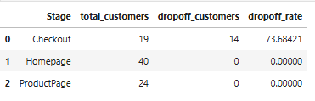

**Insights:**

* **Checkout has the highest drop-off rate (73.68%)**, meaning most customers abandon purchases at the final stage.
* **No drop-offs at Homepage & Product Page**, indicating strong initial engagement.

✅ **Recommendations:**

1. **Streamline Checkout:** Reduce steps, allow guest checkout, and autofill details.
2. **Show Total Cost Early:** Avoid unexpected fees at checkout.
3. **Offer Multiple Payment Options:** Address potential payment failures.
4. **Use Abandoned Cart Emails:** Send reminders with limited-time discounts.
5. **Improve Trust Signals:** Secure payment badges, refund policies, and customer testimonials.

🚀 **Optimizing checkout can significantly boost conversions!**

***5.Action leadind to succes conversions***

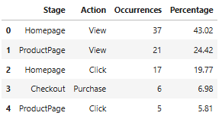

**Insights:**

* **High engagement on Homepage (43.02% views, 19.77% clicks),** but many users drop off before proceeding further.
* **Product Page views (24.42%) are decent, but clicks (5.81%) are low, indicating hesitation.**
* **Only 6.98% of users complete a purchase, showing a significant drop-off from product interest to final conversion.**

✅ **Recommendations:**

1. **Improve Product Page CTAs:** Use stronger call-to-action buttons (e.g., “Buy Now” instead of “Add to Cart”).
2. **Enhance Product Descriptions & Reviews:** Provide more details, high-quality images, and user testimonials.
3. **Personalized Recommendations:** Suggest relevant products based on browsing history.
4. **Highlight Urgency:** Use limited-time discounts or stock alerts to encourage purchases.
5. **Optimize Mobile Experience:** Ensure seamless navigation and faster loading times for mobile users.

🚀 **By addressing these issues, conversions can improve significantly!**

----------------------------------------------------------------------------------------------------------------

***6.Average duration per stage***

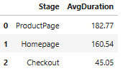

**Insights:**

* Users spend the most time on **Product Pages (182.77s)**, indicating hesitation.
* **Homepage (160.54s)** engagement is good but may need better navigation.
* **Checkout (45.05s)** is short, likely causing high drop-offs (73.68%).

✅ **Recommendations:**

1. **Simplify Product Pages** – Clear info & FAQs.
2. **Enhance Homepage Navigation** – Easy search & recommendations.
3. **Streamline Checkout** – Fewer steps, guest checkout, multiple payments.
4. **Use Exit-Intent Popups** – Discounts or assistance to reduce drop-offs.

🚀 **Optimizing these can boost conversions!**

----------------------------------------------------------------------------------------------------------------

***7. Identifying highest-rated and lowest-rated products***

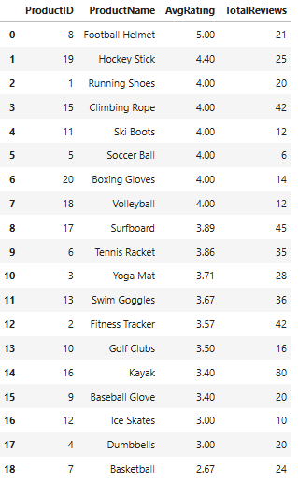

**Insights:**

* **Football Helmet (5.0, 21 reviews)** is the best-rated product.
* **Hockey Stick (4.4, 25 reviews)** and **Running Shoes (4.0, 20 reviews)** also perform well.
* **Basketball (2.67, 24 reviews)** has the lowest rating, indicating potential quality or usability issues.
* **Kayak (3.4, 80 reviews)** has high engagement but mixed feedback.

✅ **Recommendations:**

1. **Promote Top Performers** – Highlight Football Helmet & Hockey Stick in ads.
2. **Improve Low-Rated Products** – Investigate issues with Basketball & Kayak via customer feedback.
3. **Encourage Reviews** – More reviews for mid-rated products can boost credibility.
4. **Bundle & Discounts** – Pair high-rated items with lower-rated ones to improve sales.

🚀 **Optimizing product quality & visibility can drive conversions!**

----------------------------------------------------------------------------------------------------------------

***8.Repeat vs First Time buyers***

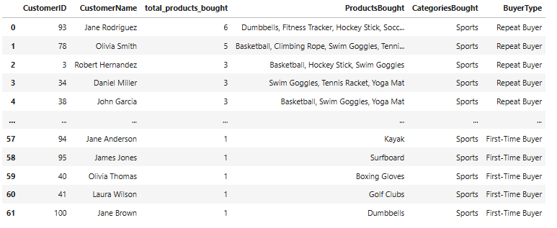



**Insights:**

* **Repeat Buyers Exist** but need more engagement.
* **Sports Products Dominate** customer interest.
* **First-Time Buyers Drop Off** after one purchase.

✅ **Recommendations:**

1. **Loyalty Rewards** for repeat customers.
2. **Cross-Sell Products** (e.g., Yoga Mat + Dumbbells).
3. **Personalized Marketing** to re-engage first-time buyers.
4. **Incentives** like free shipping or discounts on second purchases.

🚀 **Drive retention & increase repeat purchases!**

***9.Best performing products per region according to rating and reviews***

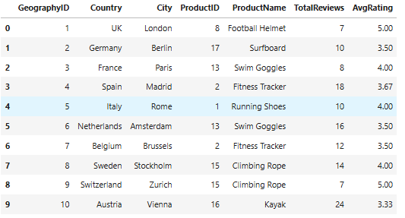

**Insights:**

* **Football Helmet in London & Climbing Rope in Zurich have perfect ratings (5.0) but low reviews.**
* **Kayak in Vienna has the highest reviews (24) but the lowest rating (3.33), indicating possible dissatisfaction.**
* **Swim Goggles in Paris (4.0) & Running Shoes in Rome (4.0) have strong ratings but need more visibility.**

✅ **Recommendations:**

1. **Increase Customer Feedback**: Encourage reviews for high-rated but low-reviewed products (e.g., Football Helmet in London).
2. **Investigate & Improve Kayak Quality**: Low rating with high reviews suggests possible product issues—consider redesign or better marketing.
3. **Targeted Promotions for Highly Rated Products**: Boost sales of high-rated items with low visibility (e.g., Climbing Rope in Zurich).
4. **Localize Ads & Discounts**: Promote top-rated products in their respective cities to increase conversions.

🚀 **Maximize sales by leveraging product reputation in key locations!**

----------------------------------------------------------------------------------------------------------------