PaLM2 tweet creator

Google Cloud Vertex AI Hackathon 2023

Metaverse Professional  
**Elias Ordaz Sanchez  
Enrique Gamboa**

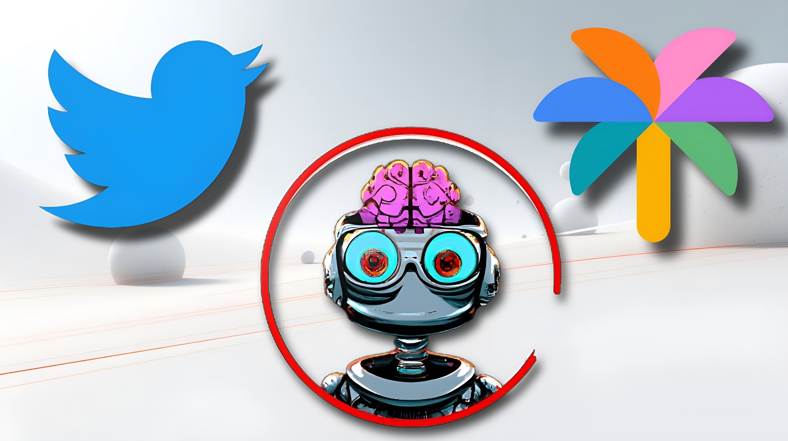

# 1. Project Summary

The Palm2 Tweet Creator is a Chrome extension aimed at helping users convert their selected web text into tweets easily. This tool's development is driven by the idea to leverage the digital networking platform Twitter more effectively by summarizing long paragraphs into concise tweets.

# 2. Description

The Palm2 Tweet Creator allows users to select text from any website, which the extension then processes to condense the selected information into a Twitter-friendly format. Using advanced summarizing technology and adhering to the Twitter character limit, the extension offers a simple way to share website content directly on Twitter without manually composing a tweet.

# 3. Workflow

Using the technology of Palm2, the extension summarizes the selected text into a tweet-friendly format.

The summarized text is then ready to be tweeted by the user. As shown in Figure 1.

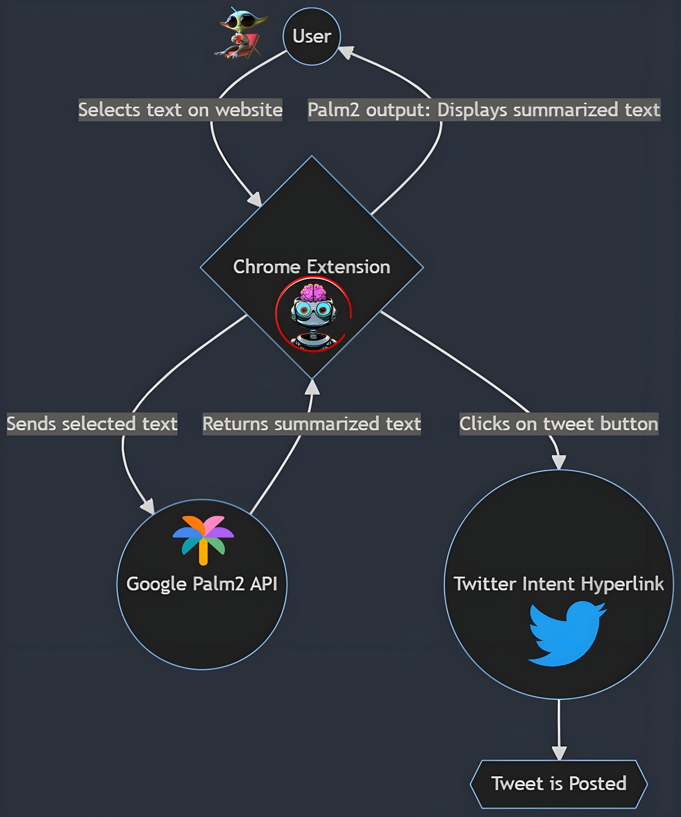

Figure 1: Application workflow

# 4. Future Business Plan

As part of our future business strategy, we aim to monetize the Palm2 Tweet Creator by integrating it with Extension Pay, a Stripe payment method. We plan to charge a nominal subscription fee to continue enjoying our services. This will ensure that we maintain and continuously improve the extension, providing top-notch services to our users and stay competitive in the market.

# Conclusion

With Palm2 Tweet Creator, sharing content from the web on Twitter becomes an effortless task. This tool is designed with the objective to enhance the experience of using Twitter, helping users to share relevant content without breaching the character limit, all within a few clicks.