Weeks 1–6: Merged Weekly Notebooks
Code, markdown/commentary, and saved notebook outputs preserved in weekly order

Week 1
Week-1-Submission-Health-LR-Notebook(1).ipynb

Week 1 - Linear Regression with Polynomial Terms, Interaction terms, Multicollinearity, variance inflation factor and regression, and categorical and continuous features.

Dataset used

BRFSS 2015 Diabetes Health Indicators

Goal

The notebook covers the week 1 requirements of Linear Regression, Polynomial Terms, Interaction Terms, multicollinearity, Variance Influence Factor(VIF), categorical and continuous features.
The overall goal of my project is to understand and predict diabetes using health and lifestyle indicators, with Diabetes_binary as the primary classification outcome. However, Week 1 focuses on linear regression, polynomial terms, interaction terms, multicollinearity, and VIF. Because standard linear regression is designed for a continuous outcome, I use BMI as the response variable for this Week 1 exercise rather than changing the overall project objective. BMI is one of the health indicators contained in the diabetes dataset and is relevant to the broader diabetes-risk analysis.

This Week 1 analysis therefore serves as an exploratory regression exercise within the larger diabetes project. I examine whether other health characteristics help explain variation in BMI and use the analysis to understand nonlinear relationships, interactions, and multicollinearity. When classification methods are introduced, I will use Diabetes_binary as the target variable for directly predicting diabetes.

Week 1 Question: How are demographic and health indicators associated with BMI and do polynomial and interaction terms improve the linear regression models?

Import Libraries and Health dataset
# 1. Import libraries
import pandas as pd
import numpy as np
import matplotlib.pyplot as plt
import statsmodels.formula.api as smf
from sklearn.model_selection import train_test_split
from sklearn.metrics import mean_squared_error, mean_absolute_error, r2_score
from statsmodels.stats.outliers_influence import variance_inflation_factor
# 2. Load the health dataset
health_url = (
"https://raw.githubusercontent.com/jeganart/"
"healthdatasetmilestone3/refs/heads/main/"
"diabetes_binary_health_indicators_BRFSS2015.csv"
)
df = pd.read_csv(health_url)
print("Dataset shape:", df.shape)
display(df.head())
Dataset shape: (253680, 22)
Diabetes_binary HighBP HighChol CholCheck BMI Smoker Stroke \
0 0.0 1.0 1.0 1.0 40.0 1.0 0.0
1 0.0 0.0 0.0 0.0 25.0 1.0 0.0
2 0.0 1.0 1.0 1.0 28.0 0.0 0.0
3 0.0 1.0 0.0 1.0 27.0 0.0 0.0
4 0.0 1.0 1.0 1.0 24.0 0.0 0.0
HeartDiseaseorAttack PhysActivity Fruits ... AnyHealthcare \
0 0.0 0.0 0.0 ... 1.0
1 0.0 1.0 0.0 ... 0.0
2 0.0 0.0 1.0 ... 1.0
3 0.0 1.0 1.0 ... 1.0
4 0.0 1.0 1.0 ... 1.0
NoDocbcCost GenHlth MentHlth PhysHlth DiffWalk Sex Age Education \
0 0.0 5.0 18.0 15.0 1.0 0.0 9.0 4.0
1 1.0 3.0 0.0 0.0 0.0 0.0 7.0 6.0
2 1.0 5.0 30.0 30.0 1.0 0.0 9.0 4.0
3 0.0 2.0 0.0 0.0 0.0 0.0 11.0 3.0
4 0.0 2.0 3.0 0.0 0.0 0.0 11.0 5.0
Income
0 3.0
1 1.0
2 8.0
3 6.0
4 4.0
[5 rows x 22 columns]

Basic EDA and Feature analysis
BMI is the continuous outcome. Age, PhysHlth, and MentHlth are numeric/ordered features. HighBP, HighChol, Smoker, PhysActivity, and Sex are binary categorical features coded as 0 and 1.
# 3. Keep the relevant variables.
columns = [
"BMI", "Age", "PhysHlth", "MentHlth",
"HighBP", "HighChol", "Smoker", "PhysActivity", "Sex"
]
week1_df = df[columns].dropna().copy()
print("Missing values:")
print(week1_df.isnull().sum())
display(week1_df.describe().T)
plt.figure(figsize=(7, 4))
plt.hist(week1_df["BMI"], bins=30, edgecolor="black")
plt.xlabel("BMI")
plt.ylabel("Frequency")
plt.title("Distribution of BMI")
plt.show()
Missing values:
BMI 0
Age 0
PhysHlth 0
MentHlth 0
HighBP 0
HighChol 0
Smoker 0
PhysActivity 0
Sex 0
dtype: int64
count mean std min 25% 50% 75% max
BMI 253680.0 28.382364 6.608694 12.0 24.0 27.0 31.0 98.0
Age 253680.0 8.032119 3.054220 1.0 6.0 8.0 10.0 13.0
PhysHlth 253680.0 4.242081 8.717951 0.0 0.0 0.0 3.0 30.0
MentHlth 253680.0 3.184772 7.412847 0.0 0.0 0.0 2.0 30.0
HighBP 253680.0 0.429001 0.494934 0.0 0.0 0.0 1.0 1.0
HighChol 253680.0 0.424121 0.494210 0.0 0.0 0.0 1.0 1.0
Smoker 253680.0 0.443169 0.496761 0.0 0.0 0.0 1.0 1.0
PhysActivity 253680.0 0.756544 0.429169 0.0 1.0 1.0 1.0 1.0
Sex 253680.0 0.440342 0.496429 0.0 0.0 0.0 1.0 1.0
<Figure size 700x400 with 1 Axes>
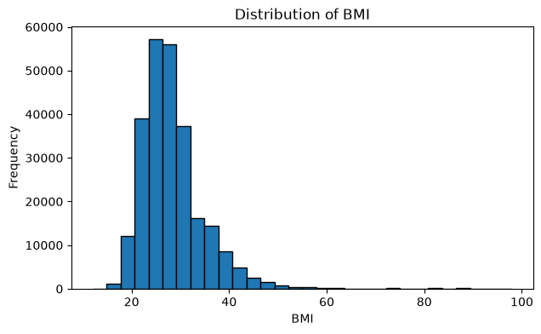

Baseline Linear Regression
I will fit a multiple linear regression using both numeric and categorical predictors to generate the baseline before adding polynomial and interaction terms
# 4. Split data into training and test sets
train_df, test_df = train_test_split(
week1_df,
test_size=0.20,
random_state=42
)
baseline_model = smf.ols(
"BMI ~ Age + PhysHlth + MentHlth + HighBP + HighChol + "
"Smoker + PhysActivity + Sex",
data=train_df
).fit()
baseline_pred = baseline_model.predict(test_df)
baseline_rmse = np.sqrt(mean_squared_error(test_df["BMI"], baseline_pred))
baseline_mae = mean_absolute_error(test_df["BMI"], baseline_pred)
baseline_r2 = r2_score(test_df["BMI"], baseline_pred)
print("Baseline RMSE:", baseline_rmse)
print("Baseline MAE:", baseline_mae)
print("Baseline R-squared:", baseline_r2)
Baseline RMSE: 6.3042234875675485
Baseline MAE: 4.477593430129073
Baseline R-squared: 0.0858884777172555
I used BMI as the continuous outcome and included both continuous health measures and binary categorical features. The baseline multiple linear regression produced an RMSE of 6.3042, MAE of 4.4776, and R-squared of 0.0859. This means that the baseline predictors explained only about 8.6% of the variation in BMI, **indicating that these health indicators alone have limited ability to predict an individual's BMI.**

Polynomial Term

A polynomial term allows a curved relationship instead of assuming that the relationship is completely linear. I center Age first and then create Age squared. Centering also helps reduce unnecessary correlation between Age and Age squared.
# 5. Center Age and create Age squared
age_mean = train_df["Age"].mean()
train_df = train_df.copy()
test_df = test_df.copy()
train_df["Age_centered"] = train_df["Age"] - age_mean
test_df["Age_centered"] = test_df["Age"] - age_mean
train_df["Age_squared"] = train_df["Age_centered"] ** 2
test_df["Age_squared"] = test_df["Age_centered"] ** 2
polynomial_model = smf.ols(
"BMI ~ Age_centered + Age_squared + PhysHlth + MentHlth + "
"HighBP + HighChol + Smoker + PhysActivity + Sex",
data=train_df
).fit()
polynomial_pred = polynomial_model.predict(test_df)
poly_rmse = np.sqrt(mean_squared_error(test_df["BMI"], polynomial_pred))
poly_mae = mean_absolute_error(test_df["BMI"], polynomial_pred)
poly_r2 = r2_score(test_df["BMI"], polynomial_pred)
print("Polynomial RMSE:", poly_rmse)
print("Polynomial MAE:", poly_mae)
print("Polynomial R-squared:", poly_r2)
Polynomial RMSE: 6.267742051079038
Polynomial MAE: 4.44497206443347
Polynomial R-squared: 0.09643747291065208

Adding the centered Age-squared polynomial term improved the model slightly. RMSE decreased from 6.3042 to 6.2677, MAE decreased from 4.4776 to 4.4450, and R-squared increased from 0.0859 to 0.0964. This suggests that the relationship between age and BMI is not completely linear and that allowing some curvature captured additional information. I then added an Age × HighBP interaction to test whether the relationship between age and BMI differed for people with and without high blood pressure. This produced the best results, with RMSE = 6.2596, MAE = 4.4336, and R-squared = 0.0988. However, **the improvement over the polynomial model was small.** Therefore, the interaction added some predictive information, but not enough to substantially change overall model performance.

Interaction Term

An interaction tests whether the relationship between one predictor and BMI changes depending on another predictor. I use **Age × HighBP** to test whether the age-BMI relationship differs for people with and without high blood pressure.
# 6. Add Age and HighBP interaction
interaction_model = smf.ols(
"BMI ~ Age_centered + Age_squared + HighBP + "
"Age_centered:HighBP + PhysHlth + MentHlth + "
"HighChol + Smoker + PhysActivity + Sex",
data=train_df
).fit()
interaction_pred = interaction_model.predict(test_df)
interaction_rmse = np.sqrt(mean_squared_error(test_df["BMI"], interaction_pred))
interaction_mae = mean_absolute_error(test_df["BMI"], interaction_pred)
interaction_r2 = r2_score(test_df["BMI"], interaction_pred)
print("Interaction RMSE:", interaction_rmse)
print("Interaction MAE:", interaction_mae)
print("Interaction R-squared:", interaction_r2)
Interaction RMSE: 6.2596261078571045
Interaction MAE: 4.433634021640617
Interaction R-squared: 0.09877595917197113

Multicollinearity and VIF

Multicollinearity occurs when predictors contain overlapping information and are strongly related. This can make regression coefficients unstable. I use Variance Inflation Factor (VIF) as a diagnostic. Higher VIF values indicate greater multicollinearity.
# 7. Calculate VIF
vif_columns = [
"Age_centered", "Age_squared", "PhysHlth", "MentHlth",
"HighBP", "HighChol", "Smoker", "PhysActivity", "Sex"
]
X_vif = train_df[vif_columns].copy()
X_vif.insert(0, "Intercept", 1)
vif_results = pd.DataFrame({
"Feature": X_vif.columns,
"VIF": [
variance_inflation_factor(X_vif.values, i)
for i in range(X_vif.shape[1])
]
})
display(vif_results.round(3))
Feature VIF
0 Intercept 8.801
1 Age_centered 1.315
2 Age_squared 1.109
3 PhysHlth 1.221
4 MentHlth 1.188
5 HighBP 1.225
6 HighChol 1.154
7 Smoker 1.050
8 PhysActivity 1.069
9 Sex 1.027
The VIF results showed no concerning multicollinearity among the predictors. All predictor VIF values were approximately 1.03–1.32, including Age_centered at 1.315 and Age-squared at 1.109. Centering Age before creating the squared term helped prevent unnecessary correlation between the polynomial terms. Overall, the analysis showed that polynomial and interaction terms can improve a linear model, but additional complexity does not necessarily produce a large improvement in prediction.

Model Comparison

I compare the models on the same test data. Lower RMSE and MAE are better, while higher R-squared is better.
# 8. Compare model performance
comparison = pd.DataFrame({
"Model": ["Baseline Linear", "Polynomial", "Polynomial + Interaction"],
"RMSE": [baseline_rmse, poly_rmse, interaction_rmse],
"MAE": [baseline_mae, poly_mae, interaction_mae],
"R-squared": [baseline_r2, poly_r2, interaction_r2]
})
display(comparison.round(4))
plt.figure(figsize=(7, 4))
plt.bar(comparison["Model"], comparison["RMSE"])
plt.ylabel("Test RMSE",fontsize=16)
plt.title("Week 1 Model Comparison")
plt.xticks(rotation=15)
plt.show()
Model RMSE MAE R-squared
0 Baseline Linear 6.3042 4.4776 0.0859
1 Polynomial 6.2677 4.4450 0.0964
2 Polynomial + Interaction 6.2596 4.4336 0.0988
<Figure size 700x400 with 1 Axes>
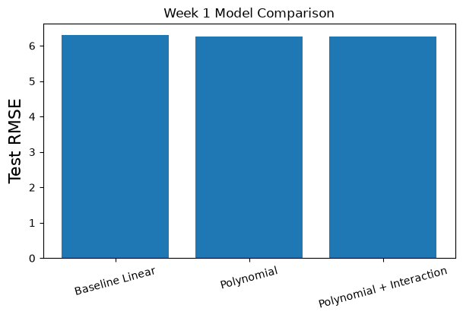
The polynomial-plus-interaction model performed best, but its R-squared of approximately 0.099 means that about 90% of the variation in BMI remains unexplained by this model. This suggests that additional factors or different modeling approaches would be needed for stronger BMI prediction.

Week 1 Summary

I used linear regression with both continuous/numeric and categorical features. I then added a polynomial term to allow a nonlinear relationship between Age and BMI and an interaction term to test whether the Age-BMI relationship changes with high blood pressure status.

I also evaluated multicollinearity using VIF. Centering Age before creating Age squared helps reduce unnecessary correlation between the polynomial terms. Finally, I compared all three models using test-set RMSE, MAE, and R-squared.

The main lesson is that polynomial and interaction terms can make a linear regression model more flexible, but additional complexity should be supported by improved results. VIF is useful for checking whether the added predictors create multicollinearity.

I expected polynomial and interaction terms to improve the baseline regression because health relationships are not necessarily linear. The results supported this expectation, but the magnitude of improvement was smaller than expected. R-squared increased only from 0.0859 to 0.0988, showing that additional model complexity captured some additional information but did not overcome the limited explanatory power of the selected predictors.

Week 2
Week-2-Submission-Hospital-LRE-Regression-Notebook(1).ipynb

Week 2 Linear Regression with Lasso, Ridge and Elastic Net Regression

The overall project examines diabetes related health and hospital outcomes, for week 2 I'm using the Hospital dataset which contains encounters for patients with diabetes and their 30-day readmission rates, Week 2 specifically focuses on linear regression with Lasso, Ridge and Elastic Net therefore time_in_hospital as a continous response variable will be used for this exercise. This allows ordinary Linear Regression, Ridge, Lasso and Elastic Net to be compared appropriately while keeping the analysis within the same diabetic patient population.

Dataset: US 130 Hospital Diabetes encounter readmission rate

Import Libraries and load dataset
# 1. Import libraries
import pandas as pd
import numpy as np
import matplotlib.pyplot as plt
from sklearn.model_selection import train_test_split
from sklearn.preprocessing import StandardScaler
from sklearn.linear_model import LinearRegression, RidgeCV, LassoCV, ElasticNetCV
from sklearn.metrics import mean_squared_error, mean_absolute_error, r2_score
# 2. Load the hospital diabetes dataset
hospital_url = (
"https://raw.githubusercontent.com/"
"jeganart/hospitaldatasetmilestone3/refs/heads/main/"
"diabetic_data.csv"
)
df = pd.read_csv(hospital_url)
print("Dataset shape:", df.shape)
display(df.head())
Dataset shape: (101766, 50)
encounter_id patient_nbr race gender age weight \
0 2278392 8222157 Caucasian Female [0-10) ?
1 149190 55629189 Caucasian Female [10-20) ?
2 64410 86047875 AfricanAmerican Female [20-30) ?
3 500364 82442376 Caucasian Male [30-40) ?
4 16680 42519267 Caucasian Male [40-50) ?
admission_type_id discharge_disposition_id admission_source_id \
0 6 25 1
1 1 1 7
2 1 1 7
3 1 1 7
4 1 1 7
time_in_hospital ... citoglipton insulin glyburide-metformin \
0 1 ... No No No
1 3 ... No Up No
2 2 ... No No No
3 2 ... No Up No
4 1 ... No Steady No
glipizide-metformin glimepiride-pioglitazone metformin-rosiglitazone \
0 No No No
1 No No No
2 No No No
3 No No No
4 No No No
metformin-pioglitazone change diabetesMed readmitted
0 No No No NO
1 No Ch Yes >30
2 No No Yes NO
3 No Ch Yes NO
4 No Ch Yes NO
[5 rows x 50 columns]

Outcome and Predictors
time_in_hospital is the continous outcome for week 2 regression exercise, the predictors describe hospital utilization and clinial activity, the categorical readmitted variable is intentionally not used as the outcome here but for later weeks we will use that for classification methods.
# 3. Select variables
target = "time_in_hospital"
features = [
"num_lab_procedures", "num_procedures", "num_medications",
"number_outpatient", "number_emergency", "number_inpatient",
"number_diagnoses"
]
model_df = df[features + [target]].dropna().copy()
print("Rows used:", len(model_df))
display(model_df.describe().T)
Rows used: 101766
count mean std min 25% 50% 75% \
num_lab_procedures 101766.0 43.095641 19.674362 1.0 31.0 44.0 57.0
num_procedures 101766.0 1.339730 1.705807 0.0 0.0 1.0 2.0
num_medications 101766.0 16.021844 8.127566 1.0 10.0 15.0 20.0
number_outpatient 101766.0 0.369357 1.267265 0.0 0.0 0.0 0.0
number_emergency 101766.0 0.197836 0.930472 0.0 0.0 0.0 0.0
number_inpatient 101766.0 0.635566 1.262863 0.0 0.0 0.0 1.0
number_diagnoses 101766.0 7.422607 1.933600 1.0 6.0 8.0 9.0
time_in_hospital 101766.0 4.395987 2.985108 1.0 2.0 4.0 6.0
max
num_lab_procedures 132.0
num_procedures 6.0
num_medications 81.0
number_outpatient 42.0
number_emergency 76.0
number_inpatient 21.0
number_diagnoses 16.0
time_in_hospital 14.0
# Distribution of time in hospital, let's examine the distribution of hospital stay durations, this provides context for the continuous target variable in our analysis.
plt.figure(figsize=(7, 4))
plt.hist(model_df["time_in_hospital"], bins=14, edgecolor="black")
plt.xlabel("Days in Hospital")
plt.ylabel("Number of Patients")
plt.title("Distribution of Time in Hospital")
plt.show()
<Figure size 700x400 with 1 Axes>
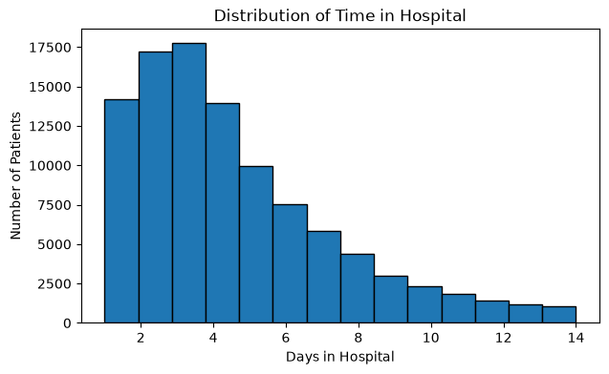

Train/Test Split and Scaling
Regularization penalizes the coefficient size, so the predictors are standardized before fitting the model, the scaler is fit only o the training data to avoid data leakage.
# 4. Split and scale
X = model_df[features]
y = model_df[target]
X_train, X_test, y_train, y_test = train_test_split(
X, y, test_size=0.20, random_state=42
)
scaler = StandardScaler()
X_train_scaled = scaler.fit_transform(X_train)
X_test_scaled = scaler.transform(X_test)
print("Training rows:", len(X_train))
print("Test rows:", len(X_test))
Training rows: 81412
Test rows: 20354

Baseline Linear Regression
Ordinary linear regression provides the baseline for determining whether regularization improves prediction
# 5. Linear Regression
linear = LinearRegression()
linear.fit(X_train_scaled, y_train)
pred_linear = linear.predict(X_test_scaled)
rmse_linear = np.sqrt(mean_squared_error(y_test, pred_linear))
mae_linear = mean_absolute_error(y_test, pred_linear)
r2_linear = r2_score(y_test, pred_linear)
print("RMSE:", rmse_linear)
print("MAE:", mae_linear)
print("R-squared:", r2_linear)
RMSE: 2.522637531387741
MAE: 1.9251166678304488
R-squared: 0.2688827201010452

Ridge Regression
Ridge uses L2 regularization, It shrinks coefficients toward zero but generally retains all predictors, Cross valiation selects the regularization strength (alpha)
# 6. Ridge Regression
alphas = np.logspace(-4, 4, 50)
ridge = RidgeCV(alphas=alphas, cv=5)
ridge.fit(X_train_scaled, y_train)
pred_ridge = ridge.predict(X_test_scaled)
rmse_ridge = np.sqrt(mean_squared_error(y_test, pred_ridge))
mae_ridge = mean_absolute_error(y_test, pred_ridge)
r2_ridge = r2_score(y_test, pred_ridge)
print("Best alpha:", ridge.alpha_)
print("RMSE:", rmse_ridge)
print("MAE:", mae_ridge)
print("R-squared:", r2_ridge)
Best alpha: 16.768329368110066
RMSE: 2.522636678848878
MAE: 1.925125289100658
R-squared: 0.26888321427096173

Lasso Regression

Lasso uses L1 regularization. It shrinks coefficients and can reduce weaker coefficients to exactly zero, so it can also perform feature selection
# 7. Lasso Regression
lasso = LassoCV(alphas=alphas, cv=5, max_iter=10000)
lasso.fit(X_train_scaled, y_train)
pred_lasso = lasso.predict(X_test_scaled)
rmse_lasso = np.sqrt(mean_squared_error(y_test, pred_lasso))
mae_lasso = mean_absolute_error(y_test, pred_lasso)
r2_lasso = r2_score(y_test, pred_lasso)
print("Best alpha:", lasso.alpha_)
print("RMSE:", rmse_lasso)
print("MAE:", mae_lasso)
print("R-squared:", r2_lasso)
Best alpha: 0.0001
RMSE: 2.5226368878002403
MAE: 1.9251196751693809
R-squared: 0.268883093153358

Elastic Net Regression

Elastic Net combines L1 and L2 regularization, providing a compromise between Lasso's feature selection behavior and Ridge's coefficient shrinkage.
# 8. Elastic Net Regression
elastic = ElasticNetCV(
alphas=alphas, l1_ratio=[0.1, 0.5, 0.9], cv=5, max_iter=10000
)
elastic.fit(X_train_scaled, y_train)
pred_elastic = elastic.predict(X_test_scaled)
rmse_elastic = np.sqrt(mean_squared_error(y_test, pred_elastic))
mae_elastic = mean_absolute_error(y_test, pred_elastic)
r2_elastic = r2_score(y_test, pred_elastic)
print("Best alpha:", elastic.alpha_)
print("Best l1 ratio:", elastic.l1_ratio_)
print("RMSE:", rmse_elastic)
print("MAE:", mae_elastic)
print("R-squared:", r2_elastic)
Best alpha: 0.00021209508879201905
Best l1 ratio: 0.1
RMSE: 2.5226366036739503
MAE: 1.925125295309868
R-squared: 0.2688832578457271

Model Comparison

Lower RMSE and MAE indicates smaller Prediction Errors, while higher R-squared indicates greater explained variation
# 9. Compare model performance
results = pd.DataFrame({
"Model": ["Linear Regression", "Ridge", "Lasso", "Elastic Net"],
"RMSE": [rmse_linear, rmse_ridge, rmse_lasso, rmse_elastic],
"MAE": [mae_linear, mae_ridge, mae_lasso, mae_elastic],
"R-squared": [r2_linear, r2_ridge, r2_lasso, r2_elastic]
})
display(results.round(4))
plt.figure(figsize=(7, 4))
plt.bar(results["Model"], results["RMSE"])
plt.ylabel("Test RMSE")
plt.title(" Model Comparison")
plt.xticks(rotation=15)
plt.show()
Model RMSE MAE R-squared
0 Linear Regression 2.5226 1.9251 0.2689
1 Ridge 2.5226 1.9251 0.2689
2 Lasso 2.5226 1.9251 0.2689
3 Elastic Net 2.5226 1.9251 0.2689
<Figure size 700x400 with 1 Axes>
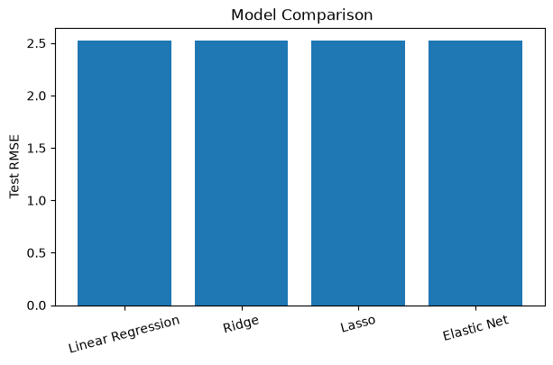

All four models produced nearly identical predictive performance, with RMSE approximately 2.523, MAE approximately 1.925 and R-squared approximately 0.268. Elastic Net had the numerically highest R-squared 0.26888325, but the difference from the ordinary Linear Regression of 0.2688827 was negligible, therefore there is no meaningful evidence that regularization improved prediction in this analysis.

Effects of Regulariztion on coefficients

The coefficient comparison shows what regularization is doing not just whether prediction changed, Ridge should shrink coefficients while retaining predictors, Lasso may reduce weaker coefficients to zero and Elastic Net combines both behaviors
# 10. Compare coefficients
coefficients = pd.DataFrame({
"Feature": features,
"Linear": linear.coef_,
"Ridge": ridge.coef_,
"Lasso": lasso.coef_,
"Elastic Net": elastic.coef_
})
display(coefficients.round(4))
print("Lasso coefficients reduced to zero:", np.sum(np.isclose(lasso.coef_, 0)))
Feature Linear Ridge Lasso Elastic Net
0 num_lab_procedures 0.5959 0.5958 0.5958 0.5958
1 num_procedures 0.0882 0.0883 0.0881 0.0883
2 num_medications 1.1268 1.1266 1.1268 1.1266
3 number_outpatient -0.1002 -0.1002 -0.1001 -0.1002
4 number_emergency -0.0857 -0.0857 -0.0856 -0.0857
5 number_inpatient 0.1266 0.1266 0.1265 0.1266
6 number_diagnoses 0.2727 0.2727 0.2726 0.2727
Lasso coefficients reduced to zero: 0

Coefficients comparison Plot

Regularization works by shrinking regression coefficients, this plot provides a direct visual comparison of how Linear Regression, Ridge, Lasso and Elastic Net treat the same predictors.
# Plot coefficients across our four models
coef_plot = coefficients.set_index("Feature")
coef_plot.plot(kind="bar", figsize=(10, 5))
plt.ylabel("Standardized Coefficient", fontsize=16)
plt.title("Effect of Regularization on Regression Coefficients")
plt.xticks(rotation=45, ha="right")
plt.legend(title="Model")
plt.tight_layout()
plt.show()
<Figure size 1000x500 with 1 Axes>
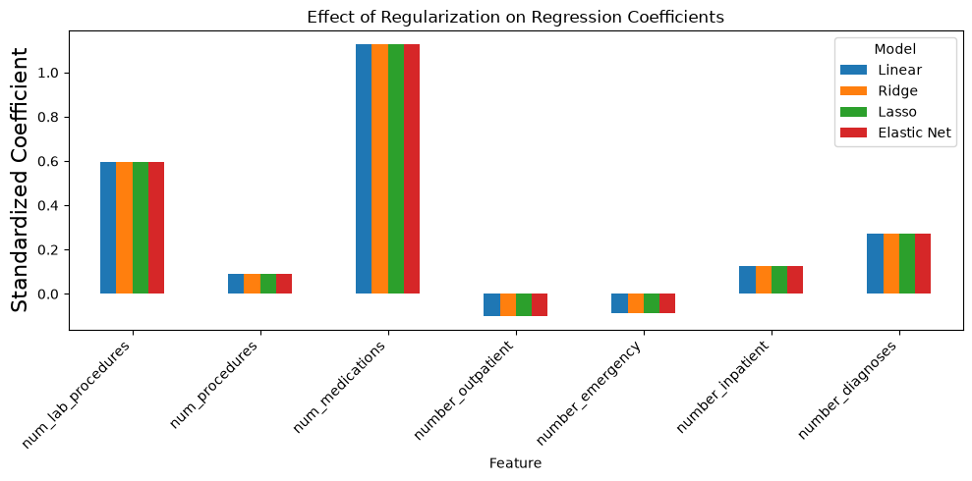

Summary

The coefficient resutls support the conclusion that regularization didn't improve the prediction in this analysis. Ridge, Lasso and Elastic Net produced coefficients that were almost identical to ordinary Linear Regression and Lasso reduced zero predictors to a coefficient of zero. Among the standardized predictors, **num_medications** had the largest positice coefficient at approximately 1.13, followed by **num_lab_procedures** at approximately 0.60 and **number_diagnoses** at approximately 0.27. These results indicate associations with longer hospital stays within this model.. They should be interpreted as causal effects.

Important finding from this week is regularization doesn't automatically improve a model. Ridge, Lasso and Elastic Net are useful for controlling model complexity and reducing overfitting, but in this dataset they provided almost no advantage over ordinary Linear Regression. The R-squared of approximately 0.269 means that the selected predictors explain only about **27% of the variation in time in hospital** leaving substantial variation unexplained. This suggests that the main limiations is not excessive coefficient size or overfitting but additional clinical or patient level information may be needed to better explain hosptial length of stay. More complex modeling method does not necessarily produce a better result. In this case Linear Regression model performed essentially as well as the regularization alternatives.

Week 3
Week-3-Submission-Health-LRE-PCR-PLSR-Notebook(1).ipynb

Week 3 Jupyter Notebook Linear Regression 3

For Week 3 apply concepts such as Linear Regression with Forward and Backward Selection, PCR and PLSR
My overall project focuses on understanding and predicting diabetes using health and lifestyle indicators from the BRFSS 2015 dataset, with Diabetes_binary as the primary classification outcome. Week 3 specifically focuses on **linear regression with forward and backward feature selection, Principal Component Regression (PCR), and Partial Least Squares Regression (PLSR)**. Because these methods are being applied in a regression setting, I use **BMI as the continuous response variable** for this week's analysis.
# Import Libraries
import pandas as pd
import numpy as np
import matplotlib.pyplot as plt
from sklearn.model_selection import train_test_split, KFold, cross_val_score
from sklearn.preprocessing import StandardScaler
from sklearn.linear_model import LinearRegression
from sklearn.feature_selection import SequentialFeatureSelector
from sklearn.pipeline import Pipeline
from sklearn.decomposition import PCA
from sklearn.cross_decomposition import PLSRegression
from sklearn.metrics import mean_squared_error, mean_absolute_error, r2_score
pd.set_option("display.max_columns", None)
## Model Evaluation Helper Function
def evaluate_regression_model(model_name, y_true, y_pred):
rmse = np.sqrt(mean_squared_error(y_true, y_pred))
mae = mean_absolute_error(y_true, y_pred)
r_squared = r2_score(y_true, y_pred)
return {
"Model": model_name,
"RMSE": rmse,
"MAE": mae,
"R_squared": r_squared
}
## 2. Load the Diabetes Health Dataset from my GitHub repository and display basic information
dataset_url = (
"https://raw.githubusercontent.com/"
"jeganart/healthdatasetmilestone3/"
"refs/heads/main/"
"diabetes_binary_health_indicators_BRFSS2015.csv"
)
df = pd.read_csv(dataset_url)
print("Dataset loaded successfully.")
print("Dataset shape:", df.shape)
display(df.head())
print("Dataset information:")
df.info()
print("\nMissing values:")
display(df.isnull().sum())
print("\nColumn names:")
print(df.columns.tolist())
Dataset loaded successfully.
Dataset shape: (253680, 22)
Diabetes_binary HighBP HighChol CholCheck BMI Smoker Stroke \
0 0.0 1.0 1.0 1.0 40.0 1.0 0.0
1 0.0 0.0 0.0 0.0 25.0 1.0 0.0
2 0.0 1.0 1.0 1.0 28.0 0.0 0.0
3 0.0 1.0 0.0 1.0 27.0 0.0 0.0
4 0.0 1.0 1.0 1.0 24.0 0.0 0.0
HeartDiseaseorAttack PhysActivity Fruits Veggies HvyAlcoholConsump \
0 0.0 0.0 0.0 1.0 0.0
1 0.0 1.0 0.0 0.0 0.0
2 0.0 0.0 1.0 0.0 0.0
3 0.0 1.0 1.0 1.0 0.0
4 0.0 1.0 1.0 1.0 0.0
AnyHealthcare NoDocbcCost GenHlth MentHlth PhysHlth DiffWalk Sex \
0 1.0 0.0 5.0 18.0 15.0 1.0 0.0
1 0.0 1.0 3.0 0.0 0.0 0.0 0.0
2 1.0 1.0 5.0 30.0 30.0 1.0 0.0
3 1.0 0.0 2.0 0.0 0.0 0.0 0.0
4 1.0 0.0 2.0 3.0 0.0 0.0 0.0
Age Education Income
0 9.0 4.0 3.0
1 7.0 6.0 1.0
2 9.0 4.0 8.0
3 11.0 3.0 6.0
4 11.0 5.0 4.0
Dataset information:
<class 'pandas.core.frame.DataFrame'>
RangeIndex: 253680 entries, 0 to 253679
Data columns (total 22 columns):
# Column Non-Null Count Dtype
--- ------ -------------- -----
0 Diabetes_binary 253680 non-null float64
1 HighBP 253680 non-null float64
2 HighChol 253680 non-null float64
3 CholCheck 253680 non-null float64
4 BMI 253680 non-null float64
5 Smoker 253680 non-null float64
6 Stroke 253680 non-null float64
7 HeartDiseaseorAttack 253680 non-null float64
8 PhysActivity 253680 non-null float64
9 Fruits 253680 non-null float64
10 Veggies 253680 non-null float64
11 HvyAlcoholConsump 253680 non-null float64
12 AnyHealthcare 253680 non-null float64
13 NoDocbcCost 253680 non-null float64
14 GenHlth 253680 non-null float64
15 MentHlth 253680 non-null float64
16 PhysHlth 253680 non-null float64
17 DiffWalk 253680 non-null float64
18 Sex 253680 non-null float64
19 Age 253680 non-null float64
20 Education 253680 non-null float64
21 Income 253680 non-null float64
dtypes: float64(22)
memory usage: 42.6 MB
Missing values:
Diabetes_binary 0
HighBP 0
HighChol 0
CholCheck 0
BMI 0
Smoker 0
Stroke 0
HeartDiseaseorAttack 0
PhysActivity 0
Fruits 0
Veggies 0
HvyAlcoholConsump 0
AnyHealthcare 0
NoDocbcCost 0
GenHlth 0
MentHlth 0
PhysHlth 0
DiffWalk 0
Sex 0
Age 0
Education 0
Income 0
dtype: int64
Column names:
['Diabetes_binary', 'HighBP', 'HighChol', 'CholCheck', 'BMI', 'Smoker', 'Stroke', 'HeartDiseaseorAttack', 'PhysActivity', 'Fruits', 'Veggies', 'HvyAlcoholConsump', 'AnyHealthcare', 'NoDocbcCost', 'GenHlth', 'MentHlth', 'PhysHlth', 'DiffWalk', 'Sex', 'Age', 'Education', 'Income']
## 3. Define Target and Predictor Variables, I needed continous value for regression analysis, LF confirmed it is ok to change to BMI instead of Diabetes_binary
target = "BMI"
predictors = [
"Diabetes_binary", "HighBP", "HighChol", "Smoker", "Stroke",
"HeartDiseaseorAttack", "PhysActivity", "HvyAlcoholConsump",
"NoDocbcCost", "GenHlth", "MentHlth", "PhysHlth", "DiffWalk",
"Sex", "Age", "Education", "Income"
]
required_columns = predictors + [target]
missing_columns = [c for c in required_columns if c not in df.columns]
if missing_columns:
raise ValueError(f"Missing columns: {missing_columns}")
model_df = df[required_columns].dropna().copy()
X = model_df[predictors]
y = model_df[target]
print("Target:", target)
print("Predictors:", predictors)
print("Records used:", len(model_df))
print("X shape:", X.shape)
print("y shape:", y.shape)
Target: BMI
Predictors: ['Diabetes_binary', 'HighBP', 'HighChol', 'Smoker', 'Stroke', 'HeartDiseaseorAttack', 'PhysActivity', 'HvyAlcoholConsump', 'NoDocbcCost', 'GenHlth', 'MentHlth', 'PhysHlth', 'DiffWalk', 'Sex', 'Age', 'Education', 'Income']
Records used: 253680
X shape: (253680, 17)
y shape: (253680,)

BMI Distribution
Before fitting the regression models, let's examine the distribution of the continous outcome being predicted.
# Distribution of the continuous outcome used in Week 3
plt.figure(figsize=(7, 4))
plt.hist(model_df["BMI"], bins=30, edgecolor="black")
plt.xlabel("BMI")
plt.ylabel("Frequency")
plt.title("Distribution of BMI")
plt.tight_layout()
plt.show()
<Figure size 700x400 with 1 Axes>
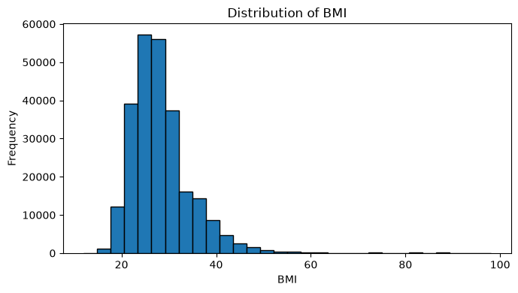
## 4. Train-Test Split
X_train, X_test, y_train, y_test = train_test_split(
X, y, test_size=0.20, random_state=42
)
print("Training observations:", X_train.shape[0])
print("Testing observations:", X_test.shape[0])
Training observations: 202944
Testing observations: 50736
## 5. Prepare Data for Feature Selection, the BRFSS dataset is large. Sequential feature selection can therefore take a long time,
# so picking a subset of 30000 observations for feature selection. After the features are selected, the final regression models are fitted on the full training dataset.
selection_size = min(30000, len(X_train))
X_selection = X_train.sample(
n=selection_size,
random_state=42
)
y_selection = y_train.loc[X_selection.index]
print("Observations used for feature selection:", selection_size)
Observations used for feature selection: 30000
# 6. Forward Feature Selection with Linear Regression
linear_model = LinearRegression()
forward_selector = SequentialFeatureSelector(
estimator=linear_model,
n_features_to_select="auto",
direction="forward",
scoring="neg_root_mean_squared_error",
cv=3,
n_jobs=-1
)
forward_selector.fit(X_selection, y_selection)
forward_features = X_train.columns[
forward_selector.get_support()
].tolist()
print("=" * 120)
print("FORWARD FEATURE SELECTION")
print("Selected features:", forward_features)
print("Number selected:", len(forward_features))
print("=" * 100)
forward_model = LinearRegression()
forward_model.fit(X_train[forward_features], y_train)
forward_predictions = forward_model.predict(
X_test[forward_features]
)
forward_results = evaluate_regression_model(
"Linear Regression - Forward Selection",
y_test,
forward_predictions
)
print("Forward Selection Test Results:")
print(forward_results)
print("=" * 120)
========================================================================================================================
FORWARD FEATURE SELECTION
Selected features: ['Diabetes_binary', 'HighBP', 'HighChol', 'Stroke', 'PhysActivity', 'GenHlth', 'DiffWalk', 'Age']
Number selected: 8
====================================================================================================
Forward Selection Test Results:
{'Model': 'Linear Regression - Forward Selection', 'RMSE': np.float64(6.148210249765894), 'MAE': 4.348877882072593, 'R_squared': 0.13057243945640273}
========================================================================================================================
## 7. Backward Feature Selection with Linear Regression
backward_selector = SequentialFeatureSelector(
estimator=linear_model,
n_features_to_select="auto",
direction="backward",
scoring="neg_root_mean_squared_error",
cv=3,
n_jobs=-1
)
backward_selector.fit(X_selection, y_selection)
backward_features = X_train.columns[
backward_selector.get_support()
].tolist()
print("=" * 120)
print("BACKWARD FEATURE SELECTION")
print("Selected features:", backward_features)
print("Number selected:", len(backward_features))
print("=" * 120)
backward_model = LinearRegression()
backward_model.fit(X_train[backward_features], y_train)
backward_predictions = backward_model.predict(
X_test[backward_features]
)
backward_results = evaluate_regression_model(
"Linear Regression - Backward Selection",
y_test,
backward_predictions
)
print("=" * 120)
print("Backward Selection Test Results:")
print(backward_results)
print("=" * 120)
========================================================================================================================
BACKWARD FEATURE SELECTION
Selected features: ['Diabetes_binary', 'HighBP', 'HighChol', 'Stroke', 'PhysActivity', 'HvyAlcoholConsump', 'GenHlth', 'DiffWalk', 'Age']
Number selected: 9
========================================================================================================================
========================================================================================================================
Backward Selection Test Results:
{'Model': 'Linear Regression - Backward Selection', 'RMSE': np.float64(6.142819518580403), 'MAE': 4.344520991926194, 'R_squared': 0.13209639370199033}
========================================================================================================================
## 8. Principal Component Regression (PCR)
# Standardize the features and perform Principal Component Regression (PCR)
cv = KFold(n_splits=5, shuffle=True, random_state=42)
pcr_scores = []
for n_components in range(1, len(predictors) + 1):
pcr_pipeline = Pipeline([
("scaler", StandardScaler()),
("pca", PCA(n_components=n_components)),
("linear_regression", LinearRegression())
])
scores = cross_val_score(
pcr_pipeline,
X_train,
y_train,
cv=cv,
scoring="neg_root_mean_squared_error",
n_jobs=-1
)
pcr_scores.append({
"n_components": n_components,
"mean_cv_rmse": -scores.mean()
})
pcr_cv_results = pd.DataFrame(pcr_scores)
best_pcr_components = int(
pcr_cv_results.loc[
pcr_cv_results["mean_cv_rmse"].idxmin(),
"n_components"
]
)
print("=" * 120)
print("Best number of PCR components:", best_pcr_components)
display(pcr_cv_results.round(4))
print("=" * 120)
pcr_model = Pipeline([
("scaler", StandardScaler()),
("pca", PCA(n_components=best_pcr_components)),
("linear_regression", LinearRegression())
])
pcr_model.fit(X_train, y_train)
pcr_predictions = pcr_model.predict(X_test)
pcr_results = evaluate_regression_model(
f"PCR - {best_pcr_components} Components",
y_test,
pcr_predictions
)
print("=" * 120)
print("PCR Test Results:")
print(pcr_results)
print("=" * 120)
plt.figure(figsize=(8, 5))
plt.plot(
pcr_cv_results["n_components"],
pcr_cv_results["mean_cv_rmse"],
marker="o"
)
plt.axvline(
best_pcr_components,
linestyle="--",
label=f"Best = {best_pcr_components}"
)
plt.title("PCR Cross-Validation Results")
plt.xlabel("Number of Principal Components")
plt.ylabel("Mean Cross-Validated RMSE")
plt.legend()
plt.tight_layout()
plt.show()
========================================================================================================================
Best number of PCR components: 17
n_components mean_cv_rmse
0 1 6.4053
1 2 6.4053
2 3 6.4046
3 4 6.3975
4 5 6.3874
5 6 6.3004
6 7 6.2948
7 8 6.2470
8 9 6.2440
9 10 6.2393
10 11 6.2359
11 12 6.2353
12 13 6.2327
13 14 6.1801
14 15 6.1604
15 16 6.1534
16 17 6.1445
========================================================================================================================
========================================================================================================================
PCR Test Results:
{'Model': 'PCR - 17 Components', 'RMSE': np.float64(6.127080191196312), 'MAE': 4.323040825157517, 'R_squared': 0.13653823628990247}
========================================================================================================================
<Figure size 800x500 with 1 Axes>
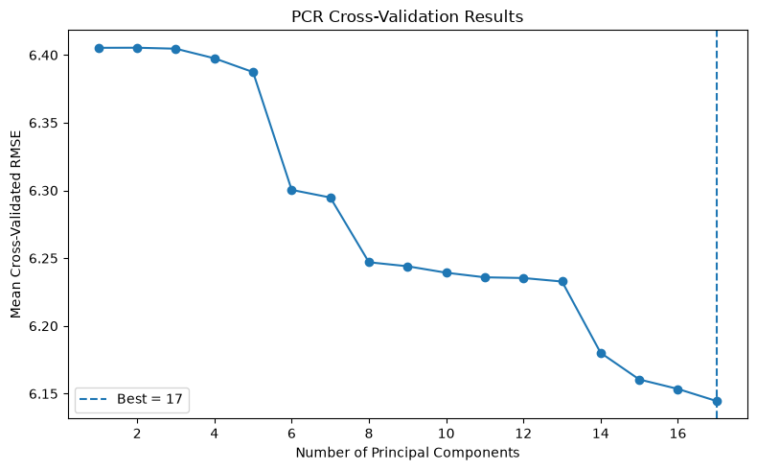
## 9. Partial Least Squares Regression (PLSR)
# Standardize the features and perform Partial Least Squares Regression (PLSR)
plsr_scores = []
for n_components in range(1, len(predictors) + 1):
plsr_pipeline = Pipeline([
("scaler", StandardScaler()),
("pls", PLSRegression(n_components=n_components))
])
scores = cross_val_score(
plsr_pipeline,
X_train,
y_train,
cv=cv,
scoring="neg_root_mean_squared_error",
n_jobs=-1
)
plsr_scores.append({
"n_components": n_components,
"mean_cv_rmse": -scores.mean()
})
plsr_cv_results = pd.DataFrame(plsr_scores)
best_plsr_components = int(
plsr_cv_results.loc[
plsr_cv_results["mean_cv_rmse"].idxmin(),
"n_components"
]
)
print("=" * 120)
print("Best number of PLSR components:", best_plsr_components)
display(plsr_cv_results.round(4))
print("=" * 120)
plsr_model = Pipeline([
("scaler", StandardScaler()),
("pls", PLSRegression(n_components=best_plsr_components))
])
plsr_model.fit(X_train, y_train)
plsr_predictions = plsr_model.predict(X_test).ravel()
plsr_results = evaluate_regression_model(
f"PLSR - {best_plsr_components} Components",
y_test,
plsr_predictions
)
print("=" * 120)
print("PLSR Test Results:")
print(plsr_results)
print("=" * 120)
plt.figure(figsize=(8, 5))
plt.plot(
plsr_cv_results["n_components"],
plsr_cv_results["mean_cv_rmse"],
marker="o"
)
plt.axvline(
best_plsr_components,
linestyle="--",
label=f"Best = {best_plsr_components}"
)
plt.title("PLSR Cross-Validation Results")
plt.xlabel("Number of PLS Components")
plt.ylabel("Mean Cross-Validated RMSE")
plt.legend()
plt.tight_layout()
plt.show()
========================================================================================================================
Best number of PLSR components: 6
n_components mean_cv_rmse
0 1 6.2929
1 2 6.1545
2 3 6.1449
3 4 6.1446
4 5 6.1445
5 6 6.1445
6 7 6.1445
7 8 6.1445
8 9 6.1445
9 10 6.1445
10 11 6.1445
11 12 6.1445
12 13 6.1445
13 14 6.1445
14 15 6.1445
15 16 6.1445
16 17 6.1445
========================================================================================================================
========================================================================================================================
PLSR Test Results:
{'Model': 'PLSR - 6 Components', 'RMSE': np.float64(6.127093589996474), 'MAE': 4.323037386182862, 'R_squared': 0.13653445982088042}
========================================================================================================================
<Figure size 800x500 with 1 Axes>
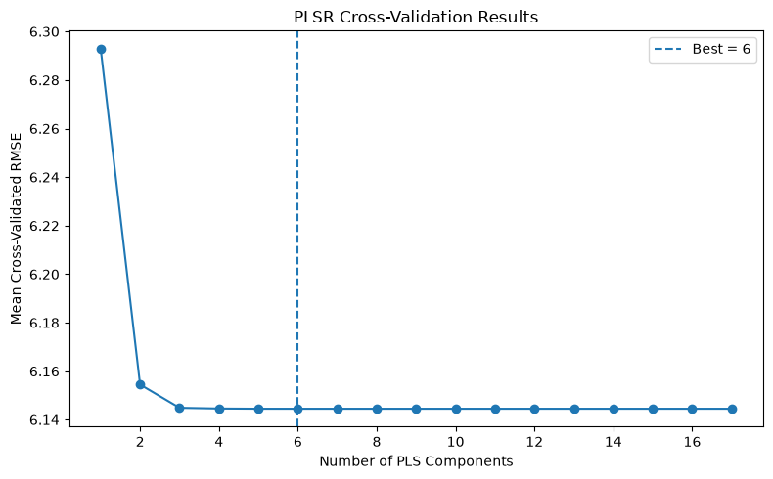
## 10. Compare All Models
comparison_results = pd.DataFrame([
forward_results,
backward_results,
pcr_results,
plsr_results
])
comparison_results = comparison_results.sort_values(
by="RMSE",
ascending=True
).reset_index(drop=True)
print("=" * 70)
print("FINAL MODEL COMPARISON")
print("=" * 70)
display(comparison_results.round(6))
best_model = comparison_results.iloc[0]
print("=" * 70)
print("Best model based on test RMSE:")
print("Model:", best_model["Model"])
print("RMSE:", round(best_model["RMSE"], 6))
print("MAE:", round(best_model["MAE"], 6))
print("R-squared:", round(best_model["R_squared"], 6))
print("=" * 70)
======================================================================
FINAL MODEL COMPARISON
======================================================================
Model RMSE MAE R_squared
0 PCR - 17 Components 6.127080 4.323041 0.136538
1 PLSR - 6 Components 6.127094 4.323037 0.136534
2 Linear Regression - Backward Selection 6.142820 4.344521 0.132096
3 Linear Regression - Forward Selection 6.148210 4.348878 0.130572
======================================================================
Best model based on test RMSE:
Model: PCR - 17 Components
RMSE: 6.12708
MAE: 4.323041
R-squared: 0.136538
======================================================================

Model Comparison Plot
The models have similar RMSE vaues, let's plot a visual comparison
# Visual comparison of test RMSE across the four approaches
plt.figure(figsize=(8, 4))
plt.bar(comparison_results["Model"], comparison_results["RMSE"])
plt.ylabel("Test RMSE", fontsize=16)
plt.title("Week 3 Model Comparison")
plt.xticks(rotation=25, ha="right")
plt.tight_layout()
plt.show()
<Figure size 800x400 with 1 Axes>
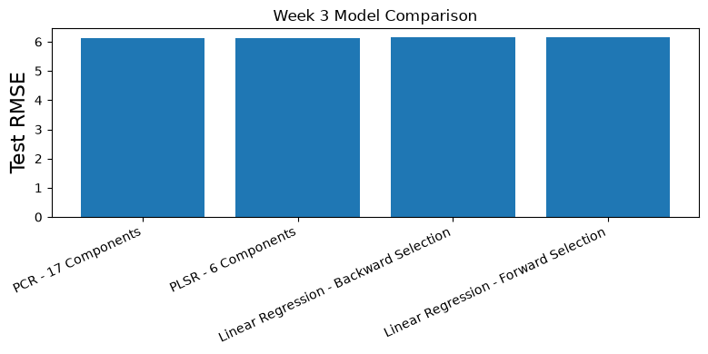

Week 3 Summary and Interpretation

I compared linear regression with forward selection, backward selection, Principal Component Regression (PCR), and Partial Least Squares Regression (PLSR) for predicting BMI. Forward selection produced an RMSE of 6.1482, MAE of 4.3489, and R-squared of 0.1306, while backward selection performed slightly better with an RMSE of 6.1428, MAE of 4.3445, and R-squared of 0.1321. PCR selected 17 components and achieved an RMSE of 6.1271, MAE of 4.3230, and R-squared of 0.1365. PLSR selected only 6 components and achieved nearly identical performance, with an RMSE of 6.1271, MAE of 4.3230, and R-squared of 0.1365.

PCR technically produced the lowest test RMSE, but the difference between PCR and PLSR was extremely small. An important finding is that PLSR achieved essentially the same predictive performance using only 6 components, compared with 17 components for PCR. This makes PLSR the more cost effective component-based model in this analysis. At the same time, the relatively low R-square values show that even the best models explained only about 13.7% of the variation in BMI, suggesting that BMI is influenced by additional factors not fully represented by these predictors.

To evaluate model generalization and limit overfitting during model selection, I maintained the same 80/20 train-test split across all four approaches and used five-fold cross-validation during feature and component selection. For PCR and PLSR, predictors were standardized within the modeling pipelines before the components were constructed. The expected result was that feature selection or dimension reduction would improve performance by reducing or reorganizing less useful predictor information. The unexpected result was how small the improvement actually was. PCR and PLSR performed only slightly better than the simpler forward and backward selection models, suggesting that the added complexity of dimension reduction provided limited predictive benefit for BMI in this dataset.

Week 4
Week-4-Submission-Hospital-LogisticRegression-Feature-Notebook(2).ipynb

Week 4 - Logistic Regression and Feature Scaling

**Dataset:** Diabetes 130-US Hospitals dataset

**Week 4 Goal:** Apply logistic regression and feature scaling to determine whether selected hospital-utilization variables can help identify patients who are readmitted within 30 days.

The overall project examines diabetes-related outcomes using two healthcare datasets. In Weeks 1 and 3, the BRFSS health dataset was used to study BMI with regression methods. Week 2 used the hospital dataset with "time_in_hospital" as a continuous outcome. Week 4 I return to the hospital dataset and use "readmitted_30" as a binary classification target.

This week is especially important because logistic regression is designed for a binary outcome. I also examine feature scaling because the selected hospital predictors are measured on very different numerical scales. The main question is whether these hospital-utilization variables can distinguish patients who are readmitted within 30 days from those who are not.
# ============================================================
# 1. Import Libraries
# ============================================================
import pandas as pd
import numpy as np
import matplotlib.pyplot as plt
from sklearn.model_selection import train_test_split
from sklearn.preprocessing import StandardScaler
from sklearn.linear_model import LogisticRegression
from sklearn.metrics import (
accuracy_score,
confusion_matrix,
classification_report,
roc_auc_score,
ConfusionMatrixDisplay
)
# ============================================================
# 2. Load Hospital Dataset
# ============================================================
hospital_url = "https://raw.githubusercontent.com/jeganart/hospitaldatasetmilestone3/refs/heads/main/diabetic_data.csv"
hospital_df = pd.read_csv(hospital_url)
print("Dataset Shape:", hospital_df.shape)
print("\nFirst 5 Rows:")
display(hospital_df.head())
#print("~" * 80)
Dataset Shape: (101766, 50)
First 5 Rows:
encounter_id patient_nbr race gender age weight \
0 2278392 8222157 Caucasian Female [0-10) ?
1 149190 55629189 Caucasian Female [10-20) ?
2 64410 86047875 AfricanAmerican Female [20-30) ?
3 500364 82442376 Caucasian Male [30-40) ?
4 16680 42519267 Caucasian Male [40-50) ?
admission_type_id discharge_disposition_id admission_source_id \
0 6 25 1
1 1 1 7
2 1 1 7
3 1 1 7
4 1 1 7
time_in_hospital ... citoglipton insulin glyburide-metformin \
0 1 ... No No No
1 3 ... No Up No
2 2 ... No No No
3 2 ... No Up No
4 1 ... No Steady No
glipizide-metformin glimepiride-pioglitazone metformin-rosiglitazone \
0 No No No
1 No No No
2 No No No
3 No No No
4 No No No
metformin-pioglitazone change diabetesMed readmitted
0 No No No NO
1 No Ch Yes >30
2 No No Yes NO
3 No Ch Yes NO
4 No Ch Yes NO
[5 rows x 50 columns]
# ============================================================
# 3. Clean Dataset
# ============================================================
# Replace ? with missing values
hospital_df = hospital_df.replace("?", np.nan)
print("Dataset Shape:", hospital_df.shape)
print("~" * 80)
print("Missing Values:")
display(
hospital_df.isnull()
.sum()
.sort_values(ascending=False)
.head(15)
)
print("~" * 80)
Dataset Shape: (101766, 50)
~~~~~~~~~~~~~~~~~~~~~~~~~~~~~~~~~~~~~~~~~~~~~~~~~~~~~~~~~~~~~~~~~~~~~~~~~~~~~~~~
Missing Values:
weight 98569
max_glu_serum 96420
A1Cresult 84748
medical_specialty 49949
payer_code 40256
race 2273
diag_3 1423
diag_2 358
diag_1 21
encounter_id 0
troglitazone 0
tolbutamide 0
pioglitazone 0
rosiglitazone 0
acarbose 0
dtype: int64
~~~~~~~~~~~~~~~~~~~~~~~~~~~~~~~~~~~~~~~~~~~~~~~~~~~~~~~~~~~~~~~~~~~~~~~~~~~~~~~~
# ============================================================
# 4. Examine Readmission Variable
# ============================================================
print("Readmission Counts:")
display(
hospital_df["readmitted"].value_counts()
)
print("~" * 80)
print("Readmission Percentages:")
display(
(
hospital_df["readmitted"]
.value_counts(normalize=True) * 100
).round(2)
)
print("~" * 80)
Readmission Counts:
readmitted
NO 54864
>30 35545
<30 11357
Name: count, dtype: int64
~~~~~~~~~~~~~~~~~~~~~~~~~~~~~~~~~~~~~~~~~~~~~~~~~~~~~~~~~~~~~~~~~~~~~~~~~~~~~~~~
Readmission Percentages:
readmitted
NO 53.91
>30 34.93
<30 11.16
Name: proportion, dtype: float64
~~~~~~~~~~~~~~~~~~~~~~~~~~~~~~~~~~~~~~~~~~~~~~~~~~~~~~~~~~~~~~~~~~~~~~~~~~~~~~~~
For logistic regression let's create binary target
1 = readmitted in less than 30 days
0 = otherwise ( not admitted or after 30 days)
# ============================================================
# 5. Create Binary Target Variable
# ============================================================
hospital_df["readmitted_30"] = (
hospital_df["readmitted"] == "<30"
).astype(int)
print("30-Day Readmission Counts:")
display(
hospital_df["readmitted_30"].value_counts()
)
print("~" * 80)
print("30-Day Readmission Percentages:")
display(
(
hospital_df["readmitted_30"]
.value_counts(normalize=True) * 100
).round(2)
)
print("~" * 80)
# ============================================================
# Readmission Class Distribution
# ============================================================
readmission_counts = (
hospital_df["readmitted_30"]
.value_counts()
.sort_index()
)
readmission_counts.index = [
"Not Readmitted Within 30 Days",
"Readmitted Within 30 Days"
]
plt.figure(figsize=(9, 5))
readmission_counts.plot(
kind="bar"
)
plt.title(
"30-Day Hospital Readmission Class Distribution"
)
plt.xlabel(
"Readmission Status"
)
plt.ylabel(
"Number of Encounters"
)
plt.xticks(
rotation=0
)
plt.tight_layout()
plt.show()
30-Day Readmission Counts:
readmitted_30
0 90409
1 11357
Name: count, dtype: int64
~~~~~~~~~~~~~~~~~~~~~~~~~~~~~~~~~~~~~~~~~~~~~~~~~~~~~~~~~~~~~~~~~~~~~~~~~~~~~~~~
30-Day Readmission Percentages:
readmitted_30
0 88.84
1 11.16
Name: proportion, dtype: float64
~~~~~~~~~~~~~~~~~~~~~~~~~~~~~~~~~~~~~~~~~~~~~~~~~~~~~~~~~~~~~~~~~~~~~~~~~~~~~~~~
<Figure size 900x500 with 1 Axes>
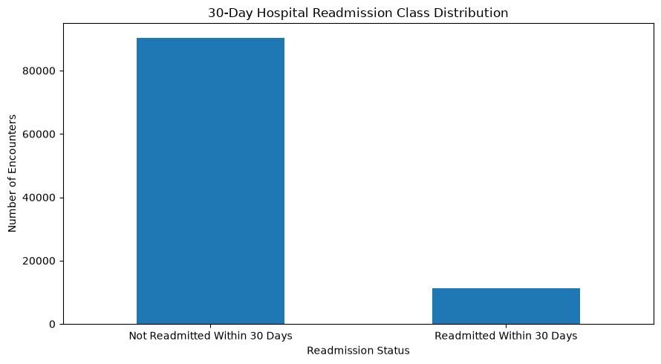
clearly this is an imbalanced dataset as admitted percentage is 11.16% compared to the otherwise 88.84%
# ============================================================
# 6. Select Numerical Predictors from the dataset, for the 699
# exercise I used only four predictors, but for this exercise
# I will use 8 numerical predictors in the dataset.
# ============================================================
features = [
"time_in_hospital",
"num_lab_procedures",
"num_procedures",
"num_medications",
"number_outpatient",
"number_emergency",
"number_inpatient",
"number_diagnoses"
]
X = hospital_df[features].copy()
y = hospital_df["readmitted_30"].copy()
print("Selected Numerical Predictors:")
for feature in features:
print(feature)
print("~" * 150)
print("Predictor Data:")
display(X.head())
print("~" * 150)
Selected Numerical Predictors:
time_in_hospital
num_lab_procedures
num_procedures
num_medications
number_outpatient
number_emergency
number_inpatient
number_diagnoses
~~~~~~~~~~~~~~~~~~~~~~~~~~~~~~~~~~~~~~~~~~~~~~~~~~~~~~~~~~~~~~~~~~~~~~~~~~~~~~~~~~~~~~~~~~~~~~~~~~~~~~~~~~~~~~~~~~~~~~~~~~~~~~~~~~~~~~~~~~~~~~~~~~~~~~
Predictor Data:
time_in_hospital num_lab_procedures num_procedures num_medications \
0 1 41 0 1
1 3 59 0 18
2 2 11 5 13
3 2 44 1 16
4 1 51 0 8
number_outpatient number_emergency number_inpatient number_diagnoses
0 0 0 0 1
1 0 0 0 9
2 2 0 1 6
3 0 0 0 7
4 0 0 0 5
~~~~~~~~~~~~~~~~~~~~~~~~~~~~~~~~~~~~~~~~~~~~~~~~~~~~~~~~~~~~~~~~~~~~~~~~~~~~~~~~~~~~~~~~~~~~~~~~~~~~~~~~~~~~~~~~~~~~~~~~~~~~~~~~~~~~~~~~~~~~~~~~~~~~~~
# ============================================================
# 7. Explore Numerical Predictors
# ============================================================
display(
X.describe().round(2)
)
print("~" * 80)
print("Missing Values:")
display(
X.isnull().sum()
)
print("~" * 80)
# ============================================================
# Average Magnitude of Numerical Predictors
# ============================================================
feature_means = (
X.mean()
.sort_values(ascending=True)
)
plt.figure(figsize=(10, 6))
plt.barh(
feature_means.index,
feature_means.values
)
plt.title(
"Average Values of Selected Numerical Predictors"
)
plt.xlabel(
"Mean Value"
)
plt.ylabel(
"Predictor"
)
plt.tight_layout()
plt.show()
time_in_hospital num_lab_procedures num_procedures num_medications \
count 101766.00 101766.00 101766.00 101766.00
mean 4.40 43.10 1.34 16.02
std 2.99 19.67 1.71 8.13
min 1.00 1.00 0.00 1.00
25% 2.00 31.00 0.00 10.00
50% 4.00 44.00 1.00 15.00
75% 6.00 57.00 2.00 20.00
max 14.00 132.00 6.00 81.00
number_outpatient number_emergency number_inpatient number_diagnoses
count 101766.00 101766.00 101766.00 101766.00
mean 0.37 0.20 0.64 7.42
std 1.27 0.93 1.26 1.93
min 0.00 0.00 0.00 1.00
25% 0.00 0.00 0.00 6.00
50% 0.00 0.00 0.00 8.00
75% 0.00 0.00 1.00 9.00
max 42.00 76.00 21.00 16.00
~~~~~~~~~~~~~~~~~~~~~~~~~~~~~~~~~~~~~~~~~~~~~~~~~~~~~~~~~~~~~~~~~~~~~~~~~~~~~~~~
Missing Values:
time_in_hospital 0
num_lab_procedures 0
num_procedures 0
num_medications 0
number_outpatient 0
number_emergency 0
number_inpatient 0
number_diagnoses 0
dtype: int64
~~~~~~~~~~~~~~~~~~~~~~~~~~~~~~~~~~~~~~~~~~~~~~~~~~~~~~~~~~~~~~~~~~~~~~~~~~~~~~~~
<Figure size 1000x600 with 1 Axes>
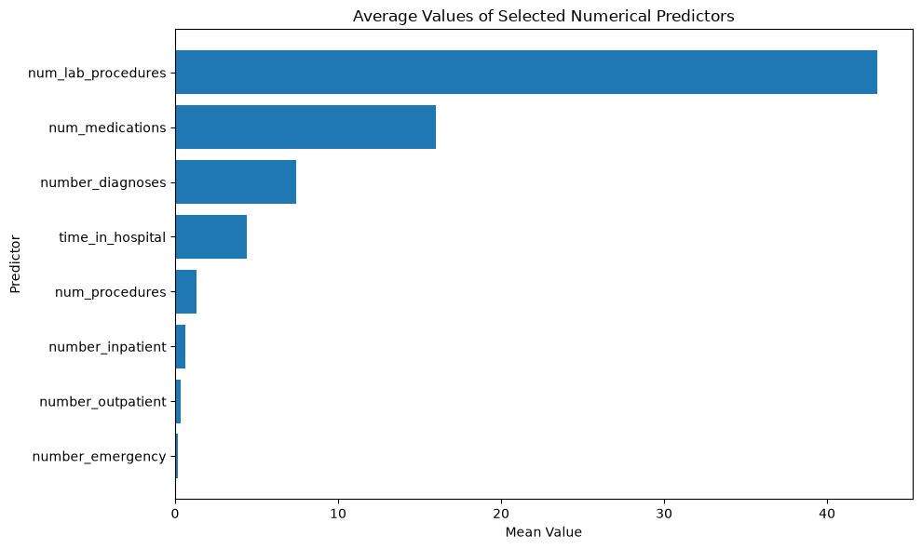
The eight numerical predictors operate on subtantially different scales, for example the average number of laboratory procedures is approximately 43.10, while the average number of emergency visits is approximately 0.20 an the average number of inpatient visits is approximately 0.64, standardization will place the predictors on a common scale before logistic regression and also makes their fitted coefficients more directly comparable in standardized units.
# ============================================================
# 8. Train-Test Split, use stratify to ensure that the target
# variable is represented in both the training and testing datasets.
# ============================================================
X_train, X_test, y_train, y_test = train_test_split(
X,
y,
test_size=0.20,
random_state=42,
stratify=y
)
print("Training Data Shape:", X_train.shape)
print("Testing Data Shape:", X_test.shape)
print("~" * 80)
Training Data Shape: (81412, 8)
Testing Data Shape: (20354, 8)
~~~~~~~~~~~~~~~~~~~~~~~~~~~~~~~~~~~~~~~~~~~~~~~~~~~~~~~~~~~~~~~~~~~~~~~~~~~~~~~~

Logistic Regression Before Feature Scaling

Before standardizing the predictors, I first fit a logistic regression model using the original numerical values. This provides a baseline that can be compared with the scaled model. The same training and testing observations are used for both models so that the comparison is consistent.
# ============================================================
# 9. Logistic Regression Before Feature Scaling
# ============================================================
unscaled_model = LogisticRegression(
max_iter=1000
)
unscaled_model.fit(
X_train,
y_train
)
unscaled_pred = unscaled_model.predict(
X_test
)
unscaled_probability = unscaled_model.predict_proba(
X_test
)[:, 1]
print("Unscaled Logistic Regression Completed.")
# ============================================================
# 10. Evaluate Unscaled Logistic Regression
# ============================================================
from sklearn.metrics import (
precision_score,
recall_score,
f1_score
)
unscaled_accuracy = accuracy_score(y_test,unscaled_pred)
unscaled_precision = precision_score(y_test,unscaled_pred,zero_division=0)
unscaled_recall = recall_score(y_test,unscaled_pred,zero_division=0)
unscaled_f1 = f1_score(y_test,unscaled_pred,zero_division=0)
unscaled_auc = roc_auc_score(y_test,unscaled_probability)
print("Unscaled Logistic Regression Results")
print("Accuracy:", round(unscaled_accuracy, 4))
print("Precision:", round(unscaled_precision, 4))
print("Recall:", round(unscaled_recall, 4))
print("F1:", round(unscaled_f1, 4))
print("ROC-AUC:", round(unscaled_auc, 4))
Unscaled Logistic Regression Completed.
Unscaled Logistic Regression Results
Accuracy: 0.8884
Precision: 0.5
Recall: 0.0145
F1: 0.0282
ROC-AUC: 0.6357

Feature Scaling

The selected predictors have noticeably different numerical ranges. For example, laboratory procedures and medications have much larger average values than emergency or inpatient visit counts. I therefore use StandardScaler after the train-test split. The scaler is fit only on the training data and the same transformation is applied to the test data. This avoids using information from the test set when estimating the scaling parameters.
# ============================================================
# 9. Feature Scaling - Standardization
# ============================================================
scaler = StandardScaler() # as we saw the predictors have different scales, so we will standardize them.
X_train_scaled = scaler.fit_transform(
X_train
)
X_test_scaled = scaler.transform(
X_test
)
print("First 5 Rows Before Standardization:")
display(
X_train.head()
)
print("~" * 150)
print("First 5 Rows After Standardization:")
scaled_df = pd.DataFrame(
X_train_scaled,
columns=features
)
display(
scaled_df.head()
)
print("~" * 150)
# ============================================================
# 10. Verify Standardization
# ============================================================
print("Mean After Standardization:")
display(
scaled_df.mean().round(3)
)
print("~" * 80)
print("Standard Deviation After Standardization:")
display(
scaled_df.std().round(3)
)
print("~" * 80)
First 5 Rows Before Standardization:
time_in_hospital num_lab_procedures num_procedures num_medications \
46943 11 45 1 18
60886 1 32 4 15
34417 5 46 2 16
57371 1 36 0 11
19626 10 54 3 16
number_outpatient number_emergency number_inpatient number_diagnoses
46943 0 0 0 9
60886 2 0 0 5
34417 0 0 0 5
57371 0 0 0 4
19626 0 0 0 7
~~~~~~~~~~~~~~~~~~~~~~~~~~~~~~~~~~~~~~~~~~~~~~~~~~~~~~~~~~~~~~~~~~~~~~~~~~~~~~~~~~~~~~~~~~~~~~~~~~~~~~~~~~~~~~~~~~~~~~~~~~~~~~~~~~~~~~~~~~~~~~~~~~~~~~
First 5 Rows After Standardization:
time_in_hospital num_lab_procedures num_procedures num_medications \
0 2.211912 0.096863 -0.198173 0.243726
1 -1.135963 -0.563264 1.563785 -0.125745
2 0.203187 0.147642 0.389146 -0.002588
3 -1.135963 -0.360148 -0.785492 -0.618374
4 1.877125 0.553874 0.976466 -0.002588
number_outpatient number_emergency number_inpatient number_diagnoses
0 -0.291734 -0.207009 -0.50194 0.816428
1 1.285124 -0.207009 -0.50194 -1.253954
2 -0.291734 -0.207009 -0.50194 -1.253954
3 -0.291734 -0.207009 -0.50194 -1.771549
4 -0.291734 -0.207009 -0.50194 -0.218763
~~~~~~~~~~~~~~~~~~~~~~~~~~~~~~~~~~~~~~~~~~~~~~~~~~~~~~~~~~~~~~~~~~~~~~~~~~~~~~~~~~~~~~~~~~~~~~~~~~~~~~~~~~~~~~~~~~~~~~~~~~~~~~~~~~~~~~~~~~~~~~~~~~~~~~
Mean After Standardization:
time_in_hospital 0.0
num_lab_procedures -0.0
num_procedures 0.0
num_medications 0.0
number_outpatient 0.0
number_emergency 0.0
number_inpatient -0.0
number_diagnoses 0.0
dtype: float64
~~~~~~~~~~~~~~~~~~~~~~~~~~~~~~~~~~~~~~~~~~~~~~~~~~~~~~~~~~~~~~~~~~~~~~~~~~~~~~~~
Standard Deviation After Standardization:
time_in_hospital 1.0
num_lab_procedures 1.0
num_procedures 1.0
num_medications 1.0
number_outpatient 1.0
number_emergency 1.0
number_inpatient 1.0
number_diagnoses 1.0
dtype: float64
~~~~~~~~~~~~~~~~~~~~~~~~~~~~~~~~~~~~~~~~~~~~~~~~~~~~~~~~~~~~~~~~~~~~~~~~~~~~~~~~

After applying StandardScaler, all eight predictors have means approximately equal to 0 and standard deviations approximately equal to 1. This confirms that standardization was performed correctly, because now the predictors expressed in standardized units, the logistic regression coefficients can subsequently be compared in terms of approximately one-standard-deviation changes.
# ============================================================
# 11. Logistic Regression
# ============================================================
log_model = LogisticRegression(
max_iter=1000
)
log_model.fit(
X_train_scaled,
y_train
)
print("Logistic Regression Model Completed.")
print("~" * 80)
Logistic Regression Model Completed.
~~~~~~~~~~~~~~~~~~~~~~~~~~~~~~~~~~~~~~~~~~~~~~~~~~~~~~~~~~~~~~~~~~~~~~~~~~~~~~~~
# ==============================================================================
# 12. Make Predictions
# The predict () returns the predicted class of 0 or 1,
# while the predict_proba () returns estimated probability of 30-day readmission.
# ===============================================================================
y_pred = log_model.predict(
X_test_scaled
)
y_probability = log_model.predict_proba(
X_test_scaled
)[:, 1]
print("First 10 Predicted Classes:")
print(y_pred[:10])
print()
print("~" * 80)
print("First 10 Predicted Probabilities:")
print(
y_probability[:10]
)
print("~" * 80)
First 10 Predicted Classes:
[0 0 0 0 0 0 0 0 0 0]
~~~~~~~~~~~~~~~~~~~~~~~~~~~~~~~~~~~~~~~~~~~~~~~~~~~~~~~~~~~~~~~~~~~~~~~~~~~~~~~~
First 10 Predicted Probabilities:
[0.12606709 0.08938551 0.10401519 0.13298433 0.11626062 0.08168732
0.07646415 0.07423178 0.28302741 0.1614616 ]
~~~~~~~~~~~~~~~~~~~~~~~~~~~~~~~~~~~~~~~~~~~~~~~~~~~~~~~~~~~~~~~~~~~~~~~~~~~~~~~~
# ============================================================
# 13. Model Evaluation
# ============================================================
accuracy = accuracy_score(y_test, y_pred)
auc = roc_auc_score(y_test, y_probability)
print("Accuracy:", round(accuracy, 4))
print("ROC-AUC:", round(auc, 4))
print("\nConfusion Matrix:")
print(confusion_matrix(y_test, y_pred))
print("\nClassification Report:")
print(classification_report(y_test, y_pred, zero_division=0))
# Confusion Matrix
cm = confusion_matrix(y_test, y_pred)
disp = ConfusionMatrixDisplay(
confusion_matrix=cm,
display_labels=["Not Readmitted", "Readmitted"]
)
disp.plot(cmap="Blues", values_format="d")
plt.title("Logistic Regression Confusion Matrix")
plt.tight_layout()
plt.show()
Accuracy: 0.8884
ROC-AUC: 0.6357
Confusion Matrix:
[[18050 33]
[ 2238 33]]
Classification Report:
precision recall f1-score support
0 0.89 1.00 0.94 18083
1 0.50 0.01 0.03 2271
accuracy 0.89 20354
macro avg 0.69 0.51 0.48 20354
weighted avg 0.85 0.89 0.84 20354
<Figure size 640x480 with 2 Axes>
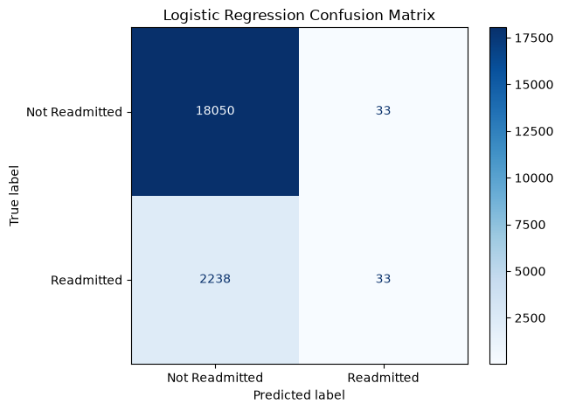

Impression

The 88.84% accuracy looks strong but the model is doing a poor job in identifying patients who are re-admitted within 30 days. The target is also clearly imbalanced with Class 0 has 18083 patients and Class 1 2271 patients, so roughly 89% of test observations are class 0, so the model achieves high accuracy largely by predicting almost everyone as not readmitted Looking at the confusion matrix, the model correctly identified 18050 non-readmitted patients, but correctly identified only 33 of 2271 patients who were readmitted within 30 days.

The class 1 recall of 0.01 is the biggest concern, that indicates the mdoel detects only 1% of the actual 30-day readmissions.

The ROC-AUC of 0.6357 provides an important contrast. Although the model preforms poorly when classifications are made at the default 0.50 threshold, its predicted probabilities still contain some ability to rank patients according to readmission risk. This suggests that the problem is partly related to the decision threshold and severe class imbalance, rather than the model containing no predictive information at all.
# ============================================================
# 14. Logistic Regression Coefficients
# ============================================================
coefficient_df = pd.DataFrame({
"Feature": features,
"Coefficient": log_model.coef_[0]
})
coefficient_df["Odds_Ratio"] = np.exp(
coefficient_df["Coefficient"]
)
coefficient_df["Absolute_Coefficient"] = abs(
coefficient_df["Coefficient"]
)
coefficient_df = coefficient_df.sort_values(
"Absolute_Coefficient",
ascending=False
)
display(
coefficient_df.round(4)
)
print("~" * 80)
Feature Coefficient Odds_Ratio Absolute_Coefficient
6 number_inpatient 0.3389 1.4034 0.3389
7 number_diagnoses 0.0946 1.0992 0.0946
0 time_in_hospital 0.0713 1.0739 0.0713
3 num_medications 0.0552 1.0568 0.0552
2 num_procedures -0.0442 0.9568 0.0442
5 number_emergency 0.0254 1.0257 0.0254
4 number_outpatient -0.0027 0.9973 0.0027
1 num_lab_procedures -0.0012 0.9988 0.0012
~~~~~~~~~~~~~~~~~~~~~~~~~~~~~~~~~~~~~~~~~~~~~~~~~~~~~~~~~~~~~~~~~~~~~~~~~~~~~~~~
#### Given we standardized the predictors, the coefficient can be interpreted for approximately a one standard deviation increase in each predictor. A positive coefficient indicates higher modeleded odds of 30-day readmission, while a negative coefficient indicates lower modeled odds, holding the other included variables as constant.

#### Impression: Among the eight standardized numerical predictors, number_inpatient has the strongest association with 30 day readmission with a co-efficient of 0.3389 and odds ration of 1.4034, this indicates that a one-standard-deviation increase in prior inpatient visits was associated with approximately 40% higher modeled odds of readmission within 30 days, holding the other predictors constant. number_diagnoses, time_in_hospital and num_medications also showed positive associations with readmission. In contrast, num_procedures had a small negative coefficient, the number_outpatient and num_lab_procedures had coefficients close to 0.
# ============================================================
# 15. Actual vs Predicted Results
# ============================================================
results_df = pd.DataFrame({
"Actual_Readmission": y_test.values,
"Predicted_Readmission": y_pred,
"Predicted_Probability": y_probability
})
display(
results_df.head(15)
)
print("~" * 80)
# Predicted vs Actual Readmission status
probability_df = pd.DataFrame({
"Actual_Readmission": y_test.values,
"Predicted_Probability": y_probability
})
not_readmitted_probability = probability_df[
probability_df["Actual_Readmission"] == 0
]["Predicted_Probability"]
readmitted_probability = probability_df[
probability_df["Actual_Readmission"] == 1
]["Predicted_Probability"]
plt.figure(figsize=(10, 6))
plt.hist(
not_readmitted_probability,
bins=30,
alpha=0.6,
label="Not Readmitted"
)
plt.hist(
readmitted_probability,
bins=30,
alpha=0.6,
label="Readmitted Within 30 Days"
)
plt.axvline(
x=0.50,
linestyle="--",
label="Default Threshold = 0.50"
)
plt.title(
"Predicted Readmission Probability by Actual Outcome"
)
plt.xlabel(
"Predicted Probability of 30-Day Readmission"
)
plt.ylabel(
"Number of Encounters"
)
plt.legend()
plt.tight_layout()
plt.show()
Actual_Readmission Predicted_Readmission Predicted_Probability
0 0 0 0.126067
1 0 0 0.089386
2 0 0 0.104015
3 1 0 0.132984
4 1 0 0.116261
5 0 0 0.081687
6 0 0 0.076464
7 0 0 0.074232
8 0 0 0.283027
9 0 0 0.161462
10 0 0 0.079904
11 0 0 0.162392
12 0 0 0.083753
13 0 0 0.097127
14 0 0 0.090109
~~~~~~~~~~~~~~~~~~~~~~~~~~~~~~~~~~~~~~~~~~~~~~~~~~~~~~~~~~~~~~~~~~~~~~~~~~~~~~~~
<Figure size 1000x600 with 1 Axes>
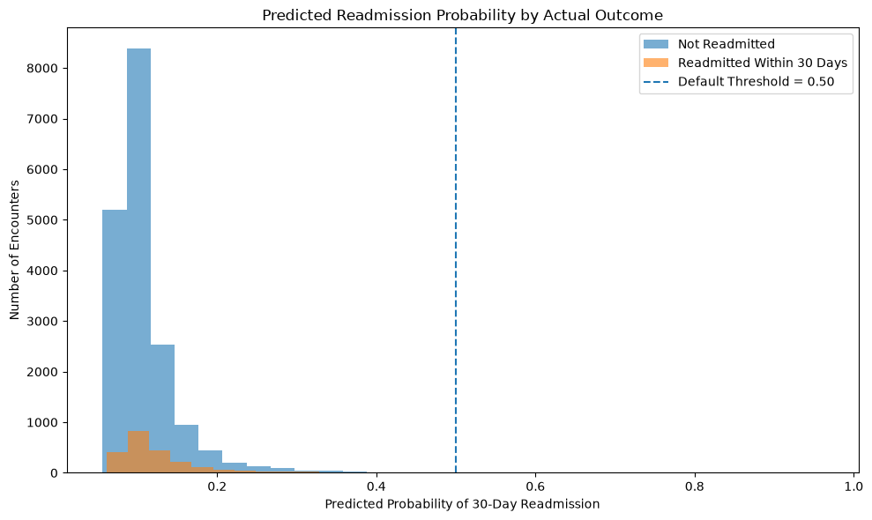

The Probability distribution help explain why the model produces so few positive classifications, Most predicted probabilities remain below the threshold of 0.50, including probabilities for many patients who were actually readmitted. Although the distribution may show some seperation between the two classes, their overlap is substantial. This is consistent with the moderate ROC-AUC of 0.6357 and extremely low class 1 recall at the default threshold.

Compare Logistic Regression Before and After Scaling

The following table compares the unscaled and standardized logistic regression models using the same test observations. Accuracy is included, but because the positive readmission class is uncommon, precision, recall, F1, ROC-AUC, and the confusion matrix are more informative for evaluating the model.
# ============================================================
# Compare Unscaled and Scaled Logistic Regression
# ============================================================
scaled_precision = precision_score(
y_test,
y_pred,
zero_division=0
)
scaled_recall = recall_score(
y_test,
y_pred,
zero_division=0
)
scaled_f1 = f1_score(
y_test,
y_pred,
zero_division=0
)
comparison_df = pd.DataFrame({
"Model": [
"Logistic Regression - Unscaled",
"Logistic Regression - Standardized"
],
"Accuracy": [
unscaled_accuracy,
accuracy
],
"Precision": [
unscaled_precision,
scaled_precision
],
"Recall": [
unscaled_recall,
scaled_recall
],
"F1": [
unscaled_f1,
scaled_f1
],
"ROC_AUC": [
unscaled_auc,
auc
]
})
display(
comparison_df.round(4)
)
Model Accuracy Precision Recall F1 \
0 Logistic Regression - Unscaled 0.8884 0.5 0.0145 0.0282
1 Logistic Regression - Standardized 0.8884 0.5 0.0145 0.0282
ROC_AUC
0 0.6357
1 0.6357
# ============================================================
# Visual Comparison of Classification Metrics
# ============================================================
comparison_plot = comparison_df.set_index("Model")[
["Precision", "Recall", "F1", "ROC_AUC"]
]
comparison_plot.T.plot(
kind="bar",
figsize=(10, 6)
)
plt.title(
"Logistic Regression Before and After Feature Scaling"
)
plt.xlabel(
"Evaluation Metric"
)
plt.ylabel(
"Score"
)
plt.xticks(
rotation=0
)
plt.legend(
title="Model"
)
plt.tight_layout()
plt.show()
<Figure size 1000x600 with 1 Axes>
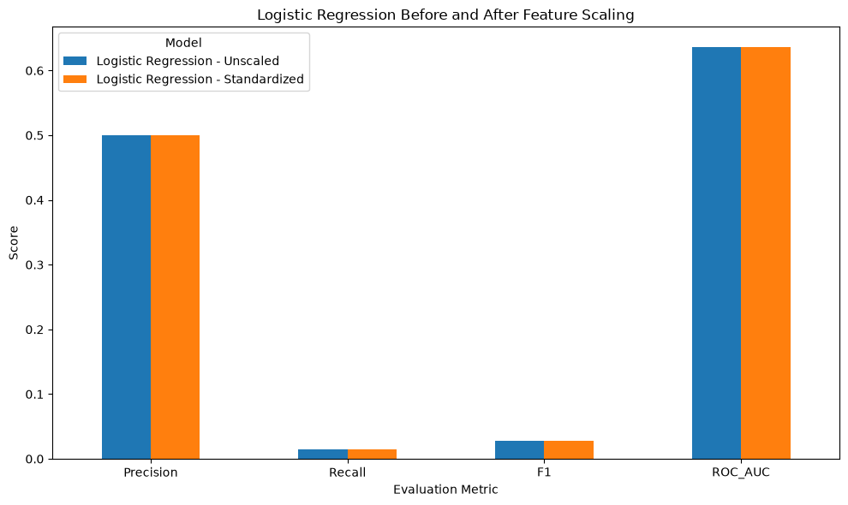

Week 4 Summary and Interpretation

Logistic regression was used to predict 30-day hospital readmission from eight numerical hospital-utilization predictors. The binary outcome was strongly imbalanced: **11.16%** of encounters were readmitted within 30 days, while **88.84%** were not. Because of this imbalance, accuracy alone was not sufficient to judge model performance.

For the standardized logistic regression model, accuracy was **0.8884** and ROC-AUC was **0.6357**. The confusion matrix was [[18050, 33], [2238, 33]]. Although the accuracy appeared high, the model correctly identified only **33 of 2,271** actual 30-day readmissions. Class 1 recall was therefore approximately **0.01** and F1 approximately **0.03**. This shows that the model predicted the majority class very well but performed poorly at identifying the minority readmission class at the default 0.50 threshold.

Feature scaling was performed using StandardScaler. The scaler was fit only on the training predictors and the same transformation was then applied to the test predictors. After standardization, each training predictor had a mean approximately equal to 0 and a standard deviation approximately equal to 1. However, standardization did not materially change predictive performance. The unscaled and standardized logistic regression models produced the same rounded accuracy (0.8884), precision (0.5000), recall (0.0145), F1 (0.0282), and ROC-AUC (0.6357). This was an important finding because it showed that although scaling placed the predictors on a common scale and made the standardized coefficients easier to compare, it did not improve classification performance for this dataset.

Among the standardized predictors, number_inpatient had the largest absolute logistic regression coefficient (**0.3389**) and an odds ratio of approximately **1.4034**. Because the predictors were standardized, a one-standard-deviation increase in prior inpatient visits was associated with approximately **40.3% higher modeled odds** of 30-day readmission, holding the other included predictors constant. This is an association within the fitted model and should not be interpreted as a causal effect.

I used a stratified **80/20 train-test split** so that the readmission-class proportions were maintained in both sets and the final model could be evaluated on observations not used for fitting. The same split was used for the unscaled and scaled models, making their test results directly comparable. I didn't do any hyperparameter tuning; the main purpose is to understand logistic regression, feature scaling, class imbalance, and appropriate classification metrics.

I expected the hospital-utilization variables to contain some information about readmission risk, and the ROC-AUC of **0.6357** supports modest ranking ability. The most unexpected finding was that **88.84% accuracy did not represent strong classification performance**. The model missed approximately **98.5%** of actual 30-day readmissions at the default threshold. This demonstrates why recall, F1, ROC-AUC, predicted probabilities, and the confusion matrix are more informative than accuracy alone for this imbalanced healthcare outcome.

Week 5
Week-5-Submission-Health-SVM-Notebook(1).ipynb

Week 5 - Support Vector Machines, Kernel Trick, and Regularization

**Dataset:** BRFSS 2015 Diabetes Health Indicators

The overall project examines diabetes-related outcomes using two healthcare datasets. Weeks 1 and 3 used the BRFSS dataset to explore BMI with regression methods, while Weeks 2 and 4 used the hospital dataset to study hospital outcomes. Week 5 returns to the BRFSS dataset and directly uses Diabetes_binary as the classification target.

The Week 5 question is: **Can selected health indicators distinguish individuals with diabetes from those without diabetes, and do nonlinear SVM kernels or different levels of SVM regularization improve classification performance?**

This analysis applies three Week 5 concepts: a support vector machine, the kernel trick through linear, polynomial, and RBF kernels, and SVM regularization through different values of the `C` parameter.
# ============================================================
# Import Libraries
# ============================================================
import pandas as pd
import numpy as np
import matplotlib.pyplot as plt
from sklearn.model_selection import train_test_split
from sklearn.preprocessing import StandardScaler
from sklearn.svm import LinearSVC
from sklearn.svm import SVC
from sklearn.metrics import (
accuracy_score,
precision_score,
recall_score,
f1_score,
confusion_matrix,
classification_report,
roc_auc_score
)
pd.set_option("display.max_columns", None)
print("Libraries imported successfully.")
print("~" * 80)
Libraries imported successfully.
~~~~~~~~~~~~~~~~~~~~~~~~~~~~~~~~~~~~~~~~~~~~~~~~~~~~~~~~~~~~~~~~~~~~~~~~~~~~~~~~
Load the dataset, the BRFSS 2015 Diabetes health indicators dataset contains health conditions, health behaviours, the healthcare access measures and demographic characteristics. Diabetes_binary is used as the binary target variable.
# Load the Health dataset
health_url = (
"https://raw.githubusercontent.com/jeganart/"
"healthdatasetmilestone3/refs/heads/main/"
"diabetes_binary_health_indicators_BRFSS2015.csv"
)
health_df = pd.read_csv(
health_url
)
print("Dataset Shape:")
print(
health_df.shape
)
print("~" * 80)
print("First 5 Rows:")
display(
health_df.head()
)
print("~" * 80)
Dataset Shape:
(253680, 22)
~~~~~~~~~~~~~~~~~~~~~~~~~~~~~~~~~~~~~~~~~~~~~~~~~~~~~~~~~~~~~~~~~~~~~~~~~~~~~~~~
First 5 Rows:
Diabetes_binary HighBP HighChol CholCheck BMI Smoker Stroke \
0 0.0 1.0 1.0 1.0 40.0 1.0 0.0
1 0.0 0.0 0.0 0.0 25.0 1.0 0.0
2 0.0 1.0 1.0 1.0 28.0 0.0 0.0
3 0.0 1.0 0.0 1.0 27.0 0.0 0.0
4 0.0 1.0 1.0 1.0 24.0 0.0 0.0
HeartDiseaseorAttack PhysActivity Fruits Veggies HvyAlcoholConsump \
0 0.0 0.0 0.0 1.0 0.0
1 0.0 1.0 0.0 0.0 0.0
2 0.0 0.0 1.0 0.0 0.0
3 0.0 1.0 1.0 1.0 0.0
4 0.0 1.0 1.0 1.0 0.0
AnyHealthcare NoDocbcCost GenHlth MentHlth PhysHlth DiffWalk Sex \
0 1.0 0.0 5.0 18.0 15.0 1.0 0.0
1 0.0 1.0 3.0 0.0 0.0 0.0 0.0
2 1.0 1.0 5.0 30.0 30.0 1.0 0.0
3 1.0 0.0 2.0 0.0 0.0 0.0 0.0
4 1.0 0.0 2.0 3.0 0.0 0.0 0.0
Age Education Income
0 9.0 4.0 3.0
1 7.0 6.0 1.0
2 9.0 4.0 8.0
3 11.0 3.0 6.0
4 11.0 5.0 4.0
~~~~~~~~~~~~~~~~~~~~~~~~~~~~~~~~~~~~~~~~~~~~~~~~~~~~~~~~~~~~~~~~~~~~~~~~~~~~~~~~
# ============================================================
# Explore Health Dataset
# ============================================================
print("Dataset Information:")
health_df.info()
print("~" * 80)
print("Missing Values:")
display(
health_df.isnull()
.sum()
.sort_values(ascending=False)
)
print("~" * 80)
print("Target Distribution:")
display(
health_df["Diabetes_binary"]
.value_counts()
.sort_index()
)
print("~" * 80)
print("Target Percentage:")
display(
(
health_df["Diabetes_binary"]
.value_counts(normalize=True)
.sort_index() * 100
).round(2)
)
print("~" * 80)
Dataset Information:
<class 'pandas.core.frame.DataFrame'>
RangeIndex: 253680 entries, 0 to 253679
Data columns (total 22 columns):
# Column Non-Null Count Dtype
--- ------ -------------- -----
0 Diabetes_binary 253680 non-null float64
1 HighBP 253680 non-null float64
2 HighChol 253680 non-null float64
3 CholCheck 253680 non-null float64
4 BMI 253680 non-null float64
5 Smoker 253680 non-null float64
6 Stroke 253680 non-null float64
7 HeartDiseaseorAttack 253680 non-null float64
8 PhysActivity 253680 non-null float64
9 Fruits 253680 non-null float64
10 Veggies 253680 non-null float64
11 HvyAlcoholConsump 253680 non-null float64
12 AnyHealthcare 253680 non-null float64
13 NoDocbcCost 253680 non-null float64
14 GenHlth 253680 non-null float64
15 MentHlth 253680 non-null float64
16 PhysHlth 253680 non-null float64
17 DiffWalk 253680 non-null float64
18 Sex 253680 non-null float64
19 Age 253680 non-null float64
20 Education 253680 non-null float64
21 Income 253680 non-null float64
dtypes: float64(22)
memory usage: 42.6 MB
~~~~~~~~~~~~~~~~~~~~~~~~~~~~~~~~~~~~~~~~~~~~~~~~~~~~~~~~~~~~~~~~~~~~~~~~~~~~~~~~
Missing Values:
Diabetes_binary 0
HighBP 0
Education 0
Age 0
Sex 0
DiffWalk 0
PhysHlth 0
MentHlth 0
GenHlth 0
NoDocbcCost 0
AnyHealthcare 0
HvyAlcoholConsump 0
Veggies 0
Fruits 0
PhysActivity 0
HeartDiseaseorAttack 0
Stroke 0
Smoker 0
BMI 0
CholCheck 0
HighChol 0
Income 0
dtype: int64
~~~~~~~~~~~~~~~~~~~~~~~~~~~~~~~~~~~~~~~~~~~~~~~~~~~~~~~~~~~~~~~~~~~~~~~~~~~~~~~~
Target Distribution:
Diabetes_binary
0.0 218334
1.0 35346
Name: count, dtype: int64
~~~~~~~~~~~~~~~~~~~~~~~~~~~~~~~~~~~~~~~~~~~~~~~~~~~~~~~~~~~~~~~~~~~~~~~~~~~~~~~~
Target Percentage:
Diabetes_binary
0.0 86.07
1.0 13.93
Name: proportion, dtype: float64
~~~~~~~~~~~~~~~~~~~~~~~~~~~~~~~~~~~~~~~~~~~~~~~~~~~~~~~~~~~~~~~~~~~~~~~~~~~~~~~~
# ============================================================
# Diabetes Class Distribution
# ============================================================
health_class_counts = (
health_df["Diabetes_binary"]
.value_counts()
.sort_index()
)
health_class_counts.index = [
"No Diabetes",
"Diabetes"
]
plt.figure(figsize=(8, 5))
health_class_counts.plot(
kind="bar"
)
plt.title("BRFSS Dataset - Diabetes Class Distribution")
plt.xlabel("Diabetes Status")
plt.ylabel("Number of Observations")
plt.xticks(rotation=0)
plt.tight_layout()
plt.show()
<Figure size 800x500 with 1 Axes>
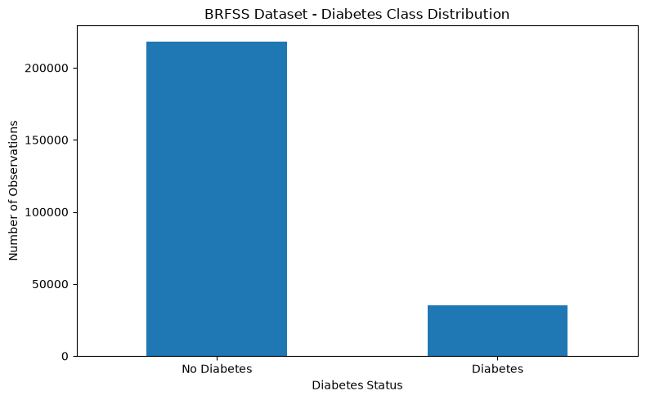
#### The target distribution is imbalanced and unequal class sizes can make accuracy misleading, given the non diabetes class substantially outnumbers the diabetes class, the model may achieve high accuracy while still performing poorly at identifying individuals with diabetes, therefore, recall, F1 score and ROC-AUC will be considered.
# ============================================================
# Target and Predictor variables
# ============================================================
health_target = "Diabetes_binary"
health_features = [
"HighBP",
"HighChol",
"BMI",
"Smoker",
"HeartDiseaseorAttack",
"PhysActivity",
"GenHlth",
"Age"
]
health_model_df = health_df[
health_features + [health_target]
].dropna().copy()
X_health = health_model_df[
health_features
]
y_health = health_model_df[
health_target
]
print("Selected Predictors:")
for feature in health_features:
print(feature)
print("~" * 80)
print("Modeling Dataset Shape:")
print(
health_model_df.shape
)
print("~" * 120)
display(
X_health.describe().round(2)
)
print("~" * 120)
Selected Predictors:
HighBP
HighChol
BMI
Smoker
HeartDiseaseorAttack
PhysActivity
GenHlth
Age
~~~~~~~~~~~~~~~~~~~~~~~~~~~~~~~~~~~~~~~~~~~~~~~~~~~~~~~~~~~~~~~~~~~~~~~~~~~~~~~~
Modeling Dataset Shape:
(253680, 9)
~~~~~~~~~~~~~~~~~~~~~~~~~~~~~~~~~~~~~~~~~~~~~~~~~~~~~~~~~~~~~~~~~~~~~~~~~~~~~~~~~~~~~~~~~~~~~~~~~~~~~~~~~~~~~~~~~~~~~~~~
HighBP HighChol BMI Smoker HeartDiseaseorAttack \
count 253680.00 253680.00 253680.00 253680.00 253680.00
mean 0.43 0.42 28.38 0.44 0.09
std 0.49 0.49 6.61 0.50 0.29
min 0.00 0.00 12.00 0.00 0.00
25% 0.00 0.00 24.00 0.00 0.00
50% 0.00 0.00 27.00 0.00 0.00
75% 1.00 1.00 31.00 1.00 0.00
max 1.00 1.00 98.00 1.00 1.00
PhysActivity GenHlth Age
count 253680.00 253680.00 253680.00
mean 0.76 2.51 8.03
std 0.43 1.07 3.05
min 0.00 1.00 1.00
25% 1.00 2.00 6.00
50% 1.00 2.00 8.00
75% 1.00 3.00 10.00
max 1.00 5.00 13.00
~~~~~~~~~~~~~~~~~~~~~~~~~~~~~~~~~~~~~~~~~~~~~~~~~~~~~~~~~~~~~~~~~~~~~~~~~~~~~~~~~~~~~~~~~~~~~~~~~~~~~~~~~~~~~~~~~~~~~~~~
#### we selected 8 predictors to keep the SVM analysis interpretable while representing several dimensions of health. The predictors include high blood pressure, high cholestral, BMI, smoking, heart disease or heart attack history, physical activity, general health and age. Diabetes_binary is the classification target.
# ============================================================
# Train-Test Split
# ============================================================
# The data is divided into 80% training and 20% testing sets,
# stratification preserves approximately the same diabetes class distribution in both datasets, as the target variable is imbalanced.
X_health_train, X_health_test, y_health_train, y_health_test = train_test_split(
X_health,
y_health,
test_size=0.20,
random_state=42,
stratify=y_health
)
print("Training Data Shape:")
print(
X_health_train.shape
)
print()
print("Testing Data Shape:")
print(
X_health_test.shape
)
print()
print("Training Target Percentage:")
display(
(
y_health_train
.value_counts(normalize=True)
.sort_index() * 100
).round(2)
)
print("~" * 80)
Training Data Shape:
(202944, 8)
Testing Data Shape:
(50736, 8)
Training Target Percentage:
Diabetes_binary
0.0 86.07
1.0 13.93
Name: proportion, dtype: float64
~~~~~~~~~~~~~~~~~~~~~~~~~~~~~~~~~~~~~~~~~~~~~~~~~~~~~~~~~~~~~~~~~~~~~~~~~~~~~~~~
# ============================================================
# Feature Scaling
# ============================================================
health_scaler = StandardScaler()
X_health_train_scaled = health_scaler.fit_transform(
X_health_train
)
X_health_test_scaled = health_scaler.transform(
X_health_test
)
health_scaled_df = pd.DataFrame(
X_health_train_scaled,
columns=health_features
)
print("Before Standardization:")
display(
X_health_train.head()
)
print("~" * 80)
print("After Standardization:")
display(
health_scaled_df.head()
)
print("~" * 80)
print("Mean After Standardization:")
display(
health_scaled_df.mean().round(3)
)
print("~" * 80)
print("Standard Deviation After Standardization:")
display(
health_scaled_df.std().round(3)
)
print("~" * 80)
Before Standardization:
HighBP HighChol BMI Smoker HeartDiseaseorAttack PhysActivity \
153147 0.0 0.0 28.0 1.0 0.0 1.0
176137 1.0 0.0 23.0 1.0 0.0 1.0
175578 1.0 1.0 29.0 0.0 0.0 1.0
177887 1.0 1.0 39.0 0.0 0.0 0.0
182143 0.0 1.0 16.0 1.0 0.0 1.0
GenHlth Age
153147 2.0 2.0
176137 2.0 13.0
175578 1.0 9.0
177887 4.0 7.0
182143 5.0 7.0
~~~~~~~~~~~~~~~~~~~~~~~~~~~~~~~~~~~~~~~~~~~~~~~~~~~~~~~~~~~~~~~~~~~~~~~~~~~~~~~~
After Standardization:
HighBP HighChol BMI Smoker HeartDiseaseorAttack PhysActivity \
0 -0.866775 -0.858504 -0.057282 1.121626 -0.322575 0.566584
1 1.153702 -0.858504 -0.815055 1.121626 -0.322575 0.566584
2 1.153702 1.164817 0.094273 -0.891563 -0.322575 0.566584
3 1.153702 1.164817 1.609820 -0.891563 -0.322575 -1.764962
4 -0.866775 1.164817 -1.875938 1.121626 -0.322575 0.566584
GenHlth Age
0 -0.479079 -1.977081
1 -0.479079 1.627845
2 -1.415079 0.316963
3 1.392923 -0.338479
4 2.328923 -0.338479
~~~~~~~~~~~~~~~~~~~~~~~~~~~~~~~~~~~~~~~~~~~~~~~~~~~~~~~~~~~~~~~~~~~~~~~~~~~~~~~~
Mean After Standardization:
HighBP -0.0
HighChol -0.0
BMI 0.0
Smoker 0.0
HeartDiseaseorAttack -0.0
PhysActivity 0.0
GenHlth 0.0
Age -0.0
dtype: float64
~~~~~~~~~~~~~~~~~~~~~~~~~~~~~~~~~~~~~~~~~~~~~~~~~~~~~~~~~~~~~~~~~~~~~~~~~~~~~~~~
Standard Deviation After Standardization:
HighBP 1.0
HighChol 1.0
BMI 1.0
Smoker 1.0
HeartDiseaseorAttack 1.0
PhysActivity 1.0
GenHlth 1.0
Age 1.0
dtype: float64
~~~~~~~~~~~~~~~~~~~~~~~~~~~~~~~~~~~~~~~~~~~~~~~~~~~~~~~~~~~~~~~~~~~~~~~~~~~~~~~~
SVM Models are sensitive to the scale of predictor variables because the algorithm uses distance and margins when constructing the decision boundary. StandardScaler transforms each predictor so that it is centered approximately around zero with a standard deviation of approximately one.
# ============================================================
# Feature Scaling Comparison
# ============================================================
scaling_features = [
"BMI",
"GenHlth",
"Age"
]
before_scaling = (
X_health_train[
scaling_features
]
.abs()
.mean()
)
after_scaling = (
health_scaled_df[
scaling_features
]
.abs()
.mean()
)
scaling_comparison = pd.DataFrame({
"Before Scaling": before_scaling,
"After Scaling": after_scaling
})
print("Scaling Comparison:")
display(
scaling_comparison.round(3)
)
scaling_comparison.plot(
kind="bar",
figsize=(9, 5)
)
plt.title("Selected Predictors Before and After Standardization")
plt.xlabel("Predictor")
plt.ylabel("Mean Absolute Value")
plt.xticks(rotation=0)
plt.tight_layout()
plt.show()
Scaling Comparison:
Before Scaling After Scaling
BMI 28.378 0.718
GenHlth 2.512 0.842
Age 8.033 0.813
<Figure size 900x500 with 1 Axes>
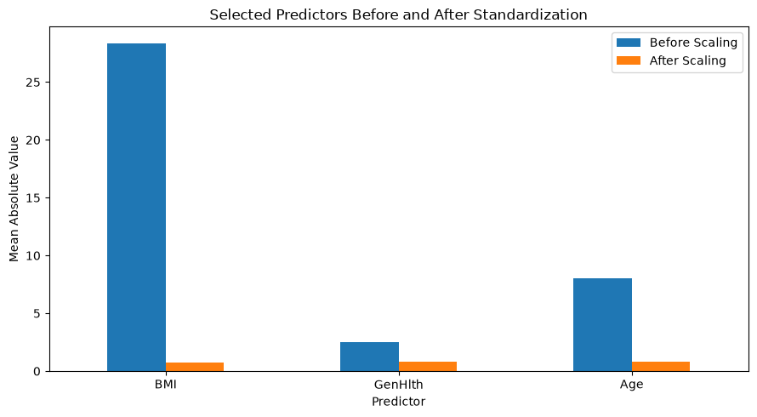
The selected predictors orginally operate on different numerical scales. Standardization places the predictors on comparable scales, preventing variables with larger numerical values from dominating the SVM simply because of their measurement scale.
#### Linear SVM

#### A Linear SVM attempts to identify a hyperplane that seperates the two diabetes classes while maximizing the margin between them, becuase the target class in imbalanced, class_weight="balanced" is used so the minority diabetes class receives greater weight during model fitting.
# ============================================================
# Linear Support Vector Machine
# ============================================================
health_linear_svm = LinearSVC(
C=1.0,
class_weight="balanced",
random_state=42,
max_iter=10000
)
health_linear_svm.fit(
X_health_train_scaled,
y_health_train
)
health_linear_pred = health_linear_svm.predict(
X_health_test_scaled
)
health_linear_score = health_linear_svm.decision_function(
X_health_test_scaled
)
print("Linear SVM Model Completed.")
print("~" * 80)
Linear SVM Model Completed.
~~~~~~~~~~~~~~~~~~~~~~~~~~~~~~~~~~~~~~~~~~~~~~~~~~~~~~~~~~~~~~~~~~~~~~~~~~~~~~~~
# ============================================================
# Evaluate Linear SVM
# ============================================================
linear_accuracy = accuracy_score(y_health_test, health_linear_pred)
linear_precision = precision_score(y_health_test, health_linear_pred)
linear_recall = recall_score(y_health_test, health_linear_pred)
linear_f1 = f1_score(y_health_test, health_linear_pred)
linear_auc = roc_auc_score(y_health_test, health_linear_score)
print("LINEAR SVM RESULTS")
print("Accuracy:", round(linear_accuracy, 4))
print("Precision:", round(linear_precision, 4))
print("Recall:", round(linear_recall, 4))
print("F1 Score:", round(linear_f1, 4))
print("ROC-AUC:", round(linear_auc, 4))
print("\nConfusion Matrix:")
print(confusion_matrix(y_health_test, health_linear_pred))
print("\nClassification Report:")
print(classification_report(y_health_test, health_linear_pred, zero_division=0))
LINEAR SVM RESULTS
Accuracy: 0.7224
Precision: 0.3032
Recall: 0.764
F1 Score: 0.4341
ROC-AUC: 0.8138
Confusion Matrix:
[[31252 12415]
[ 1668 5401]]
Classification Report:
precision recall f1-score support
0.0 0.95 0.72 0.82 43667
1.0 0.30 0.76 0.43 7069
accuracy 0.72 50736
macro avg 0.63 0.74 0.63 50736
weighted avg 0.86 0.72 0.76 50736
#### The linear SVM achieved an accuracy of 72.24% and ROC-AUC of 0.8138, indicating good overall ability to distinguish between individuals with and without diabetes. The model achieved a relatively high recall of 76.4% meaning that it correctly identified approximately three fourths of the actual diabetes cases. However the precision was considerably lower at 30.32%, indicating that many individuals predicted as having diabetes were actually non-diaetes. This produced an F1 score of 0.4331. Because the diabetes outcome is imbalanced, the high recall is particularly important and demonstrates why accuracy alone should not be used to evaluate this model.

#### Overall the Linear SVM favors sensitivity to diabetes cases over precision, identifying a large proportion of actual diabetes cases at the cost of more false-positive classifications.
# ============================================================
# Linear SVM Coefficients
# ============================================================
svm_coefficient_df = pd.DataFrame({
"Feature": health_features,
"Coefficient": health_linear_svm.coef_[0]
})
svm_coefficient_df["Absolute_Coefficient"] = abs(
svm_coefficient_df["Coefficient"]
)
svm_coefficient_df = svm_coefficient_df.sort_values(
"Absolute_Coefficient",
ascending=True
)
print("Linear SVM Coefficients:")
display(
svm_coefficient_df.round(4)
)
plt.figure(figsize=(10, 6))
plt.barh(svm_coefficient_df["Feature"], svm_coefficient_df["Coefficient"])
plt.axvline(x=0, linewidth=1)
plt.xlabel("SVM Coefficient")
plt.ylabel("Health Predictor")
plt.title("Linear SVM Coefficients for Diabetes Classification")
plt.tight_layout()
plt.show()
Linear SVM Coefficients:
Feature Coefficient Absolute_Coefficient
3 Smoker 0.0031 0.0031
5 PhysActivity -0.0105 0.0105
4 HeartDiseaseorAttack 0.0378 0.0378
1 HighChol 0.1116 0.1116
0 HighBP 0.1608 0.1608
7 Age 0.1769 0.1769
2 BMI 0.1804 0.1804
6 GenHlth 0.2427 0.2427
<Figure size 1000x600 with 1 Axes>
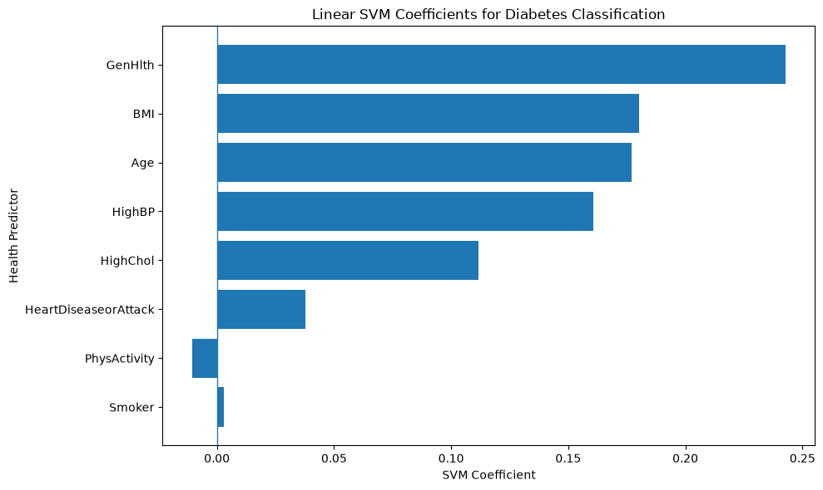
#### The coefficient graph shows how each standardized predictor contributes to the linear SVM decision function. Predictors with larger absolute coefficients have greater influence on the linear decision boundary. Positive and Negative coefficients contribute in opposite directions to the decision score. These coefficients describe the associations within the fitted classification model and should not be interpreted as causal effects.

The kernel Trick

#### A linear SVM creates a linear decision boundary, however as we have seen in the previous milestone and previous week homework the relationships between health characteristics and diabetes may not be completely linear. The kernel trick allows SVM to model more complex boundaries without manually creating all possible nonlinear transformations.

#### We will compare three kernels - Linear, Polynomial and RBF, given the dataset is large we will use stratified sample.
# ============================================================
# Creating Stratified Sample for Kernel SVM
# ============================================================
health_kernel_df, unused_health_df = train_test_split(
health_model_df,
train_size=15000,
random_state=42,
stratify=health_model_df[health_target]
)
X_health_kernel = health_kernel_df[
health_features
]
y_health_kernel = health_kernel_df[
health_target
]
X_hk_train, X_hk_test, y_hk_train, y_hk_test = train_test_split(
X_health_kernel,
y_health_kernel,
test_size=0.20,
random_state=42,
stratify=y_health_kernel
)
kernel_scaler = StandardScaler()
X_hk_train_scaled = kernel_scaler.fit_transform(
X_hk_train
)
X_hk_test_scaled = kernel_scaler.transform(
X_hk_test
)
print("Kernel SVM Sample Shape:")
print(
health_kernel_df.shape
)
print()
print("Kernel Training Shape:")
print(
X_hk_train.shape
)
print()
print("Kernel Testing Shape:")
print(
X_hk_test.shape
)
print("~" * 80)
Kernel SVM Sample Shape:
(15000, 9)
Kernel Training Shape:
(12000, 8)
Kernel Testing Shape:
(3000, 8)
~~~~~~~~~~~~~~~~~~~~~~~~~~~~~~~~~~~~~~~~~~~~~~~~~~~~~~~~~~~~~~~~~~~~~~~~~~~~~~~~
# ============================================================
# Linear Kernel SVM
# ============================================================
health_svm_linear = SVC(
kernel="linear",
C=1.0,
class_weight="balanced"
)
health_svm_linear.fit(
X_hk_train_scaled,
y_hk_train
)
health_pred_linear = health_svm_linear.predict(
X_hk_test_scaled
)
health_score_linear = health_svm_linear.decision_function(
X_hk_test_scaled
)
print("Linear Kernel Completed.")
print("~" * 80)
Linear Kernel Completed.
~~~~~~~~~~~~~~~~~~~~~~~~~~~~~~~~~~~~~~~~~~~~~~~~~~~~~~~~~~~~~~~~~~~~~~~~~~~~~~~~
# ============================================================
# Polynomial Kernel SVM
# ============================================================
health_svm_poly = SVC(
kernel="poly",
degree=2,
C=1.0,
gamma="scale",
class_weight="balanced"
)
health_svm_poly.fit(
X_hk_train_scaled,
y_hk_train
)
health_pred_poly = health_svm_poly.predict(
X_hk_test_scaled
)
health_score_poly = health_svm_poly.decision_function(
X_hk_test_scaled
)
print("Polynomial Kernel Completed.")
print("~" * 80)
Polynomial Kernel Completed.
~~~~~~~~~~~~~~~~~~~~~~~~~~~~~~~~~~~~~~~~~~~~~~~~~~~~~~~~~~~~~~~~~~~~~~~~~~~~~~~~
# ============================================================
# RBF Kernel SVM
# ============================================================
health_svm_rbf = SVC(
kernel="rbf",
C=1.0,
gamma="scale",
class_weight="balanced"
)
health_svm_rbf.fit(
X_hk_train_scaled,
y_hk_train
)
health_pred_rbf = health_svm_rbf.predict(
X_hk_test_scaled
)
health_score_rbf = health_svm_rbf.decision_function(
X_hk_test_scaled
)
print("RBF Kernel Completed.")
print("~" * 80)
RBF Kernel Completed.
~~~~~~~~~~~~~~~~~~~~~~~~~~~~~~~~~~~~~~~~~~~~~~~~~~~~~~~~~~~~~~~~~~~~~~~~~~~~~~~~
# ============================================================
# Compare SVM Kernels
# ============================================================
health_kernel_results = pd.DataFrame({
"Kernel": ["Linear", "Polynomial", "RBF"],
"Accuracy": [
accuracy_score(y_hk_test, health_pred_linear),
accuracy_score(y_hk_test, health_pred_poly),
accuracy_score(y_hk_test, health_pred_rbf)
],
"Precision": [
precision_score(y_hk_test, health_pred_linear),
precision_score(y_hk_test, health_pred_poly),
precision_score(y_hk_test, health_pred_rbf)
],
"Recall": [
recall_score(y_hk_test, health_pred_linear),
recall_score(y_hk_test, health_pred_poly),
recall_score(y_hk_test, health_pred_rbf)
],
"F1_Score": [
f1_score(y_hk_test, health_pred_linear),
f1_score(y_hk_test, health_pred_poly),
f1_score(y_hk_test, health_pred_rbf)
],
"ROC_AUC": [
roc_auc_score(y_hk_test, health_score_linear),
roc_auc_score(y_hk_test, health_score_poly),
roc_auc_score(y_hk_test, health_score_rbf)
]
})
display(health_kernel_results.round(4))
Kernel Accuracy Precision Recall F1_Score ROC_AUC
0 Linear 0.7007 0.2876 0.7775 0.4199 0.8096
1 Polynomial 0.6230 0.2365 0.7656 0.3614 0.7347
2 RBF 0.6920 0.2841 0.7967 0.4189 0.7963
#### The Linear kernel produced the strongest overall performance, with the highest accuracy of 70.07% precision 28.76%, F1 Score of 0.4199 and ROC-AUC 0.8096. The RBK kernel produced a slightly lower accuracy of 69.20% and ROC-AUC of 0.7963 but achieved highest recall of 79.63%. The polynomial kernel performed substantially worse with an accuracy of 62.30% F1 score of 0.3614 and ROC-AUC of 0.7347

#### These results show that applying the kernel trick didn't improve overall predictive performance compared with the Linear Kernel. Although the RBF Kernel increased recall slightly its overall discrimination was lower. This suggests that for the selected predictors, the additional nonlinear complexity provided by the polynomial and RBF kernels offers limited improvement over a linear decision boundary.
# ============================================================
# Kernel Performance Comparison
# ============================================================
health_kernel_results.set_index(
"Kernel"
)[
[
"Accuracy",
"Precision",
"Recall",
"F1_Score",
"ROC_AUC"
]
].plot(
kind="bar",
figsize=(12, 6)
)
plt.title("SVM Kernel Performance Comparison")
plt.xlabel("SVM Kernel", fontsize=16)
plt.ylabel("Score", fontsize=16)
plt.ylim(0, 1)
plt.xticks(rotation=0)
plt.legend(title="Evaluation Metric")
plt.tight_layout()
plt.show()
<Figure size 1200x600 with 1 Axes>
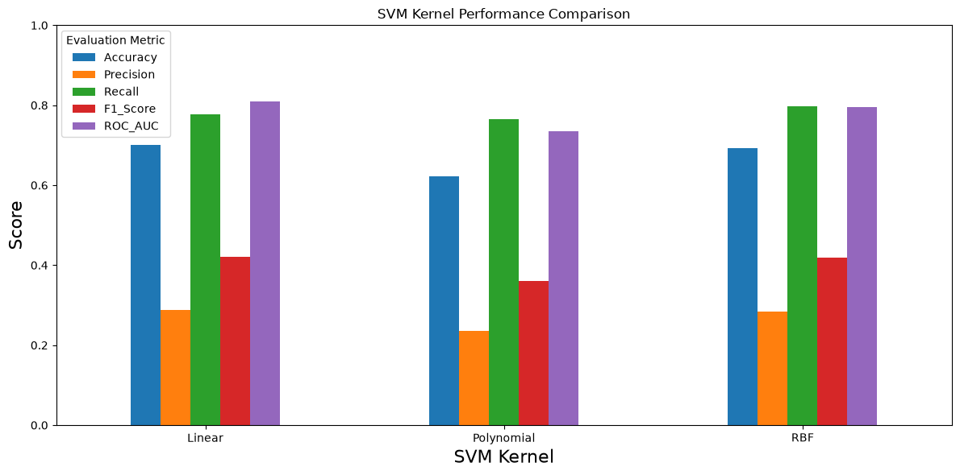
# ============================================================
# Confusion Matrices - SVM Kernels
# ============================================================
kernel_predictions = {
"Linear": health_pred_linear,
"Polynomial": health_pred_poly,
"RBF": health_pred_rbf
}
for kernel, predictions in kernel_predictions.items():
cm = confusion_matrix(y_hk_test, predictions)
print(f"\n{kernel} Kernel Confusion Matrix")
print(cm)
plt.figure(figsize=(5, 4))
plt.imshow(cm)
for i in range(2):
for j in range(2):
plt.text(j, i, cm[i, j], ha="center", va="center")
plt.title(f"{kernel} Kernel - Confusion Matrix")
plt.xlabel("Predicted Class")
plt.ylabel("Actual Class")
plt.xticks([0, 1], ["No Diabetes", "Diabetes"])
plt.yticks([0, 1], ["No Diabetes", "Diabetes"])
plt.tight_layout()
plt.show()
Linear Kernel Confusion Matrix
[[1777 805]
[ 93 325]]
<Figure size 500x400 with 1 Axes>
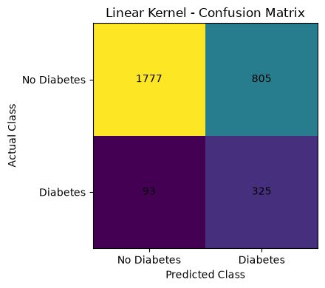
Polynomial Kernel Confusion Matrix
[[1549 1033]
[ 98 320]]
<Figure size 500x400 with 1 Axes>
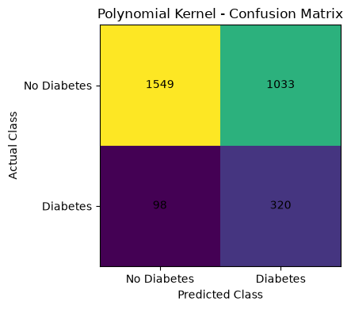
RBF Kernel Confusion Matrix
[[1743 839]
[ 85 333]]
<Figure size 500x400 with 1 Axes>
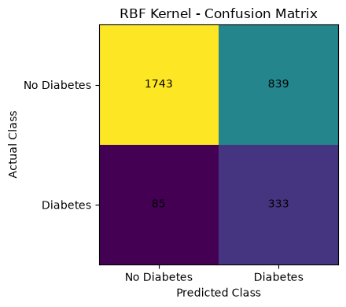
# ============================================================
# SVM Regularization
# ============================================================
C_values = [0.01, 0.1, 1, 10, 100]
regularization_results = []
for C_value in C_values:
svm_model = SVC(kernel="rbf", C=C_value, gamma="scale", class_weight="balanced")
svm_model.fit(X_hk_train_scaled, y_hk_train)
svm_prediction = svm_model.predict(X_hk_test_scaled)
svm_score = svm_model.decision_function(X_hk_test_scaled)
regularization_results.append({
"C": C_value,
"Accuracy": accuracy_score(y_hk_test, svm_prediction),
"Precision": precision_score(y_hk_test, svm_prediction),
"Recall": recall_score(y_hk_test, svm_prediction),
"F1_Score": f1_score(y_hk_test, svm_prediction),
"ROC_AUC": roc_auc_score(y_hk_test, svm_score),
"Support_Vectors": len(svm_model.support_)
})
regularization_df = pd.DataFrame(regularization_results)
print("SVM Regularization Results:")
display(regularization_df.round(4))
print("~" * 80)
# ============================================================
# Regularization vs Model Performance
# ============================================================
plt.figure(figsize=(10, 5))
for metric in ["Accuracy", "Recall", "F1_Score", "ROC_AUC"]:
plt.plot(regularization_df["C"], regularization_df[metric], marker="o", label=metric)
plt.xscale("log")
plt.xlabel("Regularization Parameter C")
plt.ylabel("Score")
plt.title("Effect of Regularization on RBF SVM Performance")
plt.ylim(0, 1)
plt.legend()
plt.tight_layout()
plt.show()
SVM Regularization Results:
C Accuracy Precision Recall F1_Score ROC_AUC Support_Vectors
0 0.01 0.6663 0.2707 0.8230 0.4073 0.8080 8157
1 0.10 0.6920 0.2849 0.8014 0.4203 0.8045 6970
2 1.00 0.6920 0.2841 0.7967 0.4189 0.7963 6569
3 10.00 0.6943 0.2825 0.7751 0.4141 0.7804 6354
4 100.00 0.6963 0.2789 0.7440 0.4057 0.7581 6127
~~~~~~~~~~~~~~~~~~~~~~~~~~~~~~~~~~~~~~~~~~~~~~~~~~~~~~~~~~~~~~~~~~~~~~~~~~~~~~~~
<Figure size 1000x500 with 1 Axes>
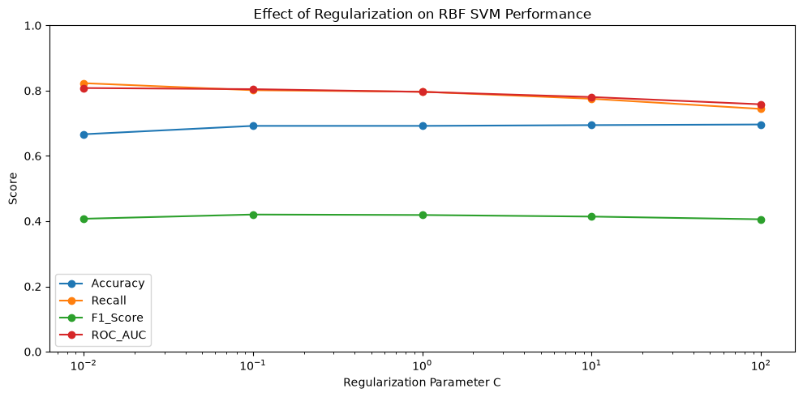
#### The regularization experiment demonstrates a clear tradeoff between accuracy and the ability to identify diabetes cases. At C= 0.01, the model achieved the highest recall of 82.30% and ROC-AUC(0.8080), but accuracy was lower at 66.63%. Increasing C gradually increased accuracy, raching 69.63% at C=100, but the recall decreased substantially from 82.30% to 74.40%. ROC-AUC also decreased from 0.8080 to 0.7581 as C increased.The highest F1 Score 0.4203 occured at C = 0.10, suggesting that moderate to strong regularization provided the best balance between precision and recall among the tested RBF models.
# ============================================================
# Best Regularization Result
# ============================================================
best_regularization = regularization_df.loc[[regularization_df["F1_Score"].idxmax()]]
print("BEST REGULARIZATION RESULT")
display(best_regularization.round(4))
BEST REGULARIZATION RESULT
C Accuracy Precision Recall F1_Score ROC_AUC Support_Vectors
1 0.1 0.692 0.2849 0.8014 0.4203 0.8045 6970
#### Based on F1 score, C=0.10 produced the best regularized RBF SVM. The model achieved 69.2% accuracy, 28.49% precision, 80.14% recall and F1 scopre of 0.4203.
# ============================================================
# Final Results Summary
# ============================================================
linear_summary_df = pd.DataFrame({
"Model": ["Linear SVM"],
"Accuracy": [linear_accuracy],
"Precision": [linear_precision],
"Recall": [linear_recall],
"F1_Score": [linear_f1],
"ROC_AUC": [linear_auc]
})
print("LINEAR SVM - FULL DATASET")
display(linear_summary_df.round(4))
print("KERNEL SVM - STRATIFIED SAMPLE")
display(health_kernel_results.round(4))
print("REGULARIZATION RESULTS")
display(regularization_df.round(4))
LINEAR SVM - FULL DATASET
Model Accuracy Precision Recall F1_Score ROC_AUC
0 Linear SVM 0.7224 0.3032 0.764 0.4341 0.8138
KERNEL SVM - STRATIFIED SAMPLE
Kernel Accuracy Precision Recall F1_Score ROC_AUC
0 Linear 0.7007 0.2876 0.7775 0.4199 0.8096
1 Polynomial 0.6230 0.2365 0.7656 0.3614 0.7347
2 RBF 0.6920 0.2841 0.7967 0.4189 0.7963
REGULARIZATION RESULTS
C Accuracy Precision Recall F1_Score ROC_AUC Support_Vectors
0 0.01 0.6663 0.2707 0.8230 0.4073 0.8080 8157
1 0.10 0.6920 0.2849 0.8014 0.4203 0.8045 6970
2 1.00 0.6920 0.2841 0.7967 0.4189 0.7963 6569
3 10.00 0.6943 0.2825 0.7751 0.4141 0.7804 6354
4 100.00 0.6963 0.2789 0.7440 0.4057 0.7581 6127

Week 5 summary and Impression

This analysis applied Support Vector Machines to the BRFSS diabetes dataset using eight health predictors. Because only 13.93% of observations were in the diabetes class, I evaluated the models using precision, recall, F1, ROC-AUC, and confusion matrices in addition to accuracy. The predictors were standardized using StandardScaler. The full-dataset Linear SVM achieved 72.24% accuracy, 76.40% recall, F1 = 0.4341, and ROC-AUC = 0.8138, correctly identifying 5,401 of 7,069 diabetes cases. The relatively high recall was useful for identifying diabetes cases, although the lower precision (30.32%) showed that this resulted in more false positives.

To test the kernel trick, I compared linear, polynomial, and RBF kernels using the same 15,000-observation stratified sample. The linear kernel performed best overall, with F1 = 0.4199 and ROC-AUC = 0.8096, while the RBF kernel had the highest recall (0.7967). The polynomial kernel performed weakest. This was somewhat unexpected because I expected nonlinear kernels to improve classification, but the additional complexity did not improve overall performance.

I also tested SVM regularization using RBF models with C values from 0.01 to 100. Smaller C values provided stronger regularization and generally better recall, while larger values slightly improved accuracy but reduced recall and ROC-AUC. Based on F1, C = 0.10 provided the best balance with recall = 0.8014, F1 = 0.4203, and ROC-AUC = 0.8045. Stratified train-test splits and training-only feature scaling were used to evaluate generalization and avoid data leakage. Overall, the results showed that more model complexity did not necessarily produce better diabetes classification, and metrics such as recall and F1 were more informative than accuracy alone for this imbalanced dataset.

Week 6
Week-6-Submission-Healthcare-DT-RF-Notebook.ipynb

Week 6 – Decision Trees and Random Forests

Diabetes Health Indicators and Hospital Readmission

This week I apply **Decision Trees** and **Random Forests** to both healthcare datasets.

**Dataset 1 – BRFSS Diabetes Health Indicators:** predict Diabetes_binary using selected health indicators.

**Dataset 2 – Hospital Readmission:** predict whether a patient is readmitted within 30 days using selected hospital utilization variables.

Because both targets are imbalanced, I compare models using **accuracy, precision, recall, F1 score, ROC-AUC, confusion matrices, and feature importance**. I also compare Decision Tree depths to examine model complexity and overfitting.
# ============================================================
# 1. Import Libraries
# ============================================================
import pandas as pd
import matplotlib.pyplot as plt
from sklearn.model_selection import train_test_split
from sklearn.tree import DecisionTreeClassifier, plot_tree
from sklearn.ensemble import RandomForestClassifier
from sklearn.metrics import accuracy_score, precision_score, recall_score
from sklearn.metrics import f1_score, roc_auc_score, ConfusionMatrixDisplay
print("Libraries imported successfully.")
Libraries imported successfully.

Part 1 – BRFSS Diabetes Health Indicators

The target is Diabetes_binary, where 0 represents no diabetes and 1 represents diabetes/prediabetes. The purpose is to compare a single Decision Tree with a Random Forest and identify the health indicators most useful for prediction.
# ============================================================
# 2. Load Health Dataset
# ============================================================
health_url = "https://raw.githubusercontent.com/jeganart/healthdatasetmilestone3/refs/heads/main/diabetes_binary_health_indicators_BRFSS2015.csv"
health_df = pd.read_csv(health_url)
print("Dataset shape:", health_df.shape)
display(health_df.head())
Dataset shape: (253680, 22)
Diabetes_binary HighBP HighChol CholCheck BMI Smoker Stroke \
0 0.0 1.0 1.0 1.0 40.0 1.0 0.0
1 0.0 0.0 0.0 0.0 25.0 1.0 0.0
2 0.0 1.0 1.0 1.0 28.0 0.0 0.0
3 0.0 1.0 0.0 1.0 27.0 0.0 0.0
4 0.0 1.0 1.0 1.0 24.0 0.0 0.0
HeartDiseaseorAttack PhysActivity Fruits ... AnyHealthcare \
0 0.0 0.0 0.0 ... 1.0
1 0.0 1.0 0.0 ... 0.0
2 0.0 0.0 1.0 ... 1.0
3 0.0 1.0 1.0 ... 1.0
4 0.0 1.0 1.0 ... 1.0
NoDocbcCost GenHlth MentHlth PhysHlth DiffWalk Sex Age Education \
0 0.0 5.0 18.0 15.0 1.0 0.0 9.0 4.0
1 1.0 3.0 0.0 0.0 0.0 0.0 7.0 6.0
2 1.0 5.0 30.0 30.0 1.0 0.0 9.0 4.0
3 0.0 2.0 0.0 0.0 0.0 0.0 11.0 3.0
4 0.0 2.0 3.0 0.0 0.0 0.0 11.0 5.0
Income
0 3.0
1 1.0
2 8.0
3 6.0
4 4.0
[5 rows x 22 columns]
# ============================================================
# 3. Health Target Distribution
# ============================================================
print("Missing values:", health_df.isnull().sum().sum())
print("\nTarget counts:")
print(health_df["Diabetes_binary"].value_counts())
print("\nTarget percentages:")
print(health_df["Diabetes_binary"].value_counts(normalize=True).mul(100).round(2))
Missing values: 0
Target counts:
Diabetes_binary
0.0 218334
1.0 35346
Name: count, dtype: int64
Target percentages:
Diabetes_binary
0.0 86.07
1.0 13.93
Name: proportion, dtype: float64
# ============================================================
# 4. Health Features and Train-Test Split
# ============================================================
health_features = [
"HighBP", "HighChol", "BMI", "Smoker",
"HeartDiseaseorAttack", "PhysActivity", "GenHlth", "Age"
]
X_health = health_df[health_features]
y_health = health_df["Diabetes_binary"].astype(int)
Xh_train, Xh_test, yh_train, yh_test = train_test_split(
X_health, y_health, test_size=0.20, random_state=42, stratify=y_health
)
print("Features:", health_features)
print("Training observations:", len(Xh_train))
print("Testing observations:", len(Xh_test))
Features: ['HighBP', 'HighChol', 'BMI', 'Smoker', 'HeartDiseaseorAttack', 'PhysActivity', 'GenHlth', 'Age']
Training observations: 202944
Testing observations: 50736

Health Decision Tree

The Decision Tree uses entropy and information gain to choose splits. I limit max_depth and require a minimum number of observations in each leaf to control model complexity. class_weight="balanced" gives more weight to the smaller diabetes class.
# ============================================================
# 5. Health Decision Tree
# ============================================================
health_tree = DecisionTreeClassifier(
criterion="entropy", max_depth=5, min_samples_leaf=50,
class_weight="balanced", random_state=42
)
health_tree.fit(Xh_train, yh_train)
health_tree_pred = health_tree.predict(Xh_test)
health_tree_prob = health_tree.predict_proba(Xh_test)[:, 1]
health_tree_accuracy = accuracy_score(yh_test, health_tree_pred)
health_tree_precision = precision_score(yh_test, health_tree_pred)
health_tree_recall = recall_score(yh_test, health_tree_pred)
health_tree_f1 = f1_score(yh_test, health_tree_pred)
health_tree_auc = roc_auc_score(yh_test, health_tree_prob)
print("HEALTH DECISION TREE")
print("Accuracy:", round(health_tree_accuracy, 4))
print("Precision:", round(health_tree_precision, 4))
print("Recall:", round(health_tree_recall, 4))
print("F1 Score:", round(health_tree_f1, 4))
print("ROC-AUC:", round(health_tree_auc, 4))
HEALTH DECISION TREE
Accuracy: 0.6916
Precision: 0.2803
Recall: 0.7744
F1 Score: 0.4117
ROC-AUC: 0.8001
# Health Decision Tree Confusion Matrix
ConfusionMatrixDisplay.from_predictions(yh_test, health_tree_pred)
plt.title("Health Dataset - Decision Tree Confusion Matrix")
plt.show()
<Figure size 640x480 with 2 Axes>
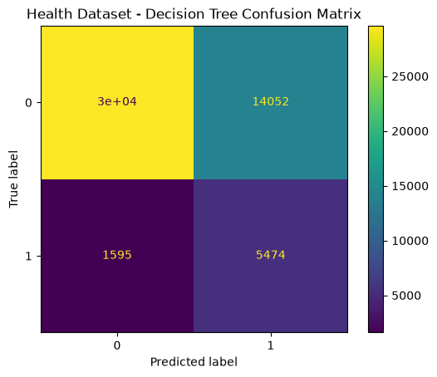
# First Three Levels of the Health Decision Tree
plt.figure(figsize=(18, 8))
plot_tree(
health_tree, feature_names=health_features,
class_names=["No Diabetes", "Diabetes"],
filled=True, max_depth=3, fontsize=8
)
plt.title("Health Decision Tree - First Three Levels")
plt.show()
<Figure size 1800x800 with 1 Axes>
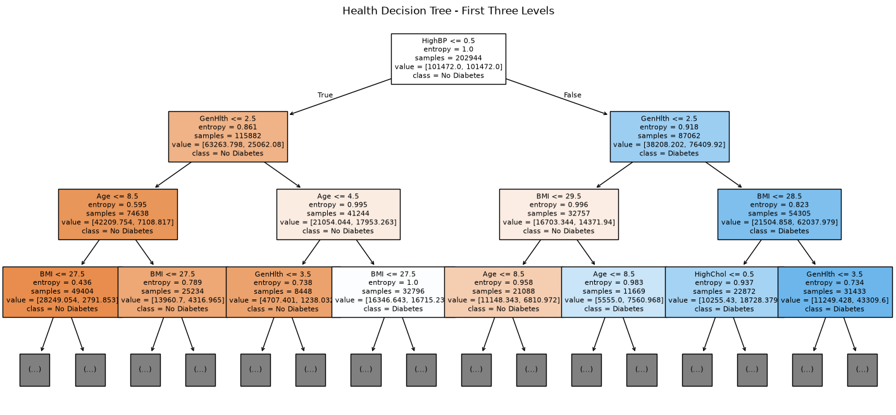

Health Random Forest

Random Forest combines predictions from many Decision Trees. Random sampling and random feature selection make the trees different from one another, which can improve stability and reduce the dependence on any single tree.
# ============================================================
# 6. Health Random Forest
# ============================================================
health_rf = RandomForestClassifier(
n_estimators=100, max_depth=10, min_samples_leaf=20,
class_weight="balanced", random_state=42, n_jobs=-1
)
health_rf.fit(Xh_train, yh_train)
health_rf_pred = health_rf.predict(Xh_test)
health_rf_prob = health_rf.predict_proba(Xh_test)[:, 1]
health_rf_accuracy = accuracy_score(yh_test, health_rf_pred)
health_rf_precision = precision_score(yh_test, health_rf_pred)
health_rf_recall = recall_score(yh_test, health_rf_pred)
health_rf_f1 = f1_score(yh_test, health_rf_pred)
health_rf_auc = roc_auc_score(yh_test, health_rf_prob)
print("HEALTH RANDOM FOREST")
print("Accuracy:", round(health_rf_accuracy, 4))
print("Precision:", round(health_rf_precision, 4))
print("Recall:", round(health_rf_recall, 4))
print("F1 Score:", round(health_rf_f1, 4))
print("ROC-AUC:", round(health_rf_auc, 4))
HEALTH RANDOM FOREST
Accuracy: 0.7196
Precision: 0.303
Recall: 0.7786
F1 Score: 0.4362
ROC-AUC: 0.8191
# ============================================================
# 7. Compare Health Models
# ============================================================
health_results = pd.DataFrame({
"Model": ["Decision Tree", "Random Forest"],
"Accuracy": [health_tree_accuracy, health_rf_accuracy],
"Precision": [health_tree_precision, health_rf_precision],
"Recall": [health_tree_recall, health_rf_recall],
"F1": [health_tree_f1, health_rf_f1],
"ROC_AUC": [health_tree_auc, health_rf_auc]
})
display(health_results.round(4))
Model Accuracy Precision Recall F1 ROC_AUC
0 Decision Tree 0.6916 0.2803 0.7744 0.4117 0.8001
1 Random Forest 0.7196 0.3030 0.7786 0.4362 0.8191

Health Model Interpretation

Random Forest performed better than the Decision Tree across all five evaluation metrics. ROC-AUC increased from **0.8001 to 0.8191**, F1 increased from **0.4117 to 0.4362**, and recall remained high at **0.7786**. Although precision remained relatively low at **0.3030**, the Random Forest provided the best overall balance of performance for diabetes classification.
# ============================================================
# 8. Health Random Forest Feature Importance
# ============================================================
health_importance = pd.DataFrame({
"Feature": health_features,
"Importance": health_rf.feature_importances_
}).sort_values("Importance", ascending=False)
display(health_importance.round(4))
plt.figure(figsize=(9, 5))
plt.barh(health_importance["Feature"][::-1], health_importance["Importance"][::-1])
plt.xlabel("Feature Importance")
plt.title("Random Forest - Important Diabetes Health Indicators")
plt.tight_layout()
plt.show()
Feature Importance
6 GenHlth 0.2825
0 HighBP 0.2357
2 BMI 0.1768
1 HighChol 0.1253
7 Age 0.1152
4 HeartDiseaseorAttack 0.0412
5 PhysActivity 0.0182
3 Smoker 0.0051
<Figure size 900x500 with 1 Axes>
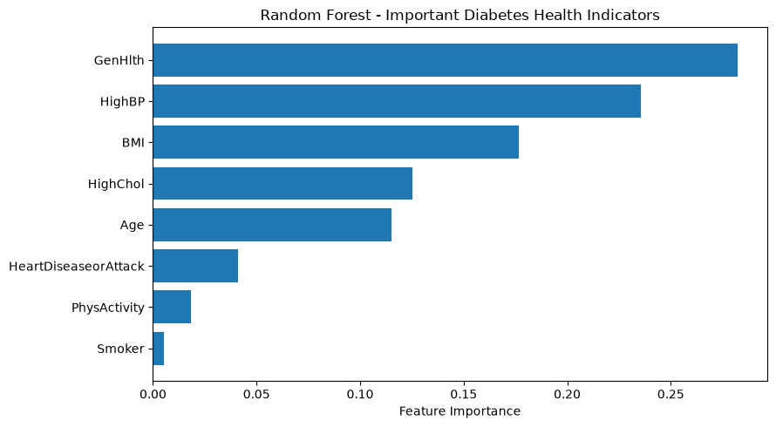

Health Feature Importance Interpretation

General Health was the most important predictor (**0.2825**), followed by High Blood Pressure (**0.2357**), BMI (**0.1768**), High Cholesterol (**0.1253**), and Age (**0.1152**). Smoking had very low importance (**0.0051**) in this model, which was an unexpected finding compared with the other selected health indicators. These values show how useful the variables were for prediction within this Random Forest and should not be interpreted as causal effects.

Decision Tree Depth and Overfitting

A Decision Tree can overfit when it grows too deep and learns patterns that do not generalize well. I compare several max_depth values using the same training and test data. F1 and ROC-AUC are used because the diabetes target is imbalanced.
# ============================================================
# 9. Health Decision Tree Depth Comparison
# ============================================================
depth_results = []
for depth in [3, 5, 10, 20]:
model = DecisionTreeClassifier(
criterion="entropy", max_depth=depth,
class_weight="balanced", random_state=42
)
model.fit(Xh_train, yh_train)
predictions = model.predict(Xh_test)
probabilities = model.predict_proba(Xh_test)[:, 1]
depth_results.append({
"Max_Depth": depth,
"Accuracy": accuracy_score(yh_test, predictions),
"Recall": recall_score(yh_test, predictions),
"F1": f1_score(yh_test, predictions),
"ROC_AUC": roc_auc_score(yh_test, probabilities)
})
depth_results = pd.DataFrame(depth_results)
display(depth_results.round(4))
Max_Depth Accuracy Recall F1 ROC_AUC
0 3 0.6098 0.8454 0.3765 0.7765
1 5 0.6916 0.7744 0.4117 0.8001
2 10 0.7195 0.7667 0.4324 0.8099
3 20 0.7190 0.6555 0.3940 0.7208
# Decision Tree Depth vs Performance
plt.figure(figsize=(8, 5))
plt.plot(depth_results["Max_Depth"], depth_results["F1"], marker="o", label="F1")
plt.plot(depth_results["Max_Depth"], depth_results["ROC_AUC"], marker="o", label="ROC-AUC")
plt.xlabel("Maximum Tree Depth")
plt.ylabel("Score")
plt.title("Health Decision Tree - Effect of Tree Depth")
plt.legend()
plt.tight_layout()
plt.show()
<Figure size 800x500 with 1 Axes>
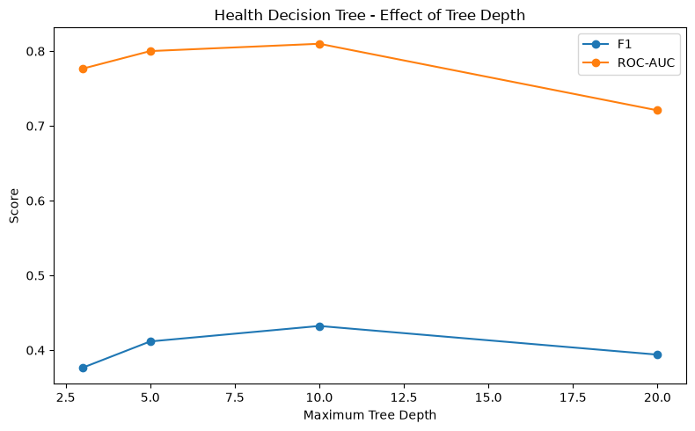

Tree Depth Interpretation

Increasing the maximum tree depth initially improved test performance. The Decision Tree with `max_depth=10` produced the best overall results among the tested depths, with accuracy of **0.7195**, F1 of **0.4324**, and ROC-AUC of **0.8099**. Increasing the depth to 20 did not improve accuracy and reduced recall to **0.6555**, F1 to **0.3940**, and ROC-AUC to **0.7208**. This pattern is consistent with poorer generalization as the tree becomes more complex and shows why controlling tree depth is important for limiting overfitting.

Part 2 – Hospital Readmission Dataset

For the hospital dataset, the target is readmitted_30, where 1 means the patient was readmitted in less than 30 days and 0 means the patient was not readmitted within 30 days. The goal is to compare Decision Tree and Random Forest performance using selected hospital utilization variables.
# ============================================================
# 10. Load Hospital Dataset
# ============================================================
hospital_url = "https://raw.githubusercontent.com/jeganart/hospitaldatasetmilestone3/refs/heads/main/diabetic_data.csv"
hospital_df = pd.read_csv(hospital_url)
print("Dataset shape:", hospital_df.shape)
display(hospital_df.head())
# ============================================================
# 11. Create 30-Day Readmission Target
# ============================================================
hospital_df["readmitted_30"] = (hospital_df["readmitted"] == "<30").astype(int)
print("30-day readmission counts:")
print(hospital_df["readmitted_30"].value_counts())
print("\n30-day readmission percentages:")
print(hospital_df["readmitted_30"].value_counts(normalize=True).mul(100).round(2))
Dataset shape: (101766, 50)
encounter_id patient_nbr race gender age weight \
0 2278392 8222157 Caucasian Female [0-10) ?
1 149190 55629189 Caucasian Female [10-20) ?
2 64410 86047875 AfricanAmerican Female [20-30) ?
3 500364 82442376 Caucasian Male [30-40) ?
4 16680 42519267 Caucasian Male [40-50) ?
admission_type_id discharge_disposition_id admission_source_id \
0 6 25 1
1 1 1 7
2 1 1 7
3 1 1 7
4 1 1 7
time_in_hospital ... citoglipton insulin glyburide-metformin \
0 1 ... No No No
1 3 ... No Up No
2 2 ... No No No
3 2 ... No Up No
4 1 ... No Steady No
glipizide-metformin glimepiride-pioglitazone metformin-rosiglitazone \
0 No No No
1 No No No
2 No No No
3 No No No
4 No No No
metformin-pioglitazone change diabetesMed readmitted
0 No No No NO
1 No Ch Yes >30
2 No No Yes NO
3 No Ch Yes NO
4 No Ch Yes NO
[5 rows x 50 columns]
30-day readmission counts:
readmitted_30
0 90409
1 11357
Name: count, dtype: int64
30-day readmission percentages:
readmitted_30
0 88.84
1 11.16
Name: proportion, dtype: float64
# ============================================================
# 12. Hospital Features and Train-Test Split
# ============================================================
hospital_features = [
"time_in_hospital", "num_lab_procedures", "num_procedures",
"num_medications", "number_outpatient", "number_emergency",
"number_inpatient", "number_diagnoses"
]
X_hospital = hospital_df[hospital_features]
y_hospital = hospital_df["readmitted_30"]
Xr_train, Xr_test, yr_train, yr_test = train_test_split(
X_hospital, y_hospital, test_size=0.20, random_state=42, stratify=y_hospital
)
print("Features:", hospital_features)
print("Missing values:", X_hospital.isnull().sum().sum())
print("Training observations:", len(Xr_train))
print("Testing observations:", len(Xr_test))
Features: ['time_in_hospital', 'num_lab_procedures', 'num_procedures', 'num_medications', 'number_outpatient', 'number_emergency', 'number_inpatient', 'number_diagnoses']
Missing values: 0
Training observations: 81412
Testing observations: 20354

Hospital Decision Tree

I again use entropy and information gain. Tree depth and minimum leaf size are limited to reduce overfitting, and class_weight="balanced" is used because 30-day readmission is the minority class.
# ============================================================
# 13. Hospital Decision Tree
# ============================================================
hospital_tree = DecisionTreeClassifier(
criterion="entropy", max_depth=5, min_samples_leaf=50,
class_weight="balanced", random_state=42
)
hospital_tree.fit(Xr_train, yr_train)
hospital_tree_pred = hospital_tree.predict(Xr_test)
hospital_tree_prob = hospital_tree.predict_proba(Xr_test)[:, 1]
hospital_tree_accuracy = accuracy_score(yr_test, hospital_tree_pred)
hospital_tree_precision = precision_score(yr_test, hospital_tree_pred)
hospital_tree_recall = recall_score(yr_test, hospital_tree_pred)
hospital_tree_f1 = f1_score(yr_test, hospital_tree_pred)
hospital_tree_auc = roc_auc_score(yr_test, hospital_tree_prob)
print("HOSPITAL DECISION TREE")
print("Accuracy:", round(hospital_tree_accuracy, 4))
print("Precision:", round(hospital_tree_precision, 4))
print("Recall:", round(hospital_tree_recall, 4))
print("F1 Score:", round(hospital_tree_f1, 4))
print("ROC-AUC:", round(hospital_tree_auc, 4))
HOSPITAL DECISION TREE
Accuracy: 0.6725
Precision: 0.1697
Recall: 0.4971
F1 Score: 0.2531
ROC-AUC: 0.6322
# Hospital Decision Tree Confusion Matrix
ConfusionMatrixDisplay.from_predictions(yr_test, hospital_tree_pred)
plt.title("Hospital Dataset - Decision Tree Confusion Matrix")
plt.show()
<Figure size 640x480 with 2 Axes>
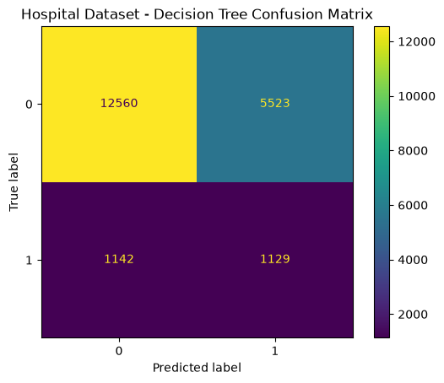

Hospital Random Forest

The Random Forest uses many trees and combines their predictions. I use the same selected hospital features and the same train-test split so the two hospital models can be compared directly.
# ============================================================
# 14. Hospital Random Forest
# ============================================================
hospital_rf = RandomForestClassifier(
n_estimators=100, max_depth=10, min_samples_leaf=20,
class_weight="balanced", random_state=42, n_jobs=-1
)
hospital_rf.fit(Xr_train, yr_train)
hospital_rf_pred = hospital_rf.predict(Xr_test)
hospital_rf_prob = hospital_rf.predict_proba(Xr_test)[:, 1]
hospital_rf_accuracy = accuracy_score(yr_test, hospital_rf_pred)
hospital_rf_precision = precision_score(yr_test, hospital_rf_pred)
hospital_rf_recall = recall_score(yr_test, hospital_rf_pred)
hospital_rf_f1 = f1_score(yr_test, hospital_rf_pred)
hospital_rf_auc = roc_auc_score(yr_test, hospital_rf_prob)
print("HOSPITAL RANDOM FOREST")
print("Accuracy:", round(hospital_rf_accuracy, 4))
print("Precision:", round(hospital_rf_precision, 4))
print("Recall:", round(hospital_rf_recall, 4))
print("F1 Score:", round(hospital_rf_f1, 4))
print("ROC-AUC:", round(hospital_rf_auc, 4))
HOSPITAL RANDOM FOREST
Accuracy: 0.6538
Precision: 0.1672
Recall: 0.5284
F1 Score: 0.254
ROC-AUC: 0.6417
# ============================================================
# 15. Compare Hospital Models
# ============================================================
hospital_results = pd.DataFrame({
"Model": ["Decision Tree", "Random Forest"],
"Accuracy": [hospital_tree_accuracy, hospital_rf_accuracy],
"Precision": [hospital_tree_precision, hospital_rf_precision],
"Recall": [hospital_tree_recall, hospital_rf_recall],
"F1": [hospital_tree_f1, hospital_rf_f1],
"ROC_AUC": [hospital_tree_auc, hospital_rf_auc]
})
display(hospital_results.round(4))
Model Accuracy Precision Recall F1 ROC_AUC
0 Decision Tree 0.6725 0.1697 0.4971 0.2531 0.6322
1 Random Forest 0.6538 0.1672 0.5284 0.2540 0.6417

Hospital Model Interpretation

Random Forest did not clearly outperform the Decision Tree on the hospital dataset. It increased recall from **0.4971 to 0.5284** and ROC-AUC from **0.6322 to 0.6417**, meaning it identified slightly more 30-day readmissions and provided slightly better discrimination. However, accuracy decreased from **0.6725 to 0.6538**, precision decreased slightly, and F1 remained nearly unchanged at approximately **0.25**. Therefore, Random Forest provided a modest improvement in identifying positive cases, but not a substantial improvement in overall predictive performance.
# ============================================================
# 16. Hospital Random Forest Feature Importance
# ============================================================
hospital_importance = pd.DataFrame({
"Feature": hospital_features,
"Importance": hospital_rf.feature_importances_
}).sort_values("Importance", ascending=False)
display(hospital_importance.round(4))
plt.figure(figsize=(9, 5))
plt.barh(hospital_importance["Feature"][::-1], hospital_importance["Importance"][::-1])
plt.xlabel("Feature Importance")
plt.title("Random Forest - Important Readmission Predictors")
plt.tight_layout()
plt.show()
Feature Importance
6 number_inpatient 0.4401
1 num_lab_procedures 0.1124
3 num_medications 0.1083
0 time_in_hospital 0.0989
5 number_emergency 0.0795
7 number_diagnoses 0.0760
2 num_procedures 0.0497
4 number_outpatient 0.0351
<Figure size 900x500 with 1 Axes>
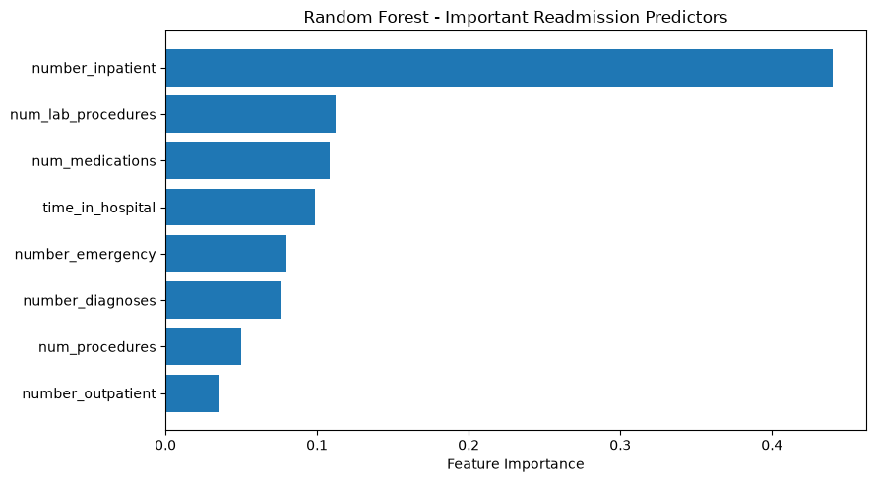

Hospital Feature Importance Interpretation

number_inpatient was by far the most important predictor, with an importance of **0.4401**. The next most important variables were num_lab_procedures (**0.1124**), num_medications (**0.1083**), and time_in_hospital (**0.0989**). This suggests that prior inpatient utilization contained particularly useful predictive information for 30-day readmission in this model. Feature importance describes predictive usefulness and does not establish causation.
# ============================================================
# 17. Final Model Comparison
# ============================================================
all_results = pd.DataFrame({
"Dataset": ["Health", "Health", "Hospital", "Hospital"],
"Model": ["Decision Tree", "Random Forest", "Decision Tree", "Random Forest"],
"Accuracy": [health_tree_accuracy, health_rf_accuracy, hospital_tree_accuracy, hospital_rf_accuracy],
"Precision": [health_tree_precision, health_rf_precision, hospital_tree_precision, hospital_rf_precision],
"Recall": [health_tree_recall, health_rf_recall, hospital_tree_recall, hospital_rf_recall],
"F1": [health_tree_f1, health_rf_f1, hospital_tree_f1, hospital_rf_f1],
"ROC_AUC": [health_tree_auc, health_rf_auc, hospital_tree_auc, hospital_rf_auc]
})
display(all_results.round(4))
Dataset Model Accuracy Precision Recall F1 ROC_AUC
0 Health Decision Tree 0.6916 0.2803 0.7744 0.4117 0.8001
1 Health Random Forest 0.7196 0.3030 0.7786 0.4362 0.8191
2 Hospital Decision Tree 0.6725 0.1697 0.4971 0.2531 0.6322
3 Hospital Random Forest 0.6538 0.1672 0.5284 0.2540 0.6417

Week 6 Summary and Interpretation

I applied Decision Trees and Random Forests to both healthcare datasets. For the BRFSS diabetes dataset, Random Forest performed better than the single Decision Tree across all evaluation metrics. Accuracy increased from **0.6916 to 0.7196**, F1 from **0.4117 to 0.4362**, and ROC-AUC from **0.8001 to 0.8191**, while recall remained high at **0.7786**. General Health, High Blood Pressure, BMI, High Cholesterol, and Age were the most important predictors. One unexpected result was the very low importance of Smoking (**0.0051**) compared with the other selected health indicators. These feature importances represent predictive associations rather than causal effects.

I also examined the effect of Decision Tree complexity by comparing maximum depths of 3, 5, 10, and 20. Test performance improved through **depth 10**, which achieved the highest F1 (**0.4324**) and ROC-AUC (**0.8099**). At depth 20, F1 decreased to **0.3940** and ROC-AUC to **0.7208**, showing that additional tree complexity did not improve test performance and was consistent with poorer generalization. This demonstrated why limiting tree depth is useful when controlling overfitting. Random Forest further improved ROC-AUC to **0.8191**, showing the benefit of combining multiple trees rather than relying on a single tree.

The hospital readmission problem was more difficult. Random Forest increased recall from **0.4971 to 0.5284** and ROC-AUC from **0.6322 to 0.6417**, but accuracy decreased from **0.6725 to 0.6538**, and F1 remained near **0.25**. Therefore, Random Forest provided only a modest improvement in identifying positive cases and did not clearly outperform the Decision Tree across all metrics. number_inpatient was the strongest hospital predictor with an importance of **0.4401**. Because both datasets were imbalanced, accuracy alone was not sufficient; precision, recall, F1, ROC-AUC, and confusion matrices provided a more complete evaluation. Overall, Random Forest clearly improved diabetes classification, while the hospital results demonstrated that a more complex ensemble model does not automatically produce substantially better predictions.

