**Explanation**:

Implemented this program using the Java design principles, Java design patterns and Java 8 features. This is program is config (property) file driven and no hardcoding inside the code. During the run time we can modify the property files and expect the output. This project was completed implemented using TDD.

**Java Design Patterns Used**

1. Singleton (with Double check) Pattern
2. Fly Weight Pattern
3. Bridge Pattern
4. Factory Pattern

**Java-8 Features**:

1. Java-8 Streaming
2. Java-8 Lambda Expression

**JDK**: 1.8.0_92

**Project Setup**:

* Code was compiled using JDK 1.8.0_92 version
* Extract the SCCode_Jegan.zip file
* “menwearProperty.txt” property file is for Mens wear Category
* “womenwearProperty.txt” property file is for Women wear Category
* “brandDiscountProperty.txt” property file is for Brand discount
* “inventoryProperty.txt” property file is for Inventory (the list of items that shop has)
* Make sure all the files are available under extracted folder.

**Java command line commands**:

* Java –jar SGTest.jar



**Output & Directory structure**

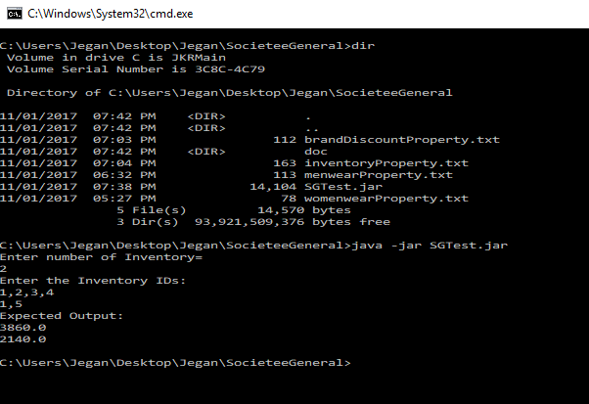

**TDD output**

