Coding Activity 4.1

Styling A Task Tracker (60:00)

#### **Learning Outcome Addressed**

 4. Style components in a separate CSS file for a React application

Now that you have experience creating and styling a ToDo list, it’s time for more practice. In this exercise, you’ll work through a similar example as the one you’ve seen in the videos so far. You’ll start with a Task Tracker CRUD application and add styling to a separate CSS file.

.

Top of Form

**Adding Styles to An Existing CRUD**

### Adding Styling to a Functional CRUD

you have seen a CRUD application being built and what a finished product could look like. Now you can practice using specific CSS fields to have a polished application. Styling can help users of your functional applications understand how to use it intuitively and effectively. In this activity, you can do exactly that by taking this Timestamped Checklist Application to its final stage by adding styling.

Consider this, when using a new application, how do you know what parts are interactive and what parts are for viewing? This is accomplished by certain styling patterns and cues. For example when hovering over an element that can be clicked, generally the cursor will be a pointer instead of the default arrow cursor.

For instance, this button as a pointer cursor.

Hello World

In this activity, you will turn the Task Tracker Application which is already functional from this un-styled version:

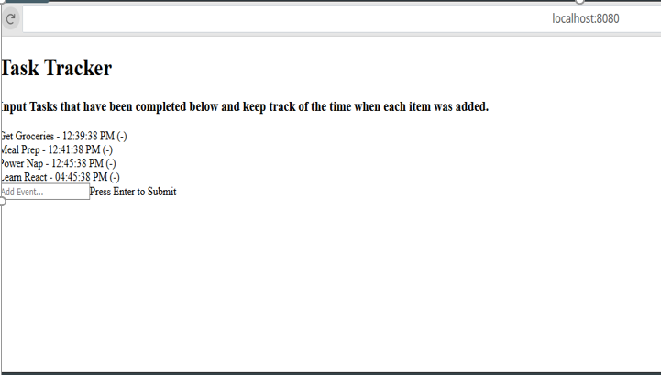

to something styled like this version:

