**Coding Assignment 6**

Improving The Tic-Tac-Toe Game (180:00)

#### **Learning Outcomes Addressed**

 2.Manage state globally at the application level

 3.Manage state locally at the component level

 4.Use React hooks and methods

Now, you’ll build on your progress by adding functionality to the Tic-Tac-Toe game. You will:

* Change the next player display to indicate Player X or Player O
* Update the color of the mark so X is red and O is white
* **Improving the game**

### React – Tic-Tac-Toe

As you've seen in the course video, you can create a Tic-tac-toe game using React. In this activity, you'll add improvements to this game.

**Your task in this activity is to do the following:**

#### Part 1

1. Display the next player to play (Player X or Player O). This should show which player's turn it is. It should be updated every time a player selects a square
2. Update the color of the mark based on the player's turn. "X" should be red, and "O" should be white.

At the end, the game board should look like the following:

[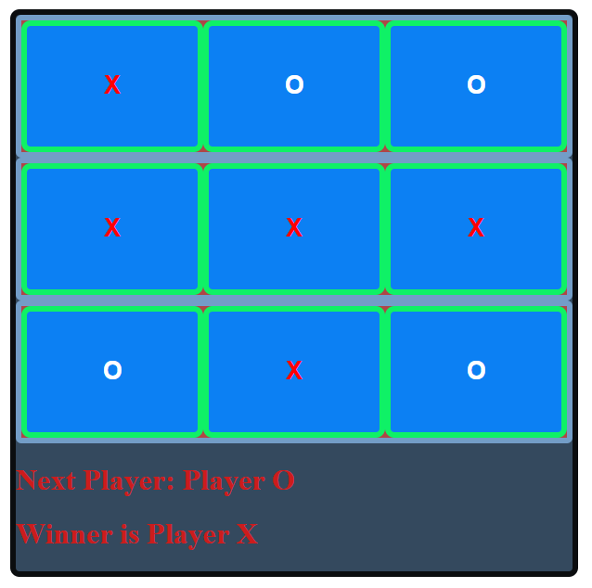](https://cdn.filestackcontent.com/G3WGZKYQcGXTyHIHiWip)