Coding Activity 8.2

HTML File :-

<!DOCTYPE html>

<html>

<head>

<link rel="stylesheet" href="./styles.css">

</head>

<body id="main">

<div class="wrapper">

<div class="box header">Header</div>

<div class="box sidebar">Sidebar</div>

<div class="box content">Content

<br /> This is the main area for content</div>

<div class="box footer">Footer</div>

</div>

</body>

</html>

CSS File:-

body {

margin: 40px;

}

.sidebar { grid-column: 1/2;

grid-row: 2/3;

/\* TODO: Define the grid area here \*/

}

.content {grid-column: 2/4;

grid-row: 2/3;

/\* TODO: Define the grid area here \*/

}

.header {

grid-column: 2/4;

/\* TODO: Define the grid area here \*/

}

.footer {

grid-column: 1/4;

grid-row: 3/4;

/\* TODO: Define the grid area here \*/

}

.wrapper {

display: grid;

grid-gap: 10px;

background-color: #fff;

color: #444;

/\* TODO: Define the grid-template-columns and grid-template-areas values here. \*/

grid-template-columns: 120px 120px 120px;

grid-template-areas:

'....... header header'

'sidebar content content'

'footer footer footer';

}

.box {

background-color: #0000ff;

color: #fff;

border-radius: 5px;

padding: 10px;

font-size: 150%;

}

.header,

.footer {

background-color: #999;

}

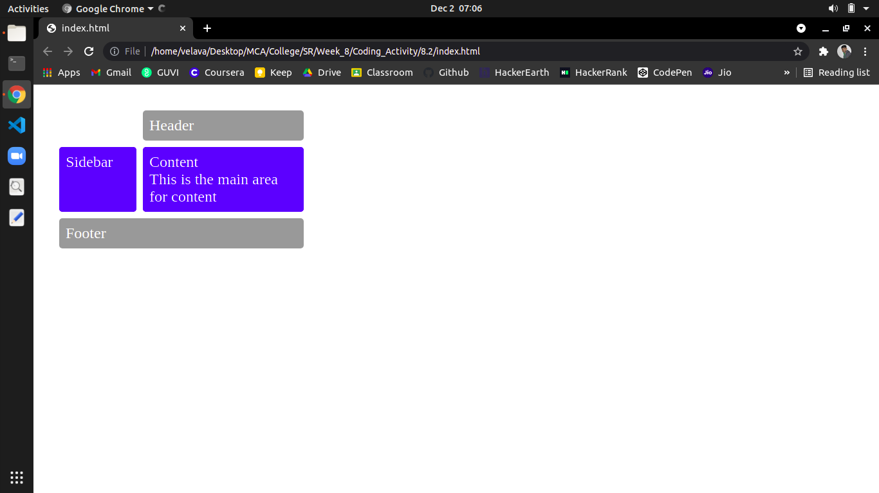OUTPUT:-