**Course**: CSC500_1

**Module & Assignment**: 6 & Portfolio Milestone

**Student**: Jegan Palaniyandi

**Understanding of the problem statement**

This is a continuation of Portfolio Milestone 4 and 6. As part of **milestone 4**, we have **created a shopping cart to display all the items with their price and the total cost**. In **milestone 6**, we continued to develop a **shopping cart class** with an init method declared with parameters. We need to write methods to **create, delete and update** the **shopping cart**. We also need to include methods that **display item & description**, a method to return the **number of items in the shopping cart**. ‘SHOPPING CART IS EMPTY’ message should be displayed if there is no item in the shopping cart.

The **main method** should **ask the user details**, then **display the shopping cart options** to perform the shopping and perform shopping based on the option selected until ‘**q**’ is entered.

**What is included as part of milestone 8?**

As part of milestone 8, I have included the **implementation of modify items and remove items** in the cart **making this as complete shopping cart application.**

**Shopping cart application at the end of milestone 8**

* User will be prompted to **ask username and date**
* Entering the above values, application will **list the MENU options**.
* The menu will have **add(a), remove(r), change(c), item descriptions(i), output cart(o),and quit(q)**
* Each of the **menu item has its own implementation**s as per the milestone requirement.

**Code**

class ItemToPurchase:  
 *"""  
 ItemToPurchase class has a default constructor with three parameters  
 initialized with three parameters with default values as  
 item_name = none  
 item_price = 0 &  
 item_quantity= 0.  
  
 The class has two methods,  
  
 1. add_print_list - returns the item name, count and price formatted.  
 This is used by list in the main method that prints  
 all the items to the receipt.  
  
 2. calculate_item_price - returns item_price by multiplying price and  
 count of item.  
  
 """* def __init__(self, item_name='none', item_price=0.00, item_quantity=0):  
 self.item_name = item_name  
 self.item_price = item_price  
 self.item_quantity = item_quantity  
  
 def add_print_list(self):  
 return '{:<32} --> {:>6.2f}$'.format(self.item_name + ' x ' + str(self.item_quantity),  
 self.item_price * self.item_quantity)  
  
 def calculate_item_price(self):  
 return self.item_price * self.item_quantity  
  
  
class ShoppingCart:  
 *"""  
 Class: ShoppingCart  
 Constructor:  
 non-default params:  
 cart_items -> List  
 Default params:  
 customer_name='none'  
 current_date='January 1, 2020'  
 """* def __init__(self, cart_items, customer_name='none', current_date='January 1, 2020'):  
 self.customer_name = customer_name  
 self.current_date = current_date  
 self.cart_items = cart_items  
 self.available_items = {'Nike Romaleos': 'Volt color, Weightlifting shoes',  
 'Chocolate Chips': 'Semi - sweet',  
 'Powerbeats 2 Headphones': 'Bluetooth headphones'  
 }  
 self.total_cost = 0  
  
 def add_item(self):  
 *"""  
 'add_item' handles adding a new item to shopping cart  
 It prompts the user to enter the item name, price and quantity  
 and saves it to a list which saves itemToPurchase object.  
 """* print(f'\nEnter item details:')  
 print('-' * 19)  
 name = input('Enter item name --> ')  
 price = float(input('Enter item price($) --> '))  
 quantity = int(input('Enter item quantity --> '))  
  
 item = ItemToPurchase(name, price, quantity)  
 self.cart_items.append(item)  
 print('{} {}(s) priced at ${:.2f} added successfully to cart.'.format(quantity, name, price))  
  
 def remove_item(self):  
 *"""  
 Prompt the user to enter the item name that needs to be removed.  
 If the entered item name is in the cart, remove it, else  
 display, 'Item not found in cart. Nothing removed.'  
 """* item_to_remove = input("Enter the item name to be removed from cart --> ")  
  
 for item in self.cart_items:  
 if item.item_name == item_to_remove:  
 self.cart_items.remove(item)  
 print('{} removed from the cart.'.format(item_to_remove))  
 return  
 print('Item not found in cart. Nothing removed.')  
  
 def modify_item(self):  
 *"""  
 If item can be found (by name) in cart,  
 check if parameter has default values for description, price,  
 and quantity. If not, modify item in cart.  
 If item cannot be found (by name) in cart,  
 output this message: Item not found in cart. Nothing modified.  
 """* item_to_modify = input("Enter the item name to be modified --> ")  
 new_quantity = int(input("Enter the new quantity --> "))  
  
 for item in self.cart_items:  
 if item.item_name == item_to_modify:  
 item.item_quantity = new_quantity  
 print('{} quantity is updated as {}.'.format(item_to_modify, new_quantity))  
 return  
 print('Item not found in cart. Nothing modified.')  
  
 def get_num_items_in_cart(self):  
 *"""  
 :return:# of items in the shopping cart  
 """* num_items = 0  
 for item in self.cart_items:  
 num_items += item.item_quantity  
 return num_items  
  
 def get_cost_of_cart(self):  
 *"""  
 Outputs total of objects in cart.  
 If cart is empty, output this message: SHOPPING CART IS EMPTY  
 :return: none  
 """* for item in self.cart_items:  
 self.total_cost += item.calculate_item_price()  
  
 # Following section prints the receipt by looping the  
 # 'itemList' and print the total cost at the bottom using  
 # 'totalCost' variable  
  
 print('-' * 44)  
 print('Total {:>36.2f}$'.format(self.total_cost))  
 print('-' * 44)  
  
 def print_total(self):  
 *"""  
 prints the total cost of items in cart. Has no parameters.  
 :return:none  
 """* print()  
 print('*' * 44)  
 print(' ' * 12 + '{}\'s Shopping Cart'.format(self.customer_name))  
 print(' ' * 16 + '{}'.format(self.current_date))  
 print('*' * 44)  
 print('{:^44}\n'.format('Total # of items : ' + str(self.get_num_items_in_cart())))  
  
 for item in self.cart_items:  
 print(item.add_print_list())  
  
 def print_descriptions(self):  
 *"""  
 prints available items and descriptions in the mart  
 :return:none  
 """* print('\n{:>55}'.format('Available Items and Descriptions'))  
 print('-' * 88)  
 print('|{:>32} |{:>34} |'.format('ITEM', 'DESCRIPTION'))  
 print('-' * 88)  
 for l_item, desc in self.available_items.items():  
 print('|{:>32} |{:>34} |'.format(l_item, desc))  
 print('-' * 88)  
  
 def output_cart(self):  
 *"""  
 prints the list of items with their total price  
 and at the bottom prints the  
 :return:  
 """* if self.get_num_items_in_cart():  
 self.print_total()  
 self.get_cost_of_cart()  
 else:  
 print('SHOPPING CART IS EMPTY')  
  
  
def print_menu_options():  
 *"""  
 Prints Menu with options and  
 prompt the user to enter an option  
 :return: shopping cart options menu  
 """* menu_options = ['a - Add item to cart', 'r - Remove item from cart', 'c - Change item quantity',  
 'i - Output items\'s descriptions', 'o - Output shopping cart', 'q - Quit']  
 print()  
 for l_option in menu_options:  
 print(f'{l_option:^80}')  
  
 selected_option = input('{:>49}'.format('Choose an option: '))  
 return selected_option  
  
  
if __name__ == '__main__':  
  
 # Print CSU groceries banner  
  
 print('*' * 100)  
 print(' ' * 25, 'CSU Groceries - User-friendly Online Shopping')  
 print('*' * 100)  
  
 # Get and print user and date  
  
 user_name = input('\nEnter your name : ')  
 today_date = input('Enter today\'s date as <Month> <date>, <year> : ')  
 print('\n{:>50} \'{}\''.format('Welcome valued customer', user_name))  
 print('{:>42} {}'.format('Shopping date :', today_date))  
  
 # Create and Initialize an empty shopping cart with entered username and date  
  
 user_cart_items = []  
 user_cart = ShoppingCart(user_cart_items, user_name, today_date)  
  
 # Print Menu for options until user enters 'q'  
  
 option_selected = ''  
 while option_selected != 'q':  
 if option_selected == 'a':  
 user_cart.add_item()  
 elif option_selected == 'i':  
 user_cart.print_descriptions()  
 elif option_selected == 'o':  
 user_cart.output_cart()  
 elif option_selected == 'r':  
 user_cart.remove_item()  
 elif option_selected == 'c':  
 user_cart.modify_item()  
 option_selected = print_menu_options()

**Output**

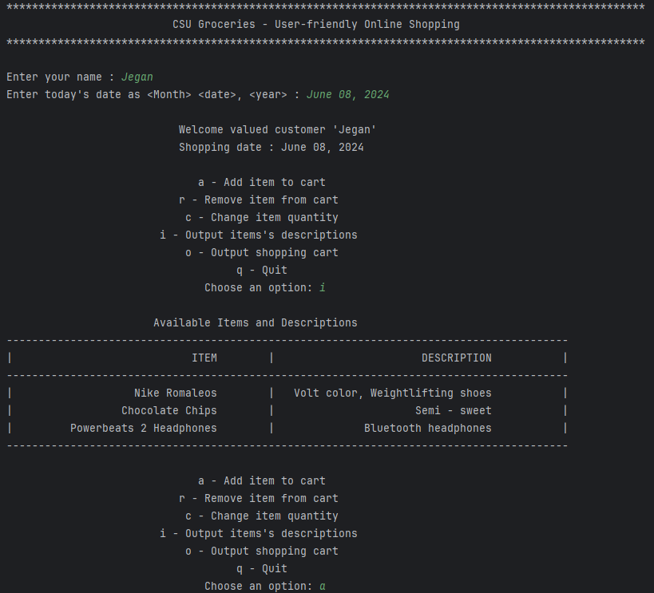

**Output continued in next page...**

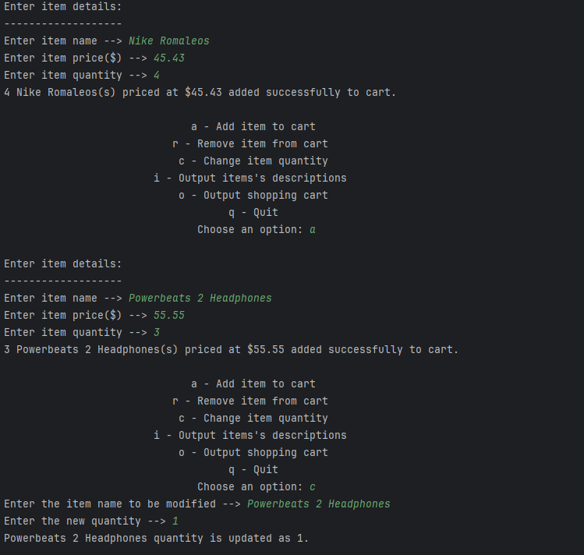

**Output continued in next page...**

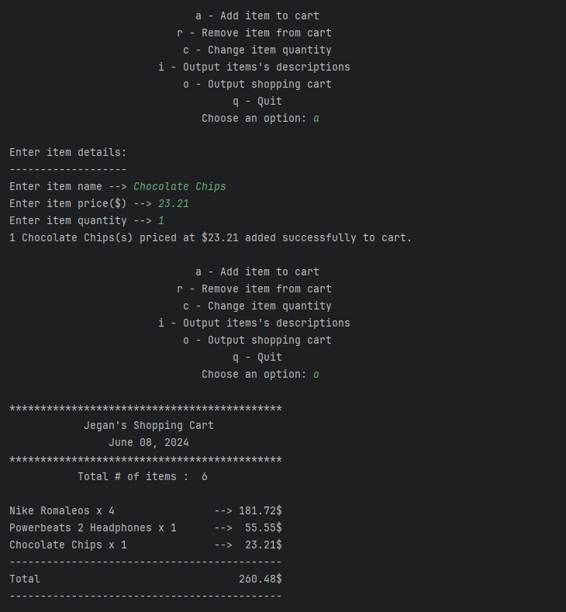

**Output continued in next page...**

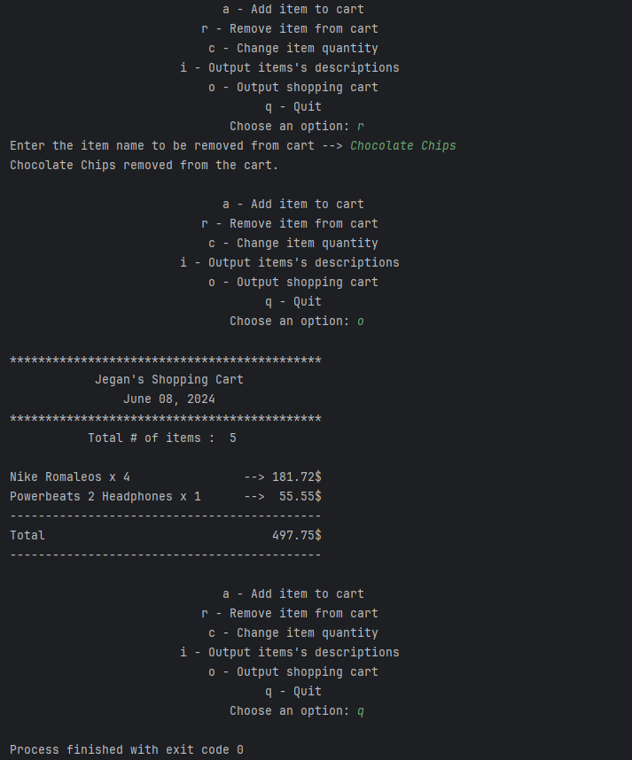

**Output logs completed in the above snap.**

**GitHub Repository**

[CSC500/moduleEight at main · jeganpalaniyandi/CSC500 (github.com)](https://github.com/jeganpalaniyandi/CSC500/tree/main/moduleEight)