**Course**: CSC500_1

**Module & Assignment**: 6 & Portfolio Milestone

**Student**: Jegan Palaniyandi

**Understanding of the problem statement**

This is a continuation of Portfolio Milestone 4 where we have created a shopping cart to display all the items with their price and the total cost.

In this milestone, we continued to develop a **shopping cart class** with an init method declared with parameters. We need to write methods to **create, delete and update** the **shopping cart**. We also need to include methods that **display item & description**, a method to return the **number of items in the shopping cart**.

The **main method** should **ask the user details**, then **display the shopping cart options** to perform the shopping and perform shopping based on the option selected until ‘**q**’ is entered.

**Code**

**class ItemToPurchase:**

***"""***

***ItemToPurchase class has a default constructor with three parameters***

***initialized with three parameters with default values as***

***item_name = none***

***item_price = 0 &***

***item_quantity= 0.***

***The class has two methods,***

***1. add_print_list - returns the item name, count and price formatted.***

***This is used by list in the main method that prints***

***all the items to the receipt.***

***2. calculate_item_price - returns item_price by multiplying price and***

***count of items.***

***"""***

**def __init__(self, item_name='none', item_price=0.00, item_quantity=0):**

**self.item_name = item_name**

**self.item_price = item_price**

**self.item_quantity = item_quantity**

**def add_print_list(self):**

**return '{:<32} --> {:>6.2f}$'.format(self.item_name + ' x ' + str(self.item_quantity),**

**self.item_price * self.item_quantity)**

**def calculate_item_price(self):**

**return self.item_price * self.item_quantity**

**class ShoppingCart:**

***"""***

***Class: ShoppingCart***

***Constructor:***

***non-default params:***

***cart_items -> List***

***Default params:***

***customer_name='none'***

***current_date='January 1, 2020'***

***"""***

**def __init__(self, cart_items, customer_name='none', current_date='January 1, 2020'):**

**self.customer_name = customer_name**

**self.current_date = current_date**

**self.cart_items = cart_items**

**self.available_items = {'Nike Romaleos': 'Volt color, Weightlifting shoes',**

**'Chocolate Chips': 'Semi - sweet',**

**'Powerbeats 2 Headphones': 'Bluetooth headphones'**

**}**

**self.total_cost = 0**

**def add_item(self):**

***"""***

***'add_item' handles adding a new item to shopping cart***

***It prompts the user to enter the item name, price and quantity***

***and saves it to a list which saves itemToPurchase objects.***

***"""***

**print(f'\nEnter item details:')**

**print('-' * 19)**

**name = input('Enter item name --> ')**

**price = float(input('Enter item price($) --> '))**

**quantity = int(input('Enter item quantity --> '))**

**item = ItemToPurchase(name, price, quantity)**

**self.cart_items.append(item)**

**print('{} {}(s) priced at ${:.2f} added successfully to cart.'.format(quantity, name, price))**

**def remove_item(self):**

***"""***

***print('Item not found in cart. Nothing removed.')***

***"""***

**def modify_item(self):**

***"""***

***If item can be found (by name) in cart,***

***check if parameter has default values for description, price,***

***and quantity. If not, modify the item in the cart.***

***If item cannot be found (by name) in cart,***

***output this message: Item not found in cart. Nothing modified.***

***"""***

**def get_num_items_in_cart(self):**

***"""***

***:return:# of items in the shopping cart***

***"""***

**num_items = 0**

**for item in self.cart_items:**

**num_items += item.item_quantity**

**return num_items**

**def get_cost_of_cart(self):**

***"""***

***Outputs total of objects in cart.***

***If cart is empty, output this message: SHOPPING CART IS EMPTY***

***:return: none***

***"""***

**for item in self.cart_items:**

**self.total_cost += item.calculate_item_price()**

**# Following section prints the receipt by looping the**

**# 'itemList' and print the total cost at the bottom using**

**# 'totalCost' variable**

**print('-' * 44)**

**print('Total {:>36.2f}$'.format(self.total_cost))**

**print('-' * 44)**

**def print_total(self):**

***"""***

***prints the total cost of items in the cart. Has no parameters.***

***:return:none***

***"""***

**print()**

**print('*' * 44)**

**print(' ' * 12 + '{}\'s Shopping Cart'.format(self.customer_name))**

**print(' ' * 16 + '{}'.format(self.current_date))**

**print('*' * 44)**

**print('{:^44}\n'.format('Total # of items : ' + str(self.get_num_items_in_cart())))**

**for item in self.cart_items:**

**print(item.add_print_list())**

**def print_descriptions(self):**

***"""***

***prints available items and descriptions in the mart***

***:return:none***

***"""***

**print('\n{:>55}'.format('Available Items and Descriptions'))**

**print('-' * 88)**

**print('|{:>32} |{:>34} |'.format('ITEM', 'DESCRIPTION'))**

**print('-' * 88)**

**for l_item, desc in self.available_items.items():**

**print('|{:>32} |{:>34} |'.format(l_item, desc))**

**print('-' * 88)**

**def output_cart(self):**

***"""***

***prints the list of items with their total price***

***and at the bottom prints the***

***:return:***

***"""***

**if self.get_num_items_in_cart():**

**self.print_total()**

**self.get_cost_of_cart()**

**else:**

**print('SHOPPING CART IS EMPTY')**

**def print_menu_options():**

***"""***

***Prints Menu with options and***

***prompt the user to enter an option***

***:return: shopping cart options menu***

***"""***

**menu_options = ['a - Add item to cart', 'r - Remove item from cart', 'c - Change item quantity',**

**'i - Output items\'s descriptions', 'o - Output shopping cart', 'q - Quit']**

**print()**

**for l_option in menu_options:**

**print(f'{l_option:^80}')**

**selected_option = input('{:>49}'.format('Choose an option: '))**

**return selected_option**

**if __name__ == '__main__':**

**# Print CSU groceries banner**

**print('*' * 100)**

**print(' ' * 25, 'CSU Groceries - User-friendly Online Shopping')**

**print('*' * 100)**

**# Get and print user and date**

**user_name = input('\nEnter your name : ')**

**today_date = input('Enter today\'s date as <Month> <date>, <year> : ')**

**print('\n{:>50} \'{}\''.format('Welcome valued customer', user_name))**

**print('{:>42} {}'.format('Shopping date :', today_date))**

**# Create and Initialize an empty shopping cart with entered username and date**

**user_cart_items = []**

**user_cart = ShoppingCart(user_cart_items, user_name, today_date)**

**# Print Menu for options until user enters 'q'**

**option_selected = ''**

**while option_selected != 'q':**

**if option_selected == 'a':**

**user_cart.add_item()**

**elif option_selected == 'i':**

**user_cart.print_descriptions()**

**elif option_selected == 'o':**

**user_cart.output_cart()**

**option_selected = print_menu_options()**

**Output**

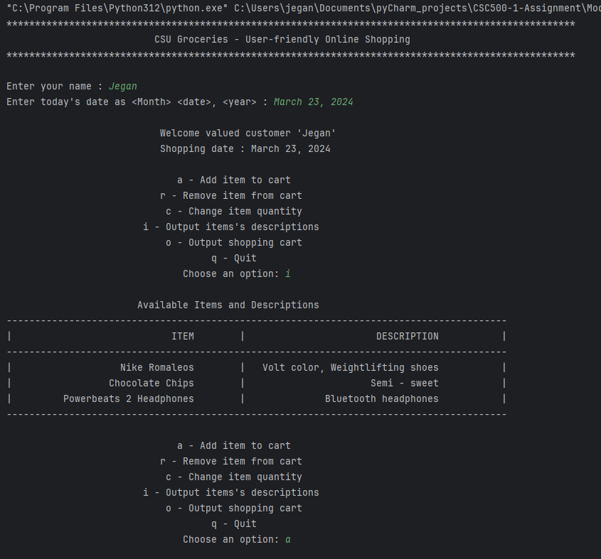

Output continued…

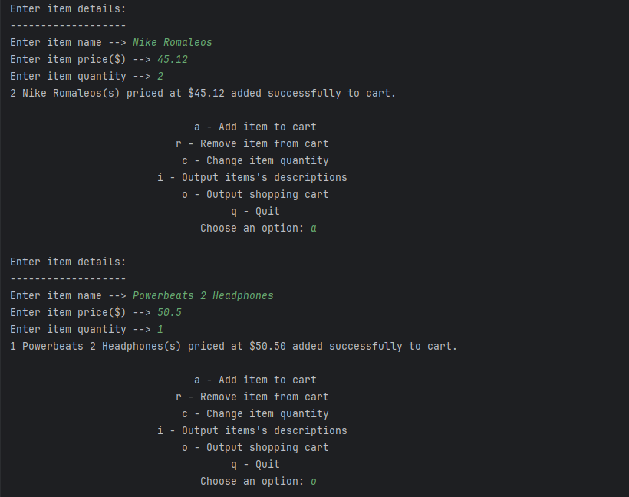

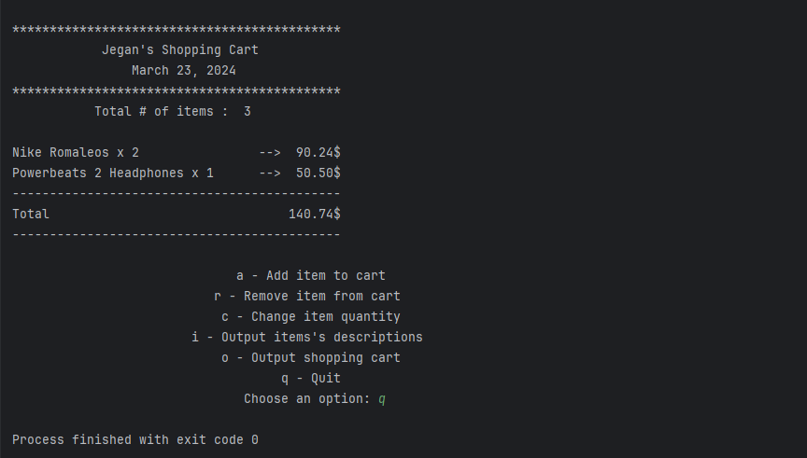

**GitHub Repository**

[**CSC500/moduleSix at main · jeganpalaniyandi/CSC500 (github.com)**](https://github.com/jeganpalaniyandi/CSC500/tree/main/moduleSix)