**Course**: CSC500_1

**Module & Assignment**: 3 & Critical Thinking Assignment

**Student**: Jegan Palaniyandi

### Creating Python Programs

#### **Part 1**

Write a program that **calculates the total amount of a meal** purchased at a restaurant. The program should **ask the user to enter the charge** for the food and then **calculate the amounts with an 18 percent tip and 7 percent sales tax**. **Display** each of these **amounts** and the **total price**.

**Pseudocode**

BEGIN

FUNCTION display_total_cost(meal_charge)

SET calculated_tip TO meal_charge TIMES 0.18

SET calculated_tax TO meal_charge TIMES 0.07

SET total_cost TO meal_charge PLUS calculated_tip PLUS calculated_tax

PRINT "Meal charge --> $", CALL format_dollars(meal_charge)

PRINT "18% tip --> $", CALL format_dollars(calculated_tip)

PRINT "7% tax --> $", CALL format_dollars(calculated_tax)

PRINT "Total Cost --> $", CALL format_dollars(total_cost)

END FUNCTION

FUNCTION format_dollars(amount)

RETURN formatted amount with two decimal places and right-aligned

END FUNCTION

# Main function is the entry point of the program

FUNCTION MAIN

SET user_charge TO USER INPUT as float

IF user_charge LESS THAN 10 OR GREATER THAN 30 THEN

PRINT "Entered charge is out of range. Please enter the correct charge."

TERMINATE PROGRAM

END IF

CALL display_total_cost(user_charge)

END

**Coding**

# This function calculates and prints the total cost including tip and tax

def display_total_cost(meal_charge):

# 18 percent tip

# 7 percent sales tax

calculated_tip = meal_charge * 0.18

calculated_tax = meal_charge * 0.07

# Total Cost = meal charge + 18% tip + 7% Sale tax

total_cost = meal_charge + calculated_tip + calculated_tax

print(f'\nMeal charge --> $ {format_dollars(meal_charge)}')

print(f' 18% tip --> $ {format_dollars(calculated_tip)}')

print(f' 7% tax --> $ {format_dollars(calculated_tax)}')

print('-' * 24)

print(f' Total Cost --> $ {format_dollars(total_cost)}')

# This function formats the given amount for equal indentation in the receipt

def format_dollars(amount):

# format amounts to 6 places with first three places for whole number

# and last three places for .(dot) and two fractional numbers

formatted_number = "{: >6.2f}".format(amount)

return formatted_number

if __name__ == '__main__':

print()

print('*' * 65)

print(' ' * 14 + 'MODULE THREE ASSIGNMENT - PART ONE')

print(' ' * 16 + '(MEALS TOTAL COST CALCULATOR)')

print('*' * 65)

# Get the meal charge from user

user_charge = float(input('\nEnter the meal charge: '))

# Validate the user charge entered

if user_charge < 10 or user_charge > 30:

print('Entered charge is out of range with average price. Please re-run the program and enter correct charge.')

exit(4)

# Calculate and display the receipt including tax and tips

display_total_cost(user_charge)

**Outputs**

**User charge = 14**

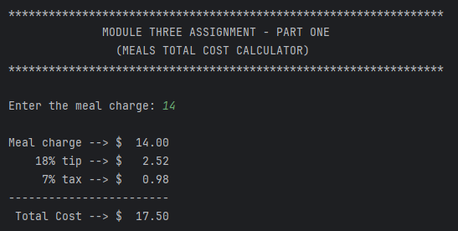

**User Charge = 15.5**

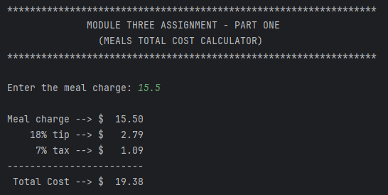

**User Charge = 43**

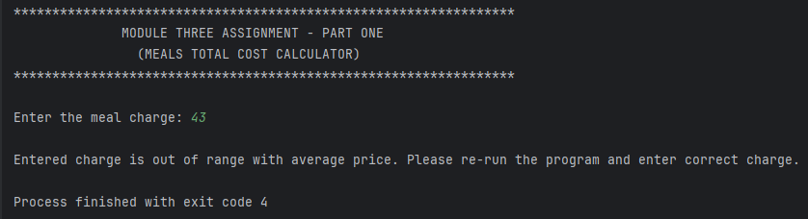

**User Charge = -10**

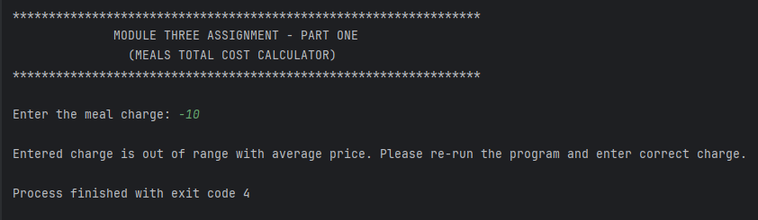

### 

### Creating Python Programs

#### **Part 2**

Many people keep time using a **24-hour clock** (11 is 11am and 23 is 11pm, 0 is midnight). If it is **currently 13** and you **set your alarm to go off in 50 hours**, it will be **15** (3pm). Write a Python program to solve the general version of the above problem. **Ask the user for the time now (in hours)** and then **ask for the number of hours to wait** for the alarm. Your program should **output what the time will be on a 24-hour clock when the alarm goes off**.

**Pseudocode**

BEGIN

FUNCTION calculate_hour_of_alarm(curr_hour, hours_from_now)

SET alarm_hour TO (curr_hour PLUS hours_from_now) MODULO 24

PRINT "Hour in a 24 hour clock when the alarm goes off -->", alarm_hour

SET meridiem TO EMPTY STRING

IF alarm_hour GREATER THAN 12 THEN

SET meridiem TO "PM"

ELSE

SET meridiem TO "AM"

END IF

PRINT "Hour in a 12 hour clock when the alarm goes off -->", alarm_hour MODULO 12, meridiem

END calculate_hour_of_alarm FUNCTION

# Main function is the entry point of the program

MAIN FUNCTION

PRINT "Welcome to the Alarm Time Hour Calculator"

SET current_hour TO USER INPUT as integer

SET alarm_hours_from_now TO USER INPUT as integer

CALL calculate_hour_of_alarm(current_hour, alarm_hours_from_now)

END MAIN FUNCTION

END

**Coding**

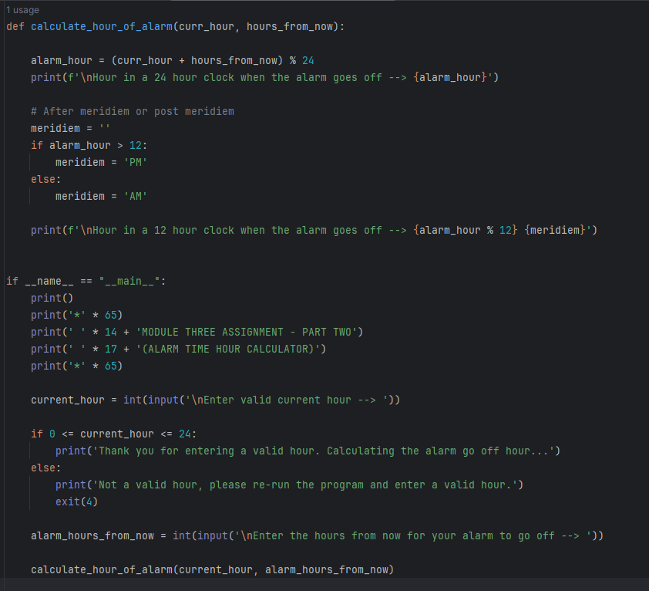

**Output One**

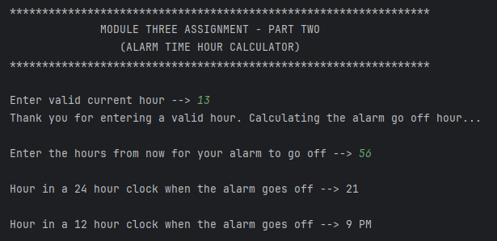

**Output Two**

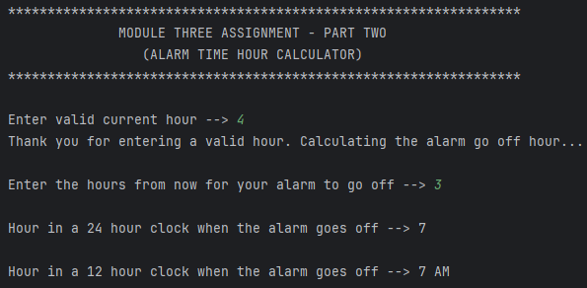

**Output Three**

