**AWS-DAY-2**

1)Create a Windows EC2 instance with t2.micro Instance and show the remote connection of that EC2 Instance.

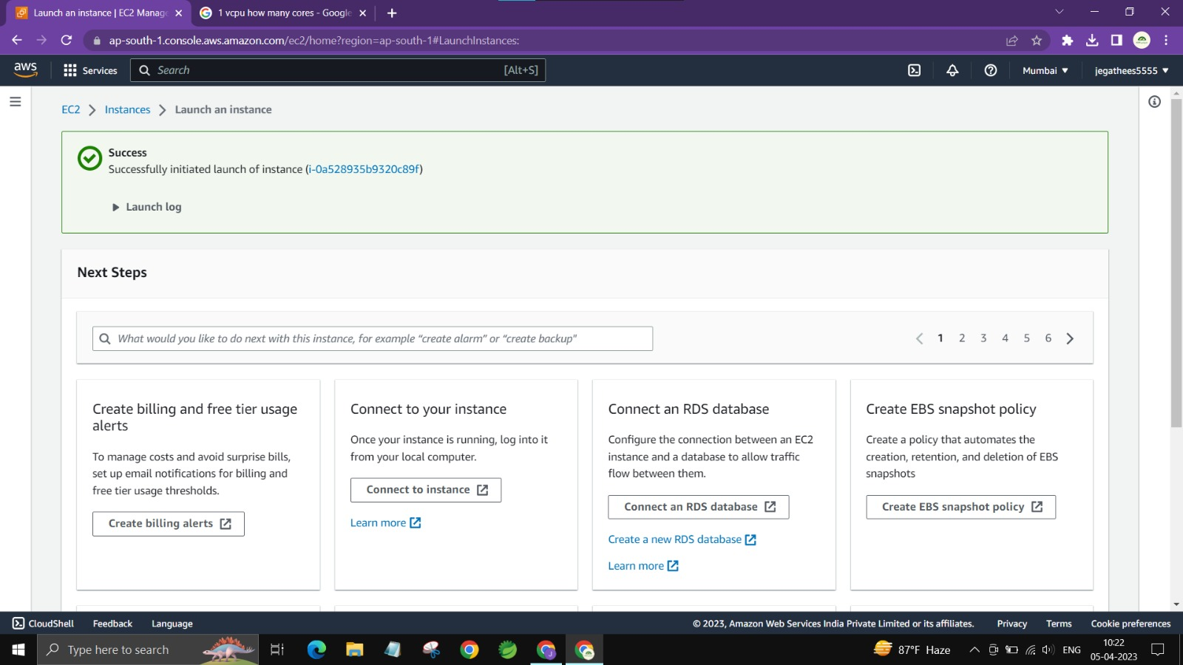

2)Create an EBS volume of 5 GB and attach to a windows EC2 instance and make partition of that EBS volume.

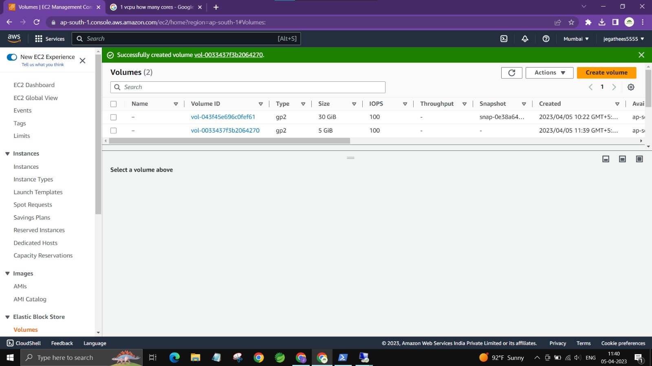

3)Create some files and folders into 5 GB EBS volume of the previous exercise and take a snapshot of that EBS volume.



4)Create a Linux EC2 instance with t2.micro Instance and show the remote connection of that EC2 Instance.

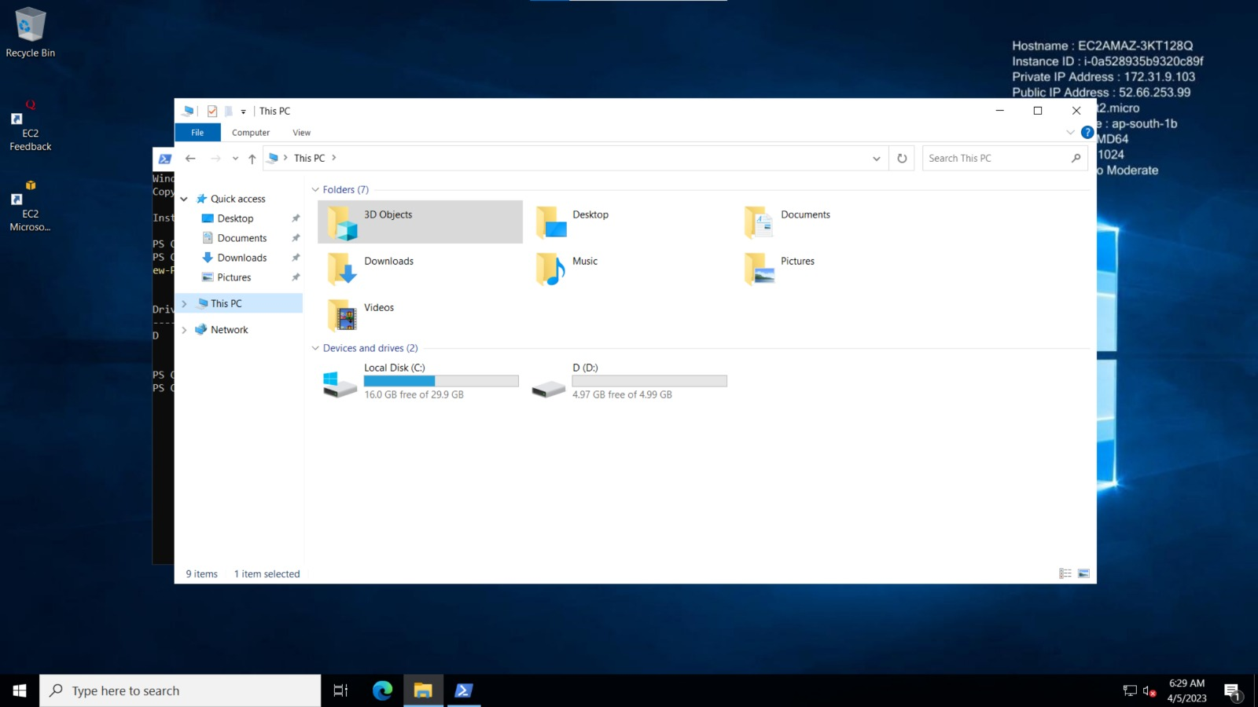

5)Install, Start and Enable the httpd webservice in that Linux EC2 Instance, then host a static website in EC2.

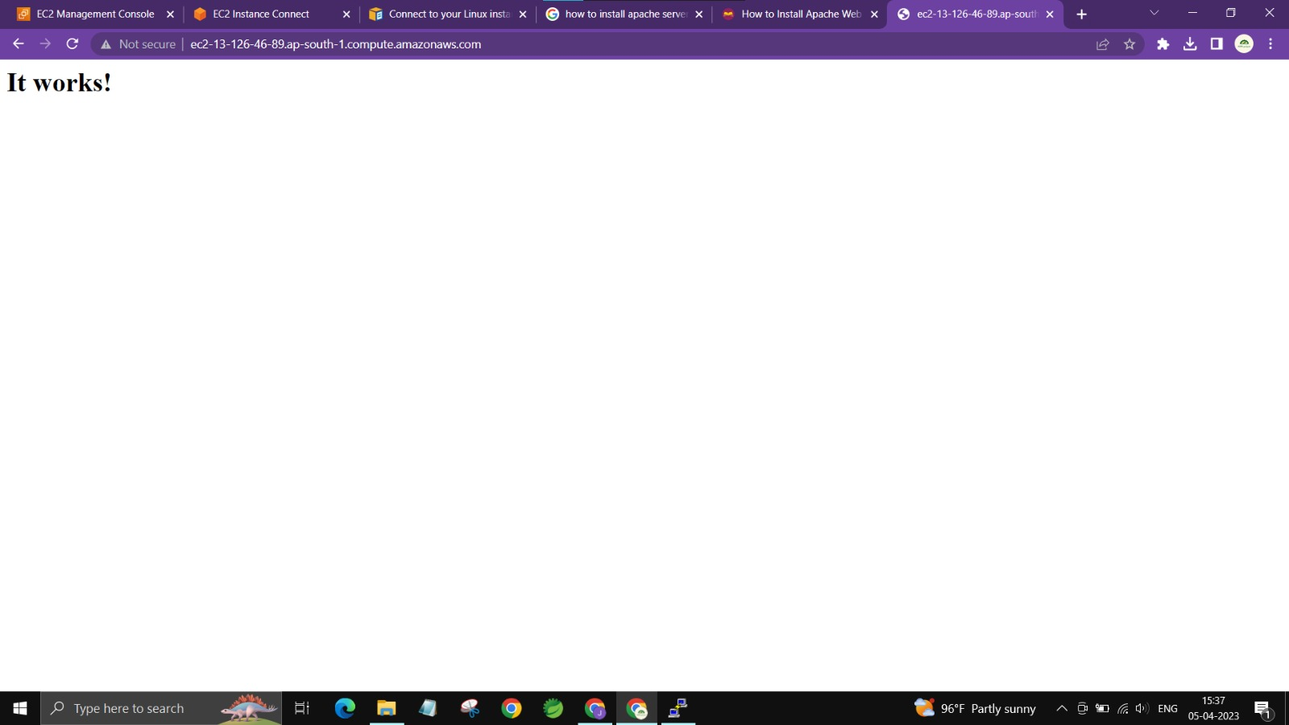

6)Create Image(MyAMI) of the linux Webserver(from the previous exercise) and launch new EC2 instance from the created Image(MyAMI)

