**AWS-DAY-5**

1)Create a launch template with a custom AMI and t2.micro instance type

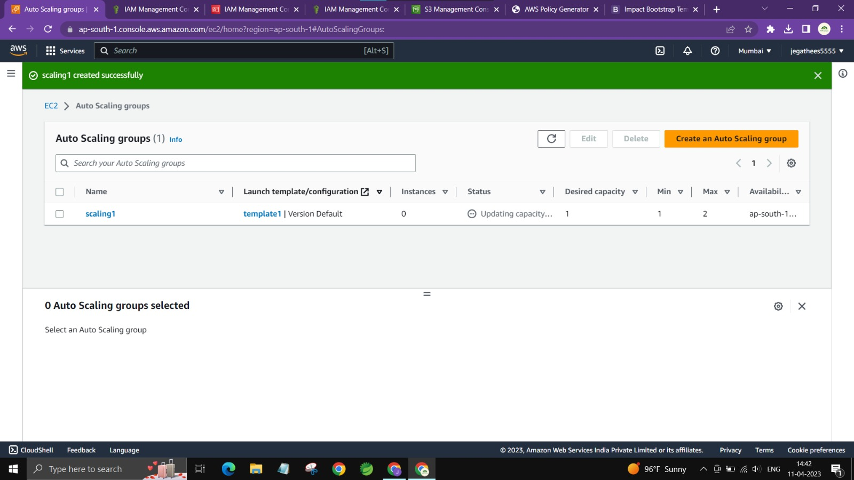

2)Create an autoscaling group with the above-created launch template

