AWS-DAY-6

1)Create a vpc with multiple subnets(atleast 1 subnet in each zone)

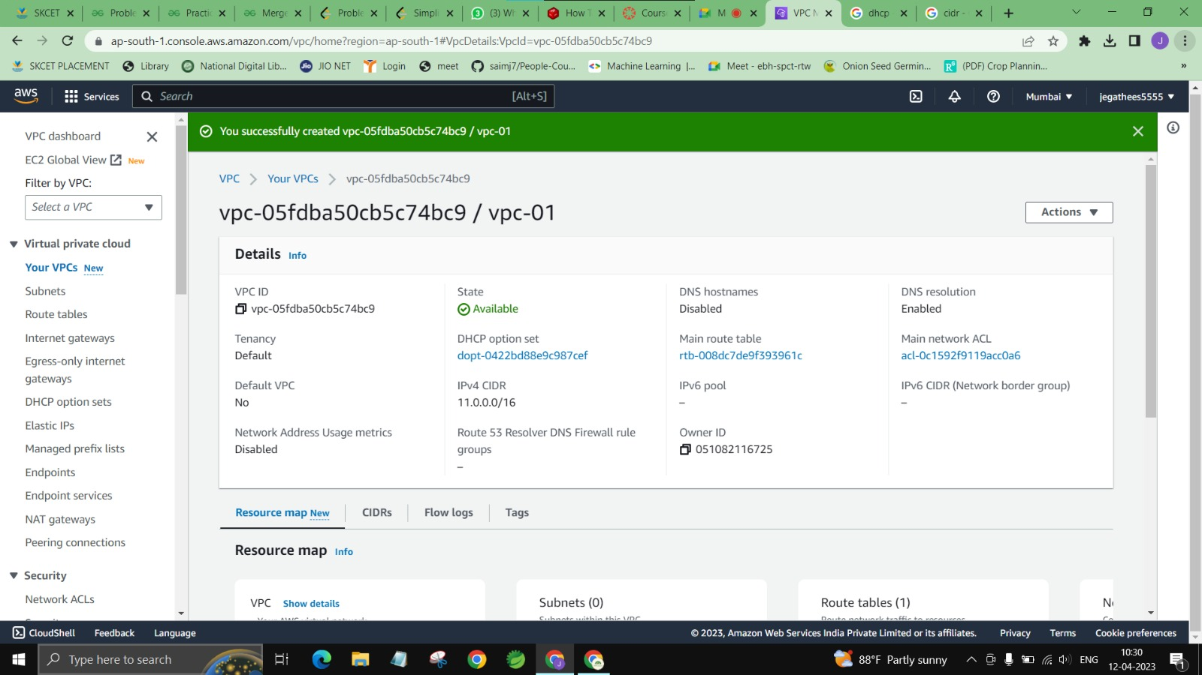

2)Make 1 public subnet and 2 private subnets in the created VPC

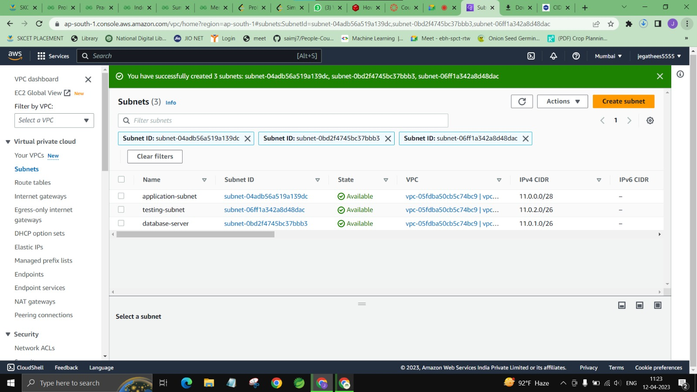

3)Make internet connection using NAT gateway for the 2 private subnets.

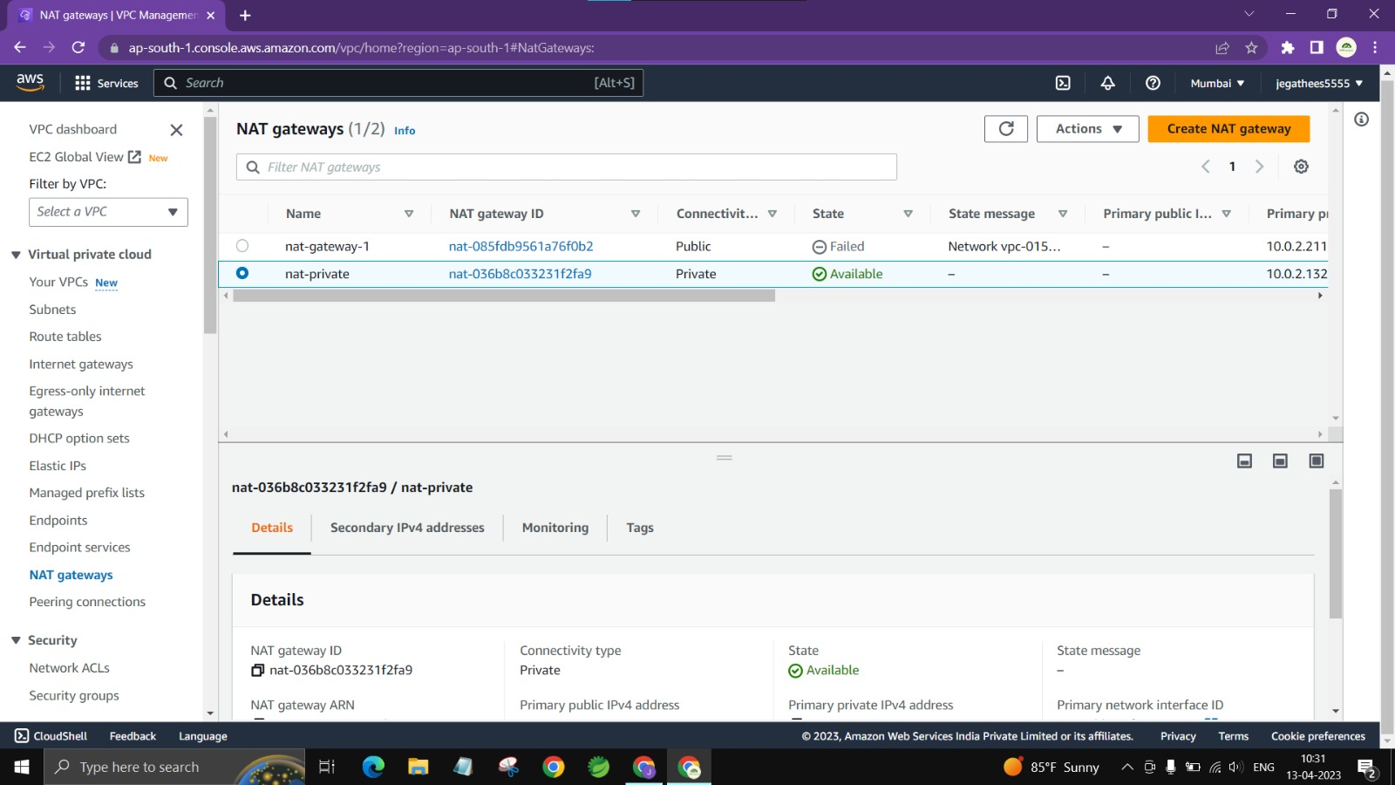

4)Create a VPC peering connetion between 2 different VPCs from 2 different regions.

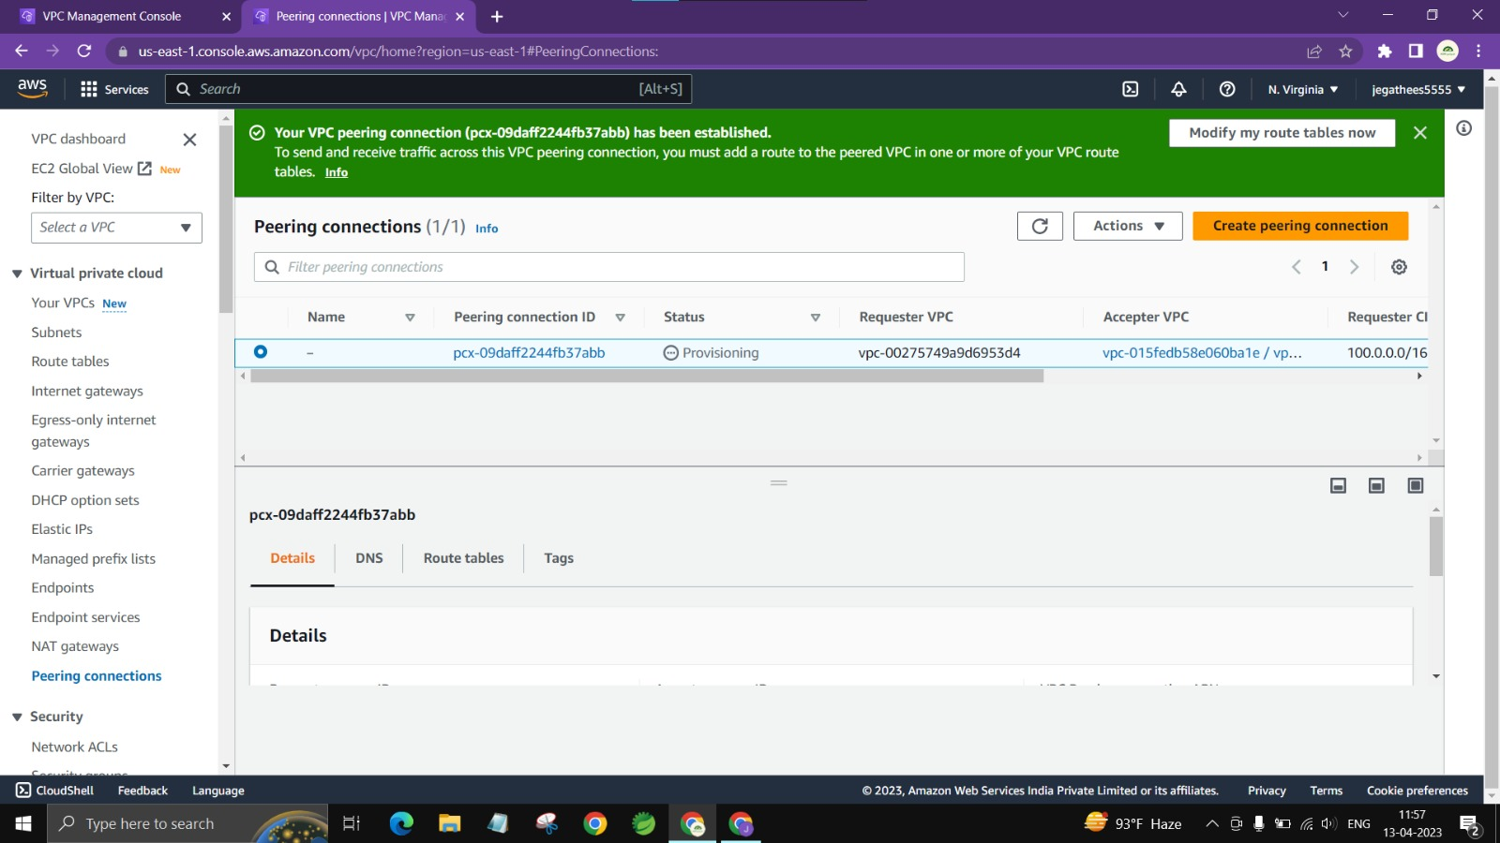

5)Create VPC peering connetions for 3 different VPCs from the same region



6)Add security rules in the VPC's NACL which should deny RDP, SSH from the public network

