**AWS-DAY-7**

1)Host a static website using classic LoadBalancer

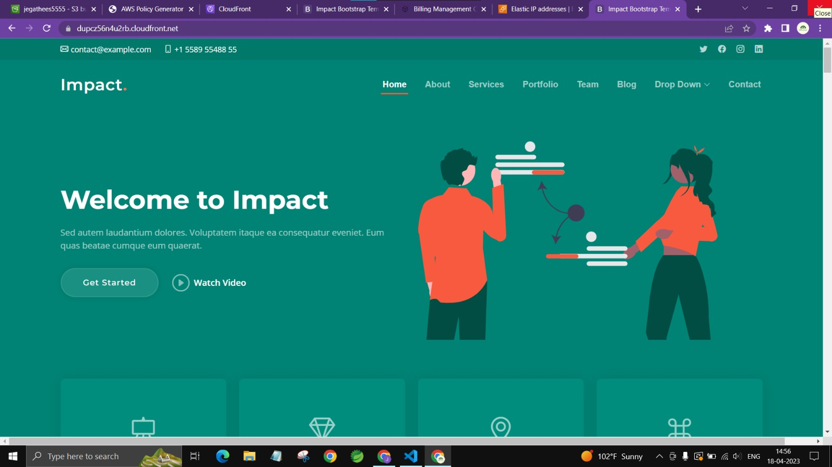

2)Host multiple pages website using Application Load Balancer

