**AWS-DAY-8**

1)Host a static website in AWS using S3 bucket and CloudFront

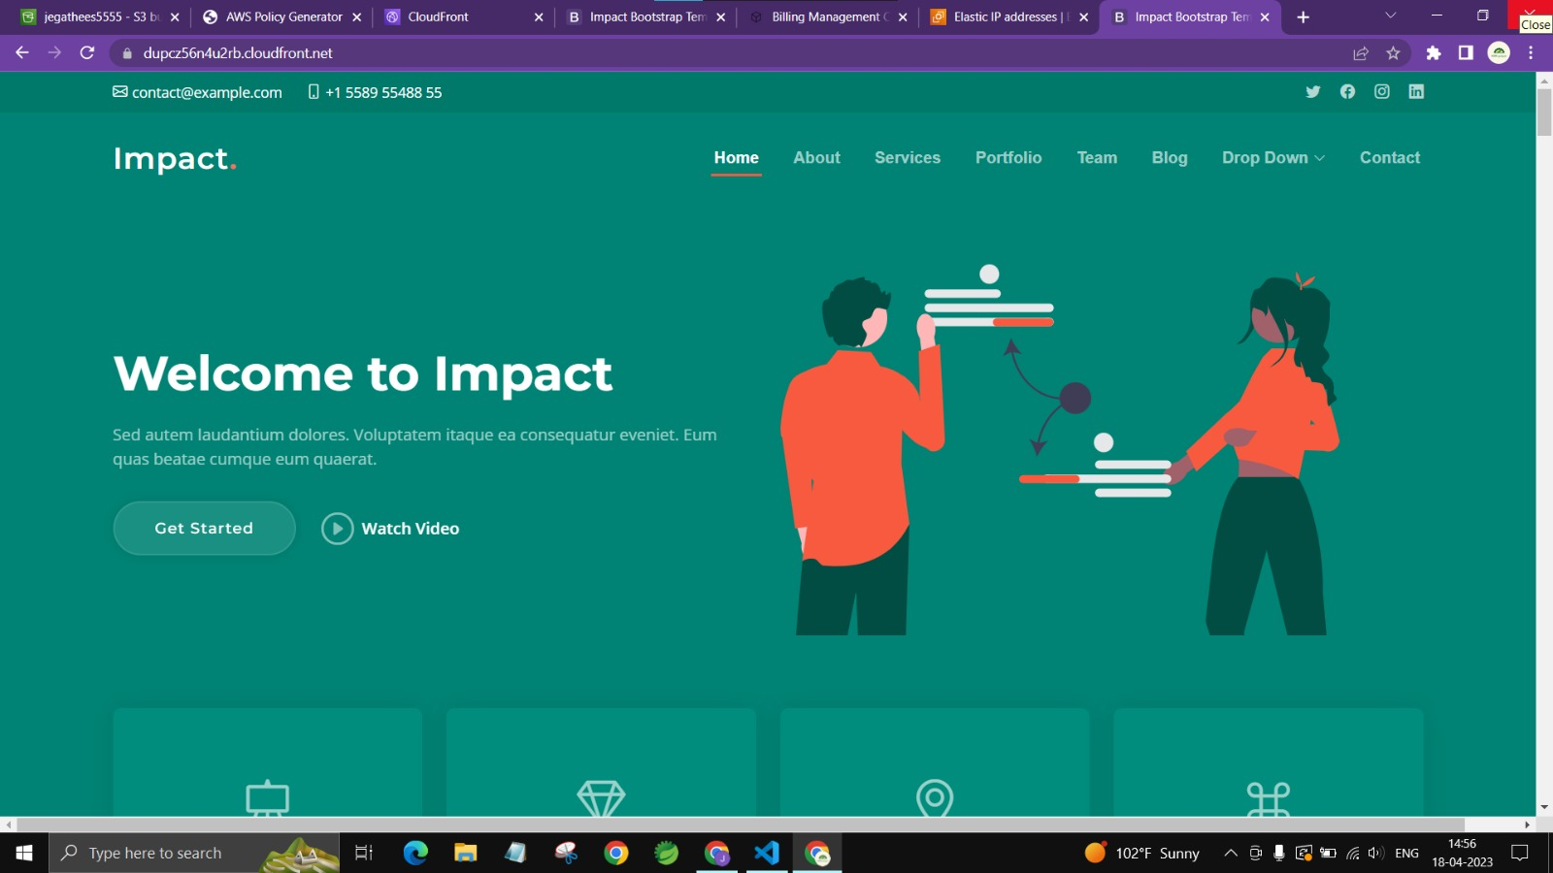

2)Host a dynamic website in AWS using EC2, ELB and CloudFront

