ROS for Arduino based Robot

Coordinate System
From http://www.ros.org/wiki/prairiedog:
Following ROS convention, x points out the front of the robot, y points to the left of the robot, and z points up.

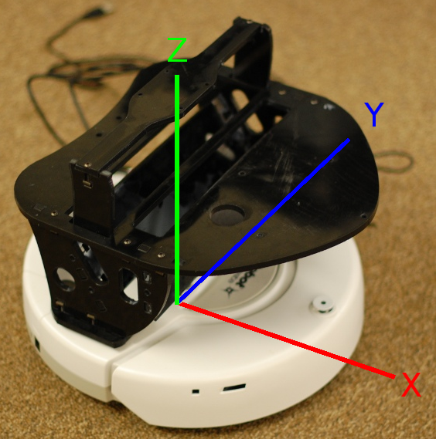

Motors and Quadrature Encoders
Pittman GM8224D201-R2
Mini Gearhead Motor with 500 cnt/rev Encoder
1 to 24 VDC
121 RPM at 6V 140 ma
251 RPM at 12V 175 ma
382 RPM at 18V 200 ma
512 RPM at 24V 220 ma
resistance approx. 4.3 ohms
gear ratio 19.5/1
motor body 1.37" dia. x 3.9" L
3/16" dia. by .7" length shaft
weight 288 grams
$27.50 65 available

Odometry Parameters
Gear ratio of 19.5 / 1 results in 9750 per wheel revolution
We detect two transitions per encoder count; i.e., 19500 ticks per wheel revolution

Wheels from http://www.servocity.com/html/precision_disk_wheels.html
Diameter: 76.2mm (3”)
Circumference: 239.4mm
Distance per tick: 239.4mm / 19500 = 0.0122764mm

PS3 Joystick Support
Rather than following the instruction on the ROS wiki I installed qtsixa on Ubuntu 10.04 (Lucid Lynx). Web site: http://qtsixa.sourceforge.net/
Configured to automatically start on boot.

ls /dev/input/
sudo jstest /dev/input/jsX

Axes: 0: 0 1: 0 2: 0 3: 0 4: 8340 5: -1192 6:-32767 7: 0 8: 0 9: 0 10: 0 11: 0 12: 0 13: 0 14: 0 15: 0 16: 0 17: 0 18: 0 19: 0 20: 0 21: 0 22: 0 23: 0 24: 0 25: 0 26: 0 27: 0 28: 0 Buttons: 0:off 1:off 2:off 3:off 4:off 5:off 6:off 7:off 8:off 9:off 10:off 11:off 12:off 13:off 14:off 15:off 16:off

Integration with ROS: see http://www.ros.org/wiki/joy/Tutorials/ConfiguringALinuxJoystick

rosparam set joy_node/dev "/dev/input/js1"
rosrun joy joy_node

New terminal:
rostopic echo joy

