Lesson 1

Numbers to 1 000

Counting to 1 000

Head Start

Count the number of circles shown below. How do you read each number?

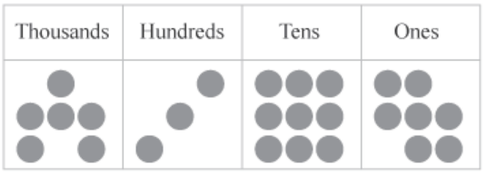

6 397 -Six thousand three hundred ninety-seven

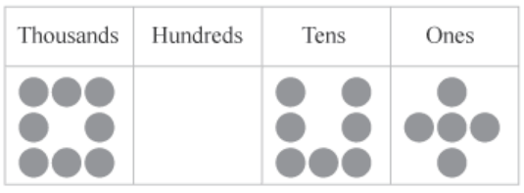

8 075 - Eight thousand seventy-five

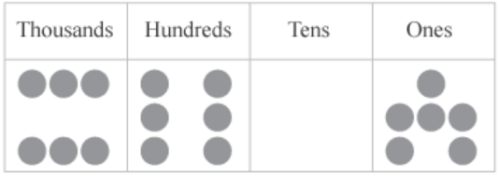

6 066 -Six thousand six hundred six

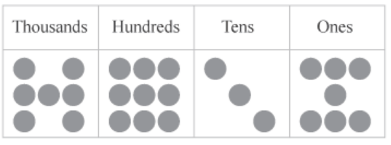

7 937 - Seven thousand nine hundred thirty-seven

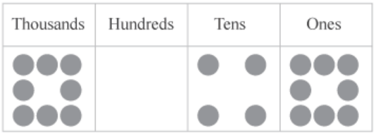

8 048 – eight thousand forty-eight

Practice More

Practice A

Fill in the blanks

|  |  |  |  |
| --- | --- | --- | --- |
| Th | H | T | O |
| 9 | 4 | 7 | 6 |
| 5 | 1 | 2 | 3 |

1. In 5 123, the digit 1 has a value of ______.
2. h
3. t
4. th
5. In 9 476, the digit 7 is in the ___ place
6. th
7. t
8. h
9. In 5 123, the digit 5 is in the _____ place.
10. th
11. h
12. t
13. In 9 476, the digit 6 has a value of ______.
14. t
15. h
16. o
17. In 9 476, the digit 9 gas a value of _____.
18. Th
19. T
20. o

Practice B

Choose the letter of the correct answer

1. One thousand, six hundred forty-five
2. 1 456
3. 1 645
4. 1 564
5. Three thousand, seven hundred eighty-nine
6. 3 789
7. 3 899
8. 3 987
9. Five thousand, seventy-two
10. 5 072
11. 5 702
12. 5 270
13. Six thousand, eight hundred fourteen
14. 6 148
15. 6 814
16. 6 418
17. Nine thousand, seven hundred three
18. 9 733
19. 9 723
20. 9 703