Lesson 2

Numbers to 100 000

Head Start

Count the number of circles shown below. How do you read each number?

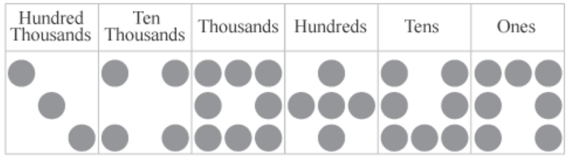

348 577 -three hundred forty-eight thousand five hundred seventy-seven

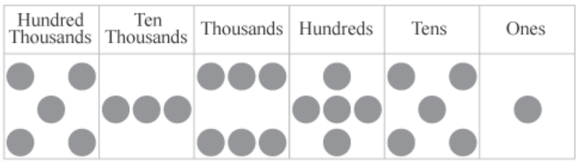

536 551 – five hundred thirty six thousand five hundred fifty-one

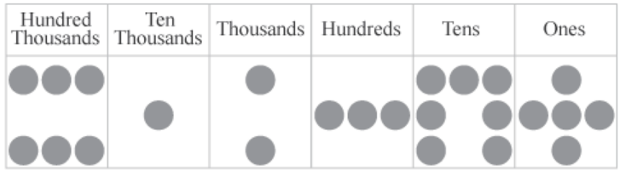

612 375 – six hundred twelve thousand three hundred seventy five

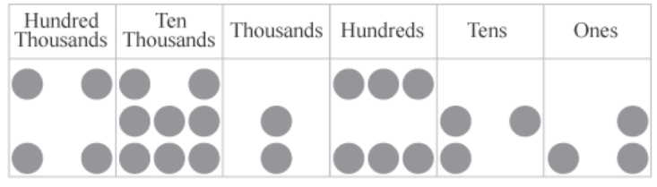

482 633 – four hundred eighty two thousand six hundred thirty-three

Practice More

1. Give the place value of the underlined digit

1. 360 714
2. Hundreds
3. Thousands
4. Tens
5. 669 170
6. Thousands
7. Hundreds
8. Ones
9. 976 312
10. Ones
11. Tens
12. Thousands
13. 258 546
14. ten thousands
15. thousands
16. ones
17. 892 445
18. hundred thousand
19. thousands
20. ones