Addition

Properties of Addition

Head Start

Commutative Property of Addition: Changing the order of the addends does not affect the sum

Example: 3+5 = 5+3

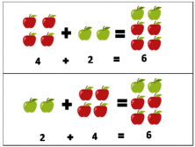

Associative Property of Addition : Changing the grouping of the addends does not affect the sum

Example: (2+3) + 4 = 2(3+4)

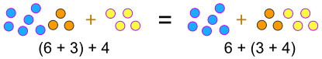

Identity Property of Addition: Adding any number to zero will give the same number

Example: 5+0 = 5

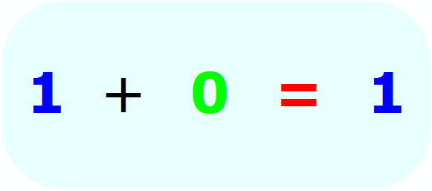

Practice More

Practice A

Re write the given addition sentences using the commutative property of addition

1. 3+7 = _+_

2. 11+4 = _+_

3. 14+1 = _+_

4. 9+5 = _+_

5. 2+18 = _+_

Practice B

Identify the property of addition shown in each number

1. 4+6 = 6+4

2. 15+0 = 15

1. (2+5)+8 = 2+(5+8)
2. 0+21 = 21
3. 8+13 = 13+8