Министерство образования Республики Беларусь Учреждение образования
«БЕЛОРУССКИЙ ГОСУДАРСТВЕННЫЙ УНИВЕРСИТЕТ ИНФОРМАТИКИ И РАДИОЭЛЕКТРОНИКИ»
Кафедра электронных вычислительных машин

ОТЧЕТ
О ЛАБОРАТОРНОЙ РАБОТЕ № 3
Data Caching
по дисциплине «Программирование на языках высокого уровня»

Выполнил ст. гр. 450502 Е.Ю. Новицкий
Проверил асс. каф. ЭВМ И.Г. Скиба

Минск 2026

1 ПОСТАНОВКА ЗАДАЧИ

1 Реализовать сложный GET-запрос с фильтрацией по вложенной сущности с использованием @Query (JPQL).
2 Реализовать аналогичный запрос через native query.Реализовать CRUD операции.
3 Добавить пагинацию (Pageable).
4 Реализовать in-memory индекс на основе HashMap<K, V> для ранее запрошенных данных. Ключ должен формироваться из параметров запроса (составной ключ). Обеспечить корректную работу индекса за счёт правильной реализации equals() и hashCode().
5 Реализовать инвалидацию индекса при изменении данных.
2 СТРУКТУРА ПРОЕКТА

finance-tracker
├── Dockerfile
├── docker-compose.yaml
├── pom.xml
├── README.md
├── config
│ └── checkstyle
│ └── checkstyle.xml
├── docs
│ ├── ER-diagram.png
│ └── api.md
│
└── src
└── main
├── java
│ └── com
│ └── finance
│ └── tracker
│ ├── FinanceTrackerApplication.java
│ ├── cache
│ │ ├── CacheKey.java
│ │ └── CacheManager.java
│ ├── controller
│ │ ├── AccountController.java
│ │ ├── BudgetController.java
│ │ ├── TagController.java
│ │ ├── TransactionController.java
│ │ └── UserController.java
│ ├── domain
│ │ ├── Account.java
│ │ ├── AccountType.java
│ │ ├── Budget.java
│ │ ├── Tag.java
│ │ ├── Transaction.java
│ │ ├── TransactionType.java
│ │ └── User.java
│ ├── dto
│ │ ├── request
│ │ │ ├── AccountRequest.java
│ │ │ ├── AccountTransferRequest.java
│ │ │ ├── BudgetRequest.java
│ │ │ ├── TagRequest.java
│ │ │ ├── TransactionRequest.java
│ │ │ └── UserRequest.java
│ │ └── response
│ │ ├── AccountResponse.java
│ │ ├── BudgetResponse.java
│ │ ├── TagResponse.java
│ │ ├── TransactionResponse.java
│ │ └── UserResponse.java
│ ├── mapper
│ │ ├── AccountMapper.java
│ │ ├── BudgetMapper.java
│ │ ├── TagMapper.java
│ │ ├── TransactionMapper.java
│ │ └── UserMapper.java
│ ├── repository
│ │ ├── AccountRepository.java
│ │ ├── BudgetRepository.java
│ │ ├── TagRepository.java
│ │ ├── TransactionRepository.java
│ │ └── UserRepository.java
│ └── service
│ ├── AccountService.java
│ ├── BudgetService.java
│ ├── TagService.java
│ ├── TransactionService.java
│ ├── UserService.java
│ └── impl
│ ├── AccountServiceImpl.java
│ ├── BudgetServiceImpl.java
│ ├── TagServiceImpl.java
│ ├── TransactionServiceImpl.java
│ └── UserServiceImpl.java
└── resources
└── application.properties
3 ЛИСТИНГ КОДА

Файл TransactionSearchQueryMode.java

package com.finance.tracker.dto.request;

public enum TransactionSearchQueryMode {
JPQL,
NATIVE
}

Файл TransactionSearchCacheKey.java

package com.finance.tracker.cache;

import java.math.BigDecimal;
import java.time.LocalDateTime;
import java.util.Objects;

import com.finance.tracker.dto.request.TransactionSearchQueryMode;

public final class TransactionSearchCacheKey {

private final TransactionSearchQueryMode queryMode;
private final String budgetName;
private final String accountName;
private final BigDecimal minAmount;
private final BigDecimal maxAmount;
private final LocalDateTime startDateTime;
private final LocalDateTime endDateTime;
private final int pageNumber;
private final int pageSize;
private final String sort;

public TransactionSearchCacheKey(
TransactionSearchQueryMode queryMode,
String budgetName,
String accountName,
BigDecimal minAmount,
BigDecimal maxAmount,
LocalDateTime startDateTime,
LocalDateTime endDateTime,
int pageNumber,
int pageSize,
String sort) {
this.queryMode = queryMode;
this.budgetName = budgetName;
this.accountName = accountName;
this.minAmount = minAmount;
this.maxAmount = maxAmount;
this.startDateTime = startDateTime;
this.endDateTime = endDateTime;
this.pageNumber = pageNumber;
this.pageSize = pageSize;
this.sort = sort;
}

@Override
public boolean equals(Object other) {
if (this == other) {
return true;
}
if (!(other instanceof TransactionSearchCacheKey that)) {
return false;
}
return pageNumber == that.pageNumber
&& pageSize == that.pageSize
&& queryMode == that.queryMode
&& Objects.equals(budgetName, that.budgetName)
&& Objects.equals(accountName, that.accountName)
&& Objects.equals(minAmount, that.minAmount)
&& Objects.equals(maxAmount, that.maxAmount)
&& Objects.equals(startDateTime, that.startDateTime)
&& Objects.equals(endDateTime, that.endDateTime)
&& Objects.equals(sort, that.sort);
}

@Override
public int hashCode() {
return Objects.hash(
queryMode,
budgetName,
accountName,
minAmount,
maxAmount,
startDateTime,
endDateTime,
pageNumber,
pageSize,
sort);
}
}

Файл TransactionSearchIndex.java

package com.finance.tracker.cache;

import java.util.HashMap;
import java.util.List;
import java.util.Map;
import java.util.Optional;

import org.springframework.data.domain.Page;
import org.springframework.data.domain.PageImpl;
import org.springframework.stereotype.Component;

import com.finance.tracker.dto.response.TransactionResponse;

@Component
public class TransactionSearchIndex {

private final Map<TransactionSearchCacheKey, Page<TransactionResponse>> entries = new HashMap<>();

public synchronized Optional<Page<TransactionResponse>> find(TransactionSearchCacheKey key) {
return Optional.ofNullable(entries.get(key))
.map(this::copyPage);
}

public synchronized void put(TransactionSearchCacheKey key, Page<TransactionResponse> page) {
entries.put(key, copyPage(page));
}

public synchronized int invalidateAll() {
int removedEntries = entries.size();
entries.clear();
return removedEntries;
}

private Page<TransactionResponse> copyPage(Page<TransactionResponse> page) {
return new PageImpl<>(
List.copyOf(page.getContent()),
page.getPageable(),
page.getTotalElements());
}
}

Файл TransactionSearchIndexInvalidator.java

package com.finance.tracker.cache;

import lombok.extern.slf4j.Slf4j;
import lombok.RequiredArgsConstructor;
import org.springframework.stereotype.Component;
import org.springframework.transaction.support.TransactionSynchronization;
import org.springframework.transaction.support.TransactionSynchronizationManager;

@Component
@Slf4j
@RequiredArgsConstructor
public class TransactionSearchIndexInvalidator {

private final TransactionSearchIndex transactionSearchIndex;

public void invalidateAfterCommitOrNow() {
if (!TransactionSynchronizationManager.isSynchronizationActive()) {
int removedEntries = transactionSearchIndex.invalidateAll();
log.info("Transaction search cache INVALIDATED immediately [entriesRemoved={}]", removedEntries);
return;
}

TransactionSynchronizationManager.registerSynchronization(new TransactionSynchronization() {
@Override
public void afterCommit() {
int removedEntries = transactionSearchIndex.invalidateAll();
log.info("Transaction search cache INVALIDATED after commit [entriesRemoved={}]", removedEntries);
}
});
}
}

Файл BudgetServiceImpl.java

package com.finance.tracker.service.impl;

import com.finance.tracker.cache.CacheManager;
import com.finance.tracker.domain.Account;
import com.finance.tracker.domain.Budget;
import com.finance.tracker.domain.User;
import com.finance.tracker.dto.request.BudgetRequest;
import com.finance.tracker.dto.response.BudgetResponse;
import com.finance.tracker.mapper.BudgetMapper;
import com.finance.tracker.repository.BudgetRepository;
import com.finance.tracker.repository.UserRepository;
import com.finance.tracker.service.BudgetService;

import lombok.RequiredArgsConstructor;

import org.springframework.data.domain.Page;
import org.springframework.data.domain.Pageable;
import org.springframework.http.HttpStatus;
import org.springframework.stereotype.Service;
import org.springframework.transaction.annotation.Transactional;
import org.springframework.web.server.ResponseStatusException;

@Service
@Transactional(readOnly = true)
@RequiredArgsConstructor
public class BudgetServiceImpl implements BudgetService {

private static final String BUDGET_NOT_FOUND_MESSAGE = "Budget not found ";

private final BudgetRepository budgetRepository;
private final UserRepository userRepository;
private final BudgetMapper budgetMapper;
private final CacheManager cacheManager;

@Override
public BudgetResponse getBudgetById(Long id) {
Budget budget = budgetRepository.findById(id)
.orElseThrow(() -> new ResponseStatusException(HttpStatus.NOT_FOUND, BUDGET_NOT_FOUND_MESSAGE + id));
return budgetMapper.toResponse(budget);
}

@Override
public Page<BudgetResponse> getAllBudgets(Pageable pageable) {
return budgetRepository.findAll(pageable)
.map(budgetMapper::toResponse);
}

@Override
@Transactional
public BudgetResponse createBudget(BudgetRequest request) {
validateDateRange(request.getStartDate(), request.getEndDate());
User user = getUser(request.getUserId());
Budget budget = budgetMapper.fromRequest(request, user);
Budget saved = budgetRepository.save(budget);
invalidateSearchCache();
return budgetMapper.toResponse(saved);
}

@Override
@Transactional
public BudgetResponse updateBudget(Long id, BudgetRequest request) {
Budget budget = budgetRepository.findById(id)
.orElseThrow(() -> new ResponseStatusException(HttpStatus.NOT_FOUND, BUDGET_NOT_FOUND_MESSAGE + id));
if (request.getName() != null) {
budget.setName(request.getName());
}
if (request.getLimitAmount() != null) {
budget.setLimitAmount(request.getLimitAmount());
}
if (request.getStartDate() != null) {
budget.setStartDate(request.getStartDate());
}
if (request.getEndDate() != null) {
budget.setEndDate(request.getEndDate());
}
validateDateRange(budget.getStartDate(), budget.getEndDate());

if (request.getUserId() != null) {
budget.setUser(getUser(request.getUserId()));
}

Budget saved = budgetRepository.save(budget);
invalidateSearchCache();
return budgetMapper.toResponse(saved);
}

@Override
@Transactional
public void deleteBudget(Long id) {
Budget budget = budgetRepository.findById(id)
.orElseThrow(() -> new ResponseStatusException(HttpStatus.NOT_FOUND, BUDGET_NOT_FOUND_MESSAGE + id));
budgetRepository.delete(budget);
invalidateSearchCache();
}

private User getUser(Long userId) {
return userRepository.findById(userId)
.orElseThrow(() -> new ResponseStatusException(HttpStatus.NOT_FOUND, "User not found: " + userId));
}

private void validateDateRange(java.time.LocalDate startDate, java.time.LocalDate endDate) {
if (startDate == null || endDate == null) {
throw new ResponseStatusException(HttpStatus.BAD_REQUEST, "Budget startDate and endDate are required");
}
if (startDate.isAfter(endDate)) {
throw new ResponseStatusException(HttpStatus.BAD_REQUEST, "Budget startDate must be <= endDate");
}
}

private void invalidateSearchCache() {
cacheManager.invalidate(User.class, Account.class, Budget.class);
}
}

Файл TransactionService.java

package com.finance.tracker.service;

import java.math.BigDecimal;
import com.finance.tracker.dto.request.TransactionPatchRequest;
import com.finance.tracker.dto.request.TransactionSearchQueryMode;
import com.finance.tracker.dto.request.TransactionRequest;
import com.finance.tracker.dto.response.TransactionResponse;
import com.finance.tracker.dto.response.TransactionSearchResult;

import java.time.LocalDateTime;
import java.util.List;

import org.springframework.data.domain.Pageable;

public interface TransactionService {

TransactionResponse findById(Long id);

List<TransactionResponse> findAll(boolean withEntityGraph);

List<TransactionResponse> findByDateRange(LocalDateTime startDateTime, LocalDateTime endDateTime);

TransactionSearchResult search(
TransactionSearchQueryMode queryMode,
String budgetName,
String accountName,
BigDecimal minAmount,
BigDecimal maxAmount,
LocalDateTime startDateTime,
LocalDateTime endDateTime,
Pageable pageable);

TransactionResponse create(TransactionRequest request);

TransactionResponse update(Long id, TransactionRequest request);
TransactionResponse patch(Long id, TransactionPatchRequest request);

void delete(Long id);
}

Файл TransactionRepository.java

package com.finance.tracker.repository;

import java.math.BigDecimal;
import java.time.LocalDateTime;
import java.util.List;

import org.springframework.data.jpa.repository.EntityGraph;
import org.springframework.data.jpa.repository.JpaRepository;
import org.springframework.data.jpa.repository.Query;
import org.springframework.data.repository.query.Param;
import org.springframework.stereotype.Repository;
import org.springframework.data.domain.Page;
import org.springframework.data.domain.Pageable;

import com.finance.tracker.domain.Transaction;

@Repository
public interface TransactionRepository extends JpaRepository<Transaction, Long> {

List<Transaction> findByOccurredAtBetween(LocalDateTime startDateTime, LocalDateTime endDateTime);
boolean existsByAccountId(Long accountId);
boolean existsByBudgetId(Long budgetId);

@Query("SELECT t FROM Transaction t")
List<Transaction> findAllTransactions();

@EntityGraph(attributePaths = { "budget", "account" })
@Query("SELECT t FROM Transaction t")
List<Transaction> findAllTransactionsWithEntityGraph();

@EntityGraph(attributePaths = { "budget", "account" })
@Query("""
SELECT t
FROM Transaction t
LEFT JOIN t.budget b
JOIN t.account a
WHERE COALESCE(LOWER(b.name), '') LIKE LOWER(CONCAT('%', :budgetName, '%'))
AND LOWER(a.name) LIKE LOWER(CONCAT('%', :accountName, '%'))
AND t.amount >= :minAmount
AND t.amount <= :maxAmount
AND t.occurredAt >= :startDateTime
AND t.occurredAt <= :endDateTime
""")
Page<Transaction> searchByNestedFiltersJpql(
@Param("budgetName") String budgetName,
@Param("accountName") String accountName,
@Param("minAmount") BigDecimal minAmount,
@Param("maxAmount") BigDecimal maxAmount,
@Param("startDateTime") LocalDateTime startDateTime,
@Param("endDateTime") LocalDateTime endDateTime,
Pageable pageable);

@Query(
value = """
SELECT t.*
FROM transactions t
JOIN accounts a ON a.id = t.account_id
LEFT JOIN budgets b ON b.id = t.budget_id
WHERE COALESCE(LOWER(b.name), '') LIKE LOWER(CONCAT('%', :budgetName, '%'))
AND LOWER(a.name) LIKE LOWER(CONCAT('%', :accountName, '%'))
AND t.amount >= :minAmount
AND t.amount <= :maxAmount
AND t.occurred_at >= :startDateTime
AND t.occurred_at <= :endDateTime
""",
countQuery = """
SELECT COUNT(*)
FROM transactions t
JOIN accounts a ON a.id = t.account_id
LEFT JOIN budgets b ON b.id = t.budget_id
WHERE COALESCE(LOWER(b.name), '') LIKE LOWER(CONCAT('%', :budgetName, '%'))
AND LOWER(a.name) LIKE LOWER(CONCAT('%', :accountName, '%'))
AND t.amount >= :minAmount
AND t.amount <= :maxAmount
AND t.occurred_at >= :startDateTime
AND t.occurred_at <= :endDateTime
""",
nativeQuery = true)
Page<Transaction> searchByNestedFiltersNative(
@Param("budgetName") String budgetName,
@Param("accountName") String accountName,
@Param("minAmount") BigDecimal minAmount,
@Param("maxAmount") BigDecimal maxAmount,
@Param("startDateTime") LocalDateTime startDateTime,
@Param("endDateTime") LocalDateTime endDateTime,
Pageable pageable);
}

4 РЕЗУЛЬТАТ РАБОТЫ ПРОГРАММЫ

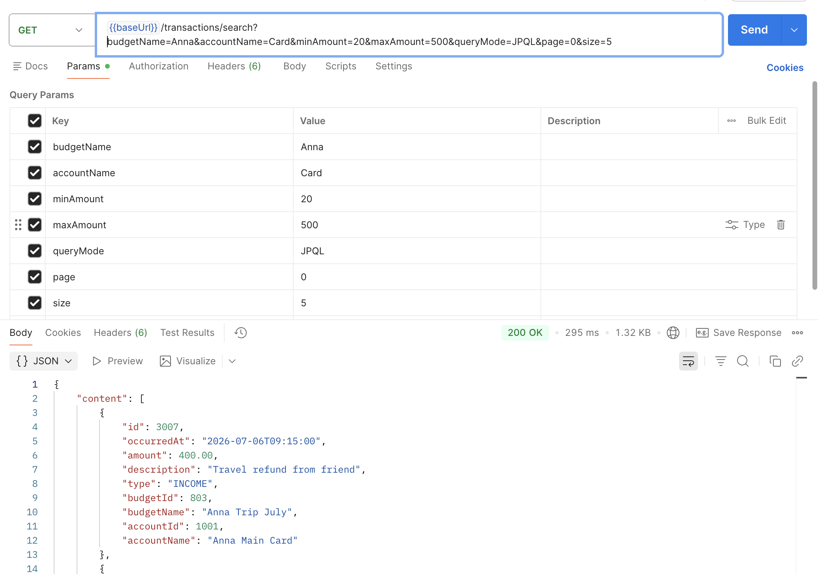

Рисунок 5.1 – Вызов GET метода со сложным JPQL запросом

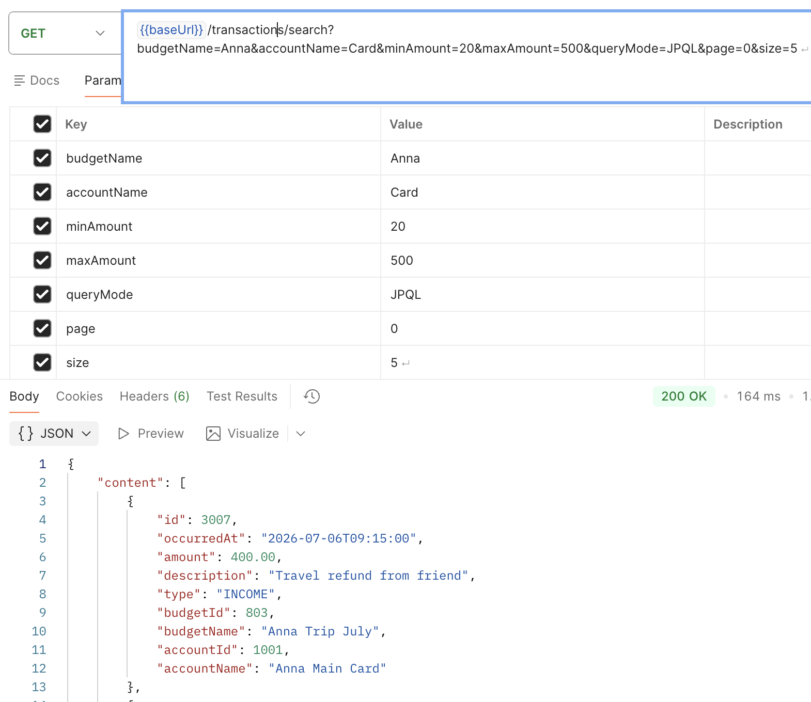

Рисунок 5.2 – Вызов GET метода со сложным native запросом

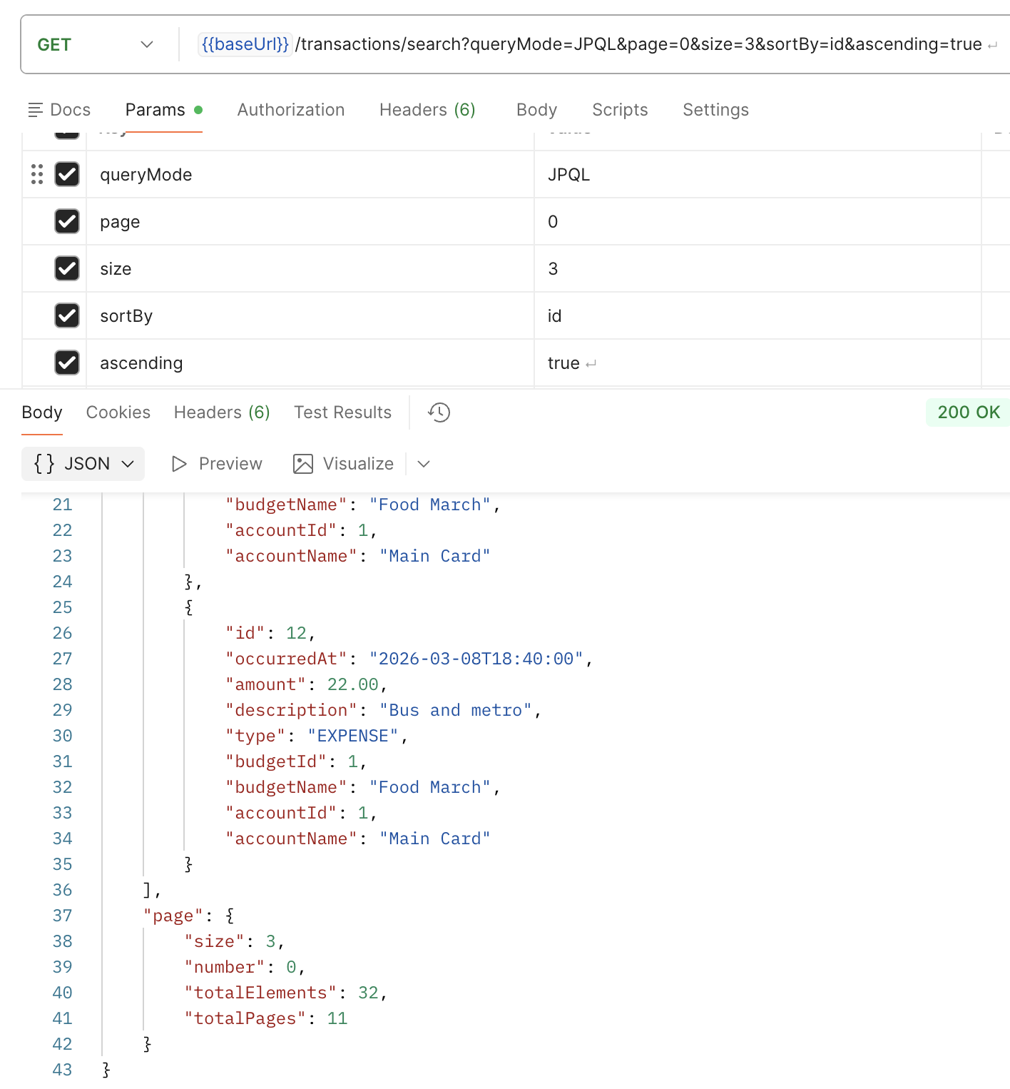

Рисунок 5.3 – Вызов GET метода с пагинацией

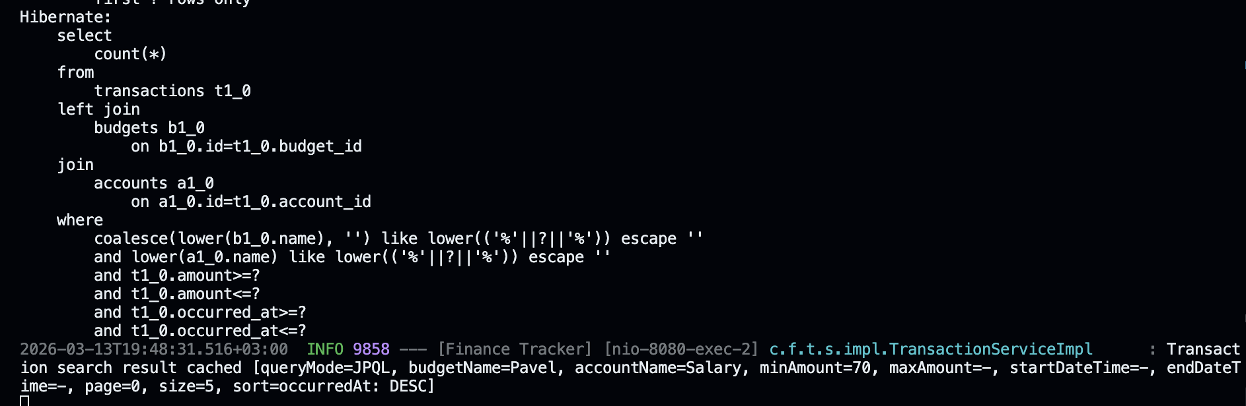

Рисунок 5.4 – Результат работы in-memory индекса

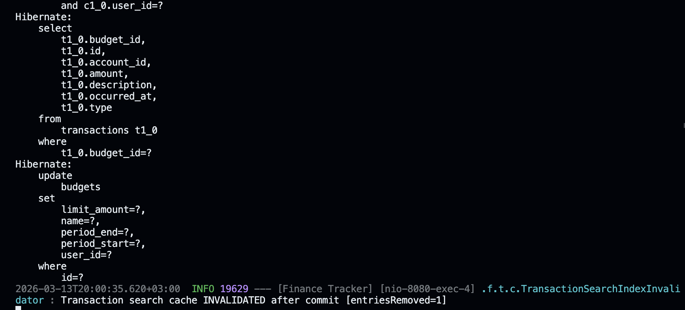

Рисунок 5.5 – Демонстрация инвалидации in-memory индекса

5 ЗАКЛЮЧЕНИЕ

В ходе лабораторной работы реализованы сложные GET-запросы с фильтрацией по вложенной сущности с использованием как JPQL (@Query), так и нативного SQL-запроса. Добавлена пагинация (Pageable) для эффективной работы с большими объемами данных.
Разработан in-memory индекс на основе HashMap, где ключом выступает составной объект CacheKey, для которого корректно реализованы equals() и hashCode(). Реализована инвалидация кэша при изменении данных.

